Diversity of ER-positive and HER2-negative breast cancer stem cells attained using selective culture techniques

Satoshi Sueoka, Azusa Kai, Yukino Kobayashi, Masaoki Ito, Shinsuke Sasada, Akiko Emi, Noriko Gotoh, Koji Arihiro, Koh Nakayama, Morihito Okada, Takayuki Kadoya

Supplementary Material
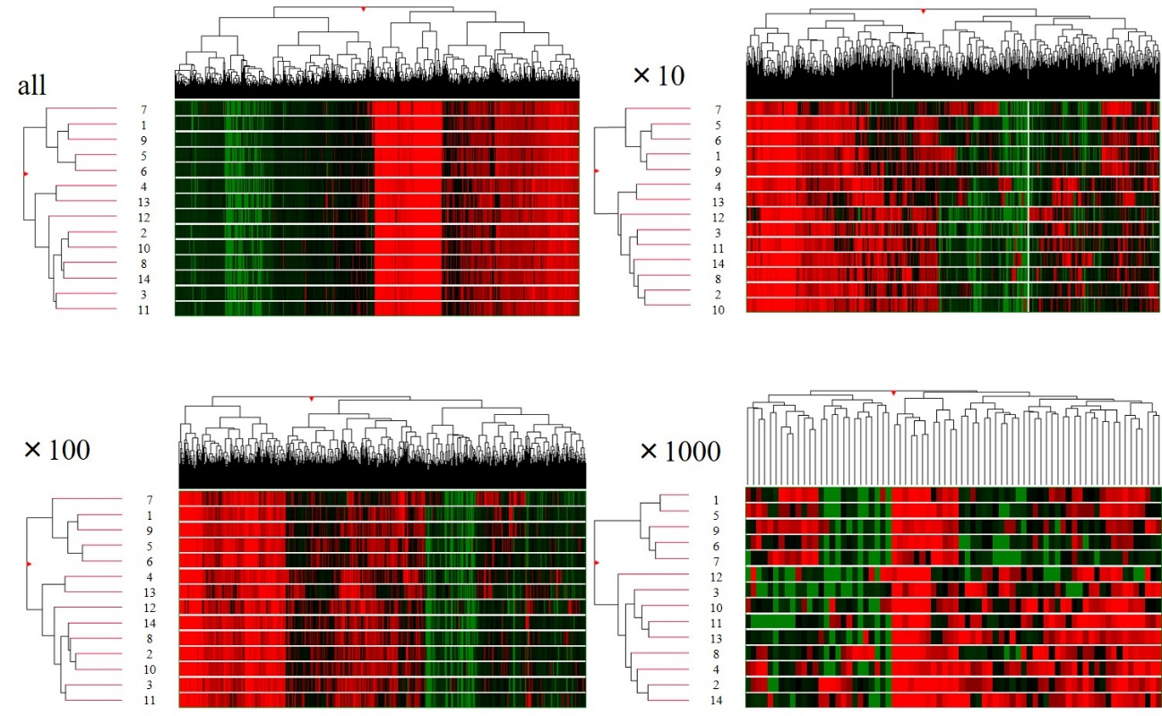

Supplementary Fig. S1. Classification of breast cancer stem cells using clustering analysis according to the cutoff values. There was no change in the classification of the two groups at either cutoff value

