Supplementary Figure 1. Spirometry results in patients with post-COVID-19 condition (PCC, red) and without post-COVID-19 condition (nPCC, blue). No significant differences were observed in any parameters. FVC = forced vital capacity, FEV1 = forced expiratory volume in one second, PEF = peak expiratory flow. The percentages represent the ratio to normalized values for the Finnish population (Kainu et al. 2018). The black lines represent median levels with a 95% confidence interval of the median level.
Supplementary Figure 2. Anti-SARS-CoV-2 S1-specific antibody responses in inpatient and outpatient cohorts. A. IgG antibody responses among inpatients at each time point. B. IgG antibody responses among outpatients. C. IgM antibody responses among inpatients. D. IgM antibody responses among outpatients. E. IgA antibody responses among inpatients. F. IgA antibody responses among outpatients. The evaluation of PCC at the acute phase and a month post-infection was based on the evaluation at the three-month follow-up. Otherwise, PCC status was evaluated at the corresponding follow-up. Yellow dots represent samples from patients vaccinated less than a month before sampling. The black lines represent median levels with a 95% confidence interval of the median level. The antibody levels at each time point were compared with a linear mixed model suitable for repeated measurements adjusted with sex and age. * p<0.05
Supplementary Figure 3. Anti-SARS-CoV-2 N-specific antibody responses among inpatient and outpatient cohorts. A. IgG antibody responses among inpatients at each time point. B. IgG antibody responses among outpatients. C. IgM antibody responses among inpatients. D. IgM antibody responses among outpatients. E. IgA antibody responses among inpatients. F. IgA antibody responses among outpatients. The evaluation of PCC at the acute phase and a month post-infection was based on the evaluation at the three-month follow-up. Otherwise, PCC status was evaluated at the corresponding follow-up. The black lines represent median levels with a 95% confidence interval of the median level. The antibody levels at each time point were compared with a linear mixed model suitable for repeated measurements adjusted with sex and age. * p<0.05

Supplementary Figure 4. Anti-SARS-CoV-2 specific IgM and IgA responses in patients with PCC and recovered individuals (nPCC). A. Anti-SARS-CoV-2 S1-specific IgM antibody responses at each time point. B. Anti-SARS-CoV-2 N-specific IgM antibody responses. C. Anti-SARS-CoV-2 S1-specific IgA antibody responses. D. Anti-SARS-CoV-2 N-specific IgA antibody responses. The evaluation of PCC at the acute phase and a month post-infection was based on the evaluation at the three-month follow-up. Otherwise, PCC status was evaluated at the corresponding follow-up. Yellow dots represent samples from patients vaccinated less than a month before sampling. The black lines represent median levels with a 95% confidence interval of the median level. The antibody levels at each time point were compared with a linear mixed model suitable for repeated measurements adjusted with sex and age. * p<0.05

Supplementary Figure 5. Levels of sST2 and cortisol among inpatient and outpatient cohorts. A. Levels of sST2 among inpatients at each time point. B. Levels of sST2 among outpatients. C. Levels of cortisol among inpatients. D. Levels of cortisol among outpatients. The evaluation of PCC at the acute phase and a month post-infection was based on the evaluation at the three-month follow-up. Otherwise, PCC status was evaluated at the corresponding follow-up. The black lines represent median levels with a 95% confidence interval of the median level. The levels of each parameter were compared with a linear mixed model suitable for repeated measurements adjusted with sex and age. * p<0.05

Supplementary Figure 6. Levels of IL-6 and hs-CRP among inpatient and outpatient cohorts. A. Levels of IL-6 among inpatients at each time point. B. Levels of IL-6 among outpatients. C. Levels of hs-CRP among inpatients. D. Levels of hs-CRP among outpatients. The evaluation of PCC at the acute phase and a month post-infection was based on the assessment at the three-month follow-up. Otherwise, PCC status was evaluated at the corresponding follow-upThe black lines represent median levels with a 95% confidence interval of the median level. The levels of each parameter were compared with a linear mixed model suitable for repeated measurements adjusted with sex and age.

Supplementary Figure 7. Serum levels of sST2, IL-6, cortisol, and hs-CRP in different categories of acute disease severity. A. Levels of sST2 at each time point. B. Levels of IL-6 at each time point. C. Levels of cortisol at each time point. D. Levels of hs-CRP at each time point. The black lines represent median levels with a 95% confidence interval of the median level. The levels of each parameter were compared with a linear mixed effects model suitable for repeated measurements adjusted by sex and age. *p<0.05; **p<0.01; ***p<0.001; **** p<0.0001

Supplementary Figure 8. Anti-SARS-CoV-2 humoral responses in different categories of acute disease severity. A. Anti-S1-specific IgG antibody responses at each time point. B. Anti-N IgG antibody responses. C. Anti-S1 IgM antibody responses. D. Anti-N IgM antibody responses. E. Anti-S1 IgA antibody responses. F. Anti-N-IgA antibody responses. The black lines represent median levels with a 95% confidence interval of the median level. The levels of each parameter were compared with a linear mixed effects model suitable for repeated measurements adjusted by sex and age. *p<0.05; **p<0.01

Supplementary Figure 9. Anti-SARS-CoV-2 humoral responses in different clusters of PCC. A. Anti-S1-specific IgG antibody responses at each time point. B. Anti-N IgG antibody responses. C. Anti-S1 IgM antibody responses. D. Anti-N IgM antibody responses. E. Anti-S1 IgA antibody responses. F. Anti-N-IgA antibody responses. The black lines represent median levels with a 95% confidence interval of the median level. The levels of each parameter were compared with a linear mixed effects model suitable for repeated measurements adjusted by sex and age. *p<0.05

Supplementary Figure 10. Levels of sST2, IL-6, cortisol and hs-CRP in different clusters of PCC. A. Levels of sST2 at each time point. B. Levels of IL-6 at each time point. C. Levels of cortisol at each time point. D. Levels of hs-CRP at each time point. The black lines represent median levels with a 95% confidence interval of the median level. The levels of each parameter were compared with a linear mixed effects model suitable for repeated measurements adjusted by sex and age. *p<0.05

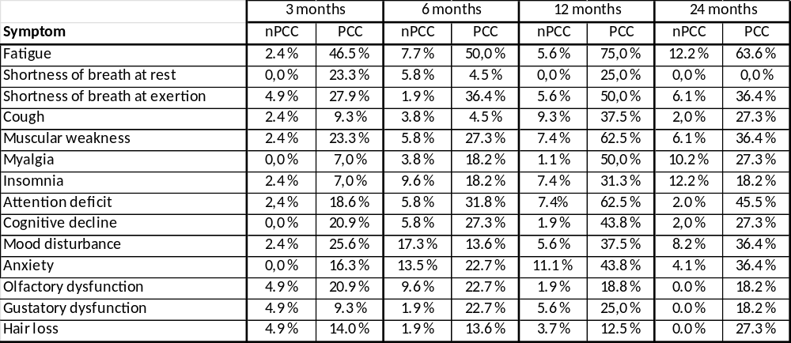
Supplementary Table 1. Percentages of patients with positive symptoms at each time point. A positive sign is a rise of 4 or more in the numerical rating scale compared to the pre-COVID situation.

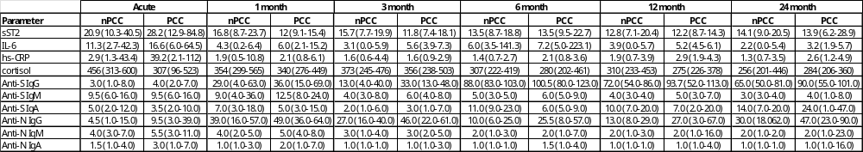
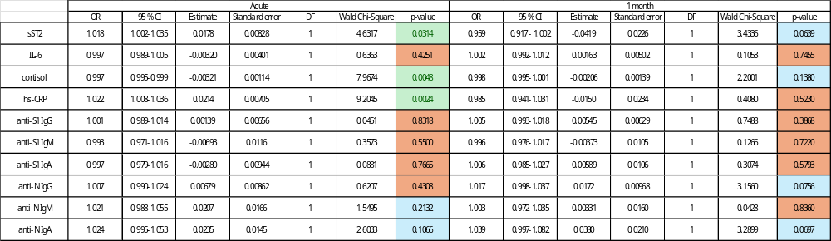
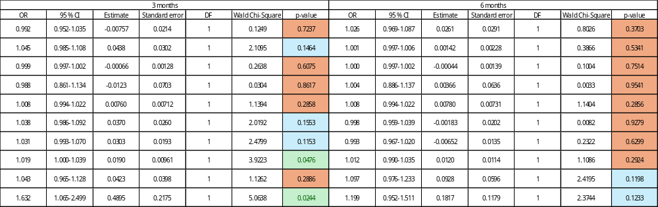
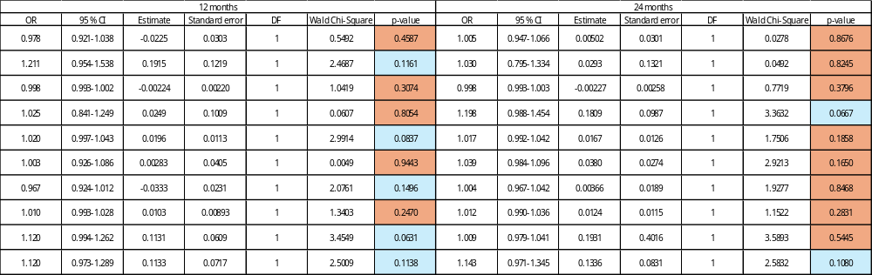
Supplementary Table 2. The top table presents the median levels with a 95% confidence interval of the parameters with age- and gender-adjusted analyses. Lower tables represent the results from the logistic regression where the prediction of laboratory measurements for post-COVID-19 condition was evaluated. These models were adjusted with gender and age. OR = odds ratio, CI = confidence interval, DF = degrees of freedom.

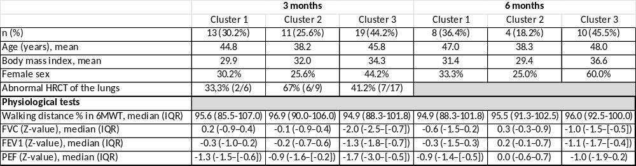
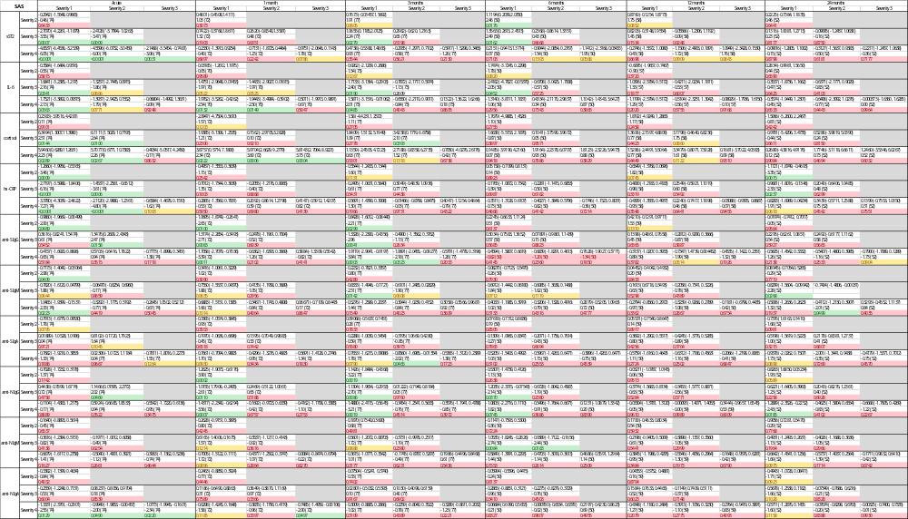
Supplementary Table 3. Baseline characteristics and physiological testing of PCC clusters. HRCT = high resolution computed tomography, FVC = Forced vital capacity, FEV 1 = Forced expiratory volume in one second, PEF = Peak expiratory flow, IQR = interquartile range.

Supplementary Table 4. The effect of severity of the acute disease to the laboratory parameters. First row in table cell represents the estimate of mean difference (Severity 1 – Severity 2) with 95% confidence interval in brackets. The middle row represents test statistics and degrees of freedom are presented in brackets. The last row presents p-value. All differences in estimates for sST2 and cortisol are reported on square root scale and all the rest laboratory variables in natural logarithm scale.

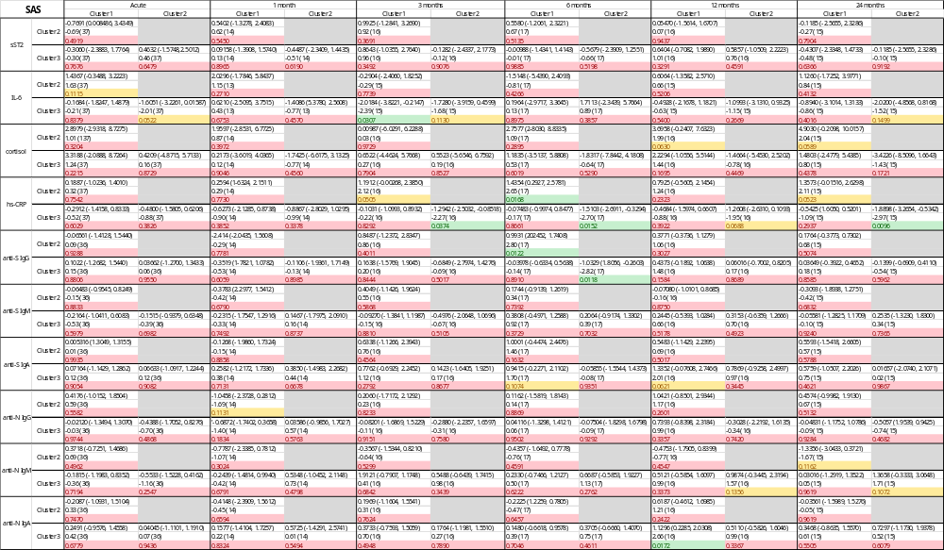
Supplementary Table 5. The effect of severity of the PCC cluster to the laboratory parameters. First row in table cell represents the estimate of mean difference (Cluster 1 – Cluster 2) with 95% confidence interval in brackets. The second row represents test statistics and degrees of freedom are presented in brackets. The last row presents p-value. All differences in estimates for sST2 and cortisol are reported on square root scale and all the rest laboratory variables in natural logarithm scale.

