Supplementary Materials

Comparative analysis of the mitochondrial genomes of the soft-shelled turtles Palea steindachneri and Pelodiscus axenaria, and phylogenetic implications for Trionychia

Chen Chenª · Liqin Jiª · Guiyun Huang^{b} · Xiaoli Liuª · Haigang Chenª · Yakun Wangª · Lingyun Yuª · Yihui Liuª · Xiaoyou Hongª · Chengqing Weiª · Congcong Wuª · Laifu Luoª · Xinping Zhu^{a*} · Wei Li^{a*}

C. Chenª · L.Q. Jiª · G.Y. Huang^{b} · X.L. Liuª · H.G. Chenª · Y.K. Wangª · L.Y. Yuª · Y.H. Liuª · X.Y. Hongª · C.Q. Weiª · C.C. Wuª · L.F. Luoª · X.P. Zhuª (✉) · W. Liª (✉)

a. Key Laboratory of Tropical and Subtropical Fishery Resources Application and Cultivation, Ministry of Agriculture and Rural Affairs, Pearl River Fisheries Research Institute, Chinese Academy of Fishery Sciences, Guangzhou 510380, China
b. Agro-Tech Extension Center of Guangdong Province，Department of Agriculture of Guangdong Province, Guangzhou, China

Email: zhuxinping_1964@163.com; 664061430@qq.com

Table S1. PCR primers and reaction conditions for the Wattle-necked soft-shelled turtle, Palea steindachneri, mitochondrial genome.
Primers | Primer Sequence | Size (bp) | Ta (℃) | Product’s Target Regions
12s(e)-F | AGTGAAAATGCCCTAAAAGTCACATC | 1869 | 54 | 12S, trnV, partial 16S
12s(e)-R | ATACTTATTGTTGCTAGGGGCTATGT
16s(g)-F | AATAACAGATGGGGTAAGTCGTAACA | 2018 | 56 | partial 12S, trnV, 16S, trnL2, partial nad1
16s(g)-R | GTGAAGAAGGCTACAGCAATTAAGAT
16Co(g)-F | GAGTTCAGACCGGAGCAATCCA | 3136 | 54 | partial 16S, trnL2, nad1, trnI, trnQ, trnM, nad2, trnW, trnA, trnN, trnC, trnY, partial cox1
16Co(g)-R | CAGTTCCTGCGCCTGTTTCAAT
COI(d)-F | CTACATGGTTTGATAAGAAGGGGAGT | 1718 | 56 | cox1, trnS2, trnD
COI(d)-R | ATTGGTGATATTGCGTCTTGAAATCC
COI-COIII-F | CACTACACCAAACCTGAACCAAAGTA | 2551 | 62 | partial cox1, trnS2, trnD, cox2, trnK, atp8, atp6, partial cox3
COI-COIII-R | GATTGTGAATGGTGCTTCGTAGTATTC
COIII(f)-F | CACACAACTATCAATGAACATAGCAC | 1152 | 56 | partial atp6, cox3, partial trnG
COIII(f)-R | TGAACTGAAATTGAATGATTGGAAGT
COND-F | CTACAAGCCATAGAATACTACGAAGCAC | 2785 | 66 | partial cox3, trnG, nad3, trnR, nad4L, nad4, trnH, trnS1, trnL1, partial nad5
COND-R | TTCAAGATCAGTTGGTGATGATTGATTC
ND5(m)-F | AATCTCCTTATAAACCGAGAAGGT | 1898 | 54 | parital trnS1, trnL1, nad5, partial nad6
ND5(m)-R | AGATTTAGTTCGTGGTTTGGCT
NdCyt-F | ATCATTGCAGGACTACTAATCTCATCA | 1082 | 52 | partial nad5, nad6, trnE, partial cytb
NdCyt-R | ATTTCATCAGATGGAGATGTTAGATGGA
Cytb(g)-F | GTCAACGCCACAGAATAAGC | 1491 | 54 | partial nad6, trnE, cytb, trnT
Cytb(g)-R | ATTCCGGTTTTGGGGATCGG
Cyt12(f)-F | GCCAACCTTGCAGTACTAACATGAAT | 2138 | 54 | partical cytb, trnT, trnP, Control Region, trnF, partial 12S
Cyt12(f)-R | TCTAATCCCAGTTTGTGTCTTAGCGA

Table S2. Trionychia and outgroup species used in phylogenetic analysis and substitution rates of protein-coding genes in this study, with their accession numbers.
Species | Accession No. | Length | References
Amyda cartilaginea | NC_054232.1/MT039230.1 | 16763 | Cui, Rao, and Zhang, 2020
Apalone ferox | KX882744.1 | 16817 | Yu et al., 2019
Apalone ferox | NC_014054.1/FJ890514.1 | 16866 | Li et al., 2017
Apalone spinifera | KX882745.1 | 16756 | Yu et al., 2019
Apalone spinifera | NC_021371.1/JF966197.1 | 16749 | Li et al., 2017
Carettochelys insculpta | NC_014048.1/FJ862792.1 | 16439 | Li et al., 2010
Chitra indica | NC_026028.1/JQ406951.1 | 16726 | Li et al., 2017
Chitra vandijki | NC_053617.1 | 16614 | Chen et al., 2021
Dogania subplana | NC_002780.1/AF366350.1 | 17289 | Unpublished
Lissemys punctata | NC_012414.1/EF050073.1 | 16490 | Unpublished
Lissemys scutata | NC_025494.1/JQ361816.1 | 16512 | Li et al., 2017
Mauremys mutica | NC_009330.1/DQ453753.1 | 16609 | Unpublished
Mauremys reevesii | FJ469674.1 | 16783 | Unpublished
Nilssonia nigricans | NC_039559.1/MG383833.1 | 16796 | Kundu et al., 2018
Palea steindachneri | KX882746.1 | 16875 | Unpublished
Palea steindachneri | NC_013841.1/FJ541030.1 | 17243 | Li et al., 2017
Palea steindachneri | OL405264.1 | 16811 | This study
Pelochelys cantorii | JN016747.1 | 17612 | Chen et al., 2013
Pelochelys cantorii | KT962834.1 | 17424 | Zhang et al., 2018
Pelochelys cantorii | NC_015825.1/JN016746.1 | 17499 | Chen et al., 2013
Pelodiscus axenaria | OR805132.1 | 17143 | This study
Pelodiscus maackii | OK377340.1 | 16258 | Baek et al., 2022
Pelodiscus sinensis | AY687385.1 | 17364 | Unpublished
Pelodiscus maackii | AY962573.1* | 17042 | Jung et al., 2006
Pelodiscus sinensis | MG431983.1 | 17145 | Zhang et al., 2019
Rafetus swinhoei | KU997642.1 | 16778 | Unpublished
Rafetus swinhoei | MT039229.1 | 16812 | Unpublished
Rafetus swinhoei | NC_017901.1/HQ709384.1 | 16990 | Li et al., 2017
Rafetus swinhoei | OK323959.1 | 16622 | Unpublished
Trionyx triunguis | NC_012833.1/AB477345.1 | 16590 | Amer and Kumazawa et al., 2009
* Species name of AY962573.1 was revised by Fritz et al. (2010).

Table S3. Codon usage of PCGs in the mitochondrial genomes of Palea steindachneri (OL405264) and Pelodiscus axenaria (OR805132).

AA | Codon | Palea steindachneri | Pelodiscus axenaria
Ala | GCU | 58 | 49
Ala | GCC | 92 | 95
Ala | GCA | 82 | 87
Ala | GCG | 2 | 3
Arg | CGU | 7 | 7
Arg | CGC | 11 | 11
Arg | CGA | 46 | 50
Arg | CGG | 4 | 1
Asn | AAU | 47 | 62
Asn | AAC | 117 | 107
Asp | GAU | 22 | 25
Asp | GAC | 42 | 36
Cys | UGU | 9 | 14
Cys | UGC | 17 | 14
Gln | CAA | 96 | 98
Gln | CAG | 7 | 5
Glu | GAA | 78 | 77
Glu | GAG | 5 | 8
Gly | GGU | 29 | 48
Gly | GGC | 59 | 45
Gly | GGA | 78 | 79
Gly | GGG | 36 | 31
His | CAU | 38 | 41
His | CAC | 66 | 60
Ile | AUU | 147 | 177
Ile | AUC | 163 | 153
Leu | UUA | 165 | 227
Leu | UUG | 14 | 20
Leu | CUU | 56 | 64
Leu | CUC | 60 | 58
Leu | CUA | 277 | 213
Leu | CUG | 25 | 17
Lys | AAA | 91 | 86
Lys | AAG | 0 | 3
Met | AUA | 209 | 214
Met | AUG | 30 | 33
Phe | UUU | 88 | 104
Phe | UUC | 126 | 110
Pro | CCU | 30 | 38
Pro | CCC | 44 | 33
Pro | CCA | 133 | 132
Pro | CCG | 3 | 3
Ser | UCU | 37 | 29
Ser | UCC | 47 | 52
Ser | UCA | 142 | 137
Ser | UCG | 2 | 5
Ser | AGU | 14 | 15
Ser | AGC | 33 | 36
Thr | ACU | 56 | 55
Thr | ACC | 151 | 128
Thr | ACA | 184 | 186
Thr | ACG | 4 | 5
Trp | UGA | 100 | 96
Trp | UGG | 9 | 13
Tyr | UAU | 50 | 55
Tyr | UAC | 73 | 69
Val | GUU | 34 | 40
Val | GUC | 26 | 20
Val | GUA | 85 | 76
Val | GUG | 16 | 17

Table S4. Likelihood ratio test (LRT) for positive selection under site models of the 13 mitochondrial PCGs genes of 17 Trionychia species performed on PAML.
PCGs | Model comparison | ℓª | Free parameters^{b} | df | 2Δℓ^{c} | Positively selected codons^{d} | posterior mean ± SE for ω | PP (ω > 1)
atp6 | M0 vs. M1a (one-ratio vs. nearly neutral) | ℓ₀ = -4656.81 | 37 vs. 38 | 1 | 100.13 | —— | —— | ——
 |  | ℓ₁ = -4606.74 |  |  |  | —— | —— | ——
 | M1a vs. M2a (nearly neutral vs. positive selection) | ℓ₀ = -4606.74 | 38 vs. 40 | 2 | 0.00 | —— | —— | ——
 |  | ℓ₁ = -4606.74 |  |  |  | —— | —— | ——
 | M7 vs. M8 (beta vs. beta&ω) | ℓ₀ = -4528.25 | 38 vs. 40 | 2 | 0.00 | —— | —— | ——
 |  | ℓ₁ = -4528.26 |  |  |  | —— | —— | ——
atp8 | M0 vs. M1a (one-ratio vs. nearly neutral) | ℓ₀ = -1267.03 | 37 vs. 38 | 1 | 69.11 | —— | —— | ——
 |  | ℓ₁ = -1232.47 |  |  |  | —— | —— | ——
 | M1a vs. M2a (nearly neutral vs. positive selection) | ℓ₀ = -1232.47 | 38 vs. 40 | 2 | 0.00 | —— | —— | ——
 |  | ℓ₁ = -1232.47 |  |  |  | —— | —— | ——
 | M7 vs. M8 (beta vs. beta&ω) | ℓ₀ = -1230.32 | 38 vs. 40 | 2 | 2.89 | —— | —— | ——
 |  | ℓ₁ = -1228.88 |  |  |  | —— | —— | ——
cox1 | M0 vs. M1a (one-ratio vs. nearly neutral) | ℓ₀ = -8277.44 | 37 vs. 38 | 1 | 32.99 | —— | —— | ——
 |  | ℓ₁ = -8260.94 |  |  |  | —— | —— | ——
 | M1a vs. M2a (nearly neutral vs. positive selection) | ℓ₀ = -8260.94 | 38 vs. 40 | 2 | 0.00 | —— | —— | ——
 |  | ℓ₁ = -8260.94 |  |  |  | —— | —— | ——
 | M7 vs. M8 (beta vs. beta&ω) | ℓ₀ = -8203.45 | 38 vs. 40 | 2 | 5.39 | —— | —— | ——
 |  | ℓ₁ = -8200.76 |  |  |  | —— | —— | ——
cox2 | M0 vs. M1a (one-ratio vs. nearly neutral) | ℓ₀ = -3533.50 | 37 vs. 38 | 1 | 48.57 | —— | —— | ——
 |  | ℓ₁ = -3509.22 |  |  |  | —— | —— | ——
 | M1a vs. M2a (nearly neutral vs. positive selection) | ℓ₀ = -3509.22 | 38 vs. 40 | 2 | 0.00 | —— | —— | ——
 |  | ℓ₁ = -3509.22 |  |  |  | —— | —— | ——
 | M7 vs. M8 (beta vs. beta&ω) | ℓ₀ = -3490.45 | 38 vs. 40 | 2 | 7.80 | —— | —— | ——
 |  | ℓ₁ = -3486.55 |  |  |  | —— | —— | ——
cox3 | M0 vs. M1a (one-ratio vs. nearly neutral) | ℓ₀ = -4235.41 | 37 vs. 38 | 1 | 124.08 | 216 M | 1.496 ± 0.990 | 0.647
 |  | ℓ₁ = -4173.37 |  |  |  | 216 M | 1.496 ± 0.990 | 0.647
 | M1a vs. M2a (nearly neutral vs. positive selection) | ℓ₀ = -4173.37 | 38 vs. 40 | 2 | 0.00 | 216 M | 1.496 ± 0.990 | 0.647
 |  | ℓ₁ = -4173.37 |  |  |  | 216 M | 1.496 ± 0.990 | 0.647
 | M7 vs. M8 (beta vs. beta&ω) | ℓ₀ = -4129.13 | 38 vs. 40 | 2 | 18.86 | 216 M | 1.496 ± 0.990 | 0.647
 |  | ℓ₁ = -4119.70 |  |  |  | 216 M | 1.496 ± 0.990 | 0.647
cytb | M0 vs. M1a (one-ratio vs. nearly neutral) | ℓ₀ = -6715.60 | 37 vs. 38 | 1 | 307.48 | 43 A  350 T  361 T | 1.197 ± 0.473  1.919 ± 1.056  1.157 ± 0.587 | 0.596  0.988*  0.553
 |  | ℓ₁ = -6561.86 |  |  |  | 43 A  350 T  361 T | 1.197 ± 0.473  1.919 ± 1.056  1.157 ± 0.587 | 0.596  0.988*  0.553
 | M1a vs. M2a (nearly neutral vs. positive selection) | ℓ₀ = -6561.86 | 38 vs. 40 | 2 | 0.00 | 43 A  350 T  361 T | 1.197 ± 0.473  1.919 ± 1.056  1.157 ± 0.587 | 0.596  0.988*  0.553
 |  | ℓ₁ = -6561.86 |  |  |  | 43 A  350 T  361 T | 1.197 ± 0.473  1.919 ± 1.056  1.157 ± 0.587 | 0.596  0.988*  0.553
 | M7 vs. M8 (beta vs. beta&ω) | ℓ₀ = -6505.59 | 38 vs. 40 | 2 | 18.87 | 43 A  350 T  361 T | 1.197 ± 0.473  1.919 ± 1.056  1.157 ± 0.587 | 0.596  0.988*  0.553
 |  | ℓ₁ = -6496.15 |  |  |  | 43 A  350 T  361 T | 1.197 ± 0.473  1.919 ± 1.056  1.157 ± 0.587 | 0.596  0.988*  0.553
nad1 | M0 vs. M1a (one-ratio vs. nearly neutral) | ℓ₀ = -6303.78 | 37 vs. 38 | 1 | 201.08 | —— | —— | ——
 |  | ℓ₁ = -6203.24 |  |  |  | —— | —— | ——
 | M1a vs. M2a (nearly neutral vs. positive selection) | ℓ₀ = -6203.24 | 38 vs. 40 | 2 | 0.00 | —— | —— | ——
 |  | ℓ₁ = -6203.24 |  |  |  | —— | —— | ——
 | M7 vs. M8 (beta vs. beta&ω) | ℓ₀ = -6120.61 | 38 vs. 40 | 2 | 3.53 | —— | —— | ——
 |  | ℓ₁ = -6118.85 |  |  |  | —— | —— | ——
nad2 | M0 vs. M1a (one-ratio vs. nearly neutral) | ℓ₀ = -1367.24 | 37 vs. 38 | 1 | 37.58 | —— | —— | ——
 |  | ℓ₁ = -1348.45 |  |  |  | —— | —— | ——
 | M1a vs. M2a (nearly neutral vs. positive selection) | ℓ₀ = -1348.45 | 38 vs. 40 | 2 | 0.00 | —— | —— | ——
 |  | ℓ₁ = -1348.45 |  |  |  | —— | —— | ——
 | M7 vs. M8 (beta vs. beta&ω) | ℓ₀ = -1339.51 | 38 vs. 40 | 2 | 0.00 | —— | —— | ——
 |  | ℓ₁ = -1339.51 |  |  |  | —— | —— | ——
nad3 | M0 vs. M1a (one-ratio vs. nearly neutral) | ℓ₀ = -2664.05 | 37 vs. 38 | 1 | 50.58 | —— | —— | ——
 |  | ℓ₁ = -2638.76 |  |  |  | —— | —— | ——
 | M1a vs. M2a (nearly neutral vs. positive selection) | ℓ₀ = -2638.76 | 38 vs. 40 | 2 | 0.00 | —— | —— | ——
 |  | ℓ₁ = -2638.76 |  |  |  | —— | —— | ——
 | M7 vs. M8 (beta vs. beta&ω) | ℓ₀ = -2598.68 | 38 vs. 40 | 2 | 1.23 | —— | —— | ——
 |  | ℓ₁ = -2598.06 |  |  |  | —— | —— | ——
nad4 | M0 vs. M1a (one-ratio vs. nearly neutral) | ℓ₀ = -655.88 | 37 vs. 38 | 1 | 11.50 | —— | —— | ——
 |  | ℓ₁ = -650.13 |  |  |  | —— | —— | ——
 | M1a vs. M2a (nearly neutral vs. positive selection) | ℓ₀ = -650.13 | 38 vs. 40 | 2 | 0.00 | —— | —— | ——
 |  | ℓ₁ = -650.13 |  |  |  | —— | —— | ——
 | M7 vs. M8 (beta vs. beta&ω) | ℓ₀ = -649.92 | 38 vs. 40 | 2 | 0.00 | —— | —— | ——
 |  | ℓ₁ = -649.92 |  |  |  | —— | —— | ——
nad4L | M0 vs. M1a (one-ratio vs. nearly neutral) | ℓ₀ = -8610.66 | 37 vs. 38 | 1 | 134.61 | 254 L | 1.264 ± 0.571 | 0.673
 |  | ℓ₁ = -8543.36 |  |  |  | 254 L | 1.264 ± 0.571 | 0.673
 | M1a vs. M2a (nearly neutral vs. positive selection) | ℓ₀ = -8543.36 | 38 vs. 40 | 2 | 0.00 | 254 L | 1.264 ± 0.571 | 0.673
 |  | ℓ₁ = -8543.36 |  |  |  | 254 L | 1.264 ± 0.571 | 0.673
 | M7 vs. M8 (beta vs. beta&ω) | ℓ₀ = -8449.38 | 38 vs. 40 | 2 | 0.20 | 254 L | 1.264 ± 0.571 | 0.673
 |  | ℓ₁ = -8449.28 |  |  |  | 254 L | 1.264 ± 0.571 | 0.673
nad5 | M0 vs. M1a (one-ratio vs. nearly neutral) | ℓ₀ = -6583.78 | 37 vs. 38 | 1 | 295.12 | 10 F  13 T  19 L  23 N  276 A  283 L | 1.145 ± 0.455  1.058 ± 0.538  1.112 ± 0.477  1.265 ± 0.382  1.514 ± 0.405  1.264 ± 0.454 | 0.574  0.501  0.554  0.693  0.948  0.695
 |  | ℓ₁ = -6436.22 |  |  |  | 10 F  13 T  19 L  23 N  276 A  283 L |  | 0.574  0.501  0.554  0.693  0.948  0.695
 | M1a vs. M2a (nearly neutral vs. positive selection) | ℓ₀ = -6436.22 | 38 vs. 40 | 2 | 0.00 | 10 F  13 T  19 L  23 N  276 A  283 L |  | 0.574  0.501  0.554  0.693  0.948  0.695
 |  | ℓ₁ = -6436.22 |  |  |  | 10 F  13 T  19 L  23 N  276 A  283 L |  | 0.574  0.501  0.554  0.693  0.948  0.695
 | M7 vs. M8 (beta vs. beta&ω) | ℓ₀ = -6353.67 | 38 vs. 40 | 2 | 20.25 | 10 F  13 T  19 L  23 N  276 A  283 L |  | 0.574  0.501  0.554  0.693  0.948  0.695
 |  | ℓ₁ = -6343.54 |  |  |  | 10 F  13 T  19 L  23 N  276 A  283 L |  | 0.574  0.501  0.554  0.693  0.948  0.695
nad6 | M0 vs. M1a (one-ratio vs. nearly neutral) | ℓ₀ = -2904.93 | 37 vs. 38 | 1 | 93.51 | —— | —— | ——
 |  | ℓ₁ = -2858.17 |  |  |  | —— | —— | ——
 | M1a vs. M2a (nearly neutral vs. positive selection) | ℓ₀ = -2858.17 | 38 vs. 40 | 2 | 0.00 | —— | —— | ——
 |  | ℓ₁ = -2858.17 |  |  |  | —— | —— | ——
 | M7 vs. M8 (beta vs. beta&ω) | ℓ₀ = -2828.21 | 38 vs. 40 | 2 | 0.00 | —— | —— | ——
 |  | ℓ₁ = -2828.21 |  |  |  | —— | —— | ——
Note: a. ℓ₀ refers to the log-likelihood score for the null model, whereas ℓ₁ represents the log-likelihood score under the alternative model. b. Free parameters include branch lengths (17 taxa tips ×2 – 3 = 31), the equilibrium frequencies (3), the transition/transversion rate ratio κ (1), and the parameters for the omega distribution according to Álvarez-Carretero et al.. c. The bold font indicates the significant difference between the compared two models. The critical values are χ2 _{1, 5%} = 3.84, and χ2 _{2, 5%} = 5.99, where 1 and 2 represent df and 5% indicates the significance level. d. The numbers in the positive selected codons column indicate the position of the codon, and the capital letter represent the codon abbreviation. * indicate codons identified as positively selected with posterior probability ＞ 0.95 estimated by Bayes empirical Bayes (BEB) analysis.

Table S5. Non-parametric likelihood-based tests of 5 alternative tree topologies recovered from this study. Five datasets correspond to the definition provided in Figure S3. Four topologies are defined as follows: T1 is the topology derived from D_{PRT}, D_{PT}; T2 is the topology derived from D_{PR}; T3 is the topology derived from D_{P} using BI algorithms; T4 is the topology derived from D_{P} using ML algorithms; T5 is the topology derived from D_{RT}. All tests are carried out by CONSEL. Bolded values indicate that the corresponding topologies are ruled out for the dataset at p < 0.05 level.
Datasets | T1 |  |  | T2 |  |  | T3 |  |  | T4 |  |  | T5
Datasets | AU | KH | SH | AU | KH | SH | AU | KH | SH | AU | KH | SH | AU | KH | SH
D_{PRT} | 0.606 | 0.589 | 0.899 | 0.402 | 0.411 | 0.782 | 2.00E-06 | 2.00E-04 | 4.00E-04 | 1.00E-04 | 0.001 | 0.001 | 7.00E-62 | 0 | 0.016
D_{PR} | 0.326 | 0.312 | 0.723 | 0.705 | 0.688 | 0.917 | 0.01 | 0.001 | 0.002 | 0.002 | 0.002 | 0.009 | 3.00E-07 | 0 | 0.011
D_{PT} | 0.777 | 0.688 | 0.937 | 0.422 | 0.312 | 0.716 | 0.130 | 0.098 | 0.146 | 0.159 | 0.118 | 0.163 | 3.00E-41 | 0 | 0.024
D_{P} | 0.479 | 0.393 | 0.796 | 0.651 | 0.607 | 0.884 | 0.259 | 0.264 | 0.375 | 0.410 | 0.317 | 0.485 | 1.00E-70 | 3.00E-05 | 0.015
D_{RT} | 0.471 | 0.363 | 0.780 | 0.196 | 0.223 | 0.507 | 9.00E-06 | 0 | 0 | 4.00E-05 | 2.00E-04 | 2.00E-04 | 0.694 | 0.637 | 0.841
Note: AU, approximately unbiased test; KH, Kishino-Hasegawa test; SH, Shimodaira-Hasegawa test.

Table S6. Sequence partition scheme and nucleotide substitution models for Bayesian inference (BI) and maximum likelihood (ML) phylogenetic analyses for the best topology T1 of dataset D_{PRT}.
Sequence partition name | Partition schemes | Nucleotide substitution model
Subset1 | atp6, atp8, nad1, nad2, nad3, nad4L, nad4, nad5, cytb | GTR+I+G
Subset2 | cox1, cox2, cox3 | GTR+I+G
Subset3 | nad6 | GTR+I+G
Subset4 | 12S, 16S | GTR + G
Subset5 | tRNA | GTR+I+G

Table S7. Sequence partition scheme and nucleotide substitution priors for divergence time estimation. Six-digit numbers represent transition/transversion split models; α is the gamma shape, and Invar is the proportion invariant.
Sequence partition name | Partition schemes | Nucleotide substitution priors
Subset1 | atp6, atp8, nad1, nad2, nad3, nad4L, nad4, nad5 | 121345: TN93  α: 0.817  Invar: 0.334
Subset2 | cox1, cox2, cox3, cytb | 121343: TN93  α: 0.967  Invar: 0.517
Subset3 | nad6 | 121134: TN93  α: 0.619  Invar: 0.116
Subset4 | 12S, 16S, trnD, trnF, trnG, trnH, trnI, trnK, trnL1, trnL2, trnM, trnR, trnS1, trnT, trnV, trnW | 123454: TVM  α: 0.379  Invar: 0.221
Subset5 | trnA, trnC, trnE, trnN, trnP, trnQ, trnS2, trnY | 123143: TN93  α: 0.316  Invar: 0.182
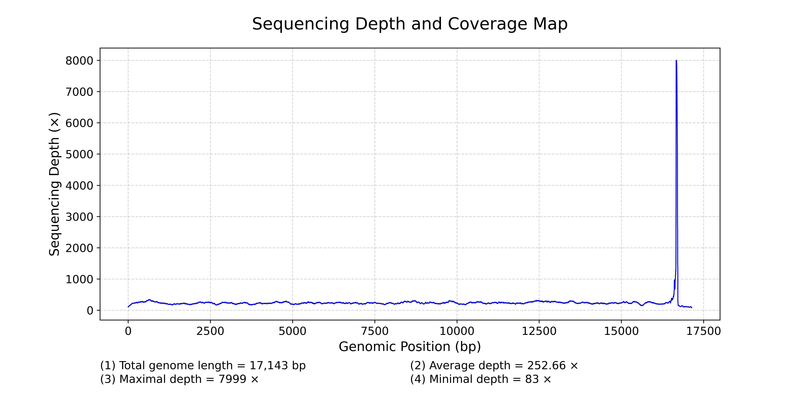
Figure S1. Sequencing depth and coverage map of Pelodiscus axenaria (OR805132) mitochondrial genome. The maximum sequencing depth reached 7999×, while the minimum was 83×, with an average depth of 252.66×. The map was created using Python script authored by Liu C, available at dx.doi.org/10.17504/protocols.io.4r3l27jkxg1y/v1.

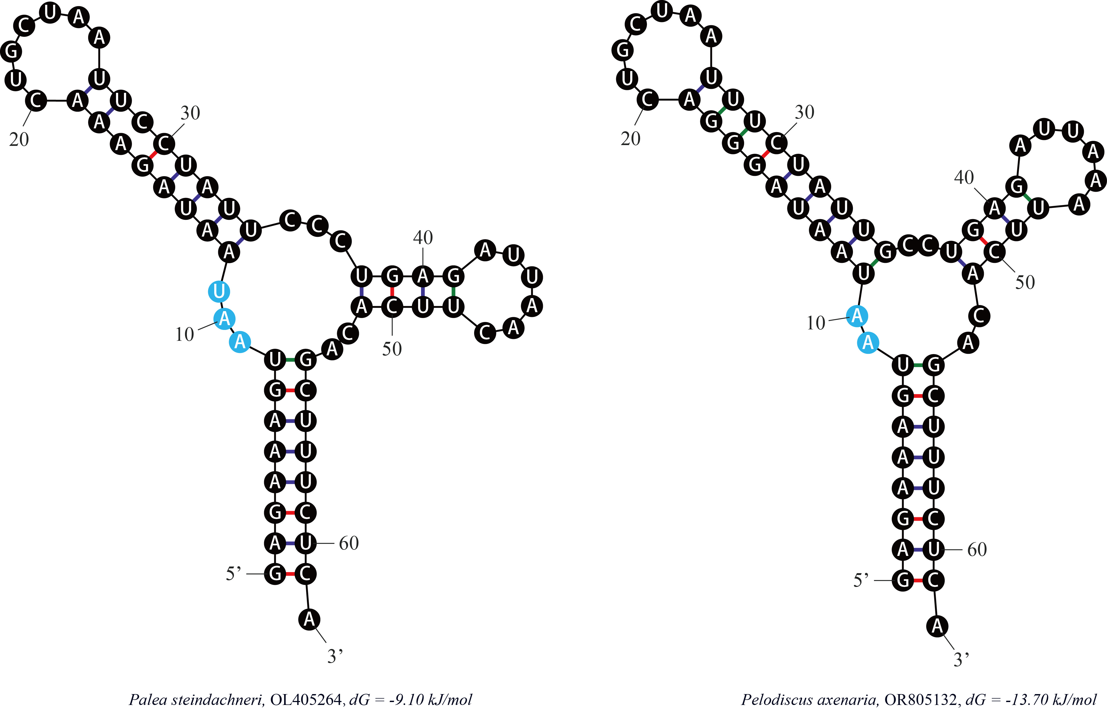
Figure S2. Potential secondary structures of tRNA^{Ser (GCU)} of the Palea steindachneri (OL405264, left) and Pelodiscus axenaria (OR805132, right) mitochondrial genomes. Inferred Watson-Crick bonds are illustrated by thin bars and wobble base pairs are illustrated by thick color bars. The bases symbols with the blue background represent the positions of the absent DHU-arm.

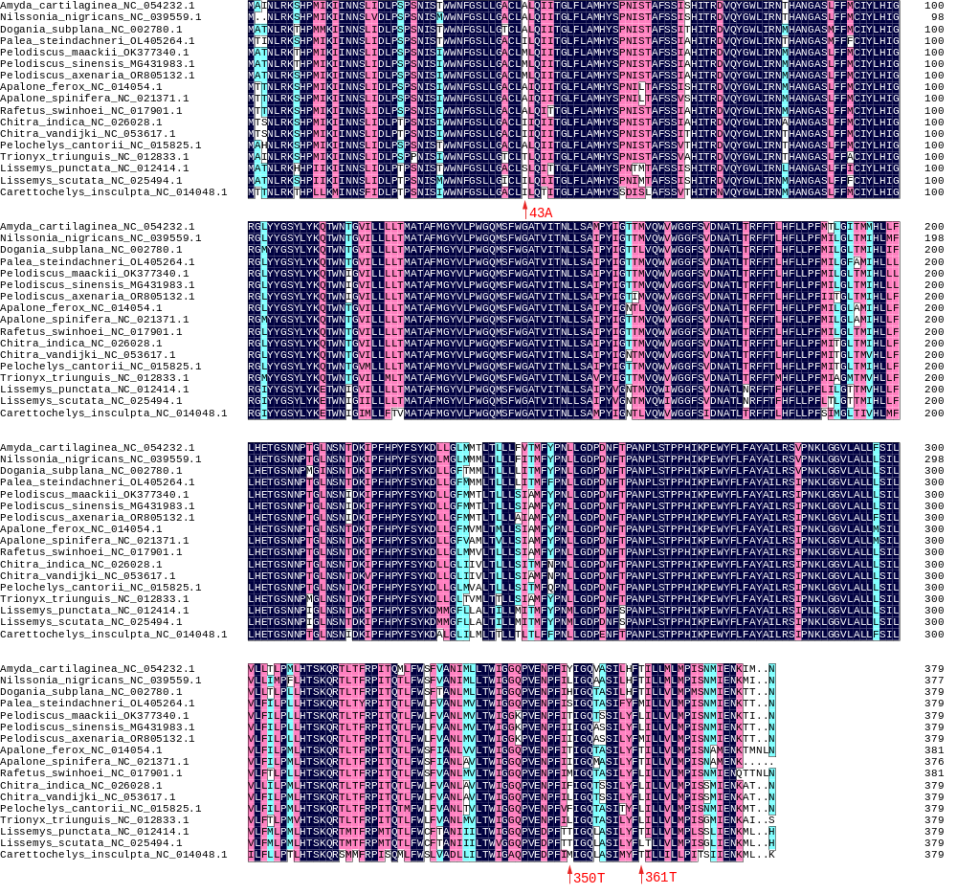
Figure S3. The amino acid alignment of the Trionychia cytb gene. The red arrows indicate the positive selection codon sites detected by the Bayes empirical Bayes (BEB) analysis, with only 350 T being significant.

Figure S4. Topologies of Trionychia inferred from five empirical datasets with Mauremys reevesii (FJ469674.1) and Mauremys mutica (NC 009330.1) as outgroups. The datasets are defined as follows: D_{PRT} = PCGs + rRNAs + tRNAs, D_{PR} = PCGs + rRNAs, D_{PT} = PCGs + tRNAs, D_{RT} = rRNAs + tRNAs, and D_{P} = PCGs. For each dataset, the Bayesian trees are placed on the left and the maximum likelihood trees are on the right. Numbers adjacent to the nodes are posterior probabilities and bootstraps, respectively. Scale bar represents the substitution rate per site. The internal nodal supports vary widely among datasets, and the D_{PRT} trees have the most strongly supported internal relationships with Bayesian posterior probabilities (PPs) of 1.00 and bootstrap proportions (BPs) of higher than 76%.

References
Amer, S. and Kumazawa, Y. Complete sequence of the mitochondrial genome of the endangered Nile soft-shelled turtle Trionyx triunguis. The Egyptian Journal of Experimental Biology (Zoology), 2009, 5: 43-50.
Álvarez-Carretero S, Kapli P, and Yang Z Beginner's Guide on the use of PAML to detect positive selection [J]. Molecular Biology and Evolution, 2023, 40: 1-18.
Baek, H. J., Kim, P., Kim, Y. C., et al. The complete mitochondrial genome of the Amur soft-shelled turtle (Pelodiscus maackii Brandt, 1858), from South Korea. Mitochondrial DNA Part B: Resources, 2022, 7: 498-500.
Chen, C., Hong, X. Y., Li, W., et al. Complete mitochondrial genome and the phylogenetic position of the Burmese narrow-headed softshell turtle Chitra vandijki (Testudines: Trionychidae). Mitochondrial DNA Part B, 2021, 6: 1216-1218.
Chen, X., Zhou, Z. M., Peng, X., et al. Complete mitochondrial genome of the endangered Asian giant softshell turtle Pelochelys cantorii (Testudinata: Trionychidae). Mitochondrial DNA, 2013, 24: 111-113.
Cui, L., Rao, D. Q., and Zhang, M. W. The complete mitochondrial genome of Amyda cartilaginea (Testudines: Trionychidae). Mitochondrial DNA Part B: Resources, 2020, 5: 3670-3672.
Fritz, U., Gong, S. P., Auer, M., et al. The world’s economically most important chelonians represent a diverse species complex (Testudines: Trionychidae: Pelodiscus). Organisms Diversity & Evolution, 2010, 10: 227-242.
Jung, S. O., Lee, Y. M., Kartavtsev, Y., et al. The complete mitochondrial genome of the Korean soft-shelled turtle Pelodiscus sinensis (Testudines, Trionychidae). DNA Sequence - Journal of DNA Sequencing and Mapping, 2006, 17: 471-483.
Kundu, S., Kumar, V., Laskar, B. A., et al. Complete mitochondrial genome of black soft-shell turtle (Nilssonia nigricans) and comparative analysis with other Trionychidae. Scientific Reports, 2018, 8: 1-11.
Li, H. F., Liu, J. J., Xiong, L., et al. Phylogenetic relationships and divergence dates of softshell turtles (Testudines: Trionychidae) inferred from complete mitochondrial genomes. Journal of Evolutionary Biology, 2017, 30: 1011-1023.
Li, X. S., Nie, L. W., Wang, L., et al. The mitochondrial genome complete sequence and organization of the Pig-nosed turtle Carettochelys insculpta (Testudines, Carettochelyidae) and its phylogeny position in Testudines. Amphibia Reptilia, 2010, 31: 541-551.
Yu, P., Yang, X. L., Zhou, W. S., et al. Comparative mitogenomic and phylogenetic analysis of Apalone spinifera and Apalone ferox (Testudines: Trionychidae). Genetica, 2019, 147: 165-176.
Zhang, J., Zhou, Q. Y., Yang, X. L., et al. Characterization of the complete mitochondrial genome and phylogenetic analysis of Pelodiscus sinensis, a mutant Chinese soft-shell turtle. Conservation Genetics Resources, 2019, 11: 279-282.
Zhang, X. C., Li, W., Zhao, J., et al. The complete mitogenome of Pelochelys cantorii (Guangning) and the comparative analysis of different habitats. Conservation Genetics Resources, 2018, 10: 17-20.

