Polycyclic Aromatic Hydrocarbons and Their Sources in a City with Diverse Air Quality Challenges
Katarzyna Szramowiat-Sala¹, Marta Marczak-Grzesik², Mateusz Karczewski¹, Magdalena Kistler², Anne Kasper Giebl², Katarzyna Styszko^{1*}
¹AGH University of Kraków, Faculty of Energy and Fuels, Al. Mickiewicza 30, 30-059 Kraków, Poland
²Jagiellonian University in Kraków, Faculty of Chemistry, ul. Gronostajowa 2, 30-387 Kraków
³Institute of Chemical Technologies and Analytics, Vienna University of Technology, Getreidemarkt 9, 1060 Vienna, Austria
*Corresponding author, Katarzyna Styszko, styszko@agh.edu.pl, tel. +48126172032

Supplementary material
Table S1. Chemical and physical characterisation of particular polycyclic aromatic hydrocarbons
No. | No. of rings | PAHs | Formula of PAHs | PAHs’ structure | Molecular weight [g∙mol⁻¹]
1 | 2-ringed | Naphtalene | C₁₀H₈ | 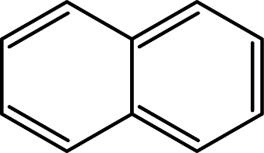 | 128.2
2 | 3-ringed | Acenaphtylene | C₁₂H₈ | 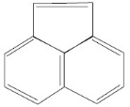 | 154.2
3 | 3-ringed | Acenaphtene | C₁₂H₁₀ | 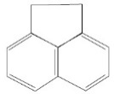 | 154.2
4 | 3-ringed | Fluorene | C₁₃H₁₀ | 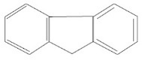 | 166.2
5 | 3-ringed | Phenanthrene | C₁₄H₁₀ | 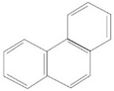 | 178.2
6 | 3-ringed | Anthracene | C₁₄H₁₀ | 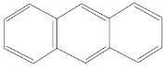 | 178.2
7 | 4-ringed | Fluoranthene | C₁₆H₁₀ | 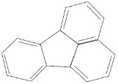 | 202.3
8 | 4-ringed | Pyrene | C₁₆H₁₀ | 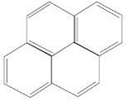 | 202.3
9 | 4-ringed | Benzo(a)anthracene | C₁₈H₁₂ | 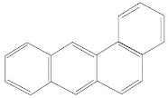 | 228.3
10 | 4-ringed | Chrysene | C₁₈H₁₂ | 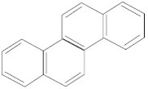 | 228.3
11 | 5-ringed | Benzo(b)fluoranthene | C₂₀H₁₂ | 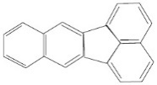 | 252.3
12 | 5-ringed | Benzo(k)fluoranthene | C₂₀H₁₂ | 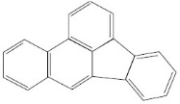 | 252.3
13 | 5-ringed | Benzo(a)pyrene | C₂₀H₁₂ | 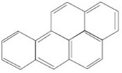 | 252.3
14 | 5-ringed | Benzo(e)pyrene | C₂₀H₁₂ | 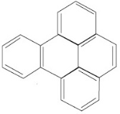 | 252.3
15 | 5-ringed | Perylene | C₂₀H₁₂ | 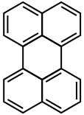 | 252.3
16 | 5-ringed | Dibenzo(a,h)anthracene | C₂₂H₁₄ | 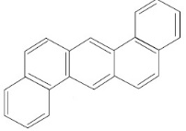 | 278.4
17 | 6-ringed | Benzo(g,h,i)perylene | C₂₂H₁₂ | 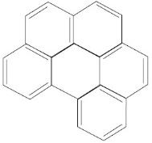 | 276.3
18 | 6-ringed | Indeno(1,2,3-c,d)pyrene | C₂₂H₁₂ | 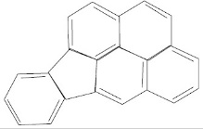 | 276.3

Table S2. Analytical results of concentrations of polycyclic aromatic hydrocarbons bound to PM10 fraction (ng m⁻³)
Date | November 2014 |  |  | December 2014 |  |  | February 2015 |  |  |  | March 2015
PAHs | 14/15 | 19/20 | 24/25 | 01/02 | 08/09 | 15/16 | 02/03 | 12/13 | 19/20 | 26/27 | 05/06
Naph  Aceny  Acene  Flu  Phe  Anth  Fla  Pyr  BaA  Chr  BeP  BbF+BkF  BaP  Per  BghiP  DBA  IcdP | 2.3  3.2  3.0  3.0  1.5  3.7  2.0  2.6  2.6  1.4  4.0  8.0  2.3  3.0  5.3  7.1  1.6 | 2.2  3.0  2.8  2.8  1.4  3.2  2.0  2.5  2.5  2.0  0.7  6.5  2.6  3.0  5.3  7.0  1.4 | 1.7  2.3  2.3  2.2  1.1  2.7  1.7  0.4  67.7  12.8  18.7  25.7  23.9  3.1  25.2  4.4  1.3 | 2.2  3.0  2.9  2.8  1.6  2.8  2.0  0.9  10.2  4.8  5.8  11  8.5  2.0  15.2  6.4  1.0 | 2.8  3.7  3.6  3.6  2.1  4.0  3.8  6.6  30.2  13.9  26.5  30.9  38.8  7.7  33.9  7.5  2.5 | 2.5  3.4  3.3  3.2  2.8  3.8  2.4  1.2  26.3  11.3  28.5  32.9  34.6  4.5  38.1  6.6  2.5 | 1.4  1.8  1.8  1.8  1.7  2.0  1.3  1.0  3.6  2.6  2.7  8.6  3.6  1.4  9.1  4.3  1.2 | 3.4  4.4  4.5  4.4  3.4  5.1  9.3  3.1  74.8  16.3  28.5  34  30.3  5.3  37.6  8.8  2.4 | 2.1  2.8  2.8  2.7  2.4  3.3  6.4  2.0  19.8  10.8  21.3  22.5  22.9  3.3  25.1  5.9  1.7 | 1.8  2.4  2.3  1.5  1.4  2.3  1.7  0.7  14.5  7.3  13  17.3  14.4  4.7  19.3  4.8  1 | 1.2  1.6  1.6  1.6  1.1  1.9  1.3  0.4  51.2  6.5  14.4  16.5  17.9  2.2  19.8  2.7  1.2
Total | 56.6 | 50.8 | 197.3 | 83.2 | 222.2 | 207.8 | 49.9 | 275.6 | 157.8 | 110.4 | 143.6

Table S3. Analytical results of concentrations of polycyclic aromatic hydrocarbons bound to PM2.5 fraction (ng m⁻³)
Date | November 2014 |  |  | December 2014 |  |  | February 2015 |  |  |  | March 2015
PAHs | 15/16 | 20/21 | 25/26 | 02/03 | 09/10 | 16/17 | 03/04 | 13/14 | 20/21 | 27/28 | 06/07
Naph  Aceny  Acene  Flu  Phe  Anth  Fla  Pyr  BaA  Chr  BeP  BbF+BkF  BaP  Per  BghiP  DBA  IcdP | 1.4  2.0  1.9  1.8  1.0  2.1  1.3  1.2  1.6  1.2  1.0  5.4  2.0  2.6  4.2  4.7  1.4 | 1.7  2.3  2.2  2.2  1.1  2.6  1.5  1.8  2.2  1.6  0.1  6.4  1.5  2.8  2.4  5.5  1.3 | 1.5  2  1.9  1.9  0.9  2.3  1.4  0.2  5.8  4.0  7.0  16.2  12.2  1.6  20.3  3.7  1.1 | 1.2  1.7  1.6  1.6  1.0  1.8  1.2  0.1  8.5  3.7  3.5  11.0  6.4  1.1  14.7  3.2  0.7 | 2.6  3.4  3.4  3.3  1.9  3.6  2.6  1.6  29.7  8.0  14.1  18.4  17.5  3.1  24.5  6.3  1.5 | 2.5  3.3  3.2  3.2  1.6  3.7  2.2  0.5  5.2  6.3  14.7  20.7  18.1  3.0  24.0  5.4  1.5 | 1.3  1.7  1.7  1.7  0.9  1.8  1.2  0.8  2.9  2.3  0.9  5.6  1.3  0.8  4.9  3.8  0.6 | 2.3  2.9  3.0  2.9  2.8  3.5  2.2  2.7  26.3  11.8  22.7  34.1  30.3  3.7  28.8  5.9  1.5 | 2.1  2.7  2.7  2.7  1.7  3.1  1.9  0.9  18.8  7.0  13.3  22.5  22.9  2.8  21.2  5.0  1.2 | 1.7  2.3  2.2  2.3  1.2  2.3  1.6  0.6  5.1  4.9  11.8  14.4  11.7  2.2  16.9  4.5  1.0 | 0.9  1.2  1.2  1.2  1.0  1.4  1.0  0.3  31.6  5.7  9.0  15.7  14.7  1.6  17.6  1.9  0.8
Total | 36.8 | 39.0 | 83.8 | 62.9 | 145.7 | 119 | 34 | 187.1 | 132.3 | 86.4 | 106.7
$$\frac{{PAHs}_{PM2.5}}{{PAHs}_{PM10}}[\%]$$ | 65.0 | 76.8 | 42.5 | 75.6 | 65.6 | 57.3 | 68.1 | 67.9 | 83.9 | 78.3 | 74.3

