Supplemental Figure 1: Kaplan-Meier curves with 8-week landmark analysis for progression-free survival (A) and overall survival (B) according to the absence or presence of immune-related adverse events (irAEs)

A

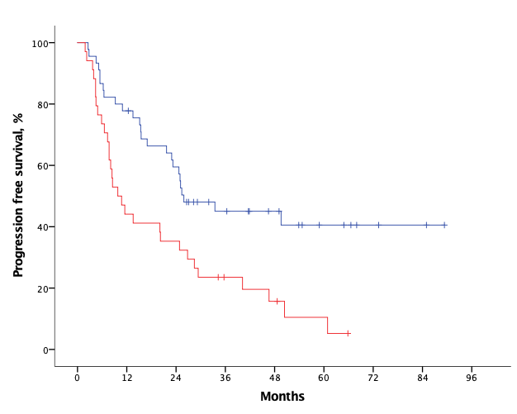
Median PFS
with irAEs (n= 45): 25.9
without irAEs (n=34): 9.8
HR (95%, CI), 2.27 (1.33-3.87)
p = 0.003

B

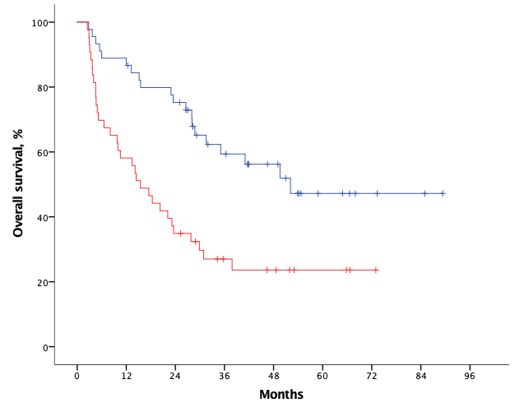
Median OS
with irAEs (n= 45): 52.1
without irAEs (n=43): 15.4
HR (95%, CI), 2.59 (1.47-4.55)
p = 0.001

Supplemental Figure 2: Kaplan-Meier curves with 12-week landmark analysis for progression-free survival (A) and overall survival (B) according to the absence or presence of immune-related adverse events (irAEs)

A

Median PFS
with irAEs (n= 43): 33.4
without irAEs (n=34): 10.7
HR (95%, CI), 2.42 (1.40-4.19)
p = 0.001

B

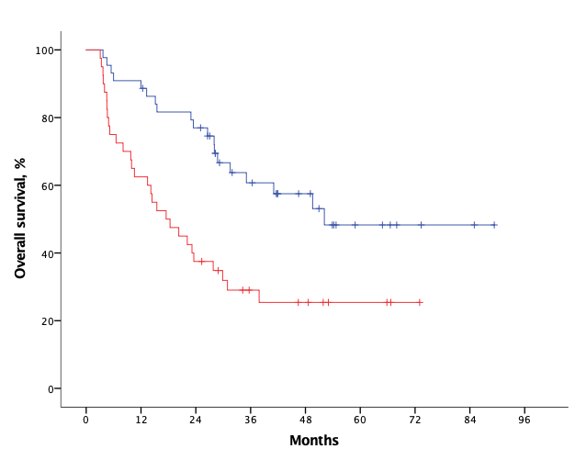
Median OS
with irAEs (n= 44): 52.1
without irAEs (n=40): 17.5
HR (95%, CI), 2.55 (1.42-4.57)
p = 0.001

Supplemental Figure 3: Kaplan-Meier curves for patients who are only receiving first-line treatment progression-free survival (A) and overall survival (B) according to the absence or presence of immune-related adverse events (irAEs)

A

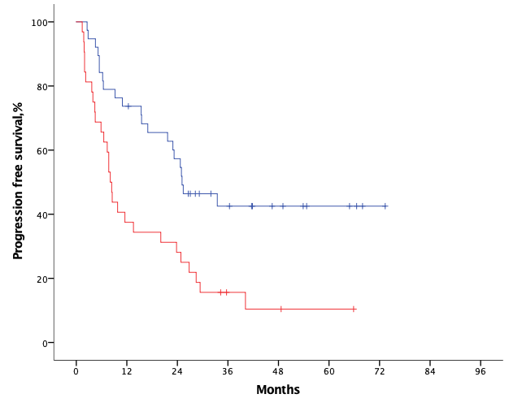
Median PFS
with irAEs (n= 38): 25.1
without irAEs (n=32): 7.7
HR (95%, CI), 2.62 (1.50-4.59)
p = 0.001
B

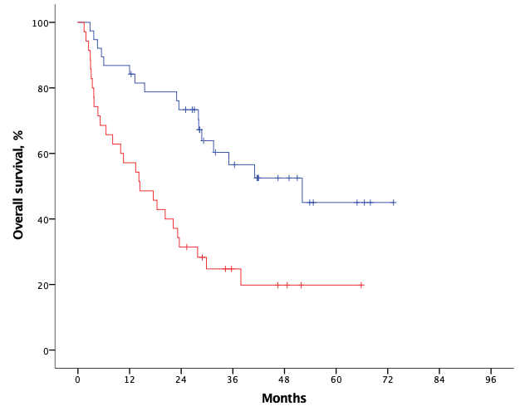
Median OS
with irAEs (n= 38): 52.1
without irAEs (n=35): 14.4
HR (95%, CI), 2.80 (1.51-5.18)
p = 0.001

