Figure 1. Western Blot original images for four repeats (Group 1)
Repeat 1

AC-Dox
A-Dox
C-Dox
Dox
Vehicle
CON
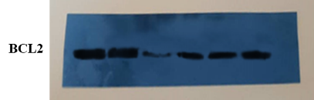
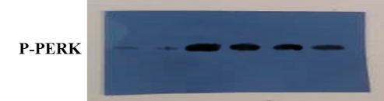
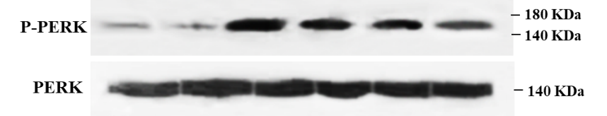

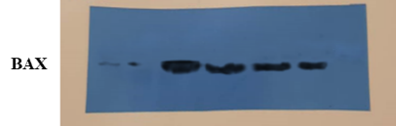
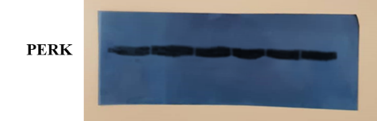

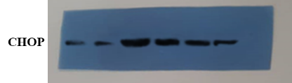
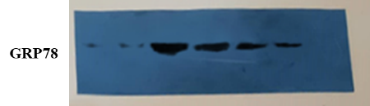
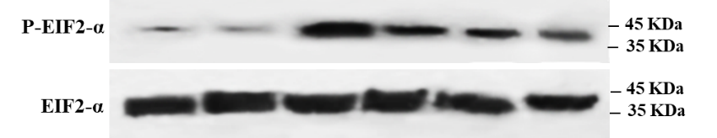
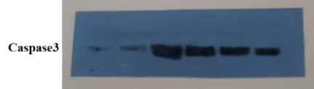
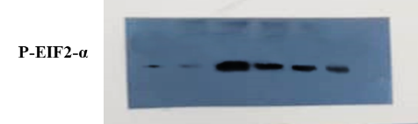
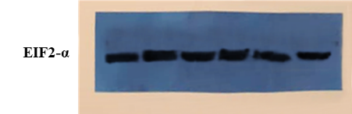

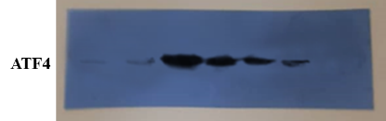
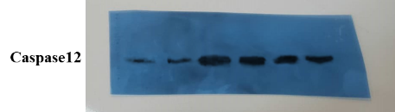
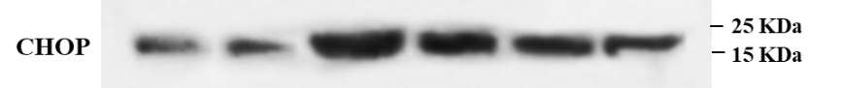
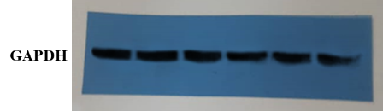

Figure 1. Western Blot original images for four repeats (Group 1)
Repeat 2
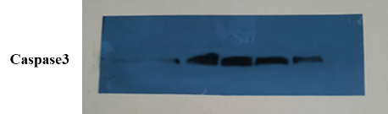
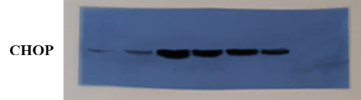
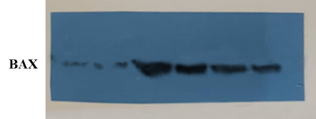
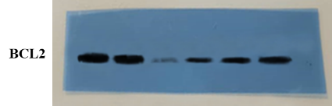
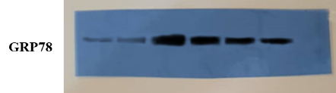
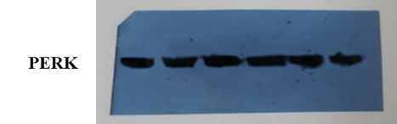
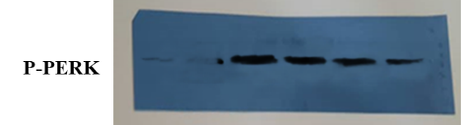
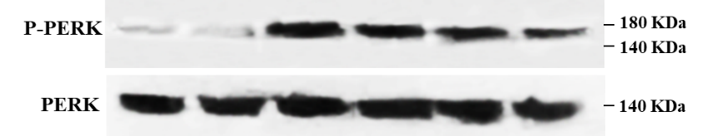
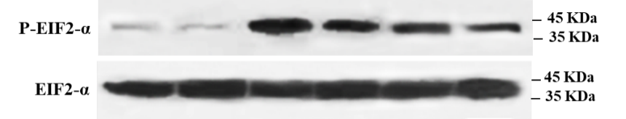
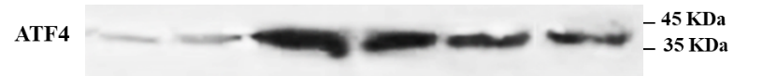
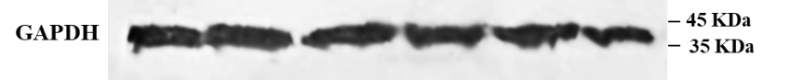
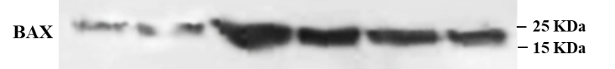
CON
Vehicle
Dox
C-Dox
A-Dox
AC-Dox

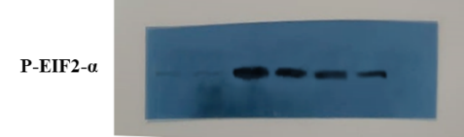

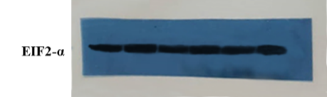

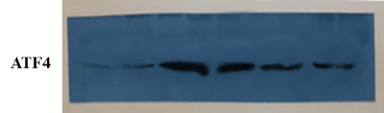

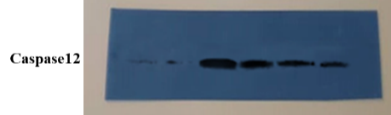

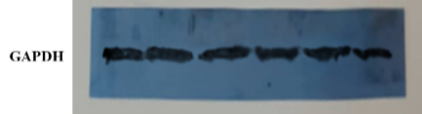

Figure 1. Western Blot original images for four repeats (Group 1)

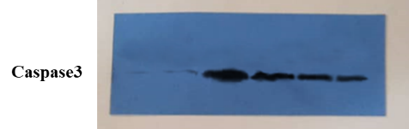
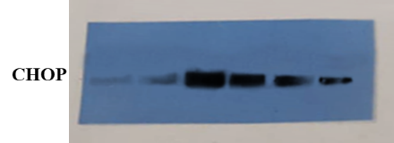
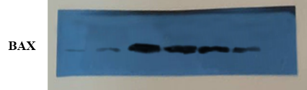
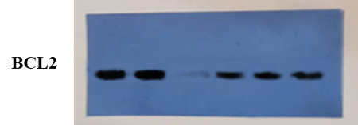
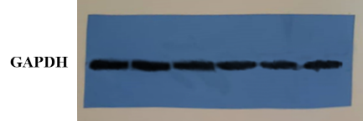
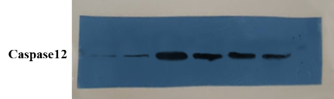
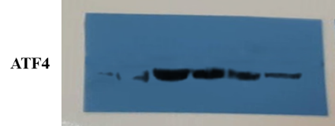
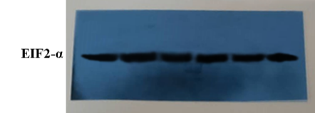
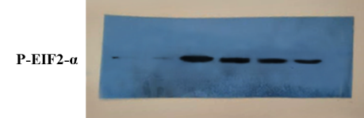
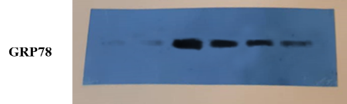
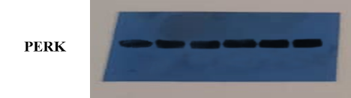
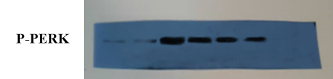
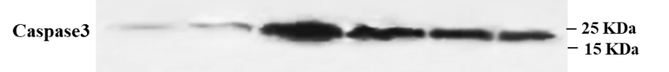
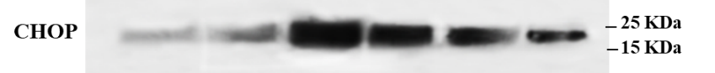
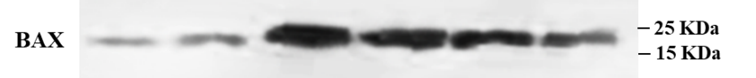
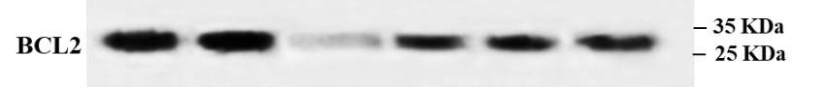
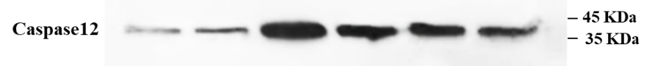
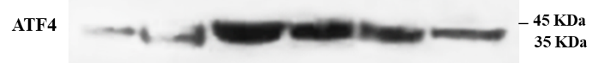
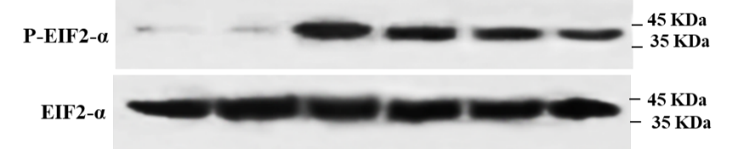
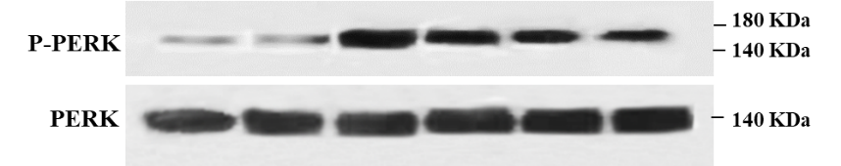
Repeat 3
AC-Dox
A-Dox
C-Dox
Dox
Vehicle
CON

Figure 1. Western Blot original images for four repeats (Group 1)
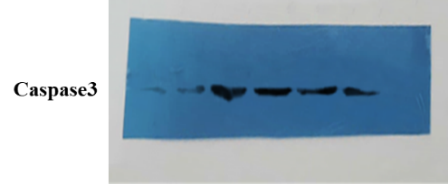
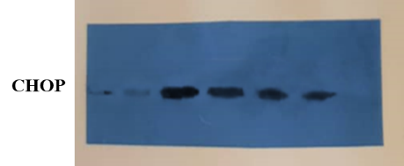
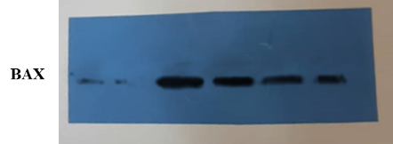
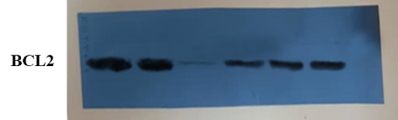
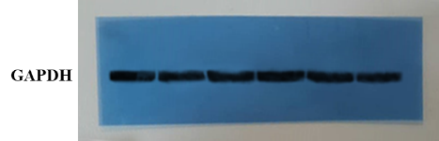
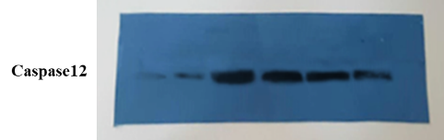
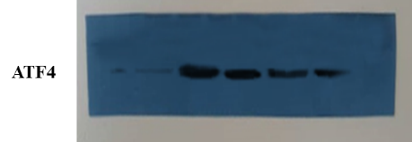
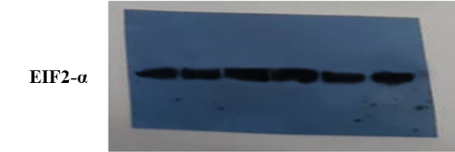
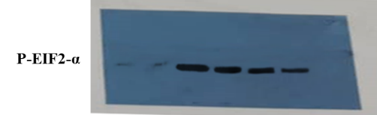
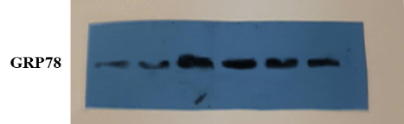
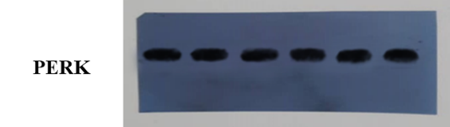
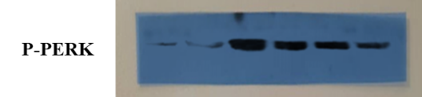
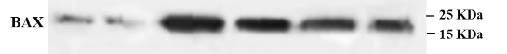
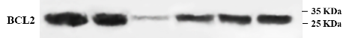
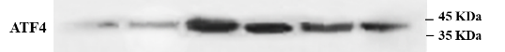
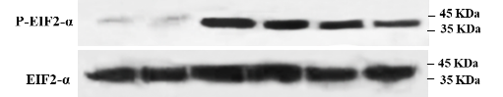
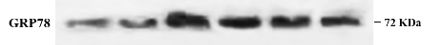
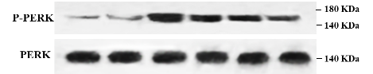
Repeat 4

AC-Dox
A-Dox
C-Dox
Dox
Vehicle
CON

Figure 2. Western Blot original images for four repeats (Group 2)
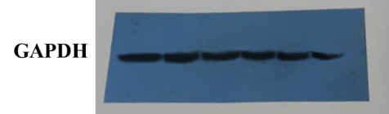
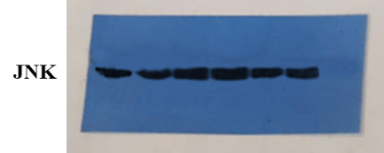
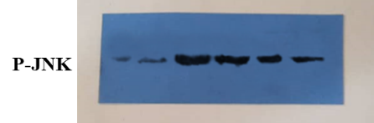
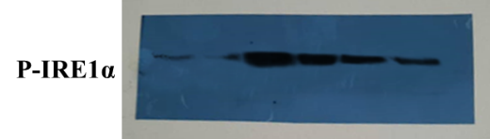
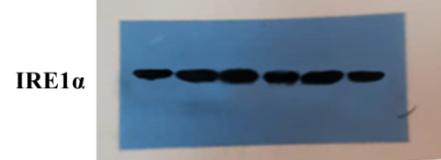
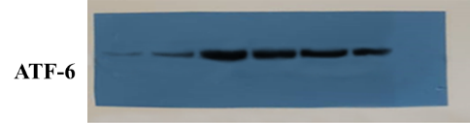
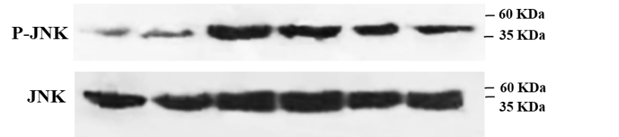
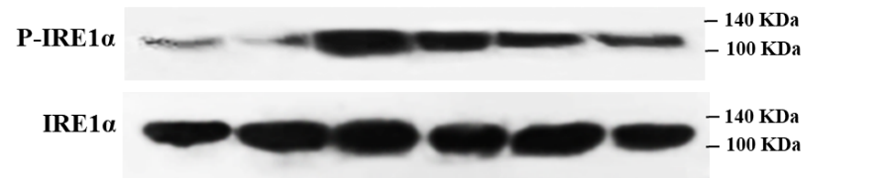
CON
Vehicle
Dox
C-Dox
A-Dox
AC-Dox
Repeat 1
Repeat 2
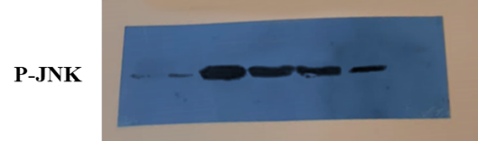
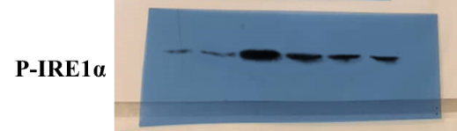
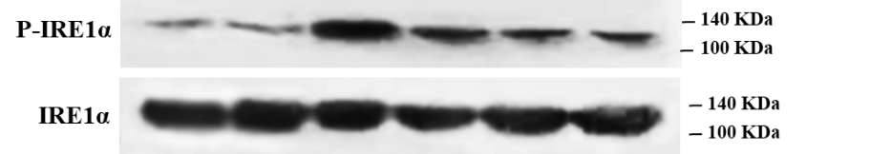

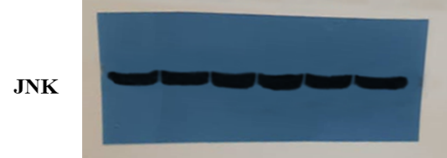
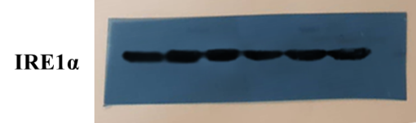
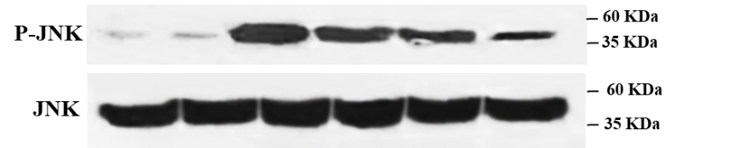

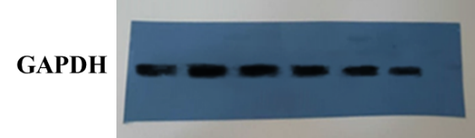
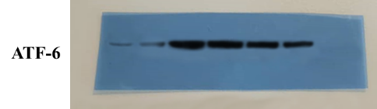

AC-Dox
A-Dox
C-Dox
Dox
Vehicle
CON

Figure 2. Western Blot original images for four repeats (Group 2)
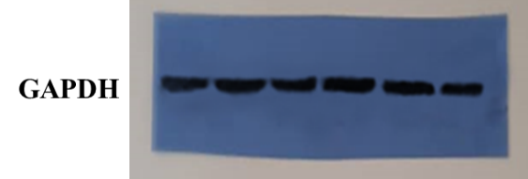
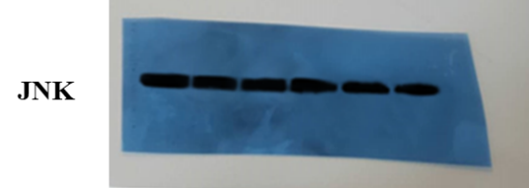
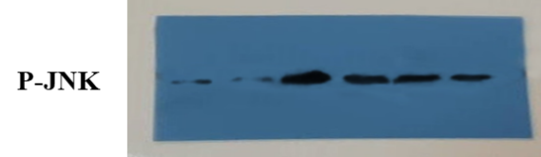
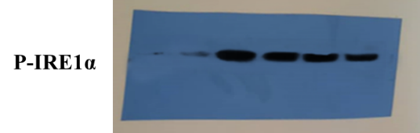
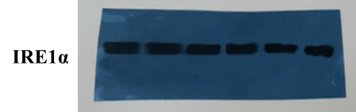
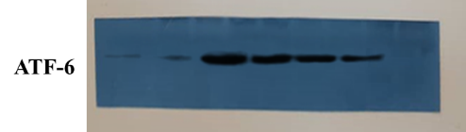
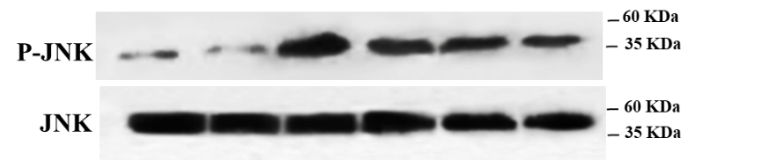
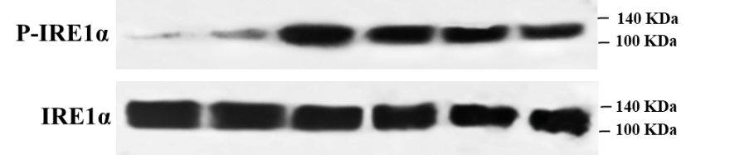
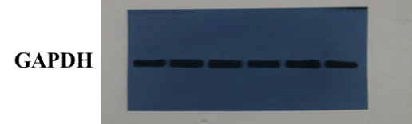
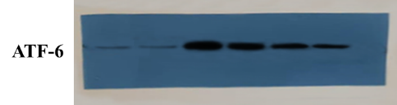
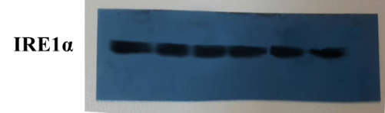
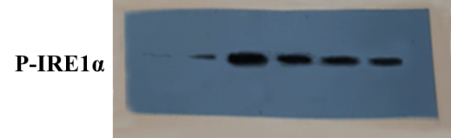
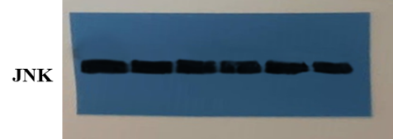
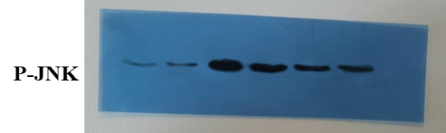

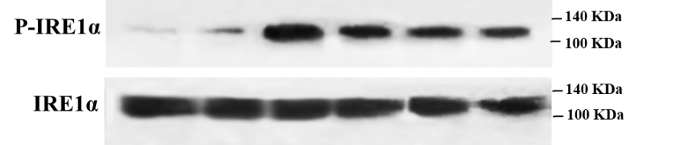
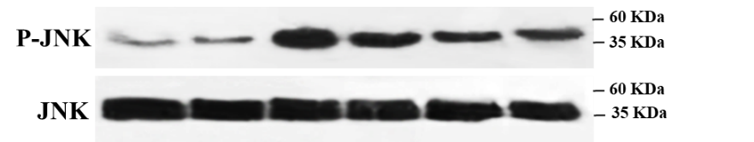
Repeat 4
AC-Dox
A-Dox
C-Dox
Dox
Vehicle
CON
AC-Dox
A-Dox
C-Dox
Dox
Vehicle
CON
Repeat 3

