Discrimination of inherent characteristics of susceptible and resistant strains of Anopheles gambiae by explainable Artificial Intelligence Analysis of Flight Trajectories
Supplementary Information
Y.M. Qureshi¹, V. Voloshin^{1, 2}, K. Gleave³, H. Ranson³, P.J. McCall³,
J.A. Covington¹, C.E. Towers¹, D.P. Towers¹

¹School of Engineering, University of Warwick, Coventry, CV4 7AL, UK
²School of Biological and Behavioural Sciences, Queen Mary University of London, E1 4NS, UK
³Vector Biology Department, Liverpool School of Tropical Medicine, Pembroke Place, Liverpool, L3 5QA, UK

Corresponding Author:
E-mail: Yasser.Qureshi@warwick.ac.uk (YMQ)

Feature Calculations
- Velocity, acceleration and Jerk
These are calculated using second-order central finite difference methods. The signed values are used – where in the case of velocity, a positive velocity indicates motion from head-to-toe of the human bait within the experiment. The axial values are also utilised.
- Angle of Flight
The angle of flight, $α_{i}$, can be calculated using the dot product of two vectors. It describes the relative change in direction between positions.
$$v_{i}=\left[\begin{matrix}x_{i}-x_{i-1} \\ y_{i}-y_{i-1}\end{matrix}\right]$$
$$v_{i+1}=\left[\begin{matrix}x_{i+1}-x_{i} \\ y_{i+1}-y_{i}\end{matrix}\right]$$
$$α_{i}=\arccos\left(\frac{v_{i}∙v_{i+1}}{\sqrt{\left(v_{i}∙v_{i}\right)\left(v_{i+1}∙v_{i+1}\right)}}\right)$$
- Angular Velocity and Angular Acceleration
The angular velocity and angular acceleration are both calculated using second-order finite difference methods. The arctangent function is used to calculate the angle between positions, then the change in angle between consecutive positions is computed. Angular velocity is calculated by dividing this change in angle by the corresponding time difference.
- Orthogonal Components of Velocity
This is a group of features that describe the tendency of a movement to head in a given direction. The persistence velocity describes the tendency to head tangential to the trajectory while the turning velocity describes the tendency to head normal to the trajectory. It involves converting from the Cartesian to the circular coordinate system:
$$ρ_{i}=\sqrt{{\left(x_{i+1}-x_{i}\right)}^{2}+{\left(y_{i+1}-y_{i}\right)}^{2}}$$
$$θ_{i}=\arctan\left(\frac{y_{i+1}-y_{i}}{x_{i+1}-x_{i}}\right)$$
The change in $θ$ and instantaneous velocity is calculated:
$$Θ_{i}=\left|θ_{i+1}-θ_{i}\right|$$
$$v_{i}=\frac{ρ_{i}}{t_{i+1}-t_{i}}$$
Then converting back to the Cartesian coordinate system:
$$P_{i}=v_{i}\cos{Θ}$$
$$T_{i}=v_{i}\sin{Θ}$$
Where $P_{i}$ and $T_{i}$ are the persistence and turning velocities, respectively.

- Tortuosity
This is the ratio of the actual distance travelled and the shortest distance between the start and end positions.
$$S=\frac{\sum_{i=0}^{N}{\sqrt{{\left(x_{i+1}-x_{i}\right)}^{2}+{\left(y_{i+1}-y_{i}\right)}^{2}}}}{\sqrt{{\left(x_{N}-x_{0}\right)}^{2}+{\left(y_{N}-y_{0}\right)}^{2}}}$$
- Convex Hull
The convex hull is the set of points that forms the smallest possible convex polygon that bounds all the points of a track. From the polygon that is formed, the area and perimeter is extracted and used as features.
- Centroid Distance Function
This calculated the distances of each position in a track to the centre point of the track.
$$x_{c}=\frac{1}{N}\sum_{i=0}^{N}{x_{i}}$$
$$y_{c}=\frac{1}{N}\sum_{i=0}^{N}{y_{i}}$$
$$C_{i}=\sqrt{{\left(x_{i}-x_{c}\right)}^{2}+{\left(y_{i}-y_{c}\right)}^{2}}$$

- Curvature
Curvature is a measure that defines the deviation of a trajectory from a straight line. It is calculated as:
$$k_{i}=\frac{\dot{x_{i}}\ddot{y_{i}}-\dot{y_{i}}\ddot{x_{i}}}{{\left({\dot{x_{i}}}^{2}+{\dot{y_{i}}}^{2}\right)}^{\frac{3}{2}}}$$

- Curvature Scale Space
This measures the inflection points in a trajectory at difference scales and is robust to affine transformations. To compute the curvature at varying levels, the trajectory is convolved with a 1D gaussian kernel of width $σ$. The value of $σ$ is varies, and the zero-crossings locations in the curvature are recorded. The locations of zero-crossings at different $σ$ levels can be plotted as a CSS image. A 1D signal is generated by taking column maximums from this CSS image.
- Fractal Dimension
Fractal dimension is a measure of the complexity of a trajectory. Values around 1 describe a linear path with a shape similar to a straight line, and values around 2 indicate convoluted movement with a shape similar to a plane. To compute fractal dimension, $d$, the following equations are used:
$$d=\frac{\log{n}}{\log{\frac{1}{S}}}$$
Where $n$ is the number of minature pieces in the path, $S$ is the scaling factor, and $d$ is the fractal dimension. For a trajectory, the values of $n$ and $S$ are defined as follows:
$$n=\sum_{i=0}^{N}{\sqrt{{\left(x_{i+1}-x_{i}\right)}^{2}+{\left(y_{i+1}-y_{i}\right)}^{2}}}$$
$$S=\frac{1}{\sqrt{{\left(\max{x}-\min{x}\right)}^{2}+{\left(\max{y}-\min{y}\right)}^{2}} }$$

Table 1. Full list of features generated, and whether they were selected for each modelling task.
Feature Name | IR vs IS, XGBoost | IR vs IS, Random Forests | IR vs IS, Logistic Regression | IR vs IR, Banfora vs VK7, XGBoost | IS vs IS, Kisumu vs N’goussu, XGBoost | Multiclass, XGBoost
X Velocity (mean) | FALSE | FALSE | FALSE | FALSE | FALSE | FALSE
X Velocity (median) | FALSE | FALSE | FALSE | FALSE | FALSE | FALSE
X Velocity (std) | TRUE | TRUE | TRUE | TRUE | FALSE | TRUE
X Velocity (1st quartile) | TRUE | TRUE | TRUE | TRUE | FALSE | TRUE
X Velocity (3rd quartile) | TRUE | TRUE | TRUE | TRUE | FALSE | TRUE
X Velocity (kurtosis) | TRUE | TRUE | TRUE | TRUE | TRUE | TRUE
X Velocity (skewness) | TRUE | TRUE | TRUE | FALSE | TRUE | TRUE
X Velocity (number of local minima) | TRUE | TRUE | TRUE | TRUE | TRUE | TRUE
X Velocity (number of local maxima) | FALSE | FALSE | FALSE | FALSE | FALSE | FALSE
X Velocity (number of zero-crossings) | TRUE | TRUE | TRUE | TRUE | TRUE | TRUE
Y Velocity (mean) | FALSE | FALSE | TRUE | TRUE | TRUE | TRUE
Y Velocity (median) | FALSE | FALSE | FALSE | TRUE | FALSE | TRUE
Y Velocity (std) | TRUE | TRUE | TRUE | TRUE | TRUE | TRUE
Y Velocity (1st quartile) | TRUE | TRUE | TRUE | TRUE | TRUE | TRUE
Y Velocity (3rd quartile) | TRUE | TRUE | TRUE | TRUE | FALSE | TRUE
Y Velocity (kurtosis) | TRUE | TRUE | TRUE | TRUE | TRUE | TRUE
Y Velocity (skewness) | TRUE | TRUE | TRUE | TRUE | TRUE | TRUE
Y Velocity (number of local minima) | FALSE | FALSE | FALSE | FALSE | FALSE | FALSE
Y Velocity (number of local maxima) | FALSE | FALSE | FALSE | FALSE | FALSE | FALSE
Y Velocity (number of zero-crossings) | FALSE | FALSE | FALSE | FALSE | TRUE | TRUE
X Acceleration (mean) | TRUE | TRUE | TRUE | TRUE | TRUE | TRUE
X Acceleration (median) | TRUE | TRUE | TRUE | TRUE | FALSE | TRUE
X Acceleration (std) | TRUE | TRUE | TRUE | FALSE | TRUE | TRUE
X Acceleration (1st quartile) | TRUE | TRUE | TRUE | FALSE | TRUE | TRUE
X Acceleration (3rd quartile) | TRUE | TRUE | TRUE | TRUE | TRUE | TRUE
X Acceleration (kurtosis) | FALSE | TRUE | FALSE | TRUE | TRUE | TRUE
X Acceleration (skewness) | TRUE | TRUE | TRUE | TRUE | FALSE | TRUE
X Acceleration (number of local minima) | FALSE | FALSE | FALSE | FALSE | FALSE | FALSE
X Acceleration (number of local maxima) | FALSE | FALSE | FALSE | FALSE | FALSE | FALSE
X Acceleration (number of zero-crossings) | FALSE | FALSE | FALSE | FALSE | FALSE | FALSE
Y Acceleration (mean) | TRUE | TRUE | TRUE | TRUE | TRUE | TRUE
Y Acceleration (median) | TRUE | TRUE | TRUE | TRUE | TRUE | TRUE
Y Acceleration (std) | TRUE | TRUE | TRUE | FALSE | FALSE | TRUE
Y Acceleration (1st quartile) | TRUE | TRUE | TRUE | TRUE | TRUE | TRUE
Y Acceleration (3rd quartile) | TRUE | TRUE | TRUE | TRUE | TRUE | TRUE
Y Acceleration (kurtosis) | TRUE | TRUE | TRUE | TRUE | TRUE | TRUE
Y Acceleration (skewness) | TRUE | TRUE | TRUE | TRUE | TRUE | TRUE
Y Acceleration (number of local minima) | FALSE | FALSE | FALSE | FALSE | FALSE | FALSE
Y Acceleration (number of local maxima) | FALSE | FALSE | FALSE | FALSE | FALSE | FALSE
Y Acceleration (number of zero-crossings) | FALSE | FALSE | FALSE | FALSE | FALSE | FALSE
Velocity (mean) | FALSE | FALSE | TRUE | FALSE | TRUE | FALSE
Velocity (median) | FALSE | FALSE | FALSE | FALSE | FALSE | FALSE
Velocity (std) | TRUE | TRUE | TRUE | TRUE | TRUE | TRUE
Velocity (1st quartile) | FALSE | FALSE | FALSE | FALSE | FALSE | FALSE
Velocity (3rd quartile) | FALSE | FALSE | FALSE | FALSE | FALSE | FALSE
Velocity (kurtosis) | TRUE | TRUE | TRUE | TRUE | TRUE | TRUE
Velocity (skewness) | FALSE | FALSE | FALSE | TRUE | TRUE | TRUE
Velocity (number of local minima) | FALSE | FALSE | FALSE | FALSE | FALSE | FALSE
Velocity (number of local maxima) | FALSE | FALSE | FALSE | FALSE | FALSE | FALSE
Velocity (number of zero-crossings) | FALSE | FALSE | FALSE | TRUE | FALSE | TRUE
Acceleration (mean) | TRUE | TRUE | TRUE | TRUE | FALSE | TRUE
Acceleration (median) | TRUE | TRUE | TRUE | TRUE | TRUE | TRUE
Acceleration (std) | TRUE | TRUE | FALSE | TRUE | TRUE | TRUE
Acceleration (1st quartile) | TRUE | TRUE | TRUE | TRUE | TRUE | TRUE
Acceleration (3rd quartile) | TRUE | TRUE | TRUE | TRUE | TRUE | TRUE
Acceleration (kurtosis) | TRUE | TRUE | TRUE | TRUE | TRUE | TRUE
Acceleration (skewness) | TRUE | TRUE | TRUE | TRUE | TRUE | TRUE
Acceleration (number of local minima) | FALSE | FALSE | FALSE | FALSE | FALSE | FALSE
Acceleration (number of local maxima) | FALSE | FALSE | FALSE | FALSE | FALSE | FALSE
Acceleration (number of zero-crossings) | FALSE | FALSE | FALSE | FALSE | FALSE | FALSE
Jerk (mean) | TRUE | TRUE | TRUE | TRUE | TRUE | TRUE
Jerk (median) | TRUE | TRUE | TRUE | TRUE | FALSE | TRUE
Jerk (std) | FALSE | FALSE | FALSE | FALSE | TRUE | FALSE
Jerk (1st quartile) | TRUE | TRUE | TRUE | TRUE | TRUE | TRUE
Jerk (3rd quartile) | TRUE | TRUE | TRUE | TRUE | TRUE | TRUE
Jerk (kurtosis) | TRUE | TRUE | FALSE | FALSE | TRUE | TRUE
Jerk (skewness) | TRUE | TRUE | TRUE | TRUE | TRUE | TRUE
Jerk (number of local minima) | FALSE | FALSE | FALSE | FALSE | FALSE | FALSE
Jerk (number of local maxima) | FALSE | FALSE | FALSE | FALSE | FALSE | FALSE
Jerk (number of zero-crossings) | FALSE | FALSE | FALSE | FALSE | FALSE | FALSE
Angular Velocity (mean) | TRUE | TRUE | TRUE | TRUE | TRUE | TRUE
Angular Velocity (median) | TRUE | TRUE | TRUE | TRUE | TRUE | TRUE
Angular Velocity (std) | FALSE | FALSE | FALSE | FALSE | FALSE | FALSE
Angular Velocity (1st quartile) | FALSE | FALSE | FALSE | FALSE | TRUE | FALSE
Angular Velocity (3rd quartile) | FALSE | FALSE | FALSE | FALSE | FALSE | FALSE
Angular Velocity (kurtosis) | FALSE | FALSE | FALSE | FALSE | TRUE | FALSE
Angular Velocity (skewness) | FALSE | FALSE | FALSE | FALSE | FALSE | FALSE
Angular Velocity (number of local minima) | FALSE | FALSE | FALSE | FALSE | FALSE | FALSE
Angular Velocity (number of local maxima) | FALSE | FALSE | FALSE | FALSE | FALSE | FALSE
Angular Velocity (number of zero-crossings) | FALSE | FALSE | FALSE | FALSE | FALSE | FALSE
Angular Acceleration (mean) | TRUE | TRUE | TRUE | TRUE | TRUE | TRUE
Angular Acceleration (median) | FALSE | FALSE | FALSE | TRUE | TRUE | TRUE
Angular Acceleration (std) | FALSE | FALSE | FALSE | FALSE | FALSE | FALSE
Angular Acceleration (1st quartile) | FALSE | FALSE | FALSE | FALSE | FALSE | FALSE
Angular Acceleration (3rd quartile) | FALSE | FALSE | FALSE | TRUE | TRUE | FALSE
Angular Acceleration (kurtosis) | FALSE | FALSE | FALSE | FALSE | FALSE | FALSE
Angular Acceleration (skewness) | FALSE | FALSE | TRUE | TRUE | FALSE | TRUE
Angular Acceleration (number of local minima) | FALSE | FALSE | FALSE | FALSE | FALSE | FALSE
Angular Acceleration (number of local maxima) | FALSE | FALSE | FALSE | FALSE | FALSE | FALSE
Angular Acceleration (number of zero-crossings) | FALSE | FALSE | FALSE | FALSE | FALSE | FALSE
Angle of Flight (mean) | TRUE | TRUE | TRUE | TRUE | TRUE | TRUE
Angle of Flight (median) | FALSE | TRUE | FALSE | TRUE | TRUE | TRUE
Angle of Flight (std) | FALSE | FALSE | FALSE | FALSE | FALSE | FALSE
Angle of Flight (1st quartile) | TRUE | TRUE | TRUE | TRUE | TRUE | TRUE
Angle of Flight (3rd quartile) | FALSE | FALSE | FALSE | FALSE | FALSE | FALSE
Angle of Flight (kurtosis) | FALSE | FALSE | FALSE | FALSE | TRUE | FALSE
Angle of Flight (skewness) | FALSE | FALSE | FALSE | FALSE | FALSE | FALSE
Angle of Flight (number of local minima) | FALSE | FALSE | FALSE | FALSE | FALSE | FALSE
Angle of Flight (number of local maxima) | FALSE | FALSE | FALSE | FALSE | FALSE | FALSE
Angle of Flight (number of zero-crossings) | TRUE | TRUE | TRUE | TRUE | TRUE | TRUE
Centroid Distance Function (mean) | TRUE | TRUE | TRUE | TRUE | TRUE | TRUE
Centroid Distance Function (median) | FALSE | FALSE | FALSE | FALSE | FALSE | FALSE
Centroid Distance Function (std) | TRUE | TRUE | TRUE | TRUE | TRUE | TRUE
Centroid Distance Function (1st quartile) | FALSE | FALSE | FALSE | FALSE | FALSE | FALSE
Centroid Distance Function (3rd quartile) | FALSE | FALSE | FALSE | FALSE | FALSE | FALSE
Centroid Distance Function (kurtosis) | TRUE | TRUE | TRUE | TRUE | TRUE | TRUE
Centroid Distance Function (skewness) | TRUE | TRUE | TRUE | TRUE | FALSE | TRUE
Centroid Distance Function (number of local minima) | TRUE | TRUE | TRUE | TRUE | FALSE | TRUE
Centroid Distance Function (number of local maxima) | FALSE | FALSE | FALSE | FALSE | FALSE | FALSE
Centroid Distance Function (number of zero-crossings) | FALSE | FALSE | FALSE | FALSE | FALSE | FALSE
Persistence Velocity (mean) | FALSE | FALSE | FALSE | FALSE | FALSE | FALSE
Persistence Velocity (median) | FALSE | FALSE | FALSE | FALSE | FALSE | FALSE
Persistence Velocity (std) | FALSE | FALSE | FALSE | FALSE | FALSE | FALSE
Persistence Velocity (1st quartile) | FALSE | FALSE | FALSE | FALSE | FALSE | FALSE
Persistence Velocity (3rd quartile) | FALSE | FALSE | FALSE | FALSE | FALSE | FALSE
Persistence Velocity (kurtosis) | TRUE | TRUE | TRUE | TRUE | TRUE | TRUE
Persistence Velocity (skewness) | TRUE | TRUE | TRUE | TRUE | TRUE | TRUE
Persistence Velocity (number of local minima) | FALSE | FALSE | FALSE | FALSE | FALSE | FALSE
Persistence Velocity (number of local maxima) | FALSE | FALSE | FALSE | FALSE | FALSE | FALSE
Persistence Velocity (number of zero-crossings) | TRUE | TRUE | TRUE | TRUE | TRUE | TRUE
Turning Velocity (mean) | TRUE | TRUE | TRUE | TRUE | TRUE | TRUE
Turning Velocity (median) | TRUE | TRUE | TRUE | TRUE | TRUE | TRUE
Turning Velocity (std) | TRUE | TRUE | TRUE | TRUE | TRUE | TRUE
Turning Velocity (1st quartile) | TRUE | TRUE | TRUE | TRUE | TRUE | TRUE
Turning Velocity (3rd quartile) | FALSE | FALSE | FALSE | FALSE | FALSE | FALSE
Turning Velocity (kurtosis) | TRUE | TRUE | TRUE | FALSE | TRUE | TRUE
Turning Velocity (skewness) | FALSE | FALSE | FALSE | FALSE | FALSE | FALSE
Turning Velocity (number of local minima) | FALSE | FALSE | FALSE | FALSE | FALSE | FALSE
Turning Velocity (number of local maxima) | FALSE | FALSE | FALSE | FALSE | FALSE | FALSE
Turning Velocity (number of zero-crossings) | TRUE | TRUE | TRUE | TRUE | TRUE | TRUE
Tortuosity | TRUE | TRUE | TRUE | TRUE | TRUE | TRUE
Convex hull (area) | TRUE | TRUE | TRUE | TRUE | TRUE | TRUE
Convex hull (perimeter) | FALSE | FALSE | FALSE | FALSE | FALSE | FALSE
Curvature Scale Space (mean) | TRUE | TRUE | TRUE | FALSE | TRUE | TRUE
Curvature Scale Space (median) | TRUE | TRUE | TRUE | TRUE | TRUE | TRUE
Curvature Scale Space (std) | FALSE | FALSE | FALSE | FALSE | FALSE | FALSE
Curvature Scale Space (1st quartile) | TRUE | TRUE | TRUE | TRUE | TRUE | TRUE
Curvature Scale Space (3rd quartile) | FALSE | FALSE | FALSE | FALSE | FALSE | FALSE
Curvature Scale Space (kurtosis) | TRUE | TRUE | TRUE | TRUE | FALSE | TRUE
Curvature Scale Space (skewness) | FALSE | FALSE | FALSE | FALSE | FALSE | FALSE
Curvature Scale Space (number of local minima) | TRUE | TRUE | TRUE | TRUE | FALSE | TRUE
Curvature Scale Space (number of local maxima) | FALSE | FALSE | FALSE | FALSE | FALSE | FALSE
Curvature Scale Space (number of zero-crossings) | TRUE | TRUE | TRUE | TRUE | FALSE | TRUE
Fractal dimension | TRUE | TRUE | TRUE | FALSE | FALSE | TRUE
Curvature (mean) | FALSE | FALSE | FALSE | TRUE | TRUE | TRUE
Curvature (median) | TRUE | TRUE | TRUE | TRUE | TRUE | TRUE
Curvature (std) | TRUE | TRUE | TRUE | TRUE | FALSE | TRUE
Curvature (1st quartile) | TRUE | TRUE | TRUE | TRUE | TRUE | TRUE
Curvature (3rd quartile) | FALSE | FALSE | FALSE | FALSE | TRUE | FALSE
Curvature (kurtosis) | FALSE | FALSE | TRUE | TRUE | FALSE | TRUE
Curvature (skewness) | FALSE | FALSE | FALSE | FALSE | FALSE | FALSE
Curvature (number of local minima) | TRUE | TRUE | TRUE | TRUE | TRUE | TRUE
Curvature (number of local maxima) | FALSE | FALSE | FALSE | FALSE | FALSE | FALSE
Curvature (number of zero-crossings) | FALSE | FALSE | FALSE | TRUE | TRUE | FALSE

Penalty functions and thresholds assessed.
To remove tracks with substantial gaps (many missing positions), various methods were assessed. These include:
- Removing tracks with percentage of interpolated positions
If the track contains greater than or equal to n% of interpolated positions, it is removed. A few values were tested including 25%, 50%, 75%.
- Removing tracks with large number of consecutive positions
If the tracks contains greater than or equal to a number of interpolated positions, it is removed. The threshold for this was assessed by the percentage of the whole track, where 25%, 50% and 75% were assessed.
- Removing tracks with penalty score larger than a threshold
This is where we developed a penalty function to score a track on its information content. Let $segment$ be a list of length $N$ where each element in the list is either 1 or 0, indicating a real position (1) or an interpolated position (0) for a segment. The penalty function $P(segment, n, m)$ is defined as:
$$P(segment, n, m)=\frac{1}{N}\sum_{i=0}^{N}{\left\{\begin{matrix}n∙m^{c_{i}}, & if x_{i}=0 \\ 0, & if x_{i}=1\end{matrix}\right.}$$
Where $c_{i}$ is the length of the consecutive artificial positions starting from position $i$ until a real position is encountered. If $x_{i}=1$, $c_{i}$ is reset to 0. Various values of $n$ and $m$ were assessed with $n=1$ and $m=1.05$ being used for the final model.
After each track is provided with a score, we can identify a threshold. A few different methods were tested. These include:
  - Mutual Information-based Threshold
To obtain a threshold for the penalty score, a threshold was determined by computing the mutual information at various score thresholds. Then the weighted average threshold is obtained based on the maximum mutual information and its corresponding threshold for each feature. This weighted average is the final score threshold.
  - Mutual information and Gradient-based Threshold
To obtain a threshold for the penalty score, the threshold is identified by computing the mutual information at various score thresholds, but then using the gradient to obtain a threshold for each feature. The gradient is the rate of change in mutual information, where the threshold is identified where the rate of change drops below a predefined value. Finally, the weighted average of these identified thresholds based on their associated mutual information values is computed to return the final threshold.

Table 2. The number of segments in each strain and class after data processing and filtering.
 | Number of Kisumu (IS) segments | Number of N’goussu (IS) segments | Number of Banfora (IR) segments | Number of VK7 segments (IR) | Number of IR segments | Number of IS segments
IR vs IS, XGBoost | 219274 | 156871 | 214279 | 105085 | 319364 | 376145
IR vs IS, Random Forests | 112036 | 80350 | 110434 | 54300 | 164734 | 192386
IR vs IS, Logistic Regression | 210396 | 150258 | 204113 | 99602 | 303715 | 360654
IS vs IS, Kisumu vs N’goussu, XGBoost | 111001 | 81149 | - | - | - | 192150
IR vs IS, Banfora vs VK7, XGBoost | - | - | 235702 | 117059 | 352761 | -
Multiclass XGboost | 216539 | 154673 | 208126 | 104629 | 208126 | 216539

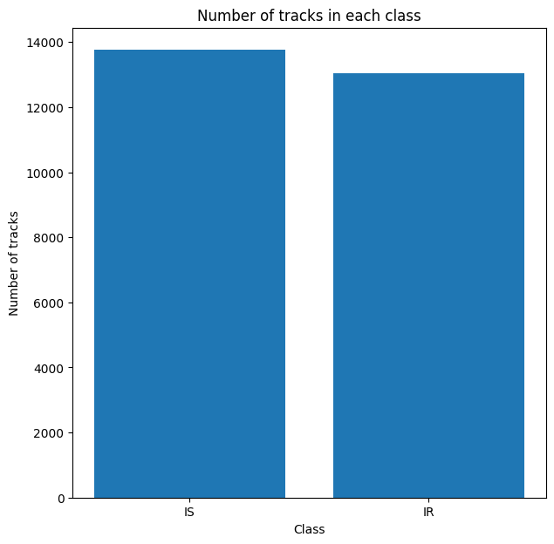
Figure 1. Numbers of tracks in each class in the full dataset.

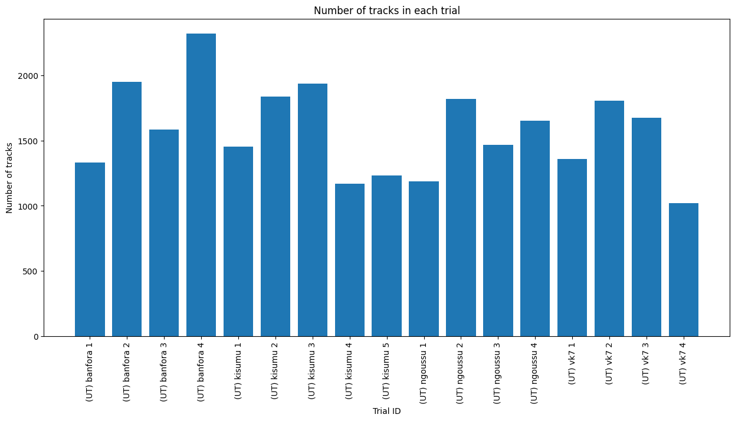
Figure 2. Number of tracks in each trial in the full dataset.

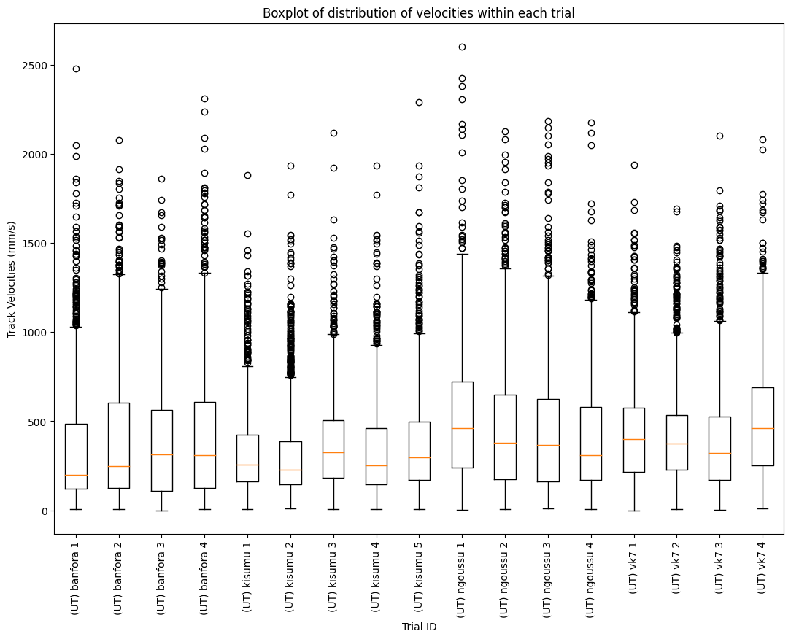
Figure 3. Boxplot displaying the average velocity in each track across each mosquito trial.
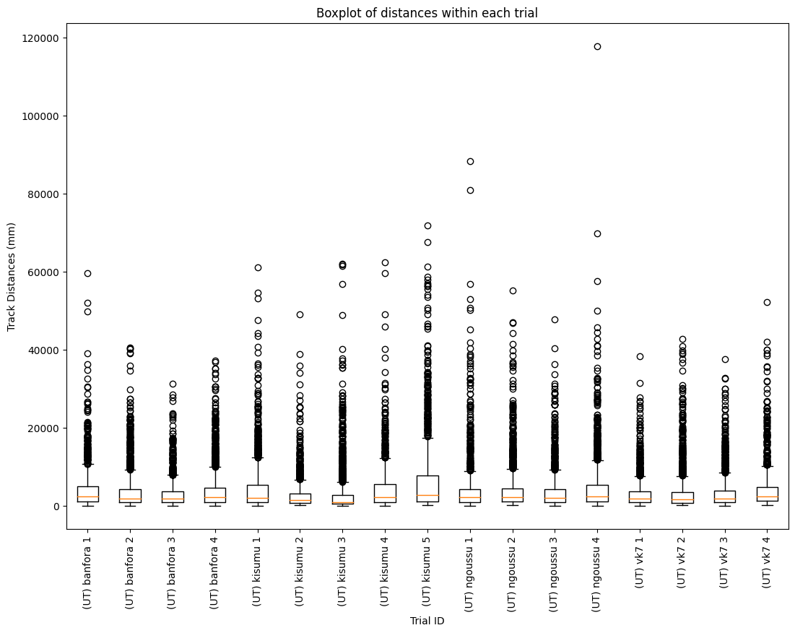
Figure 4. Boxplot displaying the distance travelled within each track across each mosquito trial.

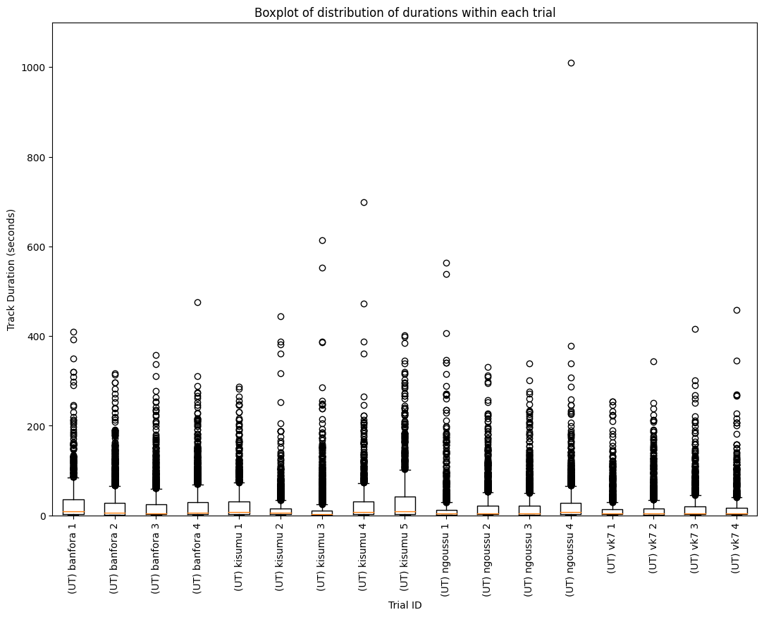
Figure 5. Boxplot displaying the durations of each track across each mosquito trial.

Table 3. Description of each performance metric used to evaluate the machine learning models.
Metric | Description | Equation
Accuracy | Proportion of correct predictions among the total number of cases. Useful for balanced classes. | $$\frac{TP+TN}{TP+TN+FP+FN}$$
Recall | Proportion of actual positives correctly identified (sensitivity). Useful to minimise false negatives | $$\frac{TP}{TP+FN}$$
Precision | Proportion of positive predictions that are correct. Useful when minimising false positives is critical. | $$\frac{TP}{TP+FP}$$
F1 Score | Harmonic mean of precision and recall, balancing between false positives and false negatives. | $$2×\frac{Precision×Recall}{Precision+Recall}$$
Balanced Accuracy | Average of recall for each class, accounting for imbalances in class distribution. | $$\frac{Recall_{positive}+Recall_{negative}}{2}$$
Matthews Correlation Coefficient | Correlation coefficient considering TP, TN, FP, FN, balanced even with imbalanced classes. Ranges from -1 to +1. | $$\frac{TP∙TN-FP∙FN}{\sqrt{\left(TP+FP\right)\left(TP+FN\right)\left(TN+FP\right)\left(TN+FN\right)}}$$
ROC AUC score | Measures model’s ability to distinguish between classes. Higher AUC indicates better performance. Calculated as area under the ROC curve. | -
PR AUC score | Measures area under the precision-recall curve, focusing on positive class performance in imbalanced datasets. | -
Cohen’s Kappa | Measures agreement between observed and predicted classifications, adjusting for chance agreement. Useful in multiclass or imbalanced datasets. | $$\frac{Observed Accuracy-Expected Accuracy}{1-Expected Accuracy}$$
Log loss | Measures the accuracy of probability predictions, penalising incorrect predictions based on confidence. Useful for probabilistic models. | $$-\frac{1}{N}\sum{\left(y_{i}\log{(p_{i}}\right)+\left(1-y_{i}\right)\log\left(1-p_{i}\right))}$$

Comparison to Dither
The SHAP plots indicate that higher number of local minima in horizontal-velocity features tend towards IR. This suggests that IR tracks have jerky motion with frequent speeding up and slowing down. This behaviour is analogous to the deliberate use of ‘dither’ in engineering control systems where it has been used successfully to minimise vibration noise (Kropp et al “The application of dither to mitigate curve squeal” (2021) Journal of Sound and Vibration, 514, art. no. 116433) and produce low vibration control of magnetic levitation vehicles (Tomono et al “Controllability improvement of zero-power magnetically levitated system by dither”, (1998) IEEE Annual Power Electronics Specialists Conference, 1, art. no. 701958, pp. 588 – 593). This low amplitude ‘dither’ in flight may allow the mosquito to be aware of its surroundings by sampling CO₂ and thermal fields. This could then lead to directed flight towards these cues which indicates a potential bloodmeal.

Table 4. Hypertuning parameter ranges for XGBoost
Parameter | Parameter values
Window size | 0.5, 1, 1.5, 2, 2.5, 3, 3.5, 4, 4.5, 5, 5.5, 6, 6.5, 7, 7.5, 8, 8.5, 9, 9.5
Window overlap | 0.5, 1, 1.5, 2, 2.5, 3, 3.5, 4, 4.5, 5, 5.5, 6, 6.5, 7, 7.5, 8, 8.5, 9
Learning rate | 0.01, 0.1, 0.3
N estimators | 50, 100, 150, 200, 250
Max depth | 3, 5, 7
Subsample | 0.5, 0.7, 0.9
Colsample bytree | 0.5, 0.7, 0.9
Reg alpha | 0, 0.01, 0.1
Reg lambda | 0, 0.01, 0.1
Min child weight | 1, 5, 15

Table 5. Hypertuning parameter ranges for random forests
Parameter | Parameter values
Window size | 0.5, 1, 1.5, 2, 2.5, 3, 3.5, 4, 4.5, 5, 5.5, 6, 6.5, 7, 7.5, 8, 8.5, 9, 9.5
Window overlap | 0.5, 1, 1.5, 2, 2.5, 3, 3.5, 4, 4.5, 5, 5.5, 6, 6.5, 7, 7.5, 8, 8.5, 9
N estimators | 100, 200, 300, 400
Criterion | Entropy, gini
Max depth | 5, 10, 15
Min samples split | 2, 3, 4
Min samples leaf | 1, 2, 3
Max depth | Log2, sqrt
Bootstrap | True, False

Table 6. Hypertuning parameter ranges for logistic regression
Parameter | Parameter values
Window size | 0.5, 1, 1.5, 2, 2.5, 3, 3.5, 4, 4.5, 5, 5.5, 6, 6.5, 7, 7.5, 8, 8.5, 9, 9.5
Window overlap | 0.5, 1, 1.5, 2, 2.5, 3, 3.5, 4, 4.5, 5, 5.5, 6, 6.5, 7, 7.5, 8, 8.5, 9
Penalty | L1, L2, None
c | 0.01, 0.1, 1, 10, 100
Solver | lbfgs, liblinear, newton-cg, sag, saga
Max iteration | 50, 100, 150

Table 7. Hypertuning parameter ranges for Kisumu vs Ngoussu – XGBoost
Parameter | Parameter values
Window size | 0.5, 1, 1.5, 2, 2.5, 3, 3.5, 4, 4.5, 5, 5.5, 6, 6.5, 7, 7.5, 8, 8.5, 9, 9.5
Window overlap | 0.5, 1, 1.5, 2, 2.5, 3, 3.5, 4, 4.5, 5, 5.5, 6, 6.5, 7, 7.5, 8, 8.5, 9
Learning rate | 0.01, 0.1, 0.3
N estimators | 100, 150, 200
Max depth | 3, 5, 7
Subsample | 0.5, 0.7, 0.9
Colsample bytree | 0.5, 0.7, 0.9
Reg alpha | 0, 0.01, 0.1
Reg lambda | 0, 0.01, 0.1
Min child weight | 1, 5, 15

Table 8. Hypertuning parameter ranges for Banfora vs VK7 – XGBoost
Parameter | Parameter values
Window size | 0.5, 1, 1.5, 2, 2.5, 3, 3.5, 4, 4.5, 5, 5.5, 6, 6.5, 7, 7.5, 8, 8.5, 9, 9.5
Window overlap | 0.5, 1, 1.5, 2, 2.5, 3, 3.5, 4, 4.5, 5, 5.5, 6, 6.5, 7, 7.5, 8, 8.5, 9
Learning rate | 0.01, 0.1, 0.3
N estimators | 100, 150, 200
Max depth | 3, 5, 7
Subsample | 0.5, 0.7, 0.9
Colsample bytree | 0.5, 0.7, 0.9
Reg alpha | 0, 0.01, 0.1
Reg lambda | 0, 0.01, 0.1
Min child weight | 1, 5, 15

Table 9. Hypertuning parameter ranges for Multiclass XGBoost
Parameter | Parameter values
Window size | 0.5, 1, 1.5, 2, 2.5, 3, 3.5, 4, 4.5, 5, 5.5, 6, 6.5, 7, 7.5, 8,
Window overlap | 0.5, 1, 1.5, 2, 2.5, 3, 3.5, 4, 4.5, 5, 5.5, 6, 6.5, 7, 7.5
Learning rate | 0.01, 0.1, 0.3
N estimators | 100, 150, 200
Max depth | 3, 5, 7
Subsample | 0.5, 0.7, 0.9
Colsample bytree | 0.5, 0.7, 0.9
Reg alpha | 0, 0.01, 0.1
Reg lambda | 0, 0.01, 0.1
Min child weight | 1, 5, 15

Table 10. Final hyperparameters for XGBoost model
Parameter | Parameter values
Window size | 8
Window overlap | 7.5
Learning rate | 0.3
N estimators | 250
Max depth | 5
Subsample | 0.5
Colsample bytree | 0.9
Reg alpha | 0
Reg lambda | 0
Min child weight | 15

Table 11. Final hyperparameters for random forests
Parameter | Parameter values
Window size | 7.5
Window overlap | 6.5
N estimators | 300
Criterion | Entropy
Max depth | 15
Min samples split | 3
Min samples leaf | 1
Max depth | sqrt
Bootstrap | False

Table 12. Final hyperparameters for logistic regression
Parameter | Parameter values
Window size | 9.5
Window overlap | 9
Penalty | L2
c | 0.01
Solver | Saga
Max iteration | 50

Table 13. Final hyperparameters for Kisumu vs Ngoussu – XGBoost
Parameter | Parameter values
Window size | 1.5
Window overlap | 0.5
Learning rate | 0.1
N estimators | 200
Max depth | 5
Subsample | 0.5
Colsample bytree | 0.7
Reg alpha | 0.01
Reg lambda | 0.1
Min child weight | 15

Table 14. Final hyperparameters for Banfora vs VK7 – XGBoost
Parameter | Parameter values
Window size | 6
Window overlap | 5.5
Learning rate | 0.1
N estimators | 200
Max depth | 3
Subsample | 0.5
Colsample bytree | 0.9
Reg alpha | 0.01
Reg lambda | 0.1
Min child weight | 15

Table 15. Final hyperparameters for Multiclass XGBoost
Parameter | Parameter values
Window size | 6
Window overlap | 5.5
Learning rate | 0.3
N estimators | 200
Max depth | 5
Subsample | 0.5
Colsample bytree | 0.5
Reg alpha | 0.1
Reg lambda | 0.1
Min child weight | 5

Figure 6. Confusion matrix for insecticide resistant vs insecticide susceptible task with sum of tracks across all folds, where (A) is the logistic regression model, (B) is the random forest model and (C) is the XGBoost model.
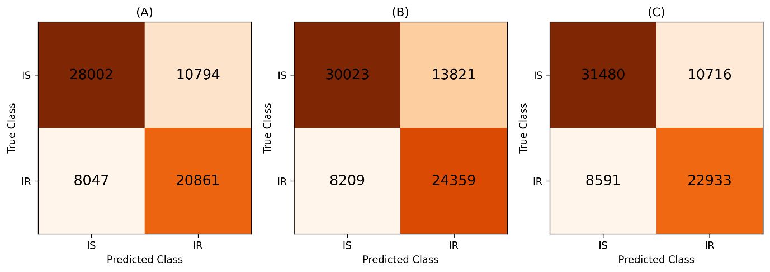
Figure 7. Confusion matrix Kisumu vs N’goussu task with sum of tracks across all folds.
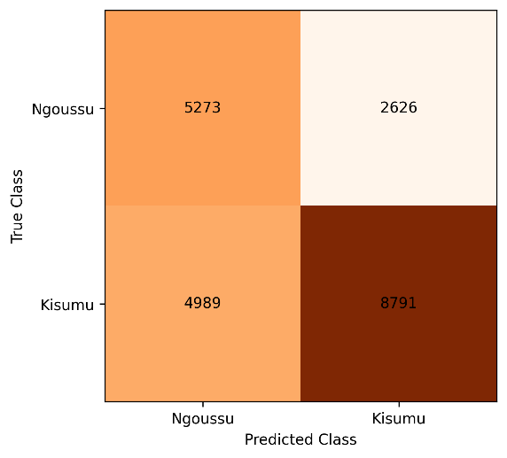
Figure 8. Confusion matrix Banfora vs VK7 task with sum of tracks across all folds.
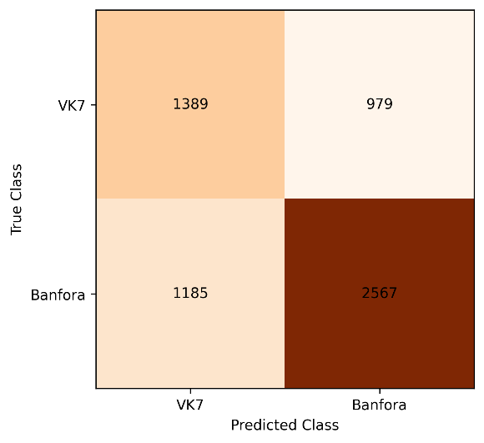

Figure 9. Boxplots displaying the range of performance for each machine learning model applied to independent test data for IR (Banfora & VK7) vs IS (Kisumu & N’goussu) across folds. The median performance is labelled.
