Supplementary Information for

Surveillance data and early warning models of highly pathogenic avian influenza in Japan and South Korea, 2020-2024 show different occurrence patterns than in Europe
Lene Jung Kjær^{1*}, Carsten Thure Kirkeby¹, Anette Ella Boklund¹, Charlotte Kristiane Hjulsager², Anthony D. Fox³, and Michael P. Ward⁴

¹Department of Veterinary and Animal Sciences, Faculty of Health and Medical Sciences, University of Copenhagen, Denmark
² Department for Virus and Microbiological Special Diagnostics, Statens Serum Institut, Copenhagen, Denmark
³Department of Bioscience, Aarhus University, Aarhus, Denmark
⁴Faculty of Science, Sydney School of Veterinary Science, University of Sydney, Camden NSW, Australia

*Corresponding author:
Email: lenju@sund.ku.dk

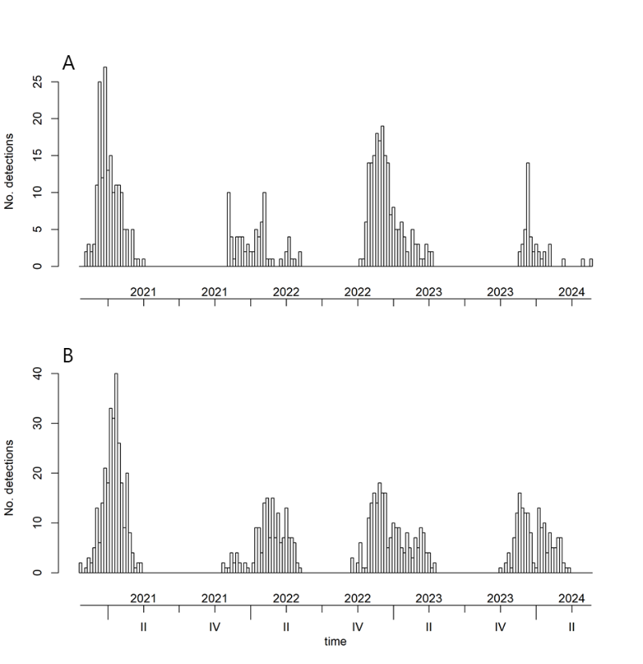

Figure S1. Total number of HPAIV H5 detections summed over all 17 regions in Japan and South Korea and shown over time, 2020-2024 in A) domestic birds (n=483) and B) wild birds (n=827).

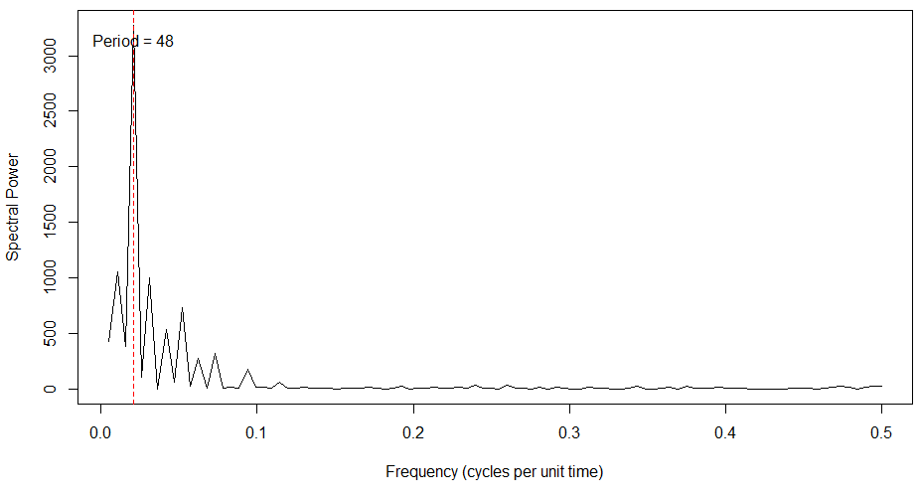
Figure S2. Periodogram of detection data showing dominant frequencies in the time series.
The x-axis represents the frequency (cycles per unit time), and the y-axis indicates the spectral power, reflecting the strength of each frequency. The largest peak corresponds to a dominant frequency of 𝑓 = 1/48, indicating a primary cycle that repeats every 48 weeks. This near-annual cycle highlights seasonality in the detection data.

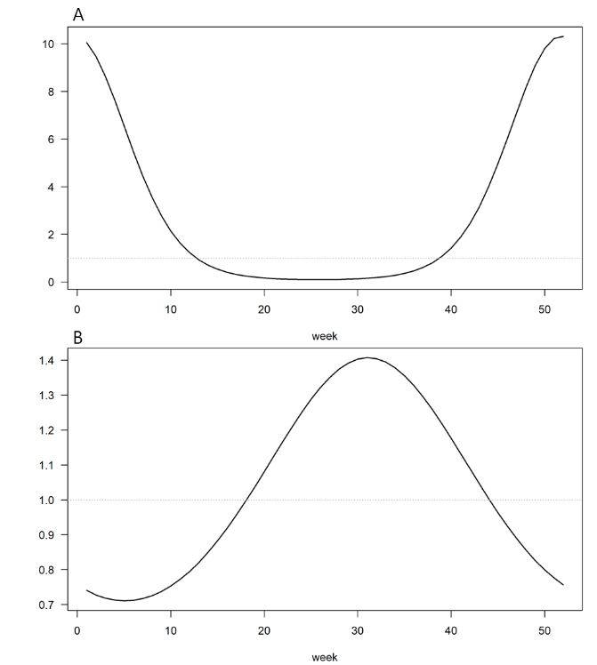

Figure S3. Seasonal waves (frequency ω = 2π/52) included in the final multivariate time-series model for A) the endemic component (1 wave), and B) the within-country effects in the epidemic component (1 wave).

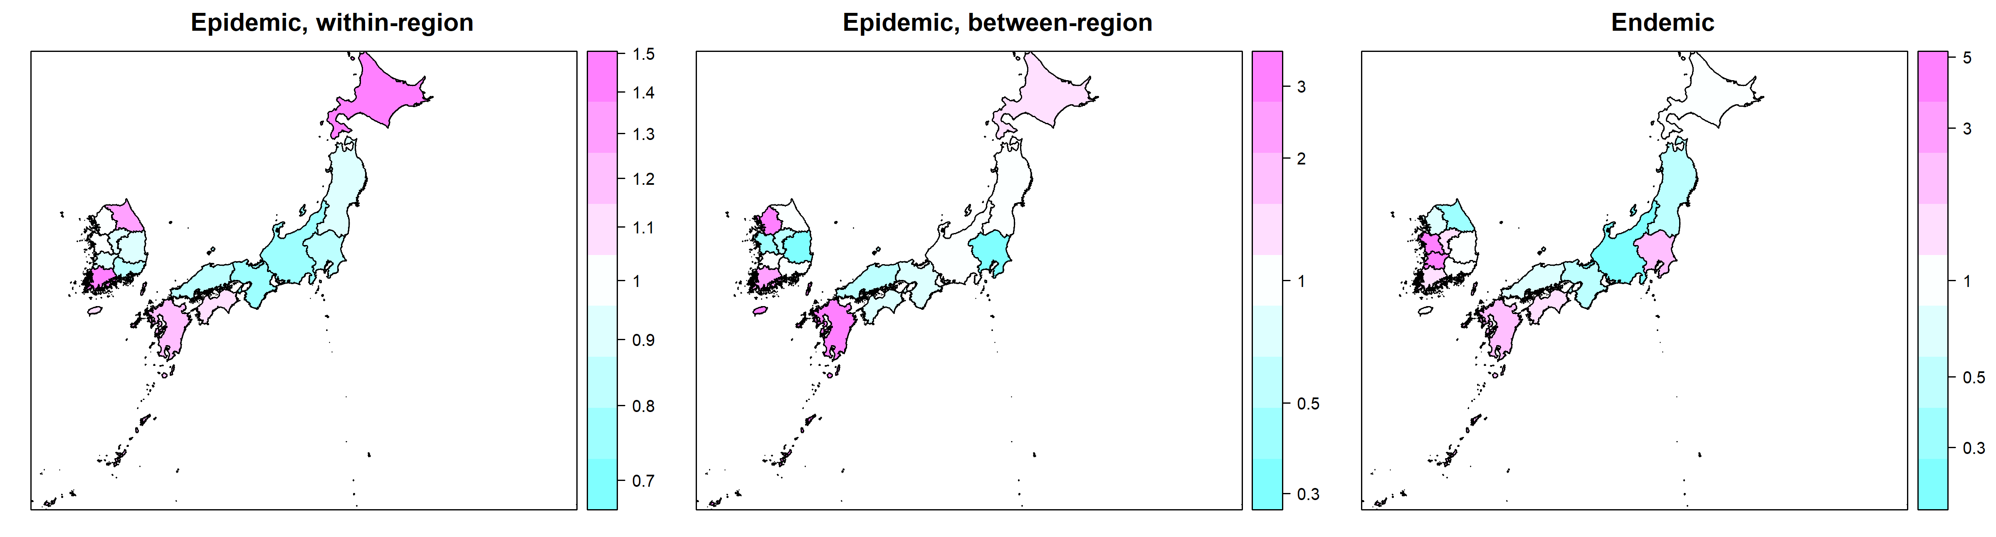
Figure S4. Epidemic (between and within region) and endemic random intercepts (RI) from the final multivariate time-series model for all 17 regions. RI < 1 suggests lower number of detections than predicted.

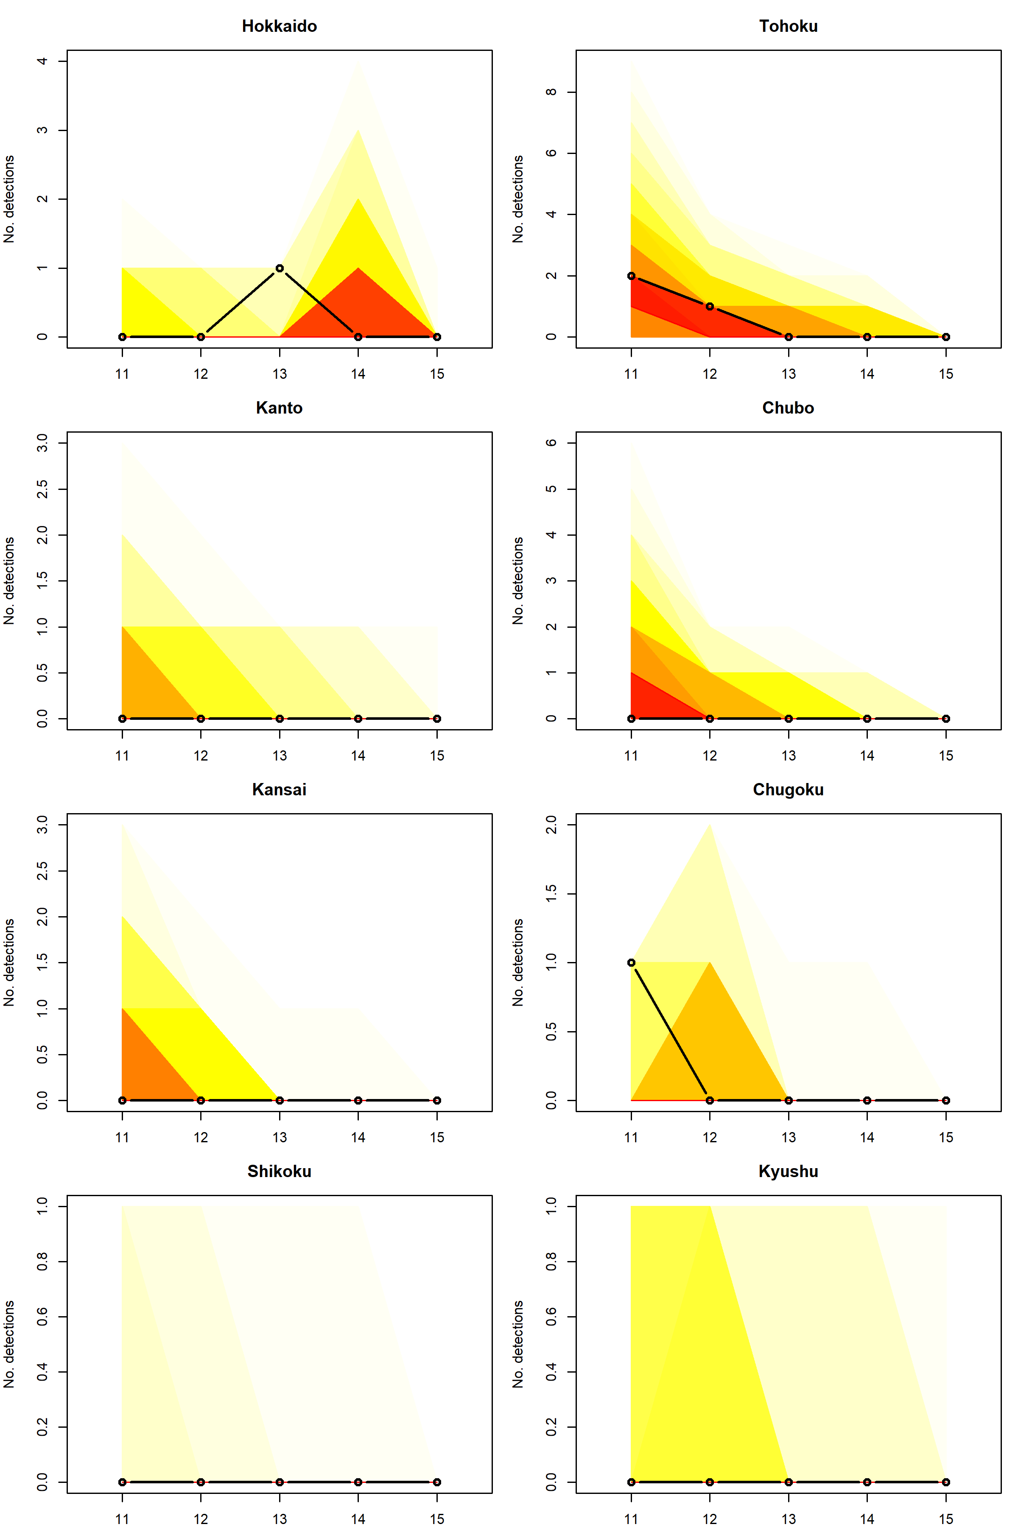
Figure S5. Fan charts displaying rolling one-week-ahead forecasts for the 8 regions of Japan from week 11 to week 15 in 2024 generated by the final multivariate time-series model. The X-axis denotes the week number, while the Y-axis indicates the number of detections. Each fan chart illustrates the 1% and 99% quantiles of the forecasts per week. Actual reported detections are marked with open circles. Please be aware that the Y-axis scales may vary across some of the graphs.
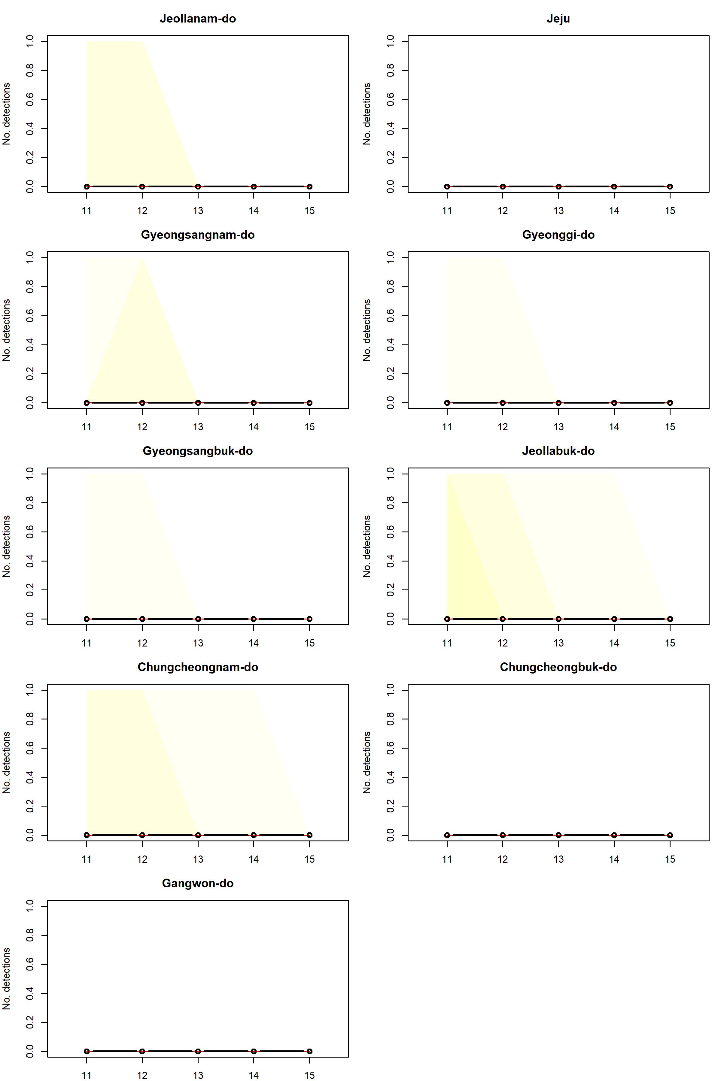

Figure S6. Fan charts displaying rolling one-week-ahead forecasts for the 9 regions of South Korea from week 11 to week 15 in 2024 generated by the final multivariate time-series model. The X-axis denotes the week number, while the Y-axis indicates the number of detections. Each fan chart illustrates the 1% and 99% quantiles of the forecasts per week. Actual reported detections are marked with open circles. Please be aware that the Y-axis scales may vary across some of the graphs.
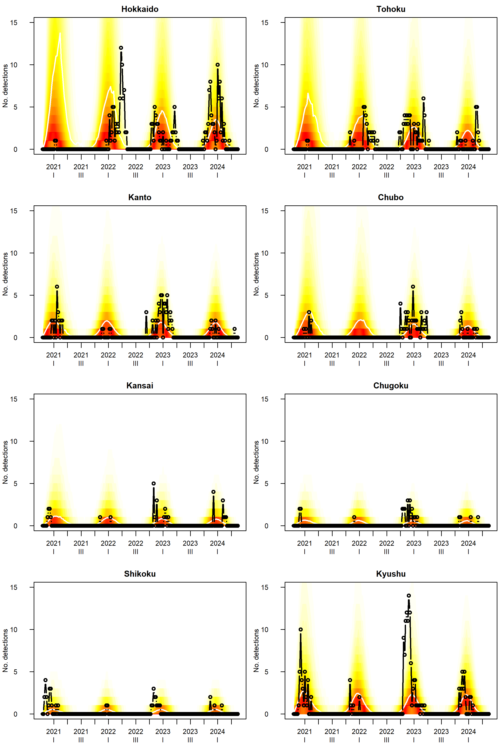
Figure S7. Simulation-based long-term forecast for the 8 regions of Japan commencing from week 43 in 2020 (indicated by the left-hand dot) through week 21 in 2024. The fan chart illustrates the mean (white line) and the 1% and 99% quantiles of the simulations for each week, while actual reported detections are denoted by open circles. Notably, data from week 11 to week 15 in 2024 were excluded from model training. Please be aware that the Y-axis scales may differ across certain graphs.
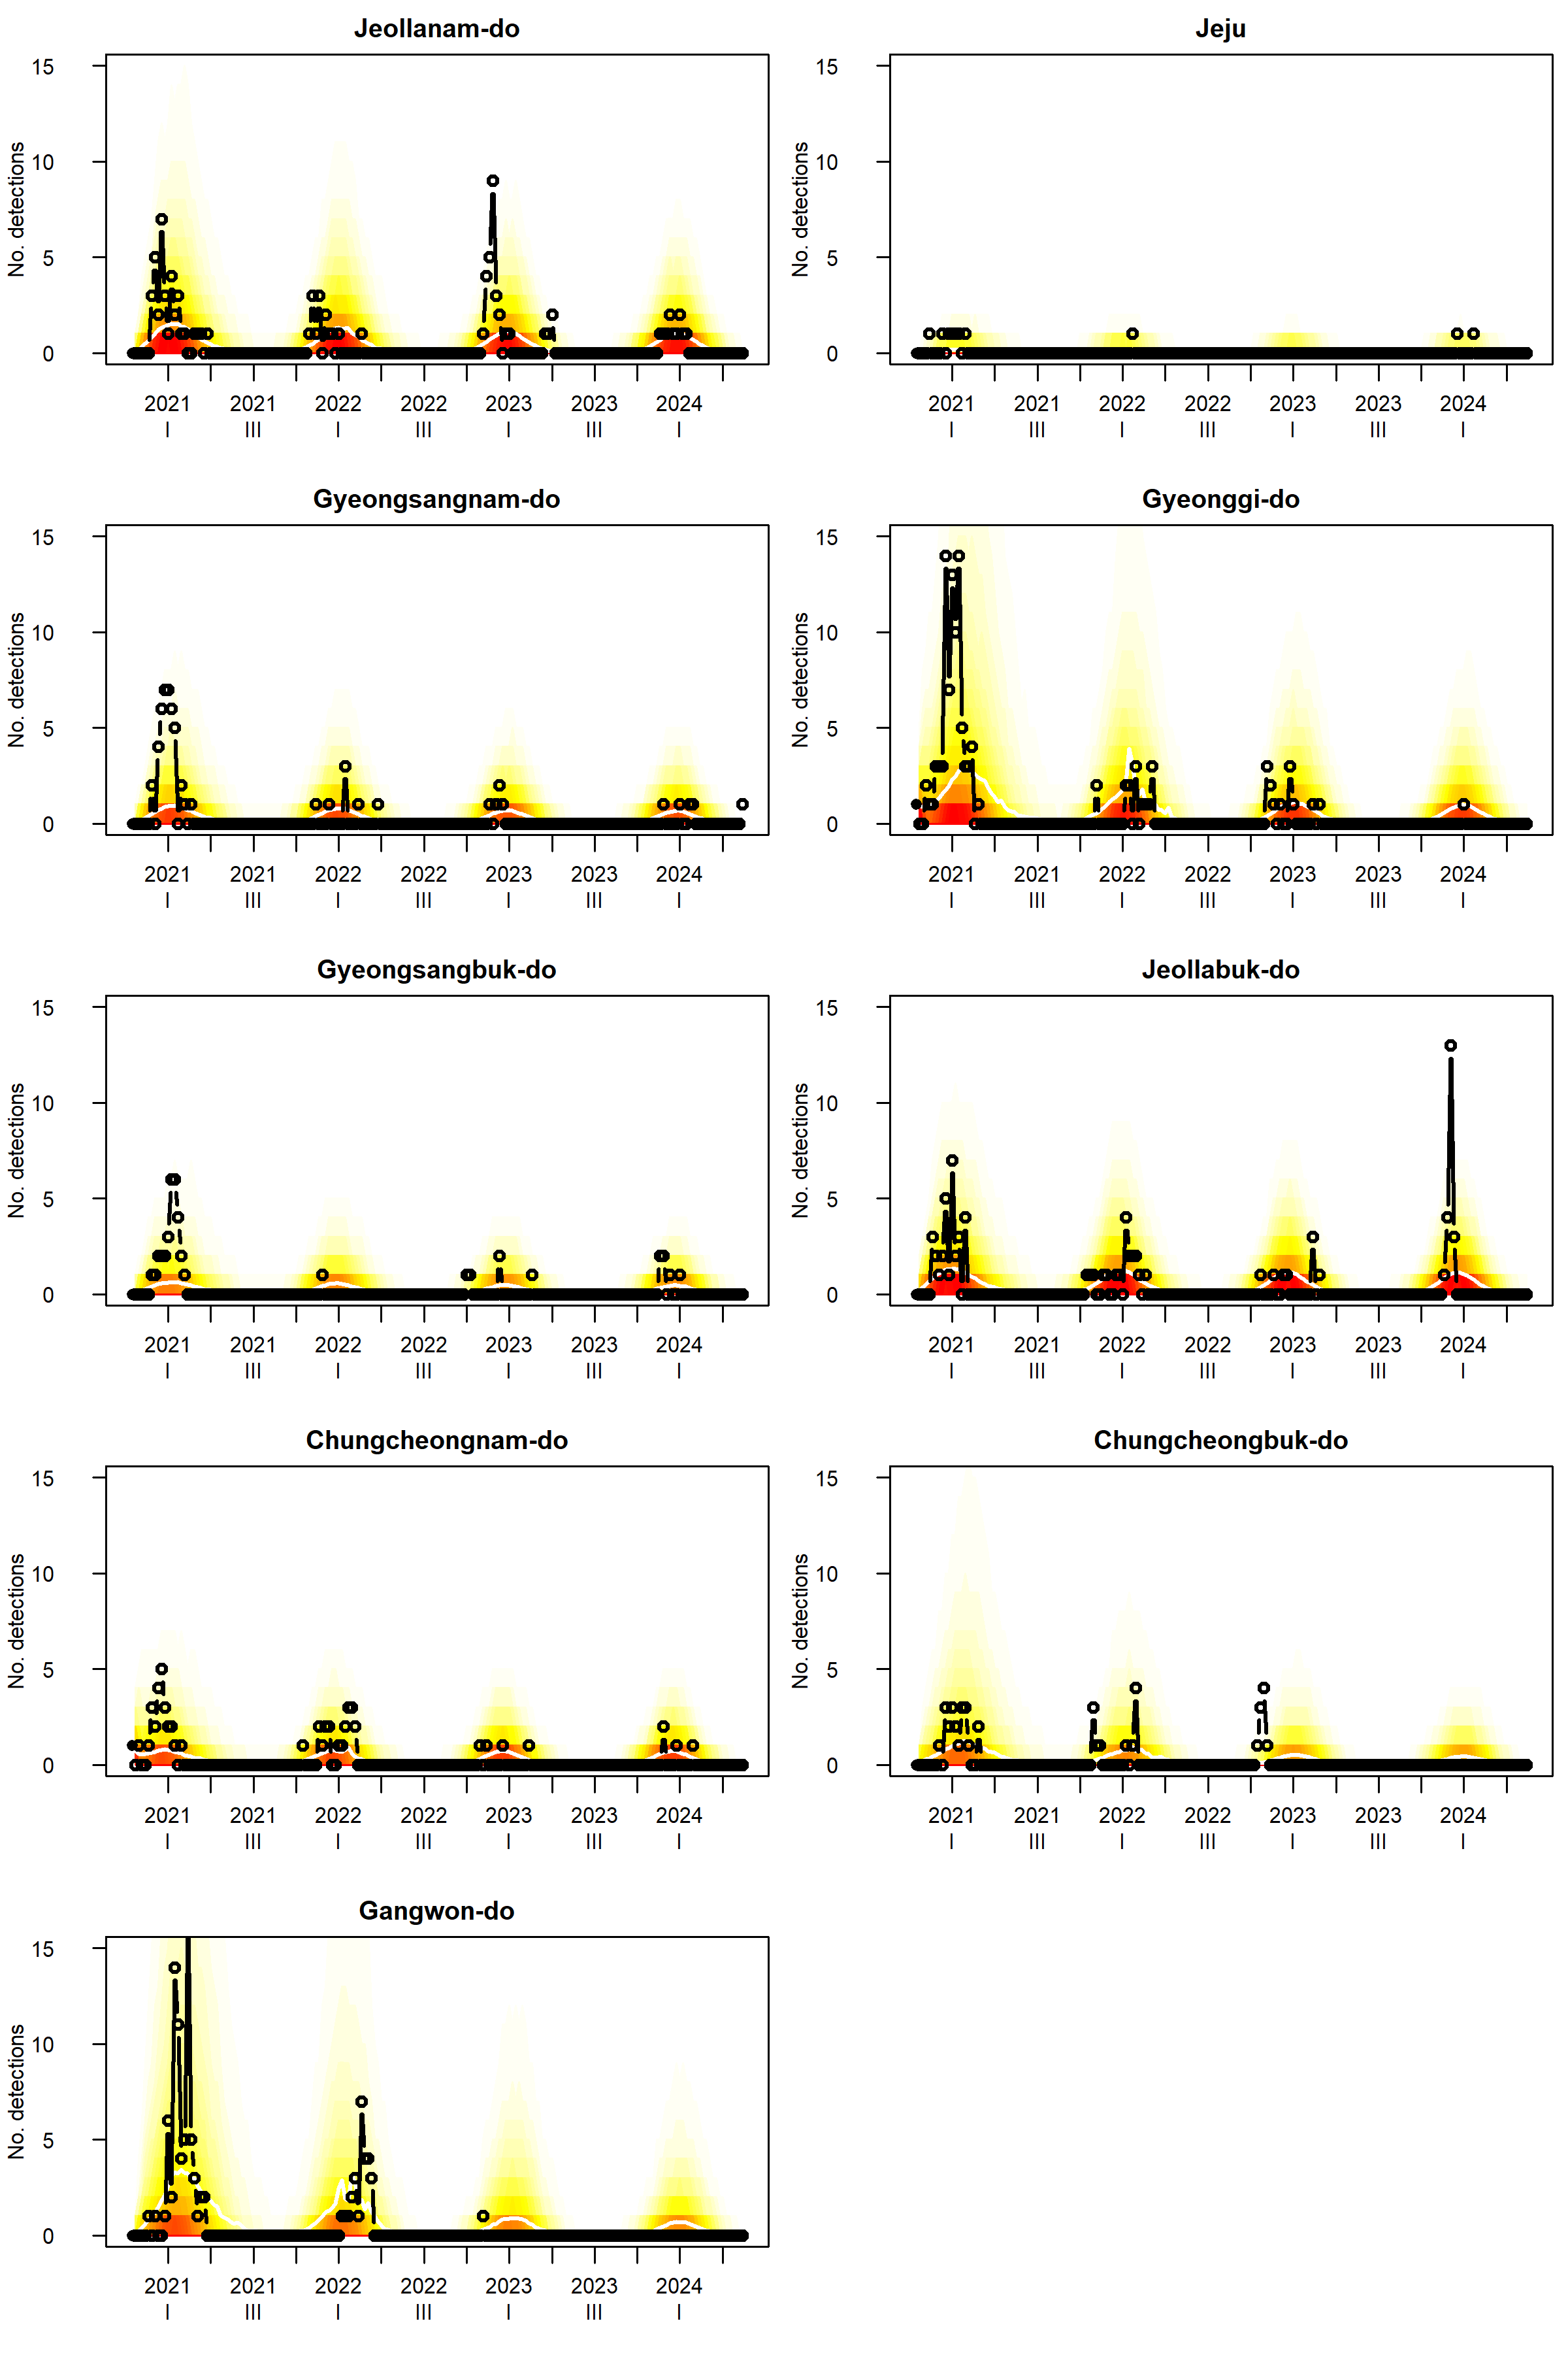
Figure S8. Simulation-based long-term forecast for the 9 regions of South Korea commencing from week 43 in 2020 (indicated by the left-hand dot) through week 21 in 2024. The fan chart illustrates the mean (white line) and the 1% and 99% quantiles of the simulations for each week, while actual reported detections are denoted by open circles. Notably, data from week 11 to week 15 in 2024 were excluded from model training. Please be aware that the Y-axis scales may differ across certain graphs.

