Supplemental Material for

Non-destructive detection of critical defects in additive manufacturing

Shaharyar Baig^{1,2}, Alireza Jam^{1,2}, Stefano Beretta^{1,2,3}, Shuai Shao^{1,2}, Nima Shamsaei^{1,2*}

¹ National Center for Additive Manufacturing Excellence (NCAME), Auburn University, Auburn, AL 36849, USA
² Department of Mechanical Engineering, Auburn University, Auburn, AL 36849, USA
³ Department of Mechanical Engineering, Politecnico di Milano, Milano, Italy 20156

*Corresponding author:
Email: shamsaei@auburn.edu
Phone: (334) 844 4839

To be submitted to:
Scientific Reports

February 2024

The sphericity vs. equivalent sphere diameter and sphericity vs. $\sqrt{area}$ plots for the ground truth dataset are presented in Figures S1(a)-(b). The larger defects in the specimen had lower sphericity values and were LoF defects, compared to smaller keyhole and entrapped gas pores which had sphericity values closer to 1. In addition, a single feature may not be adequate to distinguish between the various types of defects. This was evident in the equivalent sphere diameter vs. $\sqrt{area}$ plot in Figure S1(c), where there were several larger defects which had similar equivalent sphere diameters but very different $\sqrt{area}$ values, which was ascribed to their dissimilar morphologies
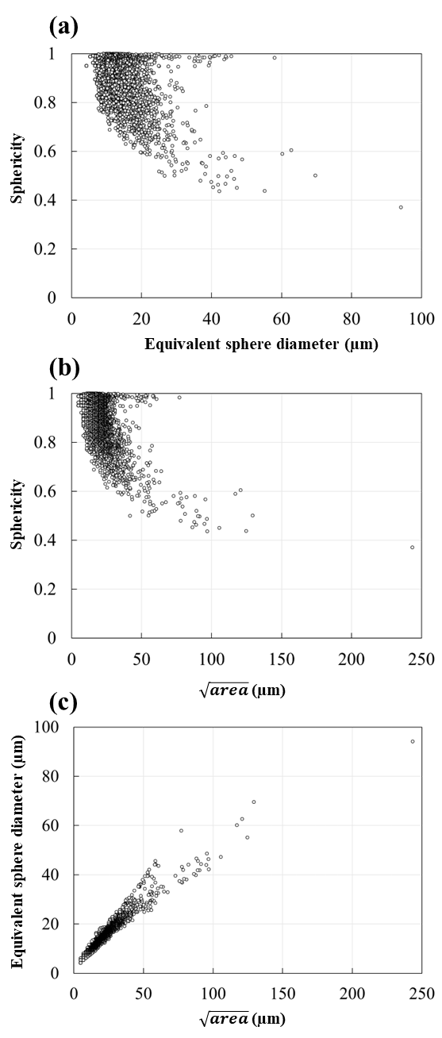
Figure S1. (a) Sphericity vs. equivalent sphere diameter, (b) sphericity vs. $\sqrt{area}$ and (c) equivalent sphere diameter vs. $\sqrt{area}$ for the 3 µm-3 mm ground truth XCT data

The sphericity vs. $\sqrt{area}$ plots for the 3 µm-3 mm, 6 µm-3 mm and 10 µm-3 mm scans are presented in Figure S2. The plots revealed that the acquisition parameters used for the XCT scans have a notable impact on the detected features. In the ground truth dataset in Figure S2(a), the larger defects exhibit lower sphericity values, while the smaller defects display more spherical morphologies. When the voxel size was increased to 6 µm, both size and sphericity measurements were affected, with the defect distribution shifting upwards and leftwards, implying the sizes for the same defects were measured to be smaller with higher sphericities compared to the ground truth dataset, as seen in Figure S2(b). Further increasing the voxel size to 10 µm amplified these discrepancies, as seen in Figure S2(c), resulting in even smaller measured sizes and higher sphericities for the same defects.

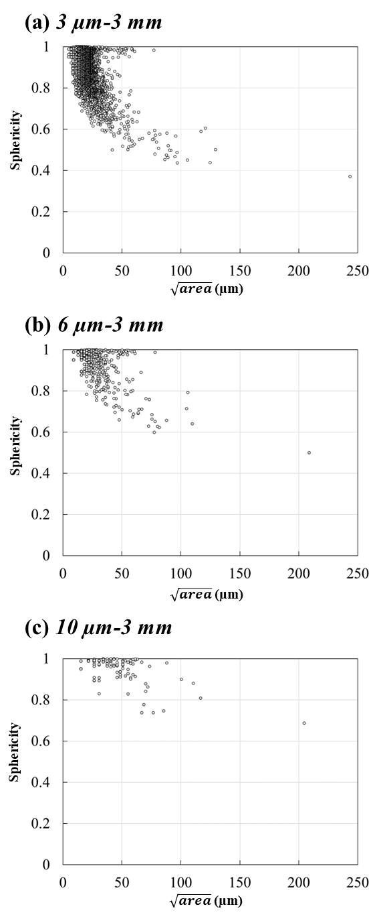
Figure S2. Sphericity vs. $\sqrt{area}$ for the (a) 3 µm-3 mm (ground truth), (b) 6 µm-3 mm and (c) 10 µm-3 mm scans.
The 50% POD, 90% POD at a confidence level of 95%, as well as the largest undetected and smallest detected defect sizes for all scan parameters investigated in this study are reported in Table S1. The table includes these values for when considering all defects indiscriminately, as well as for the defects classified as LoF (consisting of defects with sphericity≤0.7) and near-spherical (sphericity>0.7). .
Table S1. The defect sizes for 50% POD (a₅₀), 90% POD at a confidence level of 95% (a_{90/95}), the largest undetected defect (a_{LU}) and the smallest detected defect (a_{SD}).
Scan parameter | Defect  type | a₅₀  (µm) | a_{90/95}  (µm) | a_{LU}  (µm) | a_{SD}  (µm)
6 µm-3 mm | All | 26 | 33 | 53 | 20
6 µm-3 mm | LoF | 33 | 48 | 53 | 28
6 µm-3 mm | Near-spherical | 25 | 30 | 35 | 20
10 µm-3 mm | All | 47 | 62 | 77 | 29
10 µm-3 mm | LoF | 59 | 82 | 77 | 40
10 µm-3 mm | Near-spherical | 38 | 47 | 44 | 29
6 µm-6 mm | All | 28 | 35 | 53 | 18
6 µm-6 mm | LoF | 37 | 49 | 53 | 30
6 µm-6 mm | Near-spherical | 26 | 31 | 37 | 18
10 µm-6 mm | All | 47 | 62 | 77 | 32
10 µm-6 mm | LoF | 60 | 84 | 77 | 40
10 µm-6 mm | Near-spherical | 38 | 46 | 44 | 32
6 µm-10 mm | All | 41 | 54 | 79 | 24
6 µm-10 mm | LoF | 55 | 81 | 79 | 34
6 µm-10 mm | Near-spherical | 34 | 41 | 44 | 24
10 µm-10 mm | All | 70 | 98 | 95 | 37
10 µm-10 mm | LoF | 87 | 129 | 95 | 50
10 µm-10 mm | Near-spherical | 47 | 58 | 56 | 37

The hit/miss data for the POD analysis using a decision threshold of $\sqrt{area}$ ≥ 2 and $\sqrt{area}$ ≥ 3 voxels are presented in Figure S3. While increasing the noise threshold, i.e., from $\sqrt{area}$ ≥ 2 to $\sqrt{area}$ ≥ 3, seemed to have shifted the curves rightwards for all voxel/specimen sizes, the overall trend remained consistent regardless of the threshold applied.

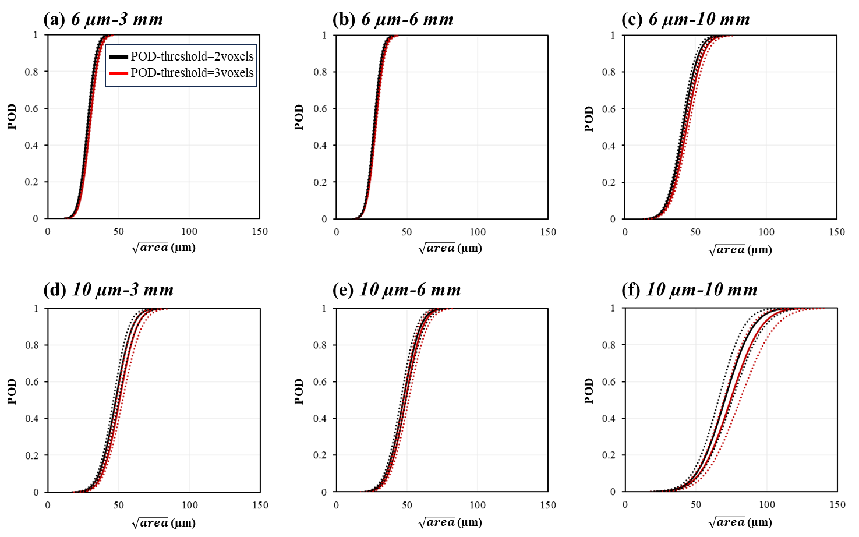
Figure S3. Comparison of POD curves using a noise threshold of 2 and 3 voxels. The dashed lines represent the confidence bands for each set of POD curves.
The XCT raw data and the reconstruction of defects 1,2 and 3 from Figure 5 in the main manuscript is presented in Figure S4. A decrease in resolution resulted in only the bulkier regions of these defects to be detected. The pairwise distances between the bulky defect segments belonging to the same defect as informed by the ground truth, are also shown in the figures.
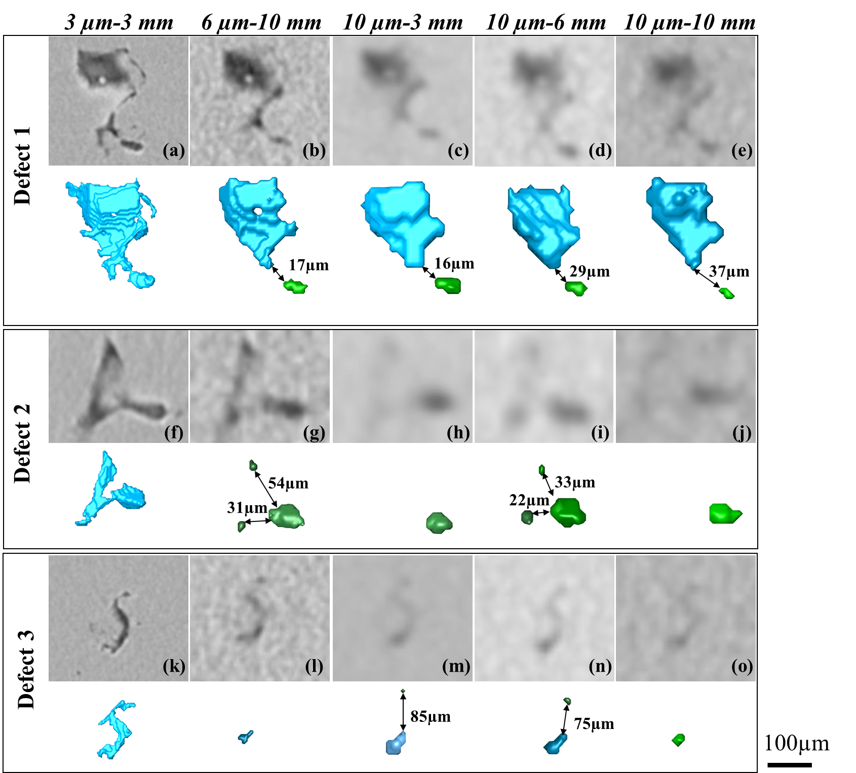
Figure S4. XCT slice images and 3D reconstruction of defects (a)-(e) 1, (f)-(j) 2 and (k)-(o)3. The distances shown are the minimum Euclidean distances between the detected cluster of entities belonging to the corresponding defect, as informed by the ground truth data.

