Supplementary Information S1

Disintegration of Commercial Biodegradable Plastic Products under Simulated Industrial Composting Conditions

Sevil V. Afsharª*, Alessio Boldrin^{a,1}, Thomas H. Christensenª, Fabiana Corami^{b,c}, Anders E. Daugaard^{d,}, Beatrice Rosso^{b,c}, Nanna B. Hartmannª
ª Department of Environmental and Resource Engineering, Technical University of Denmark, Bygningstorvet Building 115, 2800 Kgs. Lyngby, Denmark.
^{b} Institute of Polar Sciences, CNR-ISP, Campus Scientifico - Ca’ Foscari University of Venice, Via Torino, 155, 30172, Venezia-Mestre, Italy.
^{c} Department of Environmental Sciences, Informatics, and Statistics, Ca' Foscari University of Venice, Via Torino, 155, 30172, Venezia-Mestre, Italy.
^{d} Department of Chemical and Biochemical Engineering, The Danish Polymer Centre, Technical University of Denmark, Søltofts Plads Building 227, 2800 Kgs. Lyngby, Denmark.

¹ Current affiliation: Quantis, Rue de la Gare de Triage 5, 1020 Renens, Switzerland.

*Corresponding author: sevaf@dtu.dk

E-mail addresses: sevaf@dtu.dk (Sevil V. Afshar), alessio.boldrin@quantis-intl.com (Alessio Boldrin), thho@dtu.dk (Thomas H. Christensen), fabiana.corami@cnr.it (Fabiana Corami), adt@kt.dtu.dk (Anders E. Daugaard), beatrice.rosso@unive.it (Beatrice Rosso), nibh@dtu.dk (Nanna B. Hartmann)

Contents
1. Material and methods 2
1.1. Test material 2
1.2. Synthetic waste 8
1.3. Experimental set-up 8
2. Results 9
2.1. Fourier-transform infrared (FTIR) spectra 9
2.2. Differential Scanning Calorimetry (DSC) 17
2.3. Non-disintegrated test material 24
2.3. Disintegration degrees 26
2.4. Test validation 27
2.5. Microplastic analysis 30

1. Material and methods

1.1. Test material
The available product information for all test materials is provided in Table S1. The average thickness of each test material was measured based on seven measurements using a ZEISS Axioscope microscope with an Axiocam 305 color camera (Table S2).

Table S1: Description of materials used for the disintegration test.
Sample No. | Product Name | Product information
1 | - | -
2 | - | -
3 | - | -
4 | Cellulose Filter Paper | Cytiva Whatman™ Qualitative Filter Paper: Grade 1 Sheets. Format: Sheet. Material: Cellulose. Pore size: 11 μm. Thickness 180 μm. Dimensions: 26 mm x 31 mm. Item code: 11392815.
5 | Cellulose Filter Paper
6 | Cellulose Filter Paper
7 | Freezer Bag | Freezer bag, 4 L. Dimensions: 20 x 40 cm. 100 % LDPE.
8 | Freezer Bag | Freezer bag, 4 L. Dimensions: 20 x 40 cm. 100 % LDPE.
9 | Freezer Bag | Freezer bag, 4 L. Dimensions: 20 x 40 cm. 100 % LDPE.
10 | Weighing Boat | PS weighing boat. Dimensions: 85 x 85 x 24 mm. Purchased from Hounisen, Denmark. Stock Number: 2502.8080.
11 | Weighing Boat
12 | Weighing Boat
13 | Food Bag | Home Compostable Food Bags, 4 L. Purchased in Gågrøn, Nørrebro, Denmark. PHA bioplastic and organic GMO free corn. Bag for fridge and freezer. Brand: Maistic
14 | Food Bag
15 | Food Bag
16 | Waste Bag (1) | Waste bag with drawstring, 20 L. Purchased in Føtex, Nørrebro, Denmark. 100 % corn starch.  Brand: Skrald-let
17 | Waste Bag (1)
18 | Waste Bag (1)
19 | Drawstring | Drawstring from 20 L waste bag. Purchased in Føtex, Nørrebro, Denmark. 100 % corn starch.  Brand: Skrald-let
20 | Drawstring
21 | Drawstring
22 | Waste Bag (2) | Home compostable waste bags. Purchased in Føtex, Nørrebro, Denmark. PHA from agricultural waste and organic GMO free corn. Brand: Maistic
23 | Waste Bag (2)
24 | Waste Bag (2)
25 | Waste Bag (3) | BioBag, 80 L, mater-bi, 82x105 cm. Color: green. Delivered by Abena, Denmark.
26 | Waste Bag (3)
27 | Waste Bag (3)
28 | Food Container | Food container with square hinged lid, 250 mL 126x117x43 mm. Color: transparent. Biodegradable PLA. Delivered by Multiline, Denmark. Item code: 116035.
29 | Food Container
30 | Food Container
31 | Plate | Starch blend plate based on Mater-B plasti Delivered by Novamont, Italy.
32 | Plate
33 | Plate
34 | Lid | Lid, Ø11.5cm, white, PLA, snap-on, round, for World Art cups. Made from Ingeo biopolymer. Color: white. Delivered by Abena, Denmark. Item code: 1010001165.
35 | Lid
36 | Lid
37 | Flower Pot (1) | Purchased in SILVAN, Nørrebro, Denmark.
38 | Flower Pot (1) | Purchased in SILVAN, Nørrebro, Denmark.
39 | Flower Pot (1) | Purchased in SILVAN, Nørrebro, Denmark.
40 | Flower Pot (2) | Degradable flowerpot with drain hole. Purchased online at Kridtvejs Planter, din online planteskole, Denmark. Manufactured by Biodolmer, consisting of raw materials such as calcium carbonate, sugar cane, and rapeseed.
41 | Flower Pot (2)
42 | Flower Pot (2)

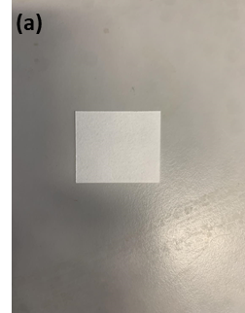 | 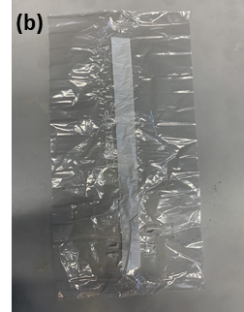 | 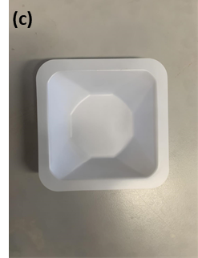
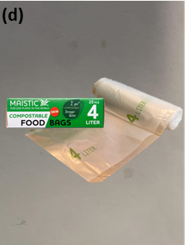 | 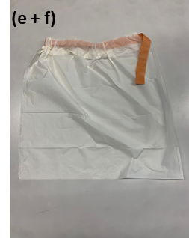 | 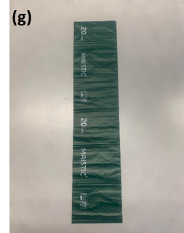
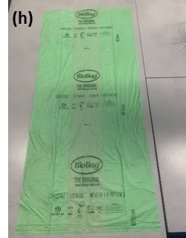 | 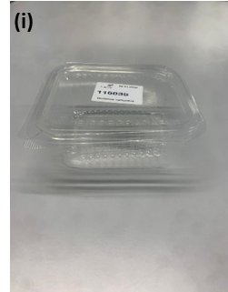 | 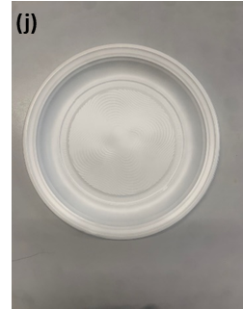
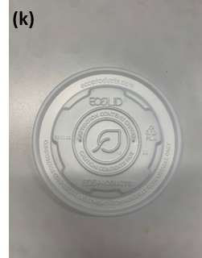 | 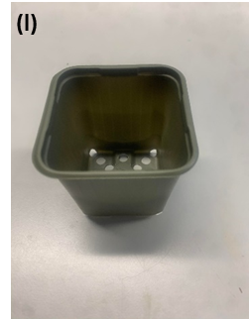 | 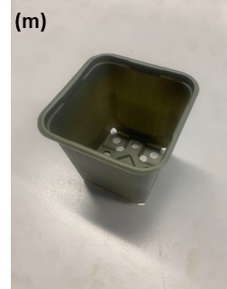

Figure S1: Photos of tested products. (a) Cellulose Filter Paper, (b) Freeze Bag, (c) Weighing Boat, (d) Food Bag, (e + f) Waste Bag (1) and Drawstring, (g) Waste Bag (2), (h) Waste Bag (3), (i) Food Container, (j) Plate, (k) Lid, (l) Flower Pot (1), and (m) Flower Pot (2).
Table S2: Measurements and microscope images of test material thickness.
Sample No. | Test material | Thicknesses (μm) | Microscope image
1-3 | - | - | -
4-6 | Cellulose Filter Paper (positive control) | 162 ± 15.0 | 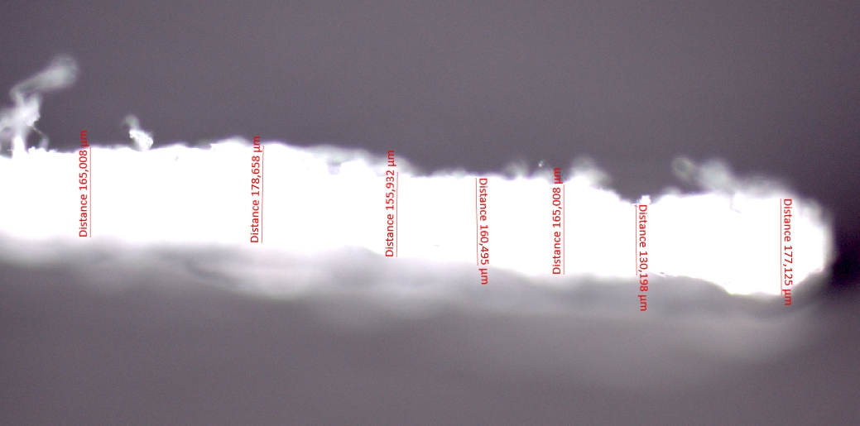
7-9 | Freezer Bag (negative control) | 32.0 ± 1.16 | 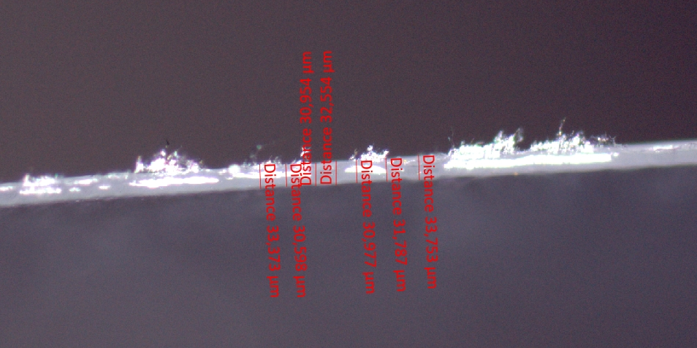
10-12 | Weighing Boat (negative control) | 253 ± 1.48 | 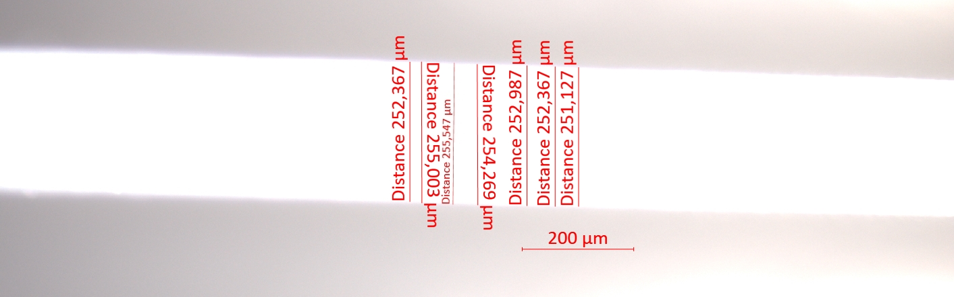
13-15 | Food Bag | 17.6 ± 1.55 | 
16-18 | Waste Bag (1) | 25.7 ± 1.21 | 
19-21 | Drawstring | 29.1 ± 0.56 | 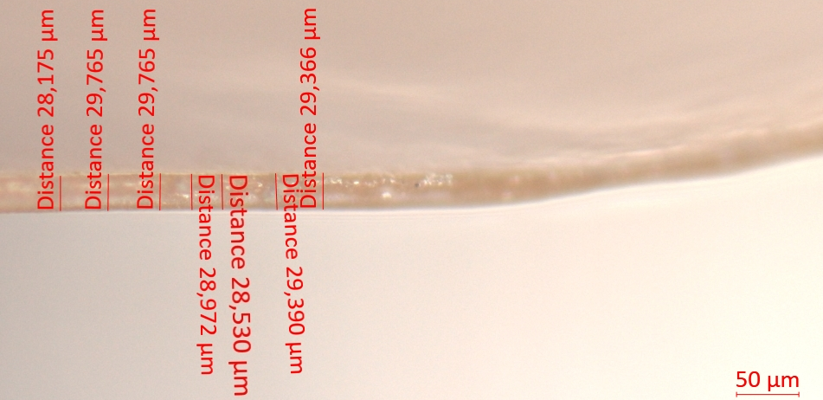
22-24 | Waste Bag (2) | 17.0 ± 2.07 | 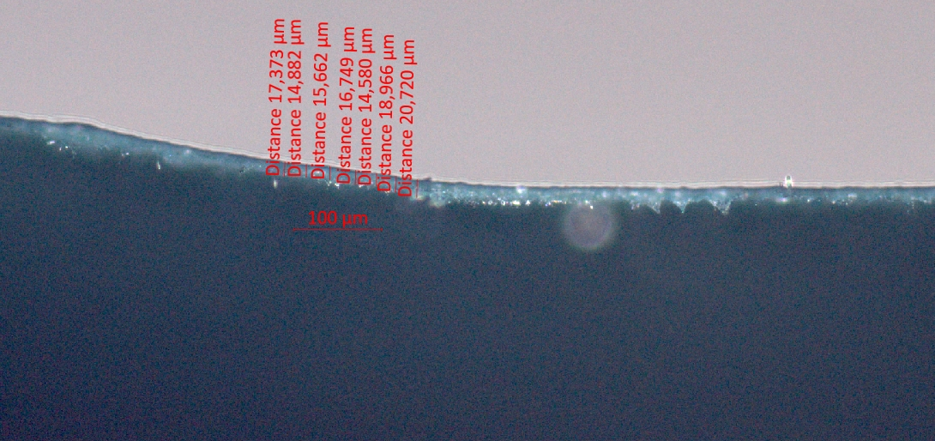
25-27 | Waste Bag (3) | 14.0 ± 1.27 | 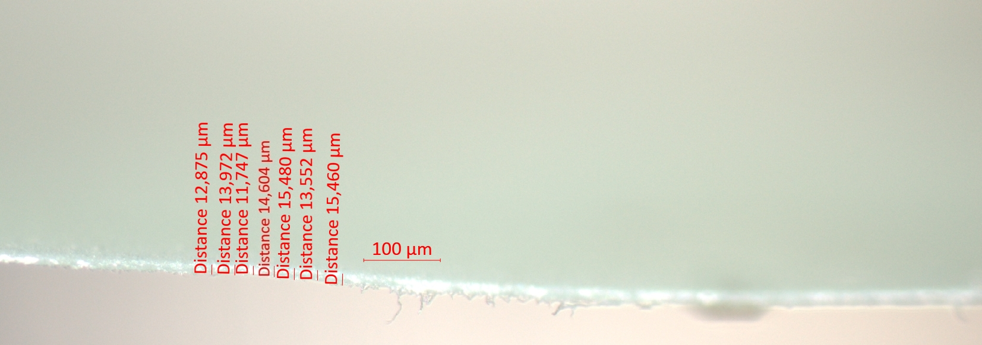
28-30 | Food Container | 170 ± 1.44 | 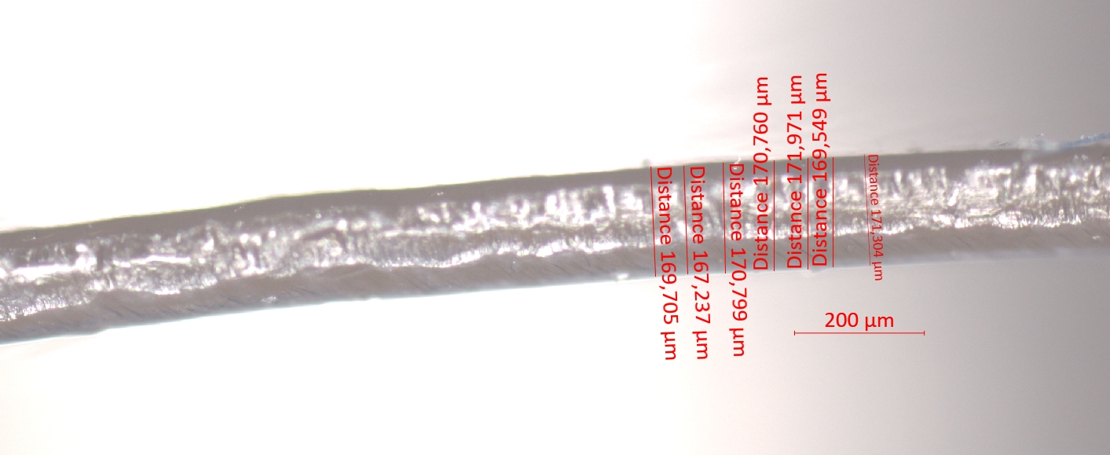
31-33 | Plate | 255 ± 5.17 | 
34-36 | Lid | 272 ± 5.91 | 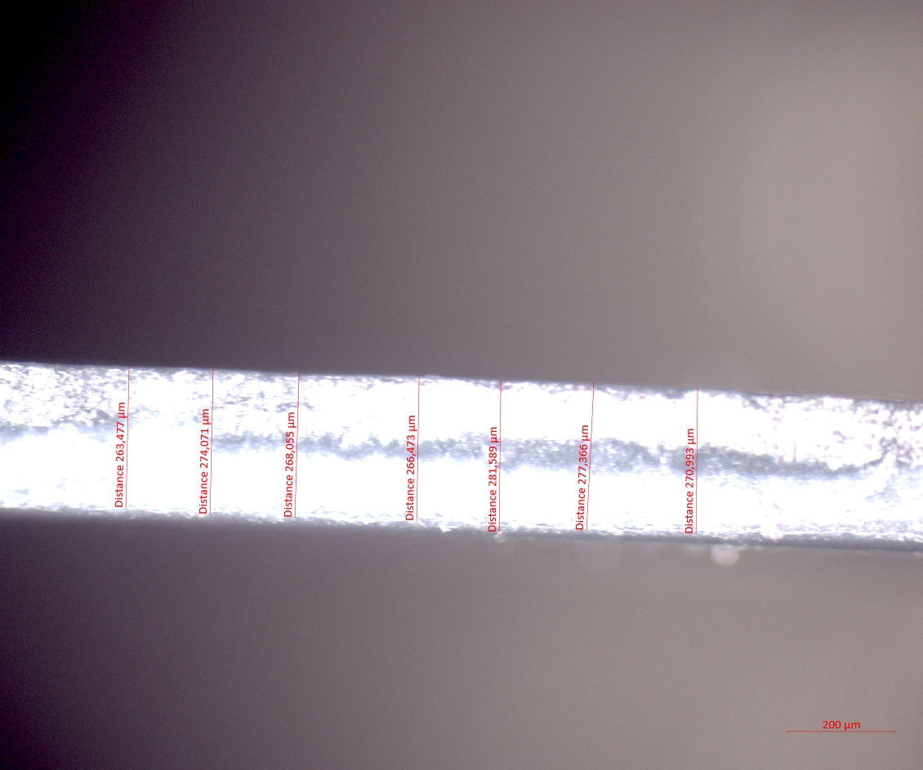
37-39 | Flower Pot (1) | 131 ± 1.98 | 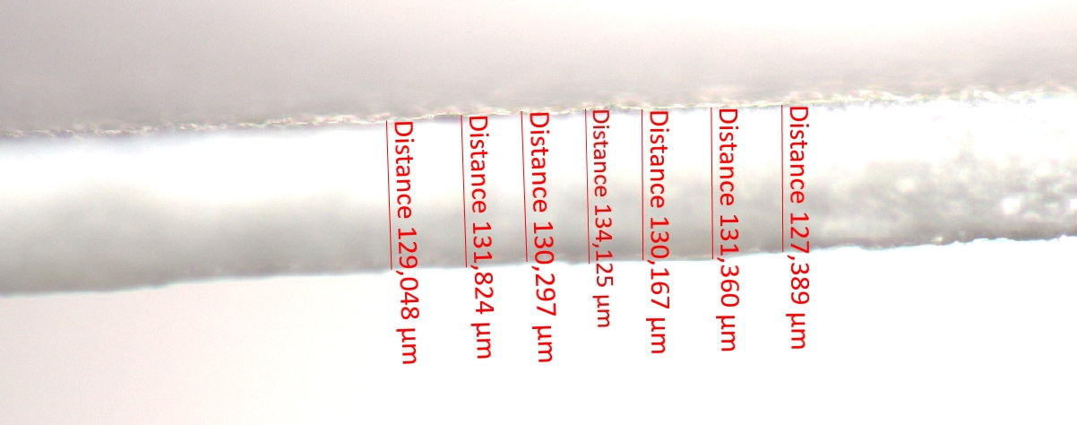
40-42 | Flower Pot (2) | 111 ± 2.24 | 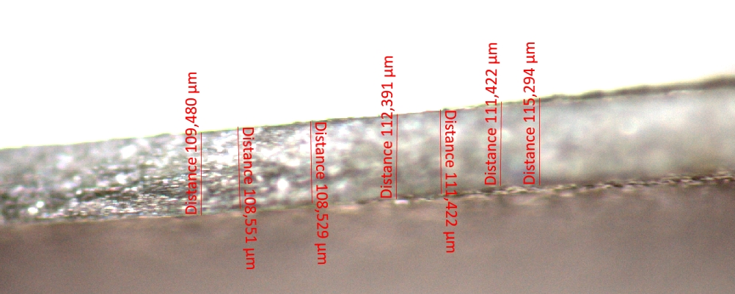

1.2. Synthetic waste
The composition of the synthetic waste used for the disintegration test is available in Table S3.
Table S3: The composition of the synthetic waste.
Material | Weight (g ww) | Weight (% dw)
Sawdust | 195 | 38
Rabbit feed | 143 | 29
Ripe compost | 52.4 | 9.6
Corn starch | 49.3 | 9.6
Saccharose | 21.6 | 4.8
Corn seed oil | 17.2 | 3.8
Urea | 30.0 | 5.3
Water | 491
Total | 1000 | 100

1.3. Experimental set-up
The experimental set-up of the disintegration test is provided in Table S4.
Table S4: Experimental overview showing the amount of test material and synthetic waste of each sample.
Sample No. | Test material | Mass of synthetic waste (g) | Mass of test material (g) | Mixture mass (synthetic waste plus test material) (g) | Initial mass of the reactor (g)
1 | - | 1000 | - | 1000 | 1273
2 | - | 1000 | - | 1000 | 1268
3 | - | 1000 | - | 1000 | 1268
4 | Cellulose Filter Paper (positive control) | 1000 | 5.01 | 1005 | 1271
5 | Cellulose Filter Paper (positive control) | 1000 | 5.02 | 1005 | 1272
6 | Cellulose Filter Paper (positive control) | 1000 | 5.04 | 1005 | 1274
7 | Freezer Bag (negative control) | 1000 | 5.01 | 1005 | 1274
8 | Freezer Bag (negative control) | 1000 | 5.02 | 1005 | 1276
9 | Freezer Bag (negative control) | 1000 | 5.04 | 1005 | 1277
10 | Weighing Boat (negative control) | 1000 | 5.01 | 1005 | 1277
11 | Weighing Boat (negative control) | 1000 | 5.01 | 1005 | 1276
12 | Weighing Boat (negative control) | 1000 | 5.00 | 1005 | 1275
13 | Food Bag | 1000 | 5.02 | 1005 | 1275
14 | Food Bag | 1000 | 5.08 | 1005 | 1271
15 | Food Bag | 1001 | 5.06 | 1006 | 1275
16 | Waste Bag (1) | 1000 | 5.04 | 1005 | 1274
17 | Waste Bag (1) | 1000 | 5.04 | 1005 | 1274
18 | Waste Bag (1) | 1000 | 5.06 | 1005 | 1276
19 | Drawstring | 1000 | 5.06 | 1005 | 1276
20 | Drawstring | 1000 | 5.08 | 1005 | 1276
21 | Drawstring | 1000 | 5.09 | 1005 | 1277
22 | Waste Bag (2) | 1000 | 5.07 | 1005 | 1276
23 | Waste Bag (2) | 1001 | 5.07 | 1006 | 1277
24 | Waste Bag (2) | 1000 | 5.08 | 1005 | 1276
25 | Waste Bag (3) | 1000 | 5.03 | 1005 | 1276
26 | Waste Bag (3) | 1000 | 5.02 | 1005 | 1272
27 | Waste Bag (3) | 1000 | 5.05 | 1005 | 1275
28 | Food Container | 1000 | 5.02 | 1005 | 1277
29 | Food Container | 1000 | 5.12 | 1005 | 1277
30 | Food Container | 1000 | 5.10 | 1005 | 1274
31 | Plate | 1000 | 5.26 | 1005 | 1274
32 | Plate | 1000 | 5.08 | 1005 | 1273
33 | Plate | 1000 | 5.13 | 1005 | 1273
34 | Lid | 1000 | 5.04 | 1005 | 1273
35 | Lid | 1003 | 5.19 | 1008 | 1276
36 | Lid | 1001 | 5.10 | 1006 | 1277
37 | Flower Pot (1) | 1000 | 5.03 | 1005 | 1272
38 | Flower Pot (1) | 1000 | 5.07 | 1005 | 1274
39 | Flower Pot (1) | 1000 | 5.03 | 1005 | 1272
40 | Flower Pot (2) | 1000 | 5.11 | 1005 | 1273
41 | Flower Pot (2) | 1000 | 5.08 | 1005 | 1276
42 | Flower Pot (2) | 1000 | 5.10 | 1005 | 1275

2. Results

2.1. Fourier-transform infrared (FTIR) spectra
The FTIR analysis of pristine and aged plastics was performed using an Agilent 4300 Handheld FTIR spectrometer with a diamond-ATR. The FTIR collected 32 scans, and each spectrum was attained within the range of 4000-650 cm⁻¹ with a wavelength resolution of 4 cm⁻¹. The collected spectra were processed in Spectragryph Version 1.2.16.1 using advanced baseline correction and advanced smoothing. The spectra of the pristine plastics obtained with Agilent 4300 Handheld FTIR spectrometer were compared with Nicolet iN10 μ-FTIR using dedicated reference libraries purchased from Thermo Fisher Scientific. A complete list of the reference libraries for comparing the spectra analyzed in this study is as follows:
- Biopolymers (20 reference spectra)
- Polymer and additives (500 reference spectra)
- HR Comprehensive Forensic FTIR collection (~ 4300 spectra)
- HR Hummel polymer and additives (2000 spectra)
- HR Paper material library (300 spectra)
- HR Aldrich FTIR Collection II (18000 spectra)
- HR Aldrich Polymers (~ 500 spectra)
Table S5: FTIR spectra of test materials before and after 90 days of composting.
Sample No. | Test material | FTIR spectrum
4-6 | Cellulose Filter Paper (positive control) | 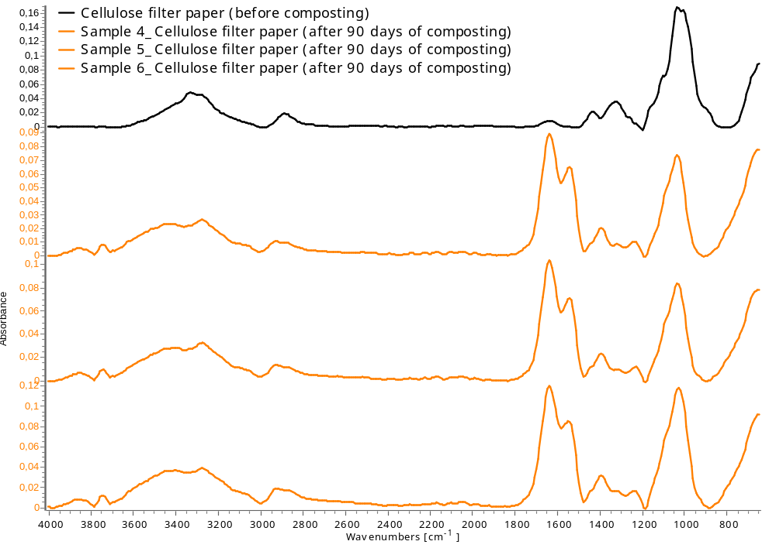
7-9 | Freezer Bag (negative control) | 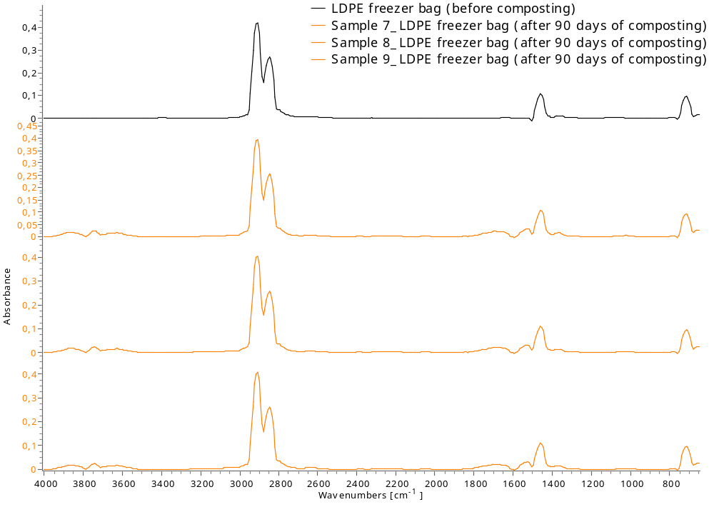
10-12 | Weighing Boat (negative control) | 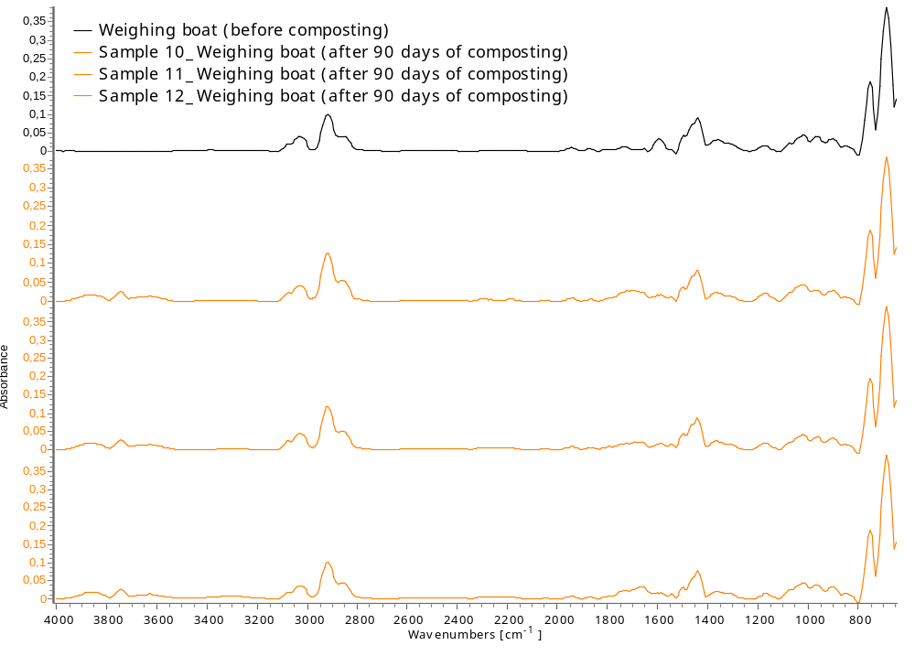
13-15 | Food Bag | 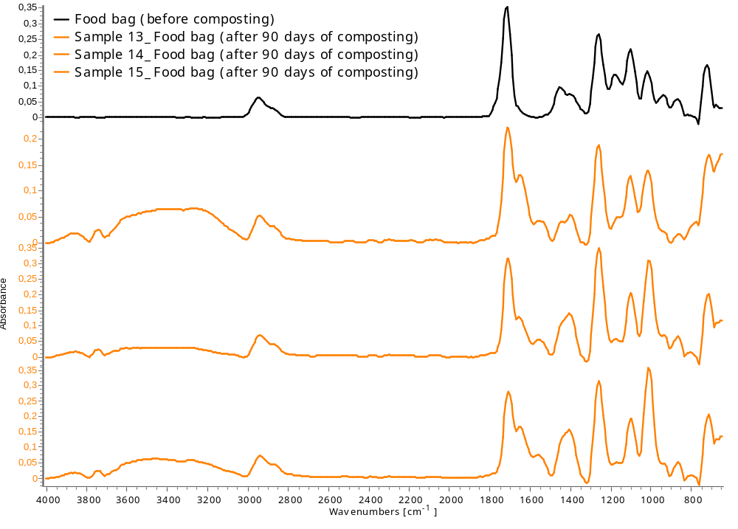
16-18 | Waste Bag (1) | 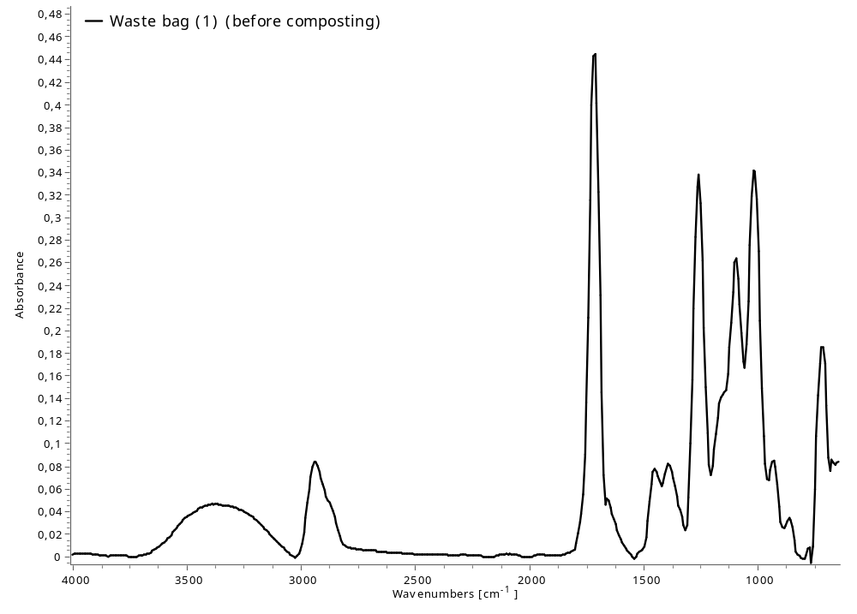
19-21 | Drawstring | 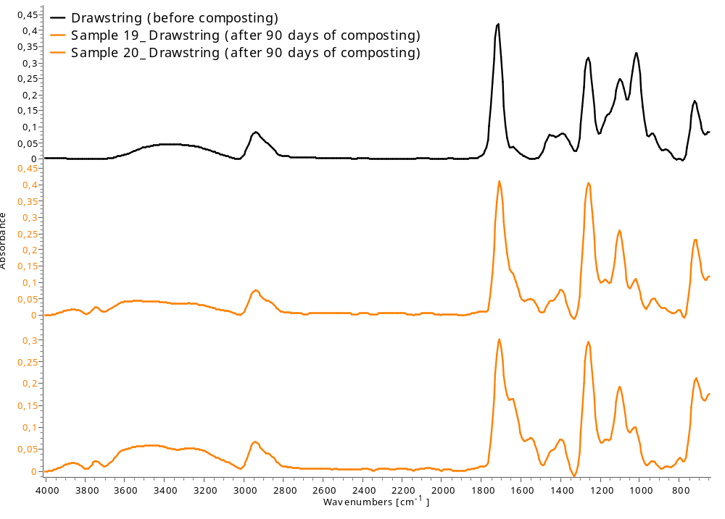
22-24 | Waste Bag (2) | 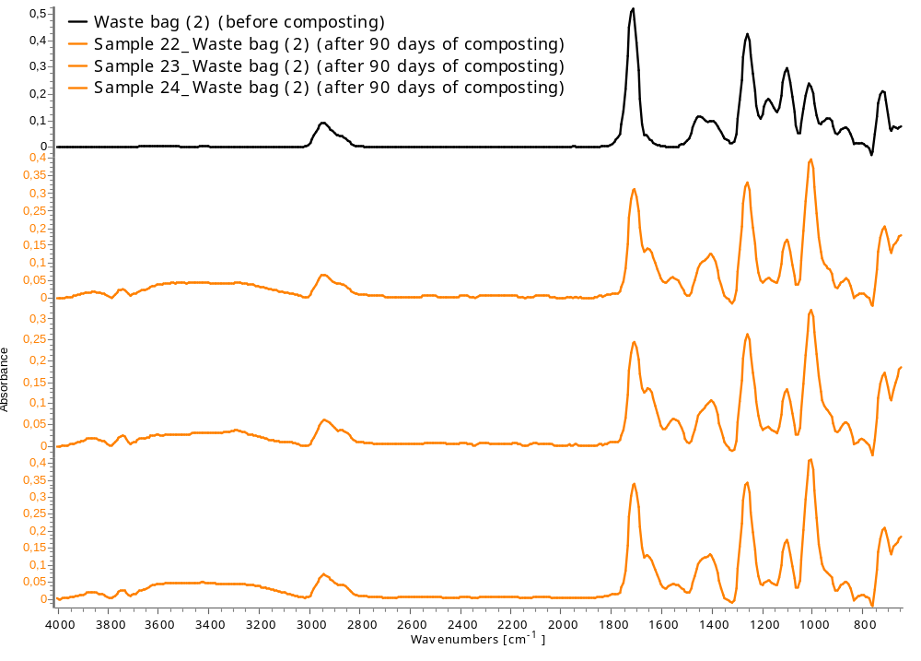
25-27 | Waste Bag (3) | 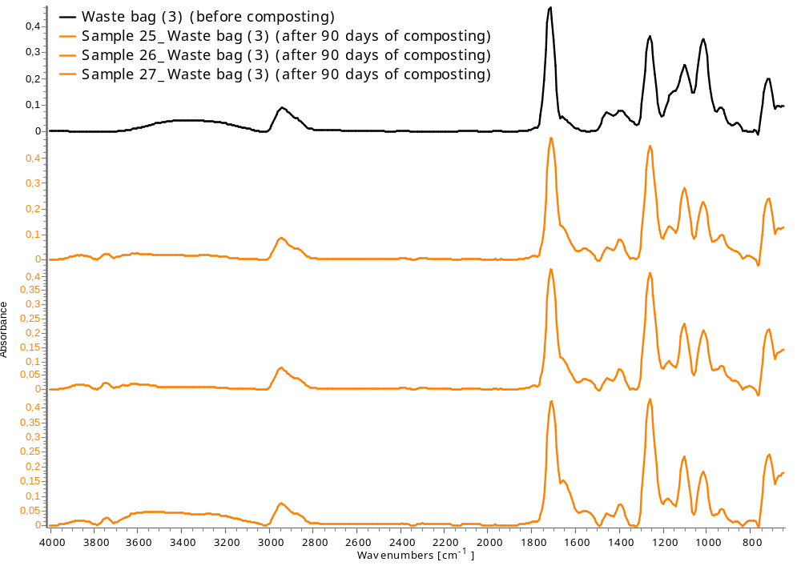
28-30 | Food Container | 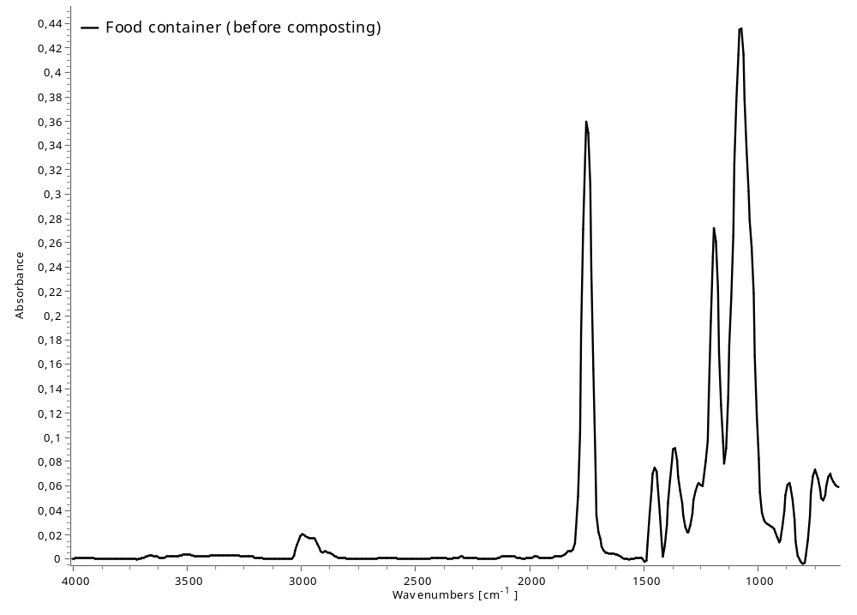
31-33 | Plate | 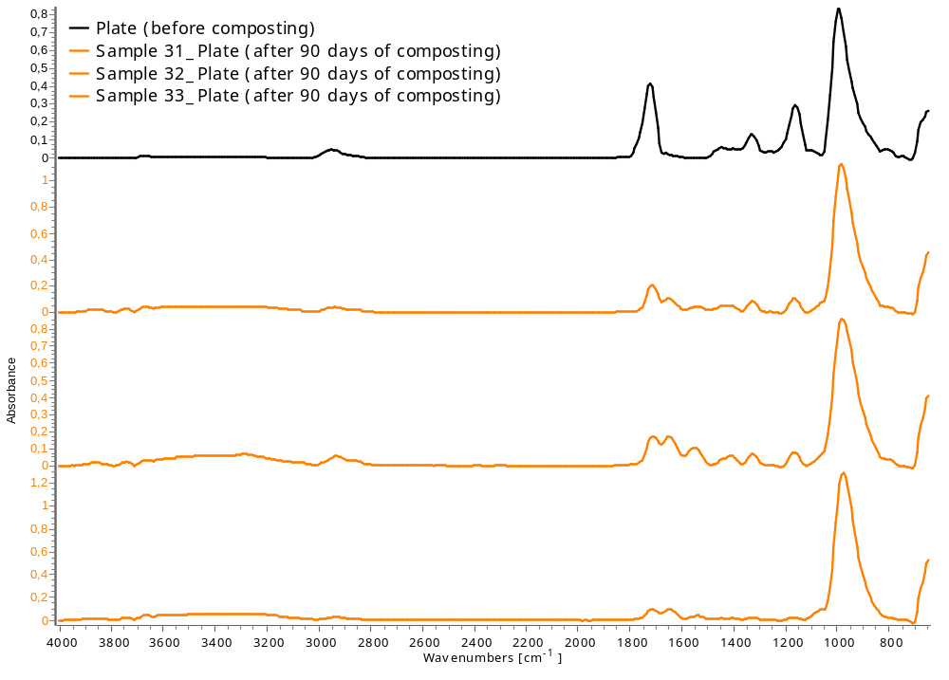
34-36 | Lid | 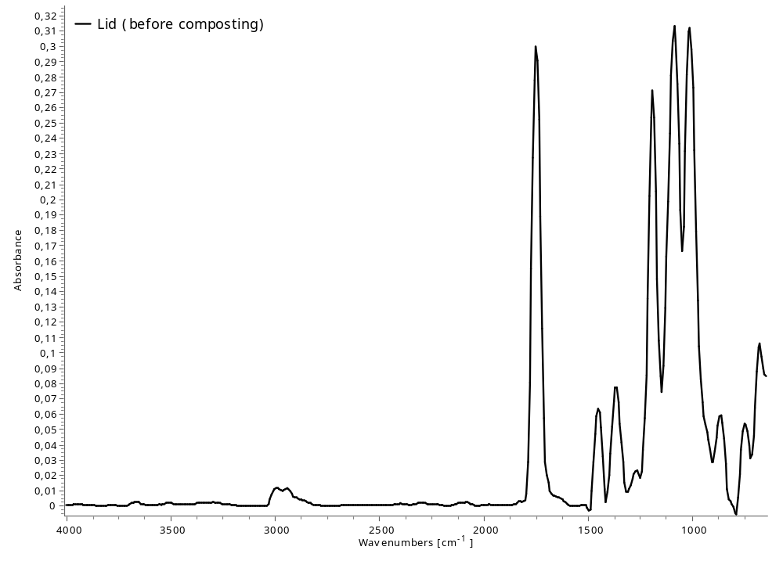
37-39 | Flower Pot (1) | 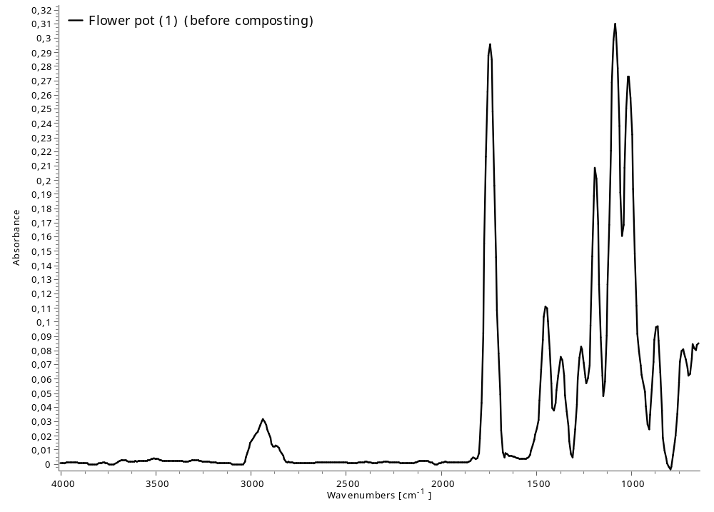
40-42 | Flower Pot (2) | 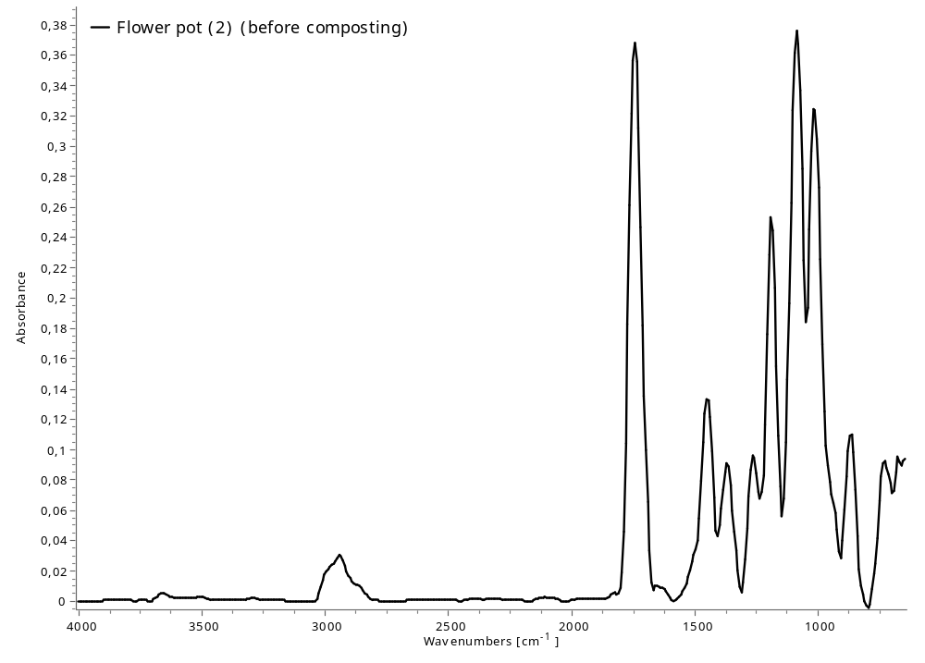

2.2. Differential Scanning Calorimetry (DSC)
Table S6: DSC analysis of the test materials before composting.
Sample No. | Test material | DSC analysis
4-6 | Cellulose Filter Paper (positive control)
7-9 | Freezer Bag (negative control)
10-12 | Weighing Boat (negative control)
13-15 | Food Bag
16-18 | Waste Bag (1)
19-21 | Drawstring
22-24 | Waste Bag (2)
25-27 | Waste Bag (3)
28-30 | Food Container
31-33 | Plate
34-36 | Lid
37-39 | Flower Pot (1)
40-42 | Flower Pot (2)

2.3. Non-disintegrated test material
Table S7: Non-disintegrated plastic after 90 days of composting.
Sample name | Sample (> 2 mm) after 90 days of composting
Cellulose Filter Paper (positive control) | Sample 4 | Sample 5 | Sample 6
Cellulose Filter Paper (positive control) | 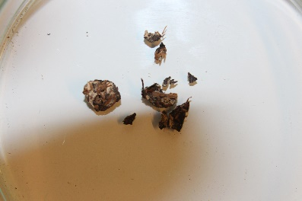 | 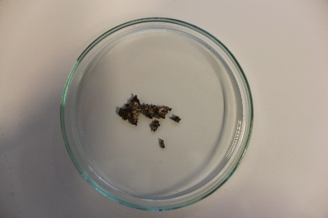 | 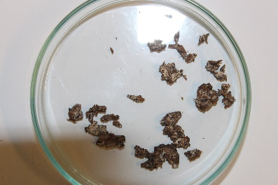
Freezer Bag (negative control) | Sample 7 | Sample 8 | Sample 9
Freezer Bag (negative control) | 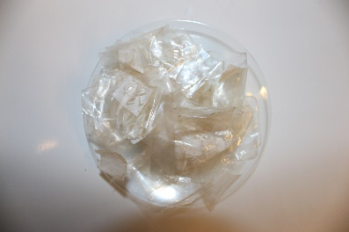 | 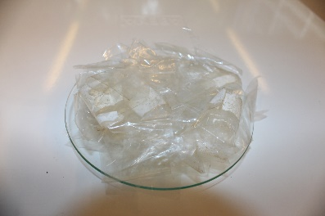 | 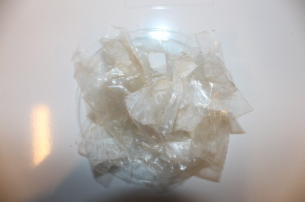
Weighing Boat (negative control) | Sample 10 | Sample 11 | Sample 12
Weighing Boat (negative control) | 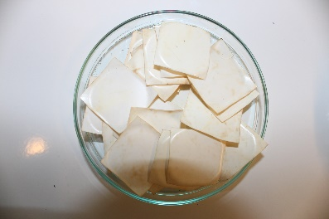 | 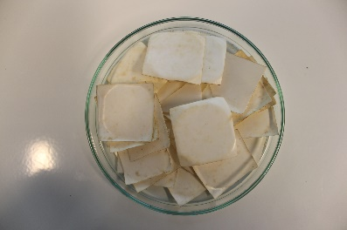 | 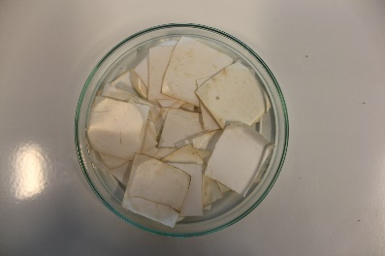
Food Bag | Sample 13 | Sample 14 | Sample 15
Food Bag | 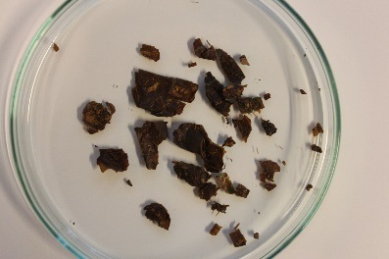 | 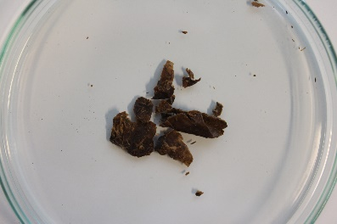 | 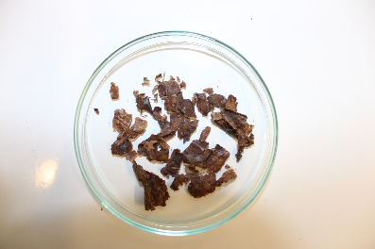
Waste Bag (1) | Sample 16 | Sample 17 | Sample 18
Waste Bag (1) | Fully disintegraded | Fully disintegraded | Fully disintegraded
Drawstring | Sample 19 | Sample 20 | Sample 21
Drawstring | 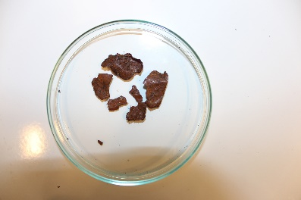 | 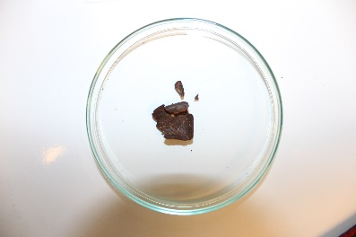 | Fully disintegraded
Waste Bag (2) | Sample 22 | Sample 23 | Sample 24
Waste Bag (2) | 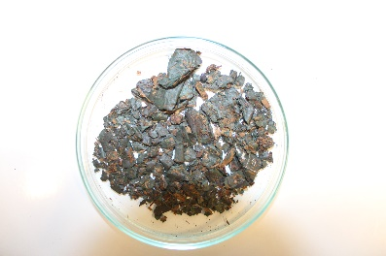 | 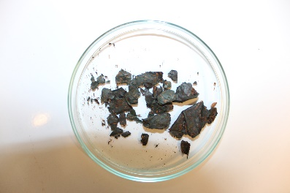 | 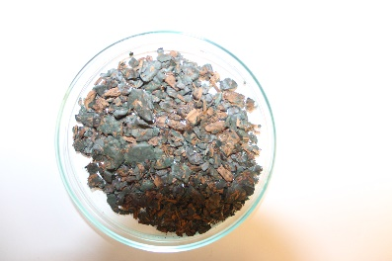
Waste Bag (3) | Sample 25 | Sample 26 | Sample 27
Waste Bag (3) | 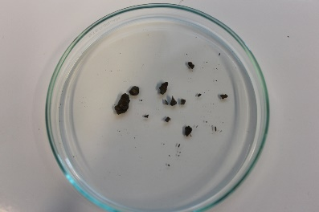 | 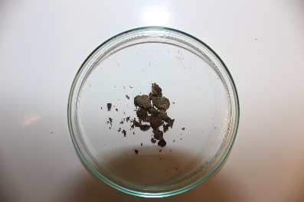 | 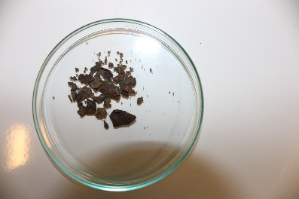
Food Container | Sample 28 | Sample 29 | Sample 30
Food Container | Fully disintegraded | Fully disintegraded | Fully disintegraded
Plate | Sample 31 | Sample 32 | Sample 33
Plate | 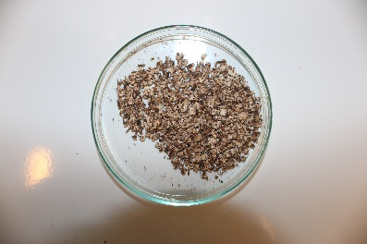 | 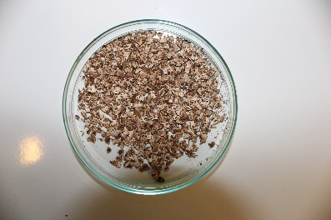 | 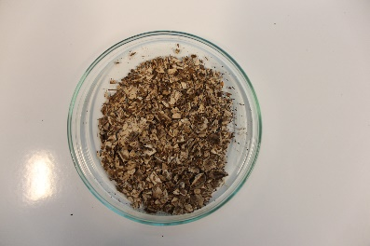
Lid | Sample 34 | Sample 35 | Sample 36
Lid | Fully disintegraded | Fully disintegraded | Fully disintegraded
Flower Pot (1) | Sample 37 | Sample 38 | Sample 39
Flower Pot (1) | Fully disintegraded | Fully disintegraded | Fully disintegraded
Flower Pot (2) | Sample 40 | Sample 41 | Sample 42
Flower Pot (2) | Fully disintegraded | Fully disintegraded | Fully disintegraded

2.3. Disintegration degrees
Table S8: Disintegration degrees for each sample after 90 days of composting and measured pH and C/N ratio in the final compost. The average disintegration degrees are based on the triplicate samples and include the standard deviation.
Sample No. | Test material | pH (in H₂O) after composting | C/N ratio after composting | Initial mass of test material (g) | Mass of test material after composting (g) | Disintegration degree (%) | Avg. disintegration degree (%)
1 | Blank | 7.39 | 27.0 | - | - | - | -
2 | Blank | 7.32 | 25.9 | - | - | - | -
3 | Blank | 7.45 | 27.7 | - | - | - | -
4 | Cellulose Filter Paper (positive control) | 7.17 | 29.5 | 5.01 | 0.03 | 99.5 | 99 ± 1.2
5 | Cellulose Filter Paper (positive control) | 7.38 | 25.6 | 5.02 | 0.05 | 99.2 | 99 ± 1.2
6 | Cellulose Filter Paper (positive control) | 7.15 | 29.2 | 5.04 | 0.26 | 96.9 | 99 ± 1.2
7 | Freezer Bag (negative control) | 7.42 | 27.7 | 5.01 | 5.01 | 0.09 | 0.37 ± 0.25
8 | Freezer Bag (negative control) | 7.17 | 27.6 | 5.02 | 5.00 | 0.69 | 0.37 ± 0.25
9 | Freezer Bag (negative control) | 7.21 | 26.2 | 5.04 | 4.99 | 0.33 | 0.37 ± 0.25
10 | Weighing Boat (negative control) | 7.35 | 26.7 | 5.01 | 5.08 | 1.04 | 0.72 ± 0.40
11 | Weighing Boat (negative control) | 7.30 | 24.0 | 5.01 | 5.02 | 0.96 | 0.72 ± 0.40
12 | Weighing Boat (negative control) | 7.40 | 19.1 | 5.00 | 5.02 | 0.16 | 0.72 ± 0.40
13 | Food Bag | 7.19 | 18.3 | 5.02 | 0.278 | 95.2 | 93 ± 5.0
14 | Food Bag | 7.18 | 16.8 | 5.08 | 0.123 | 98.0 | 93 ± 5.0
15 | Food Bag | 7.15 | 18.3 | 5.06 | 0.782 | 86.3 | 93 ± 5.0
16 | Waste Bag (1) | 7.15 | - | 5.04 | 0.00 | 100 | 100 ± 0.0
17 | Waste Bag (1) | 7.29 | 15.9 | 5.04 | 0.00 | 100 | 100 ± 0.0
18 | Waste Bag (1) | 7.27 | 17.2 | 5.06 | 0.00 | 100 | 100 ± 0.0
19 | Drawstring | 7.43 | 17.1 | 5.06 | 0.453 | 91.9 | 95 ± 3.4
20 | Drawstring | 7.19 | 13.6 | 5.08 | 0.318 | 94.3 | 95 ± 3.4
21 | Drawstring | 7.24 | 11.3 | 5.09 | 0.00 | 100 | 95 ± 3.4
22 | Waste Bag (2) | 7.41 | 11.5 | 5.07 | 1.337 | 74.1 | 75 ± 8.2
23 | Waste Bag (2) | 7.35 | 13.3 | 5.07 | 0.834 | 85.3 | 75 ± 8.2
24 | Waste Bag (2) | 7.32 | 11.4 | 5.08 | 1.950 | 65.4 | 75 ± 8.2
25 | Waste Bag (3) | 7.18 | 10.8 | 5.03 | 0.030 | 99.0 | 97 ± 2.2
26 | Waste Bag (3) | 7.18 | 13.0 | 5.02 | 0.174 | 97.0 | 97 ± 2.2
27 | Waste Bag (3) | 7.23 | 10.6 | 5.05 | 0.362 | 94.0 | 97 ± 2.2
28 | Food Container | 7.41 | 8.66 | 5.02 | 0.00 | 100 | 100 ± 0.0
29 | Food Container | 7.08 | 17.9 | 5.12 | 0.00 | 100 | 100 ± 0.0
30 | Food Container | 7.16 | 18.3 | 5.10 | 0.00 | 100 | 100 ± 0.0
31 | Plate | 7.29 | 16.7 | 5.26 | 0.916 | 82.9 | 75 ± 7.7
32 | Plate | 7.26 | 19.8 | 5.08 | 1.136 | 78.0 | 75 ± 7.7
33 | Plate | 7.36 | 15.2 | 5.13 | 1.807 | 64.8 | 75 ± 7.7
34 | Lid | 7.30 | 15.3 | 5.04 | 0.00 | 100 | 100 ± 0.0
35 | Lid | 7.23 | 18.7 | 5.19 | 0.00 | 100 | 100 ± 0.0
36 | Lid | 7.24 | 16.0 | 5.10 | 0.00 | 100 | 100 ± 0.0
37 | Flower Pot (1) | 7.21 | 15.5 | 5.03 | 0.00 | 100 | 100 ± 0.0
38 | Flower Pot (1) | 7.35 | 23.1 | 5.07 | 0.00 | 100 | 100 ± 0.0
39 | Flower Pot (1) | 7.29 | 19.4 | 5.03 | 0.00 | 100 | 100 ± 0.0
40 | Flower Pot (2) | 7.39 | 17.7 | 5.11 | 0.00 | 100 | 100 ± 0.0
41 | Flower Pot (2) | 7.30 | - | 5.08 | 0.00 | 100 | 100 ± 0.0
42 | Flower Pot (2) | 7.26 | - | 5.10 | 0.00 | 100 | 100 ± 0.0

2.4. Test validation
To validate the test, two criteria should be met: 1) the VS content of the compost should decrease by at least 30 %, and 2) for each sample, the difference between the sample and the average of the three samples should not be more than 20 % (ISO, 2015). The decrease of VS (R) was calculated based on Equation S1 (Table S9):
$R=\frac{\left[m_{i }{x \left(DM\right)}_{i }x {\left(VS\right)}_{i}\right]-[m_{f }{x \left(DM\right)}_{f }x {\left(VS\right)}_{f}]}{[m_{i }{x \left(DM\right)}_{i }x {\left(VS\right)}_{i}]} x 100$ (Equation S1)
where m_{i} is the initial mass of the wet synthetic material before composting, (DM)_{i} is the initial dry mass of synthetic waste (expressed as % divided by 100), (VS)_{i} is the VS content of the synthetic waste (expressed as % divided by 100), m_{f} is the final mass of the compost, (DM)_{f} is the final dry mass of compost (expressed as % divided by 100), and (VS)_{f} is the final VS of the compost (expressed as % divided by 100).
The difference in the disintegration degree of the triplicate samples from the average disintegration degree is calculated for each sample (Table S10). While negative control samples 8, 9, and 10-12 exceed the 20 % threshold, this is attributed to their very low degradation degrees (Table S10). Conversely, all other samples adhere to the maximum of 20 % difference from the average (Table S10).

Table S9: Decrease in total VS.
Sample No. | Test material | Initial mass of wet synthetic waste (g) | Initial dry mass of synthetic waste (%/100) | Initial VS of synthetic waste (%/100) | Final mass of wet compost (g) | Final dry mass of compost (%/100) | Final VS of compost (%/100) | Decrease in total VS (%)
1 | Blank | 1000 | 4.50 | 0.889 | 746 | 3.36 | 0.889 | 44.4
2 | Blank | 1000 | 4.50 | 0.889 | 758 | 3.41 | 0.888 | 42.6
3 | Blank | 1000 | 4.50 | 0.889 | 622 | 2.80 | 0.869 | 62.2
4 | Cellulose Filter Paper (positive control) | 1000 | 4.50 | 0.889 | 757 | 3.41 | 0.893 | 42.4
5 | Cellulose Filter Paper (positive control) | 1000 | 4.50 | 0.889 | 667 | 3.00 | 0.875 | 56.2
6 | Cellulose Filter Paper (positive control) | 1000 | 4.50 | 0.889 | 752 | 3.38 | 0.869 | 44.7
7 | Freezer Bag (negative control) | 1000 | 4.50 | 0.889 | 741 | 3.33 | 0.907 | 44.0
8 | Freezer Bag (negative control) | 1000 | 4.50 | 0.889 | 765 | 3.44 | 0.900 | 40.7
9 | Freezer Bag (negative control) | 1000 | 4.50 | 0.889 | 617 | 2.78 | 0.898 | 61.5
10 | Weighing Boat (negative control) | 1000 | 4.50 | 0.889 | 690 | 3.10 | 0.866 | 53.7
11 | Weighing Boat (negative control) | 1000 | 4.50 | 0.889 | 762 | 3.43 | 0.859 | 43.9
12 | Weighing Boat (negative control) | 1000 | 4.50 | 0.889 | 680 | 3.06 | 0.846 | 56.0
13 | Food Bag | 1000 | 4.50 | 0.889 | 690 | 3.10 | 0.877 | 53.1
14 | Food Bag | 1000 | 4.50 | 0.889 | 721 | 3.24 | 0.886 | 48.2
15 | Food Bag | 1001 | 4.50 | 0.889 | 773 | 3.48 | 0.887 | 40.4
16 | Waste Bag (1) | 1000 | 4.50 | 0.889 | 675 | 3.04 | 0.881 | 54.8
17 | Waste Bag (1) | 1000 | 4.50 | 0.889 | 709 | 3.19 | 0.837 | 52.7
18 | Waste Bag (1) | 1000 | 4.50 | 0.889 | 769 | 3.46 | 0.899 | 40.3
19 | Drawstring | 1000 | 4.50 | 0.889 | 629 | 2.83 | 0.907 | 59.6
20 | Drawstring | 1000 | 4.50 | 0.889 | 706 | 3.17 | 0.884 | 50.5
21 | Drawstring | 1000 | 4.50 | 0.889 | 757 | 3.41 | 0.876 | 43.6
22 | Waste Bag (2) | 1000 | 4.50 | 0.889 | 778 | 3.50 | 0.840 | 42.7
23 | Waste Bag (2) | 1001 | 4.51 | 0.889 | 682 | 3.07 | 0.799 | 58.3
24 | Waste Bag (2) | 1000 | 4.50 | 0.889 | 694 | 3.12 | 0.837 | 54.7
25 | Waste Bag (3) | 1000 | 4.50 | 0.889 | 629 | 2.83 | 0.869 | 61.3
26 | Waste Bag (3) | 1000 | 4.50 | 0.889 | 749 | 3.37 | 0.859 | 45.7
27 | Waste Bag (3) | 1000 | 4.50 | 0.889 | 717 | 3.23 | 0.865 | 49.9
28 | Food Container | 1000 | 4.50 | 0.889 | 689 | 3.10 | 0.902 | 51.9
29 | Food Container | 1000 | 4.50 | 0.889 | 534 | 2.40 | 0.874 | 71.9
30 | Food Container | 1000 | 4.50 | 0.889 | 665 | 2.99 | 0.893 | 55.6
31 | Plate | 1000 | 4.50 | 0.889 | 773 | 3.48 | 0.784 | 47.3
32 | Plate | 1000 | 4.50 | 0.889 | 686 | 3.09 | 0.671 | 64.4
33 | Plate | 1000 | 4.50 | 0.889 | 683 | 3.07 | 0.750 | 60.6
34 | Lid | 1000 | 4.50 | 0.889 | 710 | 3.19 | 0.845 | 52.1
35 | Lid | 1003 | 4.51 | 0.889 | 778 | 3.50 | 0.658 | 55.4
36 | Lid | 1001 | 4.50 | 0.889 | 727 | 3.27 | 0.701 | 58.4
37 | Flower Pot (1) | 1000 | 4.50 | 0.889 | 778 | 3.50 | 0.864 | 41.2
38 | Flower Pot (1) | 1000 | 4.50 | 0.889 | 779 | 3.51 | 0.861 | 41.2
39 | Flower Pot (1) | 1000 | 4.50 | 0.889 | 727 | 3.27 | 0.870 | 48.2
40 | Flower Pot (2) | 1000 | 4.50 | 0.889 | 709 | 3.19 | 0.911 | 48.5
41 | Flower Pot (2) | 1000 | 4.50 | 0.889 | 760 | 3.42 | 0.901 | 41.5
42 | Flower Pot (2) | 1000 | 4.50 | 0.889 | 747 | 3.36 | 0.894 | 43.8

Table S10: Calculated difference in disintegration degrees in the triplicate samples and the average disintegration degree.
Sample No. | Test material | Disintegration degree (%) | Avg. Disintegration degree (%) | Difference in disintegration degree from triplicate sample and avg. (%)
1 | Blank | - | - | -
2 | Blank | - | - | -
3 | Blank | - | - | -
4 | Cellulose Filter Paper (positive control) | 99.5 | 98.5 ± 1.15 | 0.994
5 | Cellulose Filter Paper (positive control) | 99.2 | 98.5 ± 1.15 | 0.638
6 | Cellulose Filter Paper (positive control) | 96.9 | 98.5 ± 1.15 | 1.65
7 | Freezer Bag (negative control) | 0.09 | 0.37 ± 0.246 | 123
8 | Freezer Bag (negative control) | 0.69 | 0.37 ± 0.246 | 60.4
9 | Freezer Bag (negative control) | 0.33 | 0.37 ± 0.246 | 10.9
10 | Weighing Boat (negative control) | 1.04 | 0.72 ± 0.396 | 36.4
11 | Weighing Boat (negative control) | 0.96 | 0.72 ± 0.396 | 28.1
12 | Weighing Boat (negative control) | 0.16 | 0.72 ± 0.396 | 126
13 | Food Bag | 95.2 | 93.2 ± 4.99 | 2.18
14 | Food Bag | 98.0 | 93.2 ± 4.99 | 5.04
15 | Food Bag | 86.3 | 93.2 ± 4.99 | 7.65
16 | Waste Bag (1) | 100 | 100 ± 0.00 | 0.00
17 | Waste Bag (1) | 100 | 100 ± 0.00 | 0.00
18 | Waste Bag (1) | 100 | 100 ± 0.00 | 0.00
19 | Drawstring | 91.9 | 95.4 ± 3.39 | 3.73
20 | Drawstring | 94.3 | 95.4 ± 3.39 | 1.16
21 | Drawstring | 100 | 95.4 ± 3.39 | 4.70
22 | Waste Bag (2) | 74.1 | 74.9 ± 8.16 | 1.14
23 | Waste Bag (2) | 85.3 | 74.9 ± 8.16 | 13.0
24 | Waste Bag (2) | 65.4 | 74.9 ± 8.16 | 13.6
25 | Waste Bag (3) | 99.0 | 96.8 ± 2.24 | 2.61
26 | Waste Bag (3) | 97.0 | 96.8 ± 2.24 | 0.333
27 | Waste Bag (3) | 94.0 | 96.8 ± 2.24 | 3.03
28 | Food Container | 100 | 100 ± 0.00 | 0.00
29 | Food Container | 100 | 100 ± 0.00 | 0.00
30 | Food Container | 100 | 100 ± 0.00 | 0.00
31 | Plate | 82.9 | 75.2 ± 7.66 | 9.76
32 | Plate | 78.0 | 75.2 ± 7.66 | 3.57
33 | Plate | 64.8 | 75.2 ± 7.66 | 14.9
34 | Lid | 100 | 100 ± 0.00 | 0.0244
35 | Lid | 100 | 100 ± 0.00 | 0.0488
36 | Lid | 100 | 100 ± 0.00 | 0.0244
37 | Flower Pot (1) | 100 | 100 ± 0.00 | 0.00
38 | Flower Pot (1) | 100 | 100 ± 0.00 | 0.00
39 | Flower Pot (1) | 100 | 100 ± 0.00 | 0.00
40 | Flower Pot (2) | 100 | 100 ± 0.00 | 0.00
41 | Flower Pot (2) | 100 | 100 ± 0.00 | 0.00
42 | Flower Pot (2) | 100 | 100 ± 0.00 | 0.00

2.5. Microplastic analysis
After 90 days of composting, compost matrices smaller than 2 mm were collected to evaluate microplastic (MP) production due to plastic degradation from the tested plastic products. The compost matrices were collected into size fractions: 1) 2 mm > compost matrix 0.85 mm and 2) compost matrix < 0.85 mm (Table S11 and Table S12). The presence of MPs in the two different size fractions was investigated using a Leica MZ5 microscope.
Table S11: Compost matrix < 2 mm and > 0.85 mm after 90 days of composting.
Sample name | 2 mm > compost matrix > 0.85 mm after 90 days of composting
Blank | Sample 1 | Sample 2 | Sample 3
Blank | 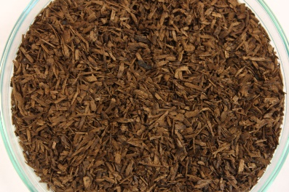 | 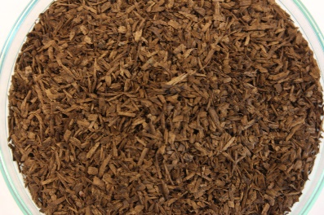 | 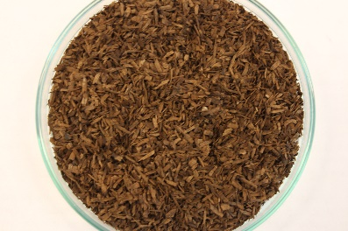
Cellulose Filter Paper (positive control) | Sample 4 | Sample 5 | Sample 6
Cellulose Filter Paper (positive control) | 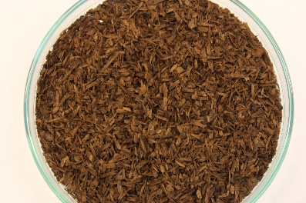 | 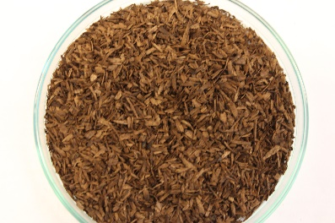 | 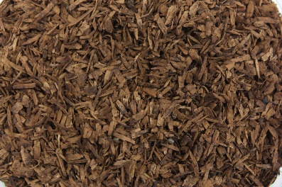
Freezer Bag (negative control) | Sample 7 | Sample 8 | Sample 9
Freezer Bag (negative control) | 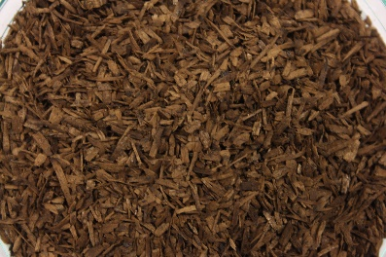 | 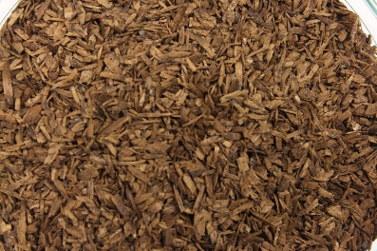 | 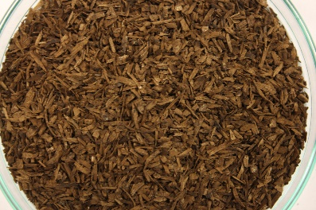
Weighing Boat (negative control) | Sample 10 | Sample 11 | Sample 12
Weighing Boat (negative control) | 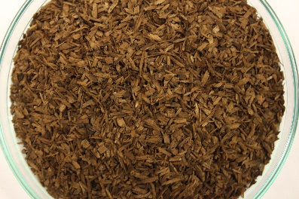 | 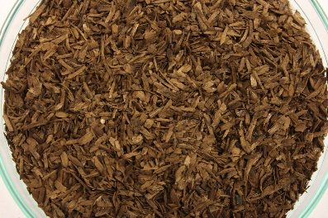 | 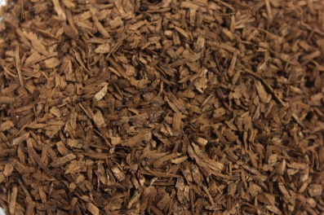
Food Bag | Sample 13 | Sample 14 | Sample 15
Food Bag | 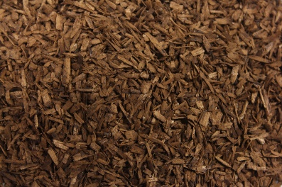 | 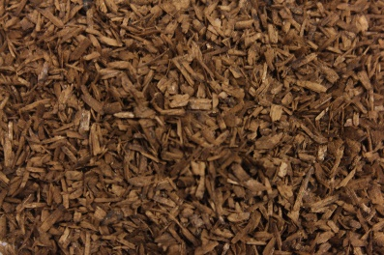 | 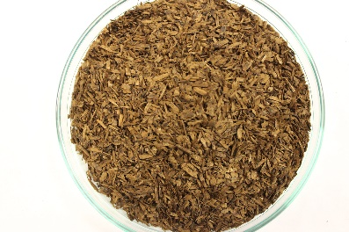
Waste Bag (1) | Sample 16 | Sample 17 | Sample 18
Waste Bag (1) | 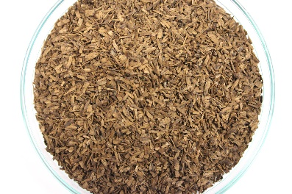 | 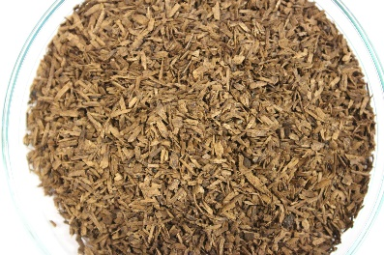 | 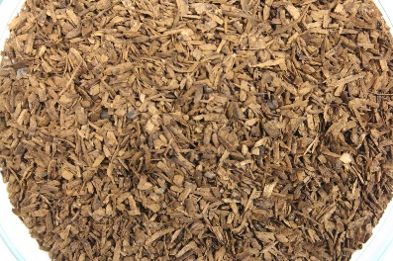
Drawstring | Sample 19 | Sample 20 | Sample 21
Drawstring | 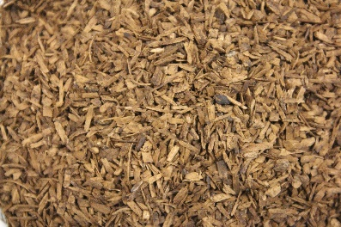 | 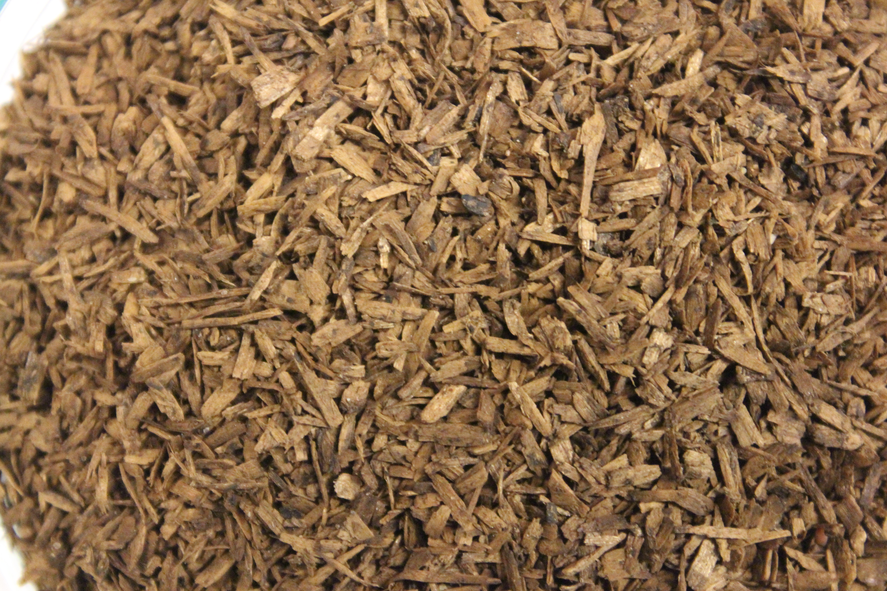 | 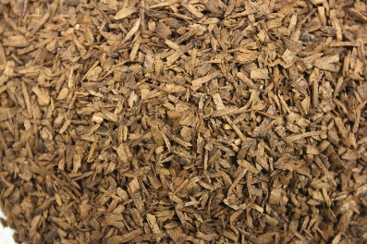
Waste Bag (2) | Sample 22 | Sample 23 | Sample 24
Waste Bag (2) | 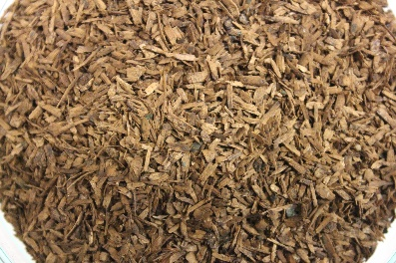 | 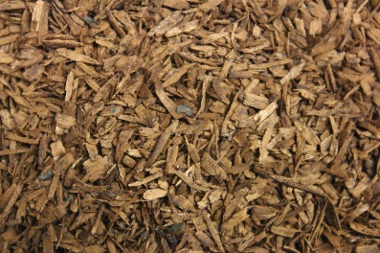 | 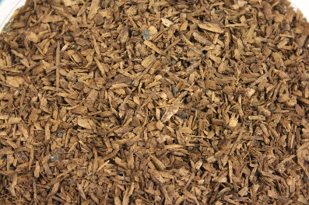
Waste Bag (3) | Sample 25 | Sample 26 | Sample 27
Waste Bag (3) | 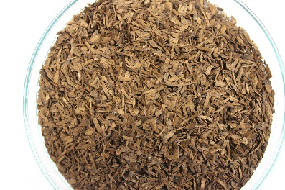 | 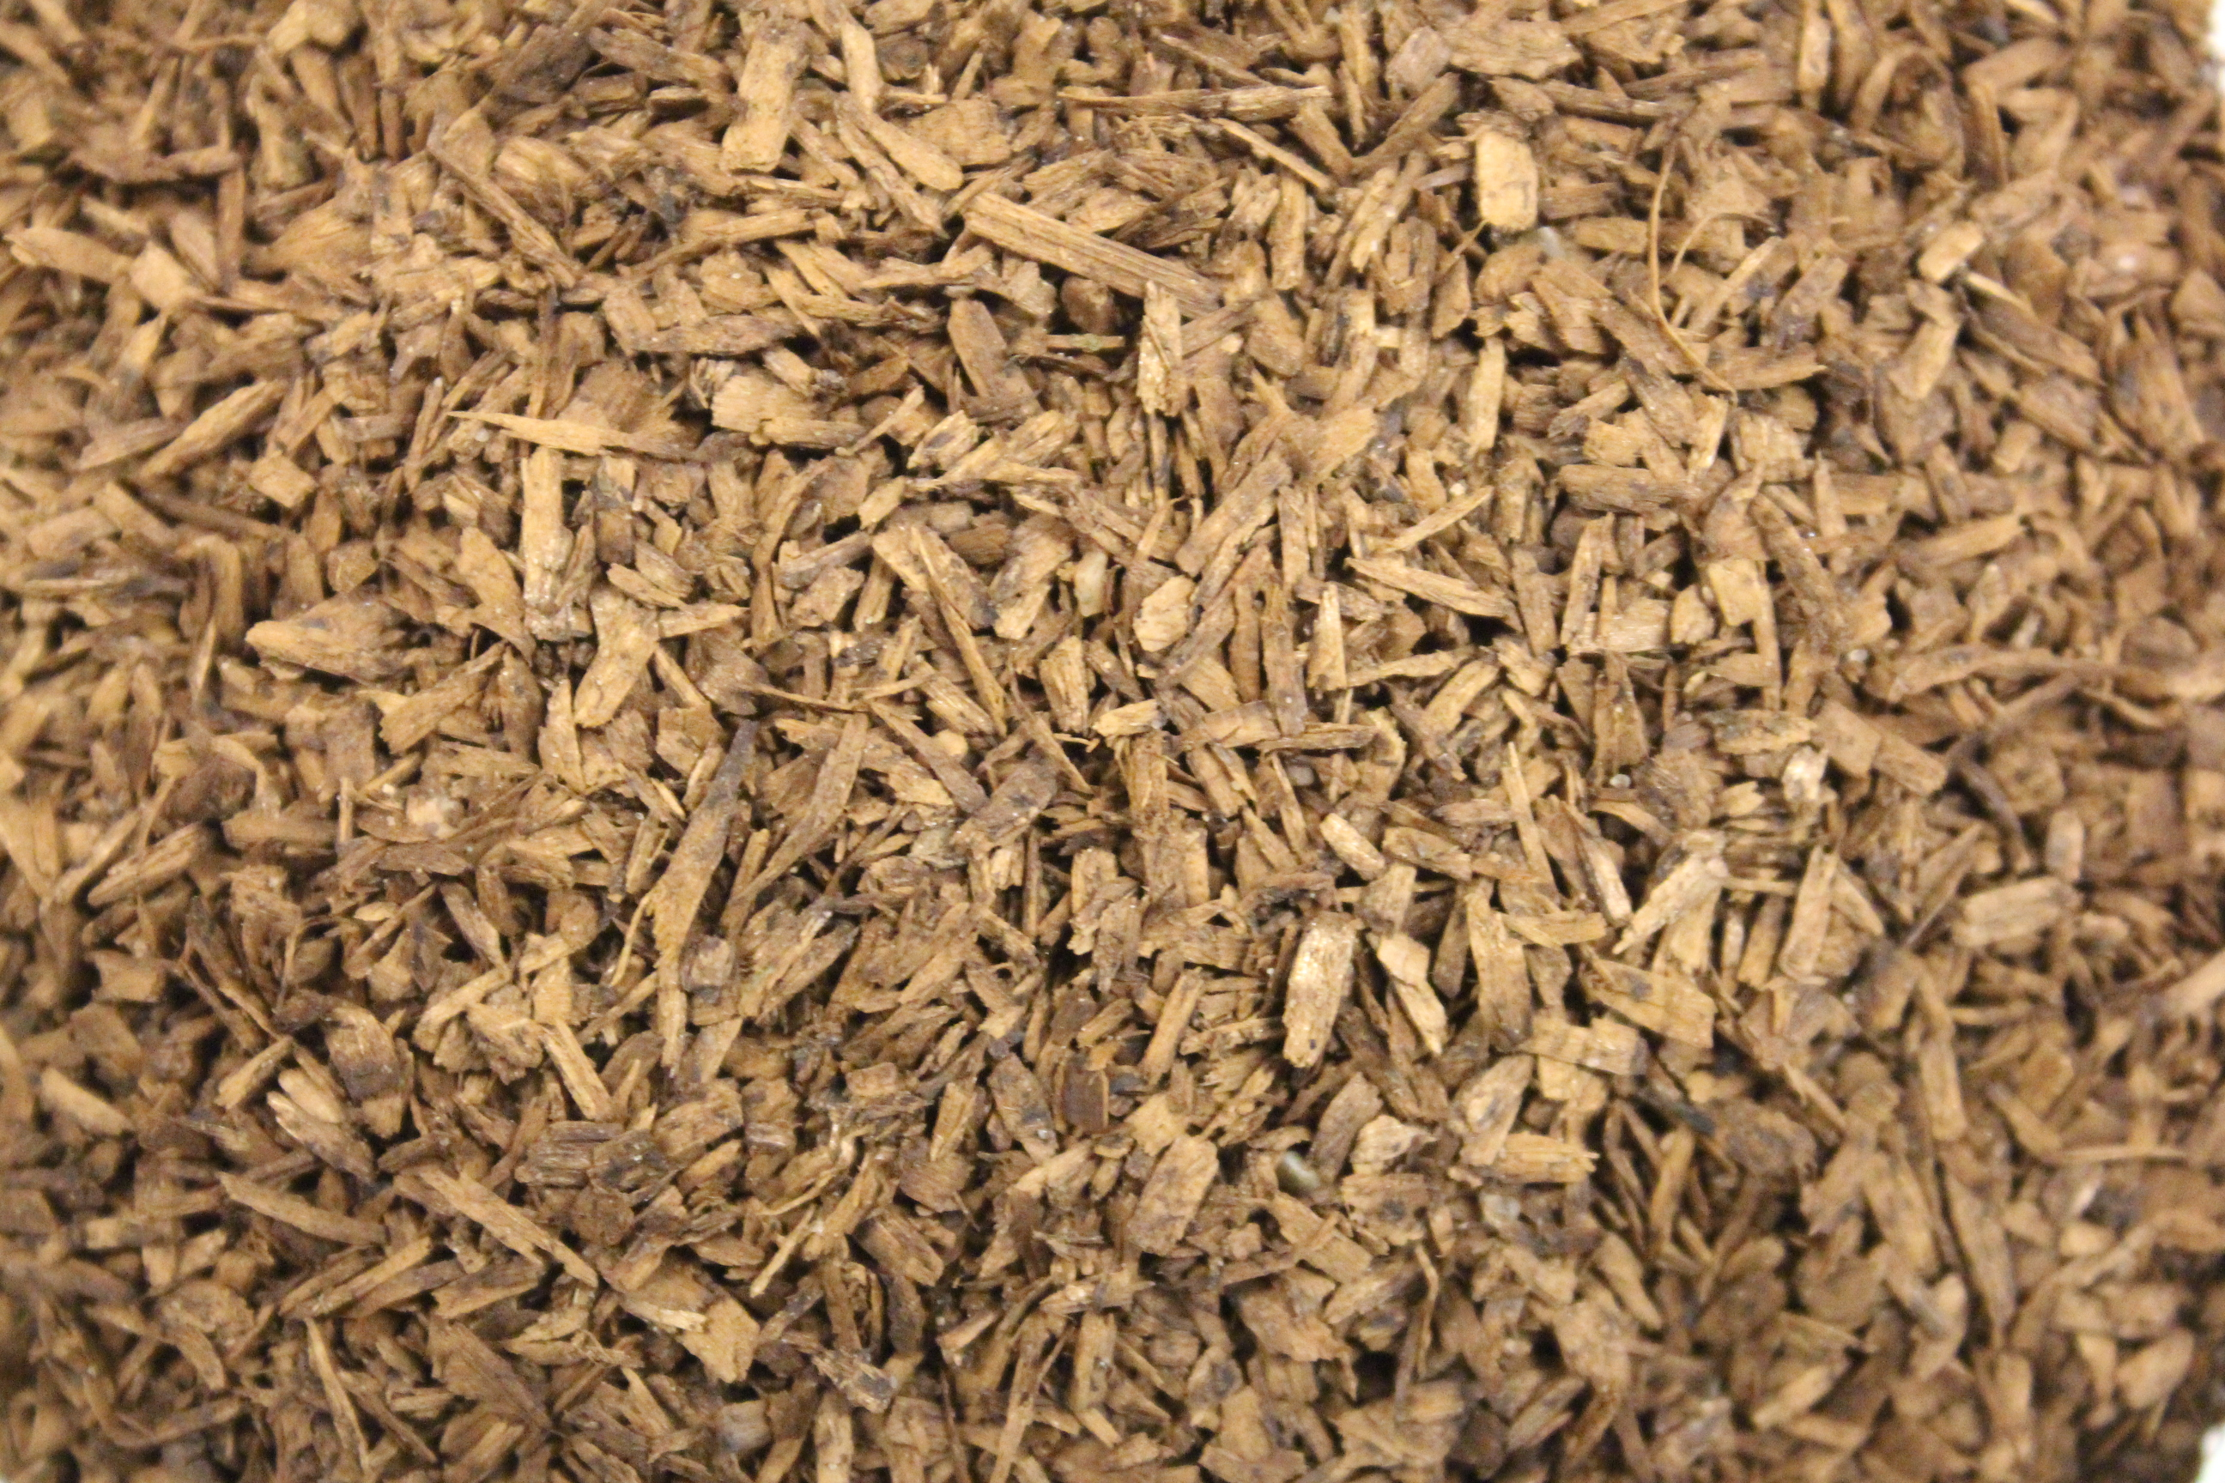 | 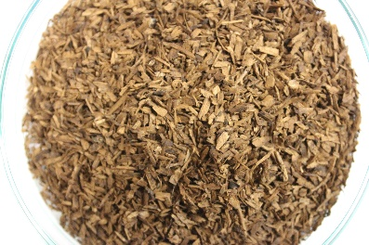
Food Container | Sample 28 | Sample 29 | Sample 30
Food Container | 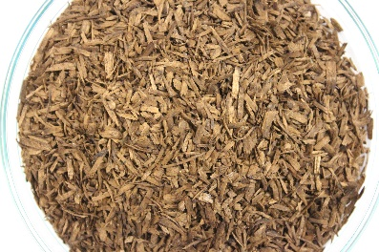 | 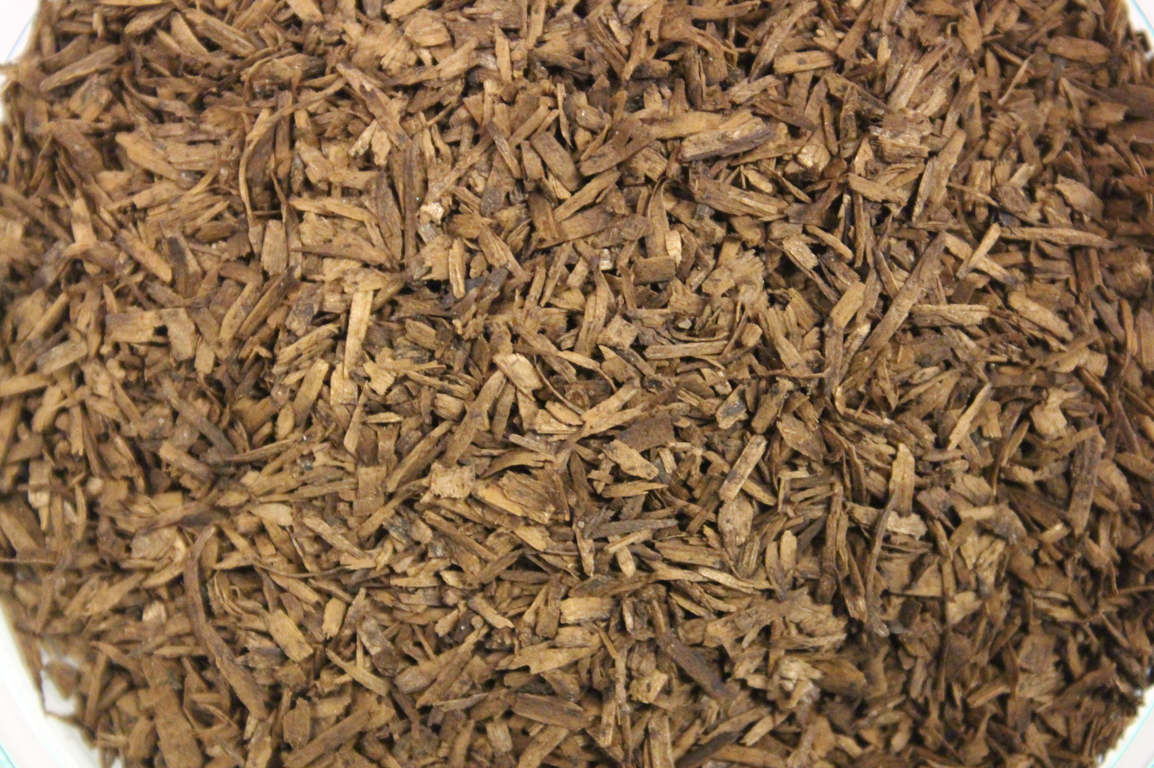 | 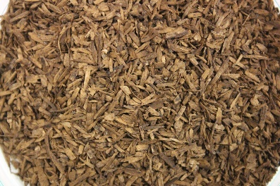
Plate | Sample 31 | Sample 32 | Sample 33
Plate | 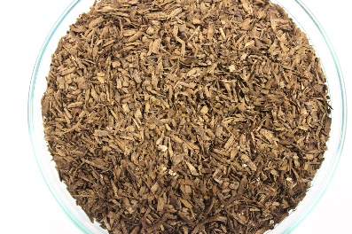 | 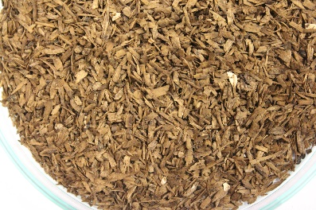 | 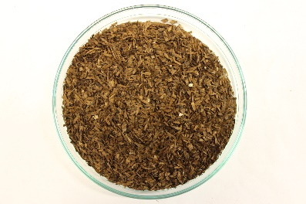
Lid | Sample 34 | Sample 35 | Sample 36
Lid | 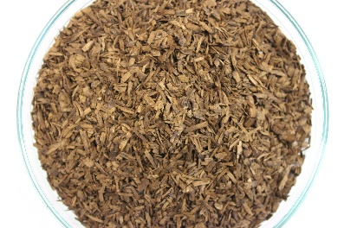 | 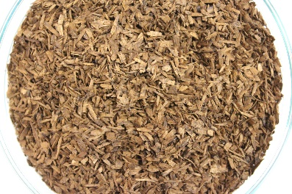 | 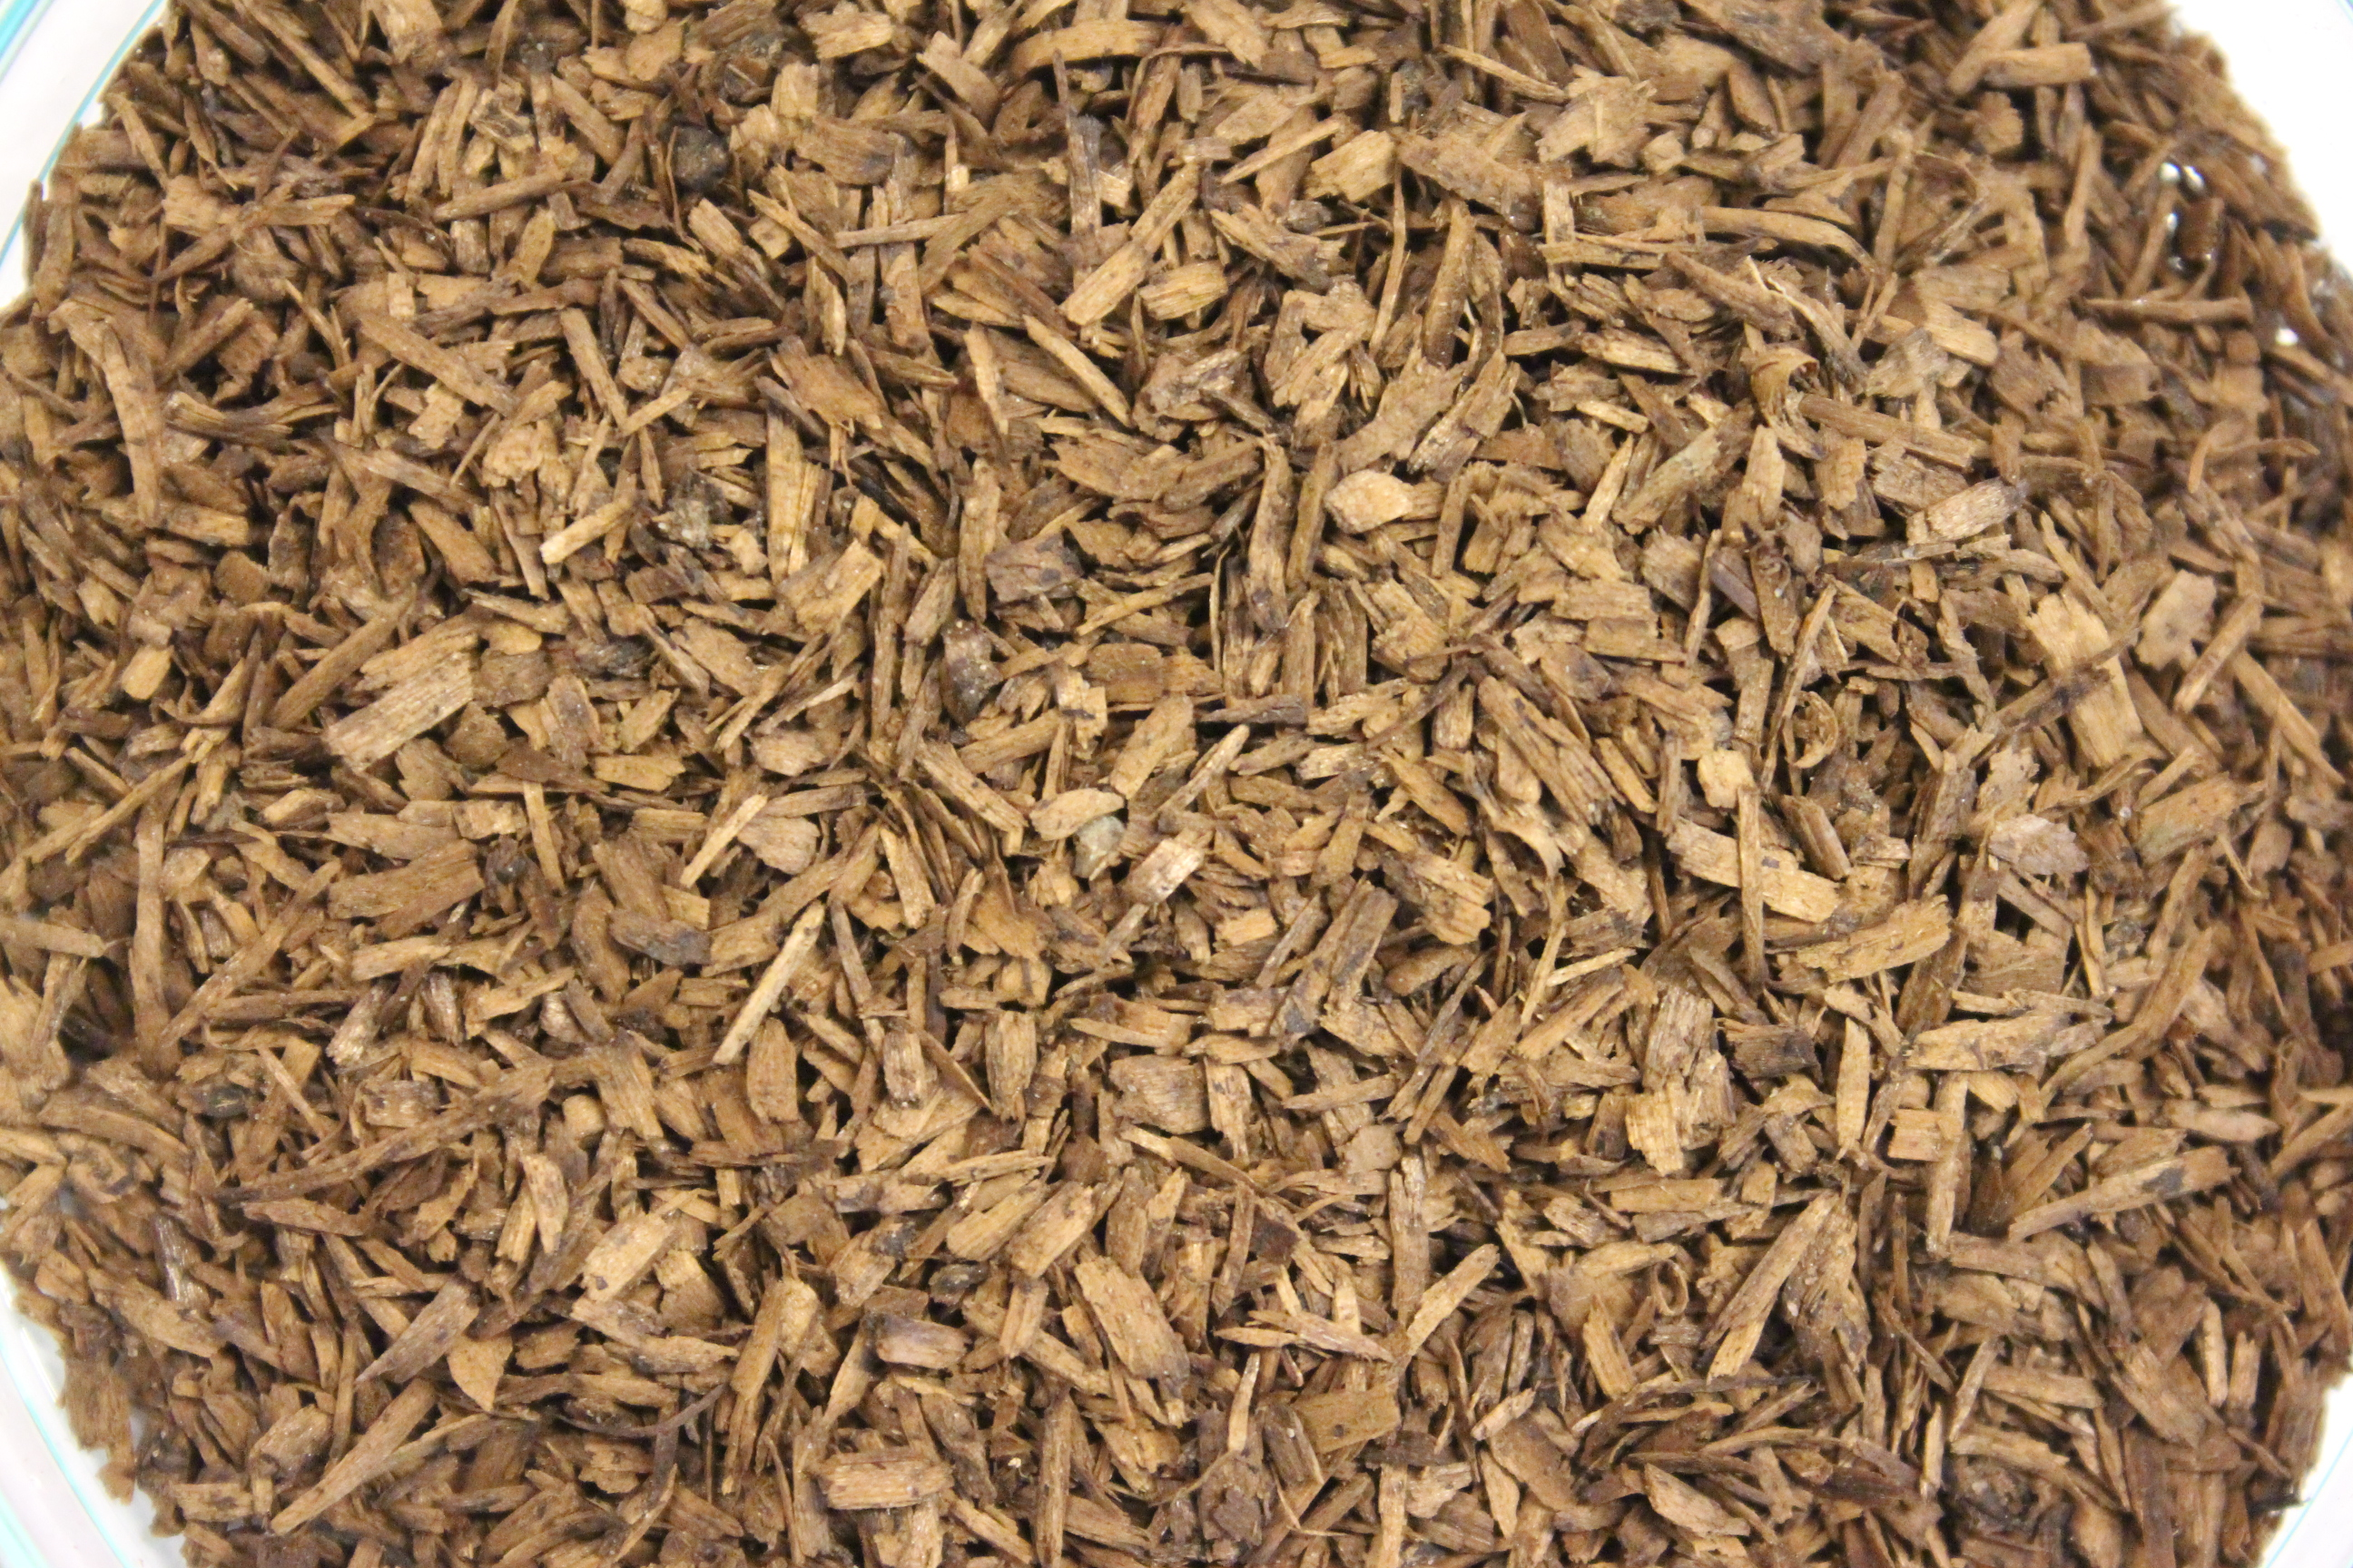
Flower Pot (1) | Sample 37 | Sample 38 | Sample 39
Flower Pot (1) |  | 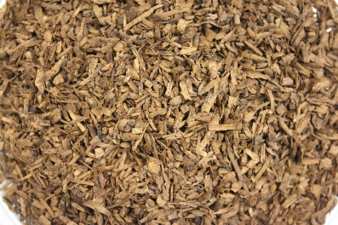 | 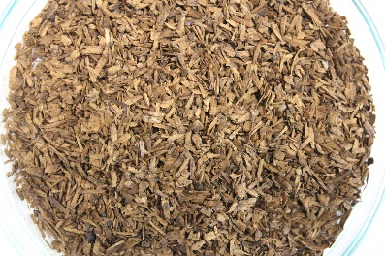
Flower Pot (2) | Sample 40 | Sample 41 | Sample 42
Flower Pot (2) | 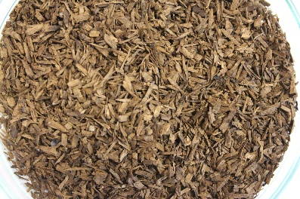 | 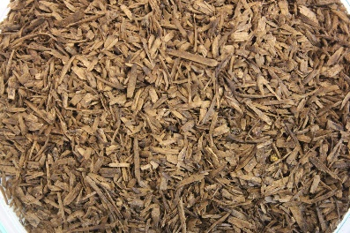 | 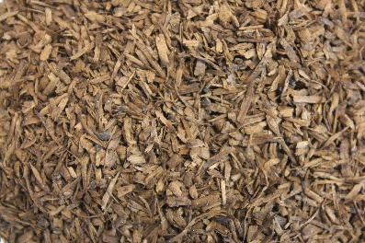

Table S12: Compost matrix < 0.85 mm after 90 days of composting.
Test material | Compost matrix < 0.85 mm after 90 days of composting
Blank | Sample 1 | Sample 2 | Sample 3
Blank | 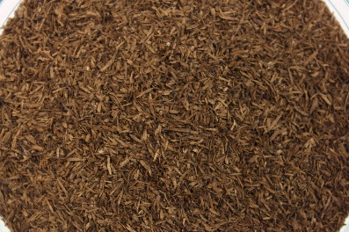 | 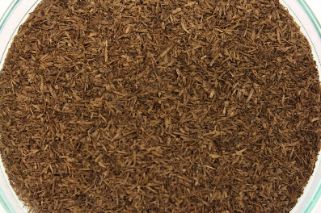 | 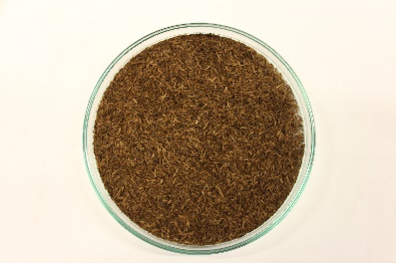
Cellulose Filter Paper (positive control) | Sample 4 | Sample 5 | Sample 6
Cellulose Filter Paper (positive control) | 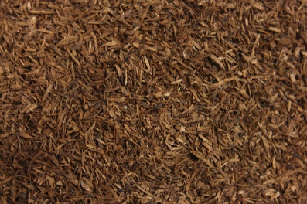 | 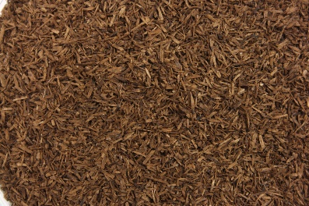 | 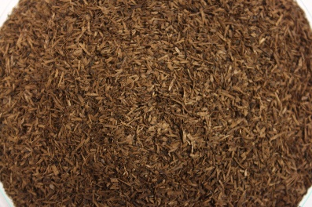
Freezer Bag (negative control) | Sample 7 | Sample 8 | Sample 9
Freezer Bag (negative control) | 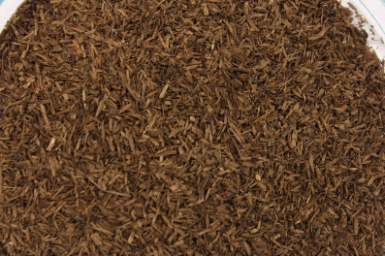 | 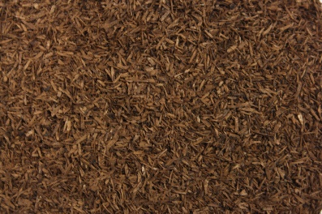 | 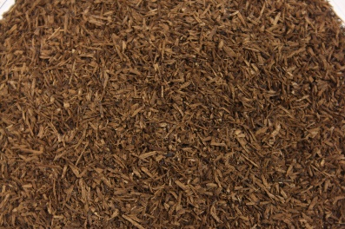
Weighing Boat (negative control) | Sample 10 | Sample 11 | Sample 12
Weighing Boat (negative control) | 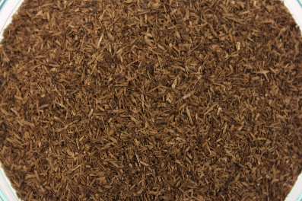 | 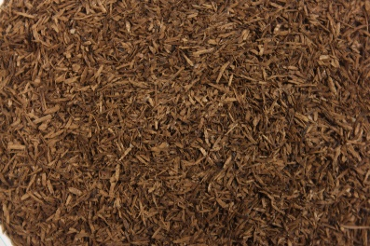
Food Bag | Sample 13 | Sample 14 | Sample 15
Food Bag | 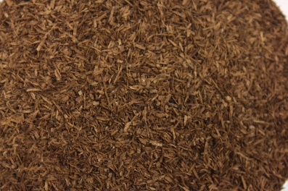 | 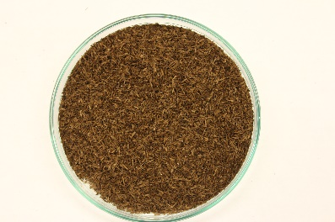 | 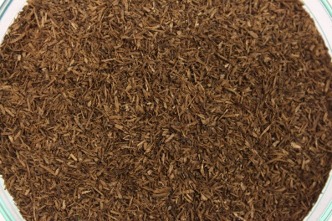
Waste Bag (1) | Sample 16 | Sample 17 | Sample 18
Waste Bag (1) | 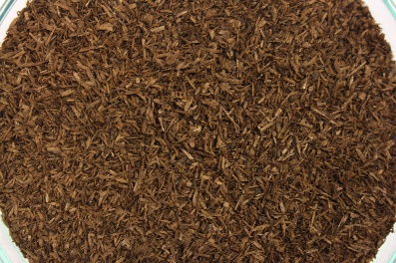 | 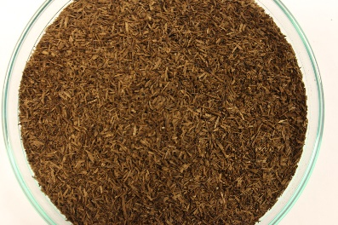 | 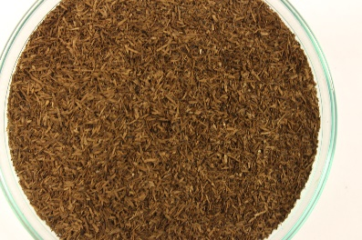
Drawstring | Sample 19 | Sample 20 | Sample 21
Drawstring | 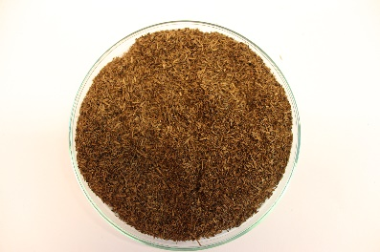 | 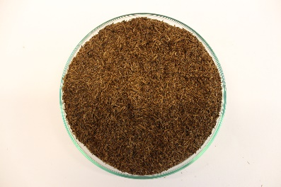 | 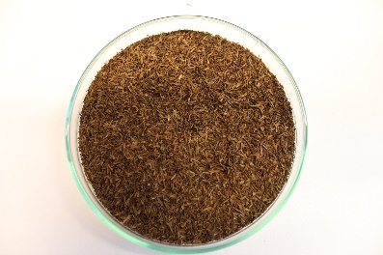
Waste Bag (2) | Sample 22 | Sample 23 | Sample 24
Waste Bag (2) | 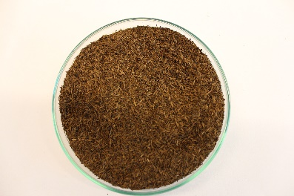 | 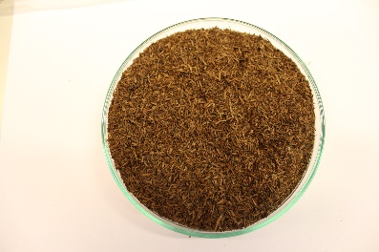 | 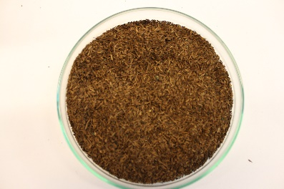
Waste Bag (3) | Sample 25 | Sample 26 | Sample 27
Waste Bag (3) | 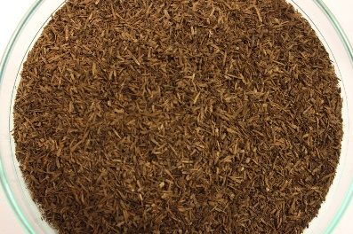 | 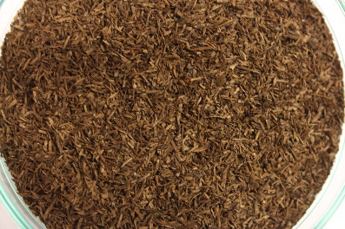 | 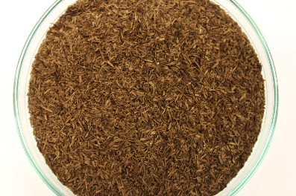
Food Container | Sample 28 | Sample 29 | Sample 30
Food Container | 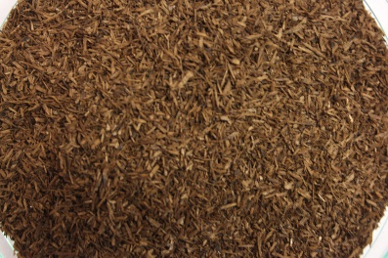 | 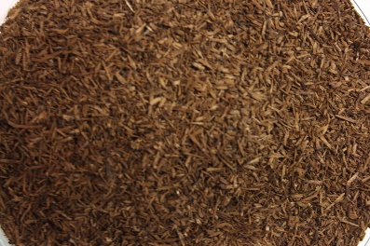 | 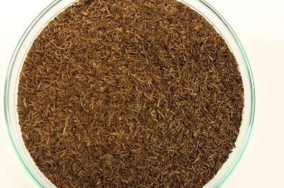
Plate | Sample 31 | Sample 32 | Sample 33
Plate | 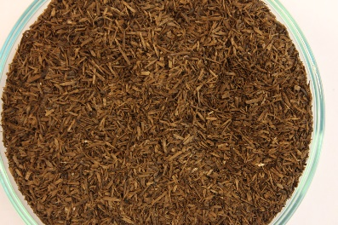 | 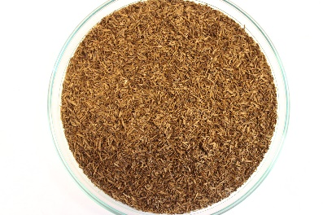 | 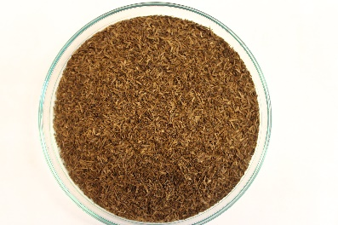
Lid | Sample 34 | Sample 35 | Sample 36
Lid | 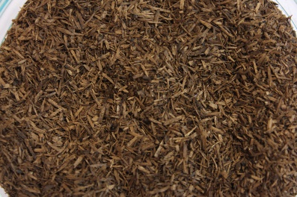 | 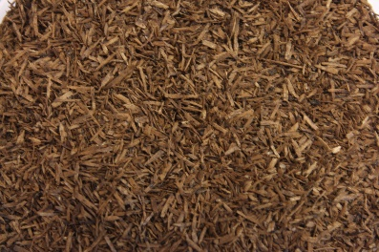 | 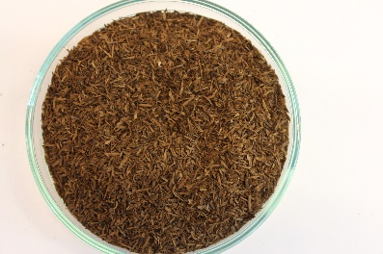
Flower Pot (1) | Sample 37 | Sample 38 | Sample 39
Flower Pot (1) | 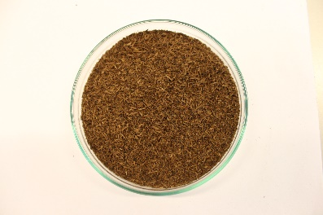 | 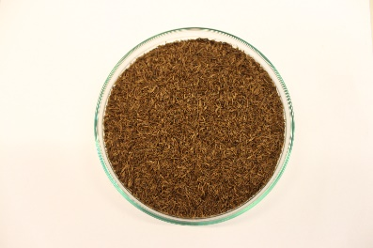 | 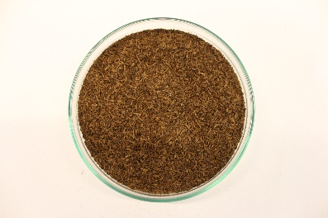
Flower Pot (2) | Sample 40 | Sample 41 | Sample 42
Flower Pot (2) | 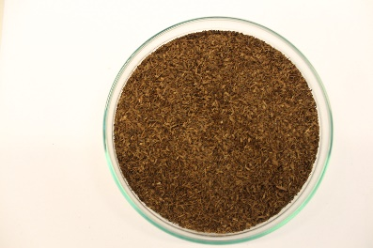 | 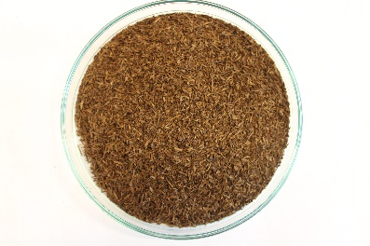 | 