Supplementary Material

Similar but different assembly processes of bacterial and micro-eukaryotic communities in an urban river

Shenwen Cai ^{1*}, Jun Zhao ¹, Enguo Sheng ¹, Leilei Fan ¹, Ziwei Shen ², Yunfeng Li ^{2*}

¹ College of Resources and Environment, Zunyi Normal University, Zunyi, China
² Yangtze River Fisheries Research Institute, Chinese Academy of Fishery Sciences, Wuhan, China
* Corresponding author: Shenwen Cai, e-mail: caishenwen@163.com
Yunfeng Li, e-mail: lyf086@yfi.ac.cn

List

Table S1. Topological properties of co-occurrence network of microbial community.
Table S2. Keystone species of bacteria and their taxonomic information in different seasons.
Table S3. Keystone species of micro-eukaryotes and their taxonomic information in different seasons.
Table S4. Environmental factors in different seasons from the Xiangjianghe river.
Table S5. Environmental factors in different sampling sites from the Xiangjianghe river.
Figure S1. Rarefaction curves for sobs index on OTU level of bacteria and micro-eukaryotes at different sampling sites in four seasons from the Xiangjianghe river.
Figure S2. Relative abundance (%) of top 20 dominant genera for bacteria (a) and micro-eukaryotes (b) at different sampling sites in four seasons from the Xiangjianghe river.
Figure S3. Nonmetric multidimensional scaling analysis (NMDS) of bacterial (a) and micro-eukaryotic (b) community at OTU level based on Bray-Curtis distance in different seasons and sampling sites.

Table S1. Topological properties of co-occurrence network of microbial community.
 | Bacteria |  |  |  | Micro-eukaryotes
 | Spring | Summer | Autumn | Winter | Spring | Summer | Autumn | Winter
Number of nodes | 652 | 512 | 702 | 775 | 552 | 473 | 523 | 461
Number of edges | 17308 | 8887 | 20399 | 23120 | 15872 | 7044 | 8674 | 5726
Average degree | 53.092 | 34.446 | 58.117 | 59.665 | 57.507 | 29.784 | 33.17 | 24.842
Graph density | 0.079 | 0.067 | 0.083 | 0.077 | 0.104 | 0.063 | 0.064 | 0.054
Modularity | 0.442 | 0.539 | 0.434 | 0.536 | 0.379 | 0.581 | 0.514 | 0.558
Average clustering coefficient | 0.469 | 0.462 | 0.467 | 0.472 | 0.474 | 0.448 | 0.404 | 0.419
Average path length | 2.654 | 2.795 | 2.659 | 2.705 | 2.619 | 2.891 | 2.846 | 2.94
Proportion of positive correlation | 67.44 | 67.26 | 86.26 | 85.24 | 66.31 | 74.03 | 69.58 | 80.61
Proportion of negative correlation | 32.56 | 32.74 | 13.74 | 14.76 | 33.69 | 25.97 | 30.42 | 19.39

Table S2. Keystone species of bacteria and their taxonomic information in different seasons.
Season | OTU | Attribution | Phylum | Genus
Spring | OTU3478 | Module hubs | Bacteroidota | unclassified_f__NS11-12_marine_group
 | OTU3706 | Connectors | Patescibacteria | unclassified_o__Candidatus_Kaiserbacteria
 | OTU4046 | Connectors | Proteobacteria | unclassified_f__Arenicellaceae
Summer | OTU3930 | Module hubs | Proteobacteria | unclassified_f__MWH-UniP1_aquatic_group
 | OTU6918 | Module hubs | Actinobacteriota | hgcI_clade
 | OTU1785 | Connectors | Proteobacteria | Brachymonas
 | OTU2386 | Connectors | Proteobacteria | Hydrogenophaga
 | OTU3759 | Connectors | Bacteroidota | Fluviicola
 | OTU4150 | Connectors | Proteobacteria | Nevskia
 | OTU4895 | Connectors | Proteobacteria | unclassified_f__Legionellaceae
Autumn | OTU10424 | Module hubs | Proteobacteria | unclassified_f__Methylomonadaceae
 | OTU10534 | Module hubs | Proteobacteria | Dechloromonas
 | OTU2435 | Module hubs | Patescibacteria | unclassified_o__Candidatus_Kaiserbacteria
 | OTU3700 | Module hubs | Proteobacteria | unclassified_f__Rhodocyclaceae
 | OTU3972 | Module hubs | Acidobacteriota | unclassified_o__Vicinamibacterales
 | OTU3642 | Connectors | Proteobacteria | unclassified_f__Comamonadaceae
 | OTU8152 | Connectors | Patescibacteria | unclassified_o__Candidatus_Moranbacteria
Winter | OTU8198 | Module hubs | Proteobacteria | unclassified_f__Oxalobacteraceae
 | OTU10134 | Connectors | Firmicutes | Roseburia
 | OTU10177 | Connectors | Proteobacteria | unclassified_f__Legionellaceae
 | OTU10331 | Connectors | Firmicutes | Streptococcus
 | OTU10341 | Connectors | Bacteroidota | Paludibacter
 | OTU10359 | Connectors | Campylobacterota | Sulfurospirillum
 | OTU10436 | Connectors | Chloroflexi | unclassified_f__JG30-KF-CM45
 | OTU10494 | Connectors | Firmicutes | Erysipelotrichaceae_UCG-003
 | OTU10499 | Connectors | Patescibacteria | unclassified_o__Saccharimonadales
 | OTU10547 | Connectors | Patescibacteria | unclassified_o__Candidatus_Kaiserbacteria
 | OTU10586 | Connectors | Proteobacteria | unclassified_c__Gammaproteobacteria
 | OTU10721 | Connectors | Proteobacteria | Collimonas
 | OTU10782 | Connectors | Bacteroidota | unclassified_f__Paludibacteraceae
 | OTU10819 | Connectors | Firmicutes | Enterococcus
 | OTU1617 | Connectors | Bacteroidota | Flavobacterium
 | OTU1640 | Connectors | Firmicutes | unclassified_f__Selenomonadaceae
 | OTU1689 | Connectors | Firmicutes | Candidatus_Bacilloplasma
 | OTU1697 | Connectors | Bacteroidota | Prevotellaceae_NK3B31_group
 | OTU1737 | Connectors | Bacteroidota | Flavobacterium
 | OTU1945 | Connectors | Dependentiae | unclassified_f__Vermiphilaceae
 | OTU2359 | Connectors | Proteobacteria | Thiovirga
 | OTU2512 | Connectors | Proteobacteria | Candidatus_Accumulibacter
 | OTU2553 | Connectors | Desulfobacterota | Desulfovibrio
 | OTU2733 | Connectors | WPS-2 | unclassified_p__WPS-2
 | OTU2830 | Connectors | Desulfobacterota | Desulfobulbus
 | OTU2948 | Connectors | Firmicutes | [Ruminococcus]_gnavus_group
 | OTU3283 | Connectors | Bacteroidota | Parabacteroides
 | OTU3388 | Connectors | Verrucomicrobiota | unclassified_f__Verrucomicrobiaceae
 | OTU3474 | Connectors | Firmicutes | Succinispira
 | OTU3475 | Connectors | Proteobacteria | Candidatus_Accumulibacter
 | OTU3592 | Connectors | Proteobacteria | Phreatobacter
 | OTU3604 | Connectors | Proteobacteria | unclassified_o__Burkholderiales
 | OTU3731 | Connectors | Synergistota | unclassified_f__Synergistaceae
 | OTU3743 | Connectors | Patescibacteria | unclassified_o__Saccharimonadales
 | OTU3744 | Connectors | Actinobacteriota | unclassified_o__PeM15
 | OTU3957 | Connectors | Bacteroidota | Flavobacterium
 | OTU4088 | Connectors | Firmicutes | Acidaminobacter
 | OTU4156 | Connectors | Proteobacteria | Propionivibrio
 | OTU4227 | Connectors | Proteobacteria | Pseudomonas
 | OTU4292 | Connectors | Firmicutes | unclassified_f__Sporomusaceae
 | OTU7976 | Connectors | Campylobacterota | Sulfuricurvum
 | OTU8002 | Connectors | Proteobacteria | unclassified_f__Comamonadaceae
 | OTU8011 | Connectors | Proteobacteria | Hydrogenophaga
 | OTU8018 | Connectors | Proteobacteria | Brachymonas
 | OTU8038 | Connectors | Proteobacteria | Sphaerotilus
 | OTU8729 | Connectors | Proteobacteria | unclassified_f__Oxalobacteraceae
 | OTU8898 | Connectors | Firmicutes | Pelosinus
 | OTU8994 | Connectors | Proteobacteria | Thiothrix
 | OTU9539 | Connectors | Proteobacteria | Sphingomonas
 | OTU995 | Connectors | Proteobacteria | Acinetobacter

Table S3. Keystone species of micro-eukaryotes and their taxonomic information in different seasons.
Season | OTU | Attribution | Phylum | Genus
spring | OTU4965 | Connectors | unclassified_k__Stramenopiles | unclassified_c__Chrysophyceae
 | OTU1921 | Connectors | unclassified_k__Stramenopiles | Synura
summer | OTU5276 | Module hubs | Cryptomycota | unclassified_p__Cryptomycota
 | OTU2994 | Module hubs | Labyrinthulomycetes | unclassified_f__Amphitraemidae
 | OTU1758 | Module hubs | Ciliophora | unclassified_f__Haptoria
 | OTU1599 | Module hubs | Ciliophora | unclassified_f__Oligohymenophorea
 | OTU1930 | Module hubs | Cryptomycota | unclassified_p__Cryptomycota
 | OTU5274 | Connectors | Diatomea | Fragilaria
 | OTU5165 | Connectors | unclassified_k__Fungi | unclassified_k__Fungi
 | OTU5163 | Connectors | Diatomea | Cocconeis
 | OTU4826 | Connectors | unclassified_k__Chloroplastida | unclassified_c__Ulvophyceae
 | OTU4700 | Connectors | LKM15 | unclassified_p__LKM15
 | OTU2721 | Connectors | Cryptomycota | Paramicrosporidium
 | OTU200 | Connectors | Ciliophora | Cryptocaryon
 | OTU1648 | Connectors | Rotifera | unclassified_o__Ploimida
 | OTU1398 | Connectors | Bicosoecida | unclassified_p__Bicosoecida
 | OTU1314 | Connectors | unclassified_k__Chloroplastida | unclassified_c__Chlorophyceae
autumn | OTU5494 | Connectors | Ciliophora | unclassified_f__Oligohymenophorea
 | OTU5454 | Connectors | Ciliophora | unclassified_f__Haptoria
 | OTU5358 | Connectors | Ciliophora | Vaginicola
 | OTU5343 | Connectors | Ciliophora | unclassified_f__Oligotrichia
 | OTU5305 | Connectors | Peronosporomycetes | unclassified_p__Peronosporomycetes
 | OTU5285 | Connectors | Cercozoa | Bodomorpha
 | OTU5265 | Connectors | unclassified_k__Chloroplastida | Neochloris
 | OTU5185 | Connectors | Ciliophora | Stokesia
 | OTU5182 | Connectors | Rotifera | unclassified_o__Philodinida
 | OTU5175 | Connectors | LKM15 | unclassified_p__LKM15
 | OTU5135 | Connectors | unclassified_k__Stramenopiles | Paraphysomonas
 | OTU5108 | Connectors | MAST-12 | unclassified_p__MAST-12
 | OTU5015 | Connectors | Peronosporomycetes | unclassified_p__Peronosporomycetes
 | OTU4824 | Connectors | unclassified_k__Chloroplastida | Tetradesmus
 | OTU4802 | Connectors | Cryptomycota | unclassified_p__Cryptomycota
 | OTU4790 | Connectors | Chytridiomycota | unclassified_c__Chytridiomycetes
 | OTU4762 | Connectors | unclassified_k__Chloroplastida | unclassified_c__Chlorophyceae
 | OTU4639 | Connectors | unclassified_k__Stramenopiles | Paraphysomonas
 | OTU3833 | Connectors | unclassified_k__Chloroplastida | Planktosphaeria
 | OTU3670 | Connectors | Diatomea | Gomphonema
 | OTU3424 | Connectors | unclassified_k__Stramenopiles | Dinobryon
 | OTU3156 | Connectors | Ciliophora | unclassified_f__Haptoria
 | OTU3043 | Connectors | unclassified_k__Chloroplastida | Neochloris
 | OTU3037 | Connectors | Chytridiomycota | unclassified_c__Chytridiomycetes
 | OTU2988 | Connectors | Ciliophora | unclassified_f__Choreotrichia
 | OTU2902 | Connectors | unclassified_k__Chloroplastida | unclassified_k__Chloroplastida
 | OTU2835 | Connectors | Gastrotricha | unclassified_o__Chaetonotida
 | OTU2810 | Connectors | unclassified_k__Alveolata | unclassified_k__Alveolata
 | OTU2750 | Connectors | Cryptomycota | unclassified_p__Cryptomycota
 | OTU2680 | Connectors | unclassified_k__Alveolata | unclassified_k__Alveolata
 | OTU2661 | Connectors | Hyphochytriomycetes | unclassified_o__Hyphochytriales
 | OTU2653 | Connectors | Cryptomycota | unclassified_p__Cryptomycota
 | OTU2512 | Connectors | unclassified_k__Fungi | unclassified_k__Fungi
 | OTU2327 | Connectors | Diatomea | Cyclotella
 | OTU2029 | Connectors | unclassified_k__Stramenopiles | Pseudopedinella
 | OTU1954 | Connectors | Ciliophora | unclassified_f__Haptoria
 | OTU1923 | Connectors | Ciliophora | unclassified_f__Haptoria
 | OTU1853 | Connectors | Cryptomycota | unclassified_p__Cryptomycota
 | OTU1843 | Connectors | Diatomea | Nitzschia
 | OTU1765 | Connectors | Vertebrata | unclassified_c__Actinopterygii
 | OTU1729 | Connectors | unclassified_k__Chloroplastida | unclassified_c__Chlorophyceae
 | OTU1716 | Connectors | Rotifera | unclassified_o__Ploimida
 | OTU1657 | Connectors | Ciliophora | unclassified_f__Oligohymenophorea
 | OTU1488 | Connectors | Gastrotricha | unclassified_o__Chaetonotida
 | OTU1397 | Connectors | unclassified_k__Chloroplastida | unclassified_c__Chlorophyceae
 | OTU1230 | Connectors | unclassified_k__Chloroplastida | Aphanochaete
 | OTU1204 | Connectors | Ciliophora | Hemiophrys
 | OTU1178 | Connectors | Peronosporomycetes | Pythium
winter | OTU644 | Module hubs | Protalveolata | unclassified_o__A31
 | OTU5145 | Module hubs | unclassified_k__Chloroplastida | Chlorella
 | OTU3937 | Module hubs | Ciliophora | unclassified_f__Oligohymenophorea
 | OTU3931 | Module hubs | Cercozoa | Heteromita
 | OTU666 | Connectors | unclassified_k__Stramenopiles | Paraphysomonas
 | OTU5763 | Connectors | Cercozoa | Allantion
 | OTU5466 | Connectors | Chytridiomycota | unclassified_c__Chytridiomycetes
 | OTU5453 | Connectors | Ciliophora | Ichthyophthirius
 | OTU5432 | Connectors | Chytridiomycota | unclassified_o__Rhizophydiales
 | OTU5242 | Connectors | Ciliophora | Colpidium
 | OTU5226 | Connectors | Chytridiomycota | unclassified_o__Rhizophydiales
 | OTU5175 | Connectors | LKM15 | unclassified_p__LKM15
 | OTU5154 | Connectors | Chytridiomycota | unclassified_f__Lobulomycetaceae
 | OTU5148 | Connectors | Chytridiomycota | unclassified_o__Rhizophydiales
 | OTU5146 | Connectors | Dinoflagellata | Symbiodinium
 | OTU5126 | Connectors | Cercozoa | Heteromita
 | OTU5123 | Connectors | Ciliophora | Telotrochidium
 | OTU5046 | Connectors | Diatomea | Gomphonema
 | OTU5017 | Connectors | Ciliophora | Lembadion
 | OTU5008 | Connectors | SAR | Sorodiplophrys
 | OTU4987 | Connectors | Ciliophora | unclassified_f__Choreotrichia
 | OTU4952 | Connectors | Ciliophora | Litonotus
 | OTU4950 | Connectors | Chytridiomycota | unclassified_o__Chytridiales
 | OTU4944 | Connectors | unclassified_k__Stramenopiles | Spumella
 | OTU4864 | Connectors | SAR | Sorodiplophrys
 | OTU4846 | Connectors | unclassified_k__Alveolata | unclassified_k__Alveolata
 | OTU4793 | Connectors | Cercozoa | Allantion
 | OTU4767 | Connectors | Chytridiomycota | unclassified_o__Rhizophydiales
 | OTU4749 | Connectors | Cnidaria | unclassified_o__Anthoathecata
 | OTU4696 | Connectors | Mucoromycota | Mortierella
 | OTU4652 | Connectors | unclassified_k__Stramenopiles | unclassified_c__Chrysophyceae
 | OTU4641 | Connectors | Chytridiomycota | unclassified_c__Chytridiomycetes
 | OTU4639 | Connectors | unclassified_k__Stramenopiles | Paraphysomonas
 | OTU3912 | Connectors | Ciliophora | Glaucoma
 | OTU297 | Connectors | Ciliophora | unclassified_f__Haptoria
 | OTU2045 | Connectors | Ciliophora | Didinium
 | OTU1918 | Connectors | unclassified_k__Stramenopiles | unclassified_c__Chrysophyceae
 | OTU1216 | Connectors | Peronosporomycetes | Pythium

Table S4. Environmental factors in different seasons from the Xiangjianghe river.
Season | TN | TP | COD | Temp | pH | ORP | DO | EC
Spring | 3.24±1.41ª | 0.21±0.18ª | 3.10±0.93ª | 15.31±1.63ª | 7.51±0.45^{b} | 94.37±16.04ª | 8.10±0.30^{c} | 448.46±188.17ª
Summer | 2.98±1.61ª | 0.18±0.10ª | 3.19±0.57ª | 23.83±1.25^{b} | 6.98±0.27ª | 286.33±19.48^{b} | 6.64±1.40^{bc} | 562.49±152.71ª
Autumn | 2.69±1.86ª | 0.17±0.06ª | 2.99±0.54ª | 21.17±1.42^{c} | 7.86±0.25^{bc} | 334.37±8.63^{c} | 4.67±1.02ª | 551.23±101.55ª
Winter | 6.79±2.64^{b} | 0.31±0.25ª | 2.85±0.64ª | 8.68±1.46^{d} | 8.07±0.39^{c} | 102.72±29.03ª | 5.99±2.44^{ab} | 422.79±83.88ª
Different superscript letters in each column denote the significant difference between different seasons (P < 0.05).

Table S5. Environmental factors in different sampling sites from the Xiangjianghe river.
Site | TN | TP | COD | Temp | pH | ORP | DO | EC
S1 | 1.96±1.05ª | 0.06±0.03ª | 2.06±0.23ª | 15.43±6.29ª | 7.51±0.64ª | 194.97±145.83ª | 5.98±2.41ª | 418.95±65.42ª
S2 | 3.48±1.65^{ab} | 0.20±0.02^{ab} | 3.17±0.25^{cd} | 16.94±6.77ª | 8.05±0.56ª | 201.28±129.47ª | 7.27±1.03ª | 525.28±83.44^{ab}
S3 | 3.56±2.72^{ab} | 0.17±0.08^{ab} | 2.87±0.36^{bc} | 17.20±6.13ª | 7.32±0.73ª | 216.19±126.47ª | 5.69±1.70ª | 384.44±106.18ª
S4 | 4.86±2.14^{ab} | 0.16±0.03^{ab} | 3.58±0.28^{d} | 17.83±8.76ª | 7.70±0.48a | 215.26±124.78ª | 7.43±1.99ª | 430.67±73.01ª
S5 | 4.69±4.24^{ab} | 0.20±0.13^{ab} | 2.55±0.59^{ab} | 17.04±7.36ª | 7.67±0.24a | 204.18±118.67ª | 4.75±2.82ª | 404.35±81.05ª
S6 | 2.81±0.96^{ab} | 0.48±0.28^{c} | 3.23±0.32^{cd} | 18.29±5.79ª | 7.44±0.45a | 203.19±114.51ª | 6.72±1.30ª | 730.09±150.05^{c}
S7 | 6.13±2.34^{b} | 0.29±0.06^{b} | 3.78±0.56^{d} | 18.00±6.24ª | 7.54±0.64ª | 196.09±114.88ª | 6.63±1.35ª | 579.92±73.77^{b}
Different superscript letters in each column denote the significant difference between different sampling sites (P < 0.05).

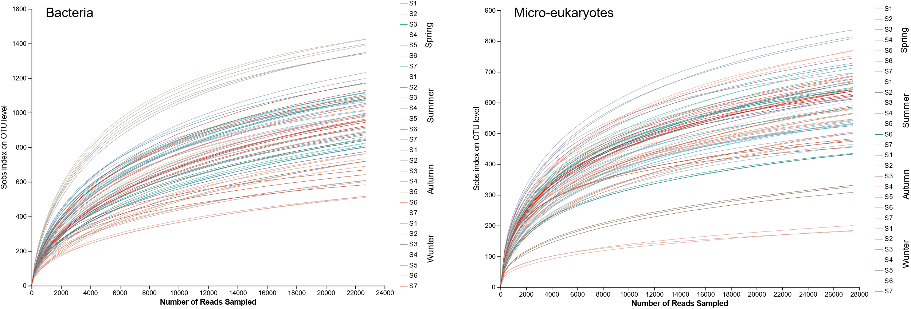
Figure S1. Rarefaction curves for sobs index on OTU level of bacteria and micro-eukaryotes at different sampling sites in four seasons from the Xiangjianghe river.

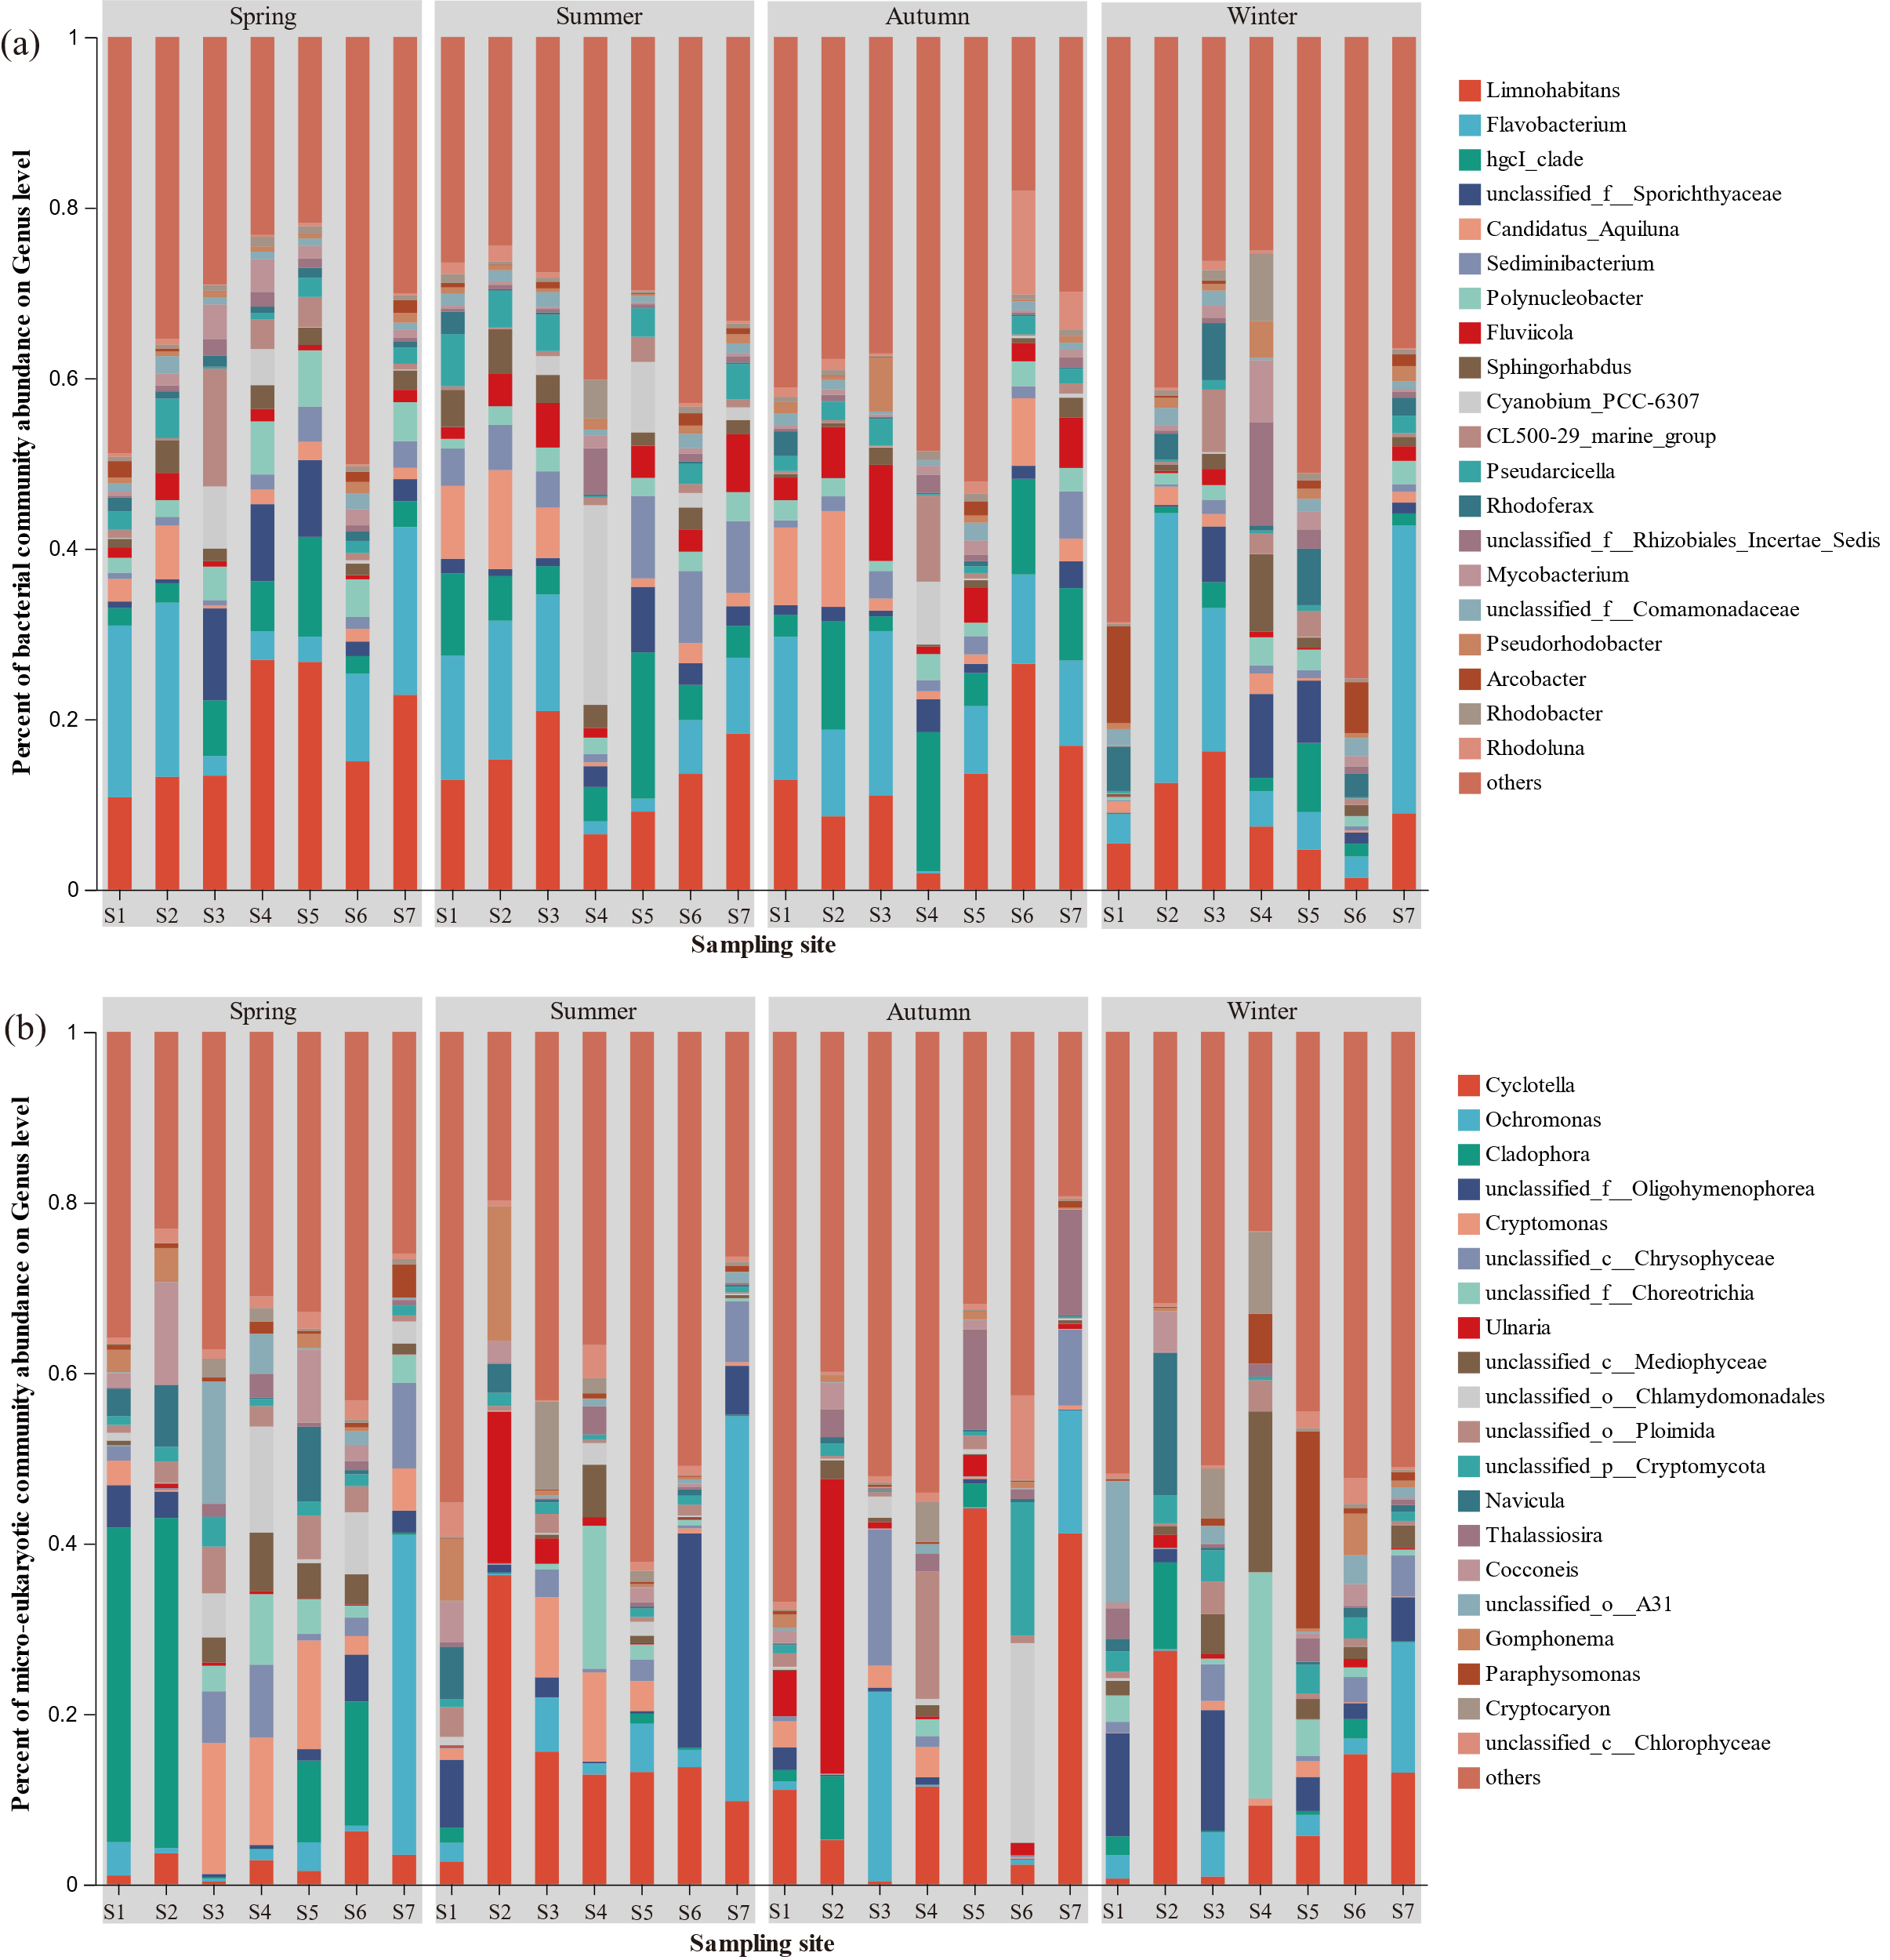
Figure S2. Relative abundance (%) of top 20 dominant genera for bacteria (a) and micro-eukaryotes (b) at different sampling sites in four seasons from the Xiangjianghe river.

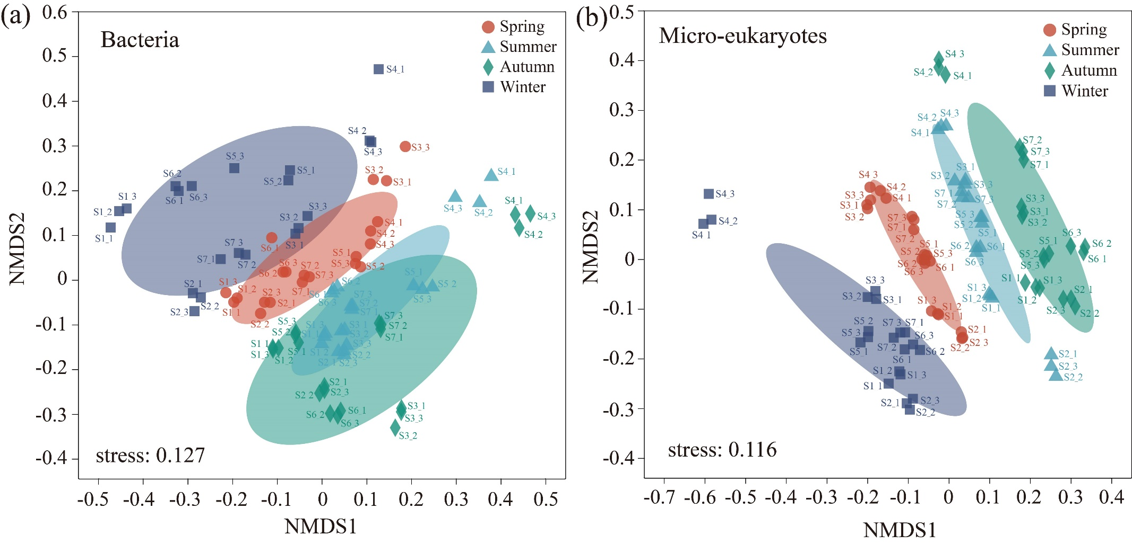
Figure S3. Nonmetric multidimensional scaling analysis (NMDS) of bacterial (a) and micro-eukaryotic (b) community at OTU level based on Bray-Curtis distance in different seasons and sampling sites.

