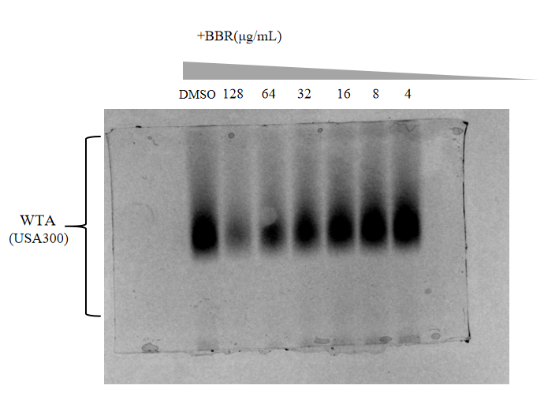

Supplementary Fig.1 WTA-PAGE analysis was performed on USA300-LAC treated with different concentrations of BBR.
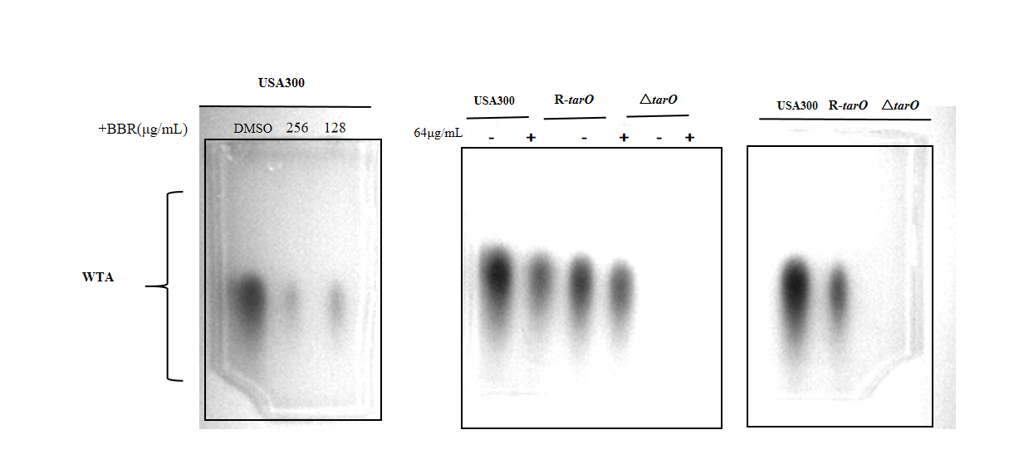

Supplementary Fig.2 WTA-PAGE analysis was performed on USA300-LAC treated with different concentrations of BBR;WTA-PAGE analysis was conducted after treatment with 64 µg/mL BBR in USA300-LAC, R-tarO, and ΔtarO strains.WTA-PAGE analysis of USA300-LAC, R-tarO and ΔtarO strains.（Some results are not shown in the article）

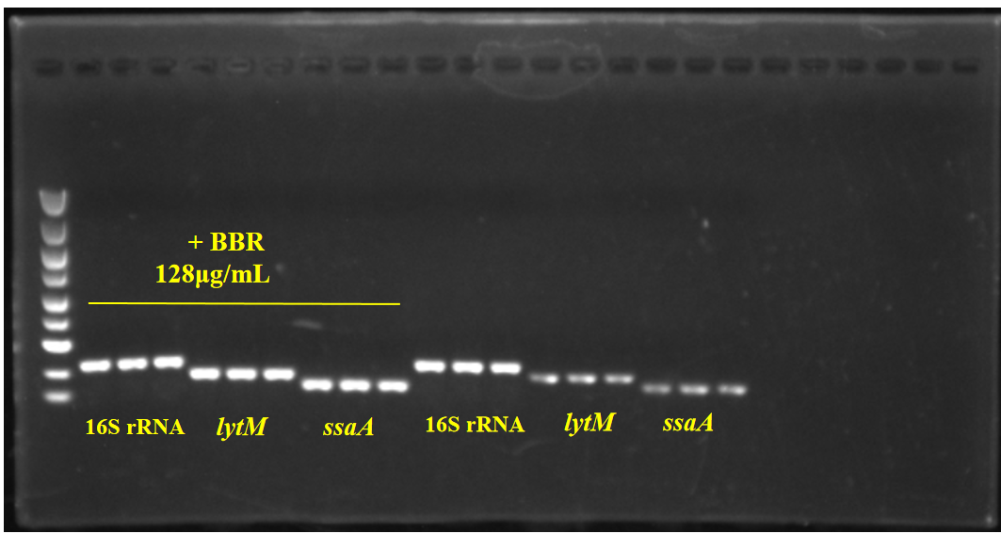

Supplementary Fig.3 The changes of lytM and ssaA gene levels in USA300 after BBR treatment for 3 hours were analyzed by qRT-PCR

Supplementary Fig.4 3D molecular docking diagram of berberine and TarO. The 3D interaction maps revealed that BBR forms hydrogen bonds with TarO’s LYS-38 and LEU-206, ensuring stable binding.

