Synthesis, Physicochemical Characterization and Biological Activity of Novel Pyrrole Flavones
Stepan Sysak^{a,b}, Barbara Wicherª, Malgorzata Kucinska^{c}, Paulina Kobylka^{b,c}, Dariusz T. Mlynarczykª, Roman Lesyk^{d,e}, Ewa Tykarskaª, Marek Murias^{c}, Tomasz Goslinski^{a,*} Wojciech Szczolko^{a,*}
ª Chair and Department of Chemical Technology of Drugs, Poznan University of Medical Sciences, Rokietnicka 3, 60-806 Poznań, Poland;
^{b} Doctoral School, Poznan University of Medical Sciences, Bukowska 70, 60-812 Poznań, Poland;
^{c} Chair and Department of Toxicology, Poznan University of Medical Sciences, Poznan University of Medical Sciences, Rokietnicka 3, 60-806 Poznań, Poland;
^{d} Department of Biotechnology and Cell Biology, Medical College, University of Information Technology and Management in Rzeszów, Sucharskiego 2, 35-225 Rzeszow, Poland;
^{e} Department of Pharmaceutical, Organic and Bioorganic Chemistry, Danylo Halytsky Lviv National Medical University, Pekarska 69, 79010 Lviv, Ukraine
* Correspondence: wszczolko@ump.edu.pl (WS), tomasz.goslinski@ump.edu.pl (TG)

Supplementary Information

Characterization of the solid-state…………………………………………...............S2
NMR data of 4a-5c.....………….………………………………….……………...…S10
UV-VIS spectra of 4a-c and 5a-c……………………………………………………S27

Characterization of the solid-state

Table S1. Crystal data and refinement details for 4a, 4b and 4c.
Identification code | 4a | 4b | 4c
Chemical formula | C₂₁H₁₇NO₂ | C₂₆H₁₉NO₂ | C₂₇H₂₅NO₆
Formula weight | 315.36 | 377.42 | 459.48
Crystal system | Monoclinic | Monoclinic | Monoclinic
Space group | P2₁/n | P2₁/c | P2₁/c
a, b, c (Å) | 14.2591 (6),  7.1953 (2),  16.5955 (5) | 6.0238 (2),  38.492 (1),  8.4012 (3) | 34.098 (5),  7.8911 (8),  18.876 (2)
β (°) | 99.396 (3) | 96.099 (4) | 105.447 (15)
Volume (Å³) | 1679.8 (1) | 1936.95 (12) | 4895.4 (11)
Z | 4 | 4 | 8
Density (calculated) (Mg m⁻³) | 1.247 | 1.294 | 1.247
Absorption coefficient (mm⁻¹) | 0.64 | 0.65 | 0.73
Crystal size (mm) | 0.40 × 0.30 × 0.05 | 0.50 × 0.07 × 0.07 | 0.20 × 0.15 × 0.02
Reflections collected | 14024 | 12963 | 38192
Reflections observed  [I > 2σ(I)] | 2571 | 2859 | 5350
R_{int} | 0.022 | 0.46 | 0.73
Data/parameters/restrains | 3425/219/ 0 | 3898/263/0 | 8991/622/2
Goodness-of-fit on F² | 1.03 | 1.03 | 1.03
Final R indices [I > 2σ(I)] | 0.0462, 0.1274 | 0.0537, 0.1404 | 0.0708, 0.1988
R indices (all data) | 0.0606, 0.1445 | 0.0705, 0.1585 | 0.1096, 0.2361
Largest diff. peak and hole | 0.13, -0.14 | 0.15, -0.22 | 0.30, -0.25
CCDC # | 2394582 | 2394581 | 2394584

Table S2. Crystal data and refinement details for 5a, 5b and 5c.
Identification code | 5a | 5b | 5c
Chemical formula | C₂₁H₁₇NO₂ | C₂₆H₁₉NO₂ | C₂₇H₂₅NO₆
Formula weight | 315.36 | 377.42 | 459.48
Crystal system | Monoclinic | Monoclinic | Monoclinic
Space group | P2₁/c | P2₁/n | P2₁/c
a, b, c (Å) | 8.0088 (3), 30.6676 (9), 7.3600 (3) | 5.5474 (2),  25.5876 (7), 13.7806 (3) | 16.5661 (4), 11.5687 (2), 12.6365 (3)
β (°) | 113.626 (5) | 94.054 (2) | 105.319 (3)
Volume (Å³) | 1656.18 (12) | 1951.19 (10) | 2335.72 (10)
Z | 4 | 4 | 4
Density (calculated) (Mg m⁻³) | 1.265 | 1.285 | 1.307
Absorption coefficient (mm⁻¹) | 0.65 | 0.64 | 0.73
Crystal size (mm) | 0.40 × 0.25 × 0.05 | 0.30 × 0.15 × 0.07 | 0.30 × 0.20 × 0.03
Reflections collected | 17097 | 16064 | 19505
Reflections observed  [I > 2σ(I)] | 2785 | 3108 | 4006
R_{int} | 0.035 | 0.32 | 0.732
Data/parameters/restrains | 3425/219/ 0 | 3976/263/0 | 4782/340/12
Goodness-of-fit on F² | 1.02 | 1.02 | 1.05
Final R indices [I > 2σ(I)] | 0.0428, 0.1105 | 0.0430, 0.1122 | 0.0589, 0.1687
R indices (all data) | 0.0510, 0.1192 | 0.0562, 0.1260 | 0.0671, 0.1805
Largest diff. peak and hole | 0.12, -0.16 | 0.15, -0.20 | 0.37, -0.36
CCDC # | 2394583 | 2394585 | 2394586

Figure S1. ORTEP representation of asymmetric units. Displacement ellipsoids are shown at the 50% probability level. H atoms have been omitted for clarity. For disordered ester moiety in 5c, only the major position is shown.

Figure S2. Powder X-ray diffractograms and DSC (black) and TGA (purple) thermograms of 4a, 4b and 4c. Red diffractograms are simulated based on crystal structures, and black are registered for the recrystallized samples.

Figure S3. Powder X-ray diffractograms and DSC (black) and TGA (purple) thermograms of 5a, 5b and 5c. Red diffractograms are simulated based on crystal structures, and black are registered for the recrystallized samples.
Table S3. Dihedral angles (°) between different ring moieties observed in the solid state.
 | Benzopyran-4-one - phenyl | Benzopyran-4-one- pyrrole | Pyrrolyl - phenyl
4a | 7.30 (6) | 76.92 (7)
4b | 9.56 (8) | 71.00 (7) | 30.48 (9)
4c-A | 10.11 (13) | 88.32 (12)
4c-B | 15.65 (13) | 88.52 (10)
5a | 10.66 (4) | 66.59 (6)
5b | 1.30 (5) | 81.68 (6) | 28.52 (7)
5c | 39.73 (8) | 75.20 (7)
Table S4. Dihedral angles (°) between benzopyran-4-one and phenyl rings observed for flavone moieties in the crystal structures deposited in the Cambridge Structural Database.
REFCODE | angle | REFCODE | angle | REFCODE | angle | REFCODE | angle
IYIWOE | 54.99 | JICKIS | 13.83 | GOPZET | 7.90 | IDAYUI | 2.97
OQOGIN | 41.18 | BALREN | 13.76 | ZUNHIB | 7.82 | SOLPUF | 2.93
OQOGIN | 40.88 | ALAJUS | 12.59 | JAYNAZ | 7.56 | VICBIV | 2.91
IYIWEU | 37.29 | HECHAY02 | 12.38 | PEHROK | 7.54 | HURCAY | 2.84
MIXVIZ | 34.71 | HECHAY | 12.23 | ALAJOM | 7.30 | GUZSIF | 2.79
NOCTIL01 | 33.40 | EJEQOB | 12.15 | QOLLAF | 7.25 | KASXIM | 2.77
LEPBOZ | 31.85 | QARGEX | 12.07 | VUXZAQ | 7.15 | BIYQAE | 2.31
EGURUU01 | 31.01 | GUZSEB | 12.02 | VOJDUU | 6.82 | PUZLII | 2.23
LEPBOZ | 30.99 | HECHAY03 | 11.91 | RAMGOB02 | 6.80 | AFOCUV | 1.90
EGURUU | 30.86 | PUZKUT | 11.85 | POMDUR | 6.70 | EMEWID | 1.82
LEPBIT | 29.91 | LOHDAQ | 11.77 | KUNFAA | 6.69 | ZOGDEH | 1.79
TOHZIC | 29.62 | EJEQAN | 11.64 | QOLMUA | 6.15 | LIXMEN | 1.61
LEPBIT | 29.18 | NIXLOW | 11.47 | PIMLAB | 6.15 | NEFQOF | 1.48
XOYVOY | 29.01 | HECHAY01 | 11.13 | KAMQOH | 6.11 | NEFQOF01 | 1.38
LEPBUF | 28.31 | RUHDOP | 10.87 | POMPAK | 6.04 | WADRAV | 1.34
JICKIS | 26.77 | KUNFEE | 10.81 | GUZRIE | 5.91 | KAMQUN | 1.20
LEPBUF | 26.29 | HIQWUZ | 10.67 | KAMQIB | 5.75
KAMJUD | 24.79 | EGURUU01 | 10.58 | KEJBAC | 5.68
KAMJUD01 | 24.77 | CAHYIW | 10.57 | YAYQOF | 5.65
BAZGOB | 24.75 | CAHYIW01 | 10.46 | POMDUR | 5.45
XAGKOF | 21.69 | WADRAV | 10.43 | KAMQOH | 5.44
ZUNHOH | 21.21 | EGURUU | 10.36 | KUPLOZ | 5.42
UQEHAA | 21.18 | GUZREA | 10.34 | WAPMIK | 5.03
GAZWUB | 19.99 | VUCFUU01 | 10.08 | LUFTIR | 4.84
VOHKEK | 19.96 | GUZRUQ | 10.05 | YULFIV | 4.53
LAMDIM | 19.03 | GUZSAX | 9.86 | NOCTIL | 4.45
GOPZET | 18.39 | ZUNHOH01 | 9.80 | LOWQOG | 4.43
RUHDOP | 18.29 | SULFUB | 9.77 | ETATOL | 4.40
IYIWIY | 18.25 | VUCFUU | 9.73 | RUHDOP | 4.31
SOLPUF01 | 17.07 | RAMGOB01 | 9.72 | LOWQOG | 4.19
OWIDIJ | 16.69 | YEJVEO | 9.67 | KAMREY | 4.04
VOHKEK01 | 16.48 | RUHDOP | 9.64 | JIJWIL | 4.04
TOLQOD | 16.38 | MUJPAL | 9.50 | EWIVEN | 3.96
OQIWIX | 16.02 | RAMGOB02 | 9.06 | LAWTOV | 3.85
JICKIS | 15.92 | UMAXEO | 8.90 | LUFTIR | 3.79
BUTWAQ | 15.52 | KAMRAU | 8.86 | SULFOV | 3.76
GUZRAW | 14.71 | TALGIX | 8.72 | EGUXUA | 3.70
QARGEX | 14.06 | EDEJUS | 8.70 | AMEXIB | 3.68
TUKGIS | 13.94 | RAMGOB | 8.60 | SULFOV | 3.43
ISATAZ | 13.94 | YULFIV | 8.35 | JILSIJ | 3.23
MURRUO | 13.91 | GUZROK | 8.03 | GUZSEB | 3.04

Table S5 Percentage contribution of short contacts to the Hirshfeld surface area.
 | H···H | C···H | O···H | C···C | O···C | N···H | O···O | N···C
4A | 57.5 | 23.9 | 8.2 | 3.8 | 6.1 | 0.6 | 0 | 0
5A | 58.0 | 19.2 | 10.6 | 8.3 | 2.9 | 0.9 | 0 | 0
4B | 56.3 | 24.6 | 7.6 | 6.5 | 4 | 0.5 | 0.3 | 0.1
5B | 50.8 | 32.5 | 9.8 | 3.8 | 2.3 | 0.5 | 0 | 0.2
4C-A | 54.1 | 15.5 | 21.6 | 4.5 | 3.9 | 0.3 | 0 | 0
4C-B | 53.4 | 16.6 | 22.0 | 3.9 | 1.8 | 0.3 | 0 | 0
5C | 47.7 | 26.3 | 22.8 | 0.3 | 1.7 | 0.6 | 0.7 | 0

Table S6 Geometry (Å,°) of short contacts observed in crystal structures.
D—H···A | D—H | H···A | D···A | D—H···A
4a
C12’-H12C···O2^{i} | 0.96 | 2.66 | 3.615 (3) | 176
C5-H5···C3^{i} | 0.93 | 2.83 | 3.560 (2) | 136
C7-H7···C10’^{xi} | 0.93 | 2.90 | 3.703 (2) | 145
5a
C8-H8···O2^{iv} | 0.93 | 2.45 | 3.311 (2) | 154
4b
C3-H3···O2^{iii} | 0.93 | 2.54 | 3.456 (2) | 170
C6’-H6’···O2^{iii} | 0.93 | 2.60 | 3.457 (3) | 153
5b
C3-H3···O2^{v} | 0.93 | 2.47 | 3.348 (2) | 158
C5-H5···C8’^{vi} | 0.93 | 2.87 | 3.681 (2) | 147
C5-H5···C9’^{vi} | 0.93 | 2.78 | 3.592 (2) | 147
C8-H8···C11’^{vii} | 0.93 | 2.82 | 3.721 (2) | 164
C8-H8···C16’^{vii} | 0.93 | 2.81 | 3.625 (2) | 147
4c
C8A-H8A···O4A’^{ix} | 0.93 | 2.52 | 3.417 (4) | 162
C8B-H8B···O4”^{viii} | 0.93 | 2.46 | 3.348 (4) | 157
C17’-H17B···O2” | 0.97 | 2.53 | 3.336 (5) | 140
5c
C6-H6···O1”^{x} | 0.93 | 2.49 | 3.391 (7) | 164
C6-H6···O1’^{x} | 0.93 | 2.78 | 3.625 (7) | 156
C2’-H2”C···O2’^{ix} | 0.96 | 2.71 | 3.493 (9) | 139
C8-H8···O2^{ix} | 0.93 | 2.61 | 3.230 (2) | 124
Symmetry codes: (i) 1.5-X, 0.5+Y, 1.5-Z; (ii) -0.5+X, 0.5-Y, -0.5+Z; (iii) -X, 0.5+Y, 0.5-Z, (iv) X, Y, -1+Z; (v) 1-X, 1-Y, 2-Z; (vi) ) 0.5+X, 0.5-Y, 0.5+Z; (vii) -1+X, Y ,Z; (viii) X, 2.5-Y, 0.5+Z; (ix) X, 0.5-Y, 0.5+Z; (x) X, 0.5-Y, -0.5+Z; (xi) 2-X, 1-Y, 1-Z

Figure S4. 3D structures in 5a and 4b. For the latter, one pair of overlay flavone phenyl and pyran-4-one rings are shown in a spacefill style.

NMR data of 4a-4c and 5a-5c
6-(2,5-Dimethylpyrrol-1-yl)-2-phenyl-chromen-4-one (4a)
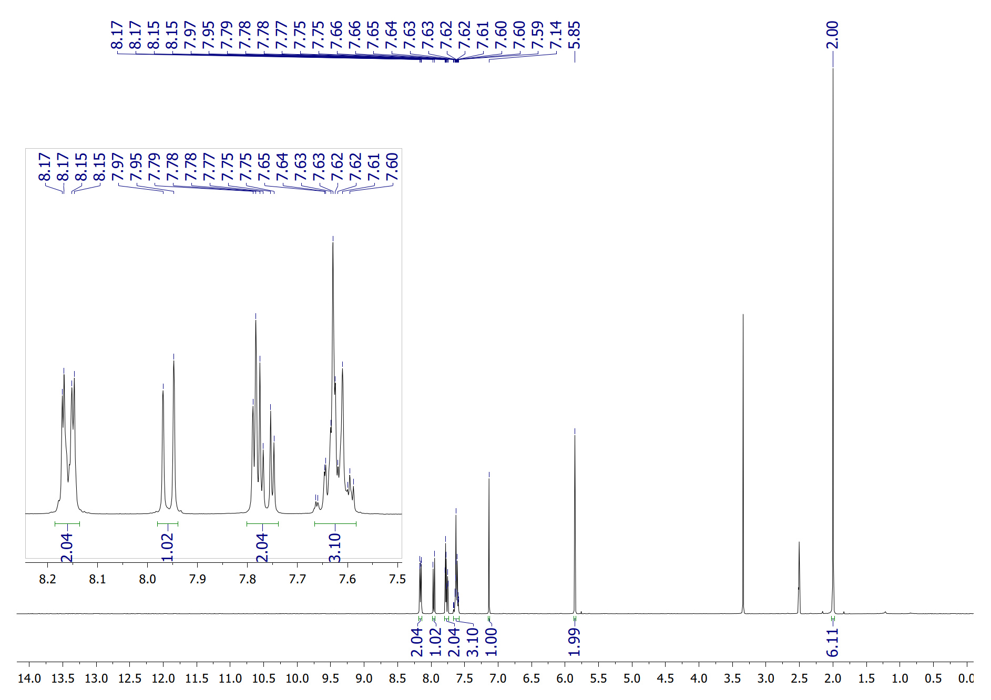
¹H NMR spectrum of 4a (DMSO-d₆, 25°C).
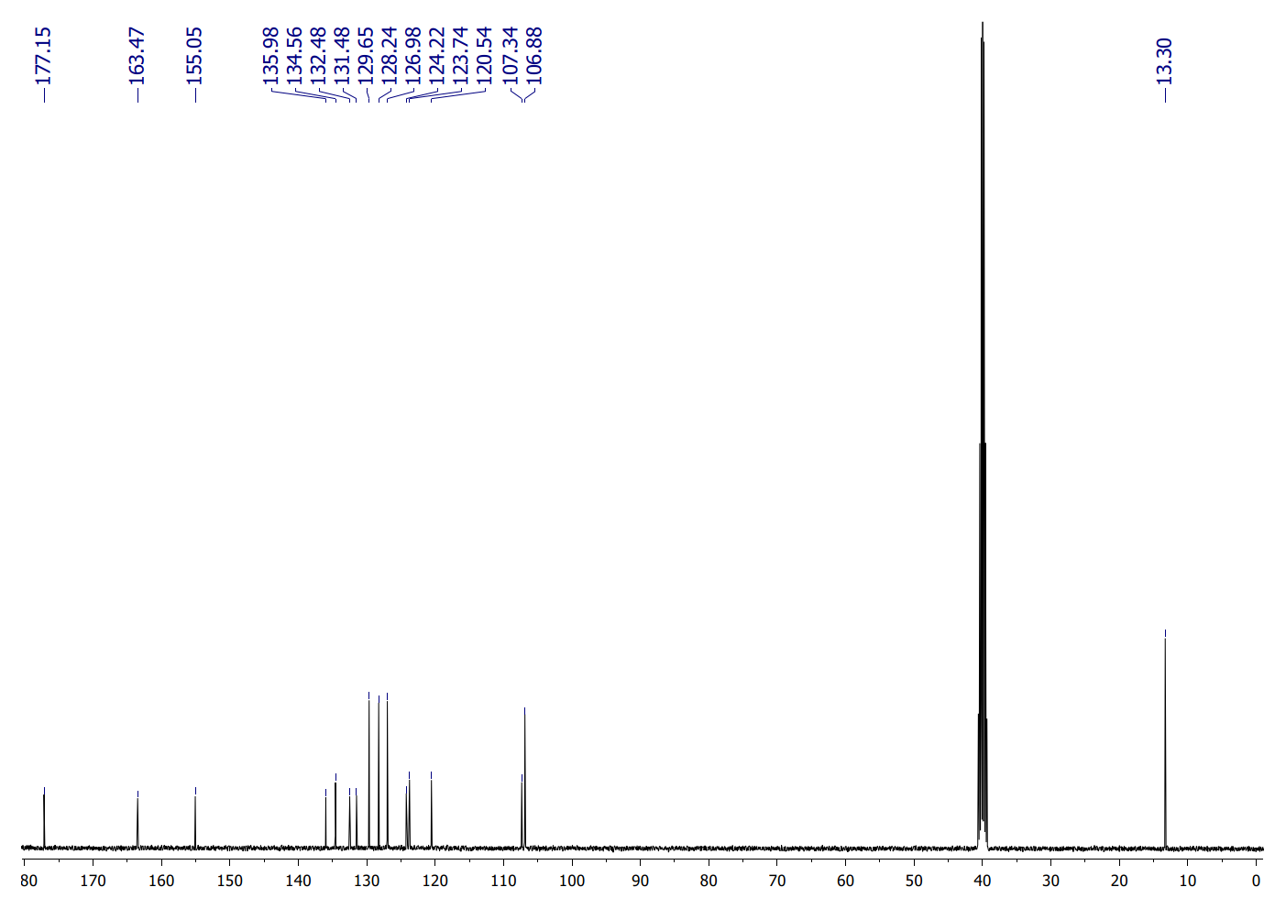
¹³C NMR spectrum of 4a (DMSO-d₆, 25°C).
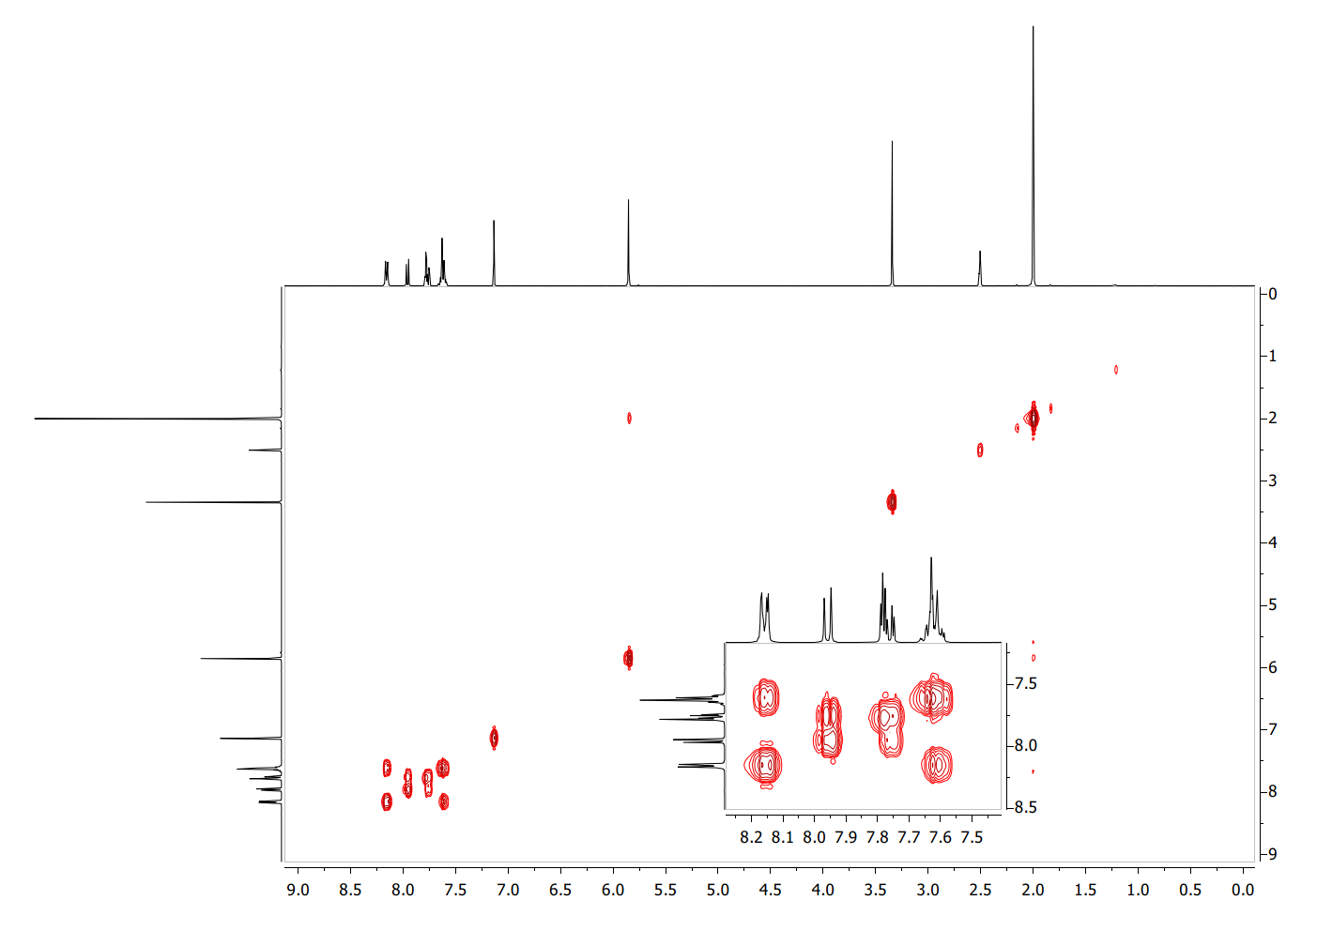
¹H¹H COSY NMR spectrum of 4a (DMSO-d₆, 25°C).
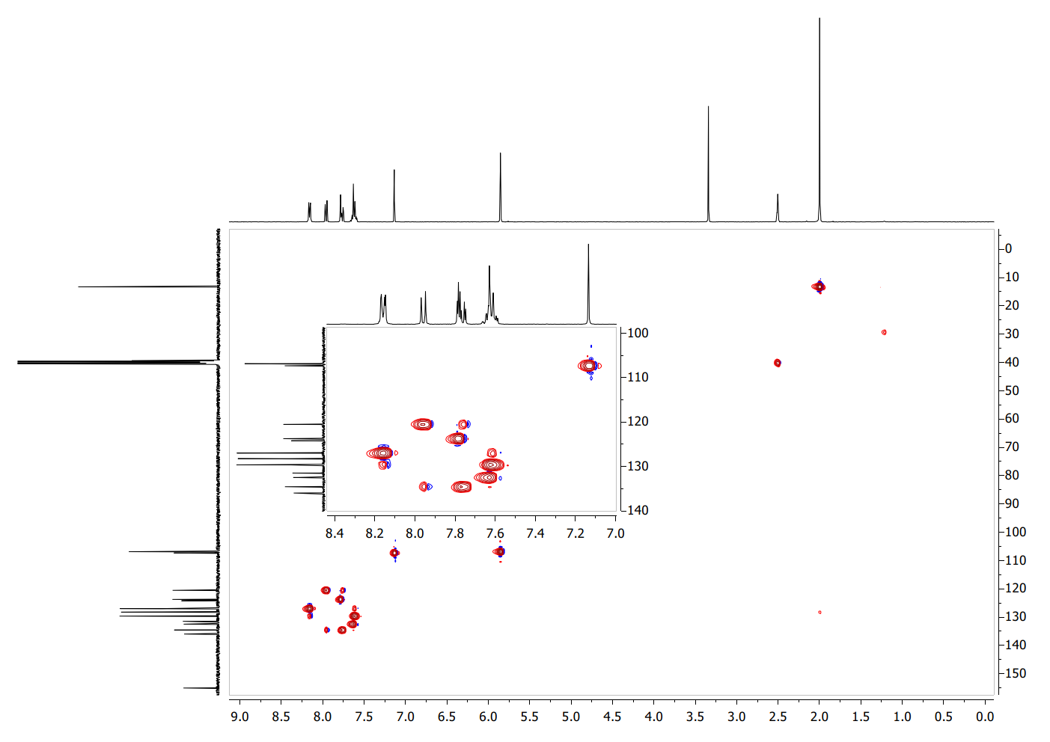
¹H¹³C HSQC NMR spectrum of 4a (DMSO-d₆, 25°C).
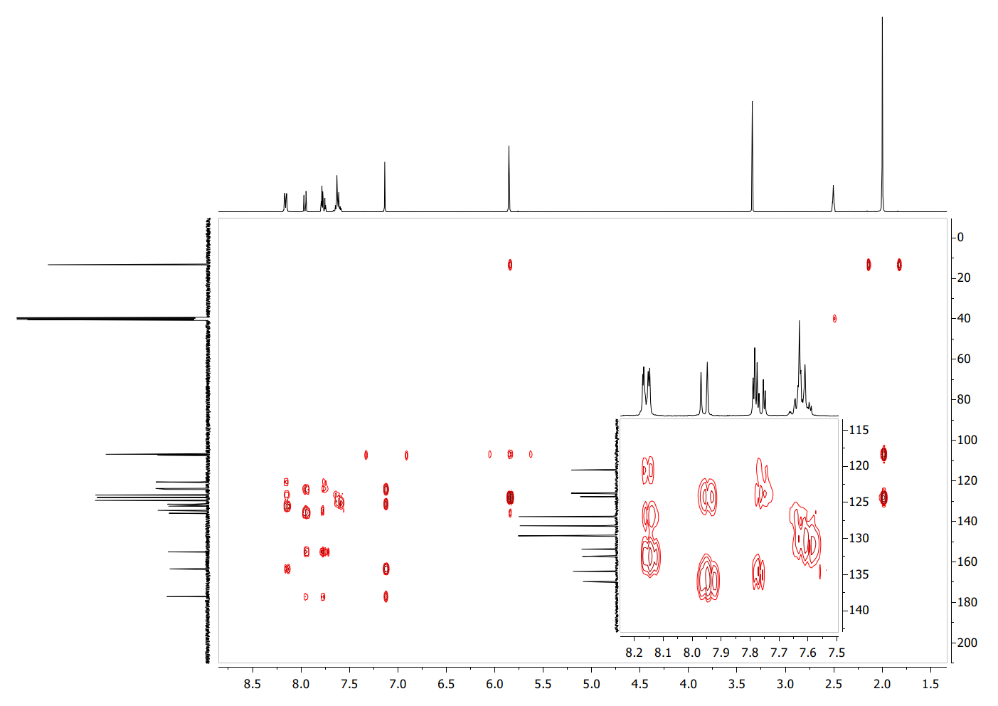
¹H¹³C HMBC NMR spectrum of 4a (DMSO-d₆, 25°C).

6-(2-Methyl-5-phenyl-pyrrol-1-yl)-2-phenyl-chromen-4-one (4b)
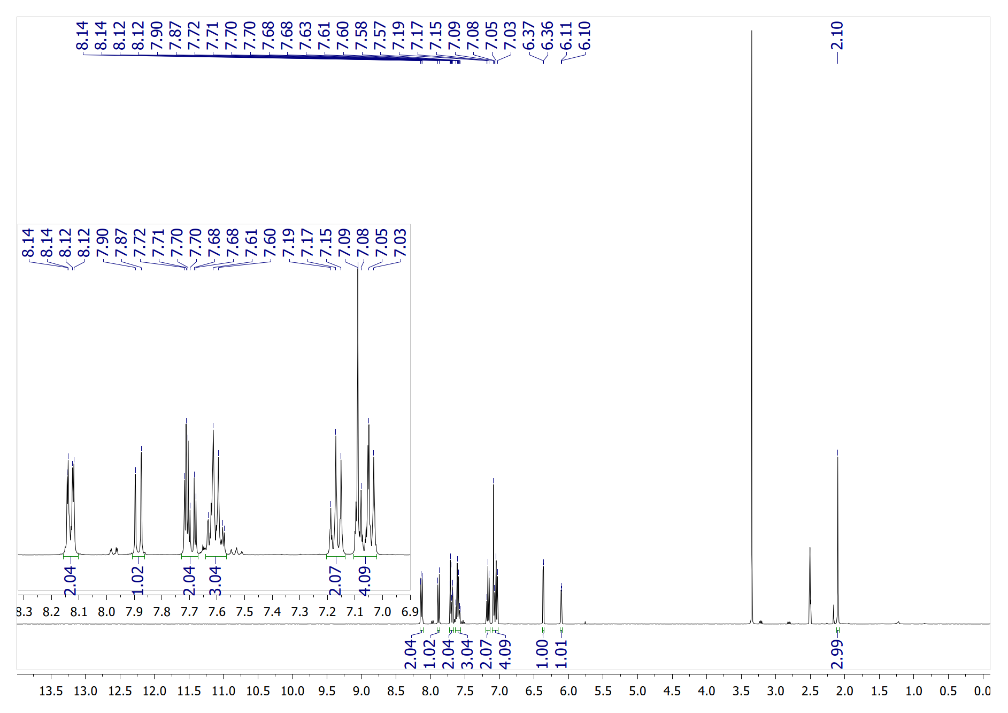
¹H NMR spectrum of 4b (DMSO-d₆, 25°C).
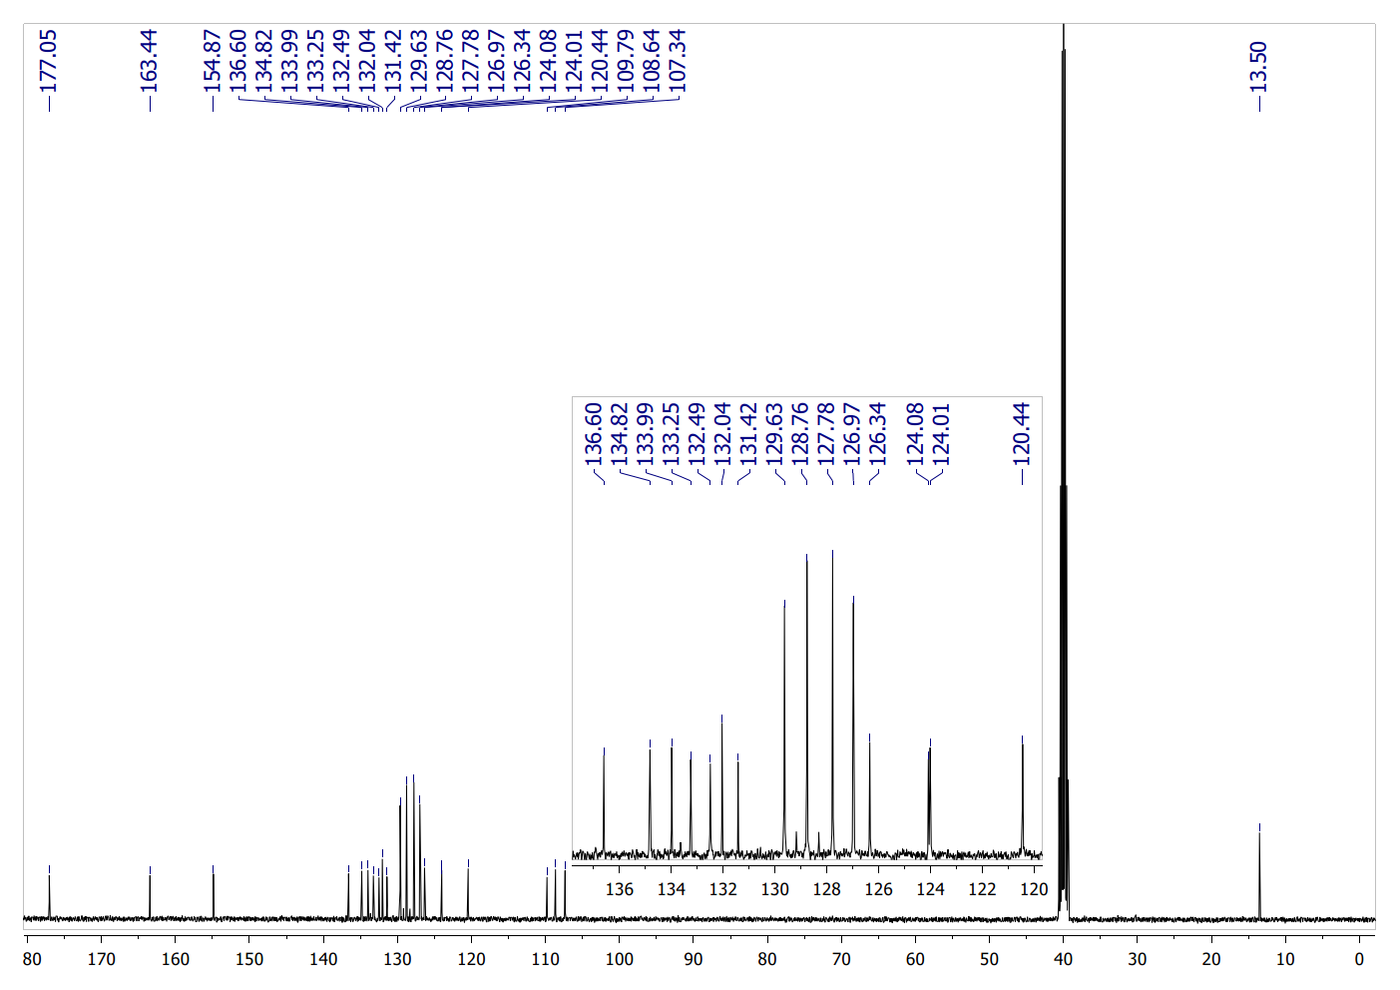
¹³C NMR spectrum of 4b (DMSO-d₆, 25°C).
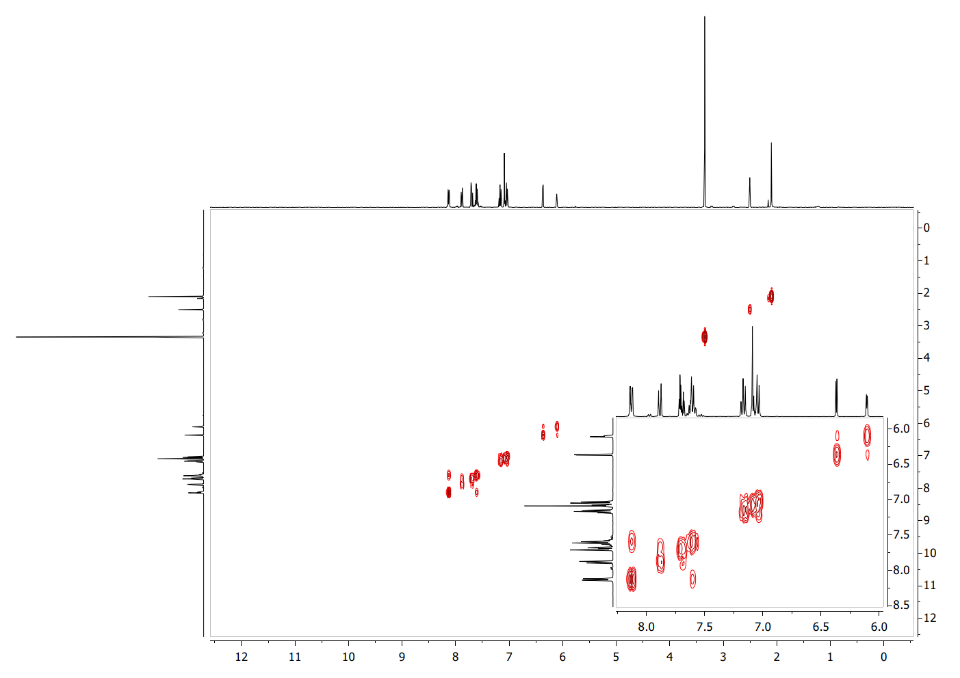
¹H¹H COSY NMR spectrum of 4b (DMSO-d₆, 25°C).
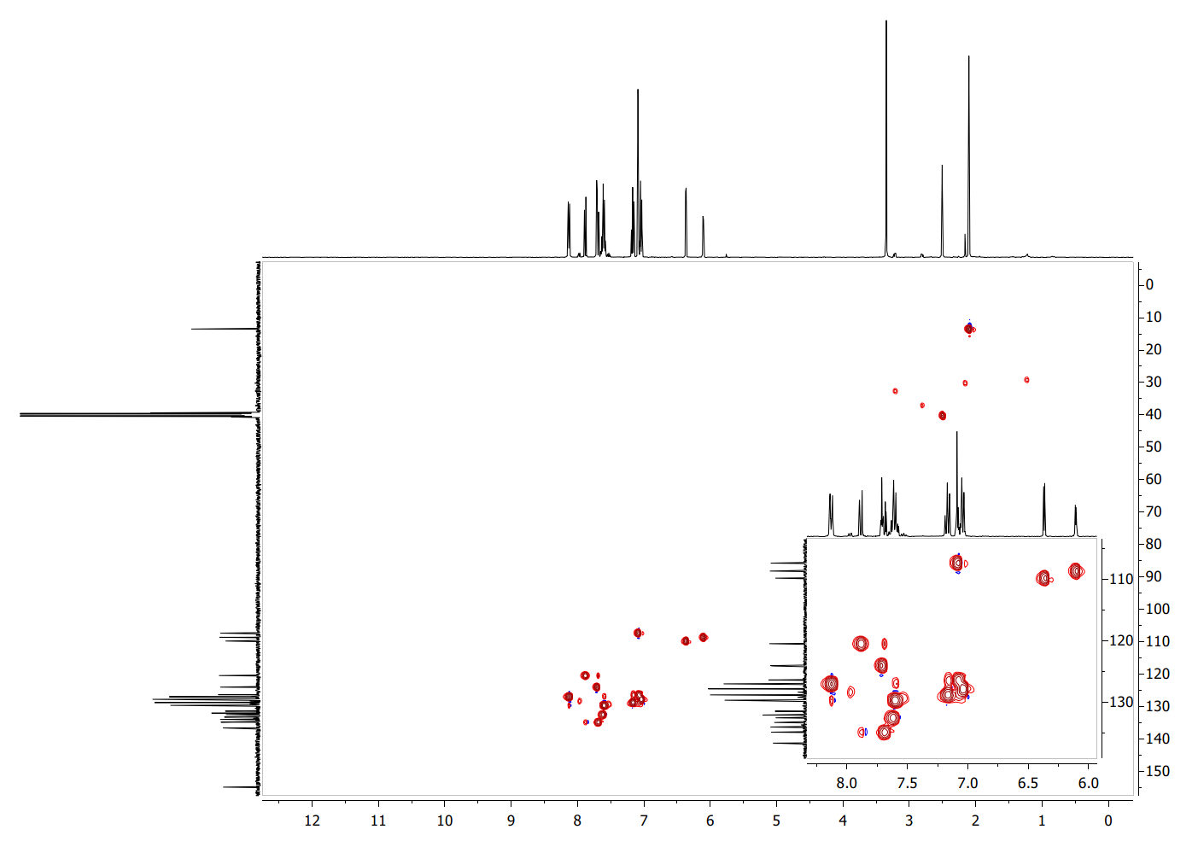
¹H¹³C HSQC NMR spectrum of 4b (DMSO-d₆, 25°C).
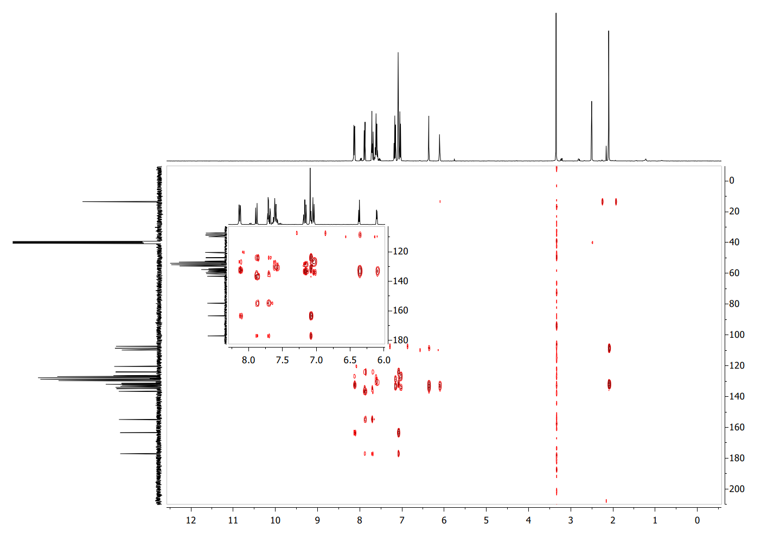
¹H¹³C HMBC NMR spectrum of 4b (DMSO-d₆, 25°C).

Diethyl 2,5-dimethyl-1-(4-oxo-2-phenyl-chromen-6-yl)pyrrole-3,4-dicarboxylate (4c)
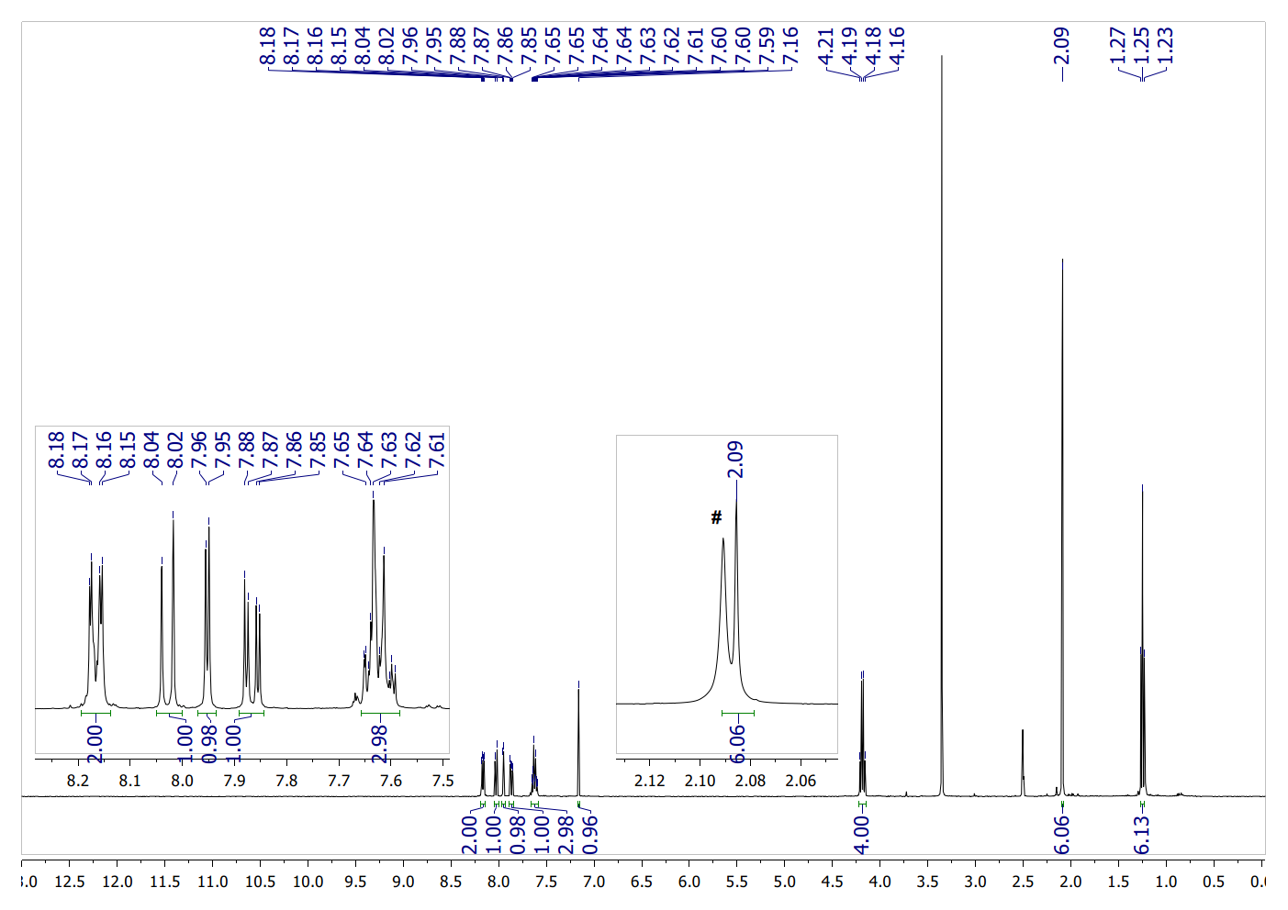
¹H NMR spectrum of 4c (DMSO-d₆, 25°C) # - residual peak from acetone.
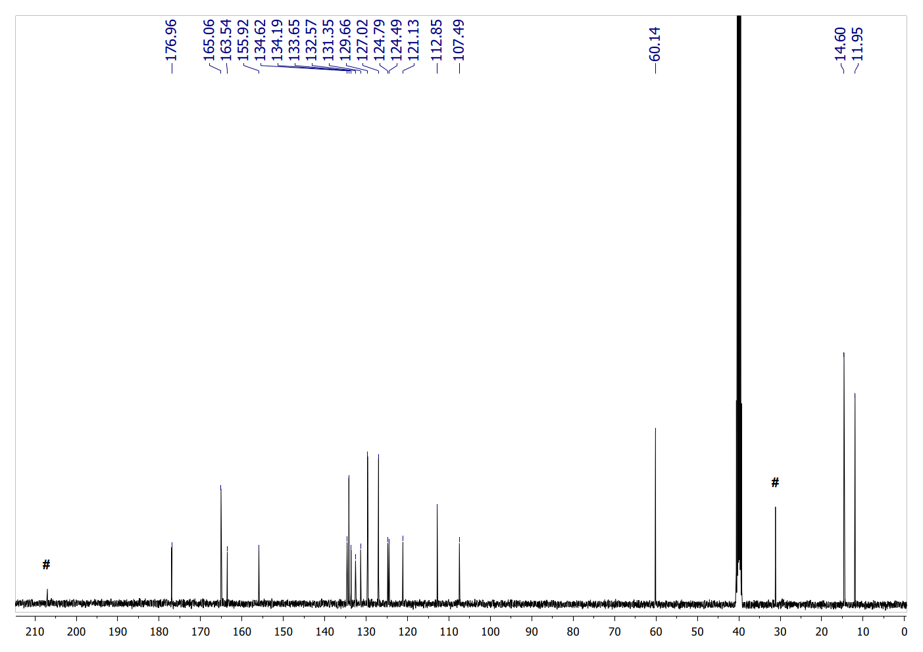
¹³C NMR spectrum of 4c (DMSO-d₆, 25°C) # - residual peaks from acetone.
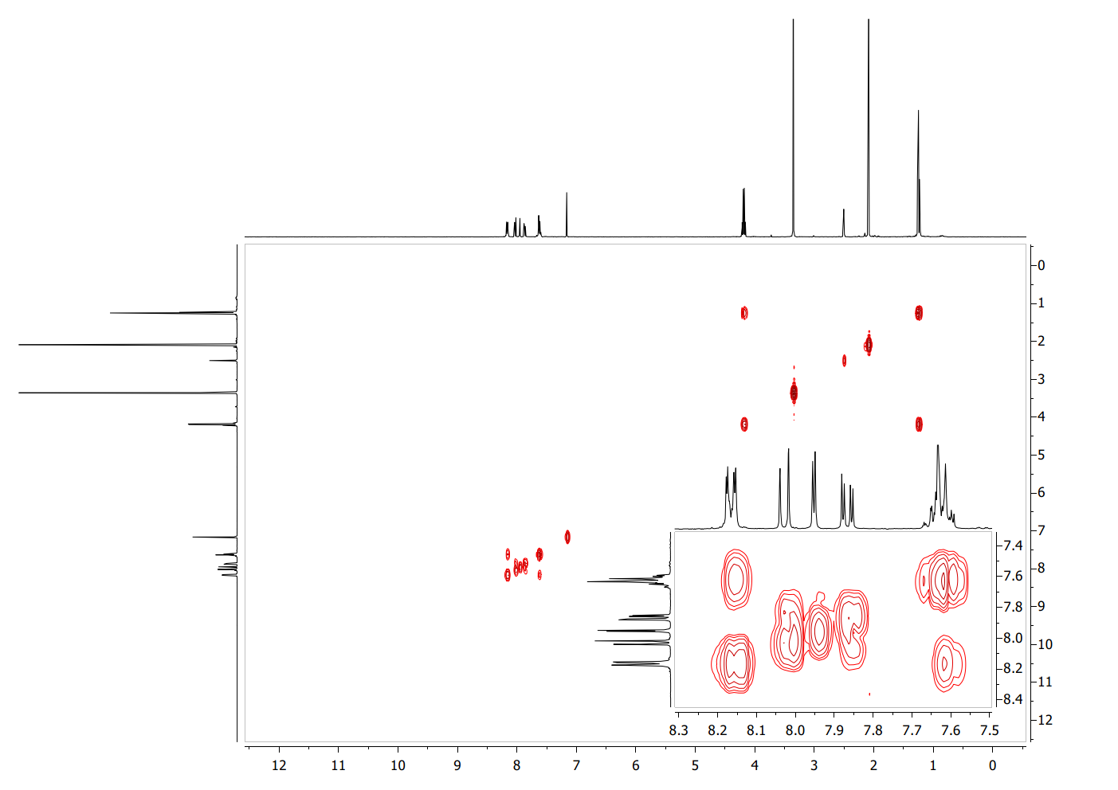
¹H¹H COSY NMR spectrum of 4c (DMSO-d₆, 25°C).
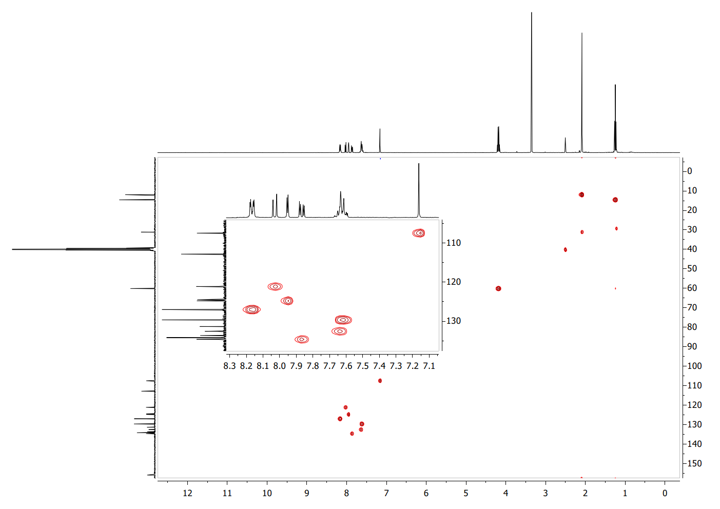
¹H¹³C HSQC NMR spectrum of 4c (DMSO-d₆, 25°C).
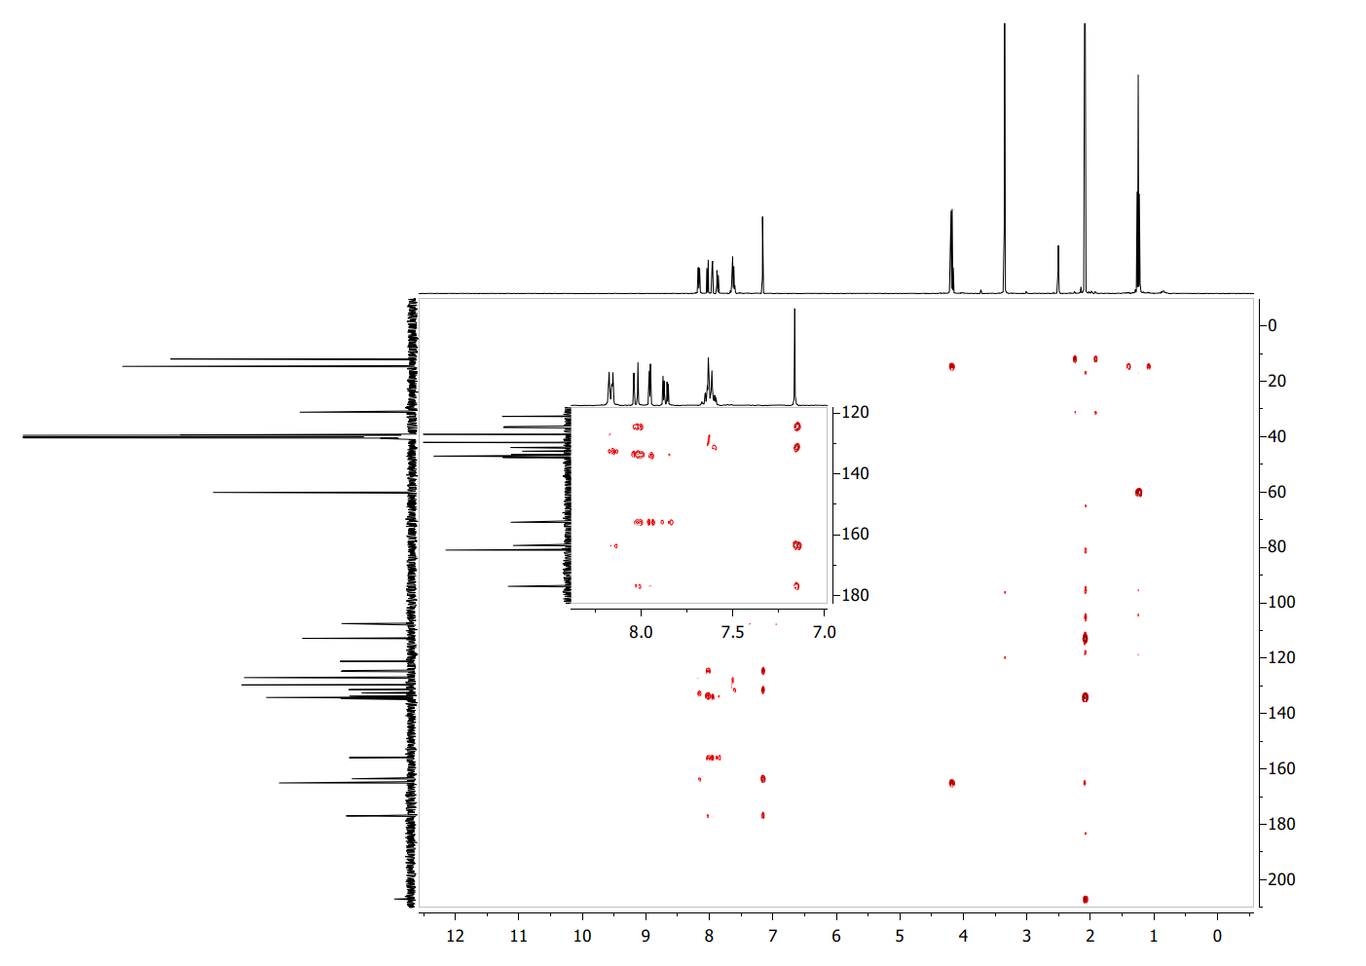
¹H¹³C HMBC NMR spectrum of 4c (DMSO-d₆, 25°C).

7-(2,5-Dimethylpyrrol-1-yl)-2-phenyl-chromen-4-one (5a)
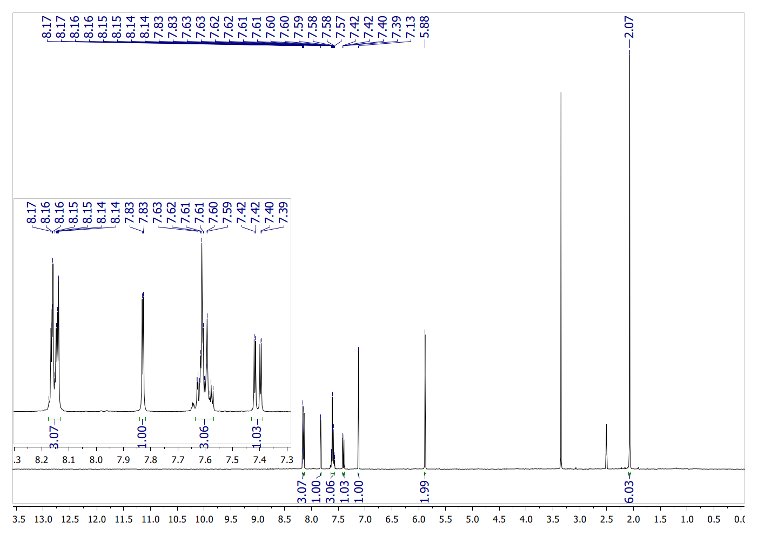
¹H NMR spectrum of 5a (DMSO-d₆, 25°C).
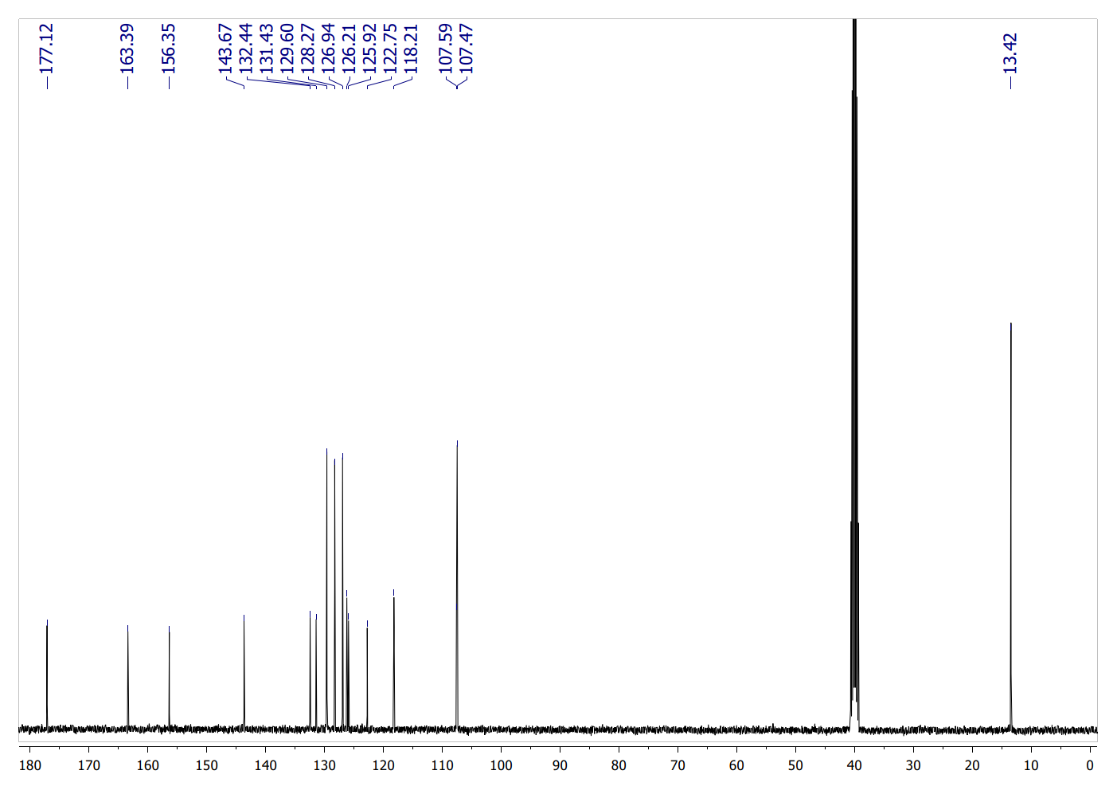
¹³C NMR spectrum of 5a (DMSO-d₆, 25°C).
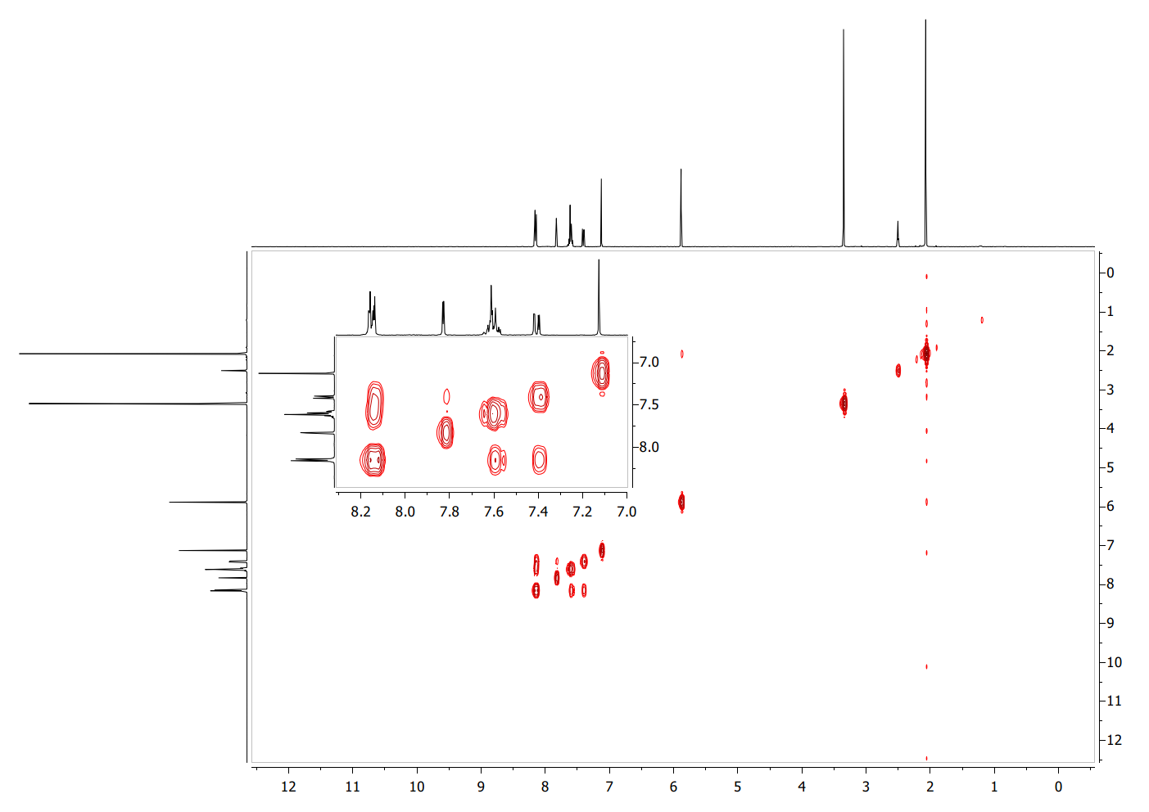
¹H¹H COSY NMR spectrum of 5a (DMSO-d₆, 25°C).
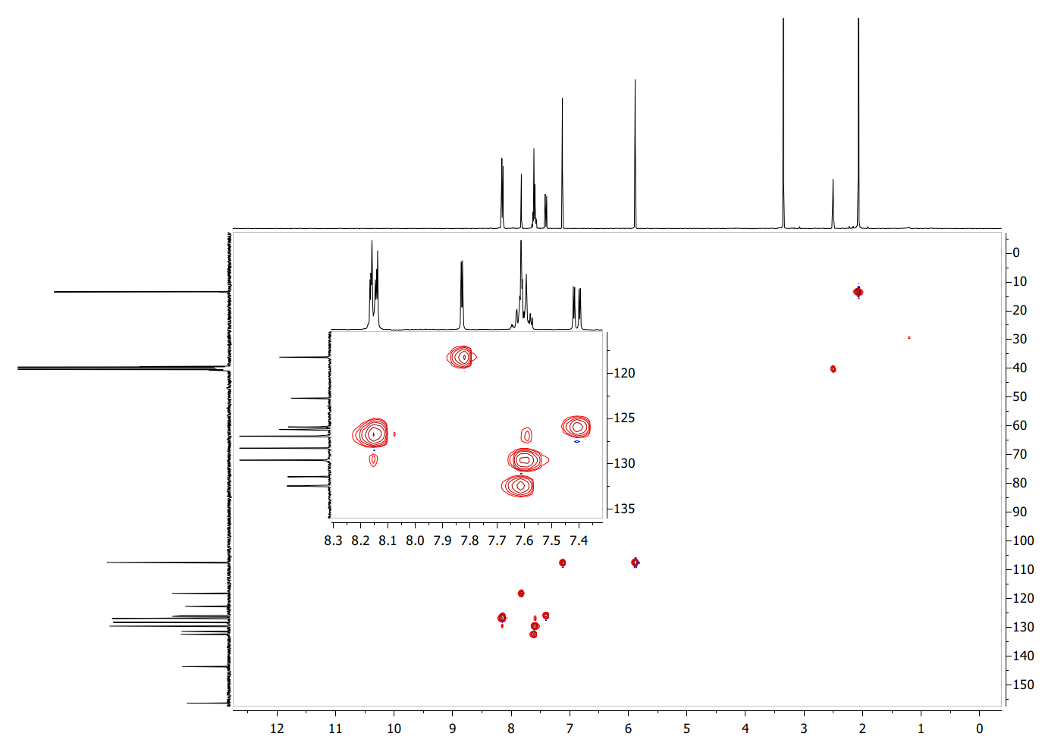
¹H¹³C HSQC NMR spectrum of 5a (DMSO-d₆, 25°C).
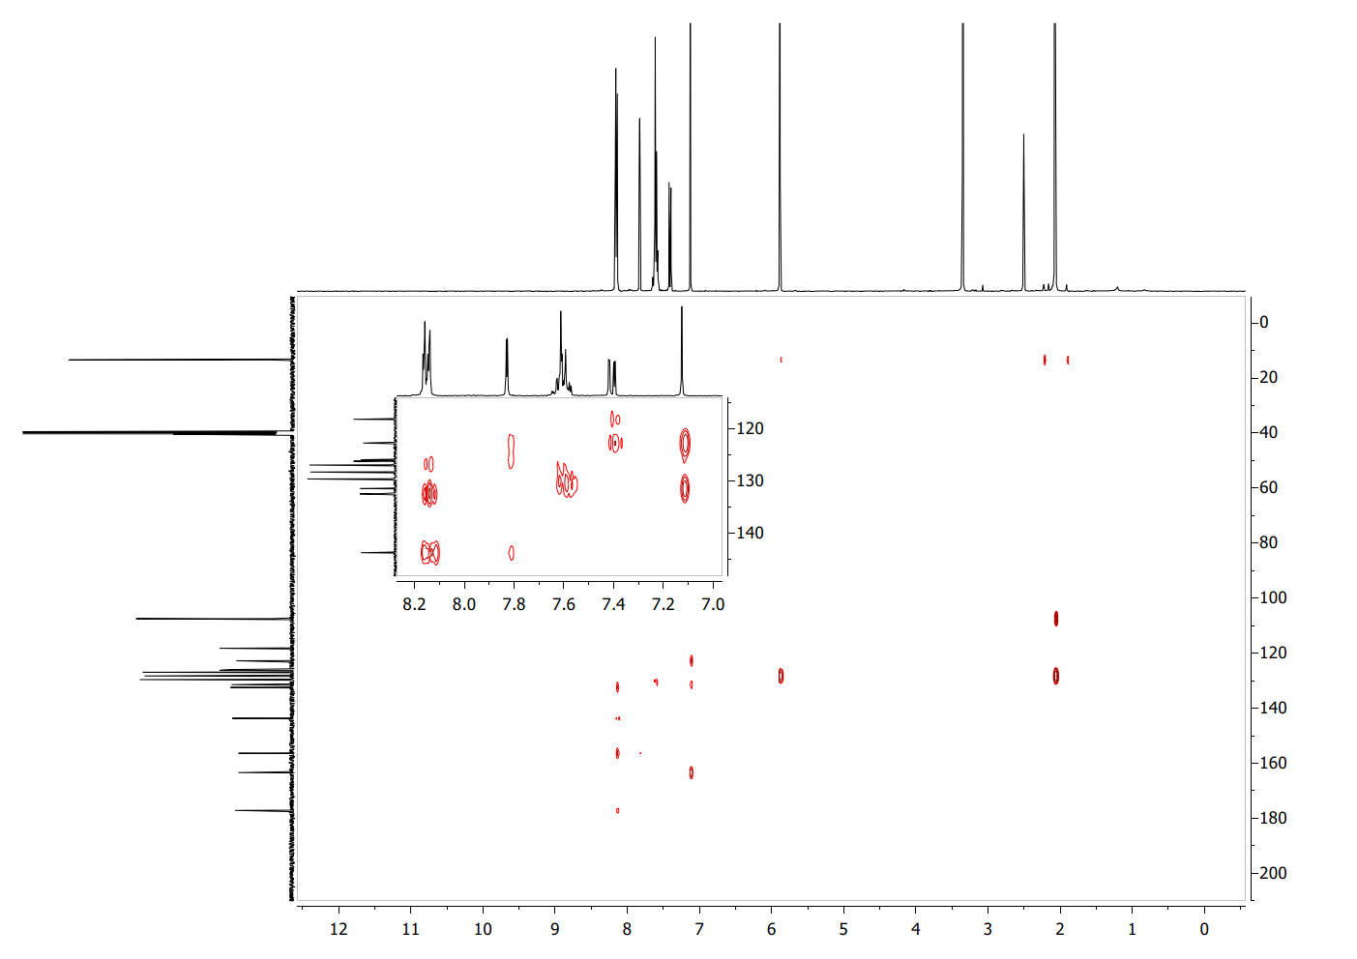
¹H¹³C HMBC NMR spectrum of 5a (DMSO-d₆, 25°C).

7-(2-Methyl-5-phenyl-pyrrol-1-yl)-2-phenyl-chromen-4-one (5b)
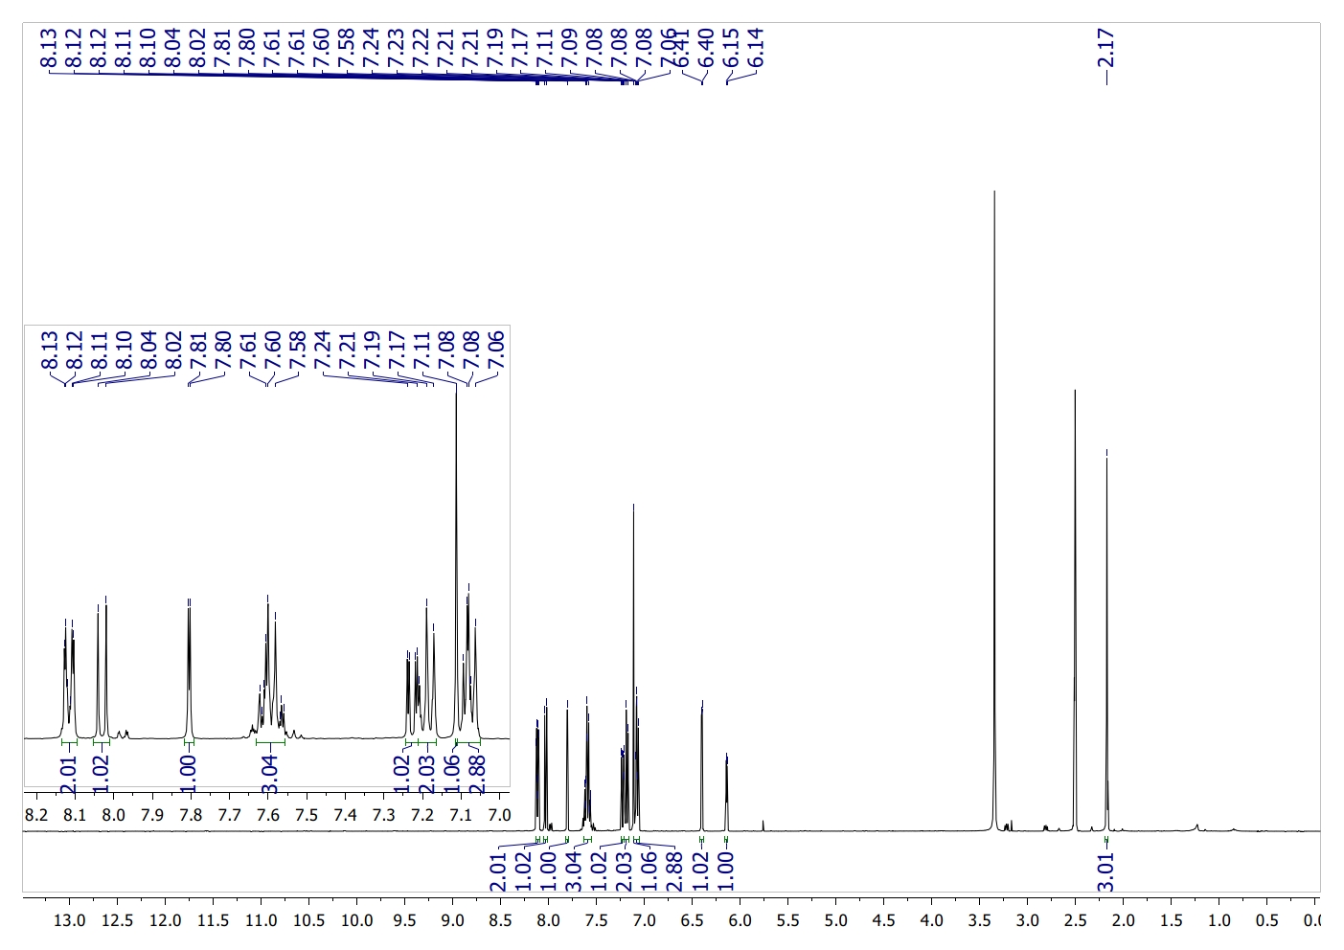
¹H NMR spectrum of 5b (DMSO-d₆, 25°C).
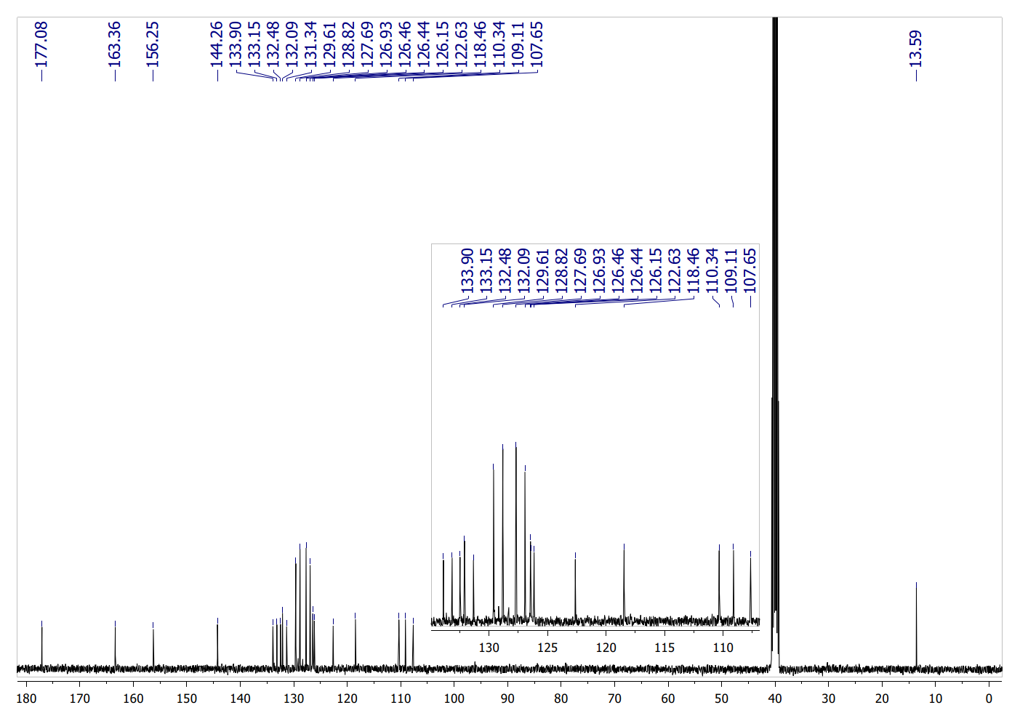
¹³C NMR spectrum of 5b (DMSO-d₆, 25°C).
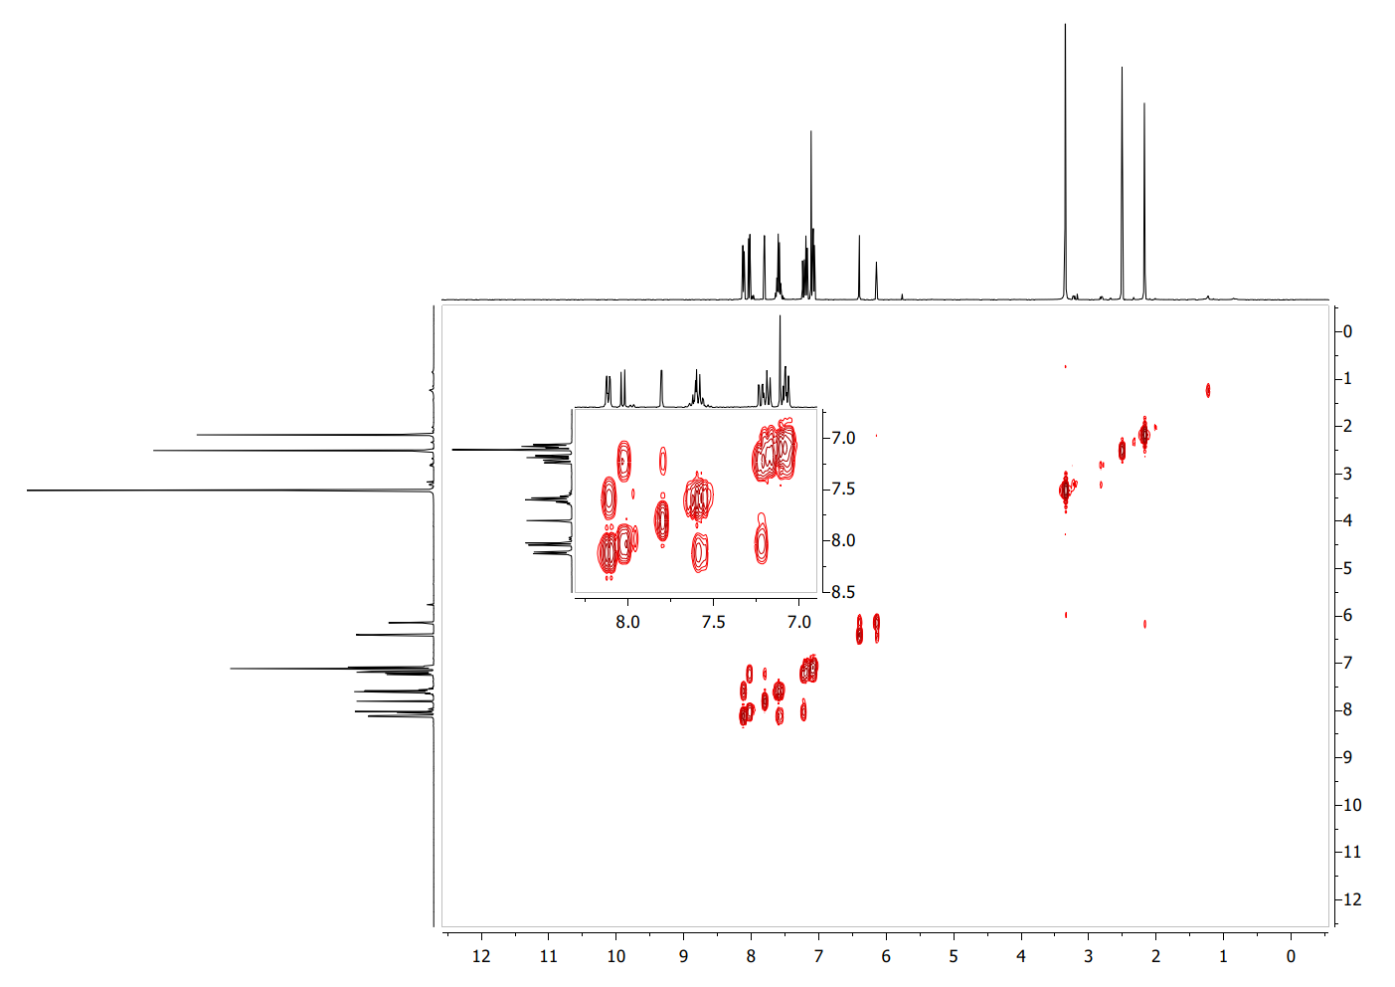
¹H¹H COSY NMR spectrum of 5b (DMSO-d₆, 25°C).
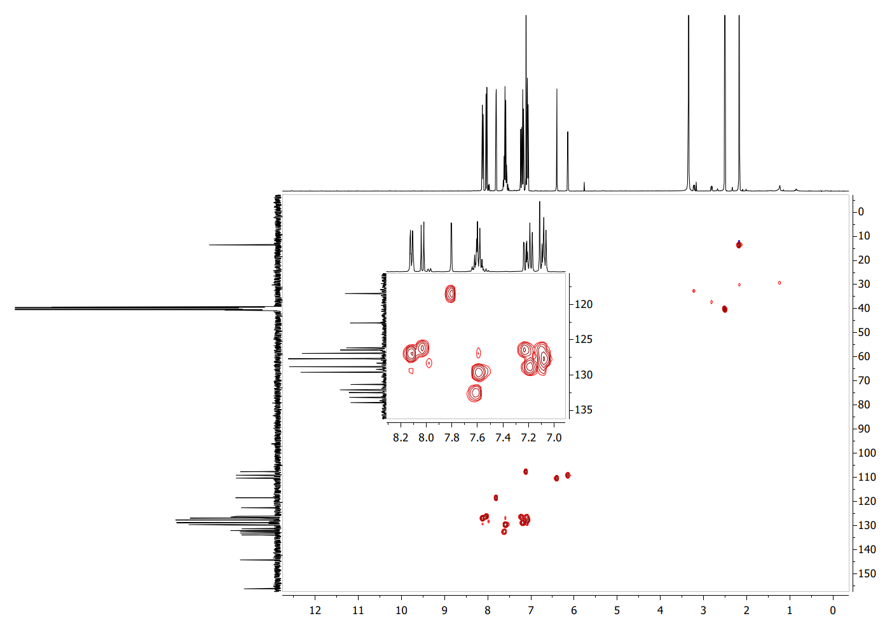
¹H¹³C HSQC NMR spectrum of 5b (DMSO-d₆, 25°C).
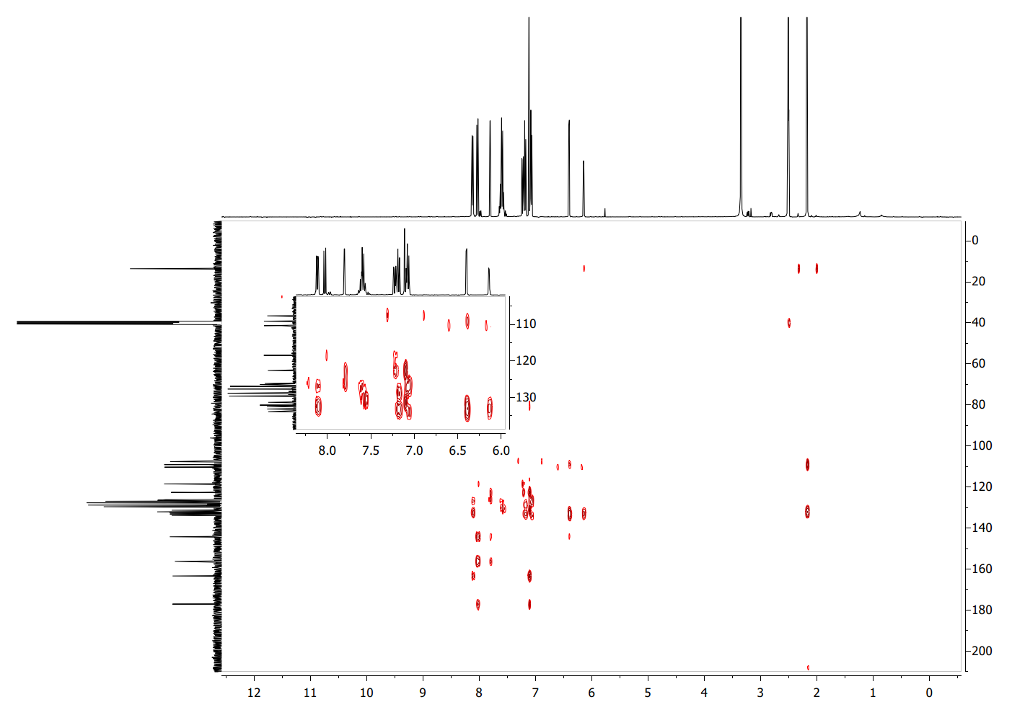
¹H¹³C HMBC NMR spectrum of 5b (DMSO-d₆, 25°C).

Diethyl 2,5-dimethyl-1-(4-oxo-2-phenyl-chromen-7-yl)pyrrole-3,4-dicarboxylate (5c)
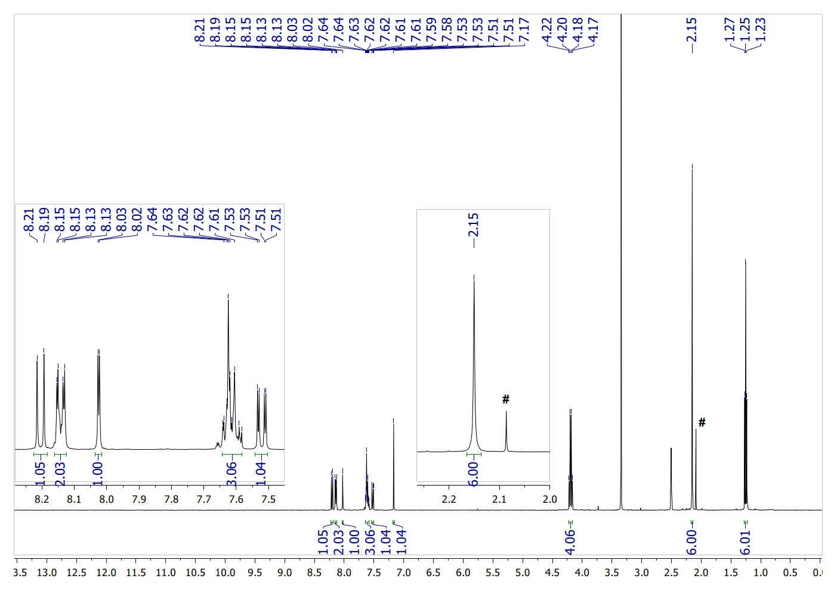
¹H NMR spectrum of 5c (DMSO-d₆, 25°C) # - residual peak from acetone.
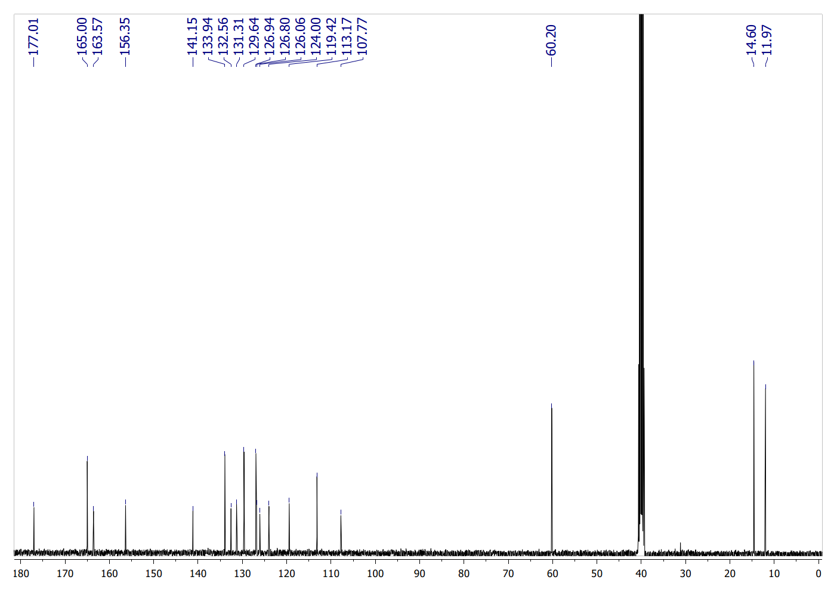
¹³C NMR spectrum of 5c (DMSO-d₆, 25°C).
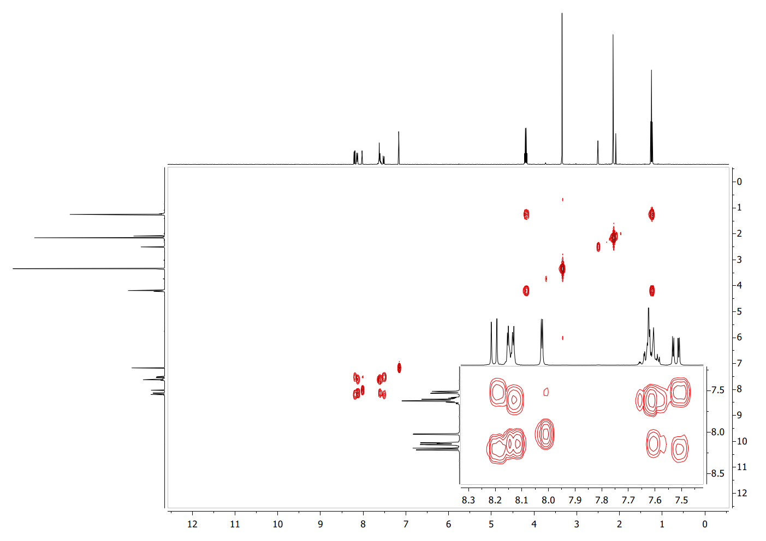
¹H¹H COSY NMR spectrum of 5c (DMSO-d₆, 25°C).
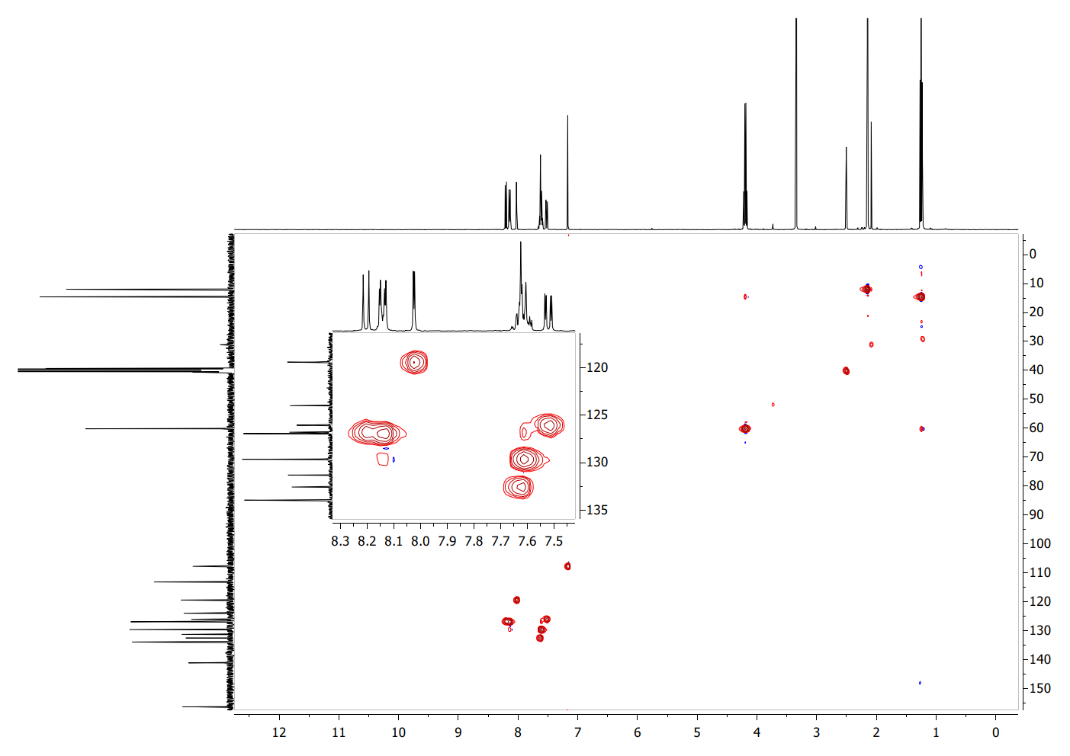
¹H¹³C HSQC NMR spectrum of 5c (DMSO-d₆, 25°C).

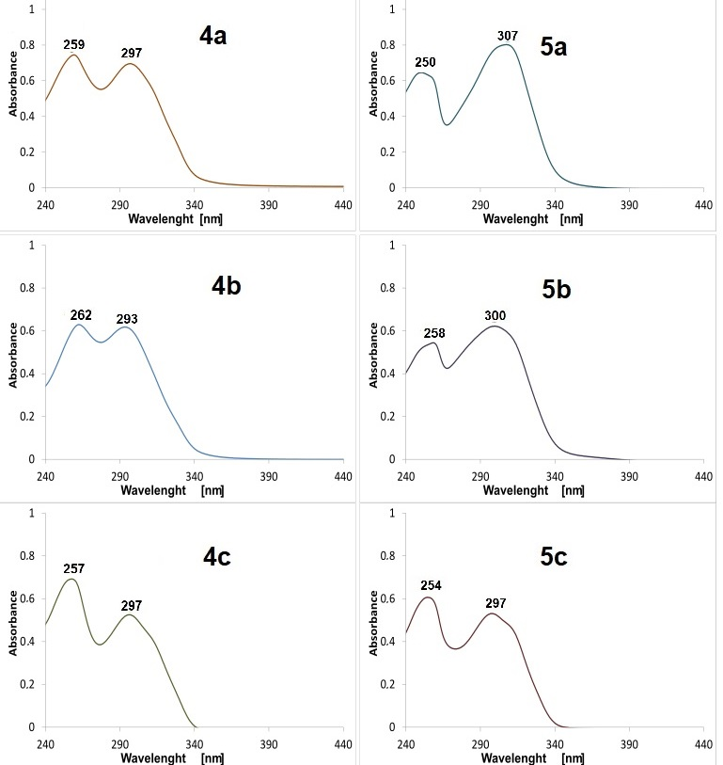
Figure S5. UV-VIS spectra recorded for 4a-c and 5a-c in methanol.

