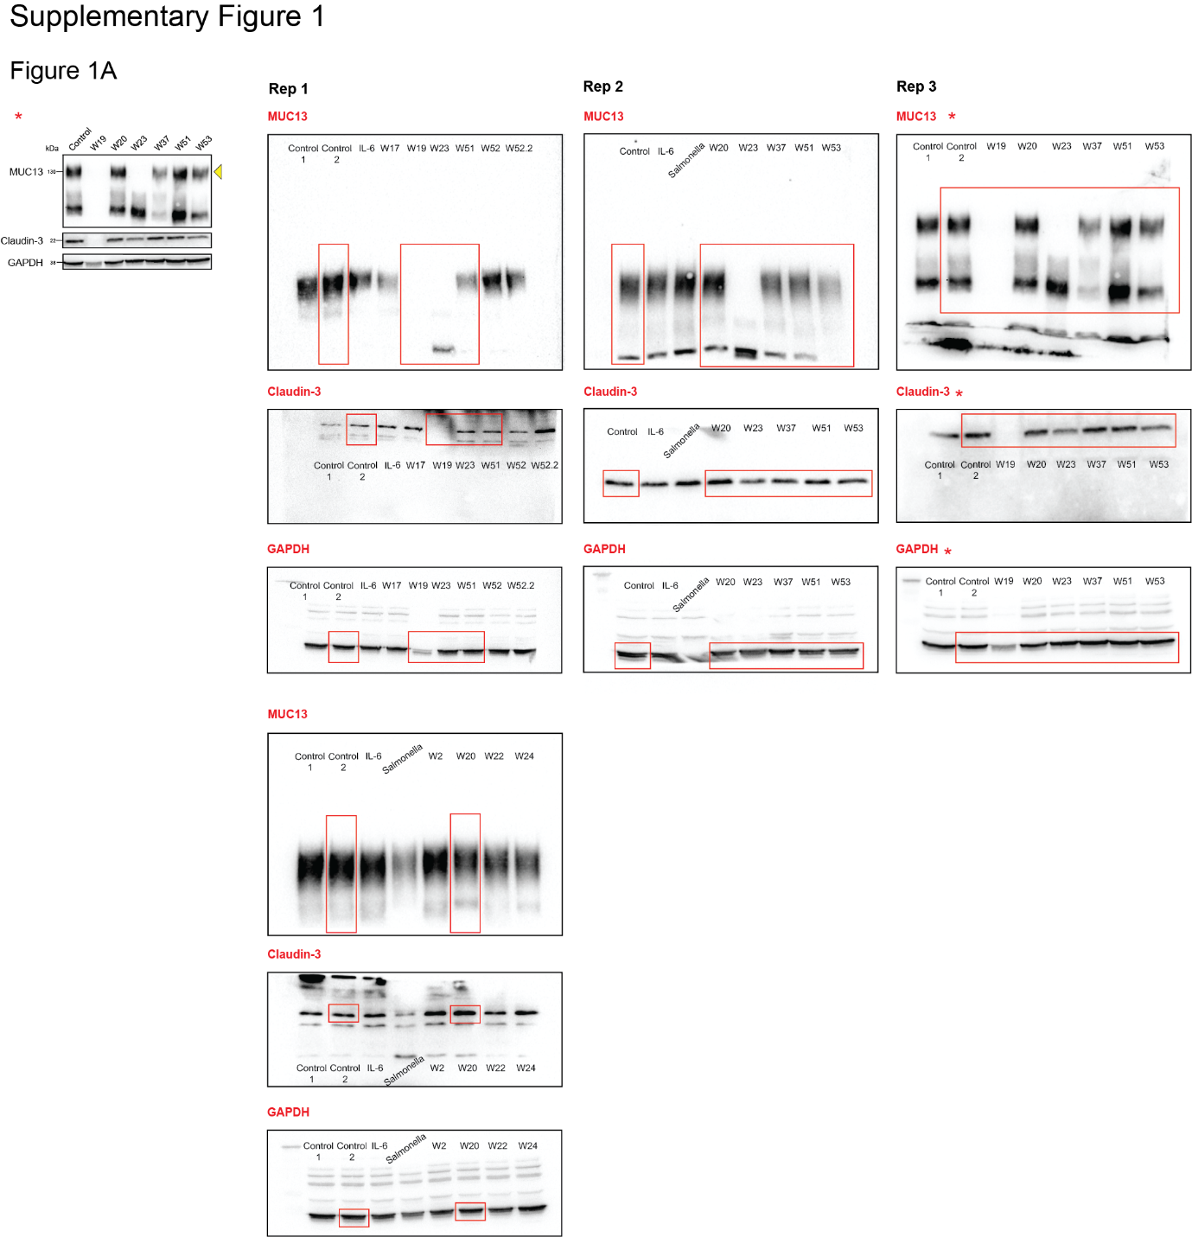

Figure S1. Original immunoblot data used for Figure 1A.
RAW immunoblot data of experimental replicates generated and analyzed for Figure 1A (left).
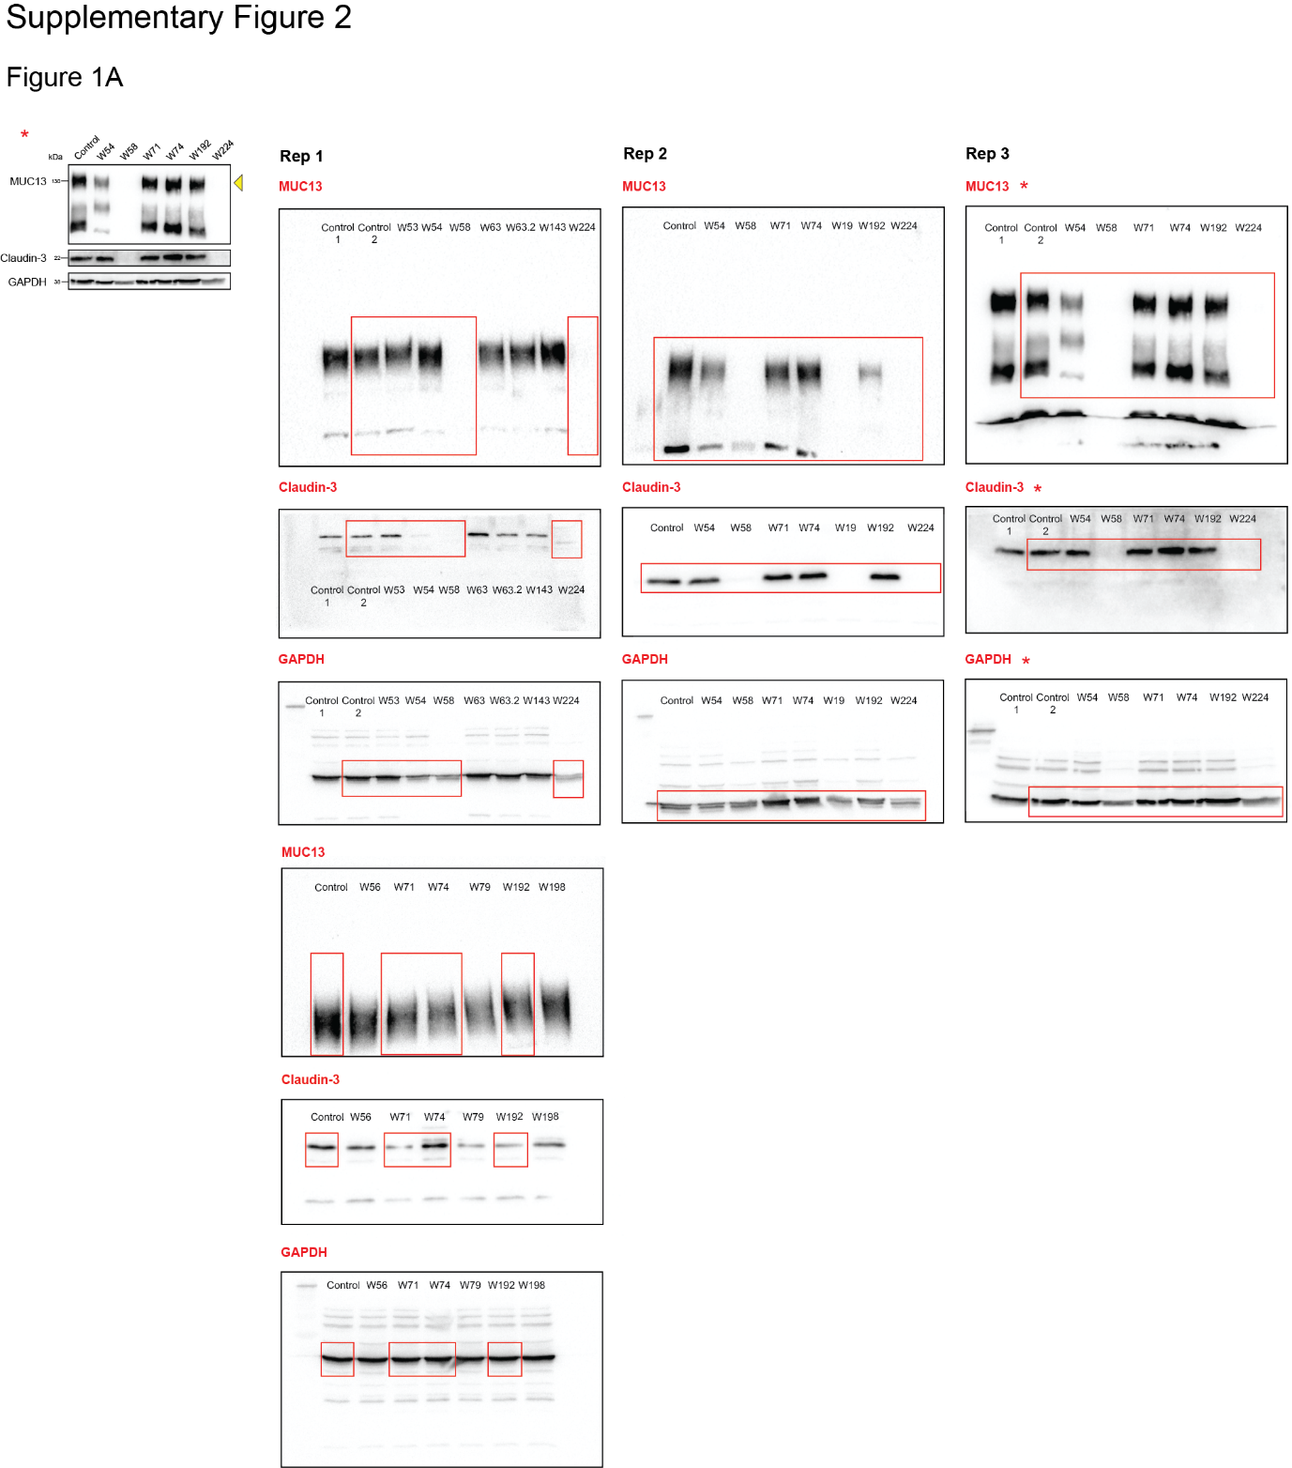

Figure S2. Original immunoblot data Figure 1A.
RAW immunoblot data generated and analyzed for Figure 1A (right).
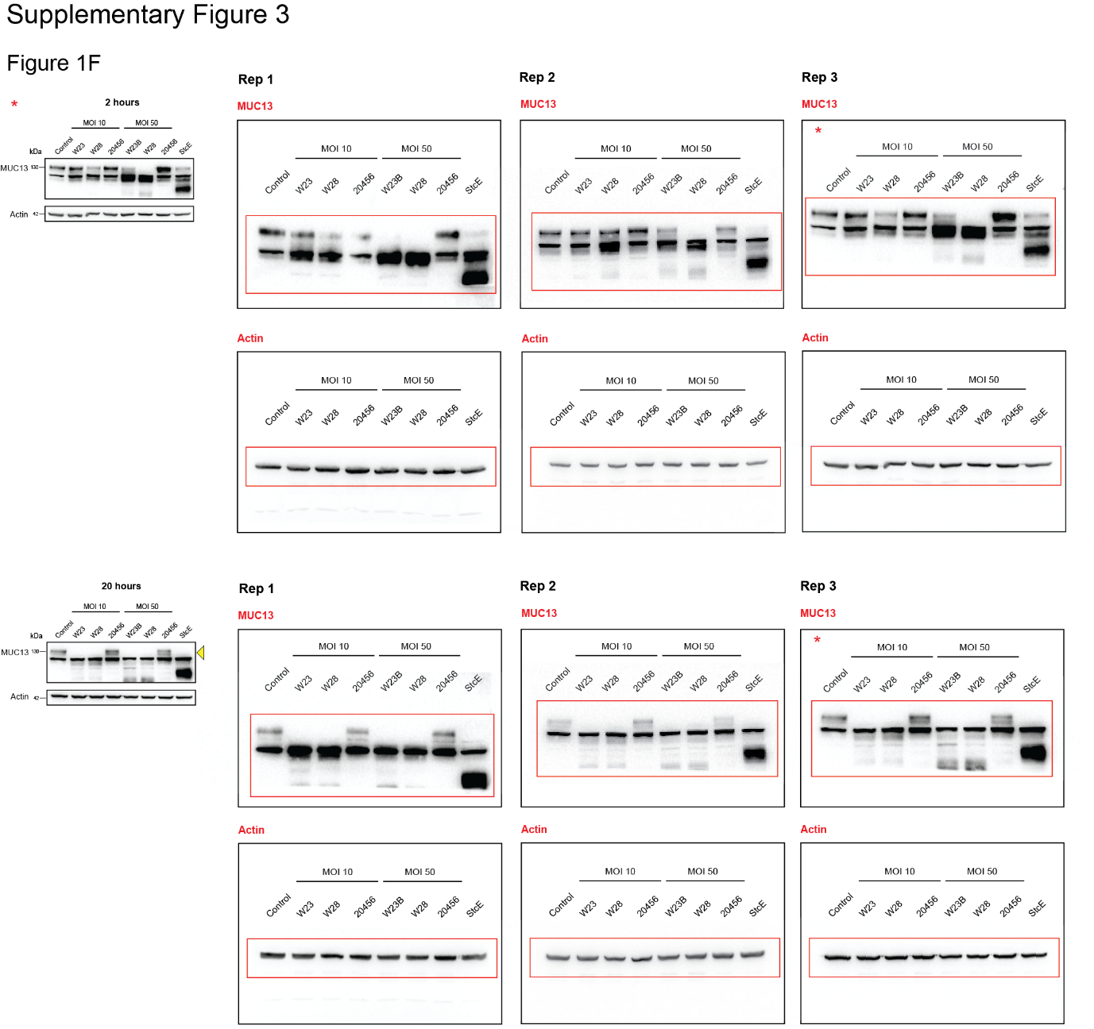
Figure S3. Original immunoblot data Figure 1F.
RAW immunoblot data of experimental replicates generated and analyzed for Figure 1F. Relevant areas are marked by red boxes.
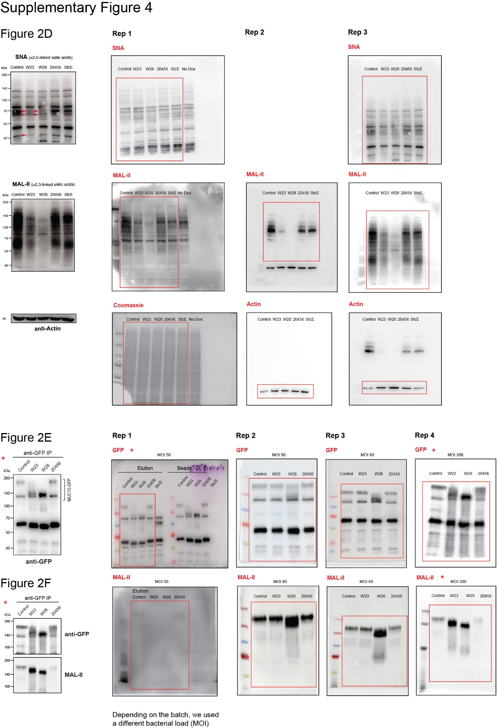

Figure S4. Original immunoblot data Figures 2D-F.
RAW immunoblot data of experimental replicates generated and analyzed for Figures 2D-F. Relevant areas are marked by red boxes.

Figure S5. Original immunoblot data Figures 2G-H.
RAW immunoblot data of experimental replicates generated and analyzed for Figures 2G-H. Relevant areas are marked by red boxes.
Figure S6. Original immunoblot data Figure 3F.
RAW immunoblot data of experimental replicates generated and analyzed for Figure 3F. Relevant areas are marked by red boxes.
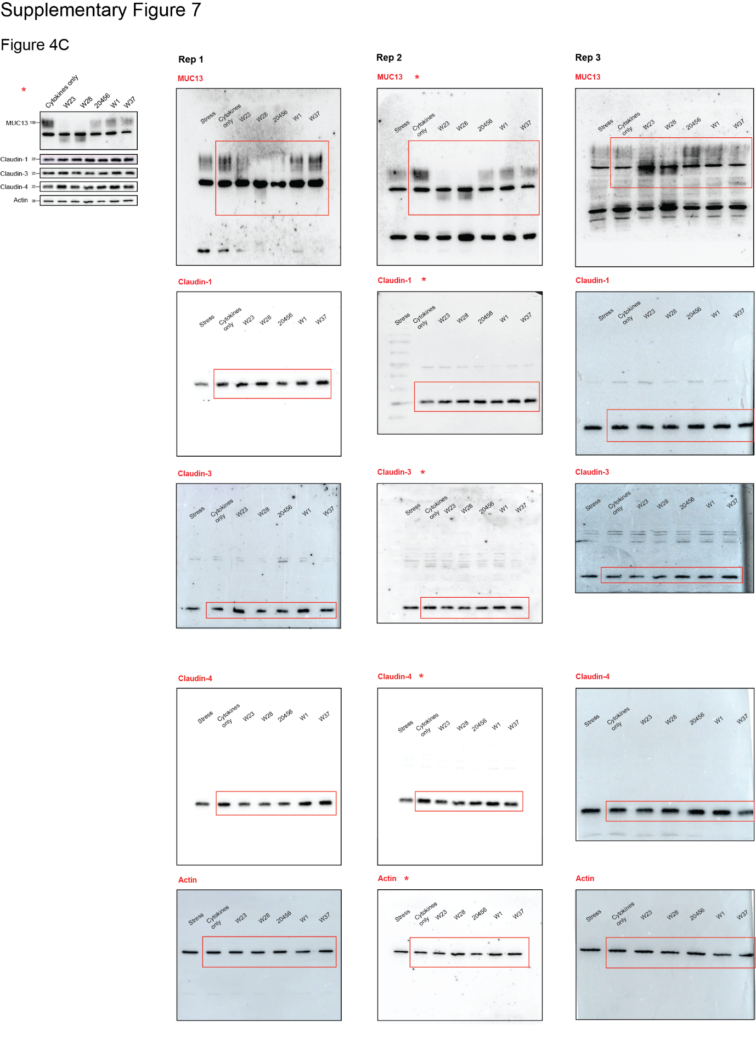
Figure S7. Original immunoblot data Figure 4C.
RAW immunoblot data of experimental replicates generated and analyzed for Figure 4C. Relevant areas are marked by red boxes.

