Supplementary Material
Identification and Biophysical Characterization of Plasmodium Peptide Binding by Common African HLAs
Marielle B. Frooman^{1‡}, Klara Choi^{1‡}, Maya Z. Kahn^{1‡}, Li-Yen Yang¹, Aubrielle Cunningham¹, Jenna M. RisCassi¹, Andrew C. McShan^{1*}
¹School of Chemistry and Biochemistry, Georgia Institute of Technology, Atlanta, GA 30332,
USA

‡These authors contributed equally to this work.

*Correspondence: Andrew C. McShan (andrew.mcshan@chemistry.gatech.edu)

Supplementary Table 1. Summary of hydrogen bonds and salt bridges between identified P. falciparum derived peptides and residues in the HLA-A*02:01 and HLA-B*08:01 grooves as determined by PDBe PISA of TFold models. Peptide residues are on the left; HLA residues on the right. HLA groove residue numbering is consistent with the literature convention from X-ray crystallography studies.
CSP 319-328 to HLA-A*02:01 | CSP 319-328 to HLA-B*08:01 | MSP1 880-889 to HLA-A*02:01 | MSP1 880-889 to HLA-B*08:01 | SSFP 93-102 to HLA-A*02:01 | SSFP 93-102 to  HLA-B*08:01 | LSA3 1229-1238 to HLA-A*02:01 | LSA3 1229-1238 to  HLA-B*08:01
Y1 - Y7  Y1 - Y159  Y1 - Y171  L2 - Y7  L2 - E63  L2 - K66  N3 - H70  N3 - Y99  Q6 - H70  Q6 - T73  S8 - K146  S8 - W147  L9 - D77 | Y1 - Y7  Y1 - Y59  Y1 - Y159  Y1 - Y171  L2 - R62  L2 - N63  N3 - N70  N3 - Y99  N3 - D156  I5 - N70  I5 - T73  S8 - W147  S8 - N80  L9 - S77  L9 - N80  L9 - Y84 | Y1 - Y7  Y1 - Y159  Y1 - Y171  Q2 - Y7  Q2 - E63  Q2 - K66  Q2 - Y99  K3 - H70  K3 - Y99  Y8 - W147  L9 - D77 | Y1 - Y7  Y1 - Y159  Y1 - Y171  Q2 - Y7  Q2 - D8  Q2 - N63  K3 - N70  K3 - Y116  K3 - D156  M5 - N70  M5 - T73  M5 - Y116  Y7 - A150  Y8 - W147  L9 - S77  L9 - Y84  L9 - T143 | N1 - Y171  N1 - Y7  N1 - K66  N1 - Y159  M2 - E63  M2 - K66  L3 - Y99  L3 - H70  T7 - R97  T8 - W147  T8 - K146  V9 - D77  V9 - K146 | N1 - Y159  N1 - Y171  M2 - Y7  M2 - N63  L3 - Y99  L3 - N70  K5 - N70  K5 - T73  K5 - S97  K5 - D9  T8 - N80  T8 - K146  T8 - W147  V9 - S77  V9 - N80  V9 - K146 | K1 - Y159  K1 - Y171  L2 - Y7  L2 - E63  L2 - K66  G3 - Y99  S8 - K146  S8 - W147  L9 - D77 | K1 - Y7  K1 - Y159  K1 - Y171  L2 - N63  G3 - N70  G3 - Y99  R5 - D9  R5 - N70  R5 - T73  R5 - S97  R5 - D74  R5 - Y116  S8 - N80  S8 - W147  L9 - S77  L9 - N80  L9 - Y84

MSP1 511-520 to HLA-A*02:01 | MSP1 511-520 to HLA-B*08:01 | MSP1 643-652 to HLA-A*02:01 | MSP1 643-652 to HLA-B*08:01 | MSP1 823-832 to HLA-A*02:01 | MSP1 823-832 to HLA-B*08:01 | LSA3 78-87 to HLA-A*02:01 | LSA3 78-87 to HLA-B*08:01
E1 - K66  E1 - Y159  E1 - W167  E1 - Y171  L2 - Y7  L2 - E63  L2 - K66  L3 - Y99  E8 - W147  M9 - D77  M9 - K146 | E1 - R62  E1 - Y159  E1 - Y171  L2 - Y7  L2 - N63  L3 - N70  L3 - Y99  K5 - D9  K5 - N70  K5 - T73  K5 - D74  K5 - S97  Y7 - W147  Y7 - A150  E8 - W147  M9 - S77  M9 - Y84  M9 - T143 | L1 - Y159  L1 - Y171  L2 - Y7  L2 - E63  L2 - K66  I3 - Y99  I6 - T73  D8 - K146  D8 - W147  L9 - D77  L9 - K146 | L1 - Y159  L1 - Y171  L2 - Y7  I3 - Y99  I3 - N70  K5 - T73  K5 - N70  K5 - D74  K5 - S97  D8 - N80  D8 - K146  D8 - W147  L9 - S77  L9 - N80  L9 - Y84 | S1 - E63  S1 - K66  S1 - Y159  S1 - Y171  M2 - E63  M2 - K66  D3 - Y99  L7 - W147  E8 - W147  V9 - D77 | S1 - R62  S1 - N63  S1 - Y159  S1 - Y171  M2 - Y7  D3 - N70  D3 - Y99  K5 - N70  K5 - T73  K5 - D74  K5 - S97  E8 - W147  V9 - S77  V9 - N80 | Y1 - Y7  Y1 - Y159  Y1 - Y171  V2 - E63  V2 - K66  D3 - Y99  N7 - Q155  K8- W147 | Y1 - Y7  Y1 - Y159  Y1 - Y171  V2 - Y7  V2 - N63  D3 - N70  D3 - Y99  K5 - N70  K5 - T73  K5 - D74  K5 - S97  K8 - W147  L9 - S77  L9 - N80  L9 - Y84

Supplementary Table 2. Summary of hydrogen bonds and salt bridges between identified P. falciparum derived peptides and residues in the HLA-C*07:02 and HLA-E*01:03 grooves as determined by PDBe PISA of TFold models. Peptide residues are on the left; HLA residues on the right. HLA groove residue numbering is consistent with the literature convention from X-ray crystallography studies.
CSP 319-328 to HLA-C*07:02 | LSA3_1229-1238 to HLA-E*01:03
Y1 - Y7  Y1 - Y159  Y1 - Y171  L2 - E63  Q6 - R69  N7 - R97  N7 - Q155  L9 - S77  L9 - N80  L9 - Y84 | K1 - Y171  K1 - Y159  L2 - E63  R5 - E152  R5 - Q156  E7 - N77  S8 - K146  L9 - N77  L9 - Y84  L9 - K146

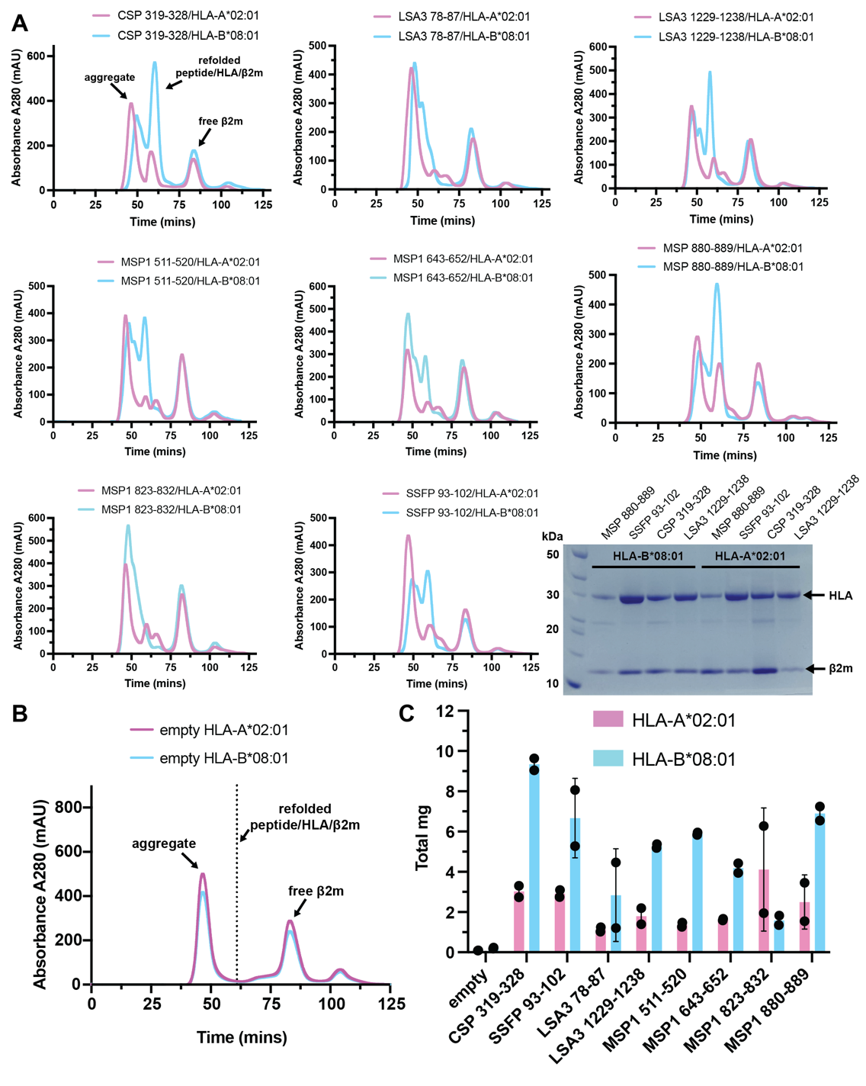
Supplementary Figure 1. (A) Size exclusion chromatography traces of HLA-A*02:01/hβ2m (pink) and HLA-B*08:01/hβ2m (cyan) refolded with P. falciparum derived 9-mer peptides (Table 1). Data were derived from purification via a 16/600 Superdex 75 pg column at 1 mL/min. A representative SDS-PAGE gel of purified P. falciparum derived peptide/HLA/hβ2m complexes is shown. (B) Size exclusion chromatography traces of HLA-A*02:01/hβ2m (pink) and HLA-B*08:01/hβ2m (cyan) refolded in the absence of any peptide (empty). The dotted line at ~60 minutes represents the expected elution time of properly folded peptide/HLA/hβ2m molecules. (C) Total amounts of protein (milligrams, mg) derived from in vitro refolding experiments for HLA-A*02:01/hβ2m (pink) or HLA-B*08:01/hβ2m (cyan) without (empty) and with a panel of predicted candidate antigens derived from Plasmodium. Error bars are derived from mean values ± standard deviation for two technical replicates (n=2).

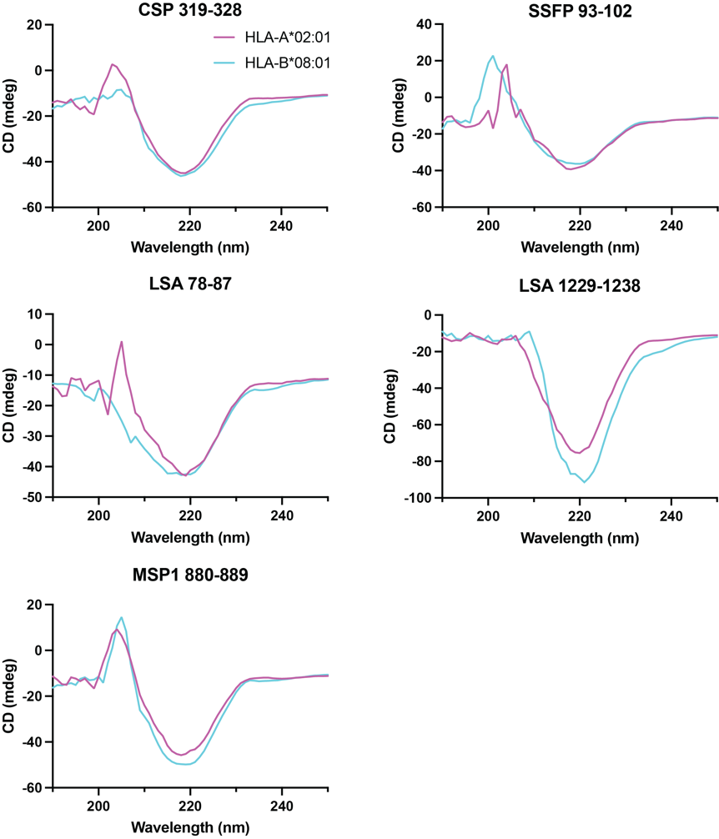
Supplementary Figure 2. Far-UV circular dichroism spectra of HLA-A*02:01/hβ2m (pink) and HLA-B*08:01/hβ2m (cyan) refolded with P. falciparum derived 9-mer peptides. Data recorded on a JASCO J-815 Spectropolarimeter measured from 190 nm to 350 with 0.3 mg/mL purified peptide/HLA/hβ2m complex.
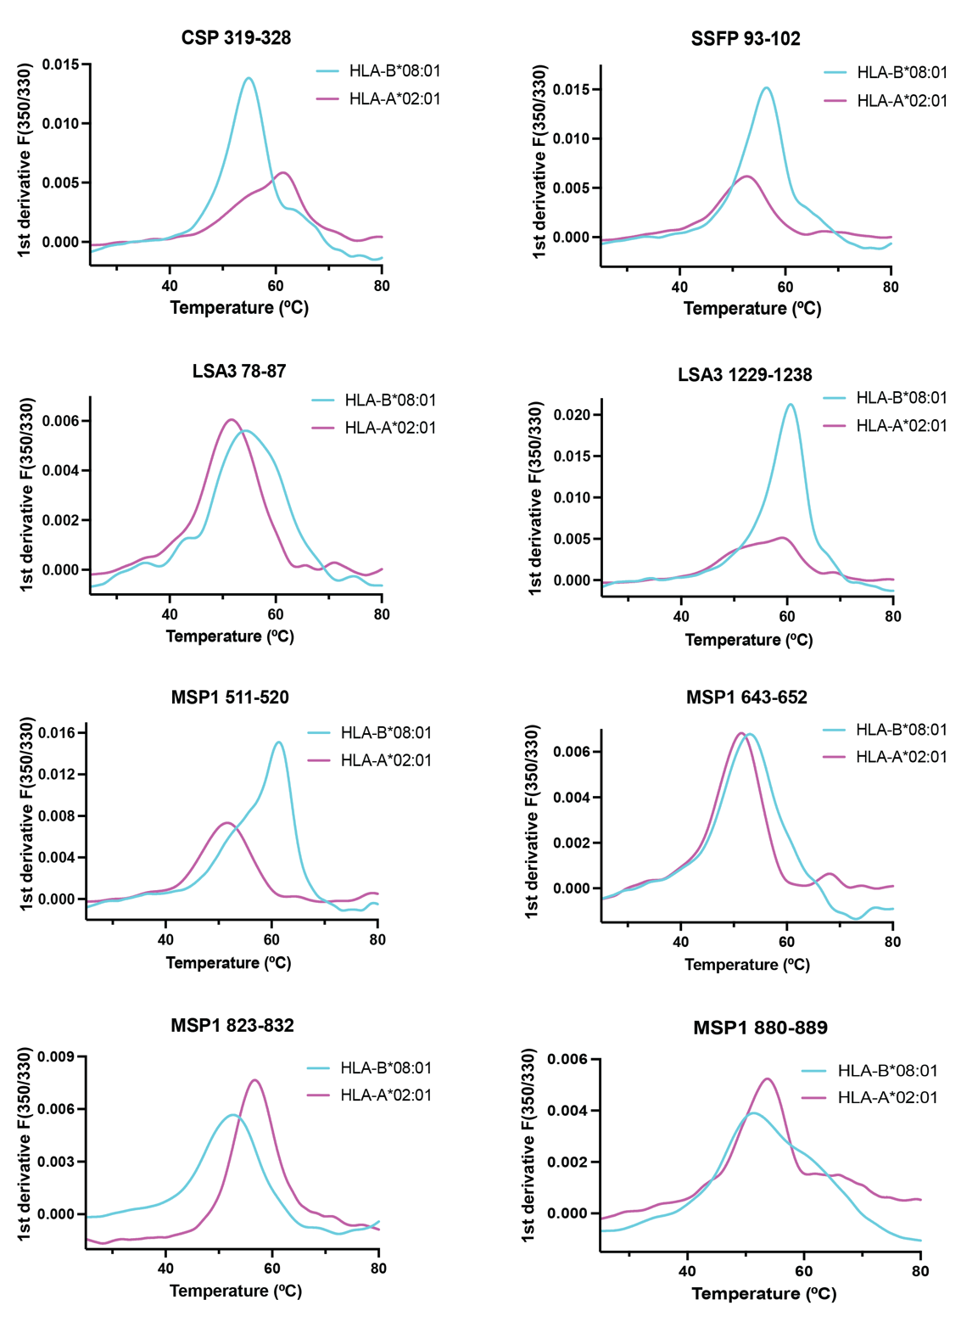
Supplementary Figure 3. Thermostability of P. falciparum derived peptide/HLA complexes probed by nanoDSF measurements. First derivatives of the unfolding curves for a panel of HLA-A*02:01/hβ2m (pink) and HLA-B*08:01/hβ2m (cyan) complexes refolded with P. falciparum derived peptides. The protein concentration used was 10 μM for each peptide/HLA/hβ2m complex.

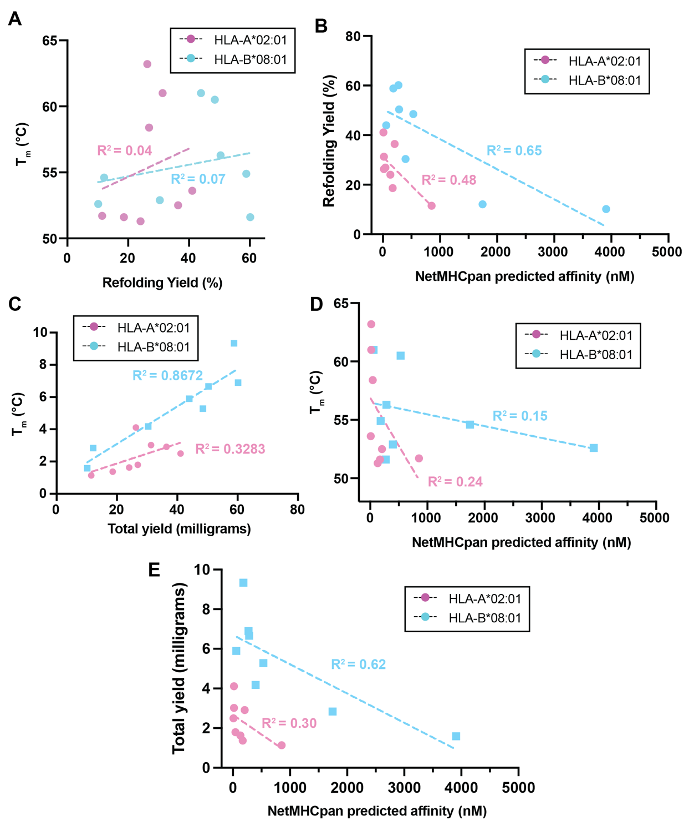
Supplementary Figure 4. Comparison of predicted binding affinity, refolding yields, thermal stability, and total yield for all P. falciparum derived peptide/HLA complexes examined in this work with HLA-A*02:01 and HLA-B*08:01. (A) Correlation between apparent in vitro refolding yields (%) and nanoDSF measured thermal stability (T_{m}, °C). (B) Correlation between apparent in vitro refolding yields (%) and netMHCpan-4.1 derived predicted binding affinities (nM). (C) Correlation between nanoDSF measured thermal stability (T_{m}, °C) and apparent in vitro refolding yields (total yield, milligrams). (D) Correlation between nanoDSF measured thermal stability (T_{m}, °C) and netMHCpan-4.1 derived predicted binding affinities (nM). (E) Correlation between apparent in vitro refolding yields (total yield, milligrams) and netMHCpan-4.1 derived predicted binding affinities (nM). In panels A to E, linear regression fits are shown as dotted lines with R² values noted.
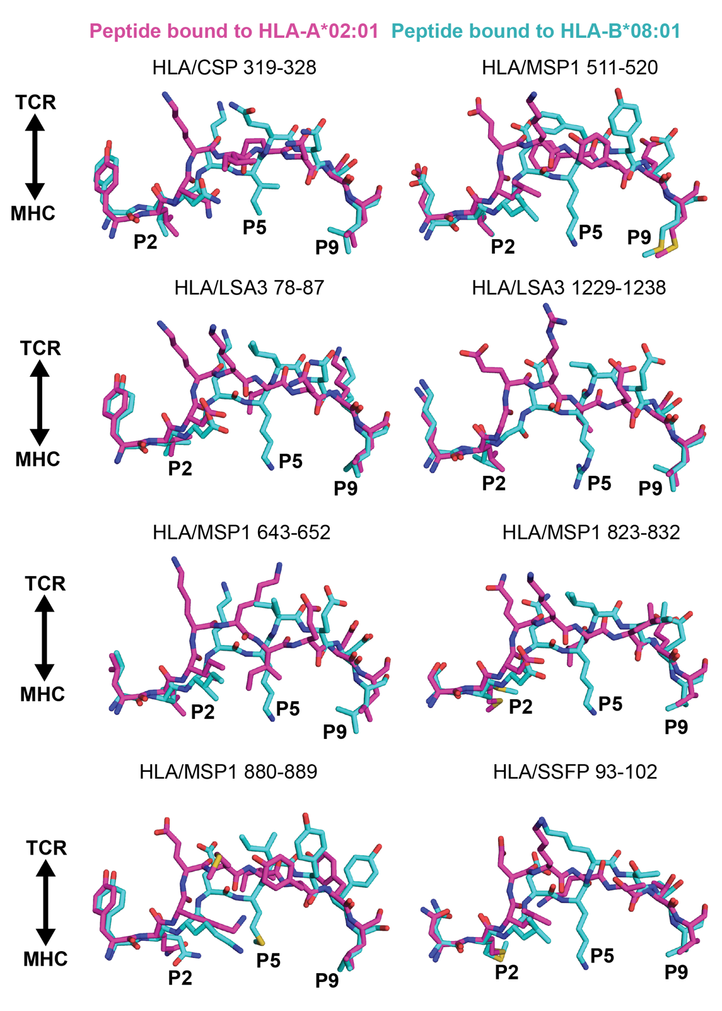
Supplementary Figure 5. In silico structural comparison of P. falciparum candidate antigens binding modes to HLA-A*02:01 and HLA-B*08:01. Superimposition of HLA-bound peptide conformations predicted by TFold for the eight identified P. falciparum 9-mer peptides. HLA-A*02:01 bound peptides are color magenta; HLA-B*08:01 bound peptides are colored cyan. The HLA groove is not shown for simplicity. P2 and P9 peptide positions form primary anchors in 9-mer peptides in both HLA-A*02:01 and HLA-B*08:01 grooves, while P5 peptide positions only form anchors in HLA-B*08:01 grooves.
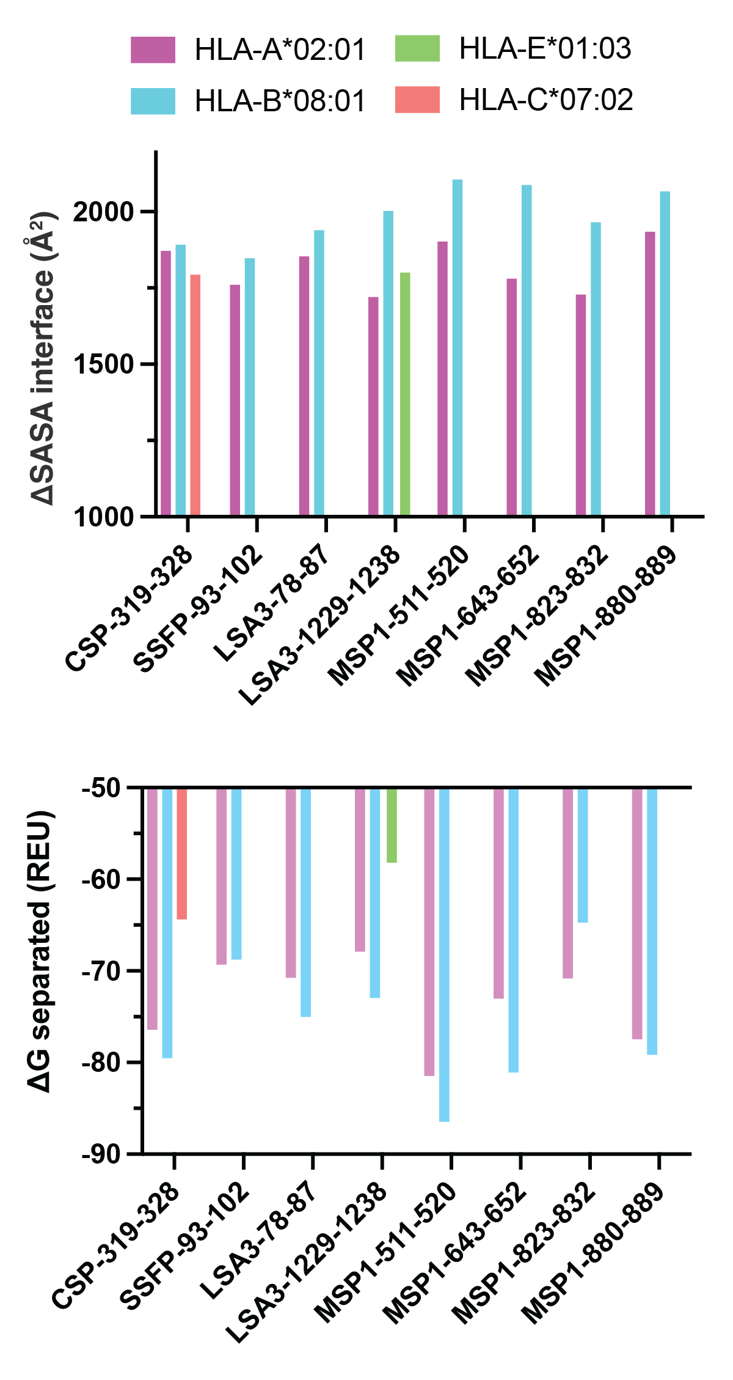
Supplementary Figure 6. Interface analysis of TFold models of P. falciparum candidate antigens with HLA-A*02:01, HLA-B*08:01, HLA-E*01:03, and HLA-C*07:02. Results from Rosetta InterfaceAnalyzer application. Top: ΔSASA interface: The solvent accessible area buried at the interface in square Angstroms. Bottom: ΔG separated: The change in Rosetta energy units (REU) when the interface forming peptide and HLA chains are separated, versus when they are complexed: the binding energy. Calculated by separating the chains.

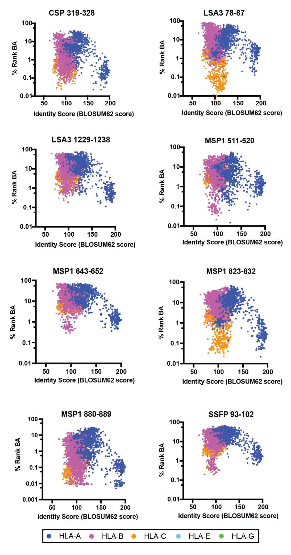
Supplementary Figure 7. In silico evaluation of the HLA class I binding repertoire of eight identified P. falciparum candidate antigens. (A) In silico netMHCpan-4.1 prediction of binding for eight identified P. falciparum candidate antigens with 10,386 different class I HLA alleles. The % rank binding affinity (BA) from netMHCpan-4.1 is compared to the BLOSUM62 identity score for all HLA alleles relative to HLA-A*02:01.

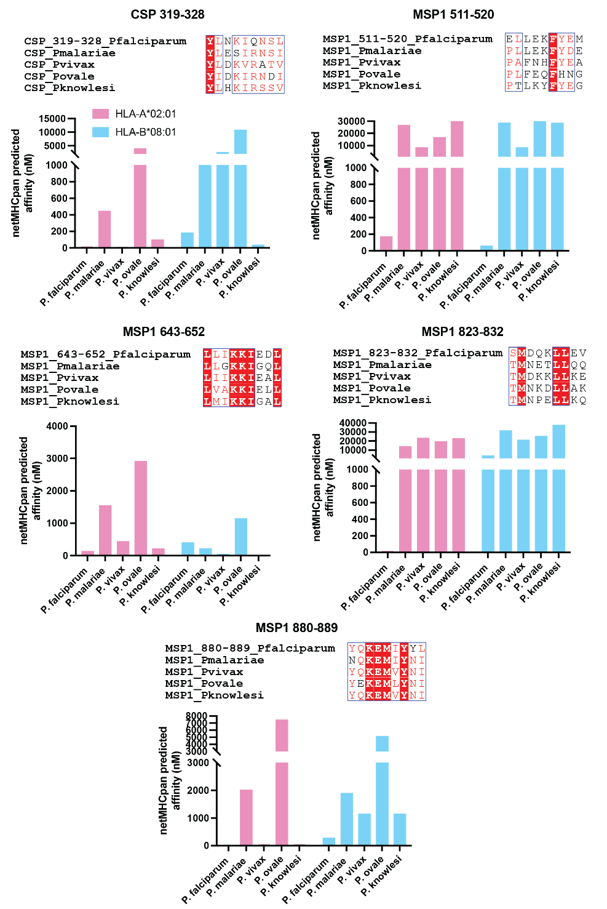
Supplementary Figure 8. Conservation and in silico evaluation of CSP and MSP1 derived 9-mer peptides to HLA-A*02:01 and HLA-B*08:01 across different Plasmodium species. For each peptide, amino acid sequence alignment was performed Clustal Omega (v1.2.4) and analyzed in ESPript v3.0. Red box, white character → Strict identity. Red character → Similarity in amino acid type. netMHCpan-4.1 predicted affinities (nM) also shown for each peptide for HLA-A*02:01 (pink) and HLA-B*08:01 (blue). CSP sequences: P. falciparum (UniProt #Q7K740), P. malariae (UniProt #P13815), P. vivax (UniProt #P08677), P. ovale (UniProt #A0A1A8X4K9), and P. knowlesi (UniProt #P02894). MSP1 sequences: P. falciparum (UniProt #Q8I0U8), P. malariae (UniProt #A0A1S5UZL2), P. vivax (UniProt #Q8I1M7), P. ovale (UniProt #A0A1S5UZL4), and P. knowlesi (UniProt #A7BG19).

