Modified magnetic chitosan with mono(6-amino-6-deoxy)-β-cyclodextrin as a novel catalyst toward the synthesis of pyrazolopyranopyrimidines and pyrano[2,3-c]pyrazole-3-carboxylates

Maryam Mousavi-Ebadiª, Javad Safaei-Ghomi*ª
ªDepartment of Organic Chemistry, Faculty of Chemistry, University of Kashan, Kashan, P.O. Box 87317-51167, I. R. Iran,
*E-mail address: safaei@kashanu.ac.ir

Section A) Supplementary information on catalyst preparation
Figure S1. EDS results of a) magnetic nanoparticles b) and magnetic chitosan
Figure S2. Elemental mapping of the magnetic nanoparticles
Figure S3. Elemental mapping of the magnetic chitosan

Part B) Supplemental information about organic derivatives including: images, physical and spectral data
Table 1S. Scope of pyrazolopyranopyrimidine (5a–q) and pyrano[2,3-c]pyrazole-3-carboxylate structures (8a–l) catalyzed by Fe₃O₄@Cs@CDNH₂.
5a White powder  Yield: 99%, Time:12 min  m.p.: 231-233˚C ¹  231-232˚C | 5b White powder  Yield: 99%, Time: 15 min  m.p.: 219-221 ˚C ²  218-221˚C | 5c White powder  Yield: 94%, Time: 25 min  m.p.: 231-233˚C ³  230-233˚C
5d (New) Pale orange powder  Yield: 90%, Time: 20 min  m.p.: 210-211˚C | 5e White powder  Yield: 98%, Time: 16 min  m.p.: 176-180˚C ⁴  175-178˚C | 5f (New) white powder  Yield: 94%, Time: 16 min  m.p.: 179-180˚C
5g Yellow powder  Yield: 93%, Time: 16 min  m.p.: 228-230˚C¹  230-233˚C | 5h White powder  Yield: 93%, Time: 14 min  m.p.: 301-303˚C ⁵  299-301˚C | 5i White powder  Yield: 98%, Time: 15 min  m.p.: 265-266˚C ³  266-268˚C
5j Yellow powder  Yield: 98%, Time: 12 min  m.p.: 204-206˚C ³  210-211˚C | 5k (New) Yellow powder  Yield: 97%, Time: 17 min  m.p.: 261-263˚C | 5l Pale orange powder  Yield: 97%, Time: 19 min  m.p.: 204-206˚C ³  198-201˚C
5m Pale orange powder  Yield: 89%, Time: 15 min  m.p.: 226-227˚C ³  226-229˚C | 5n Yellow powder  Yield: 90%, Time: 17 min  m.p.: 242-244˚C²  241-243˚C | 5o White powder  Yield: 97%, Time: 15 min  m.p.: 218-220 ⁵  220-222˚C
5p Yellow powder  Yield: 98%, Time: 15 min  m.p.: 260-263˚C ³  261-264˚C | 5q (New) Pale orange powder  Yield: 98%, Time: 18 min  m.p.: 250-252˚C | 8a Yellow powder  Yield: 96%, Time: 30 min  m.p.: 231-232˚C ⁶  231-232˚C
8b White powder  Yield: 97%, Time: 30 min  m.p.: 245-247˚C ⁶  244-246˚C | 8c Pale yellow powder  Yield: 99%, Time: 30 min  m.p.: 208-210˚C ⁷  211-212˚C | 8d (New) White powder  Yield: 96%, Time: 30 min  m.p.: 229-231˚C
8e White powder  Yield: 95%, Time: 30 min  m.p.: 258-260˚C ⁴  258-261˚C | 8f (New) Yellow powder  Yield: 88%, Time: 35 min  m.p.: 260-263˚C | 8g Brown powder  Yield: 91%, Time:32 min  m.p.: 230-232˚C ⁷  231-233˚C
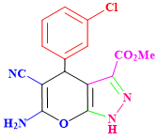  8h (New) White powder  Yield: 95%, Time: 28 min  m.p.: 261-263˚C | 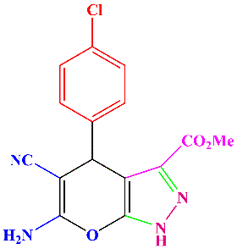  8i White powder  Yield: 90%, Time: 30 min  m.p.: 213-215˚C ⁴  211-214˚C | 8j Pale brown powder  Yield: 89%, Time: 33 min  m.p.: 244-245˚C ⁷  247-248˚C
8k Brown powder  Yield: 90%, Time: 31 min  m.p.: 219-220˚C ⁴  221-223˚C | 8l Yellow powder  Yield: 92%, Time: 30 min  m.p.: 236-237˚C ⁴  237-239˚C | 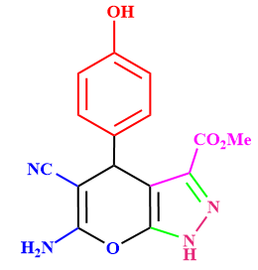  8m Brown powder  Yield: 91%, Time:32 min  m.p.: 231-233˚C ⁴  228-230˚C

4-(4-chlorophenyl)-3-methyl-6,8-dihydropyrazolo[4',3':5,6]pyrano[2,3-d]pyrimidine-5,7(1H,4H)-dione (5a): White solid; m.p.: 231-233°C; FT-IR (KBr) (ν_{max}/cm⁻¹): 3434, 2917, 1615, 1591; 855. ¹H NMR (400 MHz, DMSO-d₆) δ (ppm): 13.09 (s, 1H, NH), 10.20 (s, 2H, NH), 7.26 (d, J= 8.7), Hz, 2H, Ar), 7.09 (d, J=8.7 Hz, 2H, Ar), 5.41 (s, 1H), 2.23 (s, 3H). Analysis for C₁₅H₁₁ClN₄O₃. Elemental Analysis: C: 54.48%, H: 3.35 %, N: 16.94%. Found: C: 54.42%, H: 3.36 %, N: 17.09%.
4-(2-chlorophenyl)-3-methyl-6,8-dihydropyrazolo[4',3':5,6]pyrano[2,3-d]pyrimidine-5,7(1H,4H)-dione (5b): White solid; m.p.: 230-232°C; FT-IR (KBr) (ν_{max}/cm⁻¹): 3476, 2924, 1706, 1636, 1596; 807. ¹H NMR (400 MHz, DMSO-d₆) δ (ppm): 12.95 (s, 1H, NH), 10.22 (s, 2H, NH), 7.08-7.39 (m, 4H, Ar), 5.52 (s, 1H), 2.18 (s, 3H). Analysis for C₁₅H₁₁ClN₄O₃. Elemental Analysis: C: 54.48%, H: 3.35 %, N: 16.94%. Found: C: 54.39%, H: 3.66 %, N: 16.81%.
4-(2-hydroxyphenyl)-3-methyl-6,8-dihydropyrazolo[4',3':5,6]pyrano[2,3-d]pyrimidine-5,7(1H,4H)-dione (5c): white solid; m.p.: 230-233°C; FT-IR (KBr) (ν_{max}/cm⁻¹): 3435, 3121, 2922, 1642, 1437; 1216. ¹H NMR (400 MHz, DMSO-d₆) δ (ppm): 12.79 (s, 1H, NH), 11.98 (s, 1H, NH), 11.78 (s, 1H, NH), 10.15 (s, 1H, OH), 7.27-7.14 (m, 4H, Ar), 4.72 (s, 1H), 2.13 (s, 3H). Analysis for C₁₅H₁₂ClN₄O₄. Elemental Analysis: C: 57.69%, H: 3.87 %, N: 17.94. Found: C: 57.55%, H: 3.79 %, N: 18.19%.
4-(4-isopropylphenyl)-3-methyl-7-thioxo-4,6,7,8-tetrahydropyrazolo[4',3':5,6]pyrano[2,3-d]pyrimidin-5(1H)-one (5d): Pale orange solid; m.p.: 210-211°C; FT-IR (KBr) (ν_{max}/cm⁻¹): 3626, 3276, 3087, 2589, 1588, 1391, 1104, 998.2. ¹H NMR (400 MHz, DMSO-d₆) δ (ppm): 12.00 (s, 1H, NH), 11.17 (s, 1H, NH), 11.30 (s, 1H, NH), 10.99 (s, 1H, OH), 7.06 (d, J=8.2 Hz, 2H), 6.94 (d, J=8.2 Hz, 2H), 5.38 (s, 1H), 2.86-2.70 (m, 1H), 3.84 (s, 3H, Me), 1.11 (s, d, J=10, 6H). ¹³C NMR (400 MHz, DMSO) δ 173.4, 163.7, 159.8, 145.8, 144.0, 139.7, 127.0, 126.2, 105.8, 96.6, 33.3, 30.6, 24.3, 10.4. Analysis for C₁₆H₁₄N₄O₅. Elemental Analysis: C, 61.00; H, 5.12; N, 15.81; S, 9.05. Found: C, 60.93%, H, 4.92%, N, 15.94%, S, 9.61.
4-(2-hydroxy-3-methoxyphenyl)-3-methyl-6,8-dihydropyrazolo[4',3':5,6]pyrano[2,3-d]pyrimidine-5,7(1H,4H)-dione (5e): White solid; m.p.: 175-178°C; FT-IR (KBr) (ν_{max}/cm⁻¹): 3315, 3001, 2945, 2344, 1663, 1432; 1212. ¹H NMR (400 MHz, DMSO-d₆) δ (ppm): 12.00 (s, 1H, NH), 11.30 (s, 1H, NH), 11.30 (s, 1H, NH), 10.99 (s, 1H, OH), 7.14 (t, J= 7.5 Hz, 1H, Ar), 7.05 (d, J= 7.2 Hz, 2H, Ar), 4.70 (s, 1H), 3.84 (s, 3H, OMe), 1.91 (s, 3H). Analysis for C₁₆H₁₄N₄O₅. Elemental Analysis: C: 56.14%, H: 4.14 %, N: 16.37. Found: C: 56.18%, H: 4.93%, N: 16.19%.
4-(2-hydroxy-3-methoxyphenyl)-3,6,8-trimethyl-4,8-dihydropyrazolo[4',3':5,6]pyrano[2,3-d]pyrimidine-5,7(1H,6H)-dione (5f): White solid; m.p.: 179-181°C; FT-IR (KBr) (ν_{max}/cm⁻¹): 3049, 2936, 1649, 1620, 1580, 1572; 1436, 1198, 920, 720. ¹H NMR (400 MHz, DMSO-d₆) δ (ppm): 16.50 (s, 1H, NH), 13.31 (s, 1H, OH), 6.99-6.88 (m, 1H, Ar), 6.62 (d, J= 7.3 Hz, 2H, Ar), 5.49 (s, 1H), 3.48 (s, 3H, OMe), 2.12 (s, 6H, NMe), 1.94 (s, 3H). ¹³C NMR (100 MHz, DMSO) δ 163.8, 159.6, 159.6, 152.0, 143.9, 139.8, 134.5, 130.6, 128.8, 128.8, 127.0, 106,4, 91.75, 46.2, 32.0, 28.1, 20.9, 10.3. Analysis for C₁₈H₁₈N₄O₅. Elemental Analysis: C: 58.37%, H: 4.90 %, N: 15.13. Found: C: 58.53%, H: 4.93%, N: 15.03%.
4-(4-methoxyphenyl)-3-methyl-6,8-dihydropyrazolo[4',3':5,6]pyrano[2,3-d]pyrimidine-5,7(1H,4H)-dione (5g): Yellow solid; m.p.: 230-233°C; FT-IR (KBr) (ν_{max}/cm⁻¹): 3373, 3121, 2344, 1687, 1454; 1223. ¹H NMR (400 MHz, DMSO-d₆) δ (ppm): 11.32 (s, 1H, NH), 11.19 (s, 1H, NH), 7.07 (d, J=10 Hz, 2H, Ar), 7.02 (d, J=10 Hz, 2H, Ar), 5.02 (s, 1H), 3.82 (s, 3H, OMe), 2.19 (s, 3H). Analysis for C₁₆H₁₄N₄O₄. Elemental Analysis: C: 58.89%, H: 4.32 %, N: 17.17. Found: C: 58.34%, H: 4.76%, N: 16.89%.
4-(3-chlorophenyl)-3-methyl-6,8-dihydropyrazolo[4',3':5,6]pyrano[2,3-d]pyrimidine-5,7(1H,4H)-dione (5h): yellow solid; m.p.: 300-302°C; FT-IR (KBr) (ν_{max}/cm⁻¹): 3437, 2923, 1625, 1589, 858. ¹H NMR (400 MHz, DMSO-d₆) δ (ppm): 12.82 (s, 1H, NH), 10.85 (s, 2H, NH), 7.23 (s, 1H, Ar), 7.14 (d, J= 8.1 Hz, 2H, Ar), 6.98-7.11 (m, 1H, Ar), 5.82 (s, 1H), 2.14 (s, 3H). Analysis for C₁₅H₁₁ClN₄O₃. Elemental Analysis: C: 54.48%, H: 3.35 %, N: 16.94. Found: C: 54.19%, H: 3.90%, N: 17.01%.
3-methyl-4-(3-nitrophenyl)-6,8-dihydropyrazolo[4',3':5,6]pyrano[2,3-d]pyrimidine-5,7(1H,4H)-dione (5i): White solid; m.p.: 266-268°C; FT-IR (KBr) (ν_{max}/cm⁻¹): 3594, 3470, 3029, 2919, 1702, 1590; 1481, 1362, 1299, 862, 813. ¹H NMR (400 MHz, DMSO-d₆) δ (ppm): 13.44 (s, 1H, NH), 10.27 (s, 2H, NH), 8.02-8.05 (m, 1H. Ar), 7.86 (s, 1H, Ar), 7.53 (d, J= 8.1 Hz, 2H, Ar), 5.54 (s, 1H), 2.27 (s, 3H). Analysis for C₁₅H₁₁N₅O₅. Elemental Analysis: C: 52.79%, H: 3.25 %, N: 20.52. Found: C: 52.80%, H: 3.29%, N: 29.03%.
3-methyl-4-phenyl-6,8-dihydropyrazolo[4',3':5,6]pyrano[2,3-d]pyrimidine-5,7(1H,4H)-dione (5j): White solid; m.p.: 210-211°C; FT-IR (KBr) (ν_{max}/cm⁻¹): 3419, 2891, 2759, 1682, 1590, 1472; 1311, 781. ¹H NMR (400 MHz, DMSO-d₆) δ (ppm): 13.15 (s, 1H, NH), 10.20 (s, 2H, NH), 7.23 (t, J = 7.2 Hz, 1H, Ar), 7.13 (t, J = 7.5 Hz, 2H, Ar), 7.05 (d, J = 8.1 Hz, 2H, Ar), 5.44 (s, 1H), 2.23 (s, 3H). Analysis for C₁₅H₁₂N₄O_{3.} Elemental Analysis: C: 60.81%, H: 4.08 %, N: 18.91. Found: C: 69.58%, H: 4.29%, N: 19.01%.
3-methyl-7-thioxo-4-(m-tolyl)-4,6,7,8-tetrahydropyrazolo[4',3':5,6]pyrano[2,3-d]pyrimidin-5(1H)-one (5k): Yellow solid; m.p. 261–263°C, FT-IR (KBr) (ν_{max}/cm⁻¹): 3060,
2905, 1663, 1439, 1236, 969, 617, 511. ¹H NMR (400 MHz, [D6]DMSO): δ (ppm) = 13.51 (1H, s, NH), 11.50 (2H, s, NH₂), 6.91–7.53 (4H, m, H-Ar), 5.40 (1H, s, CH), 2.28 (6H, s, Me). ¹³C NMR (400 MHz, DMSO) δ 163.2, 159.7, 148.4, 144.0, 124.1, 122.5, 121.7, 119.7, 118.8, 117.9, 92.89, 56.1, 28.2, 10.7. Analysis for C₁₅H₁₂N₄. Elemental Analysis: C: 56.19; H: 4.12; N: 16.37; found C: 56.14; H: 4.39; N: 16.19.
3-methyl-4-(p-tolyl)-6,8-dihydropyrazolo[4',3':5,6]pyrano[2,3-d]pyrimidine-5,7(1H,4H)-dione (5l): Pale orange solid; m.p.: 198-201°C; FT-IR (KBr) (ν_{max}/cm⁻¹): 3418, 3115, 3038, 1677; 1582, 1573, 1276. ¹H NMR (400 MHz, DMSO-d₆) δ (ppm): 13.14 (s, 1H, NH), 10.16 (s, 2H, NH), 7.09-7.11 (d, J= 8.2 Hz, 2H, Ar), 6.91-6.93 (d, J=8.2 Hz, 2H, Ar), 5.40 (s, 1H), 2.51 (s, 3H), 2.22 (s, 3H Analysis for C₁₆H₁₄N₄O_{3,} Elemental Analysis: C: 61.93%, H: 4.55%, N: 18.06. Found: C: 61.99%, H: 4.78%, N: 17.95%.
3-methyl-4-(4-nitrophenyl)-6,8-dihydropyrazolo[4',3':5,6]pyrano[2,3-d]pyrimidine-5,7(1H,4H)-dione (5m): Pale orange solid; m.p.: 226-229°C; FT-IR (KBr) (ν_{max}/cm⁻¹): 3151, 3062, 2899, 1688; 1589, 1523, 1470, 1348, 1268, 828. ¹H NMR (400 MHz, DMSO-d₆) δ (ppm): 11.48 (s, 1H, NH), 9.90 (s, 2H, NH), 7.59-7.61 (d, J= 8 Hz, 2H, Ar), 7.12-7.14 (d, J=8 Hz, 2H, Ar), 5.09 (s, 1H), 1.59 (s, 3H). Analysis for C₁₅H₁₁N₅O_{5.}, Elemental Analysis: C: 52.7%, H: 3.25%, N: 20.52. Found: C: 51.98%, H: 3.39%, N: 21.02%.
3-methyl-4-(m-tolyl)-6,8-dihydropyrazolo[4',3':5,6]pyrano[2,3-d]pyrimidine-5,7(1H,4H)-dione (5n): White solid; m.p.: 241-243°C; FT-IR (KBr) (ν_{max}/cm⁻¹): 3468, 3186, 2917, 1703; 1694, 1475, 1320, 1168, 565, 543. ¹H NMR (400 MHz, DMSO-d₆) δ (ppm): 12.58 (s, 1H, NH), 10.20 (s, 2H, NH), 6.98 (t, J = 7.1 Hz 1H, Ar), 6.93 (d, J = 7.4 Hz, 2H, Ar), 6.86 (s, 1H, Ar), 5.40 (s, 1H), 2.51 (s, 3H), 2.22 (s, 3H). Analysis for C₁₆H₁₄N₄O_{5.}, Elemental Analysis: C, 61.93; H, 4.55; N, 18.06. Found: C: 62.01%, H: 4.80%, N: 18.66%.
4-(4-isopropylphenyl)-3-methyl-6,8-dihydropyrazolo[4',3':5,6]pyrano[2,3-d]pyrimidine-5,7(1H,4H)-dione (5o): White solid; m.p.: 220-222°C; FT-IR (KBr) (ν_{max}/cm⁻¹): 3449, 3219, 2992, 2017, 1698, 1420; 1297. ¹H NMR (400 MHz, DMSO-d₆) δ (ppm): 12.87 (s, 1H, NH), 10.20 (s, 2H, NH), 7.07 (d, J=8.1 Hz, 2H, Ar), 6.96 (d, J= 8.1 Hz, 2H, Ar), 5.35 (s, 1H), 2.76 (hept, J= 6.6 Hz, 1H), 2.30 (s, 3H), 1.15 (d, J= 7 Hz, 6H). Analysis for C₁₈H₁₈N₄O_{3.} Elemental Analysis: C: 63.89%, H: 5.36%, N: 16.56. Found: C: 64.02%, H: 5.39%, N: 16.93%.
4-(5-bromo-2-hydroxyphenyl)-3-methyl-4,8-dihydropyrazolo[4',3':5,6]pyrano[2,3 d]pyrimidine-5,7(1H,6H)-dione (5p): Pale yellow solid; m.p.: 261-264 °C; FT-IR (KBr) (ν_{max}/cm⁻¹): 3166, 3002, 2891, 1592, 1557, 1128, 872, 798, 497. ¹H NMR (400 MHz, DMSO-d₆) δ (ppm): 13.07 (s, 1H, OH), 10.35 (s, NH), 10.22 (s, 2H, NH), 7.39-7.92 (m, 2H, Ar), 7.13 (s, 1H, Ar), 5.56 (s, 1H), 1.07 (s, 3H). Analysis for C₁₅H₁₁BrN₄O_{4.,} Elemental Analysis: C: 46.06; H, 2.83; N, 14.32; Found: C: 46.09%, H: 2.91%, N: 14.48%.
4-(2-hydroxy-4-methoxyphenyl)-3-methyl-7-thioxo4,6,7,8tetrahydropyrazolo[4',3':5,6] pyrano[2,3-d]pyrimidin-5(1H)-one (5q): Pale yellow powder; m.p.: 250-252°C; FT-IR (KBr) (ν_{max}/cm⁻¹): 3381, 2931, 1752, 1612, 1405; 1289, 1029. ¹H NMR (400 MHz, DMSO-d₆) δ (ppm): 13.30 (s, 1H, NH), 12.31 (s, 1H, OH), 11.46 (s, 2H, NH), 6.95 (s, 1H, Ar), 6.90 (d, J = 6.9 Hz 1H, Ar), 6.67 (d, J = 6.9 Hz, 1H, Ar), 5.62 (s, 1H), 3.77 (s, 3H, OMe), 2.09 (s, 3H). Analysis for C₁₆H₁₄N₄O₄S, Elemental Analysis: C: 53.62; H: 3.94; N: 15.63. Found: C: 53.49%, H: 3.61%, N: 15.62%.
methyl 6-amino-5-cyano-4-phenyl-1,4-dihydropyrano[2,3-c]pyrazole-3-carboxylate (8a): White solid; m.p. 230–232°C, FT-IR (KBr) (ν_{max}/cm⁻¹): 3391,
3330, 3272, 2959, 2213, 1734, 1648, 1609. ,¹H NMR (400 MHz, [D6]DMSO): δ (ppm) = 13.75 (1H, s, NH), 7.27-7.29 (2H, m, ArH), 7.20-7.13 (1H, m, ArH), 7.12 (2H, d, J= 7.7 Hz, ArH), 7.04 (1H, s, NH₂), 4.75 (1H, s, CH), 3.64 (3H, s, OMe), Analysis for C₁₅H₁₂N₄O₃: Elemental Analysis: C: 60.81; H: 4.08; N: 18.91; found C 59.48, H 4.82, N 19.09.
methyl 6-amino-4-(4-bromophenyl)-5-cyano-1,4-dihydropyrano[2,3-c]pyrazole-3-carboxylate (8b): White solid; m.p. 244–246°C, FT-IR (KBr) (ν_{max}/cm⁻¹): 3320,
3321, 32781, 2999, 2023, 1742, 1649, 1463, 1371, 1019, 806, 786. ¹H NMR (400 MHz, [D6]DMSO): δ (ppm) = 13.11 (1H, s, NH), 7.19 (2H, d, J= 7.9 Hz, ArH), 7.02 (2H, d, J= 7.9 Hz, Ar), 6.65 (2H, s, NH₂), 5.45 ( 1H, s, CH), 3.27 (3H, s, OMe), Analysis for C₁₅H₁₁BrN₄O₃: Elemental Analysis: C: 48.02; H: 2.96; N: 14.93. found C: 48.89; H: 3.98; N: 15.11.
methyl 6-amino-5-cyano-4-(3-methoxyphenyl)-1,4-dihydropyrano[2,3-c]pyrazole-3-carboxylate (8c): Pale yellow solid; m.p. 211–213°C, FT-IR (KBr) (ν_{max}/cm⁻¹): 3410,
3319, 32779, 2943, 2196, 1722, 1641, 1609, 1498, 1387, 1033. ¹H NMR (400 MHz, [D6]DMSO): δ (ppm) = 13.75 (1H, s, NH), 7.34-7.70 (m, 1H, Ar), 7.16 (1H, s, H-Ar), 7.12 (2H, s, NH₂), 6.33 (d, J = 6.8 Hz, 2H, Ar), 4.78 (1H, s, CH), 4.14 (3H, s, OMe), 3.65 (3H, s, OMe), Analysis for C₁₅H₁₂N₄O₃: Elemental Analysis: C: 58.89; H: 4.32; N: 17.17; found C: 58.88; H: 4.38; N: 17.71.
methyl 6-amino-5-cyano-4-(2-hydroxy-3-methoxyphenyl)-1,4-dihydropyrano[2,3-c]pyrazole-3-carboxylate (8d): Yellow solid; m.p. 229-231˚C, FT-IR (KBr) (ν_{max}/cm⁻¹): 3432,
3308, 3155, 2907, 2200, 1727, 1639, 1612, 1493, 1388,
1045. ¹H NMR (400 MHz, [D6] DMSO): δ (ppm) = 12.12 (1H, s, NH), 8.77 (1H, s, OH), 8.22 (1H, s, NH₂), 7.37–7.38 (3H, m, H-Ar), 5.22 (1H, s, CH), 3.96 (3H, s, OMe), 3.94 (3H, s, OMe). ¹³C NMR (400 MHz, DMSO) δ 177.7, 160.8, 158.7, 156.3, 141.9, 132.5, 131.1, 129.7, 129.2, 128.8, 127.8, 120.2, 103.4, 56.5, 52.1, 34.6. Analysis for C₁₅H₁₂N₄O₃: Elemental Analysis: C: 56.19; H: 4.12; N: 16.37; found C: 56.14; H: 4.39; N: 16.19.
methyl 6-amino-4-(2-chlorophenyl)-5-cyano-1,4-dihydropyrano[2,3-c]pyrazole-3-carboxylate (8e): White solid; m.p. 258–261°C, 3411,
3333, 3279, 2976, 2211, 1736, 1643, 1605, 795. ¹H NMR (400 MHz, [D6] DMSO): δ (ppm) = 13.74 (1H, s, NH), 7.05–7.35 (7H, m, H-Ar and NH₂), 5.24 (1H, s, CH), 3.56 (3H, s, OMe), Analysis for C₁₅H₁₁ClN₄O₃: Elemental Analysis: C: 54.48; H: 3.35; N: 16.94, found C: 54.28; H: 3.88; N: 11.01.
methyl 6-amino-5-cyano-4-(2-hydroxyphenyl)-1,4-dihydropyrano[2,3-c]pyrazole-3-carboxylate (8f): Yellow solid; m.p. 260–263°C, FT-IR (KBr) (ν_{max}/cm⁻¹): 3542,
3418, 3285, 3009, 2808, 1748, 1689, 1657, 1453, 1324,
1097. ¹H NMR (400 MHz, [D6] DMSO): δ (ppm) = 11.66 (1H, s, NH), 8.95 (1H, s, OH), 7.53-6.80 (6H, m, ArH, and 2H, s, NH₂), 4.50 (1H, s, CH), 3.85 (3H, s, OMe). Analysis for C₁₅H₁₂N₄O₄: Elemental Analysis: C: 57.69; H: 3.87; N: 17.94; found C: 56.94; H: 4.09; N: 18.19.
methyl 6-amino-5-cyano-4-(2-nitrophenyl)-1,4-dihydropyrano[2,3-c]pyrazole-3-carboxylate (8g): Brown solid; m.p. 231–233°C, ¹H NMR (400 MHz, [D6]DMSO): δ (ppm) = 12.76 (1H, s, NH), 7.96 (2H, s, NH), 7.69-7.34 (4H, m, ArH), 4.34 (1H, s, CH), 3.63 (3H, s, OMe). Analysis for C₁₅H₁₁N₅O₅: Elemental Analysis: C, 52.79; H, 3.25; N, 20.52; found C: 52.37; H: 3.69; N: 20.15.
methyl 6-amino-4-(3-chlorophenyl)-5-cyano-1,4-dihydropyrano[2,3-c]pyrazole-3-carboxylate (8h): White solid; m.p. 261–263°C, FT-IR (KBr) (ν_{max}/cm⁻¹): 3302,
2955, 2191, 1669, 1574, 1417, 1117,
1019, 835, 466. ¹H NMR (400 MHz, [D6]DMSO): δ (ppm) = 12.76 (1H, s, NH), 7.18 (t, J = 6.9 Hz 1H, Ar), 7.13 (s, 2H, NH₂), 6.81 (d, J =7 Hz, 1H, Ar), 6.79 (d, J =7 Hz, 1H, Ar), 6.62 (s, ArH), 4.14 (1H, s, CH), 3.63 (3H, s, OMe), ¹³C NMR (400 MHz, DMSO) δ (ppm): 160.6, 157.1, 133.5, 132.2, 132.0, 131.0, 129.4, 127.3, 126.88, 119.9, 113.9, 111.2, 103.4, 51.9, 27.6. Analysis for C₁₅H₁₁ClN₄O₃: Elemental Analysis: C: 54.48; H: 3.35; N: 16.9; found C: 54.47; H: 3.48; N: 17.64.
methyl 6-amino-4-(4-chlorophenyl)-5-cyano-1,4-dihydropyrano[2,3-c]pyrazole-3-carboxylate (8i): White solid; m.p. 211–214°C, ¹H NMR (400 MHz, [D6]DMSO): δ (ppm) = 13.06 (1H, s, NH), 8.06-8.12 (2H, m, NH), 7.33 (2H, d, J= 9.2 Hz, ArH), 7.22 (2H, d, J= 9.2 Hz, ArH), 5.65 (1H, s, CH), 3.83 (3H, s, OMe), Analysis for C₁₅H₁₁ClN₄O₃: Elemental Analysis: C: 54.48; H: 3.35, N, 16.94; found C: 54.49; H: 3.95; N: 17.14.
FIGURE S4. ¹H NMR spectrum of Compound 5a.
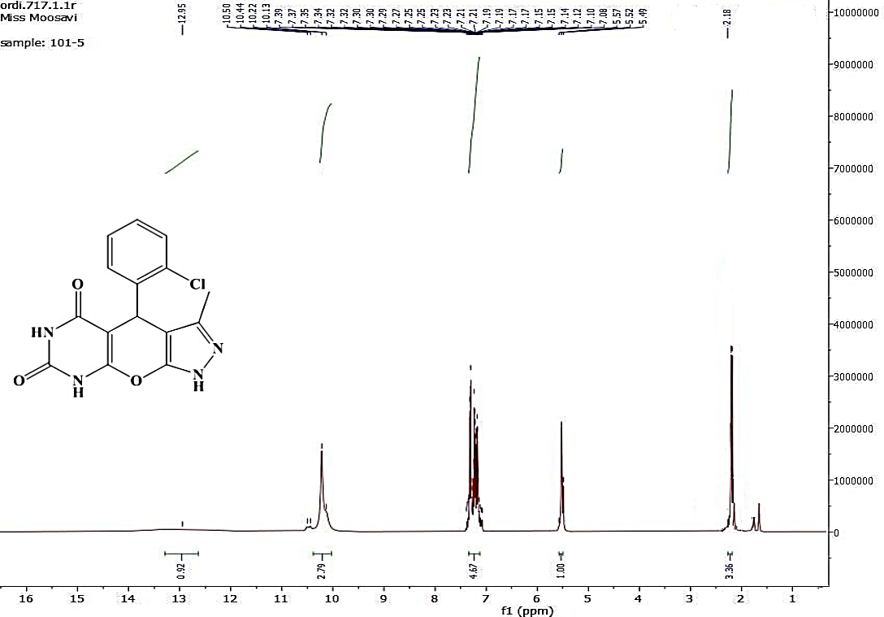
FIGURE S5. ¹H NMR spectrum of Compound 5b.
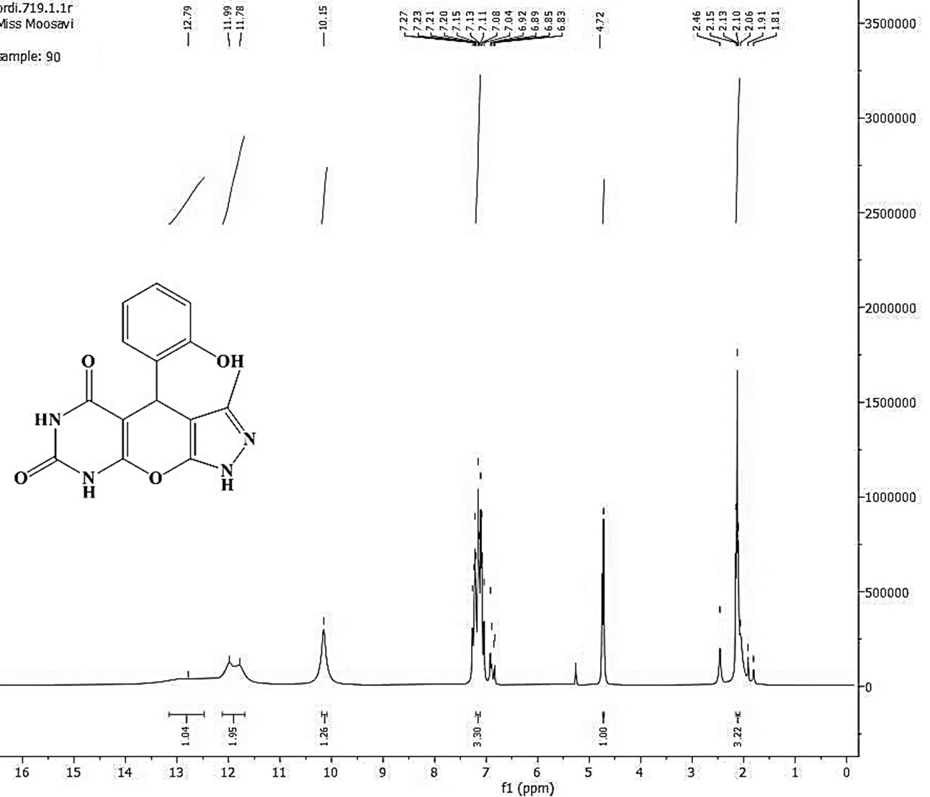
FIGURE S6. ¹H NMR spectrum of Compound 5c.
FIGURE S7. FT-IR spectrum of Compound 5d.
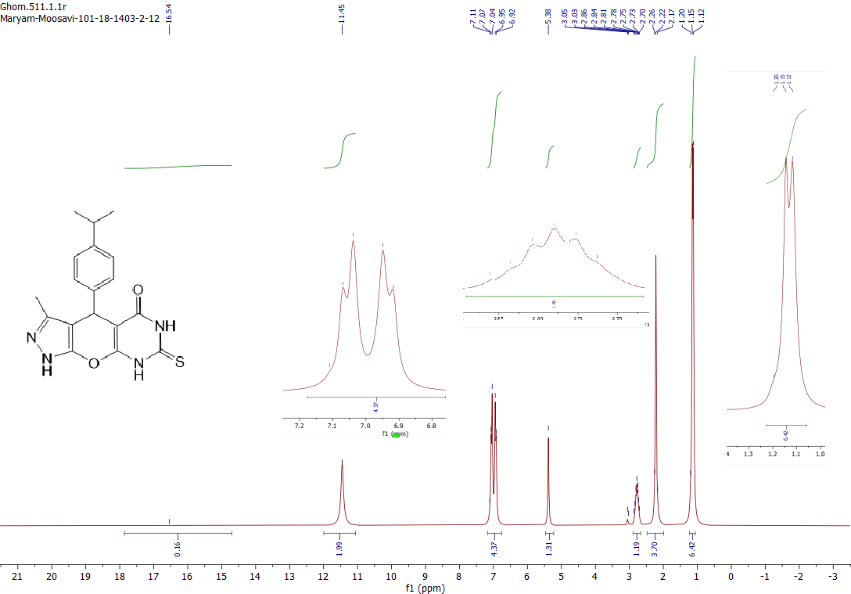
FIGURE S8. ¹H NMR spectrum of Compound 5d.
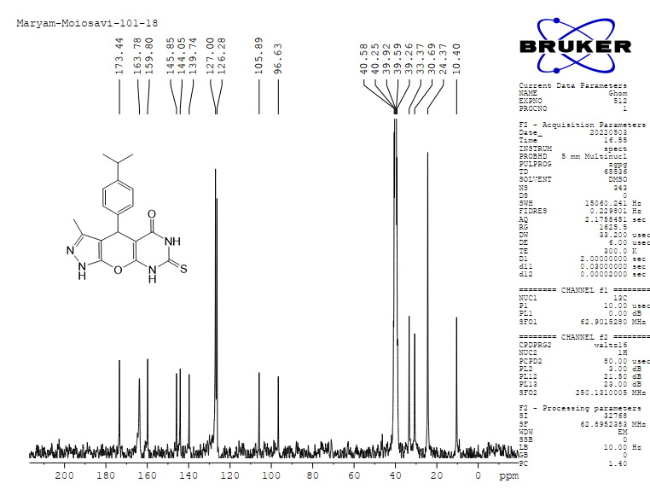
FIGURE S9. ¹³C NMR spectrum of Compound 5d.
FIGURE S10. Mass spectrum of Compound 5d.
FIGURE S11. ¹H NMR spectrum of Compound 5e.
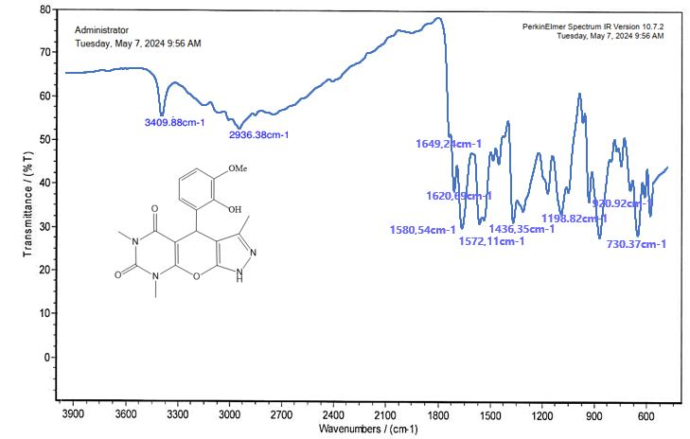
FIGURE S12. FT-IR spectrum of Compound 5f.
FIGURE S13. ¹H NMR spectrum of Compound 5f (With DMSO).
FIGURE S14. ¹H NMR spectrum of Compound 5f (With D₂O)

FIGURE S15. ¹³C NMR spectrum of Compound 5f.
FIGURE S16. Mass spectrum of Compound 5f.
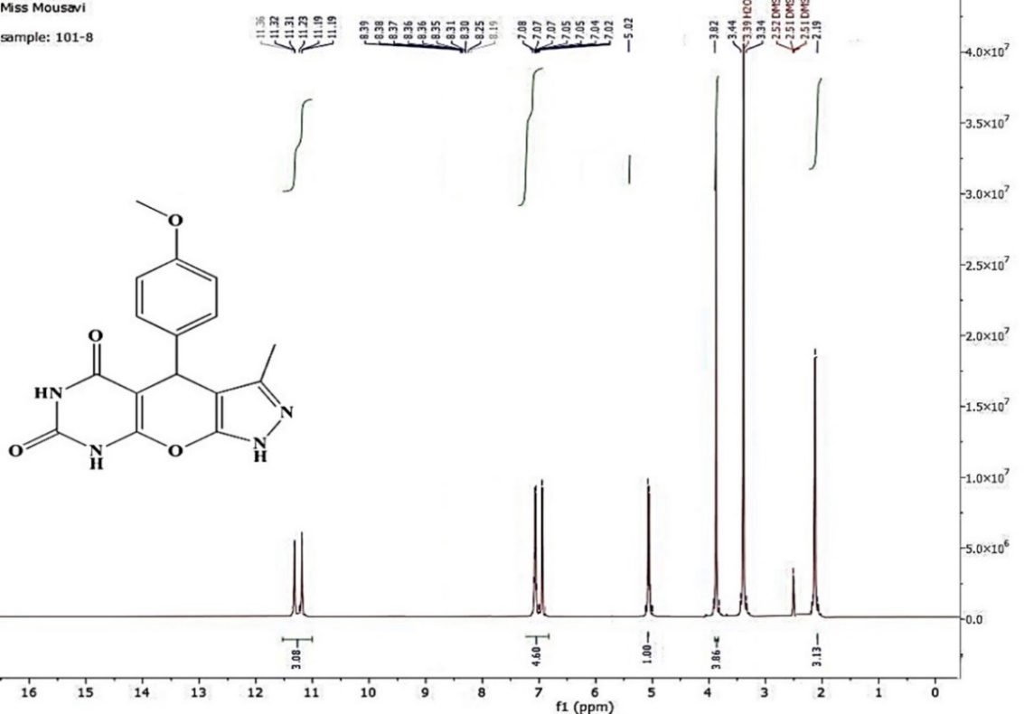
FIGURE S17. ¹H NMR spectrum of Compound 5g.
FIGURE S18. ¹H NMR spectrum of Compound 5h.
FIGURE S19. ¹H NMR spectrum of Compound 5i.
FIGURE S20. ¹H NMR spectrum of Compound 5j.
FIGURE S21. FT-IR spectrum of Compound 5k.
FIGURE S22. ¹H NMR spectrum of Compound 5k.
FIGURE S23. ¹³C NMR spectrum of Compound 5k.
FIGURE S24. Mass spectrum of Compound 5k.

FIGURE S25. ¹H NMR spectrum of Compound 5l.
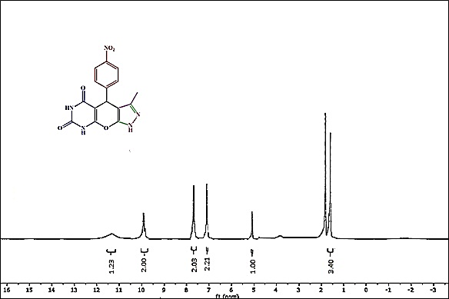
FIGURE S26. ¹H NMR spectrum of Compound 5m.
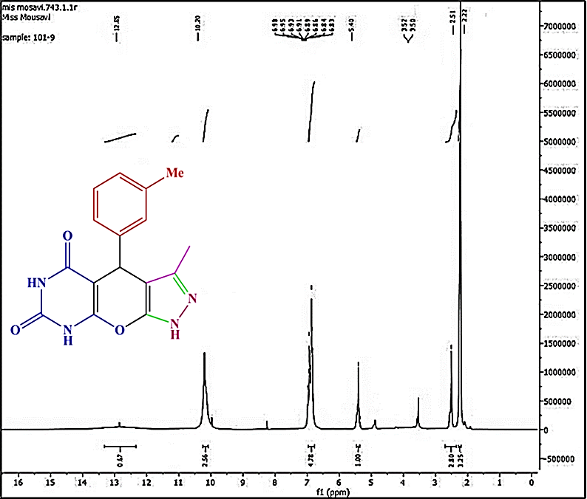
FIGURE S27. ¹H NMR spectrum of Compound 5n.
FIGURE S28. ¹H NMR spectrum of Compound 5o.
FIGURE S29. ¹H NMR spectrum of Compound 5p.
FIGURE S30. ¹H NMR spectrum of Compound 5q.
FIGURE S31. Mass spectrum of Compound 5q.
FIGURE S32. ¹H NMR spectrum of Compound 8a.
FIGURE S33. ¹H NMR spectrum of Compound 8b.
FIGURE S34. ¹H NMR spectrum of Compound 8c.
FIGURE S35. ¹H NMR spectrum of Compound 8d (with DMSO).
FIGURE S36 ¹H NMR spectrum of Compound 8d (with D₂O).
FIGURE S37. ¹³C NMR spectrum of Compound 8d.
FIGURE S38. Mass spectrum of Compound 8d.
FIGURE S39. ¹H NMR spectrum of Compound 8e.
FIGURE S40. ¹H NMR spectrum of Compound 8f.
FIGURE S41. Mass spectrum of Compound 8f.
FIGURE S42. ¹H NMR spectrum of Compound 8g.
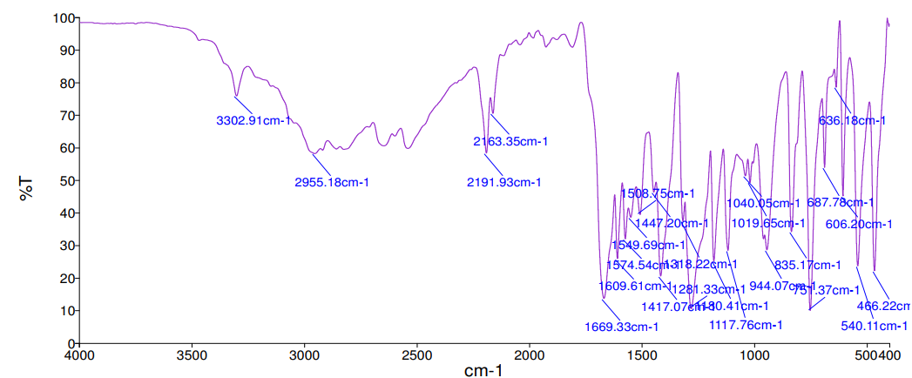
FIGURE S43. FT-IR spectrum of Compound 8h.
FIGURE S44. ¹H NMR spectrum of Compound 8h.
FIGURE S45. ¹³C NMR spectrum of Compound 8h.
FIGURE S46. Mass spectrum of Compound 8h.

FIGURE S47. ¹H NMR spectrum of Compound 8i.
References
1 Sadjadi, S. Heravi, M. M. Daraie, M. Heteropolyacid supported on amine-functionalized halloysite nano clay as an efficient catalyst for the synthesis of pyrazolopyranopyrimidines via four-component domino reaction. Res. Chem. Intermed. 43, 2201-2214, (2017).
2 Amini, H., Neamani, S., Moradi, L., Green synthesis of pyrazolo pyrano pyrimidine derivatives using ZnFe₂O₄/GA as a new effective catalyst in water media, ChemistrySelect, 6, 9608-9615, (2021).
2 Maleki, A., Jafari, A. A., Yousefi, S., Mane, A., Green cellulose-based nanocomposite catalyst: design and facile performance in aqueous synthesis of pyranopyrimidines and pyrazolopyranopyrimidines, Carbohydr. Polym. 175, 409-416, (2017).
3 Yekke-Ghasemi, Z., Heravi, M. M., Malmir, M., Jahani, G., Bisafar, M. B., & Mirzaei, M. Fabrication of heterogeneous-based lacunary polyoxometalates as efficient catalysts for the multicomponent and clean synthesis of pyrazolopyranopyrimidines. Inorganic Chemistry Communications, 140, 109456, (2022).
4 Gangu, K. K., Maddila, S., Maddila, S. N., & Jonnalagadda, S. B., Novel iron doped calcium oxalates as promising heterogeneous catalysts for one-pot multi-component synthesis of pyranopyrazoles. RSC. Adv. 7, 423-432, (2017).‏
5 D. Gandhi, A. Sethiya, D.K. Jangid, S. Agarwal, Nanocatalysed Synthesis of Pyrazoles, Indazoles, and Pyrazolines, Nanocatalysis. CRC Press, 219-243, (2022).
6 Tipale, M. R., Khillare, L. D., Deshmukh, A. R., Bhosle, M. R., An efficient four component domino synthesis of pyrazolopyranopyrimidines using recyclable choline chloride: urea deep eutectic solvent, J. Heterocycl. Chem. 55, 716-728, (2018).
7 Bhaskaruni, S. V., Maddila, S., van Zyl, W. E., Jonnalagadda, S B., An efficient and green approach for the synthesis of 2, 4-dihydropyrano [2, 3-c] pyrazole-3-carboxylates using Bi 2 O 3/ZrO 2 as a reusable catalyst, RSC adv. 8, 16336-16343, (2018).

