Luminance, or more specifically relative luminance -defined as normalized values between 0.0 and 1.0, with 1.0 being a perfect reflector of 100% reference white-, was calculated by first extracting the red, green, and blue (RGB) color channels from each pixel in the image. Since computer images are typically gamma-encoded for efficient storage, the gamma compression must be reversed by linearizing the RGB channels (Poyton, 2003). This process ensures the RGB values are proportional to the actual physical light intensity emitted by the pixels. To achieve this, each RGB channel is first normalized to the 0-1 range, and then linearized using a piecewise function:

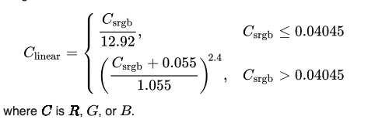

The linearized RGB values are then used to calculate relative luminance, Y , using the luminous efficiency function:

Y = 0.2126 * R + 0.7152 * G + 0.0722 * B

where R , G , and B represent the linearized red, green, and blue channels, respectively. This function weights the RGB components according to the human eye’s sensitivity to different wavelengths of light, with green contributing more to perceived brightness than blue. The resulting luminance values are thus a measure of the perceived brightness of each pixel in the image. Finally, relative luminance of the entire image was calculated by averaging the relative luminance values across all pixels.

