Table S9: HOPE analysis of deleterious nsSNPs.
nsSNP | Amino acid | Contacts | Structure | Variants | Conservation | Amino acid properties
P180L | 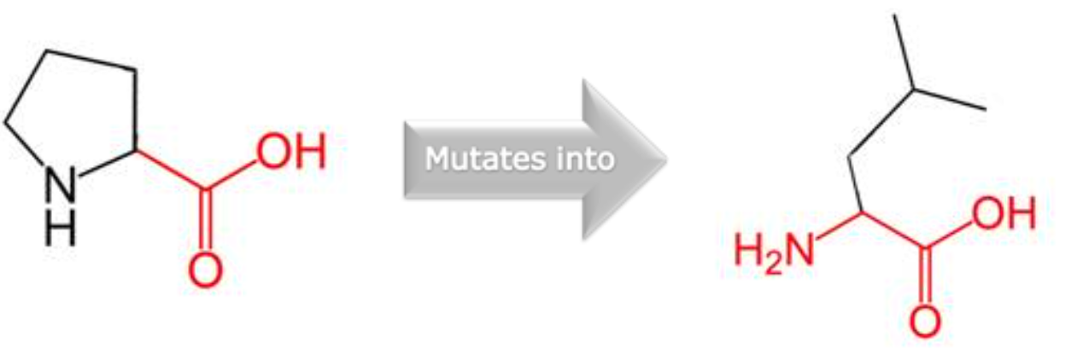 | The mutated residue is not in contact with a metal, however, one of the neighbouring residues does make a metal-contact that might be affected by the mutation in its vicinity. | The wild-type residue is a proline. Prolines are known to be very rigid and therefore induce a special backbone conformation which might be required at this position. The mutation can disturb this special conformation. | This variant's MetaRNN score is 0.9248438. It can range from 0.0 to 1.0. The higher, the more likely it is to be pathogenic. | Only this residue type was found at this position. Mutation of a 100% conserved residue is usually damaging for the protein. The mutant and wild-type residue are not very similar. Based on this conservation information this mutation is probably damaging to the protein. | The wild-type and mutant amino acids differ in size.  The mutant residue is bigger than the wild-type residue.  The residue is located on the surface of the protein, mutation of this residue can disturb interactions with other molecules or other parts of the protein.
Y262C | 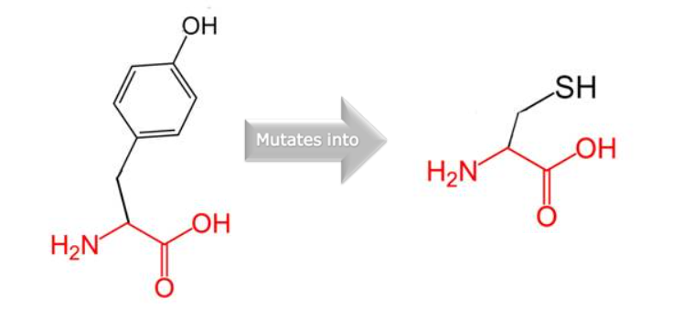 |  | The mutation is located within a domain, annotated in UniProt as: Fibronectin type-II 1. The mutation introduces an amino acid with different properties, which can disturb this domain and abolish its function. | This variant's MetaRNN score is 0.81029165. | The wild-type residue occurs often at this position in the sequence, but other residues have also been observed here.  Your mutant residue was not among the other residue types observed at this position in other, homologous sequences. However, residues with similar properties have been observed, so it is possible that your mutant residue is accepted here too.  Your mutant residue is located near a highly conserved position. | The wild-type and mutant amino acids differ in size.  The mutant residue is smaller than the wild-type residue.  This will cause a possible loss of external interactions.  The hydrophobicity of the wild-type and mutant residue differs.
C329S | 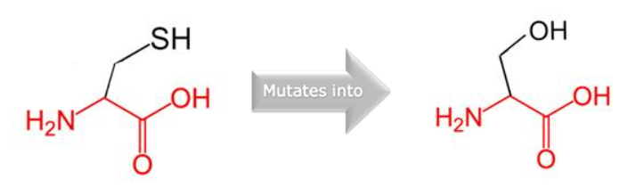 | The wild-type residue is annotated in UniProt to be involved in a cysteine bridge, which is important for stability of the protein. Only cysteines can make these types of bonds, the mutation causes loss of this interaction and will have a severe effect on the 3D-structure of the protein. Together with loss of the cysteine bond, the differences between the old and new residue can cause destabilization of the structure. | The mutation is located within a domain, annotated in UniProt as: Fibronectin type-II 2  The mutation introduces an amino acid with different properties, which can disturb this domain and abolish its function. | This variant's MetaRNN score is 0.9286783. | Only this residue type was found at this position. Mutation of a 100% conserved residue is usually damaging for the protein.  The mutant and wild-type residue are not very similar. Based on this conservation information this mutation is probably damaging to the protein.  Your mutant residue is located near a highly conserved position. | The hydrophobicity of the wild-type and mutant residue differs.  The mutation will cause loss of hydrophobic interactions in the core of the protein.
D434N | 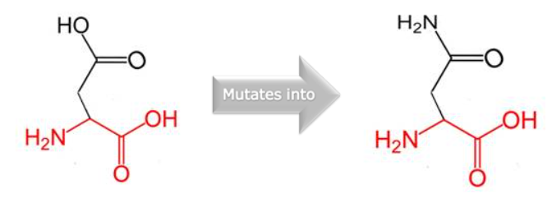 | The wild-type residue forms a hydrogen bond with: Serine at position 412 | The mutation is located within a stretch of residues annotated in UniProt as a special region: Disordered. The differences in amino acid properties can disturb this region and disturb its function. | This variant's MetaRNN score is 0.957306. | Only this residue type was found at this position. Mutation of a 100% conserved residue is usually damaging for the protein. The mutant residue, however, has some properties in common with the wild-type residue. This mutation might occur in some rare cases, but it's more likely that the mutation is damaging to the protein. Your mutant residue is located near a highly conserved position. | There is a difference in charge between the wild-type and mutant amino acid.  The charge of the wild-type residue is lost by this mutation. This can cause loss of interactions with other molecules.
R98L | 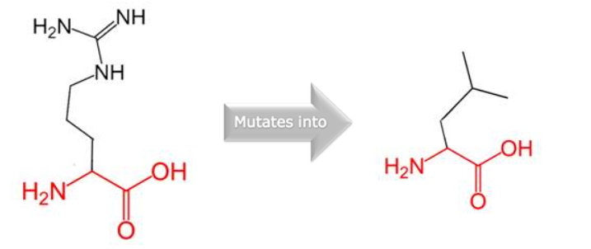 | The mutated residue is not in contact with a metal, however, one of the neighbouring residues does make a metal-contact that might be affected by the mutation in its vicinity.  The wild-type residue forms a hydrogen bond with: Tyrosine at position 48, Tyrosine at position 48, Cysteine at position 99, Aspartic Acid at position 103  The size difference between wild-type and mutant residue makes that the new residue is not in the correct position to make the same hydrogen bond as the original wild-type residue did.  The difference in hydrophobicity will affect hydrogen bond formation.  Residues in the vicinity of the mutated residue are annotated in the UniProt database as being a binding site. The mutation could affect the local structure and consequently affect this binding site.  The wild-type residue forms a salt bridge with:Aspartic Acid at position 103. The difference in charge will disturb the ionic interaction made by the original, wild-type residue. | The mutation is located within a stretch of residues annotated in UniProt as a special motif: Cysteine switch. The differences in amino acid properties will disturb the motif and probably affect its function. | This variant's MetaRNN score is 0.9435425. | Only this residue type was found at this position. Mutation of a 100% conserved residue is usually damaging for the protein.  The mutant and wild-type residue are not very similar. Based on this conservation information this mutation is probably damaging to the protein.  Your mutant residue is located near a highly conserved position. | There is a difference in charge between the wild-type and mutant amino acid.  The charge of the buried wild-type residue is lost by this mutation.  The wild-type and mutant amino acids differ in size.  The mutant residue is smaller than the wild-type residue.  The mutation will cause an empty space in the core of the protein.  The hydrophobicity of the wild-type and mutant residue differs.  The mutation will cause loss of hydrogen bonds in the core of the protein and as a result disturb correct folding.
D390Y | 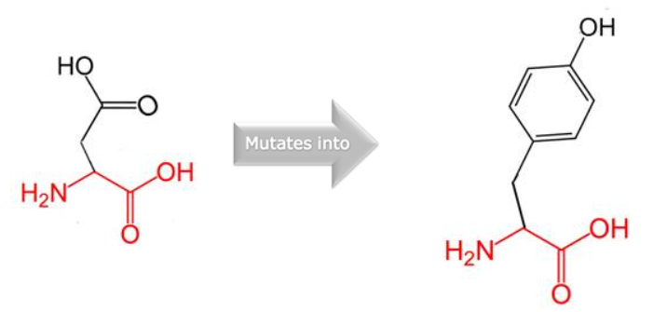 | The wild-type residue forms a hydrogen bond with: Glycine at position 392  The size difference between wild-type and mutant residue makes that the new residue is not in the correct position to make the same hydrogen bond as the original wild-type residue did.  The difference in hydrophobicity will affect hydrogen bond formation.  The wild-type residue forms a salt bridge with: Lysine at position 184 & Arginine at position 370.  The difference in charge will disturb the ionic interaction made by the original, wild-type residue. | The mutation is located within a domain, annotated in UniProt as: Fibronectin type-II 3  The mutation introduces an amino acid with different properties, which can disturb this domain and abolish its function. | This variant's MetaRNN score is 0.84961796. |  | There is a difference in charge between the wild-type and mutant amino acid.  The charge of the wild-type residue is lost by this mutation. This can cause loss of interactions with other molecules.  The wild-type and mutant amino acids differ in size.  The mutant residue is bigger than the wild-type residue.  The residue is located on the surface of the protein, mutation of this residue can disturb interactions with other molecules or other parts of the protein.  The hydrophobicity of the wild-type and mutant residue differs.
C347Y | 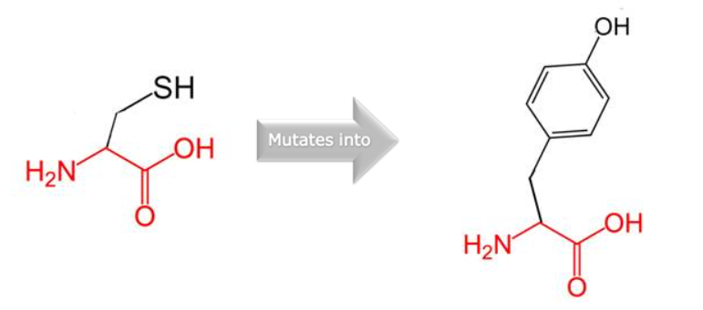 | The wild-type residue is annotated in UniProt to be involved in a cysteine bridge, which is important for stability of the protein. Only cysteines can make these types of bonds, the mutation causes loss of this interaction and will have a severe effect on the 3D-structure of the protein.  Together with loss of the cysteine bond, the differences between the old and new residue can cause destabilization of the structure. | The mutation is located within a domain, annotated in UniProt as: Fibronectin type-II 3  The mutation introduces an amino acid with different properties, which can disturb this domain and abolish its function. | This variant's MetaRNN score is 0.9791647. | Only this residue type was found at this position. Mutation of a 100% conserved residue is usually damaging for the protein.  The mutant and wild-type residue are not very similar. Based on this conservation information this mutation is probably damaging to the protein. | The wild-type and mutant amino acids differ in size.  The mutant residue is bigger than the wild-type residue.  The wild-type residue was buried in the core of the protein. The mutant residue is bigger and probably will not fit.  The hydrophobicity of the wild-type and mutant residue differs.  The mutation will cause loss of hydrophobic interactions in the core of the protein.
G438A | 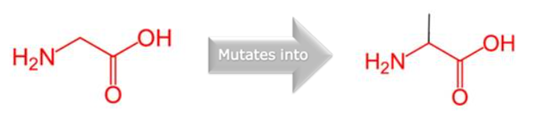 |  | The mutation is located within a stretch of residues annotated in UniProt as a special region: Disordered. The differences in amino acid properties can disturb this region and disturb its function.  The wild-type residue is a glycine, the most flexible of all residues. This flexibility might be necessary for the protein's function. Mutation of this glycine can abolish this function. | This variant's MetaRNN score is 0.92628396 | Only this residue type was found at this position. Mutation of a 100% conserved residue is usually damaging for the protein.  The mutant and wild-type residue are not very similar. Based on this conservation information this mutation is probably damaging to the protein.  Your mutant residue is located near a highly conserved position | The wild-type and mutant amino acids differ in size.  The mutant residue is bigger than the wild-type residue.  The residue is located on the surface of the protein, mutation of this residue can disturb interactions with other molecules or other parts of the protein.
G306C | 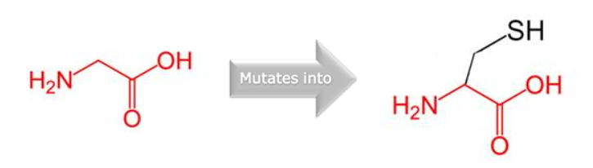 |  | The mutation is located within a domain, annotated in UniProt as:  Fibronectin type-II 2  The mutation introduces an amino acid with different properties, which can disturb this domain and abolish its function.  The wild-type residue is a glycine, the most flexible of all residues. This flexibility might be necessary for the protein's function. Mutation of this glycine can abolish this function. | This variant's MetaRNN score is 0.91895497 | Only this residue type was found at this position. Mutation of a 100% conserved residue is usually damaging for the protein.  The mutant and wild-type residue are not very similar. Based on this conservation information this mutation is probably damaging to the protein.  Your mutant residue is located near a highly conserved position. | The wild-type and mutant amino acids differ in size.  The mutant residue is bigger than the wild-type residue.  The residue is located on the surface of the protein, mutation of this residue can disturb interactions with other molecules or other parts of the protein.  The torsion angles for this residue are unusual. only glycine is flexible enough to make these torsion angles, mutation into another residue will force the local backbone into an incorrect conformation and will disturb the local structure.
G183E | 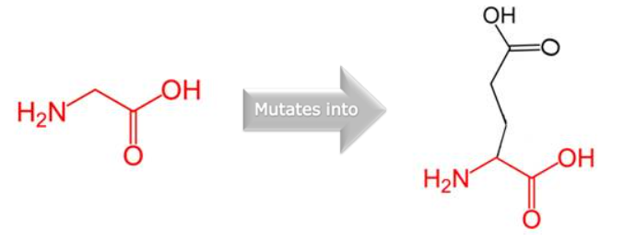 | The mutated residue is not in contact with a metal, however, one of the neighbouring residues does make a metal-contact that might be affected by the mutation in its vicinity.  Residues in the vicinity of the mutated residue are annotated in the UniProt database as being a binding site. The mutation could affect the local structure and as a consequence affect this binding site. | The wild-type residue is a glycine, the most flexible of all residues. This flexibility might be necessary for the protein's function. Mutation of this glycine can abolish this function. | This variant's MetaRNN score is 0.9183694. | Only this residue type was found at this position. Mutation of a 100% conserved residue is usually damaging for the protein.  The mutant and wild-type residue are not very similar. Based on this conservation information this mutation is probably damaging to the protein.  Your mutant residue is located near a highly conserved position. | There is a difference in charge between the wild-type and mutant amino acid.  The mutant residue introduces a charge in a buried residue which can lead to protein folding problems.  The wild-type and mutant amino acids differ in size.  The mutant residue is bigger than the wild-type residue.  The wild-type residue was buried in the core of the protein. The mutant residue is bigger and probably will not fit.  The torsion angles for this residue are unusual. only glycine is flexible enough to make these torsion angles, mutation into another residue will force the local backbone into an incorrect conformation and will disturb the local structure.
M422R | 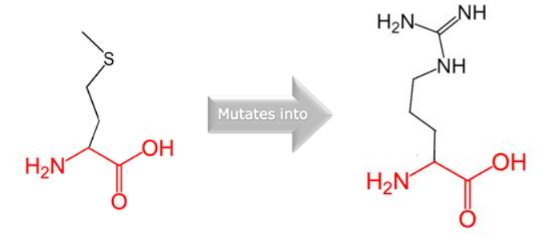 |  |  | This variant's MetaRNN score is 0.90772295. | Only this residue type was found at this position. Mutation of a 100% conserved residue is usually damaging for the protein.  The mutant and wild-type residue are not very similar. Based on this conservation information this mutation is probably damaging to the protein.  Your mutant residue is located near a highly conserved position. | There is a difference in charge between the wild-type and mutant amino acid.  The mutant residue introduces a charge in a buried residue which can lead to protein folding problems.  The wild-type and mutant amino acids differ in size.  The mutant residue is bigger than the wild-type residue.  The wild-type residue was buried in the core of the protein. The mutant residue is bigger and probably will not fit.  The hydrophobicity of the wild-type and mutant residue differs.  The mutation will cause loss of hydrophobic interactions in the core of the protein.

