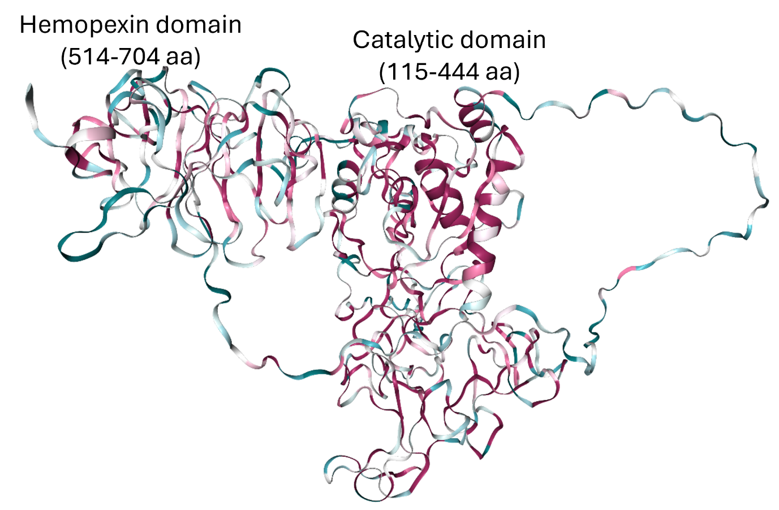
Figure S1: Cartoon structure of MMP9 protein

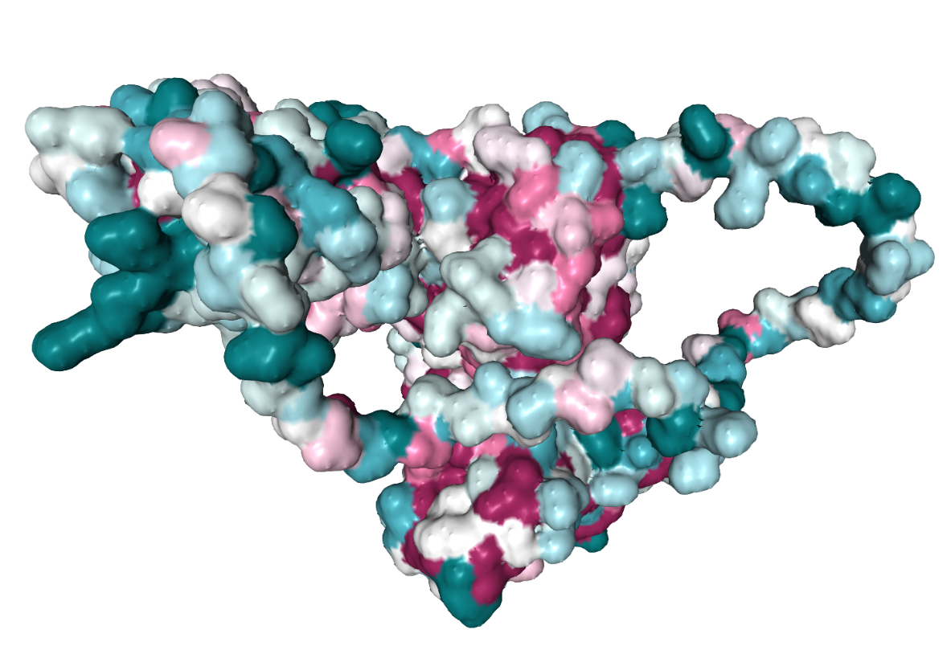
Figure S2: Surface structure of MMP9 protein

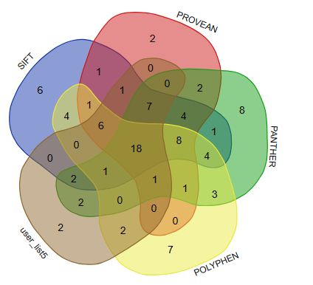
Figure S3: Eighteen common damaging nsSNPs from SIFT, PROVEAN, POLYPHEN, SNP & GO and PANTHER

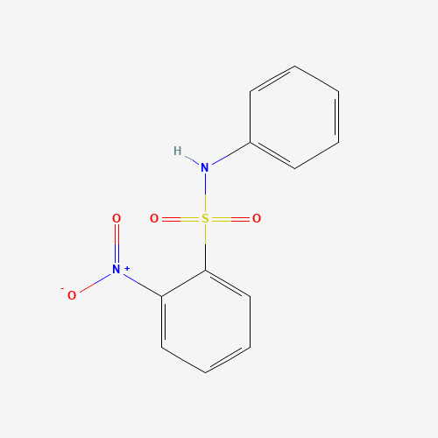
Figure S4: Structure of benzenesulfonamide, 2-nitro-N-phenyl- for molecular docking

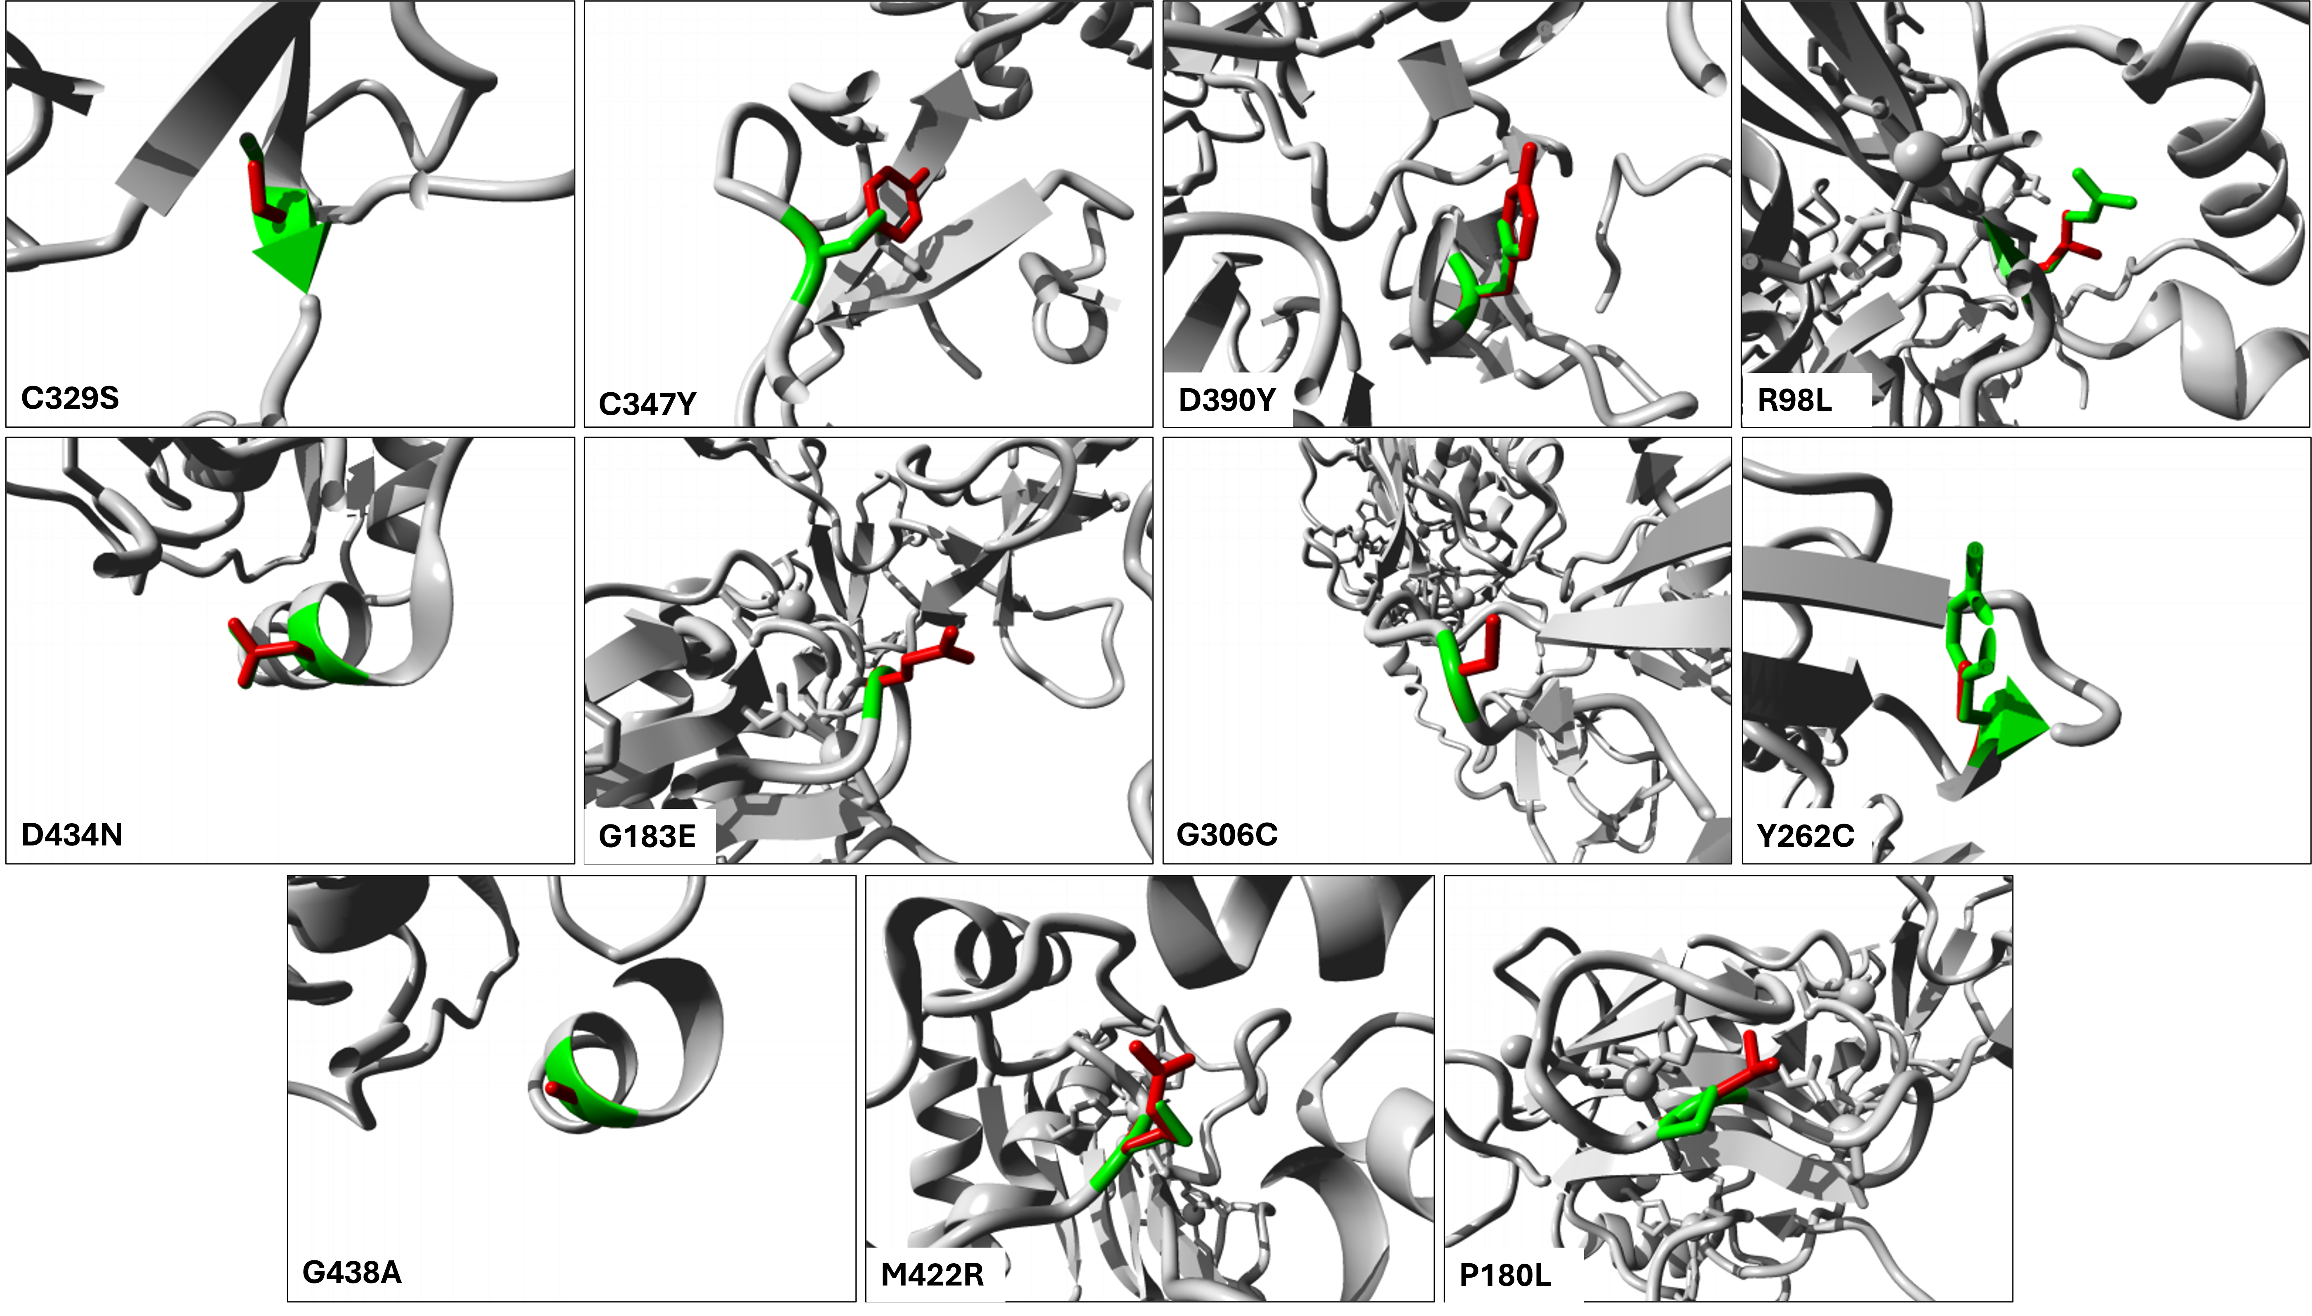
Figure S5: Structural impacts of nsSNPs predicted in HOPE. The side chains with green colour represents wild type while red colour shows mutant amino acid residues

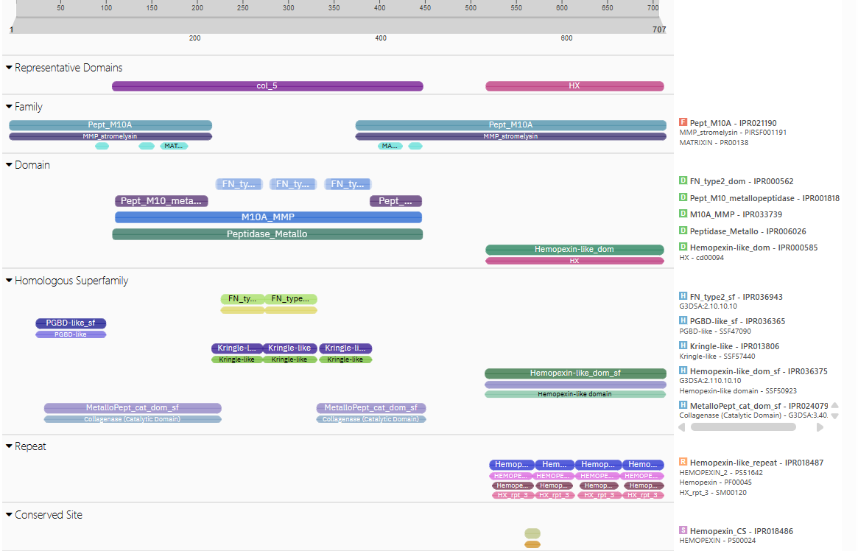
Figure S6: Interpro results of MMP9 protein.

Table S7: Eighteen nsSNPs were further checked from PHD-SNP only twelve genes were predicted to be disease and theses gene.
RS ID | Variant | Score | PHD-SNP
rs201524123 | D390Y | 2 | Disease
rs368234910 | D514Y | 0 | Neutral
rs148726595 | Y262C | 2 | Disease
rs199676062 | P180L | 5 | Disease
rs143695450 | G84C | 2 | Neutral
rs141088574 | Y179H | 0 | Neutral
rs372299611 | A523V | 7 | Disease
rs200814121 | C329S | 3 | Disease
rs201131366 | M422R | 2 | Disease
rs200590350 | A399V | 0 | Neutral
rs201932479 | G183E | 8 | Disease
rs200684686 | V657A | 7 | Neutral
rs140352541 | R98L | 3 | Disease
rs199893610 | D434N | 6 | Disease
rs35691798 | F571V | 2 | Neutral
rs201344509 | G306C | 9 | Disease
rs201169008 | G438A | 7 | Disease
rs145450508 | C347Y | 4 | Disease

Table S8: Scores of final twelve deleterious nsSNP screened from six different software.
rs ID | Substitution | SIFT |  | PROVEAN |  | PANTHER |  | POLYPHEN |  | SNP & Go |  | PhD-SNP
rs201524123 | D390Y | 0.003 | Deleterious | -6.157 | Deleterious | 0.57 | Probably damaging | 0.981 | Probably damaging | 0.804 | Disease | 2.00 | Disease
rs148726595 | Y262C | 0.002 | Deleterious | -5.091 | Deleterious | 0.57 | Probably damaging | 1 | Probably damaging | 0.615 | Disease | 2 | Disease
rs199676062 | P180L | 0.001 | Deleterious | -8.04 | Deleterious | 0.85 | Probably damaging | 1 | Probably damaging | 0.807 | Disease | 5 | Disease
rs200814121 | C329S | 0.049 | Deleterious | -6.796 | Deleterious | 0.74 | Probably damaging | 1 | Probably damaging | 0.816 | Disease | 3 | Disease
rs201131366 | M422R | 0.018 | Deleterious | -3.999 | Deleterious | 0.57 | Probably damaging | 0.982 | Probably damaging | 0.808 | Disease | 2 | Disease
rs201932479 | G183E | 0.001 | Deleterious | -5.979 | Deleterious | 0.85 | Probably damaging | 1 | Probably damaging | 0.78 | Disease | 8 | Disease
rs140352541 | R98L | 0 | Deleterious | -5.948 | Deleterious | 0.85 | Probably damaging | 1 | Probably damaging | 0.871 | Disease | 3 | Disease
rs199893610 | D434N | 0 | Deleterious | -4.442 | Deleterious | 0.85 | Probably damaging | 1 | Probably damaging | 0.864 | Disease | 6 | Disease
rs201344509 | G306C | 0.002 | Deleterious | -5.863 | Deleterious | 0.57 | Probably damaging | 1 | Probably damaging | 0.534 | Disease | 9 | Disease
rs201169008 | G438A | 0.007 | Deleterious | -5.319 | Deleterious | 0.85 | Probably damaging | 1 | Probably damaging | 0.755 | Disease | 7 | Disease
rs145450508 | C347Y | 0.001 | Deleterious | -8.206 | Deleterious | 0.74 | Probably damaging | 1 | Probably damaging | 0.861 | Disease | 4 | Disease
rs372299611 | A523V | 0.021 | Deleterious | -2.596 | Deleterious | 0.85 | Probably damaging | 0.951 | Probably damaging | 0.766 | Disease | 7 | Disease

