The impact of androgen receptor pathway inhibitors as starting treatment in metastatic castration-sensitive prostate cancer on patient outcomes (OASIS Japan)

SUPPLEMENT

Figure S1 Overall survival and time to undetectable PSA in patients with metastatic castration-sensitive prostate cancer, by starting treatment (CAB and ADT alone presented separately) – Kaplan-Meier method

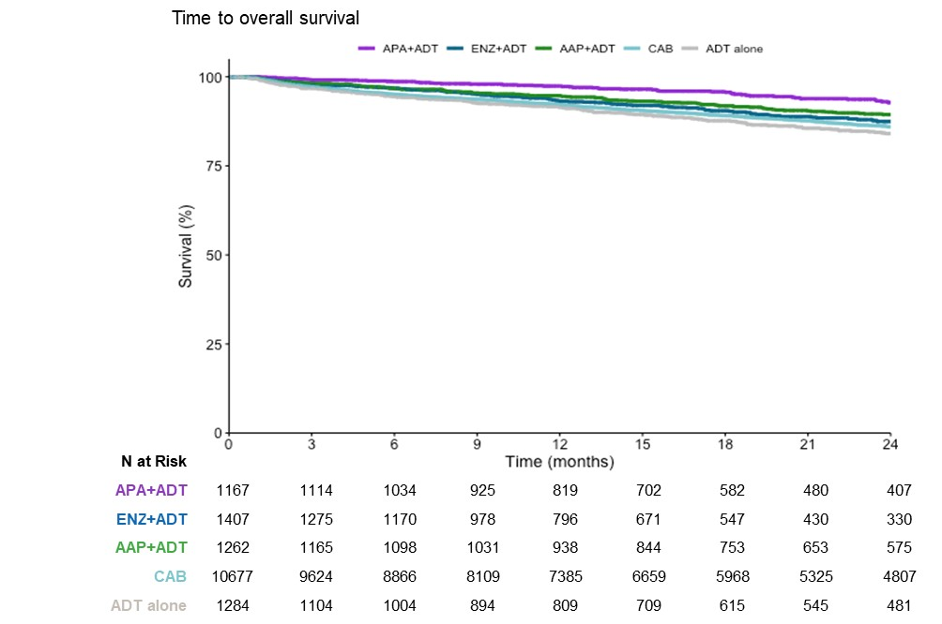

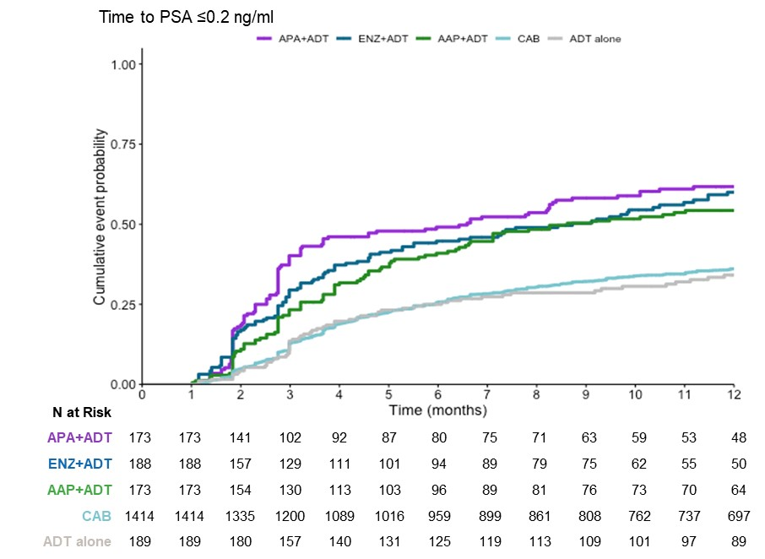
AAP, abiraterone acetate plus prednisone; ADT, androgen deprivation therapy; APA, apalutamide; CAB, combined androgen blockade; ENZ, enzalutamide; OS, overall survival

