Supplementary text
Text 1 Ansung-Ansan cohort
The KoGES collects epidemiological data (general information, disease history, questionnaire items such as diet and lifestyle, physical measurements, and the results of clinical examinations), genetic information (SNPs), and human resources (DNA, serum, plasma). This study analysed data from two independent cohorts of Ansan (urban area) and Ansung (rural area) included in the Korean Genome and Epidemiology Study (KoGES) that represent community-based cohorts of Korea. Both cohorts comprise Korean men and women aged 39–70 years between 2001 and 2002 for a prospective investigation.
The subjects included in the cohort were followed up every two years for prospective region-based epidemiological studies. The dataset collected in the Ansung-Ansan cohort was constructed using questionnaires and screening surveys, which is compatible with domestic epidemiological requirements. Detailed information on participant recruitment is available elsewhere [1,2]. In total, 5,020 participants from Ansan and 5,018 participants from Ansung took part in the baseline study from 2001 to 2003. The cohort members underwent a comprehensive health examination and a questionnaire-based interview, and biospecimens for assays were collected by health professionals at each study site. The questionnaire covered demographic characteristics, lifestyle choices, and medical history.

Text 2 The Korea Association Resource Project (KARE)
KARE, a multidisciplinary research consortium, began in 2007 to conduct a large-scale GWAS of Ansan and Ansung cohorts in the KoGES [3]. From the 10,038 participants in both cohorts, we obtained genetic information from 10,004 individuals using microarrays, but excluded the data of 1,476 individuals because they exhibited either a missing genotype call rate of <96%, heterozygosity of <70%, gender consistencies, average pair-wise identity-by-state values higher than 0.8 as estimated values from first-degree relatives of Korean sib-pair samples, or medical history of any type of cancer. In addition, individuals who did not complete a pulmonary function test or anthropometric measurement and did not report smoking status were omitted.

Text 3 Quality control (QC) and genotype imputation
Quality control
For the discovery genome wide interaction study (GWIS) with KARE data, as well as for the validation analyses using the GENIE cohort, the QC of SNPs and subjects was performed using PLINK23 and oneTOOL24. We excluded SNPs with P-values < 10^{–5} in the Hardy-Weinberg equilibrium (HWE) analysis, minor allele frequencies (MAFs) <0.05, and genotype call rates <95%. Furthermore, we excluded subjects with missing genotype call rates >5% or sex-based inconsistencies. After QC, 311,556 SNPs and 8,554 participants were included for whole-genome imputation.

Genotype imputation
For GWIS with KARE data, whole-genome imputation was performed using SHAPEIT2 and IMPUTE2 for pre-phasing data and genotype imputations. The 1,000 Genomes Phase 3 was used as the reference panel. To maintain imputation quality, the estimated imputation accuracy for imputed SNPs was evaluated using the INFO metric, and any imputed SNPs with INFO <0.5 were eliminated. The standard QC procedure was also applied for imputed SNPs, and 3,333,374 SNPs from 8,554 participants were used for the GWIS discovery study. For the validation analyses, genotypes comprising the most significant SNPs were not originally genotyped, and target imputation was performed. Target imputation for regions containing significantly associated SNPs was performed using IMPUTE2 with a buffer size of 5 million bp for each target SNP.

Supplementary tables
Table S1. Number of follow-up spirometry measurements of KARE data
Follow-up | 1 | 2 | 3 | 4 | 5 | 6 | 7
N | 1207 | 903 | 859 | 902 | 1154 | 1168 | 2361
Abbreviations: KARE, Korea Association Resource Project
Note : The KARE conducted biannual follow-ups beginning with baseline recruitment in 2001–2002. The follow-up years were as follows: baseline (2001–2002), 1st (2003–2004), 2nd (2005–2006), 3rd (2007–2008), 4th (2009–2010), 5th (2011–2012), and 6th (2013–2014). Pulmonary function tests (PFTs) were conducted during each follow-up for participants at all seven time points.

Table S2. Baseline characteristics of participants with airflow obstruction included in the study
 | Normal  (n = 7,816) | COPD  (n = 738) | Total  (n = 8,554) | P-value
Age, years, mean | 51.6 ± 8.7 | 58.5 ± 8.1 | 52.1 ± 8.8 | < 0.001
Sex, male, N (%) | 3479 (44.5) | 547 (74.1) | 4026 (100) | < 0.001
Body mass index,  kg/m², mean | 24.7 ± 3.0 | 23.7 ± 3.1 | 24.6 ± 3.1 | < 0.001
Height, cm | 159.8 ± 8.7 | 162.4 ± 7.8 | 160.0 ± 8.7 | < 0.001
Smoking status, N (%) |  |  |  | < 0.001
Never smoker | 4801 (62.0) | 220 (30.1) | 5021 (59.3)
Former smoker | 1144 (14.8) | 165 (22.6) | 1309 (15.5)
Current smoker | 1795 (23.2) | 346 (47.3) | 2141 (25.3)
Smoking, pack-year | 22.2 ± 16.8 | 30.7 ± 18.8 | 23.4 ± 17.4 | < 0.001
FEV₁, % predicted, mean | 113.7 ± 16.4 | 91.6 ± 17.5 | 111.8 ± 17.7 | < 0.001
FVC, % predicted, mean | 104.6 ± 14.4 | 106.0 ± 17.3 | 104.7 ± 14.7 | 0.027
FEV₁/FVC, % | 81.5 ± 5.5 | 62.8 ± 6.6 | 79.9 ± 7.7 | < 0.001
Abbreviations: COPD, chronic obstructive pulmonary disease; FEV₁, forced expiratory volume in 1 s; FVC, forced vital capacity.

Table S3. Validation of the most significant SNPs identified in GWIS
Marker | Minor | MAF | HWE | MISS | SNP.BETA | SNP.p | INT.BETA | Int.p | LR
rs75679995 | G/A | 0.21 | 0.337 | 0.089 | 0.058(0.127) | 0.647635 | 0.023(0.018) | 0.210252 | 0.35024
rs74676405 | A/G | 0.194 | 0.433 | 0.085 | 0.117(0.13) | 0.371256 | 0.019(0.019) | 0.306255 | 0.313309
rs10274154 | G/A | 0.208 | 0.556 | 0.067 | 0.113(0.126) | 0.372234 | 0.011(0.018) | 0.556916 | 0.492053
rs9991425 | G/A | 0.074 | 0.534 | 0.074 | 0.243(0.195) | 0.213421 | -0.01(0.028) | 0.731486 | 0.459079
rs10026067 | A/T | 0.074 | 0.592 | 0.075 | 0.268(0.195) | 0.170278 | -0.013(0.028) | 0.646054 | 0.384121
rs55764142 | T/G | 0.074 | 0.534 | 0.074 | 0.244(0.195) | 0.211523 | -0.01(0.028) | 0.728262 | 0.455996
rs55999620 | T/A | 0.074 | 0.534 | 0.074 | 0.244(0.195) | 0.211523 | -0.01(0.028) | 0.728262 | 0.455996
rs4692810 | T/C | 0.074 | 0.535 | 0.074 | 0.249(0.195) | 0.201726 | -0.01(0.028) | 0.72666 | 0.440702
rs10014884 | C/A | 0.074 | 0.534 | 0.074 | 0.243(0.195) | 0.213421 | -0.01(0.028) | 0.731486 | 0.459079
rs73279813 | A/T | 0.209 | 0.718 | 0.038 | 0.13(0.124) | 0.293917 | 0.01(0.018) | 0.586104 | 0.425723
Note : βSNP and βINT are the coefficients for the main SNP and interaction effects between SNP and time, respectively.
Abbreviations: BP, physical position; MAF, minor allele frequencies; HWE, Hardy-Weinberg equilibrium
Supplementary figure
Figure S1. Expression of MFAP3L and AADAT. The exon-level expressions of MFAP3L and AADAT across all tissues are summarised. Plots were generated from the GTEx portal. MFAP3L and AADAT show 1 and 6.828 transcripts per million kilobases in lung tissues, respectively.
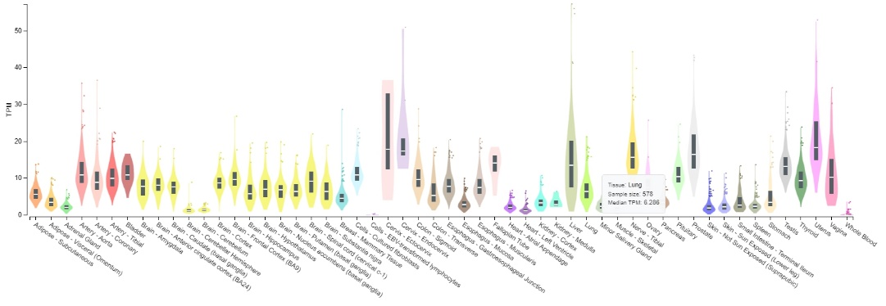
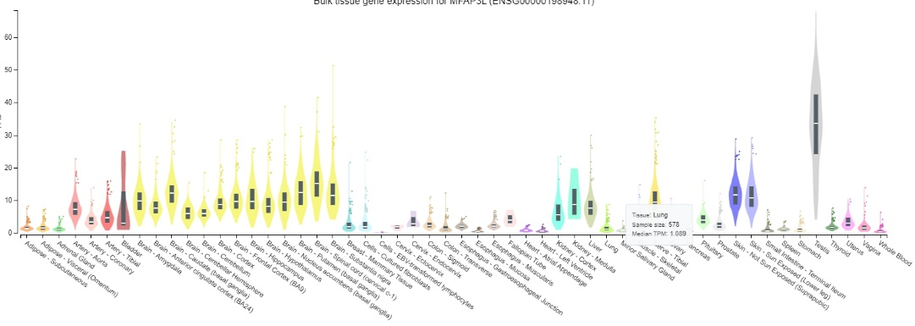

References
1. Kim, C. Y. et al. Longitudinal Evaluation of the Relationship Between Low Socioeconomic Status and Incidence of Chronic Obstructive Pulmonary Disease: Korean Genome and Epidemiology Study (KoGES). Int J Chron Obstruct Pulmon Dis 15, 3447-3454 (2020).
2. Shin, C. et al. Association of habitual snoring with glucose and insulin metabolism in nonobese Korean adult men. Am J Respir Crit Care Med 171, 287-291 (2005).
3. Gottlieb, D. J. et al. Heritability of longitudinal change in lung function. The Framingham study. Am J Respir Crit Care Med 164, 1655-1659 (2001).

