Genome Editing in Spinocerebellar Ataxia Type 3 Cells Improves Golgi Apparatus Structure

Yanlin Wang^{1,2,3#}, Yunan Cheng^{1,2,3#},Huifang Sun^{1,2,3},Zhuoya Wang¹, Na Chen⁴,Changhe Shi^{1,2,3},Han Liu¹ ,Jing Yang^{1, 2,3*}, and Yuming Xu^{1,2,3 *}

¹ Department of Neurology, The First Affiliated Hospital of Zhengzhou University, Zhengzhou, Henan, China, 450000
² NHC Key Laboratory of Prevention and treatment of Cerebrovascular Disease,Zhengzhou, Henan, China, 450000
³ Henan Key Laboratory of Cerebrovascular Diseases（Zhengzhou University）,Zhengzhou, Henan, China, 450000
⁴ Henan University of Traditional Chinese Medicine, Zhengzhou, Henan, China, 450000

# The author contributes equally to this work and is the co-first author of this paper.
* Corresponding author
Correspondence to:
Yuming Xu: Email 13903711125@126.com, Tel: 13903711125
Jing Yang: Email yangjing9527@126.com, Tel:18503826669
Corresponding author’s address:
Department of Neurology, The First Affiliated Hospital of Zhengzhou University, Zhengzhou University. 50 Jianshe Road, Zhengzhou City, Henan Province, China, 450000

Supplementary Figures

Fig. S1 Validation of The hES-HPM-001-A Targeting Vector.
（A）The the hES-HPM-001-A targeting vector was confirmed by restriction enzyme digestion after construction. (B) Schematic view of primer positions. (C) Screened an genome editing iPSCs clones having positive band using the paired primers hES-HPM-001-A-L-GT-F/Puro-GT-F for the inserted sequences. (D) The genome editing iPSCs clones had positive band using the paired primers Puro-GT-R/ hES-HPM-001-A-R-GT-R for the inserted sequences. (E) The genome editing iPSCs clones had positive band using the paired primers hES-HPM-001-A-L-GT-F/hES-HPM-001-A-R-GT-R for the wild-type allele without PolyA.

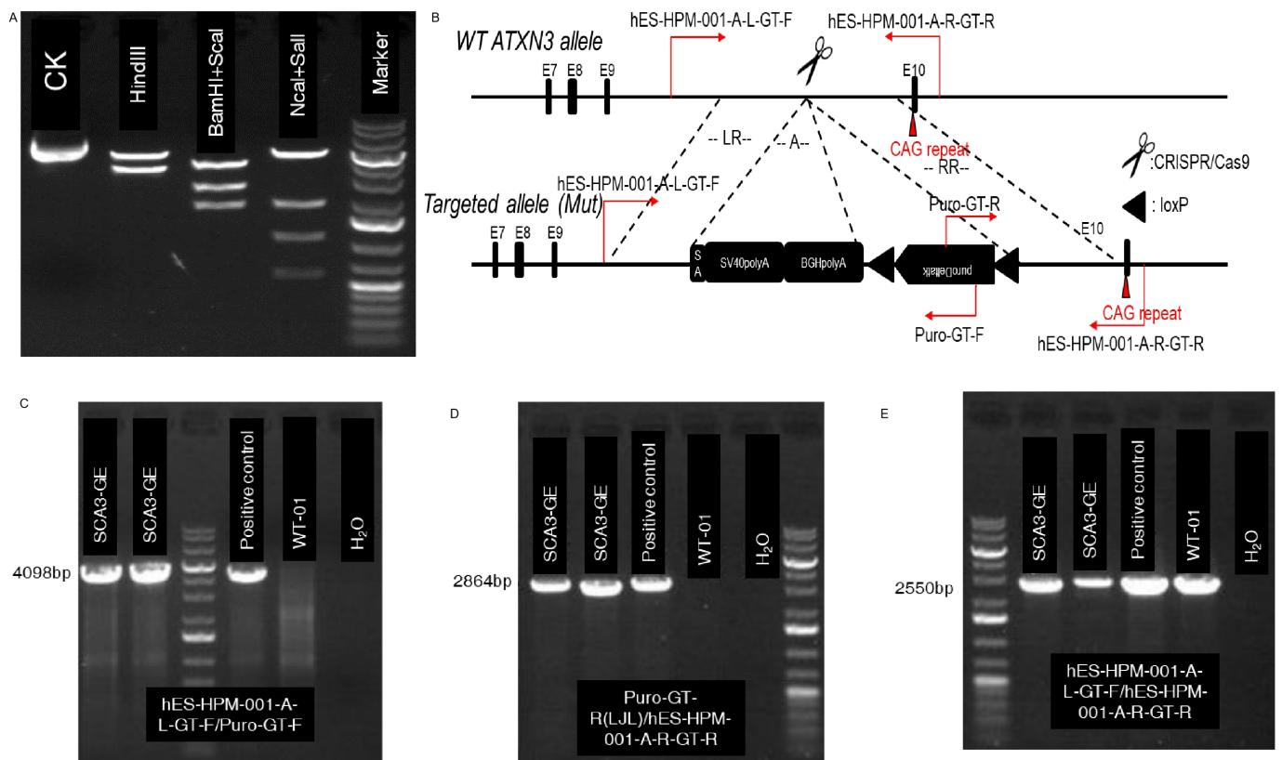

Fig. S2 Upper band/ATXN3 splicing.After genome editing, the ATXN3 gene was detected by Sanger sequencing, which included the sgRNA7 sequence at 5’ end,the structure of adenovirus splice acceptor,and from pBS302(lox2 STOP) of the hES-HPM-001 A targeting vector.
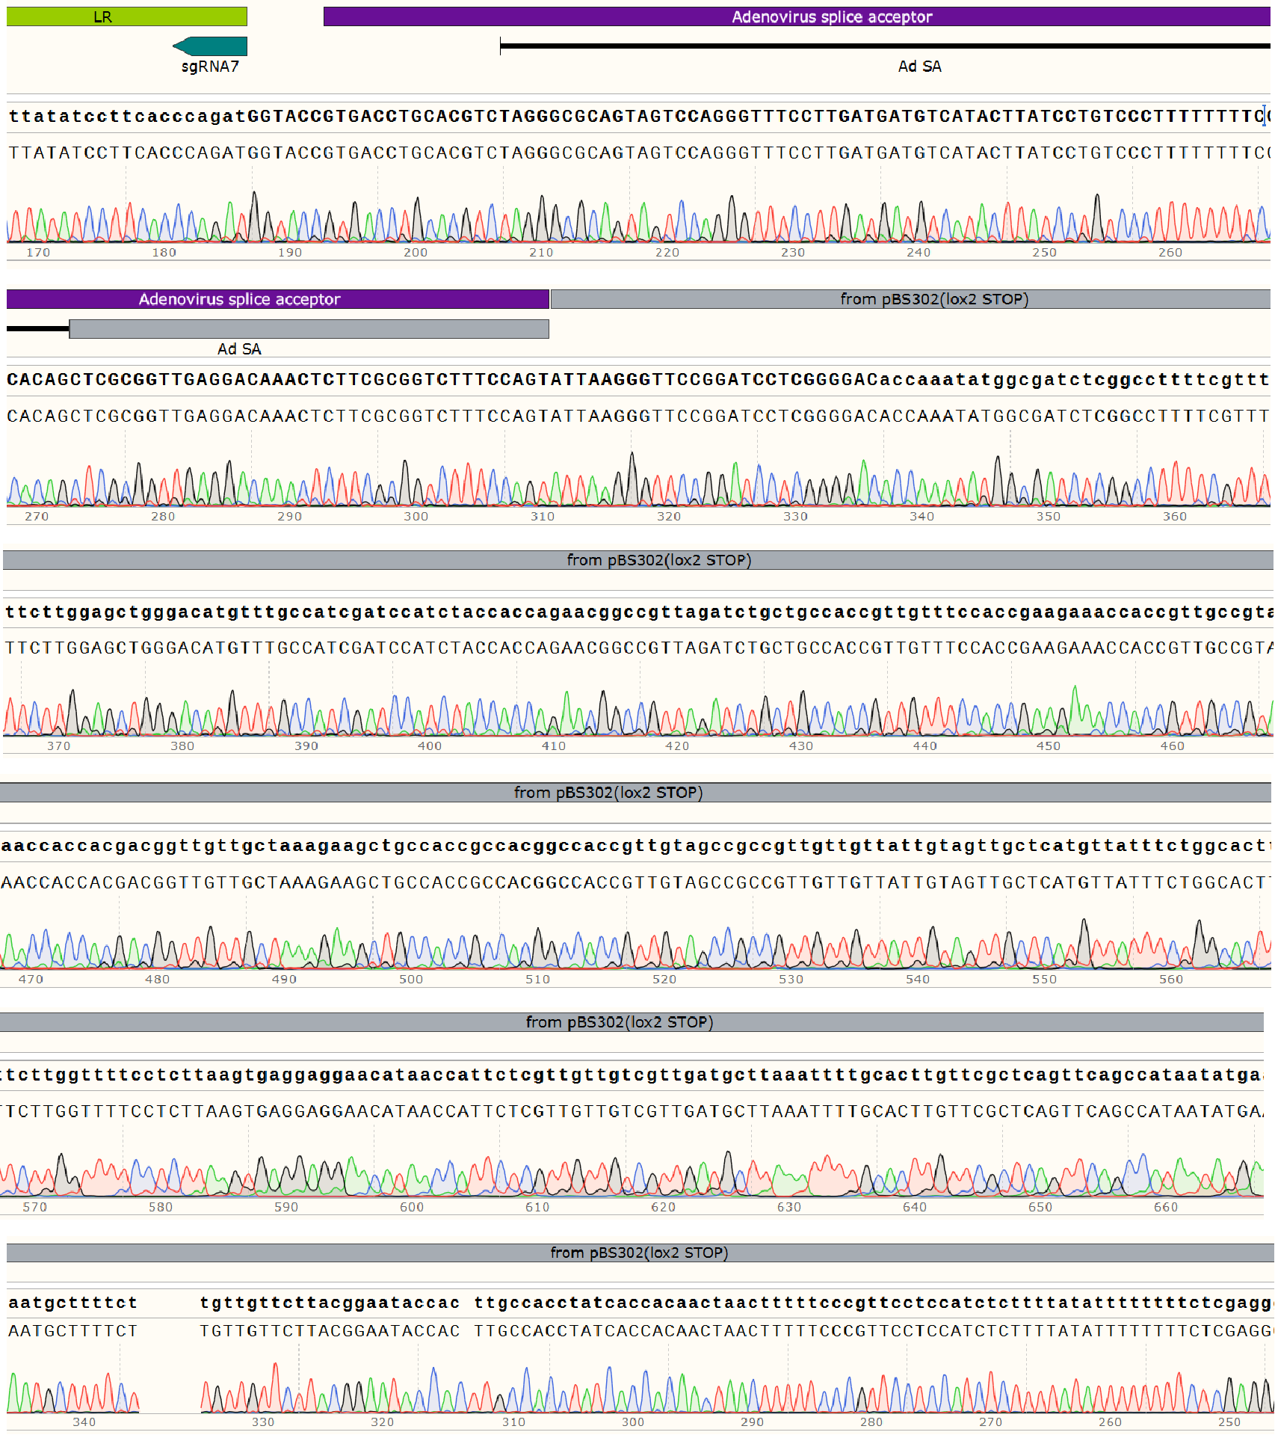

Fig. S3 Insertion of puroDelta and PolyA signal.The sequencing results included loxP,bGH poly(A) signal,PuroΔTK and ATXN3 structures of the hES-HPM-001 A targeting vector.
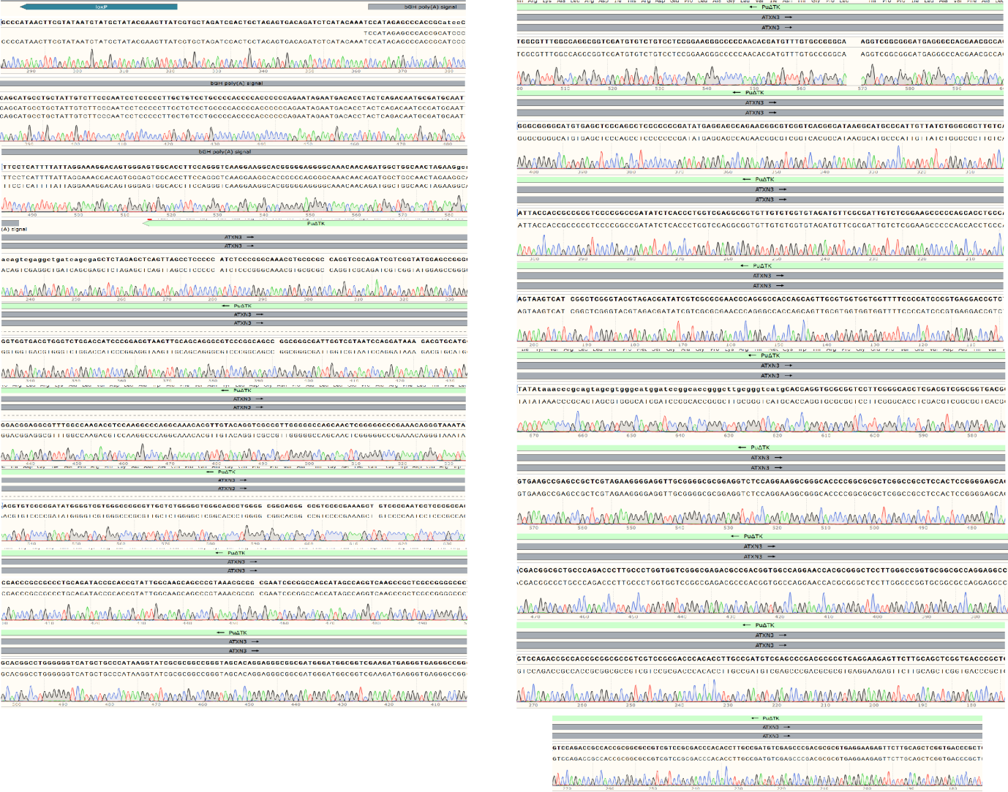

Fig. S4 Lower band/ATXN3 splicing.The sequencing results included PuroΔTK,PKG promoter,loxP and ATXN3 structures of the hES-HPM-001 A targeting vector,and the sgRNA7 sequence at 3’ end.
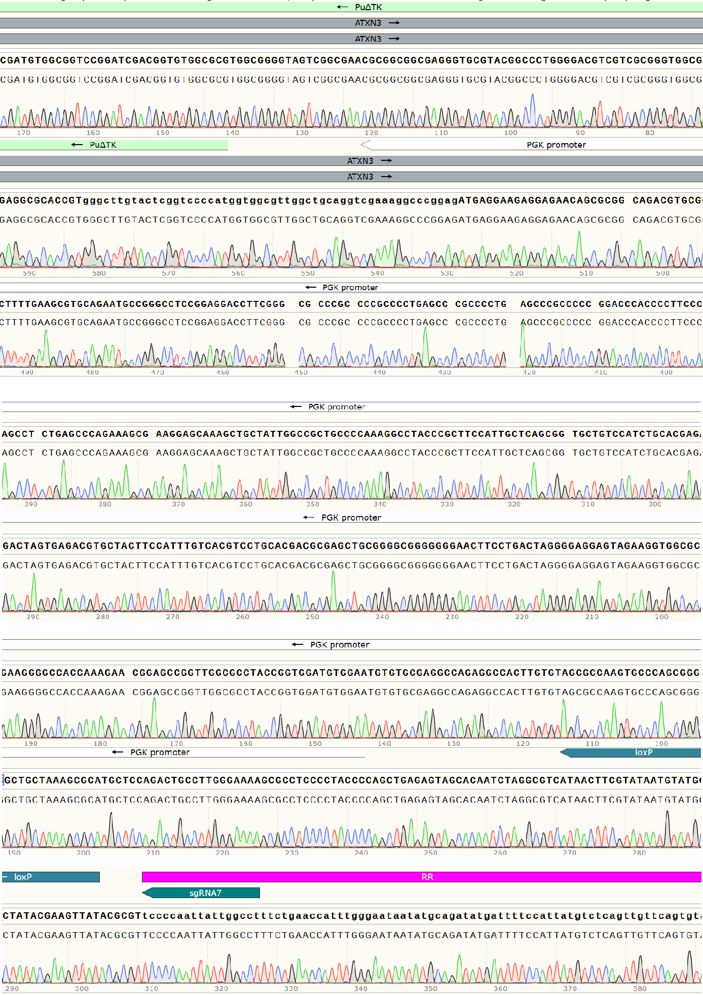
Fig. S5 Correct Insertion of PolyA Signals and deletion of puroDeltatk in the Upstream of Expanded CAG Repeats.
(A-B) The results of PCR with the paired primers hES-HPM-001-A-L-GT-F/hES-HPM-001-A-L-GT-R and hES-HPM-001-A-R-GT-F/hES-HPM-001-A-R-GT-R showed that there were 6 genome-edited iPSCs clones without PuroΔTK. (C) The results of PCR with the paired primers Puro-GT-R (LJL)/hES-HPM-001-A-R-GT-R were same as before. (D) The results of PCR with the paired primers hES-HPM-001-A-R-GT-F1/hES-HPM-001-A-R-GT-R showed the 6 clones had wild-type and mutant ATXN3 with correct insertion of PolyA and deletion of PuroΔTK. (E) Schematic view of primer positions.
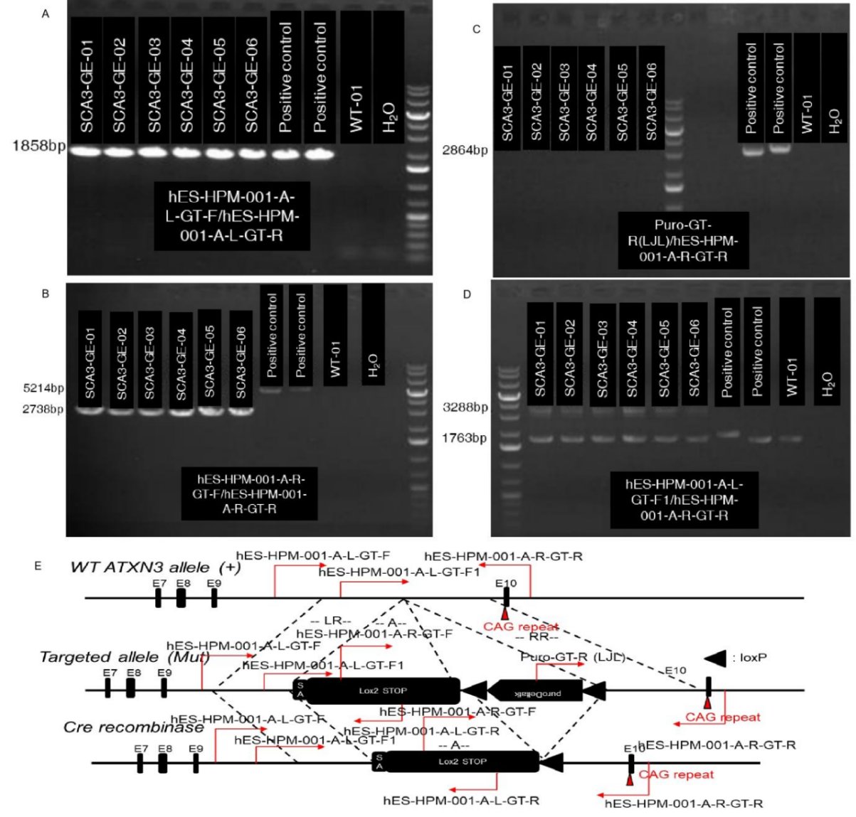

Fig. S6 Correct Insertion of PolyA Signals in the Upstream of Expanded CAG Repeats.(A)The sgRNA sequence is CCAGAT at left recombination site(LR).(B)The SV40 polyA signal sequence is AACTTGTTTATTGCAGCTTATAATGGTTACAAATAAAGCAATAGCATCACAAATTTCACAAATAAAGCATTTTTTTCACTGCATTCTAGTTGTGGTTTGTCCAAACTCATCAATGTATCTTATCATGTCTGGATC.(C)The sgRNA sequence is TCCCCAATTATTGGCCTT at right recombination site(RR).
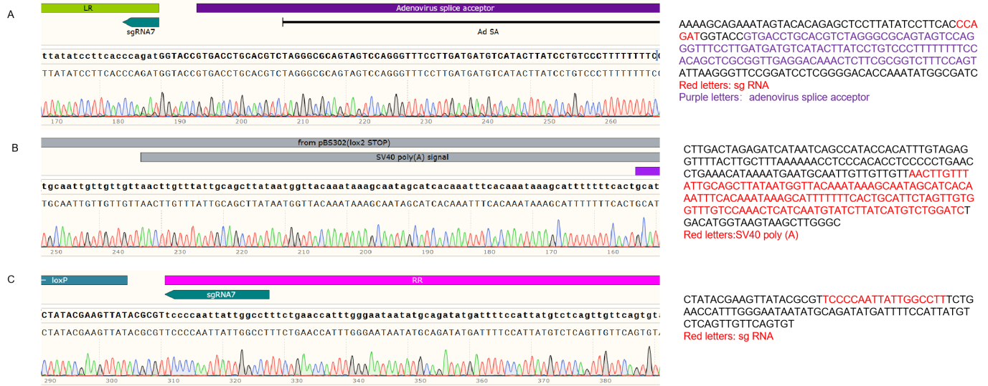

Supplementary Tables
Table S1. Sequences of Cas9/sgRNA.
5’ Guide | Sequence (5’-3’)
Guide #1 | ATGGCTAATGATGCACGTAA GGG
Guide #2 | ATGCTGCAACATAGCACAAG AGG
Guide #3 | CAGCATCAGGATTTGCTAAT GGG
Guide #4 | GAATGTCAGGTGGCTACTTT TGG
Guide #5 | ATTGGCCTTTCTGAACCATT TGG
Guide #6 | TTAGCTTACATGCCATAAAG AGG
Guide #7 | AGGCCAATAATTGGGGAATC TGG
Guide #8 | GATTTCTGATTCTCGGATTT AGG

Table S2. Sequences of primers to detect insertion of the polyA single.
Primer | Sequence (5’-3’) | Product size (bp)
hES-HPM-001-A-L-GT-F | ATGGCTAATGATGCACGTAA GGG |  | Mut: 4098
Puro-GT-F | ATGCTGCAACATAGCACAAG AGG |  | Mut: 4098
Puro-GT-R | CAGCATCAGGATTTGCTAAT GGG |  | Mut: 2864
hES-HPM-001-A-R-GT-R | GAATGTCAGGTGGCTACTTT TGG |  | Mut: 2864
hES-HPM-001-A-L-GT-F | ATTGGCCTTTCTGAACCATT TGG |  | WT: 2550
hES-HPM-001-A-R-GT-R | TTAGCTTACATGCCATAAAG AGG |  | WT: 2550

Table S3.Sequences of Primers to detect insertion of the polyA single and deletion of PuroΔTK.
Primer | Sequence (5’-3’) | Product size (bp)
Puro-GT-R (LJL) | TAAGTCATCGGCTCGGGTACGTAGA | Mut: 2864  Mut-Cre: none
hES-HPM-001-A-R-GT-R | GTAACTGCTCCTTAATCCAGGGAA | Mut: 2864  Mut-Cre: none
hES-HPM-001-A-L-GT-F | GATGGCACAGTGGGAGTGGATGC | Mut: 1858  Mut-Cre: 1858
hES-HPM-001-A-L-GT-R | GGAGGAGTAGAATGTTGAGAGAGTCAGC | Mut: 1858  Mut-Cre: 1858
hES-HPM-001-A-R-GT-F | GTAGCCGCCGTTGTTGTTATTGTAG | Mut: 5214  Mut-Cre: 2738
hES-HPM-001-A-R-GT-R | GTAACTGCTCCTTAATCCAGGGAA | Mut: 5214  Mut-Cre: 2738
hES-HPM-001-A-R-GT-F1 | GCACTATACTTACCAGTTAAGCATTC | WT: 1763  Mut: 5764  Mut-Cre: 3288
hES-HPM-001-A-R-GT-R | GTAACTGCTCCTTAATCCAGGGAA | WT: 1763  Mut: 5764  Mut-Cre: 3288

Table S4.The condition of the PCR.
Tm | Time
94℃ | 2 min
98℃  67℃  68℃ | 10 sec  30 sec (-0.7℃/cycle) 15 cycles  1 kb/min
98℃  57℃  68℃ | 10 sec  30 sec 25 cycles  1kb /cycle
68℃ | 10 min
4℃ | hold

Table S5.Primary antibodies and detailed information.
Antibody | Company | Host Species | Catalog number | Dilution | Application
Ataxin-3 | Proteintech | Rabbit | 13505-1-AP |  | IF
Ataxin-3 | Proteintech | Rabbit | 13505-1-AP | 1:1000 | WB
OCT4 | Cell Signaling Technology | Rabbit | 2750S | 1:200 | IF
TRA-1-60 | Cell Signaling Technology | Mouse | 4746S | 1:500 | IF
Nanog | Cell Signaling Technology | Rabbit | 4903S | 1:200 | IF
OCT4 | Biolegend | NA | 653705 | 1:50 | FCM
SOX2 | Biolegend | NA | 656108 | 1:50 | FCM
nestin | Proteintech | Rabbit | 19483-1-AP | 1:1000 | WB
PAX6 | Proteintech | Mouse | 67529-1-Ig | 1:2000 | WB
nestin | Proteintech | Rabbit | 19483-1-AP | 1:200 | IF
PAX6 | Proteintech | Mouse | 67529-1-Ig | 1:200 | IF
MAP2 | Proteintech | Rabbit | 17490-1-AP | 1:2000 | WB
NeuN | Proteintech | Mouse | 66836-1-Ig | 1:5000 | WB
MAP2 | Proteintech | Rabbit | 17490-1-AP | 1:300 | IF
NeuN | Proteintech | Mouse | 66836-1-Ig | 1:100 | IF
GM130 | Proteintech | Rabbit | 11308-1-AP | 1:5000 | WB
GORASP2 | Proteintech | Rabbit | 10598-1-AP | 1:2000 | WB
GM130 | Proteintech | Rabbit | 11308-1-AP | 1:500 | IF
GORASP2 | Proteintech | Rabbit | 10598-1-AP | 1:300 | IF
GAPDH | Proteintech | Rabbit | 10494-1-AP | 1:10000 | WB
OCT4:Octamer-binding Transcription Factor 4;Nanog:Nanog homeobox;SOX2:SRY（sex-determining region Y）-box transcription factor 2;PAX6:Paired box gene 6;
MAP2:Microtubule-associated protein 2;NeuN:Neuronal Nuclei Antigen;GM130:Golgi Matrix Protein 130;GORASP2:Golgi Reassembly Stacking Protein 2;GAPDH: glyceraldehyde 3-phosphate dehydrogenase;NA:not available;WB: western blotting.IF: immunofluorescence; FCM:flow cytometry；

