Genome Editing in Spinocerebellar Ataxia Type 3 Cells Improves Golgi Apparatus Structure
Yanlin Wang^{1,2,3}, Yunan Cheng ^{1,2,3#},Huifang Sun ^{1,2,3},Zhuoya Wang¹, Na Chen⁴,Changhe Shi^{1,2,3} ,Han Liu¹ ,Jing Yang^{1, 2,3*}, and Yuming Xu^{1,2,3 *}

¹ Department of Neurology, The First Affiliated Hospital of Zhengzhou University, Zhengzhou, Henan, China, 450000
² NHC Key Laboratory of Prevention and treatment of Cerebrovascular Disease,Zhengzhou, Henan, China, 450000
³ Henan Key Laboratory of Cerebrovascular Diseases（Zhengzhou University）,Zhengzhou, Henan, China, 450000
⁴ Henan University of Traditional Chinese Medicine, Zhengzhou, Henan, China, 450000

# The author contributes equally to this work and is the co-first author of this paper.
* Corresponding author
Correspondence to:
Yuming Xu: Email 13903711125@126.com, Tel: 13903711125
Jing Yang: Email yangjing9527@126.com, Tel:18503826669
Corresponding author’s address: Department of Neurology, The First Affiliated Hospital of Zhengzhou University, Zhengzhou University. 50 Jianshe Road, Zhengzhou City, Henan Province, China, 450000

Original pictures
Note: The original picture is one of many repeated experiments.

(Marker: epizyme,WJ103).
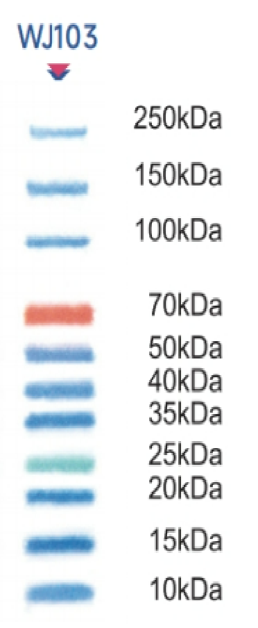

Fig1D: The successful correction of ATXN3 locus in SCA3-GE-iPSCs was verified by Western blotting, and there was no mutant ataxin-3 band (upper band) in SCA3-GE-iPSCs and the iPSCs-derived healthy persons,whereas iPSCs in SCA3 patients had both mutant ataxin-3 and normal ataxin-3(lower band).
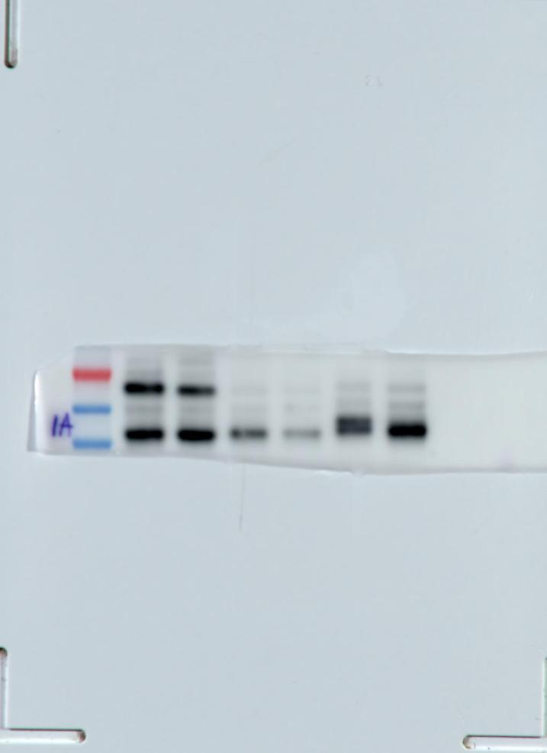
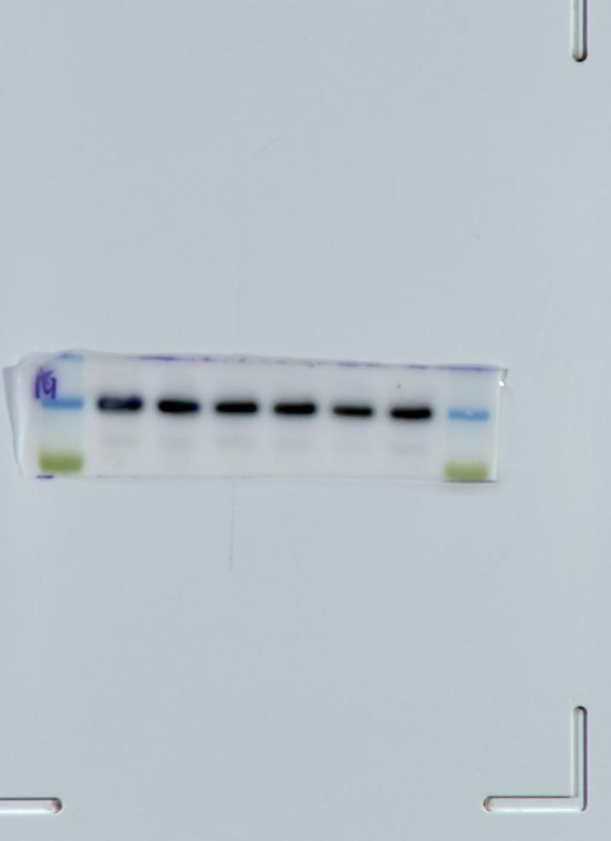
ataxin-3
GAPDH
SCA3
SCA3-GE
WT

Fig 3B:WB results showed that there was no significant difference in the expression levels of nestin and PAX6 protein among the three groups.
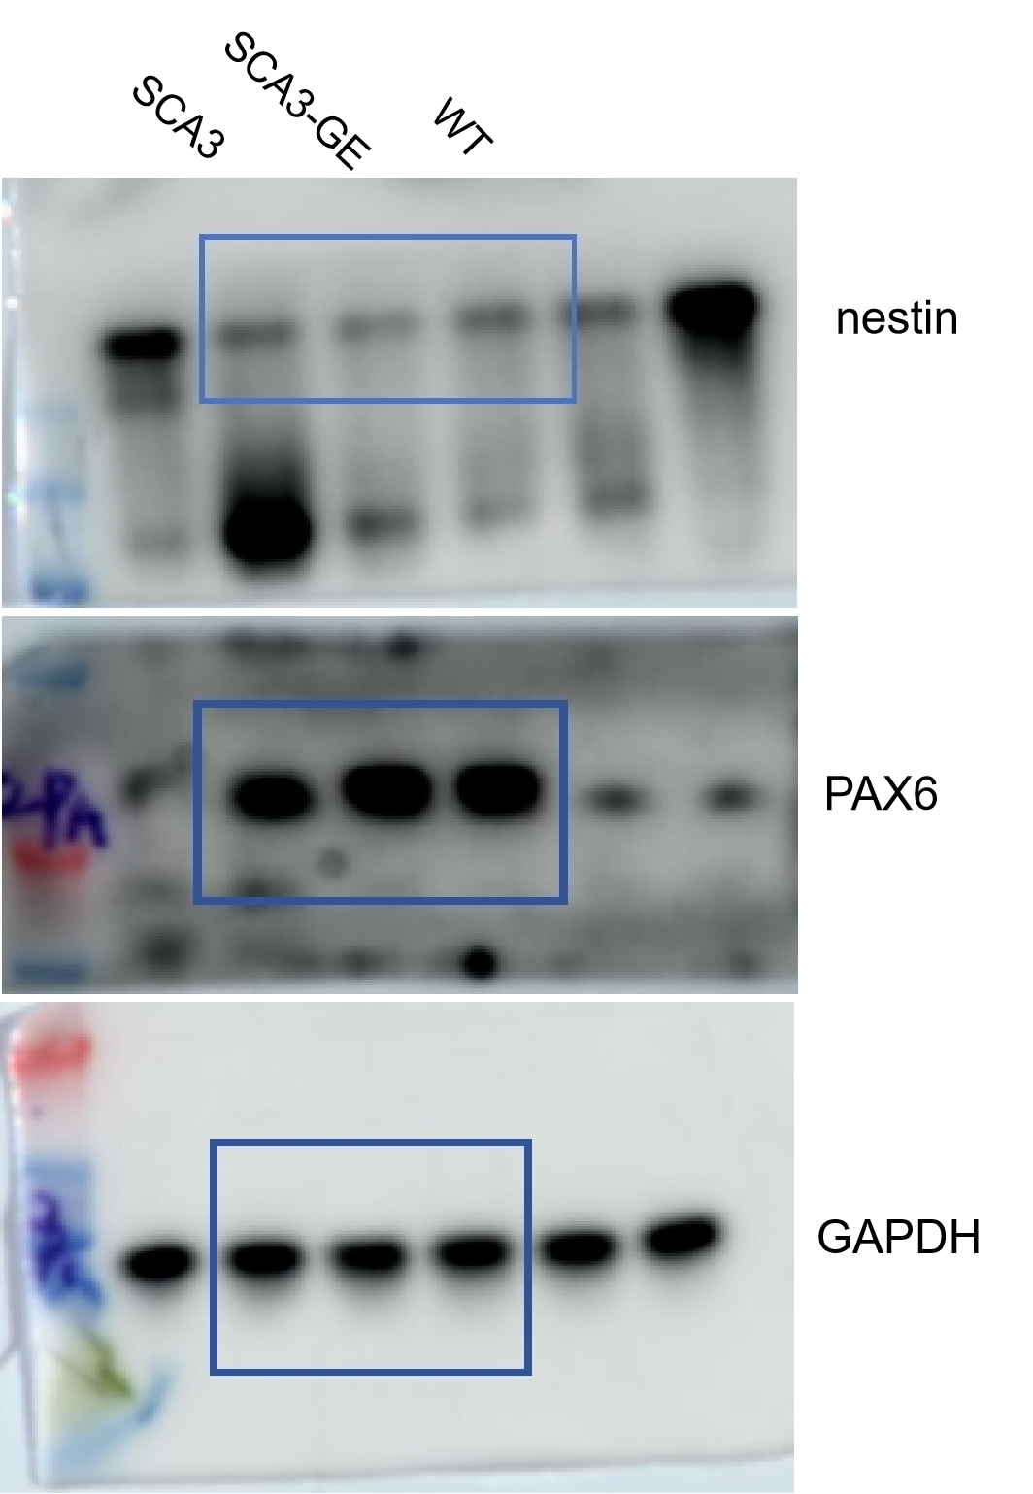

Fig4C:WB showed that there was no mutant ataxin-3(upper band) in SCA3-GE-neurons and the neurons-derived healthy persons,whereas neurons in SCA3 patients had both mutant ataxin-3 and normal ataxin-3(lower band).
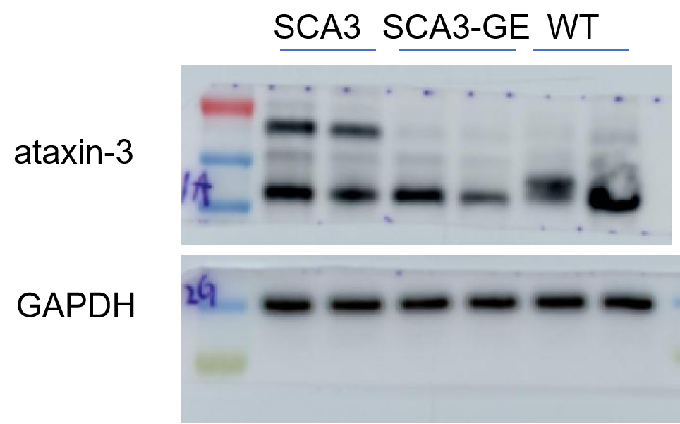

Fig 4E:WB results showed that the levels of MAP2 and NeuN proteins were similar in the three groups of neurons.
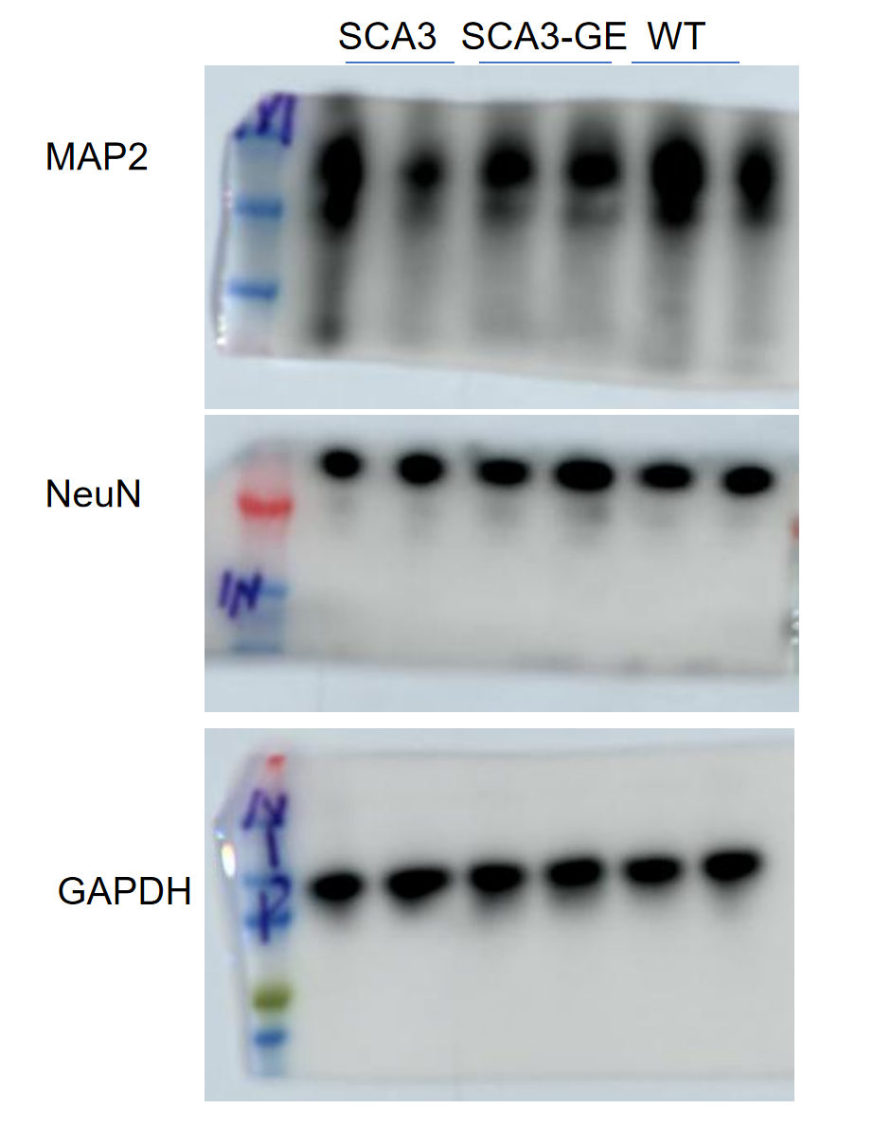

Fig5E:The results of WB both showed increased levels of GM130 and GORASP2 in genome editing neurons and the healthy than SCA3 group.
