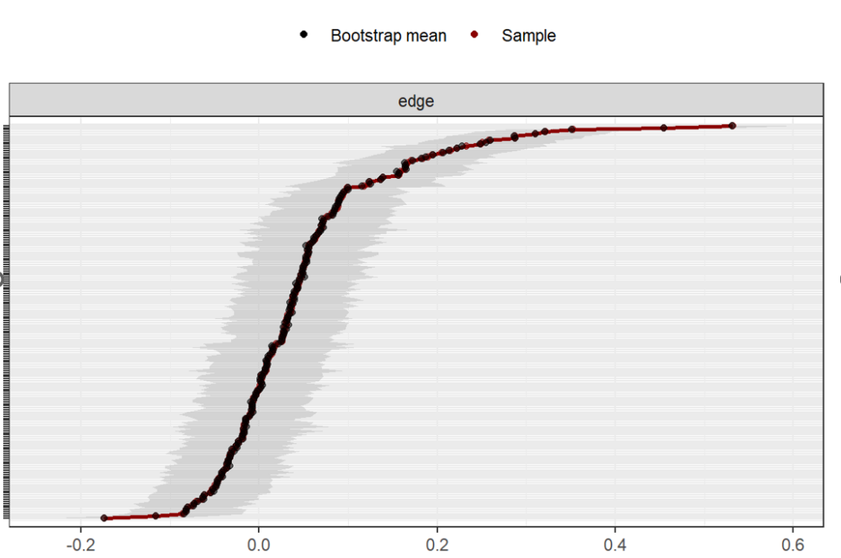
Supplementary Figure 1. Bootstrapping of the 95% confidence intervals of the edge weights for the estimated network.
Note. The red line indicates the edge weight values, and the gray area indicates the 95% CIs.

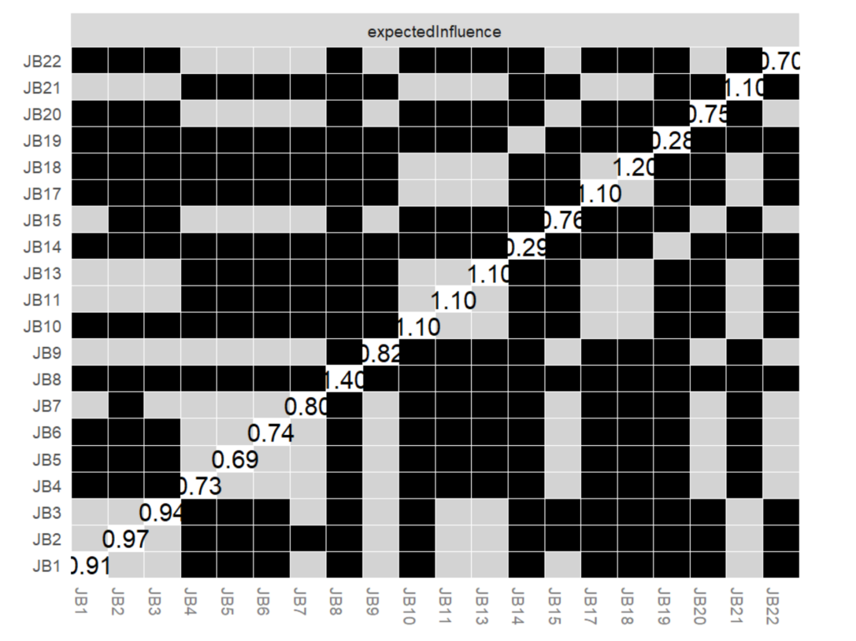
Supplementary Figure 2. Centrality difference test (α= 0.05) for the estimated network. .
Note. Numbers in white boxes are values of node strength. Off-diagnal boxes represent corresponding nodes comparisons, gray ones indicate no statistical differences while black ones indicate statistical differences.

