Supplementary Information
Supplementary Table S1: Summary statistics of the subjects in the cohort
Characteristics | AML, N = 7 | CLL, N = 4 | CML, N = 30 | p-value
Age, median (IQR) | 58 (28, 74) | 63 (62, 64) | 45 (40, 52) | 0.020*
Onset Age, median (IQR) | 38 (23, 64) | 61 (60, 64) | 40 (34, 48) | 0.072
Unknown | 1 | 1 | 9
Gender |  |  |  | 0.3
Female | 5 (71%) | 2 (50%) | 11 (37%)
Male | 2 (29%) | 2 (50%) | 19 (63%)
Weight (Kg) | 64 (64, 71) | 80 (76, 84) | 74 (68, 79) | 0.030*
Ethnicity, n (%) |  |  |  | 0.023*
Black | 3 (43%) | 3 (75%) | 25 (89%)
White | 4 (57%) | 1 (25%) | 3 (11%)
Unknown | 0 | 0 | 2

AML: Acute myeloid leukaemia, CLL: Chronic lymphocytic leukaemia, CML: Chronic myeloid leukaemia, MM- Multiple Myeloma IQR: interquartile range
Supplementary Table S2: Summary of the hematological profile of the cohort.
Characteristics | Reference range | AML | CLL | CML | p-value
Haemoglobin (g/dL) | 12.4 - 16.7 | 8.30 | 9.80 | 14.20 | 0.014*
Mean Corpuscular Volume (fL) | 79 - 100 | 93.6 | 105.6 | 90.9 | 0.13
Platelets x10⁹ | 150 -450 | 61 | 92 | 240 | 0.071
WBC x10⁹/L | 4.0 – 12.0 | 3 | 31 | 6 | 0.052*
Neutrophils x10⁹/L | 2.0 – 7.5 | 1 | 4 | 2 | 0.053*
Eosinophils x10⁹/L | 0.00 – 0.50 | 0.02 | 0.32 | 0.05 | 0.3
Basophils x10⁹/L | 0.00 - 0.30 | 0.01 | 0.02 | 0.03 | 0.11
Lymphocytes x10⁹/L | 1.0 – 4.0 | 0.84 | 25.86 | 1.94 | 0.089
Monocytes x10⁹/L | 0.2 – 1.0 | 0.52 | 0.96 | 0.40 | 0.5
+ Reference range evaluated by Bio Analytical Research Corporation South Africa (BARC SA), https://www.barcsa.co.za/test-directory/test-reference-ranges/ Accessed on 8th April 2023. AML: Acute myeloid leukaemia, CLL: Chronic lymphocytic leukaemia, CML: Chronic myeloid leukaemia. * p-value ≤ 0.05 considered statistically significant.

Supplementary Table S3: List of drugs tested for single screening in 40 patient samples
No | COMPOUND | PATHWAY/CLASS | Reason of the drug choice
1 | Cladribine | Anti-metabolite; Purine analog | Cladribine is given for leukemia treatment^{1–3}. Some patients in this study are in cladribine treatment.
2 | 5-Azacytidine | DNA methylation | Some patients in this study are in 5-azacytidine treatment. It is also given for leukemia treatment⁴.
3 | Bendamustine | DNA-damaging | Some patients in this study are in bendamustine treatment.
4 | Bortezomib | Proteasome inhibitor (26S subunit) | Bortezomib was used to study an ex vivo drug sensitivity test in leukemia⁵ and also in clinical trial⁶.
5 | Busulfan | Alkylating agent | Busulfan are given for leukemia treatment^{7,8}
6 | Chlorambucil | Alkylating agent | Some patients in this study are in chlorambucil treatment.
7 | Cyclophosphamide monohydrate | Alkylating agent | Cyclophosphamide monohydrate are given for leukemia treatment⁸.
8 | Cytarabine | DNA synthesis | Cytarabine are given for leukemia treatment⁹
9 | Dasatinib | Abl, Src, c-Kit | Some patients in this study are in Dastinib treatment.
10 | Dexamethasone | Interleukin receptor | Dexamethasone are given for leukemia treatment¹⁰
11 | Doxorubicin | DNA topoisomerase | Doxorubicin is given for leukemia treatment¹¹
12 | Everolimus | mTOR inhibitor | Everolimus is given for leukemia treatment¹².
13 | Fludarabine | DNA synthesis, | Fludarabine is given for leukemia treatment¹³.
14 | Fluorouracil | Antimetabolite | Fluorouracil is given for leukemia treatment¹⁴.
15 | Gemcitabine | Antimetabolite; Nucleoside analog | Gemcitabine is given for leukemia treatment¹⁵
16 | Ifosfamide | Nitrogen mustard alkylating agent | Ifosfamide is tested in drug testing platform for leukemia treatment¹⁶
17 | Imatinib | Abl, c-Kit, inhibitor | Some patients in this study are in imatinib treatment.
18 | Imiquimod | Immune response | Imiquimod is given for leukemia treatment¹⁷
19 | Irinotecan | topoisomerase I inhibitor | Irinotecan has been shown to have effects of leukemia¹⁸
20 | Lenalidomide | Immunomodulation | Lenalidomide is given for leukemia treatment¹⁹.
21 | Melphalan | Antineoplastic activity | Melphalan is given for leukemia treatment²⁰.
22 | Nilotinib | BCR/Abl inhibitor | Some patients in this study are in nilotinib treatment.
23 | Prednisolone | Immunomodulatory | Prednisolone is given for leukemia treatment²¹.
24 | Simvastatin | HMG-CoA reductase | Simvastatin is tested in drug testing for leukemia²².
25 | Sorafenib | Raf-1, and VEGFR-2 | Sorafenib is given for leukemia treatment²³.
26 | Tacrolimus | FKBP12 | Tacrolimus is given for leukemia treatment²⁴.
27 | Temsirolimus | mTOR inhibition | Temsirolimus is given for leukemia treatment²⁵
28 | Thalidomide | Immunomodulation, | Thalidomide is given for leukemia treatment²⁶.
29 | Tretinoin | Retinoic acid receptor agonist | Tertinoin was used to study chemotherapy effects in leukemia using an ex vivo drug sensitivity test²⁷
30 | Vinblastine | Mitotic inhibitor | Vinblastine has been used for CLL treatment²⁸
Supplementary Table S4: List of drugs tested for anchored and matrix combination.
No | Drug Name | Concentration (nm) | Anchored | Full matrix
1 | Nilatinib | 10 (anchored), 1-1000 (full) | Irinotecan | Irinotecan
2 | Irinotecan | 1-1000 (anchored and full matrix) | Nilatinib | Nilatinib
3 | Fludarabine | 10 nm (anchored), 1-1000 (full) | Cladribine | Cladribine
4 | 5-Azacytidine | 10 (anchored), 1-1000 (full) | Everolimus | Everolimus
5 | Dastinib | 10 (anchored), 1-1000 (full) | Bortezomib | Bortezomib
6 | Cladribine | 1-1000 (anchored and full) | Fludarabine | Fludarabine
7 | Bortezomib | 1-1000 (full and anchored) | Dasatinib | Dasatinib
8 | Thalidomide | 10 (anchored), 1-1000 (full) | Chlorambucil | Chlorambucil
9 | Everolimus | 1-1000 (anchored and full) | 5-azacytidine | 5-azacytidine
10 | Chlorambucil | 10 (anchored), 1-1000 (full) | Thalidomide | Thalidomide
Supplementary Table S5: List of the patients and annotations.
No | Patient annotation | Disease type
1 | DGAML01 | AML
2 | DGAML02 | AML
3 | AML03 | AML
4 | AML04 | AML
5 | DGCML01 | CML
6 | CML03 | CML
7 | CML04 | CML
8 | DGCLL01 | CLL
9 | BHX (X- represent number) | CLL
Supplementary Figures
- Drug dilutions
Concentrations | C1 | C2 | C3 | C4 | C5
Master plate  10µM | 1µM(1000nM) | 100nM | 10nM | 1nM | 0.1nM
Serial dilution | 20 | 20 | 20 | 20 | 20
Diluent | 180 | 180 | 180 | 180 | 180
b) Plate layout
 | Blank | Drug dilutions |  |  |  | Drug dilutions |  |  |  | + | -
0 | 1 | 2 | 3 | 4 | 5 | 6 | 7 | 8 | 9 | 10 | 11 | 12
A | Media only | C1 | C2 | C3 | C4 | C1 | C2 | C3 | C4 | BzCl | DSMO | Media + Cells
B | Media only | C1 | C2 | C3 | C4 | C1 | C2 | C3 | C4 | BzCl | DSMO | Media + Cells
C | Media only | C1 | C2 | C3 | C4 | C1 | C2 | C3 | C4 | BzCl | DSMO | Media + Cells
D | Media only | C1 | C2 | C3 | C4 | C1 | C2 | C3 | C4 | BzCl | DSMO | Media + Cells
E | Media only | C1 | C2 | C3 | C4 | C1 | C2 | C3 | C4 | BzCl | DSMO | Media + Cells
F | Media only | C1 | C2 | C3 | C4 | C1 | C2 | C3 | C4 | BzCl | DSMO | Media + Cells
G | Media only | C1 | C2 | C3 | C4 | C1 | C2 | C3 | C4 | BzCl | DSMO | Media + Cells
H | Media only | C1 | C2 | C3 | C4 | C1 | C2 | C3 | C4 | BzCl | DSMO | Media + Cells
Supplementary Figure 1: a) Drug dilution and b) drug plate map
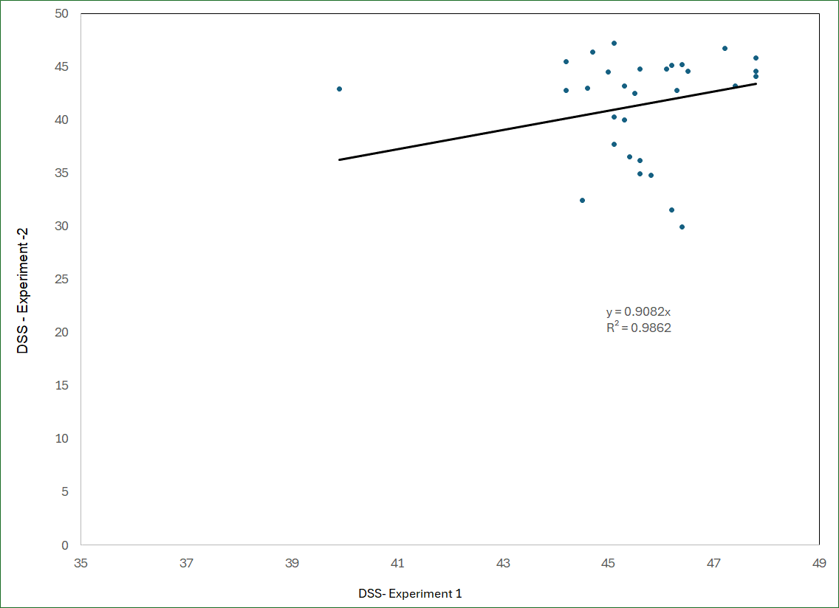
Supplementary Figure 2: Ex vivo Drug sensitivity testing is reproducible as demonstrated in HeLa cell lines.
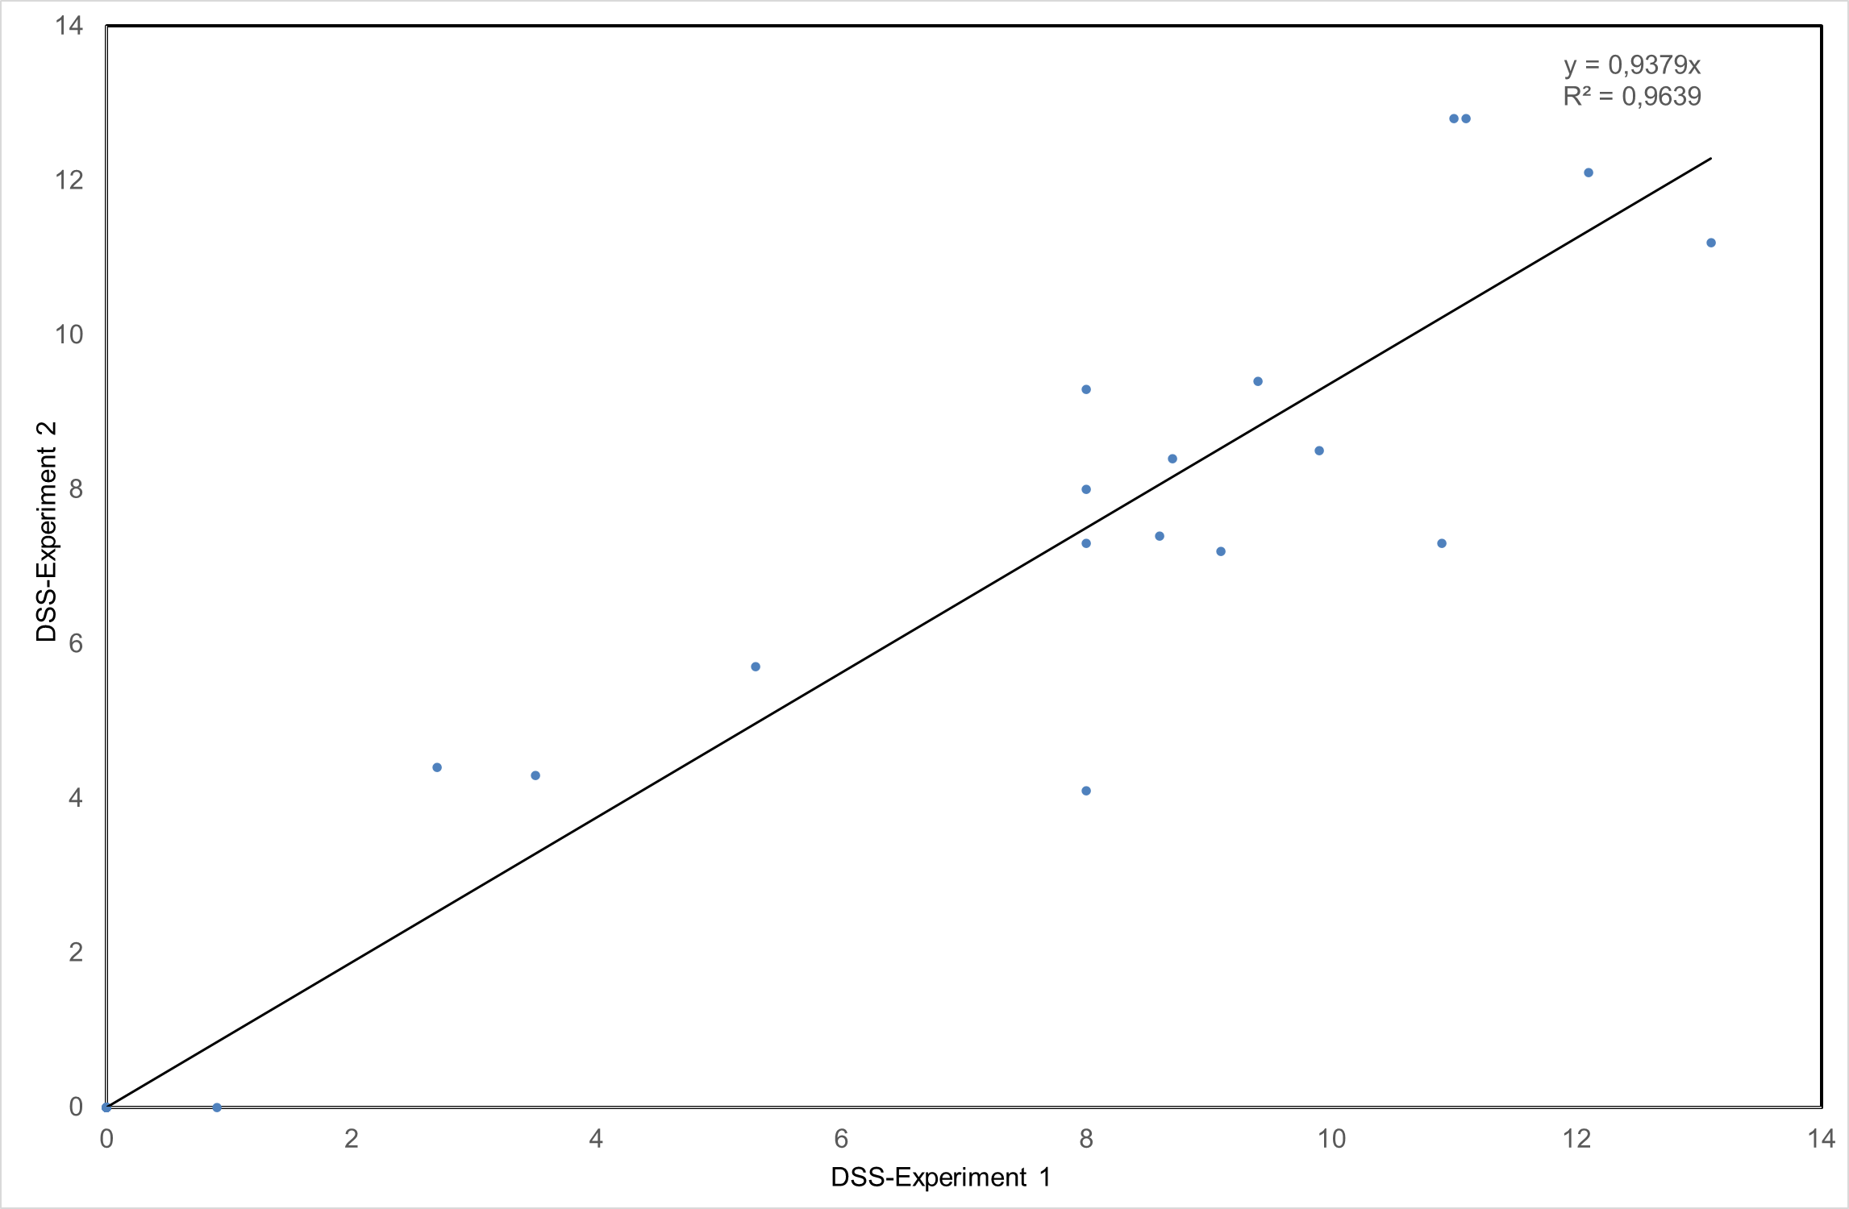
Supplementary Figure 3: Ex vivo Drug sensitivity testing is reproducible as demonstrated in Leukemia K562 cell lines.
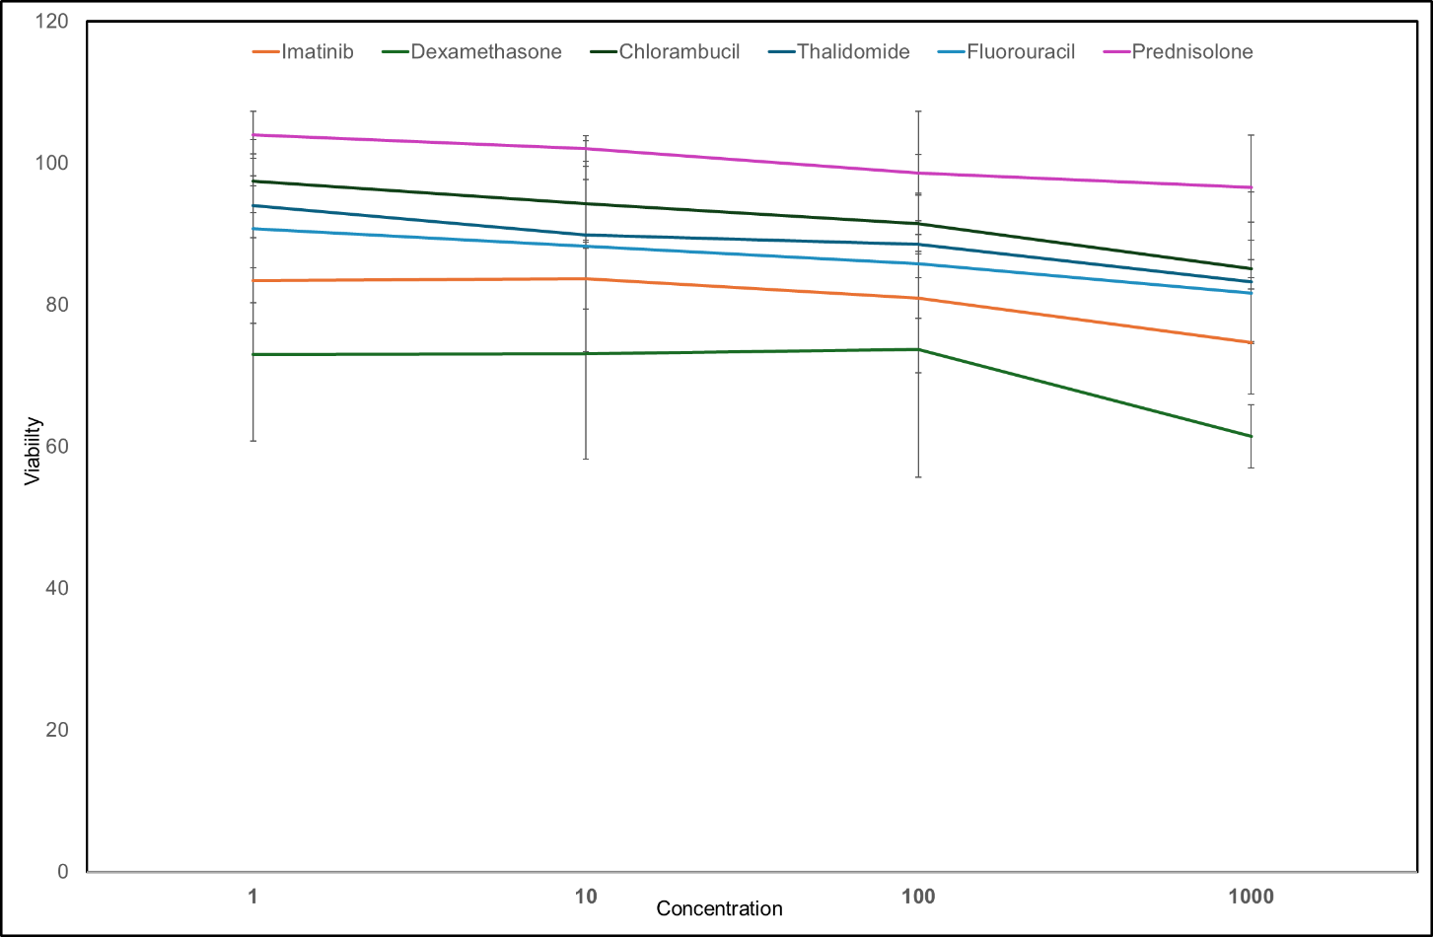
Supplementary Figure 4: Representative graphs for triplicate experiments on patient samples.
Supplementary material and methods
Preparation of Master Plate and Source Plate
The master plate was prepared by 20 µL of the 1 mM (1,000 µM) concentration of drug (n=30) was pipetted into 180 µL of DMSO resulting in 100 µM concentration stored in to a 96-well plate. From the master plate, 100 µl of each 100 µM (100,000 nM) drug stock (Drug 1 – Drug 4) was dispensed into the first column of the new source plate. For the preparation of 10 µM (10,000 nM) concentrations of each drug, 10 µL of the 100 µM stock of the respective drug was combined with 90 µL of dimethyl sulfoxide (DMSO) in the next column, ensuring 90 µL of the 100 µM stock remained in the well. Subsequent dilutions were conducted to obtain concentrations of 1 µM, 100 nM, 10 nM, and 1 nM of each drug in consecutive wells. Control: A negative control of 0.1% dimethyl sulfoxide (DMSO) and a positive control of 100 µM benzethonium chloride (BzCI) was designated. In the new printed plate, 10 µL of 1 mM BzCI was added to respective wells (H1 to H6) to yield 100 µM BzCI, while 10 µL of 1% DMSO was added to wells (H7 to H12) to create 0.1% DMSO. Finally, all drug plates were returned to storage at -20°C until further experimental use. The pre-seeded drug plates were added with 20 µL of DMEM media per well to dissolve the drugs before sealing the plate with tape and setting it aside for seeding with cells.
Printing of drug plates for Drug combination
For anchored combinations, the concentration of one drug remains constant at 10 nM while the concentration of the other drug ranges between 1-1000 nm. Dilution approach of 5 µL of the drug A with 5 µL of the drug B added to each well (5:5). For full matrix combination, all concentration of drug A and drug B (1-1000 nm) were combined.
Statistical analysis:
Statistical analysis was performed by loading Microsoft Excel sheet with data in R version 4.3.2. For p-value analysis, the Wilcoxon and Kruskal-Wallis rank-sum tests were employed to compare disparities in numerical covariates such as age and Fisher's exact test was utilized to evaluate differences between categorical variables (gender or race).

References:
1. Kreitman, R. J. et al. Cladribine with immediate rituximab for the treatment of patients with variant hairy cell leukemia. Clin. Cancer Res. Off. J. Am. Assoc. Cancer Res. 19, 10.1158/1078-0432.CCR-13–1752 (2013).
2. Masarova, L. et al. Cladribine-Based Chemotherapy for Patients with Secondary Acute Myeloid Leukemia (AML) Arising after Myeloproliferative Neoplasms (MPNs). Blood 142, 4264 (2023).
3. Steinauer, N. et al. Cladribine plus cytarabine plus venetoclax in acute myeloid leukemia relapsed or refractory to venetoclax plus hypomethylating agent. Haematologica 109, 2706–2710 (2024).
4. Diamantopoulos, P. et al. 5-Azacytidine in the Treatment of Intermediate-2 and High-risk Myelodysplastic Syndromes and Acute Myeloid Leukemia. A Five-year Experience with 44 Consecutive Patients. Anticancer Res. 35, 5141–5147 (2015).
5. Horton, T. M. et al. Bortezomib interactions with chemotherapy agents in acute leukemia in vitro. Cancer Chemother. Pharmacol. 58, 13–23 (2006).
6. Messinger, Y. H. et al. Bortezomib with chemotherapy is highly active in advanced B-precursor acute lymphoblastic leukemia: Therapeutic Advances in Childhood Leukemia & Lymphoma (TACL) Study. Blood 120, 285–290 (2012).
7. Tutschka, P. J., Copelan, E. A. & Klein, J. P. Bone marrow transplantation for leukemia following a new busulfan and cyclophosphamide regimen. Blood 70, 1382–1388 (1987).
8. Zhang, H. et al. Busulfan Plus Cyclophosphamide Versus Total Body Irradiation Plus Cyclophosphamide for Adults Acute B Lymphoblastic Leukemia: An Open-Label, Multicenter, Phase III Trial. J. Clin. Oncol. 41, 343–353 (2023).
9. Garcia-Manero, G. et al. A randomized phase III study of standard versus high-dose cytarabine with or without vorinostat for AML. Leukemia 38, 58–66 (2024).
10. Bertoli, S. et al. Dexamethasone in hyperleukocytic acute myeloid leukemia. Haematologica 103, 988–998 (2018).
11. Escherich, G., Zimmermann, M., Janka-Schaub, G., & CoALL study group. Doxorubicin or daunorubicin given upfront in a therapeutic window are equally effective in children with newly diagnosed acute lymphoblastic leukemia. A randomized comparison in trial CoALL 07-03. Pediatr. Blood Cancer 60, 254–257 (2013).
12. Daver, N. et al. A Phase I/II Study of the mTOR Inhibitor Everolimus in Combination with HyperCVAD Chemotherapy in Patients with Relapsed / Refractory Acute Lymphoblastic Leukemia. Clin. Cancer Res. Off. J. Am. Assoc. Cancer Res. 21, 2704–2714 (2015).
13. Jain, N. et al. A phase I-II trial of fludarabine, bendamustine and rituximab (FBR) in previously treated patients with CLL. Oncotarget 8, 22104–22112 (2017).
14. Park, H. J. et al. A Case of Therapy-Related Acute Myeloid Leukemia Following 5-Fluorouracil Chemotherapy. Korean J. Intern. Med. 27, 115–117 (2012).
15. Grunewald, R. et al. Gemcitabine in leukemia: a phase I clinical, plasma, and cellular pharmacology study. J. Clin. Oncol. Off. J. Am. Soc. Clin. Oncol. 10, 406–413 (1992).
16. Gökçe, F. et al. Microphysiological Drug-Testing Platform for Identifying Responses to Prodrug Treatment in Primary Leukemia. Adv. Healthc. Mater. 12, 2202506 (2023).
17. Messer, A. et al. Successful treatment of cutaneous adult T-cell leukemia/lymphoma with imiquimod. JAAD Case Rep. 5, 979–981 (2019).
18. Xu, Y. & Villalona-Calero, M. A. Irinotecan: mechanisms of tumor resistance and novel strategies for modulating its activity. Ann. Oncol. 13, 1841–1851 (2002).
19. Morice, P.-M. et al. Acute lymphoblastic leukemia in patients treated with lenalidomide for multiple myeloma: a safety meta-analysis of randomized controlled trials combined with a retrospective study of the WHO’s pharmacovigilance database. Blood Cancer J. 14, 1–4 (2024).
20. Jonsdottir, G. et al. Cumulative exposure to melphalan chemotherapy and subsequent risk of developing acute myeloid leukemia and myelodysplastic syndromes in patients with multiple myeloma. Eur. J. Haematol. 107, 275–282 (2021).
21. Inaba, H. & Pui, C.-H. Glucocorticoid use in acute lymphoblastic leukemia: comparison of prednisone and dexamethasone. Lancet Oncol. 11, 1096–1106 (2010).
22. Li, G. et al. Simvastatin Preferentially Targets FLT3/ITD Acute Myeloid Leukemia by Inhibiting MEK/ERK and p38-MAPK Signaling Pathways. Drugs RD 23, 439–451 (2023).
23. Macias, R. I. R. et al. Role of drug transporters in the sensitivity of acute myeloid leukemia to sorafenib. Oncotarget 9, 28474–28485 (2018).
24. Salhotra, A. et al. Long-Term Outcomes of Patients with Acute Myelogenous Leukemia Treated with Myeloablative Fractionated Total Body Irradiation TBI-Based Conditioning with a Tacrolimus- and Sirolimus-Based Graft-versus-Host Disease Prophylaxis Regimen: 6-Year Follow-Up from a Single Center. Biol. Blood Marrow Transplant. 26, 292–299 (2020).
25. Tasian, S. K. et al. Temsirolimus combined with cyclophosphamide and etoposide for pediatric patients with relapsed/refractory acute lymphoblastic leukemia: a Therapeutic Advances in Childhood Leukemia Consortium trial (TACL 2014-001). Haematologica 107, 2295–2303 (2022).
26. Steins, M. B. et al. Thalidomide for the treatment of acute myeloid leukemia. Leuk. Lymphoma 44, 1489–1493 (2003).
27. Stieglitz, E. et al. Tretinoin Enhances the Effects of Chemotherapy in Juvenile Myelomonocytic Leukemia Using an Ex Vivo Drug Sensitivity Assay. JCO Precis. Oncol. 7, e2300302 (2023).
28. Bates, D. J. P., Danilov, A. V., Lowrey, C. H. & Eastman, A. Vinblastine rapidly induces NOXA and acutely sensitizes primary chronic lymphocytic leukemia cells to ABT-737. Mol. Cancer Ther. 12, 1504–1514 (2013).

