Supplementary Data
Mutation Analysis
Multiple sequence alignment was done by CLUSTAL Omega (Clustal Omega < EMBL-EBI) as shown in Fig. 1

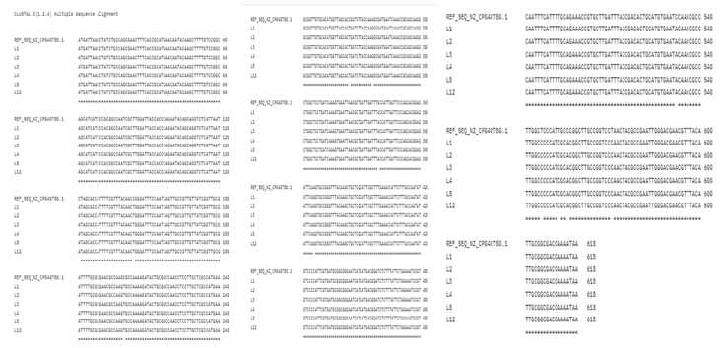
Fig. 1 Multiple Sequence alignment done by CLUSTAL Omega: here (*) means Conserved sequence, (:) conservative mutations, (.) Semi-conservative mutations
(Note: Among the isolated Lacticaseibacillus rhamnosusstrains, L1 demonstrated highest resistance to chromate toxicity and reduction capacity, with a reduction potential of 56%. Due to its efficient nature against chromate and to establish a baseline for future comparison
with other strains and for creating a more structured research path strain L1 was used for in silico analysis.)
Amino Acid sequence Alignment
Multiple Sequence alignment of amino acids done by CLUSTAL Omega as shown in Fig 2: here (*) means Conserved sequence, (:) conservative mutations, (.) Semi-conservative mutations. As it is observed in Fig. 1 that there were multiple mutations present in nucleotide sequence and only three mutations (L41I, A67V, P178T) is present at protein level.
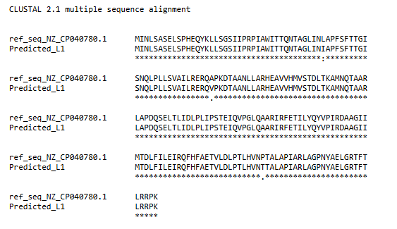
Fig. 2 Multiple Sequence alignment of amino acids by Clustal Omega.
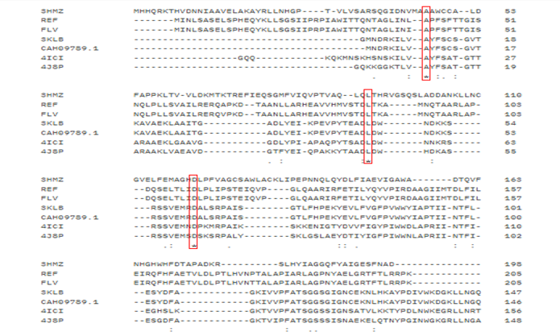
Fig. 3 Multiple sequence alignment of structurally resolved proteins from the Protein Data Bank and Flavin reductase/REF. Conserved regions in the binding pocket are highlighted, indicating functional importance.

