SUPPLEMENTARY TABLES
Supplementary Table 1. Detailed analysis of F1- metrics results of all three feature combinations according to 5-fold cv models (missing values are imputed according to median values)
Supplementary Table 2. Implemented Hyperparamaters for each Machine Learning Method

Supplementary Table 3. 10-fold CV* machine learning algorithm performance metrics on the training and test datasets with the best hyperparameters (the training dataset consists of 369 variables, and the test dataset consists of 74 variables).

Supplementary Table 4. Comparison of best algorithm results (Revel + MetaLR + SIFT) according to their best performance before preprocessing data (missing values removed from the analysis)
Supplementary Table 5. Comparison of all models (Revel + MetaLR + SIFT) according to their best performance after preprocessing
Supplementary Table 6. Hierarchical Clustering algorithms for detecting optimum number of clusters
Supplementary Table 7. K-means clustering algorithms for detecting optimum number of clusters

SUPPLEMENTARY FIGURES
Supplementary Figure 1. Best discrimination threshold according to 7-tier classification system by clustering analysis
Supplementary Figure 2. Best discrimination threshold according to amino acid polarity status by clustering analysis
Supplementary Figure 3. Best discrimination threshold according to domain category by clustering analysis.
Supplementary Figure 4 . Human pyrin protein (O15553) 3D structure according to Swiss-model[Waterhouse et al., 2018]. SWISS-MODEL Repository. Protein: Pyrin (UniProt ID: O15553). Available at: https://swissmodel.expasy.org/repository/uniprot/O15553 (Accessed on July 18, 2024)

Supplementary Table 1. Detailed analysis of F1- metrics results of all three feature combinations according to 5-fold cv models (missing values are imputed according to median values)
Model | Features | F1 Score
Random Forest | REVEL, MetaLR, SIFT | 0.9448
Random Forest | REVEL, MetaLR, CADD | 0.9704
Random Forest | REVEL, MetaLR, Mutation Assessor | 0.9483
Random Forest | REVEL, MetaLR, PolyPhen | 0.9058
Extra Trees | REVEL, MetaLR, SIFT | 0.9484
Extra Trees | REVEL, MetaLR, CADD | 0.9808
Extra Trees | REVEL, MetaLR, Mutation Assessor | 0.9590
Extra Trees | REVEL, MetaLR, PolyPhen | 0.8972
AdaBoost | REVEL, MetaLR, SIFT | 0.9198
AdaBoost | REVEL, MetaLR, CADD | 0.9528
AdaBoost | REVEL, MetaLR, Mutation Assessor | 0.9354
AdaBoost | REVEL, MetaLR, PolyPhen | 0.9071
LightGBM | REVEL, MetaLR, SIFT | 0.9494
LightGBM | REVEL, MetaLR, CADD | 0.9704
LightGBM | REVEL, MetaLR, Mutation Assessor | 0.9590
LightGBM | REVEL, MetaLR, PolyPhen | 0.9286
XGBoost | REVEL, MetaLR, SIFT | 0.9521
XGBoost | REVEL, MetaLR, CADD | 0.9606
XGBoost | REVEL, MetaLR, Mutation Assessor | 0.9590
XGBoost | REVEL, MetaLR, PolyPhen | 0.9286
SVM | REVEL, MetaLR, SIFT | 0.7910
SVM | REVEL, MetaLR, CADD | 0.4829
SVM | REVEL, MetaLR, Mutation Assessor | 0.7474
SVM | REVEL, MetaLR, PolyPhen | 0.7525

Supplementary Table 2. Implemented Hyperparamaters for each Machine Learning Method
Machine Learning Method | Hyperparamaters
Random Forest | 'n_estimators': np.arange(start=100, stop=1100, step=100),  'max_features': [None, "sqrt"],  'bootstrap': [True, False],  'max_samples': [None, .3, .5, .9],  'max_depth': np.arange(start=1, stop=11, step=1),  'min_samples_leaf': [2, 5, 10, 20, 100]
Extremely Randomized Tree Classifier | "max_depth": [None],  "max_features": [1, 3, 10],  "min_samples_split": [2, 3, 10],  "min_samples_leaf": [1, 3, 10],  "bootstrap": [False],  "n_estimators" :[100,300],  "criterion": ["gini"]}
XGBoost | 'n_estimators': [100, 200, 300],  'max_depth': [3, 5, 7],  'learning_rate': [0.01, 0.1, 0.2]
AdaBoost | "base_estimator__criterion" : ["gini", "entropy"],  "base_estimator__splitter" : ["best", "random"],  "algorithm" : ["SAMME","SAMME.R"],  "n_estimators" :[1,2],  "learning_rate": [0.0001, 0.001, 0.01, 0.1, 0.2, 0.3,1.5]
Random_state=2023

Supplementary Table 3. 10-fold CV* machine learning algorithm performance metrics on the training and test datasets with the best hyperparameters (the training dataset consists of 369 variables, and the test dataset consists of 74 variables).
CrossValidated Dataset
Algorithm | RF | ExTC | XGBoost | AdaBoost
Accuracy | 97.88 | 1 | 97.3 | 1
Precision | 98.73 | 1 | 97.58 | 1
Recall | 98.65 | 1 | 97.29 | 1
F1-Metric | 98.66 | 1 | 97.35 | 1
Kappa | 96.26 | 1 | 92.66 | 1
MCC | 96.33 | 1 | 92.92 | 1
AUCROC | 99.13 | 1 | 98.2 | 1
Best hyperparameters | {max_depth': 20, 'min_samples_leaf': 1, 'min_samples_split': 5, 'n_estimators': 200} | {'max_depth': 20, 'min_samples_leaf': 1, 'min_samples_split': 2, 'n_estimators  ': 100} | {'learning_rate': 0.1, 'max_depth': 5, 'n_estimators': 100} | {'learning_rate': 1, 'n_estimators': 200}
*3, 5, 10, and 20 fold cv evaluated. Most higher F1-metrics obtained with 10-fold cv.
The algorithms were evaluated according to best hyperparamaters
While all algorithms correctly classified all LP variants, ExTC misclassified 1 LB variant as LP , and AdaBoost misclassified 2 LP variants as LB.

Supplementary Table 4. Comparison of best algorithm results (Revel + MetaLR + SIFT) according to their best performance before preprocessing data (missing values removed from the analysis)
Model | Accuracy | Balanced Accuracy | ROC AUC | F1 Score
DecisionTreeClassifier | 0.97 | 0.97 | 0.97 | 0.97
ExtraTreesClassifier | 0.98 | 0.96 | 0.96 | 0.98
RandomForestClassifier | 0.96 | 0.95 | 0.95 | 0.96
AdaBoostClassifier | 0.95 | 0.95 | 0.95 | 0.95
LGBMClassifier | 0.95 | 0.93 | 0.93 | 0.95
ExtraTreeClassifier | 0.92 | 0.92 | 0.92 | 0.92
XGBClassifier | 0.94 | 0.92 | 0.92 | 0.94
LabelSpreading | 0.92 | 0.90 | 0.90 | 0.92
BaggingClassifier | 0.93 | 0.90 | 0.90 | 0.93
LabelPropagation | 0.92 | 0.89 | 0.89 | 0.92
KNeighborsClassifier | 0.91 | 0.87 | 0.87 | 0.90
SVC | 0.89 | 0.83 | 0.83 | 0.89
PassiveAggressiveClassifier | 0.86 | 0.82 | 0.82 | 0.86
NuSVC | 0.87 | 0.80 | 0.80 | 0.86
SGDClassifier | 0.74 | 0.79 | 0.79 | 0.75
RidgeClassifierCV | 0.85 | 0.78 | 0.78 | 0.85
RidgeClassifier | 0.85 | 0.78 | 0.78 | 0.85
LinearSVC | 0.85 | 0.78 | 0.78 | 0.85
LogisticRegression | 0.85 | 0.78 | 0.78 | 0.85
LinearDiscriminantAnalysis | 0.85 | 0.78 | 0.78 | 0.85
CalibratedClassifierCV | 0.85 | 0.78 | 0.78 | 0.85
QuadraticDiscriminantAnalysis | 0.83 | 0.76 | 0.76 | 0.82
Perceptron | 0.77 | 0.76 | 0.76 | 0.77
GaussianNB | 0.70 | 0.54 | 0.54 | 0.64

Supplementary Table 5. Comparison of all models (Revel + MetaLR + SIFT) according to their best performance after preprocessing
Model | Accuracy | Balanced Accuracy | ROC AUC | F1 Score
LGBMClassifier | 1.000 | 1.000 | 1.000 | 1.000
LabelPropagation | 0.973 | 0.941 | 0.941 | 0.972
BaggingClassifier | 0.973 | 0.941 | 0.941 | 0.972
LabelSpreading | 0.946 | 0.882 | 0.882 | 0.943
KNeighborsClassifier | 0.932 | 0.853 | 0.853 | 0.928
Perceptron | 0.838 | 0.792 | 0.792 | 0.841
LinearSVC | 0.865 | 0.788 | 0.788 | 0.862
CalibratedClassifierCV | 0.865 | 0.788 | 0.788 | 0.862
LogisticRegression | 0.865 | 0.788 | 0.788 | 0.862
LinearDiscriminantAnalysis | 0.865 | 0.788 | 0.788 | 0.862
SGDClassifier | 0.797 | 0.786 | 0.786 | 0.808
PassiveAggressiveClassifier | 0.865 | 0.768 | 0.768 | 0.858
RidgeClassifier | 0.865 | 0.768 | 0.768 | 0.858
RidgeClassifierCV | 0.865 | 0.768 | 0.768 | 0.858
SVC | 0.892 | 0.765 | 0.765 | 0.879
GaussianNB | 0.824 | 0.741 | 0.741 | 0.822
NuSVC | 0.851 | 0.676 | 0.676 | 0.822

Algorithm No. | Method | Abbreviation | Number of Clusters | Duration
1 | Krzanowski–Lai Index | KL | 6 | 5.0726
2 | Calinski–Harabasz Index | CH | 6 | 5256.832
3 | Hartigan’s Index (Hartigan’s Rule) | Hartigan | 4 | 1473.2301
4 | Cubic Clustering Criterion | CCC | 6 | 8.9826
5 | Scott’s Index | Scott | 3 | 6795.3446
6 | Marriott’s Index | Marriot | 3 | 18231290377
7 | Trace(Cov(W)) | TrCovW | 3 | 19971508.68
8 | Trace(W) | TraceW | 3 | 1986.9374
9 | Friedman’s Index | Friedman | 5 | 4.4059
10 | Rubin’s Index | Rubin | 4 | -0.3619
11 | C-Index | Cindex | 6 | 0.1668
12 | Davies–Bouldin Index | DB | 3 | 0.6935
13 | Silhouette Index | Silhouette | 2 | 0.5549
14 | Beale’s Index | Beale | 2 | 1.189
15 | Ratkowsky–Lance Index | Ratkowsky | 3 | 0.4453
16 | Ball–Hall Index | Ball | 3 | 3327.2014
17 | Point Biserial Index | PtBiserial | 3 | 0.7048
18 | Frey’s Index | Frey | 4 | 1.4567
19 | McClain–Rao Index | McClain | 2 | 0.0721
20 | Dunn Index | Dunn | 2 | 0.0323
21 | SD Index | SDindex | 3 | 1.975
22 | SDbw Index | SDbw | 6 | 0.3916
Supplementary Table 6. Hierarchical Clustering algorithms for detecting optimum number of clusters

Supplementary Table 7. K-means clustering algorithms for detecting optimum number of clusters
Algorithm No. | Method | Abbreviation | n_Clusters | Duration
1 | "Gap Statistic" | Gap_Maechler2012 | 1 | 252.5413501
2 | "Frey’s Index" | Frey | 1 | 18.39768314
3 | "Elbow Method" | Elbow | 2 | 4.87864995
4 | "Duda Index" | Duda | 2 | 0.308128119
5 | "Pseudo T-Squared Index" | Pseudot2 | 2 | 0.281054974
6 | "Beale’s Index" | Beale | 2 | 0.260266781
7 | "McClain–Rao Index" | Mcclain | 2 | 18.78092408
8 | "Silhouette Index" | Silhouette | 3 | 1.320719957
9 | "Hartigan’s Index (Hartigan’s Rule)" | Hartigan | 3 | 2.503213167
10 | "Scott’s Index" | Scott | 3 | 0.485836983
11 | "Marriott’s Index" | Marriot | 3 | 0.465415001
12 | "Trace of Cov(W)" | trcovw | 3 | 0.476954222
13 | "Trace(W)" | Tracew | 3 | 0.462976933
14 | "Davies–Bouldin Index" | DB | 3 | 0.300670147
15 | "Ratkowsky–Lance Index" | Ratkowsky | 3 | 0.540727854
16 | "Ball–Hall Index" | Ball | 3 | 0.272428036
17 | "Point Biserial Index" | PtBiserial | 3 | 325.0525279
18 | "SD Index" | SDindex | 3 | 0.709460974
19 | "Rubin’s Index" | Rubin | 4 | 0.470714092
20 | "Friedman’s Index" | Friedman | 5 | 0.725016832
21 | "Calinski–Harabasz Index" | Ch | 6 | 2.447740793
22 | "Dunn Index" | Dunn | 6 | 3.076062202
23 | "Mixture Model (EVV)" | "Mixture (EVV)" | 6 | 28.71990514
24 | "Krzanowski–Lai Index" | kl | 7 | 2.15196085
25 | "C-Index" | Cindex | 8 | 2.872522116
26 | "Gap Statistic" | Gap_Dudoit2002 | 9 | 234.239491
27 | "SDbw Index" | SDbw | 9 | 4.363837004
28 | "Cubic Clustering Criterion" | CCC | 10 | 0.493592024
29 | "Mixture Model (VEV)" | "Mixture (VEV)" | 10 | 28.71990514

Supplementary Figures
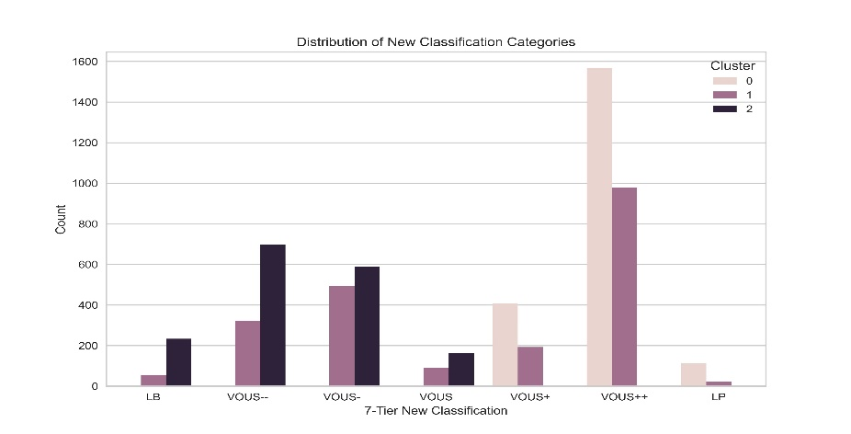

Supplementary Figure 1. Best discrimination threshold according to 7-tier classification system by clustering analysis.

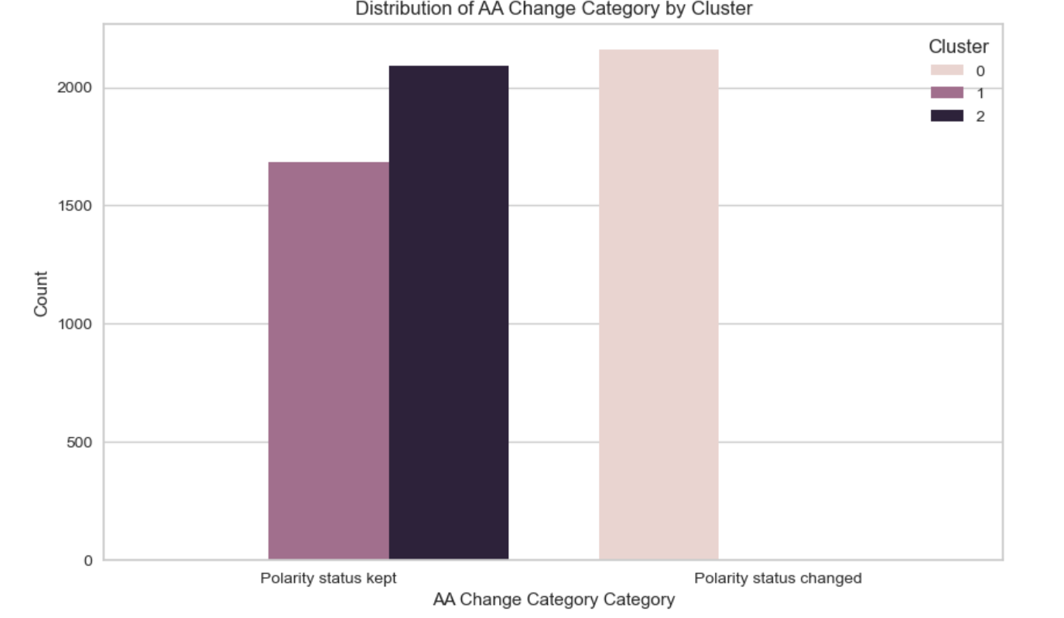

Supplementary Figure 2. Best discrimination threshold according to amino acid polarity status by clustering analysis.

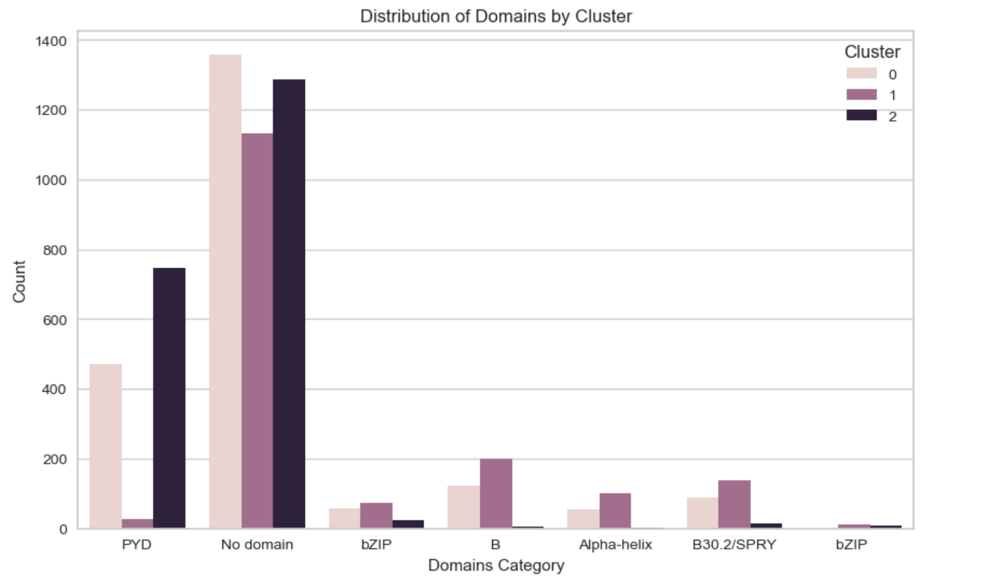

Supplementary Figure 3. Best discrimination threshold according to domain category by clustering analysis.

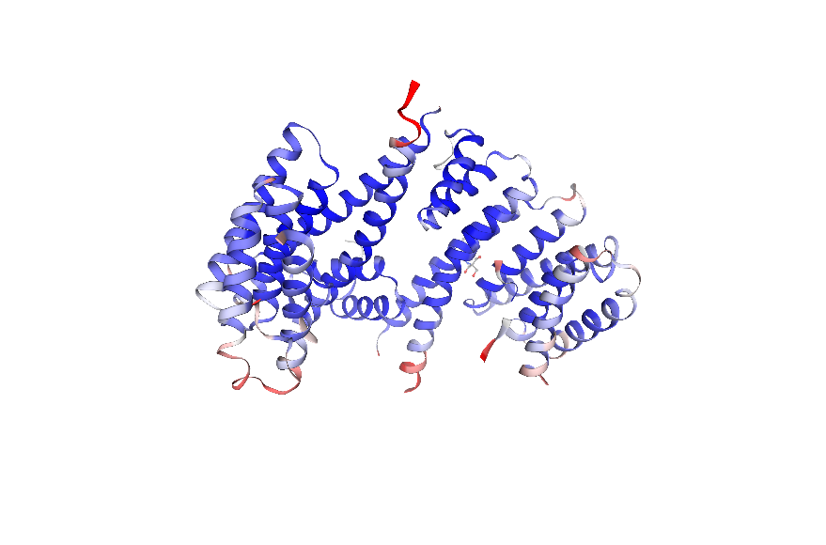
Supplementary Figure 4 . Human pyrin protein (O15553) 3D structure according to Swiss-model[Waterhouse et al., 2018]. SWISS-MODEL Repository. Protein: Pyrin (UniProt ID: O15553). Available at: https://swissmodel.expasy.org/repository/uniprot/O15553 (Accessed on July 18, 2024)

References
Waterhouse A, Bertoni M, Bienert S, Studer G, Tauriello G, Gumienny R, Heer FT, de Beer TAP, Rempfer C, Bordoli L, Lepore R, Schwede T. 2018. SWISS-MODEL: homology modelling of protein structures and complexes. Nucleic Acids Res. 46: W296–W303.

