Supplementary information

Intranasal administration of a pan-reactive anti-influenza antibody reveals Fc-independent mode of protection
Anna L. Beukenhorst ^{1,2,}*, Keira L. Rice ², Jacopo Frallicciardi ², Martin H. Koldijk ², Carolyn M. Boudreau², Justin Crawford ², Lisette A. H. M. Cornelissen³, Kelly A. S. da Costa ⁴, Babette A. de Jong ², Stephanie Fischinger ², Boris Julg ^{2,5}, Jaco M. Klap ², Clarissa M. Koch ², Zoltán Magyarics ², Faez A. Nait Mohamed ⁵, Vintus Okonkwo ⁵, Lindsey Adams ⁵, Caitlin M. McCarthy ⁵, Larance Ronsard ⁵, Nigel Temperton ⁴, Helene Vietsch ², Kanin Wichapong ^{6,7}, Bertjan Ziere², Daniel Lingwood ⁵, Jaap Goudsmit ¹
¹ Departments of Epidemiology, Immunology and Infectious Diseases, Harvard TH Chan School of
Public Health, Boston, Massachusetts, United States of America
² Leyden Laboratories, Leiden, The Netherlands.
³ Wageningen Bioveterinary Research, Wageningen University & Research, Lelystad, The Netherlands
⁴ Viral Pseudotype Unit, Medway School of Pharmacy, University of Kent and University of Greenwich, Chatham, United Kingdom
⁵ The Ragon Institute of Mass General, MIT and Harvard, Cambridge, Massachusetts, United States of America.
⁶ Department of Biochemistry, Cardiovascular Research Institute Maastricht (CARIM), Maastricht University, Maastricht, Netherlands
₇ Hillmark B.V., Maastricht, the Netherlands
*email: anna.beukenhorst@leydenlabs.com
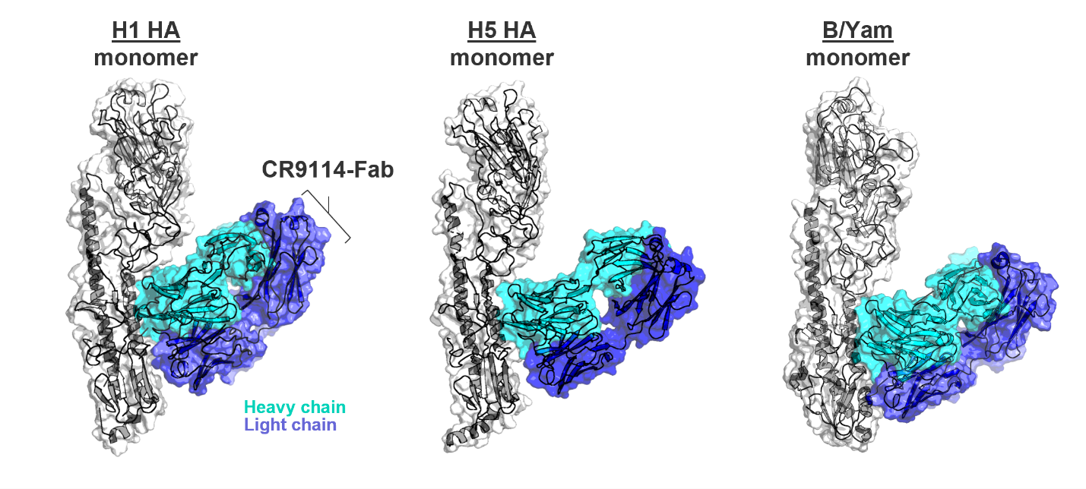
Supplementary Figure 1. Three-dimensional (3D) structures of CR9114 Fab in complex with H1, H5, and B/Yam HA.

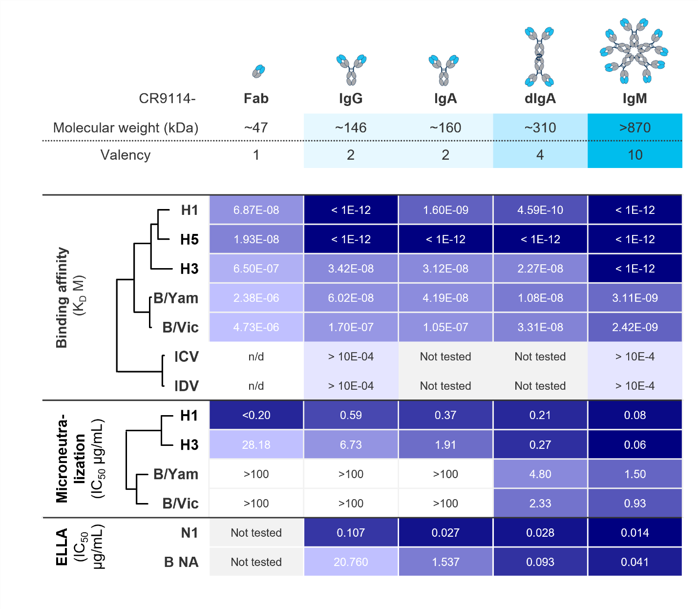
Supplementary Figure 2. Basic avidity effects on binding, neutralization, and neuraminidase inhibition. In a separate experiment conducted only with CR9114-IgG, CR9114 did not inhibit B/Vic. NA, whereas it did inhibit N2 NA (IC₅₀: 1.266 µg/mL).

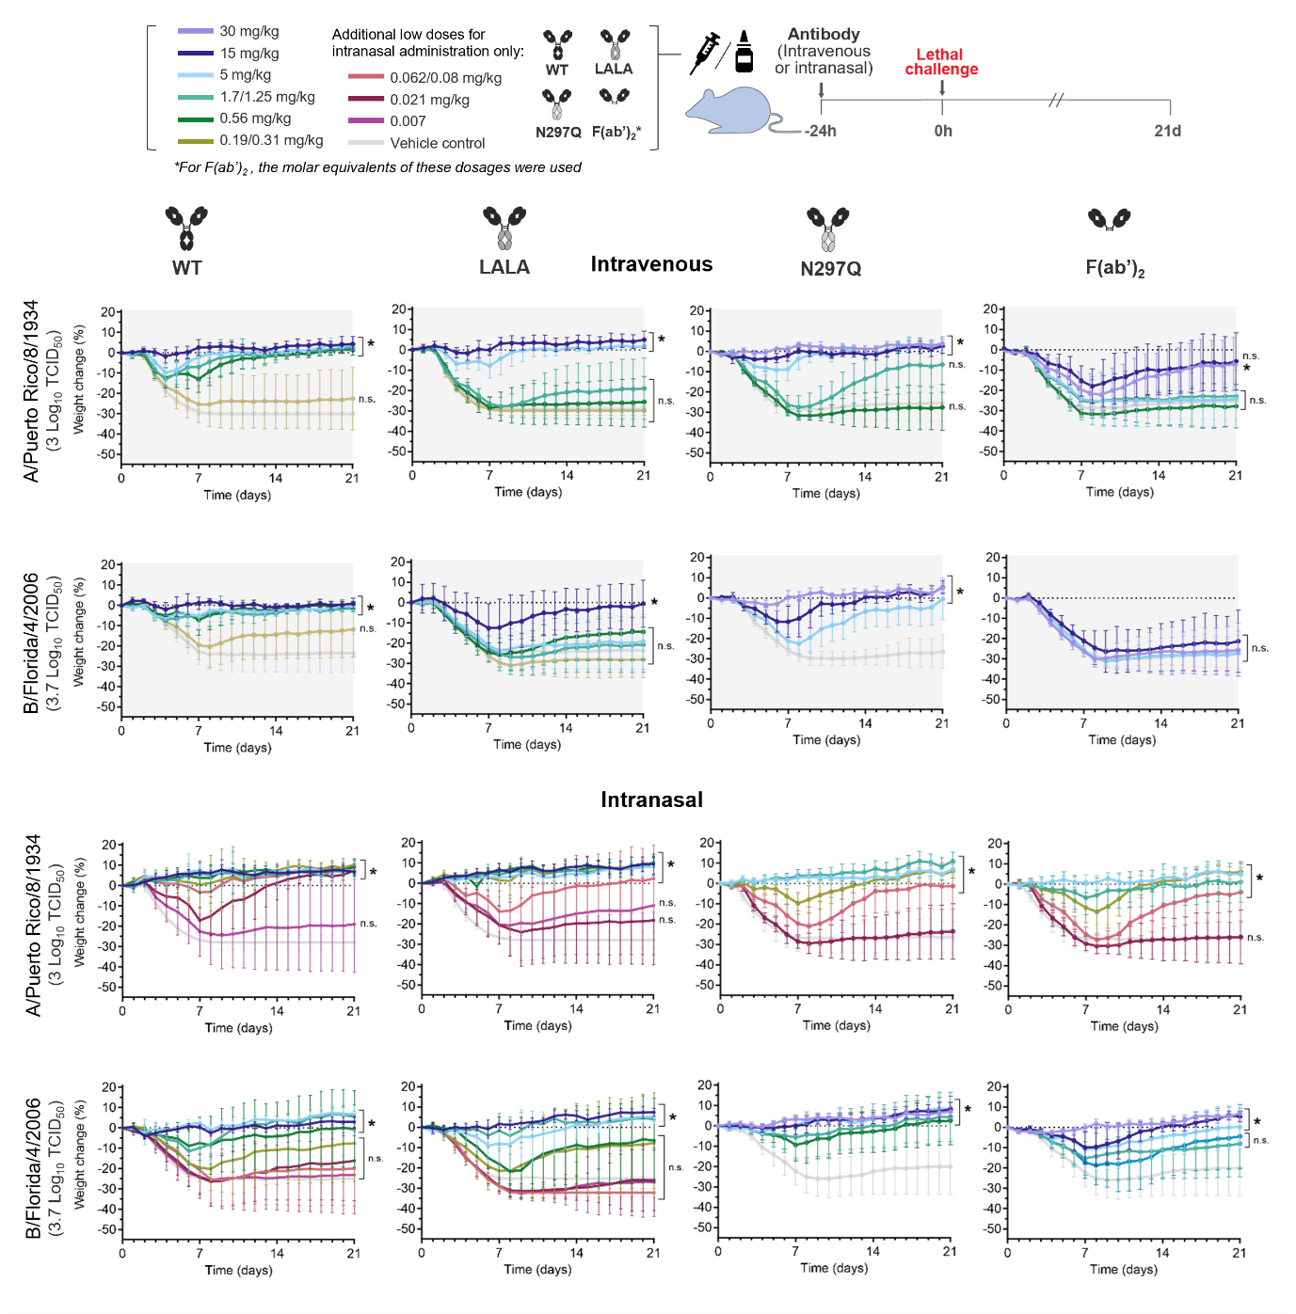
Supplementary Figure 3. Changes in body weight of mice treated with indicated doses of different modalities of CR9114 (also see Table S4) via intravenous or intranasal administration or PBS control.

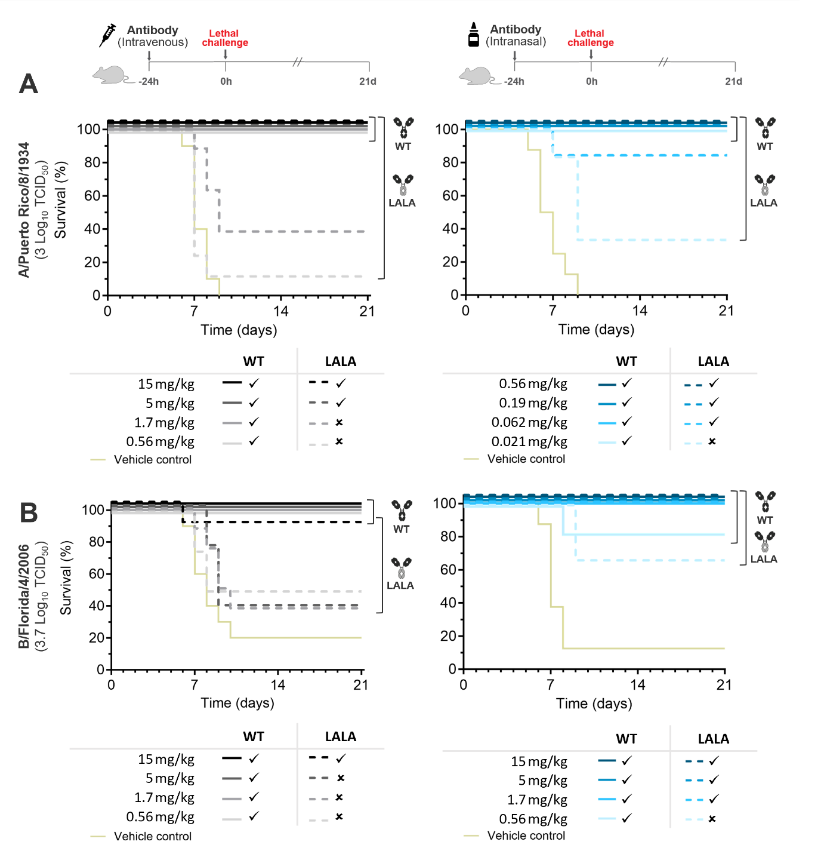
Supplementary Figure 4. Intranasal administration route reveals low dose protection against influenza A and B independent of the antibody Fc, occurring via antigen-binding site only (related to figures 4 and 5). (A, B) Kaplan–Meier survival curves showing the in vivo efficacy of (left) intravenous and (right) intranasal delivered CR9114 and CR9114-LALA in protecting mice in lethal challenge against influenza A (A/Puerto Rico/8/1934 - H1N1) and influenza B (B/Florida/4/2006 – B/Yamagata). Mice were treated with indicated doses of CR9114 or PBS via intravenous or intranasal administration 24 hours before challenge as shown in the legend. “” indicates significant differences in survival proportions at day 21 compared with PBS control (P < 0.05). “.” indicates not significant compared with PBS control.
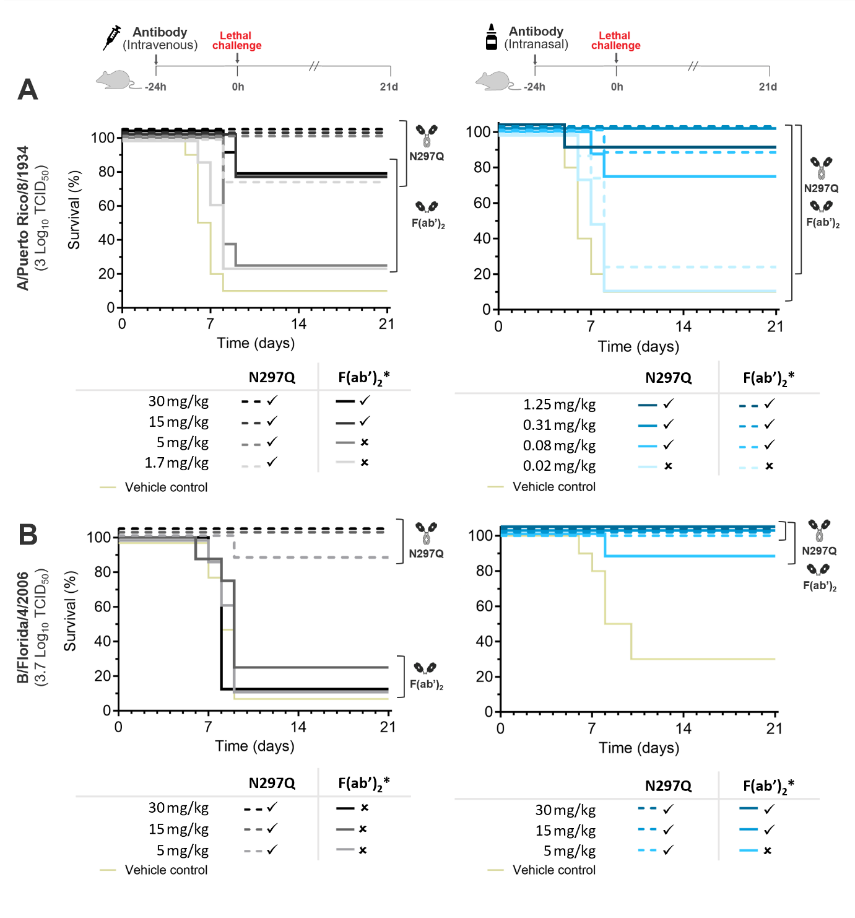
Supplementary Figure 5. Intranasal administration route reveals low dose protection against influenza A and B independent of the antibody Fc, occurring via antigen-binding site only (related to figures 4 and 5). (A, B) Kaplan–Meier survival curves showing the in vivo efficacy of (left) intravenous and (right) intranasal delivered CR9114-N297Q and CR9114-F(ab’)₂ in protecting mice in lethal challenge against influenza A (A/Puerto Rico/8/1934 - H1N1) and influenza B (B/Florida/4/2006 – B/Yamagata). Mice were treated with indicated doses of CR9114 or PBS via intravenous or intranasal administration 24 hours before challenge as shown in the legend. “” indicates significant differences in survival proportions at day 21 compared with PBS control (P < 0.05). “.” indicates not significant compared with PBS control.

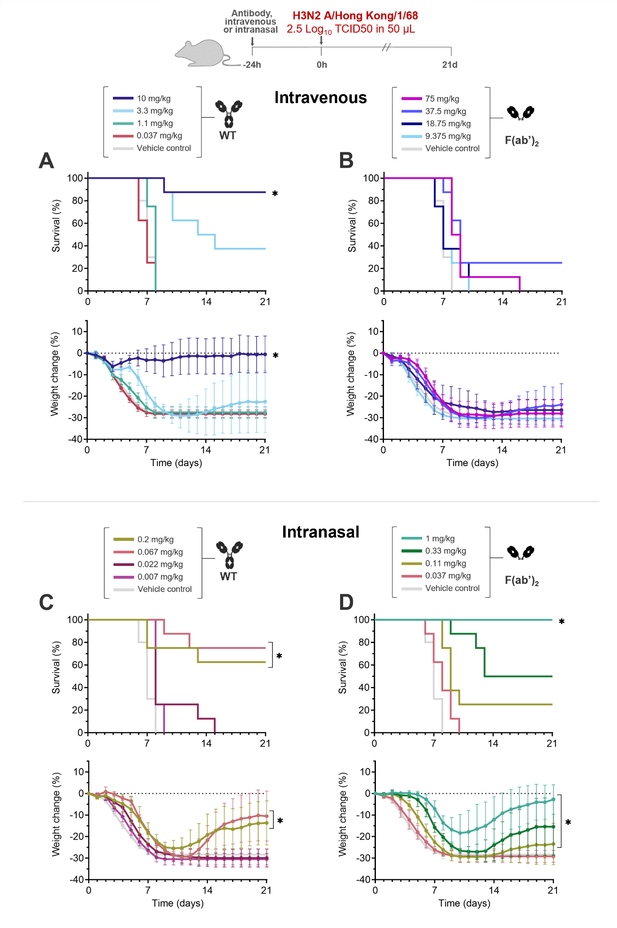
Supplementary Figure 6. Intranasal administration route reveals low dose protection against influenza A group 2 independent of the antibody Fc, occurring via antigen-binding site only (related to figure 2). Kaplan–Meier survival curves and bodyweight change showing the in vivo efficacy of (A, B) intravenous and (C, D) intranasal delivered (A, C) CR9114 and (B, D) CR9114-F(ab’)₂ in protecting mice in lethal challenge against influenza A group 2 (A/Hong Kong/1/1968 – H3N2). CR9114 data from Figure 2 is shown here again for comparison to F(ab’)_{2.} Mice were treated with indicated doses of antibody or PBS via intravenous or intranasal administration 24 hours before challenge as shown in the legend. “*” indicates significant differences in survival proportions at day 21 compared with PBS control (P < 0.05).

Supplementary Table 1. List of residues involved in the binding between CR9114 (paratope) and the HA of Influenza virus A and B (epitope).
CR9114 |  | H1 HA | H5 HA | H3 HA | B/Vic HA | B/Yam HA
T28 | HCDR1 |  | - | N53 (HA2) – helix | -
N31 | HCDR1 | N50 (HA2) - helix | Q42 (HA2) - helix | Q42 (HA2) - helix | - | Q42 / N46 (HA2) -helix
N31 | HCDR1 |  | D46 (HA2) – helix | D46 (HA2) – helix | Q389 - helix
P52A | HCDR2 |  | Q40 (HA1) | - | -
I53 | HCDR2 | T318 (HA1) |  |  |  | N330 (HA1)
F54 | HCDR2 | W21 (HA2) - FP | W21 (HA2) - FP | W21 (HA2) - FP
N97 | HCDR3 | Q38/Q42 (HA2) - helix
Y98 | HCDR3 | D19 (HA2) - FP | D19 (HA2) - FP | T41 (HA2) - helix | G367 - FP | A19 (HA2) – FP
Y98 | HCDR3 |  | Q42 (HA2) - helix | Q42 (HA2) - helix | Q389 - helix | Q42 (HA2) - helix
Y99 | HCDR3 | I18 (HA2) - FP
Y100A | HCDR3 | D19 (HA2) - FP | D19 (HA2) - FP | D19 (HA2) | -
D72 | FR3 | S291 (HA1) | S291 (HA1) | -
N76 | FR3 | N53 (HA2)
R31 | Light Chain | D19 (HA2) - FP |  |  |  | D150 (HA2)

Supplementary Table 2. List of residues involved in the binding between CR9114 (paratope) and the HEF of Influenza virus C and D (epitope).
CR9114 |  | ICV HEF | IDV HEF
T28 | HCDR1 | -
N30 | HCDR1 | Q53 (HEF2) - helix | Q54 (HEF2) - helix
N30 | HCDR1 | E42 (HEF2) | D47 (HEF2) - helix
N31 | HCDR1 | - | -
Y32 | HCDR1 | E42 (HEF2) | -
P52A | HCDR2 | - | K29 (HEF1)
I53 | HCDR2 | T28 (HEF1) | -
F54 | HCDR2 | S14 (HEF1) | -
Y98 | HCDR3 | Y24 (HEF1) | A44 (HEF2)
Y98 | HCDR3 | S40 (HEF1) | -
Y99 | HCDR3 | - | Q43 (HEF2)
Y100A | HCDR3 | - | T42 (HEF2)
D72 | FR3 | - | -
I73 | FR3 | Q53 (HEF2) - helix | Q54 (HEF2) – helix
F74 | FR3 | Q53 (HEF2) - helix | -
N76 | FR3 | - | Q54 (HEF2) – helix

Supplementary Table 3. Virus challenge strains and corresponding doses (TCID₅₀).
Figure | Subtype/ lineage | Strain | Dose per mouse
2 | H1N1 | A/WSN/33/1933 | 4.3 Log₁₀ TCID₅₀ in 50 µL
4 and S3 | H1N1 | A/Puerto Rico/8/1934 | 3 Log₁₀ TCID₅in 30 µL
3 | H5N1 | A/Hong Kong/156/1997 | 4.8 Log₁₀ TCID₅₀ in 50 µL
3 | B/Yam | B/Florida/04/2006 | 4.8 Log₁₀ TCID₅₀ in 50 µL
5 and S3 | B/Yam | B/Florida/04/2006 | 3.7 Log₁₀ TCID₅₀in 30 µL
2 | B/Vic | B/Malaysia/2506/2004 | 5.5 Log₁₀ TCID₅₀ in 50 µL
2 | H3N2 | A/Hong Kong/01/1968-MA20 | 2.5 Log₁₀ TCID₅₀ in 50 µL

Supplementary table 4 Doses tested for CR9114 WT, CR9114-LALA, CR9114-N297Q, and CR9114-F(ab’)₂, indicating where significant protection compared to vehicle control was observed in terms of survival (related to Figure 4 and 5).

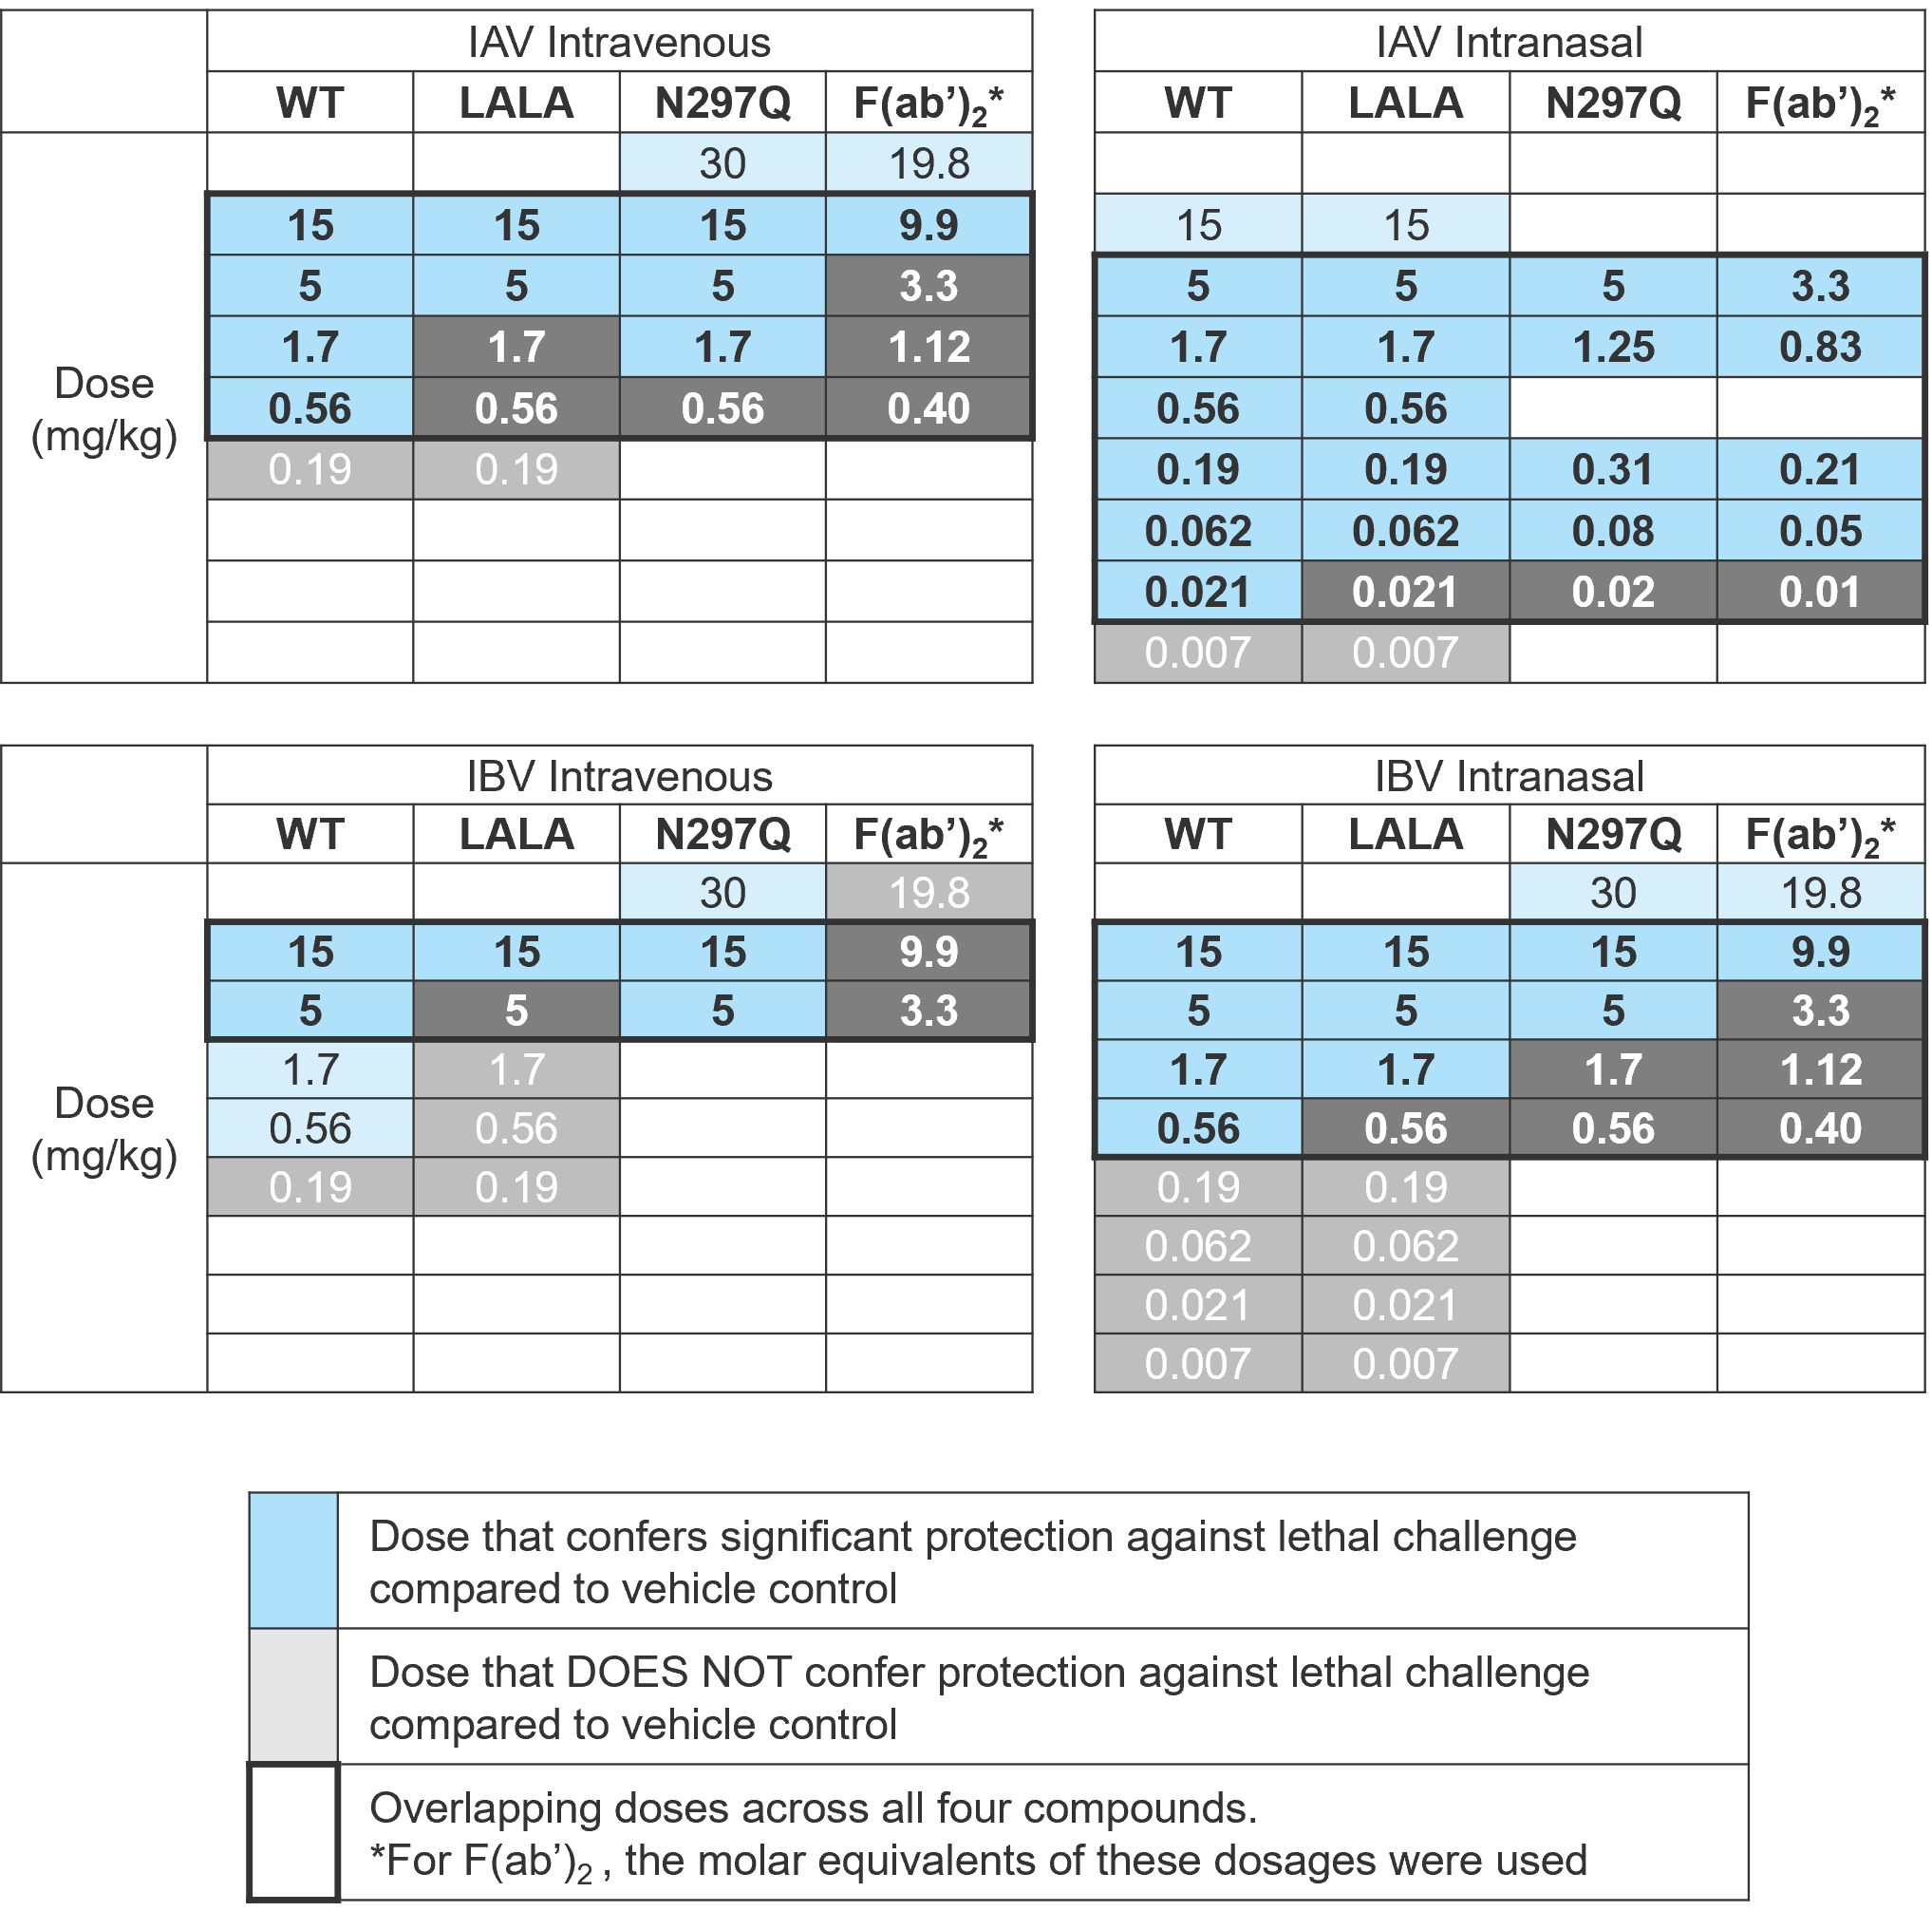
Supplementary table 5 Doses tested for CR9114 WT, CR9114-LALA, CR9114-N297Q, and CR9114-F(ab’)₂, indicating where significant protection compared to vehicle control was observed in terms of bodyweight loss (related to Figure 4 and 5)

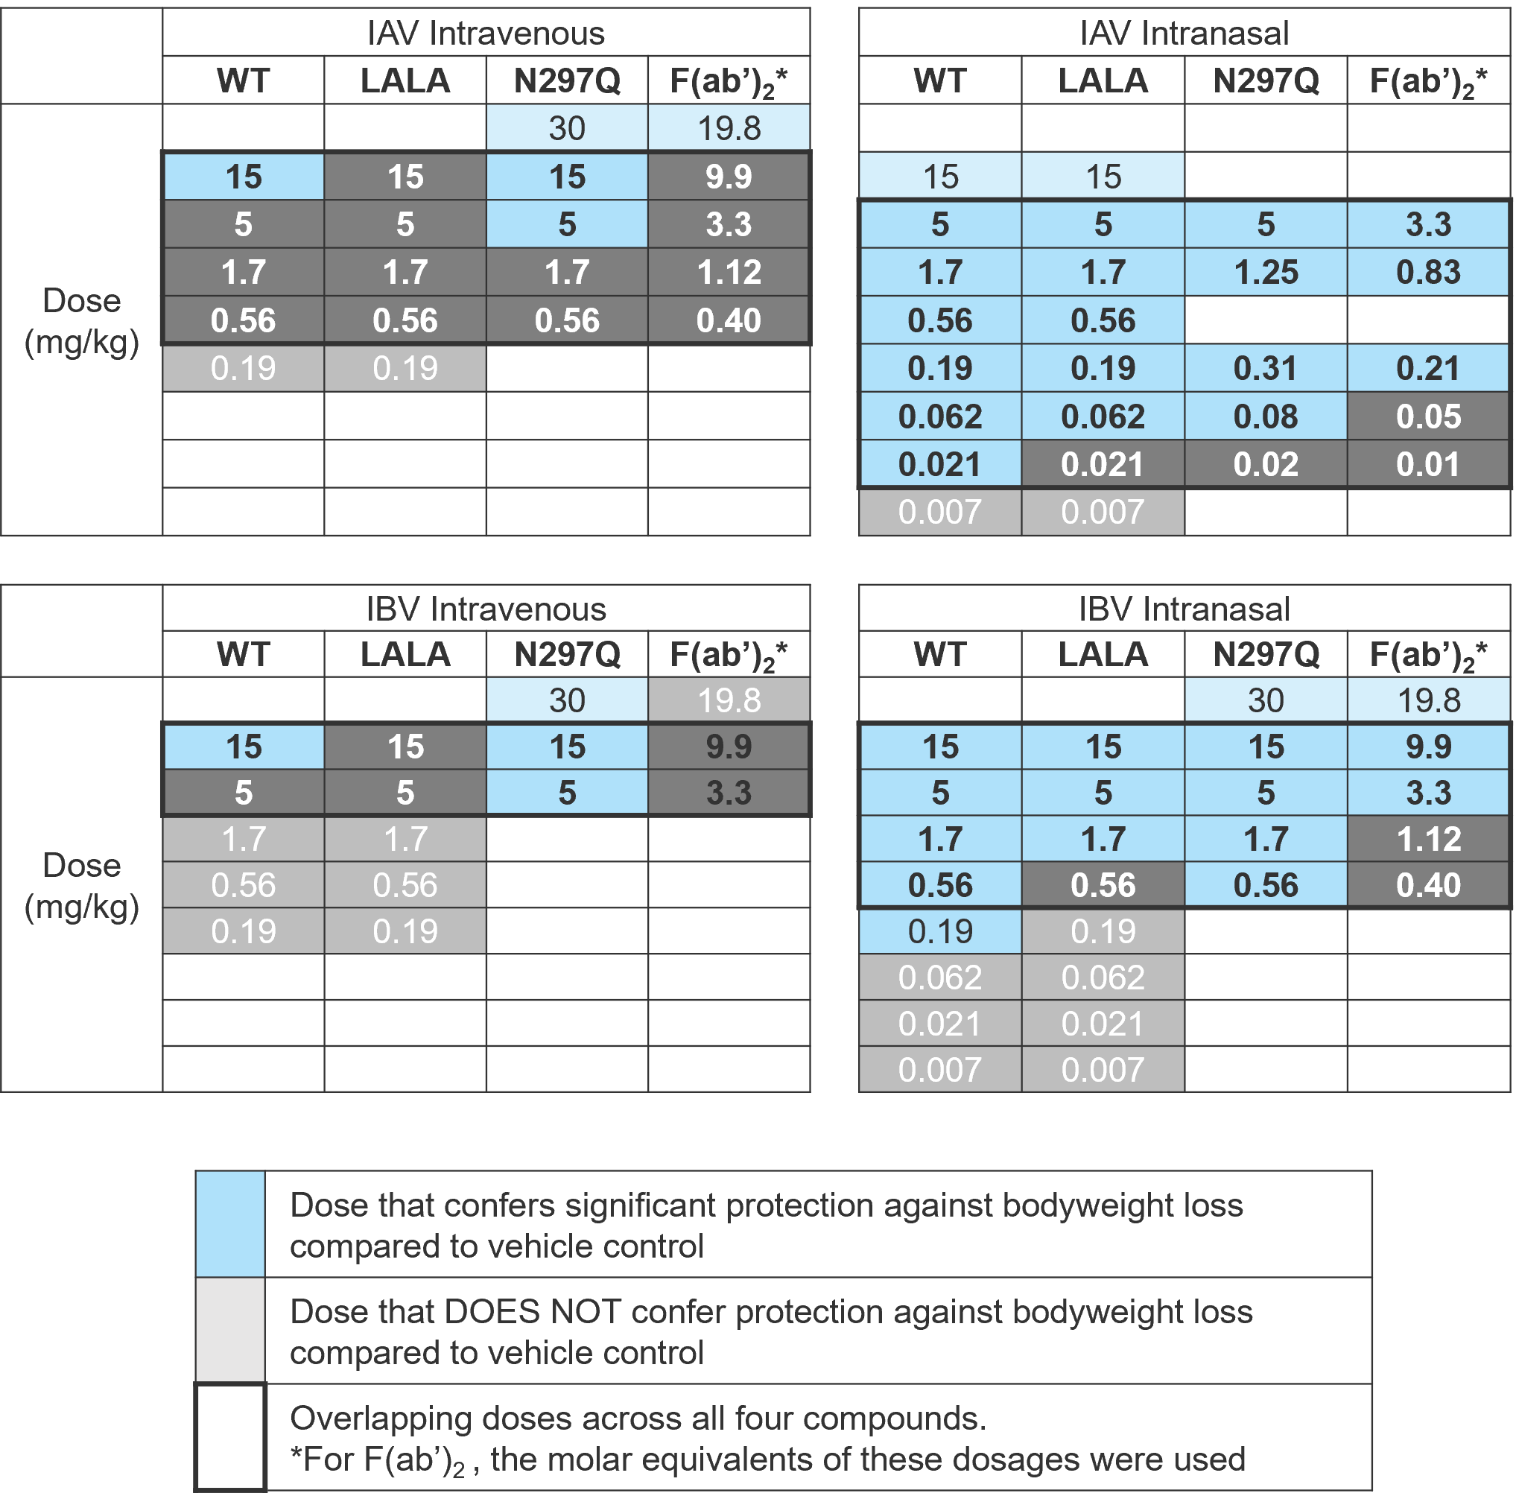

Supplementary Table 6. Median effective dosage (ED₅₀) of CR9114 IgG, IgG Fc-mutants, or F(ab’)₂ only when delivered via the intravenous or intranasal route. ED₅₀ values are expressed as mg/kg (studies with IgG formats only; top panels) nmol/kg (studies with F(ab’)₂ ; bottom panels). The ratio indicates fold-change between CR9114 and CR9114-LALA, or between CR9114-N297Q and CR9114-F(ab’)₂.

