Characterization of Contrast-mediated Collinear Interactions in the Human Visual System

Supplementary materials

In this supplementary material, we plot our data using the same x and y axes as Figure 10b from the paper by Zenger & Sagi (1996). The models represented in the figures are polynomial regressions. This was achieved by calculating orthogonal polynomials for the SOA variable using the poly() function in R.

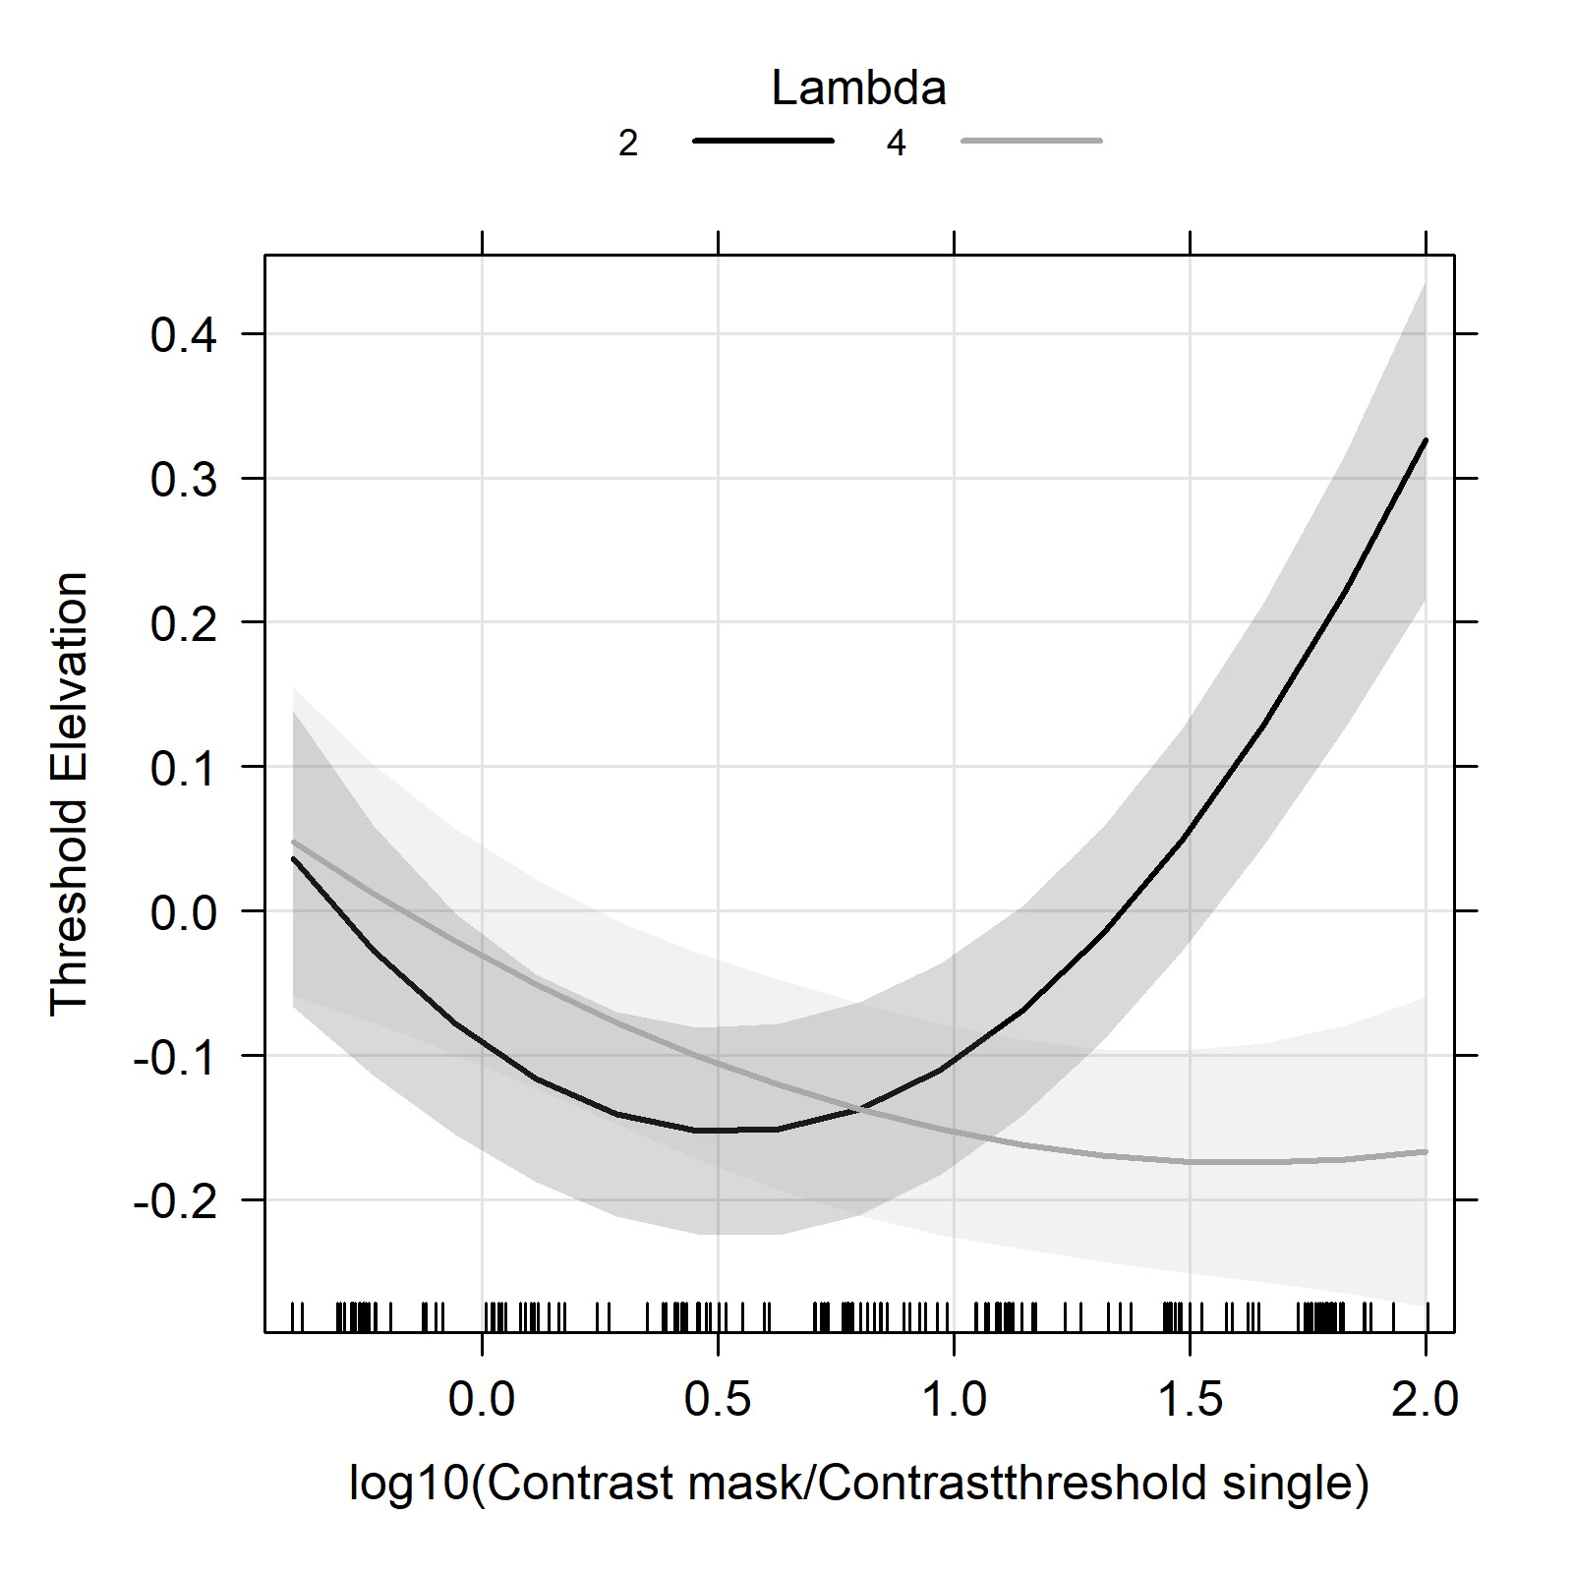
Figure S1: Data from Experiment 1 plotted using the x and y axes from Zenger and Sagi (1996).

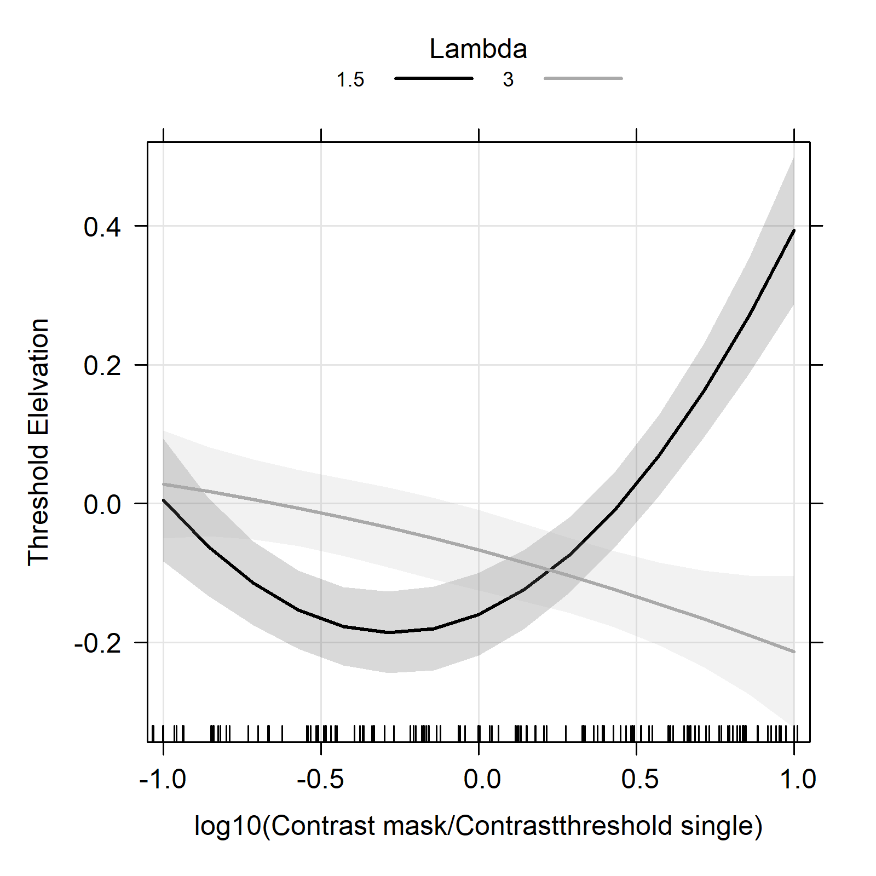
Figure S2: Data from Experiment 2 plotted using the x and y axes from Zenger and Sagi (1996).

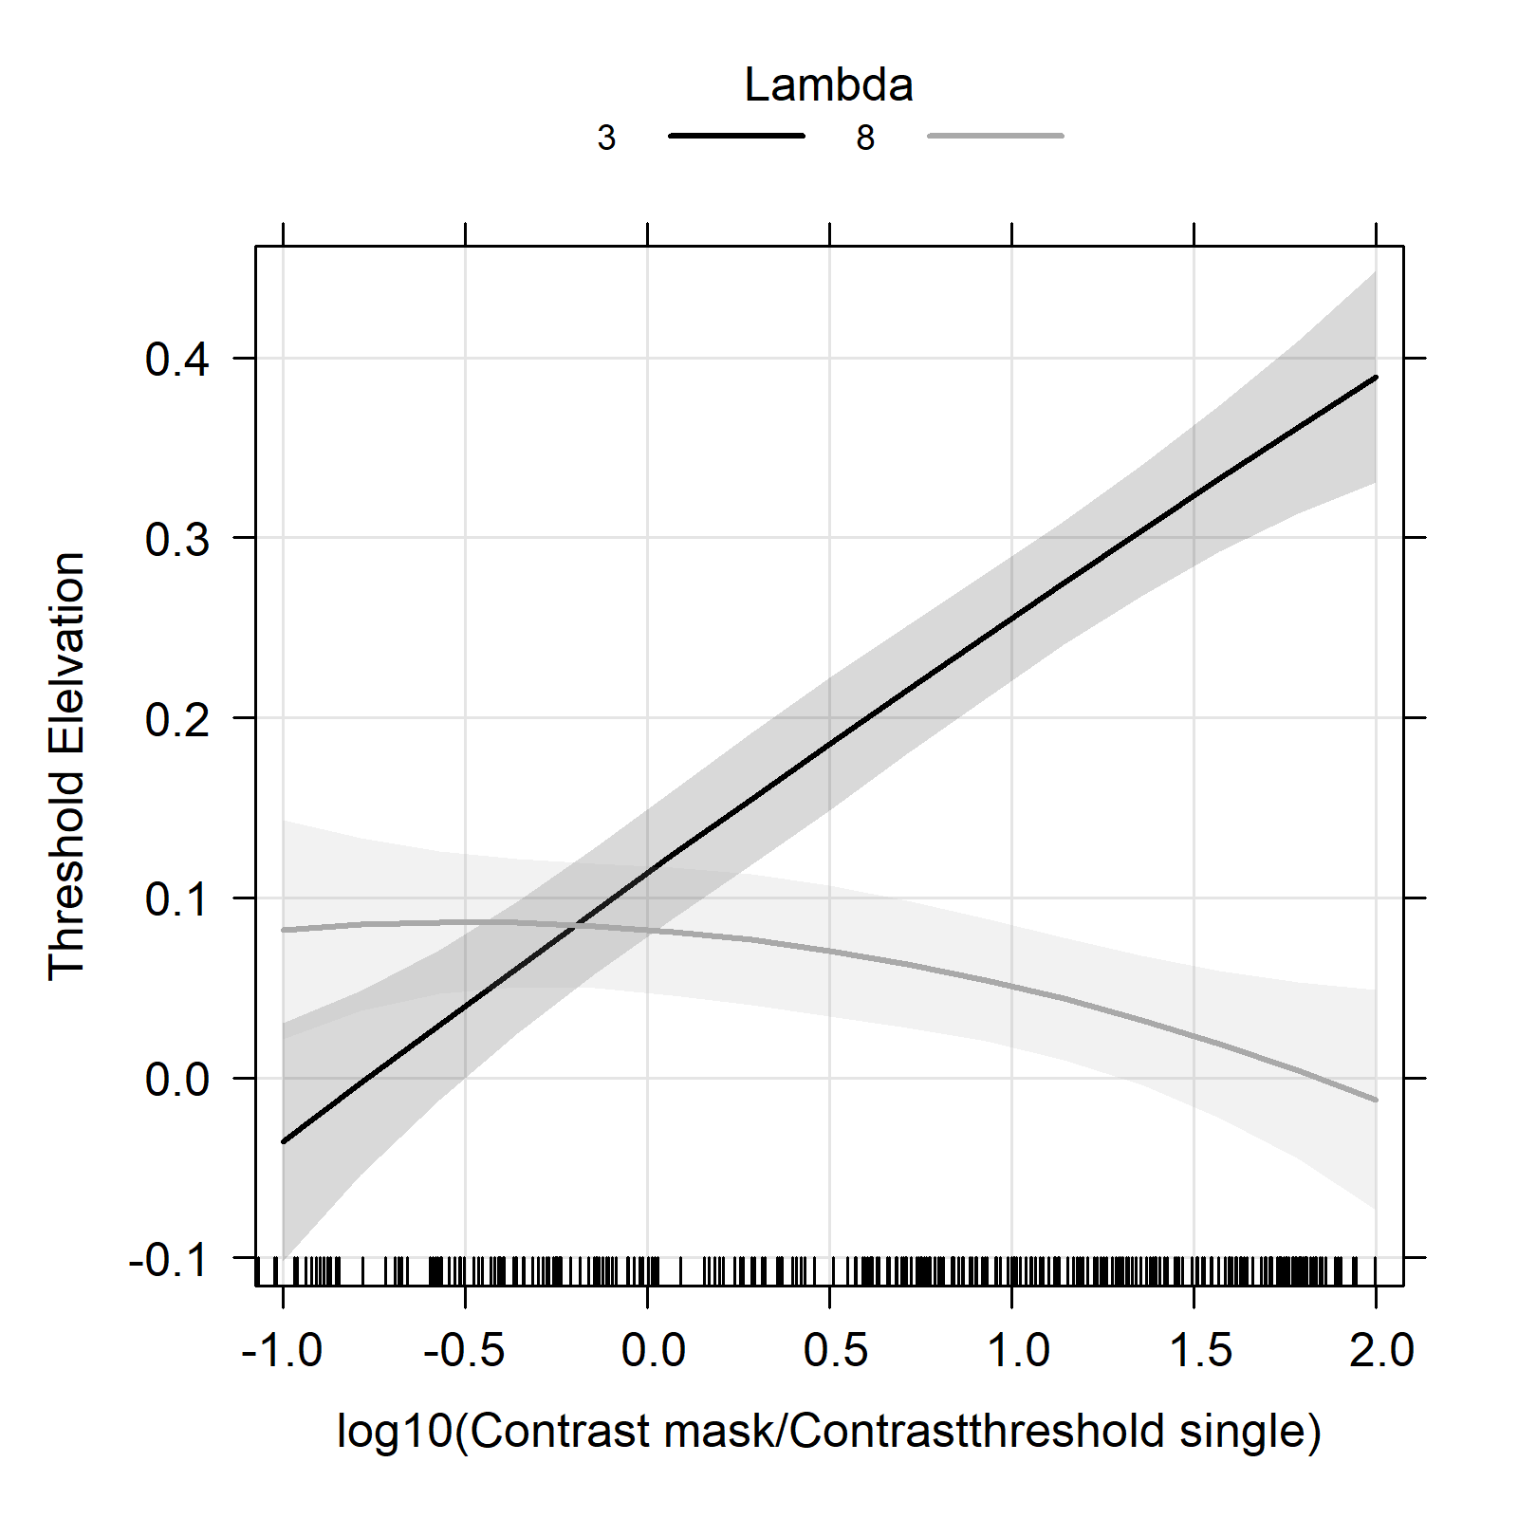
Figure S3: Data from Experiment 3 plotted using the x and y axes from Zenger and Sagi (1996).

In these figures, the x-axis was replaced with the formula from the Zenger & Sagi model (1996). The figures representing the results of Experiments 1 and 2 confirm the model, whereas this is not the case for Experiment 3 with the peripheral configuration (4°). These figures were created to compare empirical data with the mathematical model presented in Zenger & Sagi (1996).

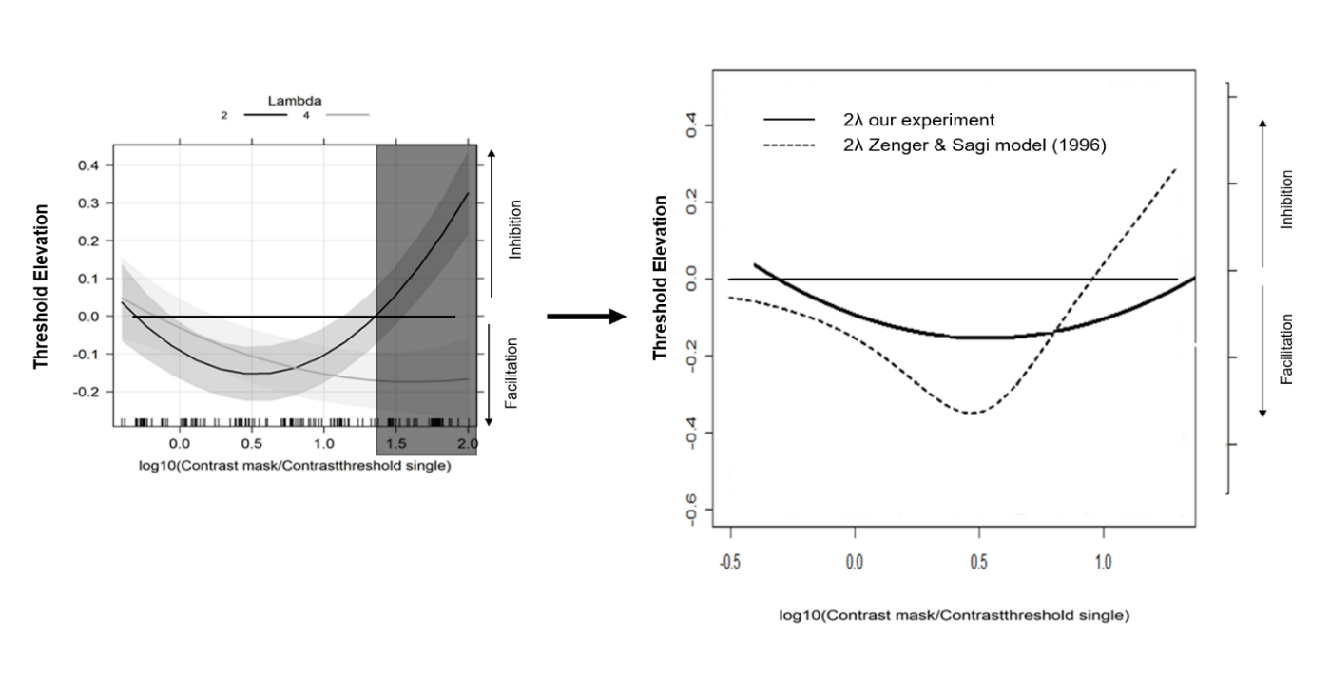
Figure S4: Comparison between our data obtain in the 2lambda condition and data predicted by Zenger & Sagi model (1996)

These graphs are designed to reveal the differences between empirical data and the mathematical model presented by Zenger & Sagi (1996). Although facilitation can be observed for low target-flankers ratios and low flanker contrast, our data show that facilitation is lesser than in the Zenger & Sagi model, and the transition point from facilitation to inhibition occurs later (at higher flanker contrast).

