Supplementary information to manuscript “Socio-ecological vulnerability assessment to Sargassum arrivals”
by Julien Jouanno, Rafael Almar, Frank Muller-Karger, Guillaume Morvan, Brigitta van Tussenbroek, Rachid Benshila, Patrick Marchesiello, Kwasi Appeaning Addo

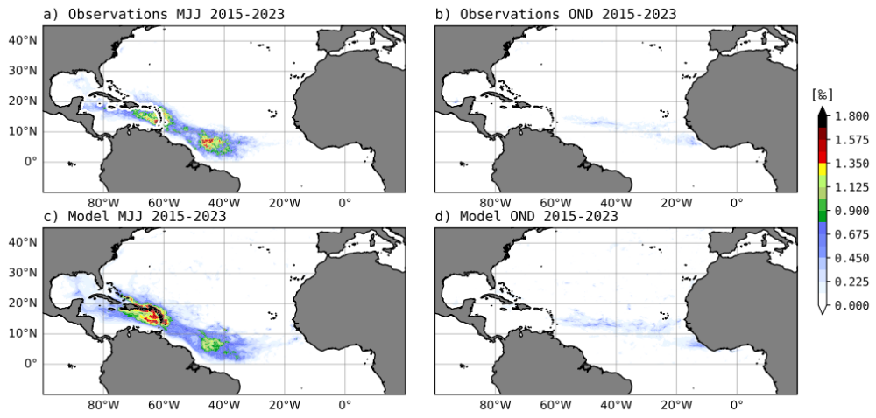
Figure S1 Seasonal cycle of Sargassum areal coverage (‰) in the Tropical Atlantic computed using MODIS detections and model outputs from 2018 to 2022. The areal coverage is defined as the proportion of a pixel area occupied by Sargassum mats. Here the pixel area is 1/12° or ∼9x9 km.

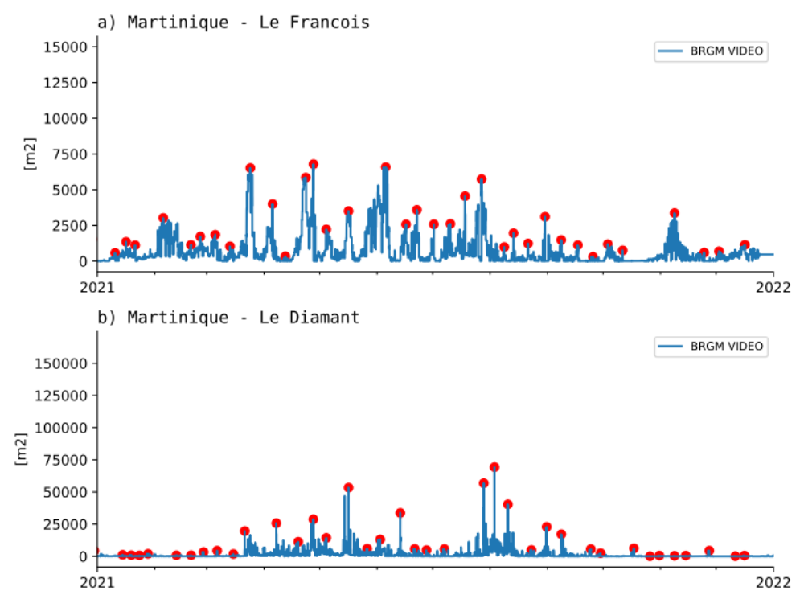

Figure S2. Time series of Sargassum cover (in m²) obtained from video-camera monitoring at two locations in Martinique in 2021: Le François (on the island’s east coast) and Le Diamant Bay (in the south). Details on the methodology and site-specific characteristics are provided in Bouvier (2022, 2024). Data acquisitions were conducted daily at 8 AM, 10 AM, 12 PM, 2 PM, and 4 PM. Red points indicate Sargassum arrivals, identified as local maxima within an 8-day moving window, which are used to estimate monthly arrivals in Figure S3.
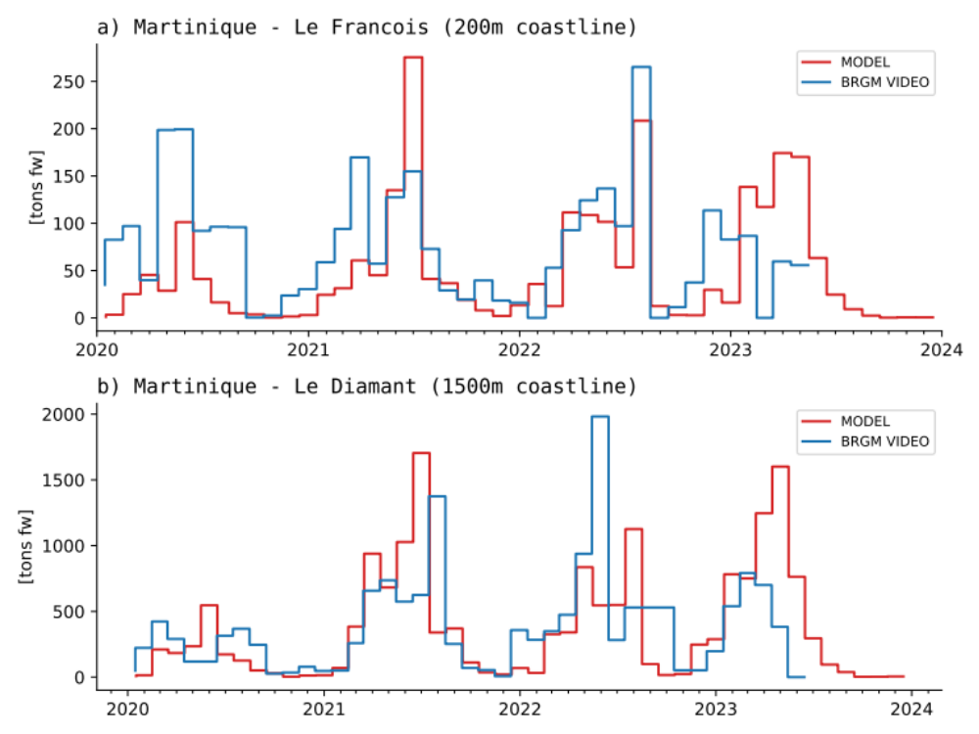

Figure S3. (a) Monthly time series of Sargassum biomass (in tons of fresh weight) at two locations in Martinique—Le François (a) and Le Diamant (b)—estimated from video camera observations (blue) and the NEMO-Sarg 1/12° nudged simulation. The local maxima of Sargassum cover (in m²), obtained from the video-camera system shown in Figure S2, were accumulated over one-month periods and converted into biomass using an arbitrary mean density of 10 kg m⁻². Since the coastline lengths of both sites are smaller than the model's pixel size (9 km), the model's stranded biomass estimates were rescaled based on a representative coastline length of 200 m for Le François and 1,500 m for Le Diamant.

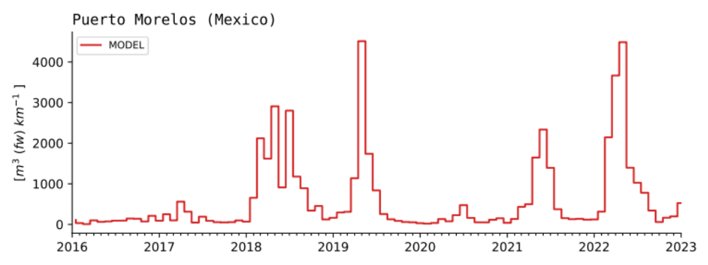

Figure S4. Time series of Sargassum volume stranded (m³ of fresh weight per kilometer of coastline) as simulated by NEMO-Sarg from 2016 to 2023, rescaled for a 1 km coastline.

