Content
Supplementary 1: PRISMA Checklist 1
Supplementary 2: The search strategy 4
Supplementary 3: Definitions of physical activity types 6
Supplementary 4: Bias risk summary of the included studies. 7
Supplementary 5：Grading the evidence for primary outcome 8
5.1 Summary of study limitations of the included studies 8
5.2 Reasons for downgrading 9
5.3 CINeMA for the primary outcome 12
Supplementary 6: Evaluation of inconsistency 18
Supplementary 7: Assessment of the transitivity 22
7.1 Publish years 22
7.2 Mean age 23
7.3 Sample size 24
7.4 Exercise period 25
Supplementary 8：Sensitivity analyses 26
8.1 Exclude studies with high risk of bias 27
8.2 Exclude studies with sample size of less than 30 28
Supplementary 9: Publication bias 29
Supplementary 10: The list for the included studies 31
Supplementary 11: Study Characteristics 35

Supplementary 1: PRISMA Checklist
Section and Topic | Item # | Checklist item | Location where item is reported
TITLE
Title | 1 | Identify the report as a systematic review. | Page1
ABSTRACT
Abstract | 2 | See the PRISMA 2020 for Abstracts checklist. | Page1
INTRODUCTION
Rationale | 3 | Describe the rationale for the review in the context of existing knowledge. | Page3-4
Objectives | 4 | Provide an explicit statement of the objective(s) or question(s) the review addresses. | Page3
METHODS
Eligibility criteria | 5 | Specify the inclusion and exclusion criteria for the review and how studies were grouped for the syntheses. | Page4
Information sources | 6 | Specify all databases, registers, websites, organisations, reference lists and other sources searched or consulted to identify studies. Specify the date when each source was last searched or consulted. | Page4
Search strategy | 7 | Present the full search strategies for all databases, registers and websites, including any filters and limits used. | Page4
Selection process | 8 | Specify the methods used to decide whether a study met the inclusion criteria of the review, including how many reviewers screened each record and each report retrieved, whether they worked independently, and if applicable, details of automation tools used in the process. | Page4-5
Data collection process | 9 | Specify the methods used to collect data from reports, including how many reviewers collected data from each report, whether they worked independently, any processes for obtaining or confirming data from study investigators, and if applicable, details of automation tools used in the process. | Page5-6
Data items | 10a | List and define all outcomes for which data were sought. Specify whether all results that were compatible with each outcome domain in each study were sought (e.g. for all measures, time points, analyses), and if not, the methods used to decide which results to collect. | Page4-5
Data items | 10b | List and define all other variables for which data were sought (e.g. participant and intervention characteristics, funding sources). Describe any assumptions made about any missing or unclear information. | Page4-5
Study risk of bias assessment | 11 | Specify the methods used to assess risk of bias in the included studies, including details of the tool(s) used, how many reviewers assessed each study and whether they worked independently, and if applicable, details of automation tools used in the process. | Page5-6
Effect measures | 12 | Specify for each outcome the effect measure(s) (e.g. risk ratio, mean difference) used in the synthesis or presentation of results. | Page6
Synthesis methods | 13a | Describe the processes used to decide which studies were eligible for each synthesis (e.g. tabulating the study intervention characteristics and comparing against the planned groups for each synthesis (item #5)). | Page4-5
Synthesis methods | 13b | Describe any methods required to prepare the data for presentation or synthesis, such as handling of missing summary statistics, or data conversions. | Page6
Synthesis methods | 13c | Describe any methods used to tabulate or visually display results of individual studies and syntheses. | Page6
Synthesis methods | 13d | Describe any methods used to synthesize results and provide a rationale for the choice(s). If meta-analysis was performed, describe the model(s), method(s) to identify the presence and extent of statistical heterogeneity, and software package(s) used. | Page6
Synthesis methods | 13e | Describe any methods used to explore possible causes of heterogeneity among study results (e.g. subgroup analysis, meta-regression). | Page6
Synthesis methods | 13f | Describe any sensitivity analyses conducted to assess robustness of the synthesized results. | Page6
Reporting bias assessment | 14 | Describe any methods used to assess risk of bias due to missing results in a synthesis (arising from reporting biases). | Page5-6
Certainty assessment | 15 | Describe any methods used to assess certainty (or confidence) in the body of evidence for an outcome. | Page5-6
RESULTS
Study selection | 16a | Describe the results of the search and selection process, from the number of records identified in the search to the number of studies included in the review, ideally using a flow diagram. | Page6-7
Study selection | 16b | Cite studies that might appear to meet the inclusion criteria, but which were excluded, and explain why they were excluded. | Page7
Study characteristics | 17 | Cite each included study and present its characteristics. | Page6-7
Risk of bias in studies | 18 | Present assessments of risk of bias for each included study. | Page7-8
Results of individual studies | 19 | For all outcomes, present, for each study: (a) summary statistics for each group (where appropriate) and (b) an effect estimate and its precision (e.g. confidence/credible interval), ideally using structured tables or plots. | Page6-7
Results of syntheses | 20a | For each synthesis, briefly summarise the characteristics and risk of bias among contributing studies. | Page6-8
Results of syntheses | 20b | Present results of all statistical syntheses conducted. If meta-analysis was done, present for each the summary estimate and its precision (e.g. confidence/credible interval) and measures of statistical heterogeneity. If comparing groups, describe the direction of the effect. | Page8-10
Results of syntheses | 20c | Present results of all investigations of possible causes of heterogeneity among study results. | Page8-10
Results of syntheses | 20d | Present results of all sensitivity analyses conducted to assess the robustness of the synthesized results. | Page8-10
Reporting biases | 21 | Present assessments of risk of bias due to missing results (arising from reporting biases) for each synthesis assessed. | Page7-8
Certainty of evidence | 22 | Present assessments of certainty (or confidence) in the body of evidence for each outcome assessed. | Page8-10
DISCUSSION
Discussion | 23a | Provide a general interpretation of the results in the context of other evidence. | Page10-13
Discussion | 23b | Discuss any limitations of the evidence included in the review. | Page10-13
Discussion | 23c | Discuss any limitations of the review processes used. | Page10-13
Discussion | 23d | Discuss implications of the results for practice, policy, and future research. | Page10-13
OTHER INFORMATION
Registration and protocol | 24a | Provide registration information for the review, including register name and registration number, or state that the review was not registered. | Page
Registration and protocol | 24b | Indicate where the review protocol can be accessed, or state that a protocol was not prepared. | Page
Registration and protocol | 24c | Describe and explain any amendments to information provided at registration or in the protocol. | Page
Support | 25 | Describe sources of financial or non-financial support for the review, and the role of the funders or sponsors in the review. | Page
Competing interests | 26 | Declare any competing interests of review authors. | Page
Availability of data, code and other materials | 27 | Report which of the following are publicly available and where they can be found: template data collection forms; data extracted from included studies; data used for all analyses; analytic code; any other materials used in the review. | Page

From: Page MJ, McKenzie JE, Bossuyt PM, Boutron I, Hoffmann TC, Mulrow CD, et al. The PRISMA 2020 statement: an updated guideline for reporting systematic reviews. BMJ 2021;372:n71. doi: 10.1136/bmj.n71
For more information, visit: http://www.prisma-statement.org/

Supplementary 2: The search strategy
Database | Search strategy | 5983
PubMed
#1 | Search ((((((Osteoporosis[MeSH Terms]) OR osteopenia[MeSH Terms]) OR Osteoporosis[Title/Abstract]) OR Osteoporoses[Title/Abstract]) OR osteopenia[Title/Abstract]) OR "Bone Losses"[Title/Abstract]) OR "bone mineral density"[Title/Abstract] Sort by: Best Match | 148596
#2 | Search ((((((((((exercise[MeSH Terms]) OR exercise[Title/Abstract]) OR physical activity*[Title/Abstract]) OR training*[Title/Abstract]) OR resistance exercise*[Title/Abstract]) OR aerobics[Title/Abstract]) OR tai chi[Title/Abstract]) OR whole body vibration[Title/Abstract]) OR aerobic combined with resistance exercise[Title/Abstract]) OR walking[Title/Abstract]) OR impact exercise[Title/Abstract] OR mixed exercise[Title/Abstract] Sort by: Best Match | 1061038
#3 | Search ((randomized controlled trial [pt] OR controlled clinical trial [pt] OR randomized [tiab] OR placebo [tiab] OR clinical trials as topic [mesh: noexp] OR randomly [tiab] OR trial [ti]) NOT (animals [mh] NOT humans [mh])) | 168822
#4 | #1 AND #2 AND #3 | 167
Embase
#1 | osteoporosis:ab,ti OR 'bone losses':ab,ti OR osteoporoses:ab,ti OR 'bone density':ab,ti OR 'bone mineral density' | 175032
#2 | exercise:ab,ti OR 'physical activity':ab,ti OR training*:ab,ti OR resistance exercise∗:ab,ti OR aerobics:ab,ti OR taichi:ab,ti OR whole body vibration:ab,ti OR aerobic combined with resistance exercise:ab,ti OR walking:ab,ti OR impact exercise:ab,ti OR mixed exercise:ab,ti | 25953
#3 | 'randomized controlled trial'/exp OR 'controlled clinical trial'/exp OR 'clinical trial'/exp OR randomized:ab,ti OR placebo:ab,ti OR randomly:ab,ti OR trial:ti OR blind*:ab,ti | 2952679
#4 | #1 AND #2 AND #3 AND [humans]/lim AND [embase]/lim | 226
Cochrane
#1 | MeSH descriptor: [osteoporosis] explode all trees
#2 | MeSH descriptor: [bone density] explode all trees
#3 | (osteoporosis):ti,ab,kw OR ('bone losses'):ti,ab,kw
#4 | #1 or #2 or #3
#5 | MeSH descriptor: [Exercise] explode all trees
#6 | (physical activity*):ti,ab,kw OR (training*):ti,ab,kw OR (exercise):ti,ab,kw
#7 | (resistance exercise):ti,ab,kw OR (taichi):ti,ab,kw OR (aerobics):ti,ab,kw OR (whole body vibration):ti,ab,kw OR (aerobic combined with resistance exercise):ti,ab,kw OR (walking):ti,ab,kw OR (impact exercise):ti,ab,kw OR (mixed exercise):ti,ab,kw
#8 | #5 or #6 or #7
#9 | #4 and #8 | 724
Web of science
#1 | TOPIC: (osteoporosis) OR TOPIC: (bone lossest) OR TOPIC: (bone mineral density)
#2 | TOPIC: (exercise*) OR TOPIC: (physical activity*) OR TOPIC: (training*) OR TOPIC: (resistance exercise*) OR TOPIC: (taichi) OR TOPIC: (aerobics) OR TOPIC: (whole body vibration) OR TOPIC: (kw OR (aerobic combined with resistance exercise) OR TOPIC: (walking) OR TOPIC: (impact exercise*) OR TOPIC: (mixed exercise)
#3 | TOPIC: (randomized controlled trial) OR TOPIC: (controlled clinical trial) OR TOPIC: (clinical trial) AND TOPIC: (randomized) OR TOPIC: (placebo) OR TOPIC: (randomly) OR TOPIC: (trial) OR TOPIC: (blind*)
#4 | #1 AND #2 AND #3 | 4490
SCOPUS
#1 | TITLE-ABS ( osteoporosis OR osteoporosis OR ( bone AND losses ) OR ( bone AND mineral AND density ) )
#2 | TITLE-ABS ( exercise OR ( physical AND activity* ) OR training* OR resistance exercise* OR aerobics OR taichi OR whole body vibration OR aerobic combined with resistance exercise OR walking OR impact exercise OR mixed exercise)
#3 | TITLE-ABS ( randomized AND controlled AND trials OR controlled AND clinical AND trial OR clinical AND trial OR placebo OR randomly OR blind* OR randomized )
#4 | #1 AND #2 AND #3 | 376

Supplementary 3: Definitions of physical activity types and non-exercise training control
abbreviation | Full name | Definitions
AE | Aerobic Exercise | Aerobic exercise is performed by repeating sequences of light-to-moderate intensity activities for extended periods of time.e.g., jogging, bicycle, etc.
CON | Control group | Non-exercise intervention, usual care, or health education
RT | Resistance Training | Exercise training designed to improve the strength, power, endurance and size of skeletal muscles.
AE+RT | Aerobic Mixed Resistance Exercise | An exercise programme that combines traditional aerobic methods with resistance training.
Mix | Mixed exercise | An exercise programme that combines three and more types of exercise.
IE | Impact exercise | A movement in which the point of force produces an impact reaction force on the body at the moment the force is applied during the movement.
Walking | Walking exercise | A form of physical training through slow or fast walking.
TC | Tai Chi | It is an internal Chinese martial art practiced for defense training, health benefits, and meditation.
WBV | Whole Body Vibration | Exposure to low-amplitude, low-frequency mechanical stimulation throughout the body for a certain period of time.

Supplementary 4: Bias risk summary of the included studies.
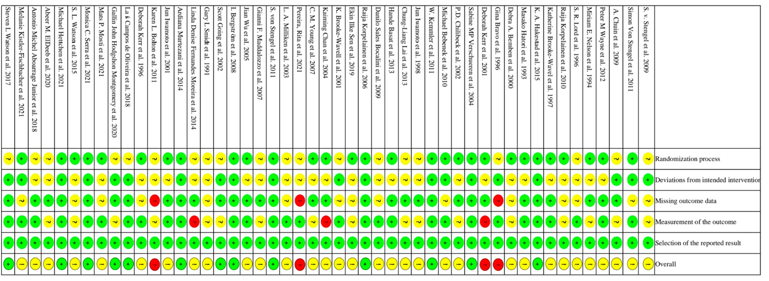

Supplementary 5：Grading the evidence for primary outcome of the network meta-analysis using CINeMA

5.1 Summary of study limitations of the included studies
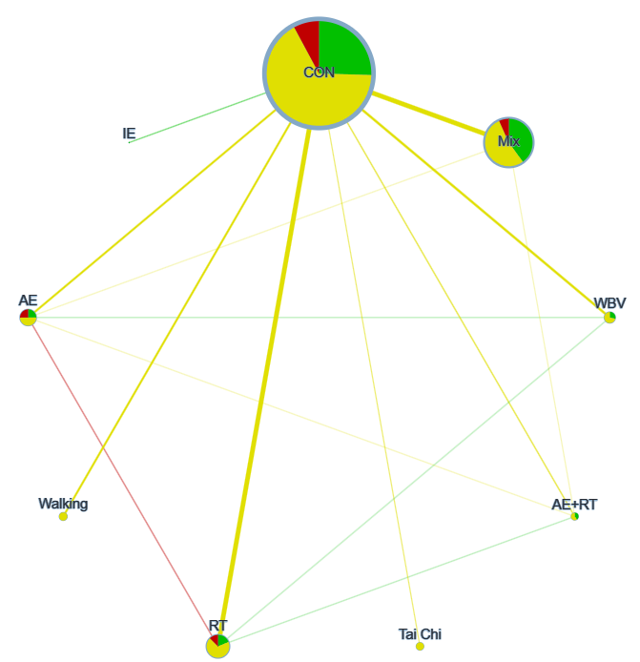
Figure 5.1.1: Network plot of study limitations of the included studies of lumbar vertebra . Node size by sample size, node color by RoB. The colors in the circles indicate the percentage of low RoB studies (green), moderate RoB studies (yellow), high RoB studies (red) about each physical activity type. Edge width by number of studies. Edge color by average RoB. The colors of the lines indicate the summative RoB assessment of each comparison. Low RoB is green, moderate RoB is yellow, high RoB is red. AE+RT Aerobic Mixed Resistance Exercise, WBV Whole Body Vibration, RT Resistance Training, Tai Chi Tai Chi exercise, AE Aerobic Exercise, MIX Mixed Exercise, IE Impact Exercise, Walking Walking Exercise.
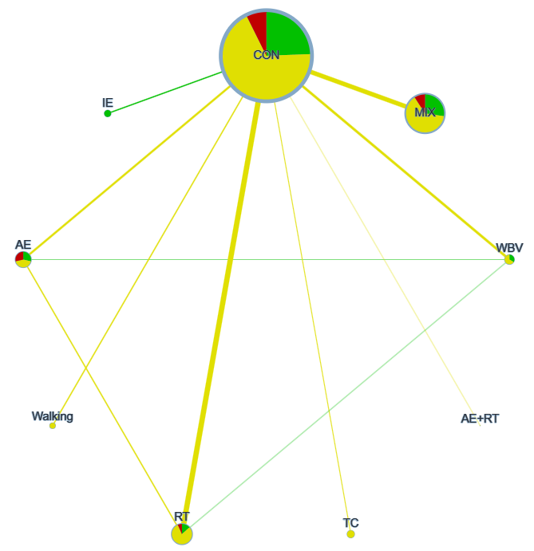
Figure 5.1.2 : Network plot of study limitations of the included studies of femoral neck . Node size by sample size, node color by RoB. The colors in the circles indicate the percentage of low RoB studies (green), moderate RoB studies (yellow), high RoB studies (red) about each physical activity type. Edge width by number of studies. Edge color by average RoB. The colors of the lines indicate the summative RoB assessment of each comparison. Low RoB is green, moderate RoB is yellow, high RoB is red. AE+RT Aerobic Mixed Resistance Exercise, WBV Whole Body Vibration, RT Resistance Training, Tai Chi Tai Chi exercise, AE Aerobic Exercise, MIX Mixed Exercise, IE Impact Exercise, Walking Walking Exercise.

5.2 Reasons for downgrading
Based on the recommendations of the CINeMA online document (https://cinema.ispm.unibe.ch/), we only graded the results of the bone density of lumbar vertebra, and judged whether each module needs to be downgraded according to the following criteria.

With-study bias
We classified an overall risk of bias for every study based on the individual risk of bias items.
The table below shows how the global rating is coded base on the individual items of the risk of bias tool:
Global rating | Items with high risk | Items with unclear risk
low risk | 0 | =< 3
moderate | 0 | < 3
moderate | 1 | any
high risk | >1 | any
Table 5.2: Global risk of bias rating based on the individual risk of bias items
Across-study bias (publication bias)
Our search was relatively comprehensive, including published and unpublished studies. Due to the language is not limited, Chinese studies were also included in the scope of our inclusion. Even if it is possible that we missed other small unpublished experiments, then it does not seem to affect our results. We evaluated the outcome of publication bias, and comparison-adjusted funnel plots for exercise types showed no evidence of asymmetry. Therefore, the outcome was deemed to have no publication bias.
Indirectness
We performed a point inconsistency test on the outcome measures by the SIDE test and found no significant differences. Therefore, no indirectness was assumed and no comparison was downgraded for this reason.
Imprecision
The outcome (bone density of lumbar vertebra) of this network meta-analysis is a continuous variable, and the effect size measure for continuous outcomes chooses the standardized mean difference (SMD) of the change score (end-point minus baseline score) because the studies use different rating scales or units. Therefore, for CON comparisons the clinically meaningful threshold was set at a standardized mean difference of higher or lower than 0, and for the comparisons of the two types of exercise, the threshold was set at SMD -0.1 and 0.1. If the confidence interval crossed one threshold, it will be downgraded by one level, and two thresholds will be downgraded by two levels.
Heterogeneity
For heterogeneity, we used the same threshold as the above clinically significant threshold and follow the recommendations automatically provided by CINeMA (https://cinema.ispm.unibe.ch/). No need to downgrade when the result was “no concerns”, downgrade one level when “some concerns” and downgrade two level when “major concerns”.
Incoherence
For incoherence, we will use global and local methods to test the inconsistency of the research results. For global inconsistency, we evaluated inconsistency statistically using the design-by-treatment test. In addition, we will assessment of local inconsistency by separating indirect from direct evidence (SIDE test) using the R netmeta package. No need to downgrade when p >0.1, downgrade one level when p was 0.05-0.1 and downgrade two level when p <0.05 .
Summarising judgments across the 6 domains
Τhe final output of CINeMA is a table with the level of concern for each of the 6 domains. we choose to summarise judgments across domains using the 4 levels of confidence of the GRADE approach: very low, low, moderate, or high.(Puhan et al., 2014) Due to factors that may reduce the confidence in a treatment effect may affect more than 1 domain. Indirectness includes consideration of intransitivity, which is manifested as statistical incoherence in the data. Heterogeneity will increase the imprecision of treatment effect, and may be related to the variability of bias within the study or the existence of reporting bias. In addition, in the presence of heterogeneity, the ability to detect important discontinuities will be reduced.(Veroniki, Mavridis, Higgins, & Salanti, 2014) Therefore, the 6 CINeMA domains should be considered jointly rather than in isolation to avoid downgrading the overall level of confidence more than once for related concerns.

5.3 CINeMA for the primary outcome
Table 5.3.1 CINeMA for the primary outcome “bone density of lumbar vertebra”
Comparison | Number of studies | Within-study bias | Reporting bias | Indirectness | Imprecision | Heterogeneity | Incoherence | Confidence rating | Reason(s) for downgrading
AE:AE+RT | 1 | Some concerns | Low risk | No concerns | Major concerns | No concerns | No concerns | Low | ["Within-study bias","Imprecision"]
AE:CON | 6 | Some concerns | Low risk | No concerns | No concerns | Major concerns | No concerns | Low | ["Within-study bias","Heterogeneity"]
AE:Mix | 1 | Some concerns | Low risk | No concerns | Major concerns | No concerns | No concerns | Low | ["Within-study bias","Imprecision"]
AE:RT | 2 | Some concerns | Low risk | No concerns | Major concerns | No concerns | No concerns | Low | ["Within-study bias","Imprecision"]
AE:WBV | 1 | Some concerns | Low risk | No concerns | Major concerns | No concerns | No concerns | Low | ["Within-study bias","Imprecision"]
AE+RT:CON | 3 | Some concerns | Low risk | No concerns | No concerns | Major concerns | No concerns | Low | ["Within-study bias","Heterogeneity"]
AE+RT:Mix | 1 | Some concerns | Low risk | No concerns | Major concerns | No concerns | No concerns | Low | ["Within-study bias","Imprecision"]
AE+RT:RT | 1 | Some concerns | Low risk | No concerns | Major concerns | No concerns | No concerns | Low | ["Within-study bias","Imprecision"]
CON:IE | 2 | No concerns | Low risk | No concerns | Major concerns | No concerns | No concerns | Low | ["Imprecision"]
CON:Mix | 14 | Some concerns | Low risk | No concerns | No concerns | Major concerns | No concerns | Low | ["Within-study bias","Heterogeneity"]
CON:RT | 14 | Some concerns | Low risk | No concerns | No concerns | Major concerns | No concerns | Low | ["Within-study bias","Heterogeneity"]
CON:Tai Chi | 2 | Some concerns | Low risk | No concerns | Major concerns | No concerns | No concerns | Low | ["Within-study bias","Imprecision"]
CON:WBV | 7 | Some concerns | Low risk | No concerns | Major concerns | No concerns | No concerns | Low | ["Within-study bias","Imprecision"]
CON:Walking | 6 | Some concerns | Low risk | No concerns | Major concerns | No concerns | No concerns | Low | ["Within-study bias","Imprecision"]
RT:WBV | 1 | Some concerns | Low risk | No concerns | Major concerns | No concerns | No concerns | Low | ["Within-study bias","Imprecision"]
AE:IE | 0 | Some concerns | Low risk | No concerns | Major concerns | No concerns | No concerns | Low | ["Within-study bias","Imprecision"]
AE:Tai Chi | 0 | Some concerns | Low risk | No concerns | Major concerns | No concerns | No concerns | Low | ["Within-study bias","Imprecision"]
AE:Walking | 0 | Some concerns | Low risk | No concerns | Major concerns | No concerns | No concerns | Low | ["Within-study bias","Imprecision"]
AE+RT:IE | 0 | No concerns | Low risk | No concerns | Major concerns | No concerns | No concerns | Low | ["Imprecision"]
AE+RT:Tai Chi | 0 | Some concerns | Low risk | No concerns | Major concerns | No concerns | No concerns | Low | ["Within-study bias","Imprecision"]
AE+RT:WBV | 0 | Some concerns | Low risk | No concerns | Major concerns | No concerns | No concerns | Low | ["Within-study bias","Imprecision"]
AE+RT:Walking | 0 | Some concerns | Low risk | No concerns | Major concerns | No concerns | No concerns | Low | ["Within-study bias","Imprecision"]
IE:Mix | 0 | No concerns | Low risk | No concerns | Major concerns | No concerns | No concerns | Low | ["Imprecision"]
IE:RT | 0 | Some concerns | Low risk | No concerns | Major concerns | No concerns | No concerns | Low | ["Within-study bias","Imprecision"]
IE:Tai Chi | 0 | Some concerns | Low risk | No concerns | Major concerns | No concerns | No concerns | Low | ["Within-study bias","Imprecision"]
IE:WBV | 0 | No concerns | Low risk | No concerns | Major concerns | No concerns | No concerns | Low | ["Imprecision"]
IE:Walking | 0 | Some concerns | Low risk | No concerns | Major concerns | No concerns | No concerns | Low | ["Within-study bias","Imprecision"]
Mix:RT | 0 | Some concerns | Low risk | No concerns | Major concerns | No concerns | No concerns | Low | ["Within-study bias","Imprecision"]
Mix:Tai Chi | 0 | Some concerns | Low risk | No concerns | Major concerns | No concerns | No concerns | Low | ["Within-study bias","Imprecision"]
Mix:WBV | 0 | Some concerns | Low risk | No concerns | Major concerns | No concerns | No concerns | Low | ["Within-study bias","Imprecision"]
Mix:Walking | 0 | Some concerns | Low risk | No concerns | Major concerns | No concerns | No concerns | Low | ["Within-study bias","Imprecision"]
RT:Tai Chi | 0 | Some concerns | Low risk | No concerns | Major concerns | No concerns | No concerns | Low | ["Within-study bias","Imprecision"]
RT:Walking | 0 | Some concerns | Low risk | No concerns | Major concerns | No concerns | No concerns | Low | ["Within-study bias","Imprecision"]
Tai Chi:WBV | 0 | Some concerns | Low risk | No concerns | Major concerns | No concerns | No concerns | Low | ["Within-study bias","Imprecision"]
Tai Chi:Walking | 0 | Some concerns | Low risk | No concerns | Major concerns | No concerns | No concerns | Low | ["Within-study bias","Imprecision"]
Walking:WBV | 0 | Some concerns | Low risk | No concerns | Major concerns | No concerns | No concerns | Low | ["Within-study bias","Imprecision"]

Table 5.3.2 CINeMA for the primary outcome “bone density of femoral neck”
Comparison | Number of studies | Within-study bias | Reporting bias | Indirectness | Imprecision | Heterogeneity | Incoherence | Confidence rating | Reason(s) for downgrading
AE:CON | 5 | Some concerns | Low risk | No concerns | Major concerns | No concerns | No concerns | Low | ["Within-study bias","Imprecision"]
AE:RT | 3 | Some concerns | Low risk | No concerns | Major concerns | No concerns | No concerns | Low | ["Within-study bias","Imprecision"]
AE:WBV | 1 | Some concerns | Low risk | No concerns | Major concerns | No concerns | No concerns | Low | ["Within-study bias","Imprecision"]
AE+RT:CON | 1 | Some concerns | Low risk | No concerns | Major concerns | No concerns | No concerns | Low | ["Within-study bias","Imprecision"]
CON:IE | 3 | No concerns | Low risk | No concerns | Major concerns | No concerns | No concerns | Low | ["Imprecision"]
CON:MIX | 11 | Some concerns | Low risk | No concerns | Major concerns | No concerns | No concerns | Low | ["Within-study bias","Imprecision"]
CON:RT | 13 | Some concerns | Low risk | No concerns | No concerns | Major concerns | No concerns | Low | ["Within-study bias","Heterogeneity"]
CON:TC | 2 | Some concerns | Low risk | No concerns | Major concerns | No concerns | No concerns | Low | ["Within-study bias","Imprecision"]
CON:WBV | 6 | Some concerns | Low risk | No concerns | Major concerns | No concerns | No concerns | Low | ["Within-study bias","Imprecision"]
CON:Walking | 3 | Some concerns | Low risk | No concerns | Major concerns | No concerns | No concerns | Low | ["Within-study bias","Imprecision"]
RT:WBV | 1 | Some concerns | Low risk | No concerns | Major concerns | No concerns | No concerns | Low | ["Within-study bias","Imprecision"]
AE:AE+RT | 0 | Some concerns | Low risk | No concerns | Major concerns | No concerns | No concerns | Low | ["Within-study bias","Imprecision"]
AE:IE | 0 | Some concerns | Low risk | No concerns | Major concerns | No concerns | No concerns | Low | ["Within-study bias","Imprecision"]
AE:MIX | 0 | Some concerns | Low risk | No concerns | Major concerns | No concerns | No concerns | Low | ["Within-study bias","Imprecision"]
AE:TC | 0 | Some concerns | Low risk | No concerns | Major concerns | No concerns | No concerns | Low | ["Within-study bias","Imprecision"]
AE:Walking | 0 | Some concerns | Low risk | No concerns | Major concerns | No concerns | No concerns | Low | ["Within-study bias","Imprecision"]
AE+RT:IE | 0 | Some concerns | Low risk | No concerns | Major concerns | No concerns | No concerns | Low | ["Within-study bias","Imprecision"]
AE+RT:MIX | 0 | Some concerns | Low risk | No concerns | Major concerns | No concerns | No concerns | Low | ["Within-study bias","Imprecision"]
AE+RT:RT | 0 | Some concerns | Low risk | No concerns | Major concerns | No concerns | No concerns | Low | ["Within-study bias","Imprecision"]
AE+RT:TC | 0 | Some concerns | Low risk | No concerns | Major concerns | No concerns | No concerns | Low | ["Within-study bias","Imprecision"]
AE+RT:WBV | 0 | Some concerns | Low risk | No concerns | Major concerns | No concerns | No concerns | Low | ["Within-study bias","Imprecision"]
AE+RT:Walking | 0 | Some concerns | Low risk | No concerns | Major concerns | No concerns | No concerns | Low | ["Within-study bias","Imprecision"]
IE:MIX | 0 | No concerns | Low risk | No concerns | Major concerns | No concerns | No concerns | Low | ["Imprecision"]
IE:RT | 0 | No concerns | Low risk | No concerns | Major concerns | No concerns | No concerns | Low | ["Imprecision"]
IE:TC | 0 | Some concerns | Low risk | No concerns | Major concerns | No concerns | No concerns | Low | ["Within-study bias","Imprecision"]
IE:WBV | 0 | No concerns | Low risk | No concerns | Major concerns | No concerns | No concerns | Low | ["Imprecision"]
IE:Walking | 0 | Some concerns | Low risk | No concerns | Major concerns | No concerns | No concerns | Low | ["Within-study bias","Imprecision"]
MIX:RT | 0 | Some concerns | Low risk | No concerns | Major concerns | No concerns | No concerns | Low | ["Within-study bias","Imprecision"]
MIX:TC | 0 | Some concerns | Low risk | No concerns | Major concerns | No concerns | No concerns | Low | ["Within-study bias","Imprecision"]
MIX:WBV | 0 | Some concerns | Low risk | No concerns | Major concerns | No concerns | No concerns | Low | ["Within-study bias","Imprecision"]
MIX:Walking | 0 | Some concerns | Low risk | No concerns | Major concerns | No concerns | No concerns | Low | ["Within-study bias","Imprecision"]
RT:TC | 0 | Some concerns | Low risk | No concerns | Major concerns | No concerns | No concerns | Low | ["Within-study bias","Imprecision"]
RT:Walking | 0 | Some concerns | Low risk | No concerns | Major concerns | No concerns | No concerns | Low | ["Within-study bias","Imprecision"]
TC:WBV | 0 | Some concerns | Low risk | No concerns | Major concerns | No concerns | No concerns | Low | ["Within-study bias","Imprecision"]
TC:Walking | 0 | Some concerns | Low risk | No concerns | Major concerns | No concerns | No concerns | Low | ["Within-study bias","Imprecision"]
Walking:WBV | 0 | Some concerns | Low risk | No concerns | Major concerns | No concerns | No concerns | Low | ["Within-study bias","Imprecision"]

Supplementary 6: Evaluation of inconsistency
Table 6.1 Details of SIDE splitting results of lumbar vertebra
Comparison | k | prop | NMA |  | direct |  | indir |  | diff |  | P
Comparison | k | prop | TE | seTE | TE | seTE | TE | seTE | TE | seTE | P
AE vs AE+RT | 1 | 0.041527 | -10.0237 | 14.51317 | 1 | 71.21948 | -10.5013 | 14.82423 | 11.5013 | 72.74595 | 0.874376
AE vs CON | 6 | 0.811714 | 22.32558 | 7.989983 | 21.93016 | 8.86838 | 24.03027 | 18.41354 | -2.10011 | 20.43787 | 0.918157
AE vs IE | 0 | 0 | 22.26758 | 51.50912 | NA | NA | 22.26758 | 51.50912 | NA | NA | NA
AE vs Mix | 1 | 0.021908 | 11.71394 | 9.617015 | 8 | 64.97322 | 11.79713 | 9.724125 | -3.79713 | 65.69687 | 0.95391
AE vs RT | 2 | 0.480736 | 5.947841 | 8.825393 | 0.55981 | 12.72861 | 10.93609 | 12.24728 | -10.3763 | 17.6639 | 0.556916
AE vs TC | 0 | 0 | 18.0455 | 21.03273 | NA | NA | 18.0455 | 21.03273 | NA | NA | NA
AE vs Walking | 0 | 0 | 16.21607 | 11.45259 | NA | NA | 16.21607 | 11.45259 | NA | NA | NA
AE vs WBV | 1 | 0.066548 | 5.157324 | 13.96454 | -10 | 54.13259 | 6.237927 | 14.45375 | -16.2379 | 56.02899 | 0.771959
AE+RT vs CON | 3 | 0.776732 | 32.34926 | 12.38332 | 25.99038 | 14.05081 | 54.4714 | 26.20742 | -28.481 | 29.73641 | 0.338172
AE+RT vs IE | 0 | 0 | 32.29126 | 52.37076 | NA | NA | 32.29126 | 52.37076 | NA | NA | NA
AE+RT vs Mix | 1 | 0.029532 | 21.73763 | 13.48788 | 7 | 78.48693 | 22.18611 | 13.69157 | -15.1861 | 79.67219 | 0.848833
AE+RT vs RT | 1 | 0.224192 | 15.97153 | 13.16339 | 43 | 27.80084 | 8.160891 | 14.94481 | 34.83911 | 31.56318 | 0.269684
AE+RT vs TC | 0 | 0 | 28.06918 | 23.06257 | NA | NA | 28.06918 | 23.06257 | NA | NA | NA
AE+RT vs Walking | 0 | 0 | 26.23975 | 14.85492 | NA | NA | 26.23975 | 14.85492 | NA | NA | NA
AE+RT vs WBV | 0 | 0 | 15.18101 | 16.95786 | NA | NA | 15.18101 | 16.95786 | NA | NA | NA
IE vs CON | 2 | 1 | 0.058002 | 50.88565 | 0.058002 | 50.88565 | NA | NA | NA | NA | NA
Mix vs CON | 14 | 0.992243 | 10.61163 | 5.418122 | 10.55528 | 5.439258 | 17.82043 | 61.5196 | -7.26515 | 61.75959 | 0.906356
RT vs CON | 14 | 0.895779 | 16.37774 | 5.790095 | 15.12033 | 6.117659 | 27.18513 | 17.93524 | -12.0648 | 18.9499 | 0.524341
TC vs CON | 2 | 1 | 4.28008 | 19.456 | 4.28008 | 19.456 | NA | NA | NA | NA | NA
Walking vs CON | 6 | 1 | 6.109511 | 8.204995 | 6.109511 | 8.204995 | NA | NA | NA | NA | NA
WBV vs CON | 7 | 0.966315 | 17.16825 | 11.6205 | 16.59661 | 11.8213 | 33.56718 | 63.31536 | -16.9706 | 64.40945 | 0.792181
IE vs Mix | 0 | 0 | -10.5536 | 51.17329 | NA | NA | -10.5536 | 51.17329 | NA | NA | NA
IE vs RT | 0 | 0 | -16.3197 | 51.21401 | NA | NA | -16.3197 | 51.21401 | NA | NA | NA
IE vs TC | 0 | 0 | -4.22208 | 54.4783 | NA | NA | -4.22208 | 54.4783 | NA | NA | NA
IE vs Walking | 0 | 0 | -6.05151 | 51.54291 | NA | NA | -6.05151 | 51.54291 | NA | NA | NA
IE vs WBV | 0 | 0 | -17.1103 | 52.19565 | NA | NA | -17.1103 | 52.19565 | NA | NA | NA
Mix vs RT | 0 | 0 | -5.7661 | 7.921019 | NA | NA | -5.7661 | 7.921019 | NA | NA | NA
Mix vs TC | 0 | 0 | 6.331554 | 20.19633 | NA | NA | 6.331554 | 20.19633 | NA | NA | NA
Mix vs Walking | 0 | 0 | 4.502123 | 9.832496 | NA | NA | 4.502123 | 9.832496 | NA | NA | NA
Mix vs WBV | 0 | 0 | -6.55662 | 12.82065 | NA | NA | -6.55662 | 12.82065 | NA | NA | NA
RT vs TC | 0 | 0 | 12.09766 | 20.29928 | NA | NA | 12.09766 | 20.29928 | NA | NA | NA
RT vs Walking | 0 | 0 | 10.26823 | 10.04227 | NA | NA | 10.26823 | 10.04227 | NA | NA | NA
RT vs WBV | 1 | 0.087892 | -0.79052 | 12.8391 | 4 | 43.30709 | -1.25214 | 13.44348 | 5.252141 | 45.34569 | 0.907792
TC vs Walking | 0 | 0 | -1.82943 | 21.11534 | NA | NA | -1.82943 | 21.11534 | NA | NA | NA
TC vs WBV | 0 | 0 | -12.8882 | 22.66212 | NA | NA | -12.8882 | 22.66212 | NA | NA | NA
Walking vs WBV | 0 | 0 | -11.0587 | 14.22525 | NA | NA | -11.0587 | 14.22525 | NA | NA | NA

Table 6.2 Details of SIDE splitting results of femoral neck
Comparison | k | prop | NMA |  | direct |  | indir |  | diff |  | P
Comparison | k | prop | TE | seTE | TE | seTE | TE | seTE | TE | seTE | P
AE vs AE+RT | 0 | 0 | -132.468 | 50.91798 | NA | NA | -132.468 | 50.91798 | NA | NA | NA
AE vs CON | 5 | 0.541811 | 7.532074 | 5.947249 | 3.155353 | 8.079644 | 12.70757 | 8.78605 | -9.55221 | 11.9363 | 0.423557
AE vs IE | 0 | 0 | 4.52546 | 12.16253 | NA | NA | 4.52546 | 12.16253 | NA | NA | NA
AE vs MIX | 0 | 0 | 2.296582 | 7.151514 | NA | NA | 2.296582 | 7.151514 | NA | NA | NA
AE vs RT | 3 | 0.79074 | -9.45169 | 5.525346 | -7.86145 | 6.21359 | -15.4608 | 12.0786 | 7.59937 | 13.58312 | 0.57584
AE vs TC | 0 | 0 | -1.61085 | 14.08333 | NA | NA | -1.61085 | 14.08333 | NA | NA | NA
AE vs Walking | 0 | 0 | 7.724908 | 10.20327 | NA | NA | 7.724908 | 10.20327 | NA | NA | NA
AE vs WBV | 1 | 0.104172 | -18.5338 | 13.02229 | 0 | 40.34715 | -20.689 | 13.75863 | 20.689 | 42.62853 | 0.627441
AE+RT vs CON | 1 | 1 | 140 | 50.56947 | 140 | 50.56947 | NA | NA | NA | NA | NA
AE+RT vs IE | 0 | 0 | 136.9934 | 51.67038 | NA | NA | 136.9934 | 51.67038 | NA | NA | NA
AE+RT vs MIX | 0 | 0 | 134.7645 | 50.7252 | NA | NA | 134.7645 | 50.7252 | NA | NA | NA
AE+RT vs RT | 0 | 0 | 123.0162 | 50.73425 | NA | NA | 123.0162 | 50.73425 | NA | NA | NA
AE+RT vs TC | 0 | 0 | 130.8571 | 52.15594 | NA | NA | 130.8571 | 52.15594 | NA | NA | NA
AE+RT vs Walking | 0 | 0 | 140.1928 | 51.24459 | NA | NA | 140.1928 | 51.24459 | NA | NA | NA
AE+RT vs WBV | 0 | 0 | 113.9341 | 51.92419 | NA | NA | 113.9341 | 51.92419 | NA | NA | NA
IE vs CON | 3 | 1 | 3.006614 | 10.6093 | 3.006614 | 10.6093 | NA | NA | NA | NA | NA
MIX vs CON | 11 | 1 | 5.235491 | 3.971698 | 5.235491 | 3.971698 | NA | NA | NA | NA | NA
RT vs CON | 13 | 0.917572 | 16.98376 | 4.085715 | 17.36731 | 4.265284 | 12.71423 | 14.23087 | 4.653073 | 14.85632 | 0.754125
TC vs CON | 2 | 1 | 9.142919 | 12.76598 | 9.142919 | 12.76598 | NA | NA | NA | NA | NA
Walking vs CON | 3 | 1 | -0.19283 | 8.290773 | -0.19283 | 8.290773 | NA | NA | NA | NA | NA
WBV vs CON | 6 | 0.955853 | 26.06586 | 11.78349 | 25.58815 | 12.05254 | 36.40914 | 56.08204 | -10.821 | 57.36252 | 0.850373
IE vs MIX | 0 | 0 | -2.22888 | 11.32836 | NA | NA | -2.22888 | 11.32836 | NA | NA | NA
IE vs RT | 0 | 0 | -13.9772 | 11.36883 | NA | NA | -13.9772 | 11.36883 | NA | NA | NA
IE vs TC | 0 | 0 | -6.1363 | 16.59903 | NA | NA | -6.1363 | 16.59903 | NA | NA | NA
IE vs Walking | 0 | 0 | 3.199448 | 13.46455 | NA | NA | 3.199448 | 13.46455 | NA | NA | NA
IE vs WBV | 0 | 0 | -23.0593 | 15.85585 | NA | NA | -23.0593 | 15.85585 | NA | NA | NA
MIX vs RT | 0 | 0 | -11.7483 | 5.698022 | NA | NA | -11.7483 | 5.698022 | NA | NA | NA
MIX vs TC | 0 | 0 | -3.90743 | 13.36954 | NA | NA | -3.90743 | 13.36954 | NA | NA | NA
MIX vs Walking | 0 | 0 | 5.428326 | 9.193003 | NA | NA | 5.428326 | 9.193003 | NA | NA | NA
MIX vs WBV | 0 | 0 | -20.8304 | 12.43483 | NA | NA | -20.8304 | 12.43483 | NA | NA | NA
RT vs TC | 0 | 0 | 7.840845 | 13.40386 | NA | NA | 7.840845 | 13.40386 | NA | NA | NA
RT vs Walking | 0 | 0 | 17.1766 | 9.242834 | NA | NA | 17.1766 | 9.242834 | NA | NA | NA
RT vs WBV | 1 | 0.125938 | -9.0821 | 12.33503 | -13 | 34.75852 | -8.51759 | 13.19378 | -4.48241 | 37.17836 | 0.904036
TC vs Walking | 0 | 0 | 9.335753 | 15.22193 | NA | NA | 9.335753 | 15.22193 | NA | NA | NA
TC vs WBV | 0 | 0 | -16.9229 | 17.373 | NA | NA | -16.9229 | 17.373 | NA | NA | NA
Walking vs WBV | 0 | 0 | -26.2587 | 14.4079 | NA | NA | -26.2587 | 14.4079 | NA | NA | NA
NA not available, k Number of studies providing direct evidence, prop Direct evidence proportion, NMA Estimated treatment effect (SMD) in network meta-analysis, direct Estimated treatment effect (SMD) derived from direct evidence, indir. Estimated treatment effect (SMD) derived from indirect evidence, Diff Difference between direct and indirect treatment estimates, p p-value of test for disagreement (direct versus indirect).

Supplementary 7: Assessment of the transitivity
Different clinical trials need to ensure that their baseline levels are consistent. If the baseline levels are inconsistent, the results cannot be transitive. Therefore, the transitivity assumption was evaluated by comparing the distribution of potential effect modifiers (publication year, sample size, mean age, and Exercise period) across studies grouped before analyzing the results, and we use the R ggplot2 package to draw boxplots between the above potential influencing factors and various types of exercise.

7.1 Publish years
We checked the publication year distribution of the included studies. The range is from 1993 to 2023, with a median of 2008. The results of one-way ANOVA showed that there was no statistical difference in the years of publication between the types of exercise. (F=1.72,P=0.0941)
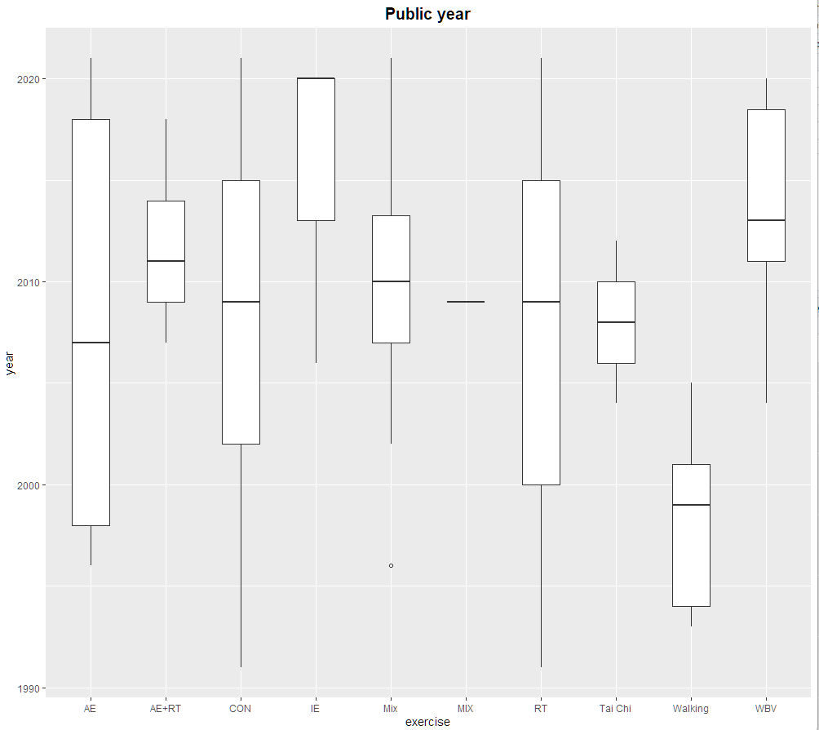
Figure 7.1: Boxplot for distribution of publication year. AE+RT Aerobic Mixed Resistance Exercise, WBV Whole Body Vibration, RT Resistance Training, TC Tai Chi, AE Aerobic Exercise, MIX Mixed Exercise, IE Impact Exercise, Walking Walking Exercise.

7.2 Mean age
We checked the mean age distribution of the included study participants. The range is from 54.96 to 66.7, with a median of 60.83. The results of one-way ANOVA showed that there was no statistical difference in the mean age between the types of exercise. (F=0.717,P=0.692)
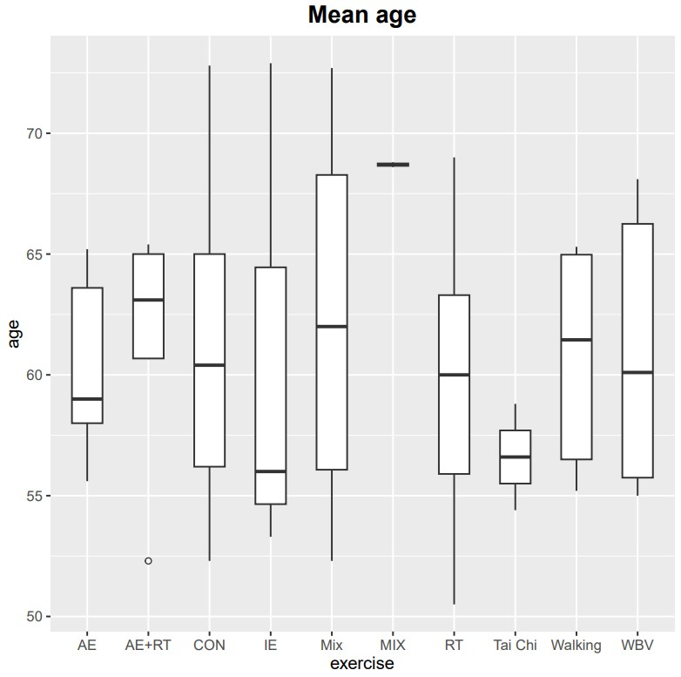
Figure 7.2: Boxplot for distribution of mean age. AE+RT Aerobic Mixed Resistance Exercise, WBV Whole Body Vibration, RT Resistance Training, TC Tai Chi, AE Aerobic Exercise, MIX Mixed Exercise, IE Impact Exercise, Walking Walking Exercise.

7.3 Sample size
We checked the sample size distribution of the included studies each arm. The range is from 7 to 84, with a median of 26.5. The results of the one-way ANOVA showed that there was statistical difference in the sample size between the types of exercise. Supplementary 11 performed sensitivity analysis for its significant transmission. (F=3.184,P=0.002**)
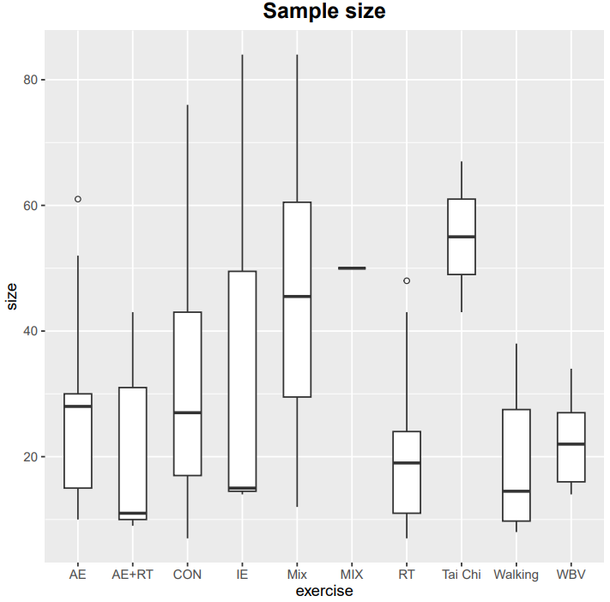
Figure 7.3: Boxplot for distribution of sample size. AE+RT Aerobic Mixed Resistance Exercise, WBV Whole Body Vibration, RT Resistance Training, TC Tai Chi, AE Aerobic Exercise, MIX Mixed Exercise, IE Impact Exercise, Walking Walking Exercise.

7.4 Exercise period
We checked the exercise period distribution of the included studies. The range is from 2 to 72, with a median of 37. The results of one-way ANOVA showed that there was statistical difference in the exercise period between the types of exercise. (F=0.739,P=0.672)
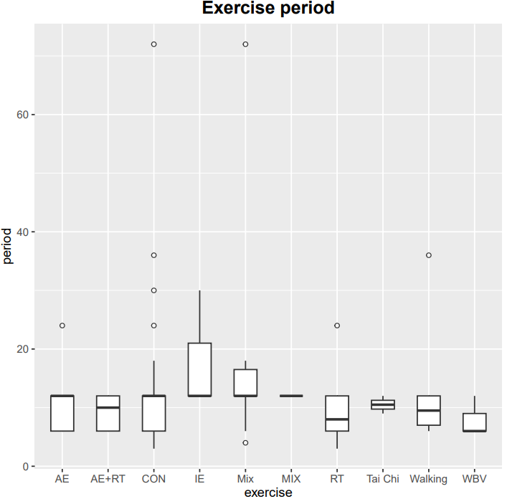
Figure 7.4: Boxplot for distribution of exercise period. AE+RT Aerobic Mixed Resistance Exercise, WBV Whole Body Vibration, RT Resistance Training, TC Tai Chi, AE Aerobic Exercise, MIX Mixed Exercise, IE Impact Exercise, Walking Walking Exercise.

Supplementary 8：Sensitivity analyses
We evaluated the sensitivity of our results by repeating each network meta-analysis after excluding studies with sample sizes less than 30.
Changes in heterogeneity
Below we present the results from the changes in heterogeneity in each sensitivity analysis.
Including only studies with | Number of studies included | τ | % of variance explained
None | - | 0.013 | -
studies at overall low risk of bias | 45 | 0.008 | 2.5%
Sample size ≥30 | 20 | 0.005 | -63.08%

8.1 Exclude studies with high risk of bias
After excluding studies with high risk of bias，the hierarchy did not change significantly.
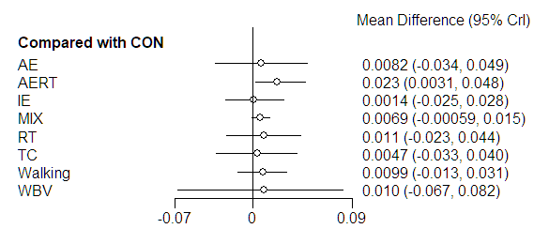
Figure 8.1: Forest plot of studies at overall low risk of bias. Treatments are ranked according to MD compared to CON. Treatments crossing the y-axis are not significantly different from CON. MD Mean Difference, CrI Credible Interval, AERT Aerobic Mixed Resistance Exercise, WBV Whole Body Vibration, RT Resistance Training, TC Tai Chi, AE Aerobic Exercise, MIX Mixed Exercise, IE Impact Exercise, Walking Walking Exercise.

8.2 Exclude studies with sample size of less than 30
After excluding studies with sample size of less than 30,the hierarchy did not change significantly.
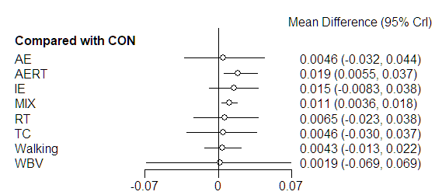
Figure 8.2: Forest plot of sample size ≥30. Treatments are ranked according to MD compared to CON. Treatments crossing the y-axis are not significantly different from CON. MD Mean Difference, CrI Credible Interval, AERT Aerobic Mixed Resistance Exercise, WBV Whole Body Vibration, RT Resistance Training, TC Tai Chi, AE Aerobic Exercise, MIX Mixed Exercise, IE Impact Exercise, Walking Walking Exercise.

Supplementary 9: Publication bias
As shown in the figure below, the funnel plot had good symmetry, and the linear fitting line (green) is not perpendicular to the 0 quadrant, and the result of Egger test showed the p=0.541. Therefore, no small study effect was found for the primary outcome.
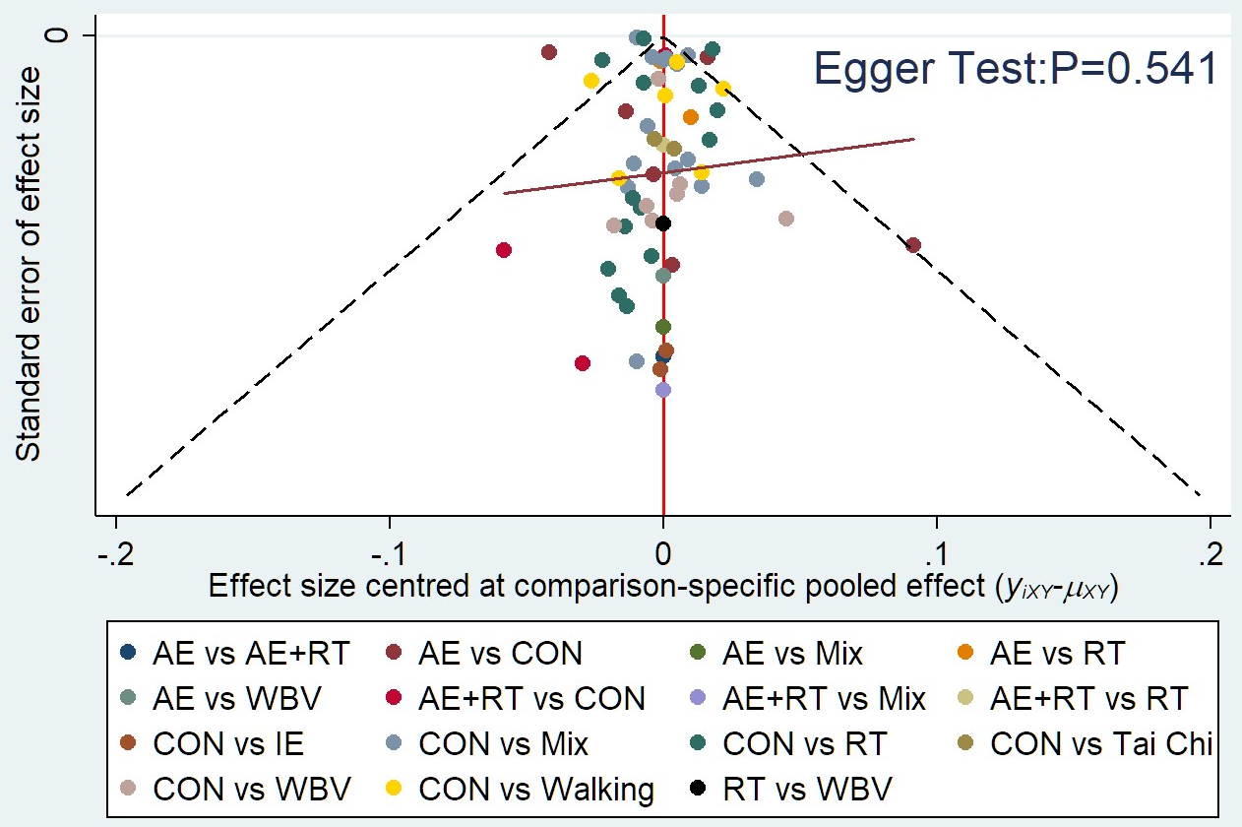
Figure 9.1 The funnel plot of change of lumbar vertebra. AE+RT Aerobic Mixed Resistance Exercise, WBV Whole Body Vibration, RT Resistance Training, TC Tai Chi, AE Aerobic Exercise, MIX Mixed Exercise, IE Impact Exercise, Walking Walking Exercise.

As shown in the figure below, the funnel plot had good symmetry, and the linear fitting line is not perpendicular to the 0 quadrant, and the result of Egger test showed the p=0.119. Therefore, no small study effect was found for the primary outcome.
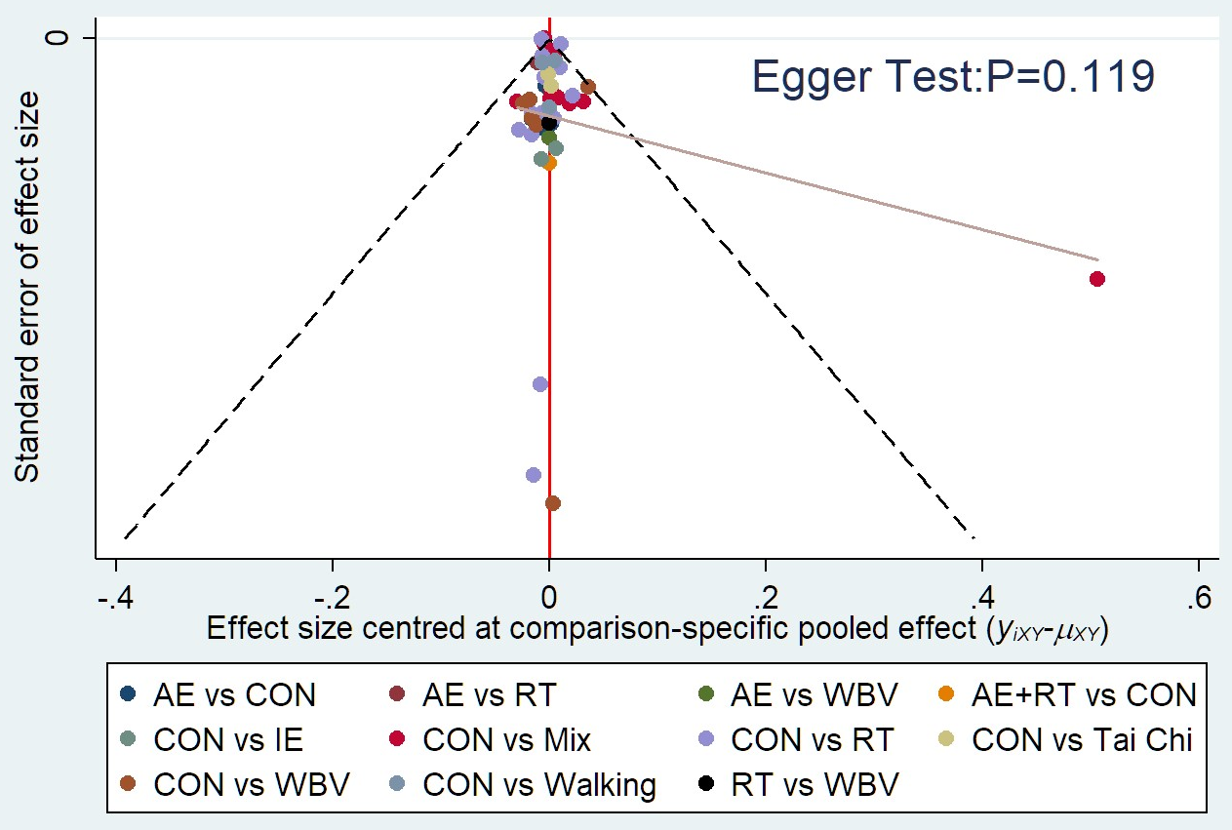
Figure 9.2 The funnel plot of change of femoral neck. AE+RT Aerobic Mixed Resistance Exercise, WBV Whole Body Vibration, RT Resistance Training, TC Tai Chi, AE Aerobic Exercise, MIX Mixed Exercise, IE Impact Exercise, Walking Walking Exercise.

Supplementary 10: The list for the included studies
- von Stengel S, Kemmler W, Mayer S, Engelke K, Klarner A, Kalender WA. [Effect of whole body vibration exercise on osteoporotic risk factors]. Dtsch Med Wochenschr. Jul 2009;134(30):1511-6. Effekte eines Ganzkorpervibrationstrainings auf Parameter des Frakturrisikos.
- Von Stengel S, Kemmler W, Bebenek M, Engelke K, Kalender WA. Effects of whole-body vibration training on different devices on bone mineral density. Med Sci Sports Exerc. Jun 2011;43(6):1071-9.
- Chuin A, Labonte M, Tessier D, et al. Effect of antioxidants combined to resistance training on BMD in elderly women: a pilot study. Osteoporos Int. Jul 2009;20(7):1253-8.
- Wayne PM, Kiel DP, Buring JE, et al. Impact of Tai Chi exercise on multiple fracture-related risk factors in post-menopausal osteopenic women: a pilot pragmatic, randomized trial. Article. Bmc Complementary and Alternative Medicine. Jan 30 2012;127.
- Nelson ME, Fiatarone MA, Morganti CM, Trice I, Greenberg RA, Evans WJ. Effects of high-intensity strength training on multiple risk factors for osteoporotic fractures. A randomized controlled trial. Clinical Trial; ; Randomized Controlled Trial; Research Support, U.S. Gov't, Non-P.H.S.; Research Support, U.S. Gov't, P.H.S. Jama. 1994-Dec-28 1994;272(24):1909-14.
- Zivanovic SRLJAWPWE. The Effects of a Community Exercise Program on Fracture Risk Factors in Older Women. article. Osteonorosi International. Oct 1996;27(10):2879-2886.
- Korpelainen R, Keinänen-Kiukaanniemi S, Nieminen P, Heikkinen J, Väänänen K, Korpelainen J. Long-term Outcomes of Exercise Follow-up of a Randomized Trial in Older Women With Osteopenia. ARCH INTERN MED. SEP 27 2010;170(17):1548-1556.
- BROOKE-WAVELL K, JONES PRM, HARDMAN AE. Brisk walking reduces calcaneal bone loss in post-menopausal women. Clinical Science. 1997;92:75-80.
- Hakestad KA, Torstveit MK, Nordsletten L, Risberg MA. Effect of exercises with weight vests and a patient education programme for women with osteopenia and a healed wrist fracture: a randomized, controlled trial of the OsteoACTIVE programme. BMC Musculoskelet Disord. Nov 14 2015;16:352.
- Hatori M, Hasegawa A, Adachi H, et al. The Effects of Walking at the Anaerobic Threshold Level on Vertebral Bone Loss in Postmenopausal Women. Calcified Tissue International. 1993;(52):411-414.
- Bemben DA, Fetters NL, Bemben MG, Nabavi N, Koh ET. Musculoskeletal responses to high- and low-intensity resistance training in early postmenopausal women. Article. Medicine and Science in Sports and Exercise. Nov 2000;32(11):1949-1957.
- Bravo G, Gauthier P, Roy PM, et al. Impact of a 12-month exercise program on the physical and psychological health of osteopenic women. Clinical Trial; Comparative Study; ; Randomized Controlled Trial; Research Support, Non-U.S. Gov't. Journal of the American Geriatrics Society. 1996-Jul 1996;44(7):756-62.
- Kerr D, Ackland T, Maslen B, Morton A, Prince R. Resistance training over 2 years increases bone mass in calcium-replete postmenopausal women. Article. Journal of Bone and Mineral Research. Jan 2001;16(1):175-181.
- Verschueren SM, Roelants M, Delecluse C, Swinnen S, Vanderschueren D, Boonen S. Effect of 6-month whole body vibration training on hip density, muscle strength, and postural control in postmenopausal women: a randomized controlled pilot study. J Bone Miner Res. Mar 2004;19(3):352-9.
- Chilibeck PD, Davison KS, Whiting SJ, Suzuki Y, Janzen CL, Peloso P. The effect of strength training combined with bisphosphonate (etidronate) therapy on bone mineral, lean tissue, and fat mass in postmenopausal women. Can J Physiol Pharmacol. Oct 2002;80(10):941-50.
- Bebenek M, Kemmler W, von Stengel S, Engelke K, Kalender WA. Effect of exercise and Cimicifuga racemosa (CR BNO 1055) on bone mineral density, 10-year coronary heart disease risk, and menopausal complaints: the randomized controlled Training and Cimicifuga racemosa Erlangen (TRACE) study. Menopause. Jul 2010;17(4):791-800.
- Kemmler W, Bebenek M, von Stengel S, Engelke K, Kalender WA. Effect of block-periodized exercise training on bone and coronary heart disease risk factors in early post-menopausal women: a randomized controlled study. Scand J Med Sci Sports. Feb 2013;23(1):121-9.
- Iwamoto J, Takeda T, Otani T, Yabe Y. Effect of increased physical activity on bone mineral density in postmenopausal osteoporotic women. Clinical Trial; Controlled Clinical Trial; ; Research Support, Non-U.S. Gov't. The Keio journal of medicine. 1998-Sep 1998;47(3):157-61.
- Lai CL, Tseng SY, Chen CN, et al. Effect of 6 months of whole body vibration on lumbar spine bone density in postmenopausal women: a randomized controlled trial. Clin Interv Aging. 2013;8:1603-9.
- Basat H, Esmaeilzadeh S, Eskiyurt N. The effects of strengthening and high-impact exercises on bone metabolism and quality of life in postmenopausal women: a randomized controlled trial. J Back Musculoskelet Rehabil. 2013;26(4):427-35.
- Bocalini DS, Serra AJ, dos Santos L, Murad N, Levy RF. Strength Training Preserves the Bone Mineral Density of Postmenopausal Women Without Hormone Replacement Therapy. Article. Journal of Aging and Health. Jun 2009;21(3):519-527.
- Korpelainen R, Keinanen-Kiukaanniemi S, Heikkinen J, Vaananen K, Korpelainen J. Effect of impact exercise on bone mineral density in elderly women with low BMD: a population-based randomized controlled 30-month intervention. Osteoporos Int. Jan 2006;17(1):109-18.
- Sen EI, Esmaeilzadeh S, Eskiyurt N. Effects of whole-body vibration and high impact exercises on the bone metabolism and functional mobility in postmenopausal women. J Bone Miner Metab. May 2020;38(3):392-404.
- Brooke-Wavell K, Jones PRM, Hardman AE, Tsuritani I, Yamada Y. Commencing, continuing and stopping brisk walking: Effects on bone mineral density, quantitative ultrasound of bone and markers of bone metabolism in postmenopausal women. Article. Osteoporosis International. 2001 2001;12(7):581-587.
- Chan KM, Qin L, Lau MC, et al. A randomized, prospective study of the effects of Tai Chi Chun exercise on bone mineral density in postmenopausal women. Article. Archives of Physical Medicine and Rehabilitation. May 2004;85(5):717-722.
- Young CM, Weeks BK, Beck BR. Simple, novel physical activity maintains proximal femur bone mineral density, and improves muscle strength and balance in sedentary, postmenopausal Caucasian women. Osteoporos Int. Oct 2007;18(10):1379-87.
- Pereira R, Krustrup P, Castagna C, et al. Effects of recreational team handball on bone health, postural balance and body composition in inactive postmenopausal women - A randomised controlled trial. Bone. Apr 2021;145:115847.
- Milliken LA, Going SB, Houtkooper LB, et al. Effects of exercise training on bone remodeling, insulin-like growth factors, and bone mineral density in postmenopausal women with and without hormone replacement therapy. Calcif Tissue Int. Apr 2003;72(4):478-84.
- von Stengel S, Kemmler W, Engelke K, Kalender WA. Effects of whole body vibration on bone mineral density and falls: results of the randomized controlled ELVIS study with postmenopausal women. Osteoporos Int. Jan 2011;22(1):317-25.
- Maddalozzo GF, Widrick JJ, Cardinal BJ, Winters-Stone KM, Hoffman MA, Snow CM. The effects of hormone replacement therapy and resistance training on spine bone mineral density in early postmenopausal women. Bone. May 2007;40(5):1244-51.
- Wu J, Oka J, Higuchi M, et al. Cooperative effects of isoflavones and exercise on bone and lipid metabolism in postmenopausal Japanese women: a randomized placebo-controlled trial. Metabolism. Apr 2006;55(4):423-33.
- Bergstrom I, Landgren B, Brinck J, Freyschuss B. Physical training preserves bone mineral density in postmenopausal women with forearm fractures and low bone mineral density. Osteoporos Int. Feb 2008;19(2):177-83.
- Going S, Lohman T, Houtkooper L, et al. Effects of exercise on bone mineral density in calcium-replete postmenopausal women with and without hormone replacement therapy. Osteoporos Int. Aug 2003;14(8):637-43.
- SMIDT GL, LIN S-Y, O'DWYER KD, BLANPIED PR. The Effect of High-Intensity Trunk Exercise on Bone Mineral Density of Postmenopausal Women. ASIAN SPINE JOURNAL. 1992;17(3):280-285.
- Moreira LD, Fronza FC, Dos Santos RN, et al. The benefits of a high-intensity aquatic exercise program (HydrOS) for bone metabolism and bone mass of postmenopausal women. J Bone Miner Metab. Jul 2014;32(4):411-9.
- Murtezani A, Nevzati A, Ibraimi Z, Sllamniku S, Meka VS, Abazi N. The effect of land versus aquatic exercise program on bone mineral density and physical function in postmenopausal women with osteoporosis: a randomized controlled trial. Ortop Traumatol Rehabil. May-Jun 2014;16(3):319-25.
- Iwamoto J, Takeda T, Ichimura S. Effect of exercise training and detraining on bone mineral density in postmenopausal women with osteoporosis. Orthopaedic Science. May 6 2001;(6):128-132.
- Bolton KL, Egerton T, Wark J, et al. Effects of exercise on bone density and falls risk factors in post-menopausal women with osteopenia: a randomised controlled trial. J Sci Med Sport. Mar 2012;15(2):102-9.
- PRINCE DKAMIDR. Exercise Effects on Bone Mass in Postmenopausal Women Are Site-Specific and Load-Dependent. JOURNAL OF BONE AND MINERAL RESEARCH December 11 1996;11(2):218-225.
- de Oliveira LC, de Oliveira RG, de Almeida Pires-Oliveira DA. Effects of Whole-Body Vibration Versus Pilates Exercise on Bone Mineral Density in Postmenopausal Women: A Randomized and Controlled Clinical Trial. J Geriatr Phys Ther. Apr/Jun 2019;42(2):E23-E31.
- Montgomery GJ, Abt G, Dobson CA, Evans WJ, Aye M, Ditroilo M. A 12-month continuous and intermittent high-impact exercise intervention and its effects on bone mineral density in early postmenopausal women: a feasibility randomized controlled trial. J Sports Med Phys Fitness. May 2020;60(5):770-778.
- Mosti MP, Kaehler N, Stunes AK, Hoff J, Syversen U. MAXIMAL STRENGTH TRAINING IN POSTMENOPAUSAL WOMEN WITH OSTEOPOROSIS OR OSTEOPENIA. Article. Journal of Strength and Conditioning Research. Oct 2013;27(10):2879-2886.
- Serra MC, Ryan AS. Bone Mineral Density Changes during Weight Regain following Weight Loss with and without Exercise. Nutrients. Aug 19 2021;13(8)
- Watson SL, Weeks BK, Weis LJ, Horan SA, Beck BR. Heavy resistance training is safe and improves bone, function, and stature in postmenopausal women with low to very low bone mass: novel early findings from the LIFTMOR trial. Osteoporos Int. Dec 2015;26(12):2889-94.
- Hettchen M, von Stengel S, Kohl M, et al. Changes in Menopausal Risk Factors in Early Postmenopausal Osteopenic Women After 13 Months of High-Intensity Exercise: The Randomized Controlled ACTLIFE-RCT. Clin Interv Aging. 2021;16:83-96.
- ElDeeb AM, Abdel-Aziem AA. Effect of Whole-Body Vibration Exercise on Power Profile and Bone Mineral Density in Postmenopausal Women With Osteoporosis: A Randomized Controlled Trial. J Manipulative Physiol Ther. May 2020;43(4):384-393.
- Aboarrage Junior AM, Teixeira CVS, Dos Santos RN, et al. A High-Intensity Jump-Based Aquatic Exercise Program Improves Bone Mineral Density and Functional Fitness in Postmenopausal Women. Rejuvenation Res. Dec 2018;21(6):535-540.
- Kistler-Fischbacher M, Yong JS, Weeks BK, Beck BR. A Comparison of Bone-Targeted Exercise With and Without Antiresorptive Bone Medication to Reduce Indices of Fracture Risk in Postmenopausal Women With Low Bone Mass: The MEDEX-OP Randomized Controlled Trial. J Bone Miner Res. Sep 2021;36(9):1680-1693.
- Watson SL, Weeks BK, Weis LJ, Harding AT, Horan SA, Beck BR. High-Intensity Resistance and Impact Training Improves Bone Mineral Density and Physical Function in Postmenopausal Women With Osteopenia and Osteoporosis: The LIFTMOR Randomized Controlled Trial. J Bone Miner Res. Feb 2018;33(2):211-220.

Supplementary 11: Study Characteristics
Author | year | Sample size(n) | Age(years) | Menopausal age/Duration of menopause(years) | Type and specifications of the exercise content | Duration  (months) | Motor frequency | Session Duration(mins) | Exercise Intensity
S. v. Stengel et al. | 2009 | Mix：50  Mix：50  CON：51 | Mix：68.8±3.6  Mix：68.6±3.0  CON：68.1±2.7 | Mix：49.9±6.1  Mix：48.4±6.2  CON：50.8±5.2 | Mix：AE、BT、ST；Functional strength training(Vibrating platform)  Mix：AE、BT、ST；Functional strength training  CON：gemnastics、relaxing exercise | 12 months | Mix：2/week  CON：1/week | Mix (60mins)  CON(60mins) | NA
Simon Von Stengel et al. | 2011 | WBV：34  WBV：29  CON：33 | WBV：68.1±4.0  WBV：67.9±3.8  CON：67.6±4.1 | WBV：49.6±5.4  WBV：48.8±5.6  CON：49.8±5.3 | WBV：leg strengthening exercises(vibration plate , 35Hz，1.7mm)  WBV：leg strengthening exercises(vibration plate ，12.5Hz，12mm)  CON：Light physical exercises , Relaxation exercises | 12 months | WBV：3/week  CON：2/week | WBV：15mins | NA
A. Chuin et al. | 2009 | AE+RT：11  CON：7 | AE+RT：65.4±3.5  CON：67.4±3.8 | NA | AE+RT：Static drawing(treadmill or cycle ergometer)、 Resistance training (large and small muscle groups) | 6 months | AE+RT：3/week | AE+RT：60 mins | AE+RT：3 sets of 8 reps (1 RM)
Peter M Wayne et al. | 2012 | Tai Chi：43  CON：43 | Tai Chi：58.8 ± 5.6  CON：60.4 ± 5.3 | duration of menopause ≥12 months | Tai Chi：Tai Chi exercise | 9 months | Tai Chi:(1)first month：2/week class+2/week extra training  (2)thereafter：1/week class+3/week extra training | (1)first month：minimum class duration of 60mins  (2)thereafter：minimum of 30mins | Tai Chi training a total of 99.5 hours over the 9 month interventions
Miriam E. Nelson et al. | 1994 | RT：20  CON：19 | RT：61.1±3.7  CON：57.3±6.3 | duration of menopause：  RT：11.6±5.0  CON：9.8±4.6 | RT：high-intensity strength training(including concentric and eccentric contractions)  CON：maintain their current level of physical activity | 12 months | RT：2/week | NA | RT：80% of the maximum(1RM) for each muscle group
S. R. Lord et al. | 1996 | Mix：68  CON：70 | Mix：71.7±5.4  CON：71.5±5.3 | NA | Mix：aerobic exercise、activities for balance ，hand-eye and foot-eye coordination，strengthening exercises、Stretching  CON：no organized activity | 12 months | Mix：2/week | Mix：60 mins | NA
Raija Korpelainen et al. | 2010 | Mix：84  CON：76 | Mix：72.7±1.1  CON：72.6±1.2 | NA | Mix：balance、leg strength、impact training  CON：daily routine activities | 72 months | Mix:1/week+everyday training | Mix：20 mins  (training at home) | NA
Katherine Brooke-Wavel et al. | 1997 | Walking：38  CON：40 | Walking:64.9±3.0  CON：64.2±3.1 | duration of menopause:  Walking:15.1±5.5  CON:14.6±6.6 | Walking：Walking | 12 months | Walking：everyday | Walking：20-50 mins | NA
K. A. Hakestad et al. | 2015 | Mix：31  CON：33 | Mix： 65.5 ± 7.1  CON：63.9 ± 7.1 | duration of menopause:  Mix： 16.7 ± 8.7  CON：13.6 ± 8.3 | Mix：strength、balance、coordination and core stability exercises | 12 months | Mix：3/week | Mix：60 mins | NA
Masako Hatori et al. | 1993 | CON：12  Walking：9  Walking：12 | CON：58±8  Walking：58±5  Walking：56±4 | duration of menopause：  CON：8.9±7.6  Walking: 5.8±4.3  Walking: 7.5±4.8 | Walking：stretching exercise(legs，torso，arms)、walking  Walking：stretching exercise(legs，torso，arms)、walking | 7 months | 3/week | 30mins of walking | Walking：90% of the heart rate at the AT  Walking：110% of the heart rate at the AT
Debra A. Bemben et al. | 2000 | RT：10  RT：7  CON：8 | RT：50.5±2.0  RT：51.9±2.3  CON：52.3±1.4 | duration of menopause:  RT：3.6±0.7  RT：2.4±0.7  CON：3.0±0.7 | NA | 6 months | 3/week | 60 mins | RT：8 repetitions of each exercise，at an intensity of 80% of 1RM  RT：16 repetitions of each exercise，at 40% of 1RM
Gina Bravo et al. | 1996 | AE：61  CON：63 | AE：59.6±5.82  CON：59.9±6.36 | duration of menopause:  AE:12.4±8.91  CON:18.6±13.20 | AE：weight training(rapid walking、stepping up and down from benches)aerobic dance、flexibility exercises | 12 months | 3/week | 60 mins | AE： reach 60 to 70% of her heart rate
Deborah Kerr et al. | 2001 | RT：24  AE：30  CON：36 | RT：60±5  AE：59±5  CON：62±6 | duration of menopause:  RT：11±6  AE：9±5  CON：12±6 | RT：brisk walking、stretching and resistance weight training+loading  AE：brisk walking、stretching and resistance weight training+bicycle riding | 24 months | 3/week | 60 mins | RT： increased their load，three sets of eight repetitions (3 * 8 RM)  AE：heart rate less than 150 beats/minute
Sabine MP Verschueren et al. | 2004 | WBV：25  RT：22  CON：24 | WBV：64.6±3.3  RT：63.90±3.8  CON：64.2±3.1 | duration of menopause:  WBV：16.9±6.3  RT：15.5±6.0  CON：14.6±6.6 | WBV：static and dynamic knee-extensor exercises(vibration platform)  RT：standardized warm-up，resistance training for knee(leg extension and aleg press machine) | 6 months | 3/week | WBV：max of 30 mins  RT：60 mins | RT：first 14 weeks ：2sets/20RM-2sets/15RM-2sets/12RM-2sets/10RM-2sets/8RM  last 10 weeks：between 3 sets/12RM and 1set/8RM
P.D. Chilibeck et al. | 2002 | RT：10  CON：12 | RT：56.8±2.0  CON：58.8±1.8 | duration of menopause:  RT：8.6±2.2  CON：8.3±1.7 | Strength training | 12 months | 3/w | NA | strength training：2 sets/8-10 reps，first 2 weeks at 70% of onerepetition maximum for the bench press and leg press
Michael Bebenek et al. | 2010 | Mix：43  CON：42 | Mix：52.3±2.3  CON：52.4±2.7 | duration of menopause:  Mix：13.4±1.1  CON：13.1±1.2 | Mix：endurance block：Nordic walking/aerobic dance，step aerobics，aerobic/resistance(high-impact aerobics、functional gymnastics、isometric strength training、stretching sequences、 isometric floor exercises)，dynamic exercises  EG：low-frequency/low intensity exercises | 12 months | Mix：3/week  CON：1/w | 60mins | Mix：(1)Nordic walking at 65% to 75% maximum heart rate，replaced by 60 minutes of aerobic dance performed with corresponding exercise intensity (70%-80%Hrmax)  (2)step aerobics at 75% to 85% Hrmax  (3)aerobic/resistance：at 75% to 85% Hrmax  CON：warm-up： at 50% to 60% HRmax
W. Kemmler et al. | 2011 | AE+RT：43  CON：42 | AE+RT：52.3±2.3  CON：52.4±2.7 | duration of menopause: AE+RT：2.0±0.7  CON：2.1±0.6 | AE+RT:bone block:high-impact、aerobic dance，high impact /step aerobic exercises，resistance、sequence(functional gymnastics)，dynamic resistance training  metabolic block:moderate intensity/moderate volume exercise(Nordic Walking，low-impact step aerobics，aerobic/resistance sessions) | 12 months | AE+RT：1/week  CON：1/week | AE+RT：45-60 mins  CON：60 mins | AE+RT：high-impact aerobic dance:75–85% Hrmax  Nordic Walking:65–75% Hrmax  flow-impact step aerobics：75–85% Hrmax  aerobic/resistance：55–60% 1 RM  CON：65% HRmax
Jun Iwamoto et al. | 1998 | AE：15  CON：20 | AE：64.8±6.1  CON：64.8±5.7 | duration of menopause:  AE：15.5±7.4  CON：14.8±6.4 | AE：walking，gymnastic training | 12 months | AE：walking：everyday  gymnastic training：2 sets/day | NA | NA
Chung-Liang Lai et al. | 2013 | WBV：14  CON：14 | WBV：60.1±7.1  CON：62.4±7.1 | duration of menopause: WBV：9.8±8.7  CON：10.6±6.9 | WBV：vibration exercise(vibration platform) | 6 months | WBV：3/week | WBV：5 mins | frequency of 30 Hz，magnitude of 3.2 g
Hande Basat et al. | 2013 | RT：11  AE：12  CON：12 | RT：55.9±4.9  AE：55.6±2.9  CON：56.2±4.0 | duration of menopause:  RT：6.0±3.6  AE：6.5±2.0  CON：6.2±3.3 | RT：Abdominal isometrics，Hip extensor, flexor, abductor and adductor isometrics，Knee extensor and flexor isometrics，push-up，cat-camel  AE：jump rope | 6 months | 3/week | 60 mins | NA
Danilo Sales Bocalini et al. | 2009 | CON：10  RT：15 | CON：67±8  RT：69±9 | NA | Strength Training | 6 months | 3/week | 60 mins | warm-up：50% of maximum heart rate，  one set at 50% of 1RM，increase load achieved three sets of 10 maximal repetitions for given  exercise at 85% of 1RM
Raija Korpelainen et al. | 2006 | IE：84  CON：76 | IE：72.9±1.1  CON：72.8±1.2 | NA | IE：long-term impact exercise(jumping and balance exercise) | 36months，6months/year | NA | exercise classes：45 mins  thereafter：20 mins | NA
Ekin Ilke Sen et al. | 2019 | WBV：15  RT：16  CON：18 | WBV：55.0±4.6  RT：53.1±4.4  CON：54.5±6.0 | duration of menopause:  WBV：8.0±4.1  RT：7.7±5.3  CON：9.3±4.0 | WBV：posture and stretching, back extensor, knee extensor, and hip abductor, fexor, and extensor muscle strengthening exercises、vibration stimulus  HI： posture and stretching, back extensor, knee extensor, and hip abductor, fexor, and extensor muscle strengthening exercises | 6 months | 3/week | 20-60 mins/sets | NA
K. Brooke-Wavell et al. | 2001 | CON:20  Walking:17 | CON：65.0±2.7  Walking：65.0±3.2 | duration of menopause:＞5 years | Walking：brisk walk | 12 months | Walking：least 3 brisk walks/week | Walking：280 mins/2 weeks | NA
Kaiming Chan et al. | 2004 | Tai Chi：67  CON：65 | Tai Chi：54.4±3.3  CON：53.6±3.2 | duration of menopause:  Tai Chi：4.9±2.5  CON：4.5±2.4 | Tai Chi：Tai Chi exercise (Yang style)  CON：retained sedentary lifestyle | 12 months | 5/week | 50 mins | NA
C. M. Young et al. | 2007 | AE：10  AE+RT：9  Mix：12 | AE：65.2±7.7  AE+RT: 63.1±4.6  Mix：65.1±7.6 | duration of menopause:  AE：16.1±4.9  AE+RT: 11.8±8.3  Mix：14.9±9.2 | AE：Line dancing  AE+RT：Line dancing，Muscle strengthening  Mix：Line dancing，Muscle strengthening，Stamping | 12 months | AE：1/w  AE+RT：LD：1/w；MS：5/w  Mix：LD：1/w；MS：5/w；stamp：5/w | AE：45 mins  AE+RT：LD：45mins  Mix：LD：45 mins | NA
Pereira, Rita et al. | 2021 | Mix：41  CON：26 | Mix：67.3±6.5  CON：69.9±5.4 | duration of menopause:≥3 years | Mix：recreational team handball-based exercise, including running, coordination, strength, flexibility and balance exercises、recreational team handball matches | 4 months | Mix：2-3/week | Mix：60 mins | NA
L. A. Milliken et al. | 2003 | Mix：26  CON：30 | 56.9 ± 4.6 | duration of menopause:  6.05 ± 2.94 | Mix：aerobic weight-bearing activity(jumping, skipping while wearing weight vests)、resistance exercises (small and large muscle weight lifting)、stretching and balance | 12 months | 3/week | 75 mins | aerobic weight-bearing activity：intensity of 50–70% of maximal heart rate  resistance training： at 70–80% of a one repetition maximum for each exercise
S. von Stengel et al. | 2011 | Mix：50  Mix：50  CON：51 | Mix：68.8±3.6  Mix：68.6±3.0  CON：68.1±2.7 | Mix：49.9±6.1  Mix：48.4±6.2  CON：50.8±5.2 | Mix：controlled training：aerobic dancing、general coordination and balance  training、functional gymnastics, isometric strength training, and stretching sequences、upper body exercises、dynamic exercises(vibration platform)  Mix：controlled training：aerobic dancing、general coordination and balance  home training：strength and stretching exercises training、functional gymnastics, isometric strength training, and stretching sequences、upper body exercises、dynamic exercises  home training：strength and stretching exercises  CON：light physical exercises and a relaxation program | 18 months | Mix：controlled training：2/week  home training：2/week  Mix：controlled training：2/week  home training：2/week  CON：1/week | controlled training：60 mins  home training：20 mins | aerobic dancing：70–80% Hrmax
Gianni F. Maddalozzo et al. | 2007 | Mix：29  CON：29 | Mix：52.3±3.3  CON：52.5±3.0 | months post menopausal  Mix: 25.3±9.4  CON：23.4±8.7 | Mix：resistance training、back squat exercise、deadlift exercise | 9 months | 2/week | 50 mins | NA
Jian Wu et al. | 2005 | Walking：31  CON：33 | Walking:55.2±2.8  CON:54.9±2.9 | duration of menopause:  Walking: 3.6±1.8  CON：3.7±2.1 | Walking：supervised walking exercise | 6 months | 3/week | 60 mins | NA
I. Bergström et al. | 2008 | Mix：48  CON：44 | Mix：58.9±4.3  CON：59.6±3.6 | NA | Mix：strengthening exercises(arms, legs, back and stomach)、aerobic exercise、stretching | 12 months | Mix：1-2 sessions/week+3 walks/week | Mix：sessions(1 h)、walks(30 mins) | NA
Scott Going et al. | 2002 | Mix：71  CON：59 | Mix：55.8±4.7  CON：57.1±5.0 | duration of menopause:  3-10.9 years | Mix：stretching, balance and aerobic weight-bearing activity for warm-up, weightlifting | 12 months | Mix：3/week | Mix：30-35 mins | weightlifting：70–80% 1RM  weight-bearing circuit：60% of maximal heart rate
Gary L Smidt et al. | 1991 | RT：22  CON：27 | RT：56.6±6.6  CON：55.4±8.0 | duration of menopause:  RT：9.1±6.8  CON：11.3±6.0 | RT：sit-up、double leg raise、prone trunk extension | 12 months | RT：3-4/week | NA | RT：exercise intensity level was 70%，each month a 2-5% increase
Linda Denise Fernandes Moreira et al. | 2014 | Mix：64  CON：44 | Mix：58.6±6.71  CON：59.3±6.07 | NA | Mix：Aquatic exercise(warm-up、strength/power training、 cardiorespiratory training、stretching and balance exercises) | 6 months | Mix：3/week | Mix：50-60 mins | Mix：55 % of their maximum heart rate
Ardiana Murtezani et al. | 2014 | AE+RT：31  RT：30 | AE+RT:60.68±7.62  RT:59.778±5.996 | NA | AE+RT： exercise training(aerobic weight bearing and progressive, resistive exercises)  RT： weight resistive activities | 10 months | AE+RT：3/week  RT：3/week | AE+RT：55 mins  RT：35 mins | AE+RT： resistive exercise：70% or 80% 1RM
Jun Iwamoto et al. | 2001 | Walking：8  CON：20 | Walking：65.3±4.7  CON：64.9±5.7 | duration of menopause: Walking:16.3±5.9  CON：14.8±6.4 | Walking： brisk walking and gymnastic training | 36 months | Daily | NA | NA
Karen L. Bolton et al. | 2011 | RT：19  CON：18 | RT：60.3±5.6  CON：56.3±4.7 | duration of menopause:  RT：13.0±1.8  CON：12.8±1.8 | RT： resistance training exercises | 12 months | RT：3/week | RT：60 mins | NA
Deborah Kerr et al. | 1996 | RT：28  AE：28 | RT：55.7±4.7  AE：58.4±3.7 | duration of menopause:  RT：6.3±4.0  AE：7.8±3.5 | NA | NA | RT：3/week  AE：3/week | NA | NA
Laís Campos de Oliveira et al. | 2018 | WBV：17  AE：17  CON：17 | WBV：56.4±6.5  AE：55.6±6.8  CON：54.1±5.3 | duration of menopause: WBV：8.8±5.1  AE：8.4±7.1  CON：9.1±7.0 | WBV：vibration exercise  AE：strengthening and stretching exercises | 6 months | 3/week | WBV：5 mins  AE：60 mins | NA
Gallin John Hodgshon Montgomery et al. | 2020 | IE：15  IE：14  CON：12 | IE：56.0±3.0  IE：53.3±3.2  CON：54.3±3.8 | NA | IE：countermovement jump  IE：countermovement jump | 12 months | 3/week | IE：2 mins  IE：7.5 mins | IE：15 jumps/min  IE：4 jumps/min
Mats P. Mosti et al. | 2021 | RT：8  CON：8 | RT：61.9±5.0  CON：66.7±7.4 | duration of menopause: ≥ 2 years | RT：Squat exercise | 3 months | RT：3/week | NA | RT：warm-up：50% of the participant’s training load  fllowed exercises：85–90% of 1RM
Monica C. Serra et al. | 2021 | CON：26  AE：28 | CON：62.71±7.63  AE：58.00±6.73 | NA | AE: Aerobic treadmill brisk walking/jogging exercise. | 6 months | AE：3/week | 45 mins | AE：>85% heart rate reserve
S. L. Watson et al. | 2015 | RT：12  CON：16 | RT：65.3±3.9  CON：66.7±5.4 | duration of menopause: 0-5 years | RT：high intensity progressive resistance training with impact loading  CON：low-intensity home-based exercise | 8 months | RT：2/week  CON：2/week | RT：30 mins  CON：30 mins | RT：80-85% 1RM
Michael Hettchen et al. | 2021 | CON：27  Mix：27 | CON：54.5±1.6  Mix：53.6±2.0 | duration of menopause:  CON：3.5±1.1  Mix：3.7±1.0 | Mix：aerobic dance with moderate to high ground reaction forces，jumping and resistance exercise. | 18 months | Mix：2-3/week  CON：1/week | Mix：40-50 mins  CON：45 mins | Mix：Aerobic sequence：80–85% HRmax and 65–70% HRmax
Abeer M. ElDeeb et al. | 2020 | CON：21  WBV：22 | CON：57.29±4.44  WBV：55.09±4.19 | duration of menopause: ≥3 years | WBV：whole-body vibration exercises | 6 months | 2/week | WBV： the duration of the vibration exposure increased gradually from 5 to 10 minutes | WBV：the frequency was vibration increased gradually from 20Hz to 35 Hz
Antonio Michel Aboarrage Junior et al. | 2018 | CON：15  AE+RT：10 | 65±7 | NA | CON：Water based exercise | 6 months | CON：3/week | CON：30 mins | NA
Melanie Kistler-Fischbacher et al. | 2021 | AE：52  RT：48 | AE：63.6±4.9  RT：63.3±6.4 | NA | AE：Pilates and functional movement  RT：High-intensity resistance and impact training | 8 months | 2/week | 40 mins | RT：80% to 85% of 1RM or a rating of ≥16 (ie, “very hard”) on a 6- to20-point Borg scale of perceived exertion
Steven L Watson et al. | 2017 | CON：43  RT：43 | CON：65±5  RT：65±5 | duration of menopause: 0-5years | CON：home-based, low-intensity exercise  RT：High-intensity resistance and impact training | 8 months | 2/week | 30 mins | CON：<60% 1 RM  RT：>80% to 85% 1 RM
Ardiana Murtezani et al. | 2014 | RT：30  AE+RT：31 | RT：59.8±6.0  AE+RT：60.7±7.6 | NA | RT：Water based exercises  AE+RT：aerobic weight bearing and progressive，resistive exercises | 10 months | RT：3/w  AE+RT：3/w | RT：35 mins  AE+RT：55 mins | RT：12-14 on the 20-point Borg perceived exertion scale  AE+RT：resistive exercises：2 sets of 6-8 repetitions at 70% or 80% 1RM
Linda Denise Fernandes Moreira et al. | 2014 | CON：44  Mix：64 | CON：59.3±6.07  Mix：58.6±6.7 | NA | CON：sedentary  Mix：Water based exercises | 6 months | Mix：3/w | Mix：50-60mins | NA
AE+RT Aerobic Mixed Resistance Exercise, WBV Whole Body Vibration, RT Resistance Training, TC Tai Chi, AE Aerobic Exercise, MIX Mixed Exercise, IE Impact Exercise, Walking Walking Exercise

