Supplementary Information for
Diverse Evolutionary Pathways of Spheroidal Asteroids Driven by Rotation Rate
Y. Shimizu¹, *H. Miyamoto¹, P. Michel^{1, 2}
¹ Department of Systems Innovation, The University of Tokyo, Tokyo, Japan.
² Universite Côte d’Azur, Observatoire de la Côte d’Azur, Centre National de la Recherche Scientifique, Laboratoire Lagrange, Nice, France.
*Corresponding author: Hideaki Miyamoto (hm@sys.t.u-tokyo.ac.jp)

Supplementary Figures
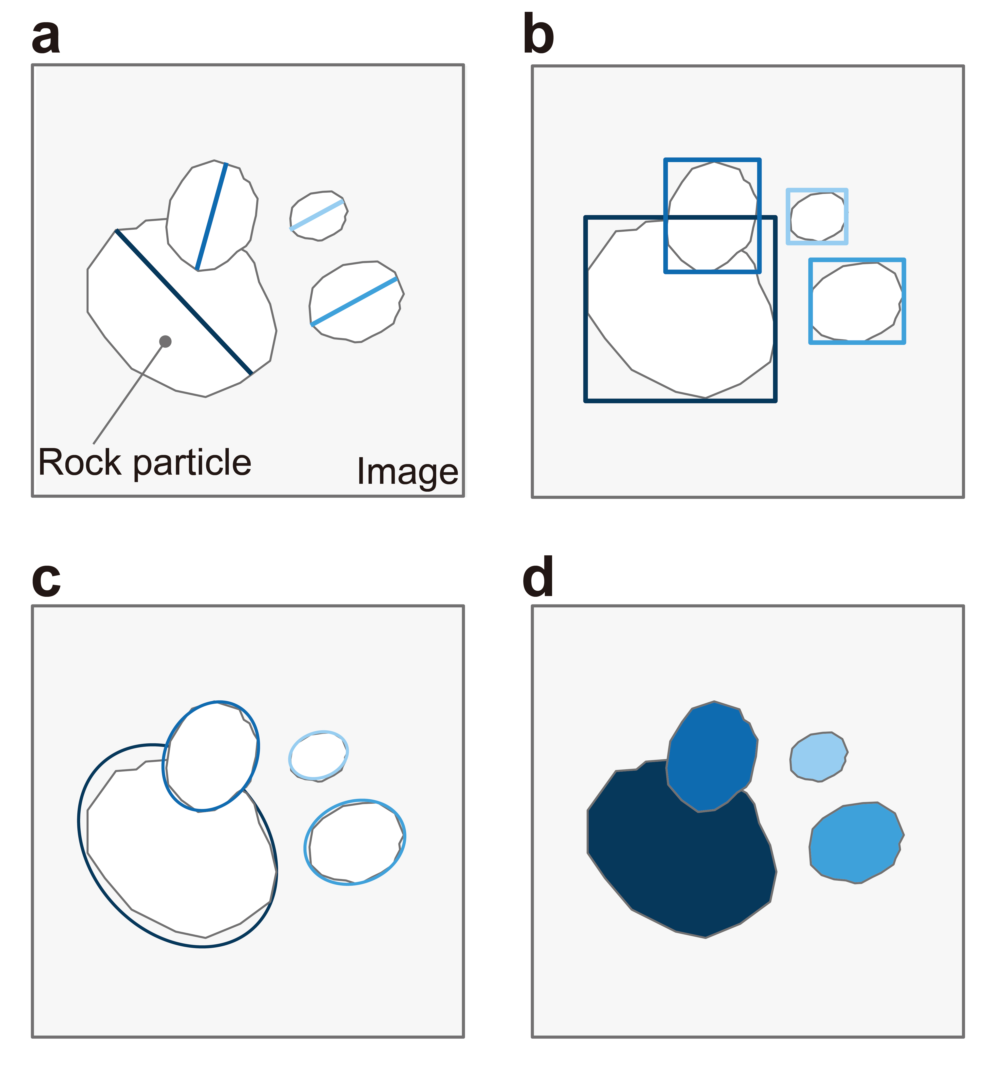
Supplementary Fig. S1. Identification methods for rock particles. (a) Polylines. They are the simplest and identify only the longest dimensions of rock particles, including their sizes, positions, and orientations. (b) Bounding boxes. The boxes are placed to be fitted to the profiles of rock particles. They allow obtaining positions of particles, but they cannot reveal precise sizes and other properties such as orientations. (c) Ellipses. Particles are identified with ellipses which fit to the profiles. They show sizes of the largest and second largest dimensions of particles, as well as their orientations, and positions. (d) Polygons. They identify rock particles by determining areas of individual particles in pixel level. They provide us with the maximum information including the shapes, sizes, positions, and orientations, while the identification itself is the most challenging.

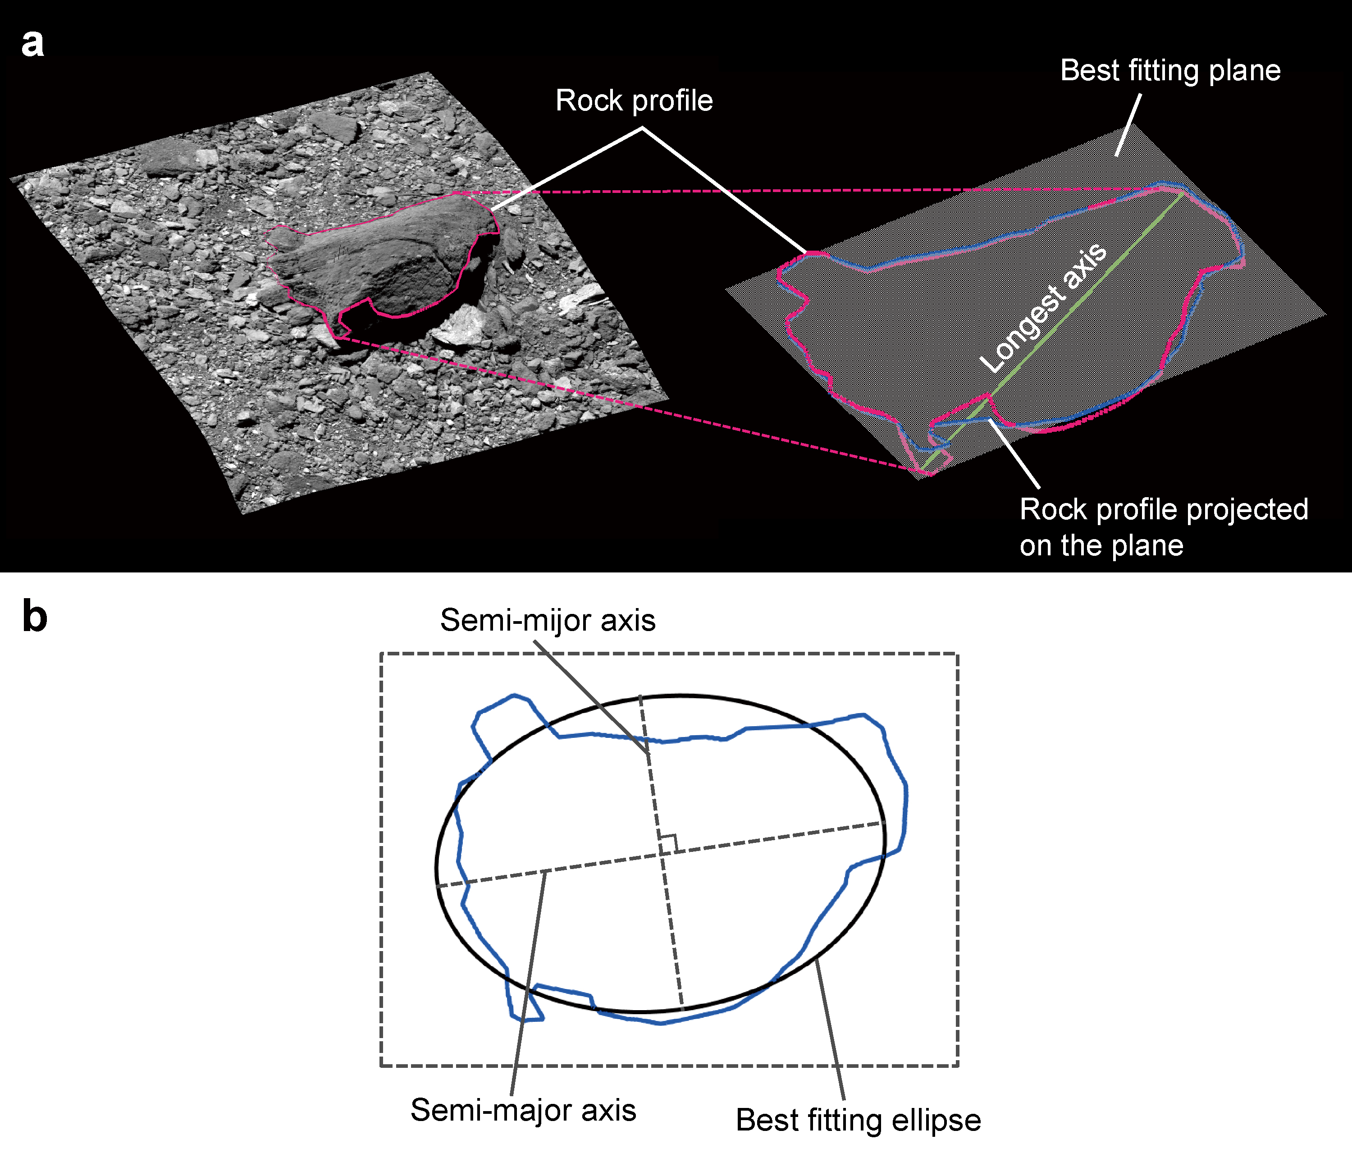
Supplementary Fig. S2. The concept of measuring the size of rock particles. (a) A rock profile identified automatically is projected on the surface of the three-dimensional shape model by using backplanes (red line). The longest axis is determined by calculating the longest dimension of the mapped rock profile (green line). The best fitting plane of the rock profile is also obtained from the following processes (blue line). (b) On the best-fitting plane, an ellipse that best fits the projected profile is obtained. The semi-major and semi-minor axes of the ellipse are calculated, and their lengths are recorded.
Supplementary Tables
Supplementary Table S1. Image dataset for training the model. OCAMS and ONC-T images utilized for developing the model to perform the automatic identification of rocks are listed. Each image was cropped into 512×512 pixel images without any overlapping and then used as training, validation, and test dataset.

Supplementary Table S2. Catalog of boulders on Bennu. All boulder identifications were automatically performed using the global mosaic image of Bennu and further processed to avoid any duplicated identifications. In total, 173,775 boulders are recorded on the global surface of Bennu.

Supplementary Table S3. Image dataset of Ryugu used in this study. These images were obtained by ONC-T onboard Hayabusa2 spacecraft. They were used to create the three-dimensional shape model of Ryugu, and to identify boulders existing on the surface of Ryugu. In total, 425 images were selected and utilized.

Supplementary Table S4. Catalog of boulders on Ryugu. Boulder identifications were automatically performed using images from Hayabusa2 mission, and those identifications were further processed to avoid any duplicated records. As a result, 20,714 boulders are mapped on the global surface of Ryugu.

