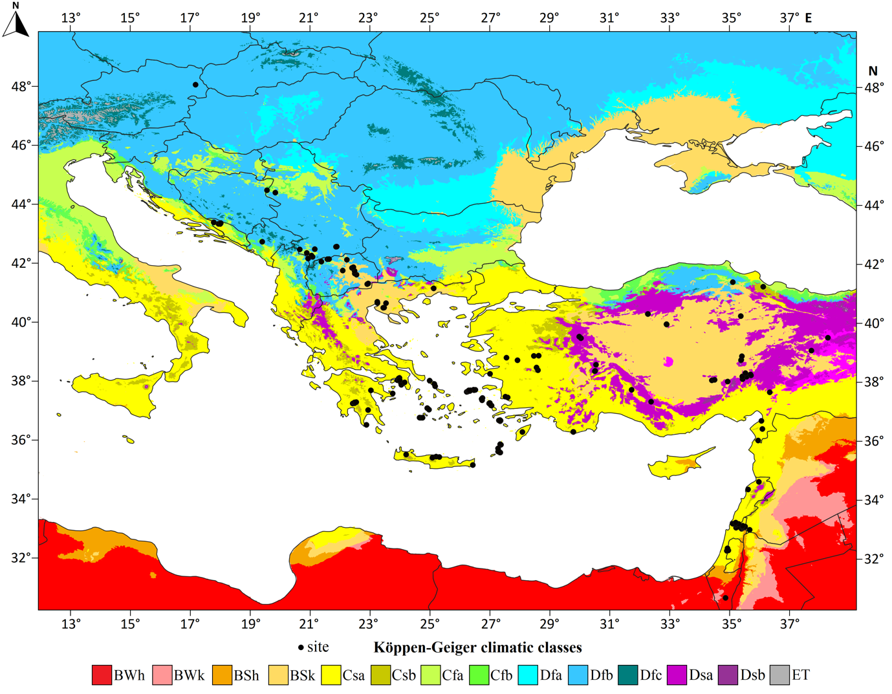
Supplementary Figure 1. The studied Ph. simici sites projected to the reference period’s Köppen-Geiger model. BWh: hot desert climates, BWk: cold desert climates, BSh: hot semi-arid climates, BSk: cold semi-arid climate, Csa: hot-summer Mediterranean climate, Csb: warm-summer Mediterranean climate, Cfa: humid subtropical climate, Cfb: temperate oceanic climate, Dfa: hot-summer humid continental climate, Dfb: warm-summer humid continental climate, Dfc: subarctic climate, Dsa: Mediterranean-influenced hot-summer humid continental climate; Dsb: Mediterranean-influenced warm-summer humid continental climate; ET: Tundra climate.

