Table S1. Chemical composition and the lower limit of detection of mVOCs
Variable code | Analyte | LLOD (ug/mL)
URX2MH | Urinary 2-Methylhippuric acid | 5
URX34M | Urinary 3- and 4-Methylhippuric acid | 8
URXAAM | Urinary N-Acetyl-S-(2-carbamoylethyl)-L-cysteine | 2.2
URXAMC | Urinary N-Acetyl-S-(N-methylcarbamoyl)-L-cysteine | 6.26
URXATC | Urinary 2-Aminothiazoline-4-carboxylic acid | 15
URXBMA | Urinary N-Acetyl-S-(benzyl)-L-cysteine | 0.5
URXBPM | Urinary N-Acetyl-S-(n-propyl)-L-cysteine | 1.2
URXCEM | Urinary N-Acetyl-S-(2-carboxyethyl)-L-cysteine | 6.96
URXCYM | Urinary N-Acetyl-S-(2-cyanoethyl)-L-cysteine | 0.5
URXDHB | Urinary N-Acetyl-S-(3,4-dihydroxybutyl)-L-cysteine | 5.25
URXGAM | Urinary N-Acetyl-S-(2-carbamoyl-2-hydroxyethyl)-L-cysteine | 9.4
URXHEM | Urinary N-Acetyl-S-(2-hydroxyethyl)-L-cysteine | 0.791
URXHP2 | Urinary N-Acetyl-S-(2-hydroxypropyl)-L-cysteine | 5.3
URXHPM | Urinary N-Acetyl-S-(3-hydroxypropyl)-L-cysteine | 13
URXMAD | Urinary Mandelic acid | 12
URXMB3 | Urinary N-Acetyl-S-(4-hydroxy-2-butenyl)-L-cysteine | 0.6
URXPHG | Urinary Phenylglyoxylic acid | 12
URXPMM | Urinary N-Acetyl-S-(3-hydroxypropyl-1-methyl)-L-cysteine | 1.13

Table S2. Detection rate of volatile organic compound metabolites (mVOCs)
mVOCs | Total non-missing cases | At or above LLOD cases | Below LLOD cases | Detection rate (%)
URXPMM | 10729 | 10729 | 0 | 100.00
URXDHB | 10451 | 10449 | 2 | 99.98
URXAAM | 10647 | 10636 | 11 | 99.90
URXHPM | 10548 | 10523 | 25 | 99.76
URXAMC | 10715 | 10668 | 47 | 99.56
URX34M | 10763 | 10706 | 57 | 99.47
URXBMA | 10757 | 10693 | 64 | 99.41
URXPHG | 10709 | 10636 | 73 | 99.32
URXCEM | 10745 | 10645 | 100 | 99.07
URXMAD | 10670 | 10513 | 157 | 98.53
URXATC | 10659 | 10361 | 298 | 97.20
URXMB3 | 10656 | 10300 | 356 | 96.66
URXHP2 | 10732 | 10147 | 585 | 94.55
URX2MH | 10506 | 9559 | 947 | 90.99
URXCYM | 10712 | 9055 | 1657 | 84.53
URXBPM | 10634 | 7846 | 2788 | 73.78
URXHEM | 10772 | 5369 | 5403 | 49.84
URXGAM | 10772 | 4435 | 6337 | 41.17
LLOD for lower limit of detection.

Table S3. Relative parent volatile organic compounds (VOCs) to the metabolites of VOCs (mVOCs)
 | Urine metabolites of VOCs (mVOCs) | Official abbreviation of mVOCs*
Acrolein | N-Acetyl-S-(2-carboxyethyl)-L-cysteine | CEMA
Acrolein | N-Acetyl-S-(3-hydroxypropyl)-L-cysteine | 3HPMA
Acrylamide | N-Acetyl-S-(2-carbamoylethyl)-L-cysteine | AAMA
Acrylonitrile | N-Acetyl-S-(2-cyanoethyl)-L-cysteine | CYMA
Crotonaldehyde | N-Acetyl-S-(3-hydroxypropyl-1-methyl)-L-cysteine | HPMMA
Cyanide | 2-Aminothiazoline-4-carboxylic acid | ATCA
Ethylbenzene, styrene | Phenylglyoxylic acid | PGA
Ethylbenzene, styrene | Mandelic acid | MA
N, N-Dimethylformamide | N-Acetyl-S-(N-methylcarbamoyl)-L-cysteine | AMCC
Propylene oxide | N-Acetyl-S-(2-hydroxypropyl)-L-cysteine | 2HPMA
Toluene | N-Acetyl-S-(benzyl)-L-cysteine | SBMA
Xylene | 2-Methylhippuric acid | 2MHA
Xylene | 3- and 4-Methylhippuric acid | 3,4-MHA
1,3-Butadiene | N-Acetyl-S-(3,4-dihydroxybutyl)-L-cysteine | DHBMA
1,3-Butadiene | N-Acetyl-S-(4-hydroxy-2-butenyl)-L-cysteine | MHBMA3
*Reference: Li, A.J., V.K. Pal, and K. Kannan, A review of environmental occurrence, toxicity, biotransformation and biomonitoring of volatile organic compounds. Environmental Chemistry and Ecotoxicology, 2021. 3: p. 91-116.

Table S4. Comparison of baseline characteristics between included and excluded populations
Characteristic | Included Sample (Median/%) | Excluded Sample (Median/%) | p-value
Age, (years) | 39 | 37 | 0.2
Gender, n (%) |  |  | 0.6
Male | 50% | 51%
Female | 50% | 49%
Race, n (%) |  |  | <0.001
Mexican American | 10% | 8%
Other Hispanic | 8% | 6%
Non-Hispanic white | 61% | 48%
Non-Hispanic Black | 12% | 25%
Other/multiracial | 9% | 14%
Education level, n (%) |  |  | 0.2
Less than 9th grade | 4% | 4%
9-11th grade (includes 12th grade with no diploma） | 9% | 15%
High school graduate/GED | 22% | 20%
Some college or AA | 32% | 35%
College graduate or above | 33% | 26%
PIR, (%) |  |  | 0.17
<1 | 16% | 21%
1~4 | 47% | 49%
≥4 | 37% | 30%
Drinking, (%) |  |  | 0.004
Never drink | 19% | 34%
1-5/ month | 53% | 46%
5-10/ month | 11% | 5.00%
10+/ month | 16% | 15%
Smoking, (%) |  |  | 0.3
Never smoke | 59% | 63%
Former smoker | 19% | 13%
Current smoker | 21% | 24%
Sedentary time, (minutes) | 360 | 300 | 0.2
Physical activity, (%) |  |  | 0.062
0 MET-min/week | 27% | 38%
0-599 MET-min/week | 11% | 8.50%
>600 MET-min/week | 62% | 54%
Energy intake, (g/day) | 2,140.90 | 2,115.53 | 0.9
BMI, (kg/m2) | 28 | 27 | 0.14
Hypertension, (%) | 27% | 29% | 0.8
Diabetes, (%) | 11% | 14% | 0.4
CVD, (%) | 3.40% | 5.40% | 0.2
Cancer, (%) | 4.90% | 4.10% | 0.7
CKD, (%) | 7.60% | 8.50% | 0.6
HDL-C, (mg/dl) | 51 | 48 | 0.09
TC, (mg/dl) | 187 | 195 | 0.6
2MHA, (ng/0.01mgCr) | -1.16 | -1.52 | 0.084
34MHA, (ng/0.01mgCr) | 0.54 | 0.26 | 0.15
AAMA, (ng/0.01mgCr) | -0.66 | -0.64 | >0.9
AMCC, (ng/0.01mgCr) | 0.47 | 0.33 | 0.1
ATCA, (ng/0.01mgCr) | 0.13 | 0.13 | 0.4
SBMA, (ng/0.01mgCr) | -2.8 | -2.85 | 0.8
CEMA, (ng/0.01mgCr) | -0.1 | -0.09 | 0.9
CYMA, (ng/0.01mgCr) | -4.09 | -4.31 | 0.4
DHBMA, (ng/0.01mgCr) | 1.08 | 1.03 | 0.3
2HPMA, (ng/0.01mgCr) | -1.21 | -1.20 | 0.6
3HPMA, (ng/0.01mgCr) | 0.81 | 0.79 | 0.8
MA, (ng/0.01mgCr) | 0.29 | 0.17 | 0.12
MHBMA3, (ng/0.01mgCr) | -3.09 | -3.30 | 0.3
PGA, (ng/0.01mgCr) | 0.7 | 0.63 | 0.25
HPMMA, (ng/0.01mgCr) | 0.7 | 0.59 | 0.11
Sarcopenia, (%) | 7.20% | 7.00% | >0.9
The median for continuous variables: the p-value was calculated by the Wilcoxon rank-sum test. % for categorical variables: the p value was calculated by weighted chi-square test.
PIR, poverty impact ratio; MET, metabolic equivalent; BMI, body mass index; CVD, cardiovascular disease; CKD, chronic kidney disease; HDL-C, high-density lipoprotein cholesterol; TC, total cholesterol.

Table S5. Association between a single urinary mVOC quartile and the risk of sarcopenia in an investigation weighted multivariate logistic regression.
 | OR (95%CI)
 | Q1 | Q2 | Q3 | Q4
2MHA
Unadjusted Model | Reference | 0.80 (0.48, 1.32) | 1.00 (0.59, 1.69) | 0.87 (0.56, 1.36)
Adjusted Model 1 | Reference | 0.83 (0.49, 1.40) | 1.07 0.60, 1.92) | 0.86 (0.52, 1.43)
Adjusted Model 2 | Reference | 0.93 (0.50, 1.74) | 1.39 (0.75, 2.57) | 1.63 (0.83, 3.19)
3,4-MHA
Unadjusted Model | Reference | 1.18 (0.68, 2.03) | 1.30 (0.74, 2.30) | 1.51 (0.79, 2.90)
Adjusted Model 1 | Reference | 1.23 (0.70, 2.17) | 1.38 (0.74, 2.56) | 1.83 (0.94, 3.53)
Adjusted Model 2 | Reference | 1.23 (0.64, 2.37) | 2.23 (1.11, 4.48) * | 2.43 (1.18, 4.97) *
AAMA
Unadjusted Model | Reference | 1.09 (0.62, 1.60) | 1.31 (0.77, 2.23) | 0.71 (0.44, 1.14)
Adjusted Model 1 | Reference | 1.07 (0.62, 1.84) | 1.36 (0.80, 2.32) | 0.97 (0.53, 1.77)
Adjusted Model 2 | Reference | 1.10 (0.63, 1.93) | 1.38 (0.76, 2.51) | 0.77 (0.39, 1.54)
AMCC
Unadjusted Model | Reference | 1.23 (0.74, 2.04) | 1.65 (0.97, 2.81) | 1.21 (0.72, 2.04)
Adjusted Model 1 | Reference | 1.00 (0.81, 1.23) | 1.10 (0.89, 1.35) | 0.93 (0.75, 1.17)
Adjusted Model 2 | Reference | 1.18 (0.64, 2.18) | 1.58 (0.88, 2.84) | 1.79 (0.83, 3.84)
ATCA
Unadjusted Model | Reference | 1.09 (0.65, 1.82) | 1.12 (0.67, 1.82) | 1.93 (1.16, 3.23)
Adjusted Model 1 | Reference | 1.02 (0.56, 1.70) | 1.14 (0.58, 1.78) | 1.64 (1.03, 2.96)
Adjusted Model 2 | Reference | 1.05 (0.62, 1.80) | 1.01 (0.63, 1.55) | 1.94 (1.11, 3.39) *
SBMA
Unadjusted Model | Reference | 0.96 (0.57, 1.59) | 0.65 (0.40, 1.07) | 1.05 (0.62, 1.77)
Adjusted Model 1 | Reference | 0.92 (0.53, 1.57) | 0.57 (0.34, 1.04) | 0.97 (0.57, 1.64)
Adjusted Model 2 | Reference | 1.02 (0.57, 1.84) | 0.64 (0.36, 1.13) | 0.12 (0.60, 2.12)
CEMA
Unadjusted Model | Reference | 1.48 (0.90, 2.42) | 1.35 (0.78, 2.32) | 1.79 (1.11, 2.88)
Adjusted Model 1 | Reference | 1.39 (0.82, 2.35) | 1.25 (0.67, 2.34) | 1.69 (1.01, 2.82)
Adjusted Model 2 | Reference | 1.24 (0.74, 2.08) | 1.47 (1.15, 1.90) * | 1.92 (1.16, 3.19) *
CYMA
Unadjusted Model | Reference | 1.54 (0.98, 2.42) | 1.71 (1.06, 2.77) | 1.17 (0.71, 1.92)
Adjusted Model 1 | Reference | 1.66 (1.02, 2.71) | 1.98 (1.18, 3.34) | 1.27 (0.74, 2.20)
Adjusted Model 2 | Reference | 1.86 (1.12, 3.09) * | 2.49 (1.33, 4.66) * | 2.34 (0.88, 6.21)
DHBMA
Unadjusted Model | Reference | 1.53 (0.86, 2.70) | 1.48 (0.83, 2.62) | 1.96 (1.20, 3.19)
Adjusted Model 1 | Reference | 1.39 (0.74, 2.60) | 1.36 (0.72, 2.56) | 1.58 (1.02, 2.77)
Adjusted Model 2 | Reference | 1.34 (0.66, 2.72) | 1.66 (0.83, 3.29) | 2.06 (1.07, 3.94) *
2HPMA
Unadjusted Model | Reference | 1.03 (0.62, 1.72) | 1.00 (0.58, 1.72) | 0.82 (0.49, 1.35)
Adjusted Model 1 | Reference | 1.06 (0.87, 1.29) | 0.95 (0.78, 1.16) | 0.91 (0.75, 1.11)
Adjusted Model 2 | Reference | 1.00 (0.62, 1.60) | 1.39 (0.78, 2.48) | 1.10 (0.65, 1.83)
3HPMA
Unadjusted Model | Reference | 1.07 (0.59, 1.61) | 1.38 (1.15, 1.67) | 1.61 (0.99, 2.62)
Adjusted Model 1 | Reference | 1.07 (0.52, 1.84) | 1.23 (1.05, 1.75) | 1.45 (0.84, 2.49)
Adjusted Model 2 | Reference | 1.09 (0.61, 1.77) | 1.27 (1.02, 1.74) * | 1.84 (1.05, 3.21) *
MA
Unadjusted Model | Reference | 1.14 (0.71, 1.83) | 1.06 (0.70, 1.61) | 0.92 (0.58, 1.47)
Adjusted Model 1 | Reference | 1.11 (0.67, 1.83) | 0.98 (0.62, 1.55) | 0.82 (0.50, 1.36)
Adjusted Model 2 | Reference | 1.08 (0.60, 1.94) | 1.08 (0.66, 1.76) | 1.23 (0.67, 2.27)
MHBMA3
Unadjusted Model | Reference | 1.32 (0.84, 2.10) | 1.34 (0.78, 2.31) | 1.30 (0.78, 2.17)
Adjusted Model 1 | Reference | 1.42 (0.91, 2.23) | 1.27 (0.73, 2.22) | 1.33 (0.76, 2.23)
Adjusted Model 2 | Reference | 1.19 (0.72, 1.96) | 1.30 (0.72, 2.35) | 2.45 (0.98, 5.33)
PGA
Unadjusted Model | Reference | 0.76 (0.48, 1.20) | 0.85 (0.53, 1.36) | 0.76 (0.43, 1.34)
Adjusted Model 1 | Reference | 0.68 (0.40, 1.15) | 0.76 (0.44, 1.32) | 0.66 (0.35, 1.23)
Adjusted Model 2 | Reference | 0.64 (0.36, 1.16) | 0.92 (0.48, 1.78) | 0.88 (0.42, 1.80)
HMPMA
Unadjusted Model | Reference | 0.94 (0.56, 1.59) | 1.42 (0.90, 2.25) | 0.82 (0.52, 1.27)
Adjusted Model 1 | Reference | 0.86 (0.50, 1.49) | 1.31 (0.82, 2.10) | 0.67 (0.41, 1.09)
Adjusted Model 2 | Reference | 0.73 (0.43, 1.25) | 1.11 (0.67, 1.83) | 0.93 (0.55, 1.56)
*P value < 0.05.

Model 1: adjusted for sociodemographic data (age, sex, race, education level, family income).

Model 2: further adjusted for lifestyle characteristics (body mass index, sedentary behavior, physical activity, total caloric intake, smoking status, alcohol consumption), comorbidities (hypertension, diabetes, cardiovascular disease, cancer, chronic kidney disease), and lipid profile.

mVOCs, metabolites of volatile organic compounds; OR, odds ratio; CI, confidence interval; 2MHA，2-Methylhippuric acid; 3,4MHA，3- and 4-Methylhippuric acid; AAMA，N-Acetyl-S-(2-carbamoylethyl)-L-cysteine; AMCC，N-Acetyl-S-(N-methylcarbamoyl)-L-cysteine; ATCA, 2-Aminothiazoline-4-carboxylic acid; SAMA，N-Acetyl-S-(benzyl)-L-cysteine; CEMA，N-Acetyl-S-(2-carboxyethyl)-L-cysteine; CYMA，N-Acetyl-S-(2-cyanoethyl)-L-cysteine; DHBMA，N-Acetyl-S-(3,4-dihydroxybutyl)-L-cysteine; 2HPMA，N-Acetyl-S-(2-hydroxypropyl)-L-cysteine; 3HPMA，N-Acetyl-S-(3-hydroxypropyl)-L-cysteine; MA， Mandelic acid; MHBMA3，N-Acetyl-S-(4-hydroxy-2-butenyl)-L-cysteine; PGA，Phenylglyoxylic acid； HPMMA，N-Acetyl-S-(3-hydroxypropyl-1-methyl)-L-cysteine.

Table S6. Combined association of mVOCs mixtures with sarcopenia in LASSO-based qgcomp regression models (positive and negative directions).
Mixture OR (95%CI) | Direction | mVOCs | Weight (%)
1.47 (1.14,1.91) * | Positive direction | DHBMA | 31.7%
1.47 (1.14,1.91) * |  | 3HPMA | 26.1%
1.47 (1.14,1.91) * |  | ATCA | 18.0%
1.47 (1.14,1.91) * |  | 3,4MHA | 14.0%
1.47 (1.14,1.91) * |  | AMCC | 10.2%
1.47 (1.14,1.91) * | Negative direction | MHBMA3 | 34.3%
1.47 (1.14,1.91) * |  | SBMA | 22.0%
1.47 (1.14,1.91) * |  | AAMA | 21.8%
1.47 (1.14,1.91) * |  | 2HPMA | 21.8%
*P value < 0.05.
Covariates included sociodemographic data (age, sex, race, education level, family income), lifestyle characteristics (body mass index, sedentary behavior, physical activity, total caloric intake, smoking status, alcohol consumption), presence of comorbidities (hypertension, diabetes, cardiovascular disease, cancer, chronic kidney disease), and lipid profile.
LASSO, least absolute shrinkage and selection operator; qgcomp: quantileg computation; mVOCs, metabolites of volatile organic compounds; OR, odds ratio; CI, confidence interval; 3,4MHA，3- and 4-Methylhippuric acid; AAMA，N-Acetyl-S-(2-carbamoylethyl)-L-cysteine; AMCC，N-Acetyl-S-(N-methylcarbamoyl)-L-cysteine; ATCA, 2-Aminothiazoline-4-carboxylic acid; SAMA，N-Acetyl-S-(benzyl)-L-cysteine; DHBMA，N-Acetyl-S-(3,4-dihydroxybutyl)-L-cysteine; 2HPMA，N-Acetyl-S-(2-hydroxypropyl)-L-cysteine; 3HPMA，N-Acetyl-S-(3-hydroxypropyl)-L-cysteine; MHBMA3，N-Acetyl-S-(4-hydroxy-2-butenyl)-L-cysteine.

Table S7. The relationship between 3,4MHA exposure and the prevalence of sarcopenia according to different subgroups.
3,4MHA subgroups | OR (95CI) | P for interaction
Age |  | 0.08
<40 | 1.15(0.92,1.43)
>=40 | 1.37(1.14,1.65)
Sex |  | 0.3
male | 1.18(0.98,1.43)
female | 1.37(1.12,1.67)
BMI |  | 0.06
<30 | 1.08(0.89,1.31)
>=30 | 1.29(1.04,1.60)
Sedentary time |  | 0.081
<6h/day | 1.10(0.91,1.32)
>=6h/day | 1.44(1.16,1.79)
Hypertension |  | 0.2
Yes | 1.50(1.16,1.94)
No | 1.17(1.09,1.44)
Diabetes mellitus |  | 0.7
Yes | 1.36(0.98,1.86)
No | 1.25(1.07,1.47)
CVD |  | 0.16
Yes | 2.64(0.46,32.9)
No | 1.23(1.06,1.41)
CKD |  | 0.9
Yes | 1.09(0.71,1.62)
No | 1.30(1.11,1.51)
Significant exposure contaminant interactions with covariates are highlighted in bold.
Covariates included sociodemographic data (age, sex, race, education level, family income), lifestyle characteristics (body mass index, sedentary behavior, physical activity, total caloric intake, smoking status, alcohol consumption), presence of comorbidities (hypertension, diabetes, cardiovascular disease, cancer, chronic kidney disease), and lipid profile.
3,4MHA：3- and 4-Methylhippuric acid; OR, odds ratio; CI, confidence interval; BMI, body mass index; CVD, cardiovascular disease; CKD, chronic kidney disease.

Table S8. The relationship between ATCA exposure and the prevalence of sarcopenia according to different subgroups.
ATCA subgroups | OR (95CI) | P for interaction
Age |  | 0.9
<40 | 1.29(1.01,1.68)
>=40 | 1.30(1.03,1.64)
Sex |  | 0.023
male | 1.07(0.87,1.33)
female | 1.59(1.21,2.12)
BMI |  | 0.6
<30 | 1.16(0.88,1.53)
>=30 | 1.29(1.02,1.64)
Sedentary time |  | 0.1
<6h/day | 1.07(0.85,1.36)
>=6h/day | 1.49(1.16,1.92)
Hypertension |  | 0.5
Yes | 1.28(0.97,1.71)
No | 1.26(1.02,1.56)
Diabetes mellitus |  | 0.2
Yes | 1.90(1.29,2.88)
No | 1.16(0.96,1.41)
CVD |  | 0.9
Yes | 2.31(0.24,130)
No | 1.25(1.05,1.50)
CKD |  | 0.4
Yes | 1.08(0.65,1.79)
No | 1.30(1.09,1.57)
Significant exposure contaminant interactions with covariates are highlighted in bold.
Covariates included sociodemographic data (age, sex, race, education level, family income), lifestyle characteristics (body mass index, sedentary behavior, physical activity, total caloric intake, smoking status, alcohol consumption), presence of comorbidities (hypertension, diabetes, cardiovascular disease, cancer, chronic kidney disease), and lipid profile.
ATCA：2-Aminothiazoline-4-carboxylic acid; OR, odds ratio; CI, confidence interval; BMI, body mass index; CVD, cardiovascular disease; CKD, chronic kidney disease.

Table S9. The relationship between DHBMA exposure and the prevalence of sarcopenia according to different subgroups.
DHBMA subgroups | OR (95CI) | P for interaction
Age |  | 0.4
<40 | 1.76(0.96,3.25)
>=40 | 2.13(1.28,3.54)
Sex |  | 0.3
male | 2.51(1.48,4.29)
female | 1.65(0.94,2.92)
BMI |  | 0.048
<30 | 1.27(0.69,2.34)
>=30 | 1.95(1.14,3.33)
Sedentary time |  | 0.2
<6h/day | 1.76(1.02,3.04)
>=6h/day | 2.23(1.25,4.04)
Hypertension |  | 0.5
Yes | 2.26(1.16,4.47)
No | 1.76(1.10,2.82)
Diabetes mellitus |  | 0.9
Yes | 3.16(1.24,8.69)
No | 1.86(1.21,2.85)
CVD |  | 0.4
Yes | 3.69(0.18,157)
No | 1.83(1.23,2.73)
CKD |  | 0.12
Yes | 3.35(0.92,13.3)
No | 1.77(1.17,2.68)
Significant exposure contaminant interactions with covariates are highlighted in bold.
Covariates included sociodemographic data (age, sex, race, education level, family income), lifestyle characteristics (body mass index, sedentary behavior, physical activity, total caloric intake, smoking status, alcohol consumption), presence of comorbidities (hypertension, diabetes, cardiovascular disease, cancer, chronic kidney disease), and lipid profile.
DHBMA：N-Acetyl-S-(3,4-dihydroxybutyl)-L-cysteine; OR, odds ratio; CI, confidence interval; BMI, body mass index; CVD, cardiovascular disease; CKD, chronic kidney disease.

Table S10 The relationship between 3HPMA exposure and the prevalence of sarcopenia according to different subgroups.

3HPMA subgroups | OR (95CI) | P for interaction
Age |  | 0.3
<40 | 1.51(1.13,2.01)
>=40 | 1.19(0.93,1.52)
Sex |  | 0.9
male | 1.29(1.01,1.68)
female | 1.30(1.04,1.67)
BMI |  | 0.4
<30 | 1.21(0.91,1.59)
>=30 | 1.29(1.02,1.64)
Sedentary time |  | 0.1
<6h/day | 1.16(0.91,1.49)
>=6h/day | 1.43(1.08,1.90)
Hypertension |  | 0.6
Yes | 1.87(1.16,3.08)
No | 1.22(0.95,1.74)
Diabetes mellitus |  | 0.7
Yes | 1.51(1.07,2.03)
No | 1.20(0.99,1.47)
CVD |  | 0.8
Yes | 1.62(0.65,15.3)
No | 1.24(1.03,1.50)
CKD |  | 0.7
Yes | 0.69(0.37,1.25)
No | 1.34(1.10,1.62)
Significant exposure contaminant interactions with covariates are highlighted in bold.
Covariates included sociodemographic data (age, sex, race, education level, family income), lifestyle characteristics (body mass index, sedentary behavior, physical activity, total caloric intake, smoking status, alcohol consumption), presence of comorbidities (hypertension, diabetes, cardiovascular disease, cancer, chronic kidney disease), and lipid profile.
3HPMA：N-Acetyl-S-(3-hydroxypropyl)-L-cysteine; OR, odds ratio; CI, confidence interval; BMI, body mass index; CVD, cardiovascular disease; CKD, chronic kidney disease.

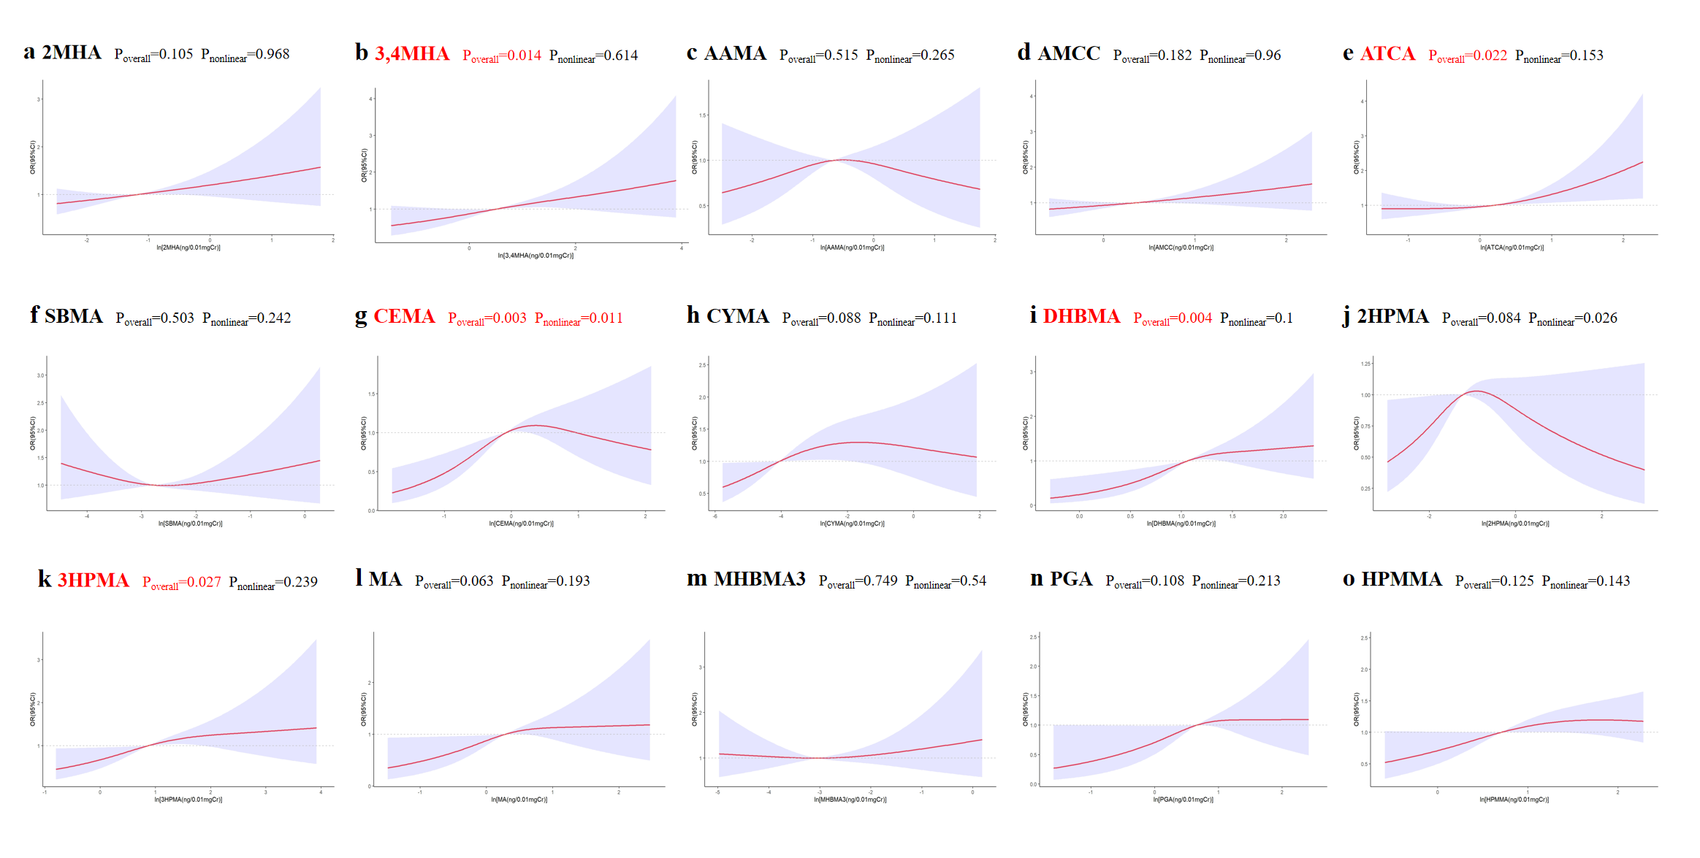
Figure S1. Restricted cubic spline analysis of the dose-response relationship between mVOCs and sarcopenia. The horizontal dashed line indicates OR = 1. The red curve shows the value of the OR. The blue shaded area indicates the 95% confidence interval. All mVOCs were adjusted for urine creatinine and then logarithmized. Covariates included sociodemographic data (age, sex, race, education level, family income), lifestyle characteristics (body mass index, sedentary behavior, physical activity, total caloric intake, smoking status, alcohol consumption), presence of comorbidities (hypertension, diabetes, cardiovascular disease, cancer, chronic kidney disease), and lipid profile. mVOCs, metabolites of volatile organic compounds; OR, odds ratio; CI, confidence interval; 2MHA，2-Methylhippuric acid; 3,4MHA，3- and 4-Methylhippuric acid; AAMA，N-Acetyl-S-(2-carbamoylethyl)-L-cysteine; AMCC，N-Acetyl-S-(N-methylcarbamoyl)-L-cysteine; ATCA, 2-Aminothiazoline-4-carboxylic acid; SAMA，N-Acetyl-S-(benzyl)-L-cysteine; CEMA，N-Acetyl-S-(2-carboxyethyl)-L-cysteine; CYMA，N-Acetyl-S-(2-cyanoethyl)-L-cysteine; DHBMA，N-Acetyl-S-(3,4-dihydroxybutyl)-L-cysteine; 2HPMA，N-Acetyl-S-(2-hydroxypropyl)-L-cysteine; 3HPMA，N-Acetyl-S-(3-hydroxypropyl)-L-cysteine; MA， Mandelic acid; MHBMA3，N-Acetyl-S-(4-hydroxy-2-butenyl)-L-cysteine; PGA，Phenylglyoxylic acid； HPMMA，N-Acetyl-S-(3-hydroxypropyl-1-methyl)-L-cysteine.

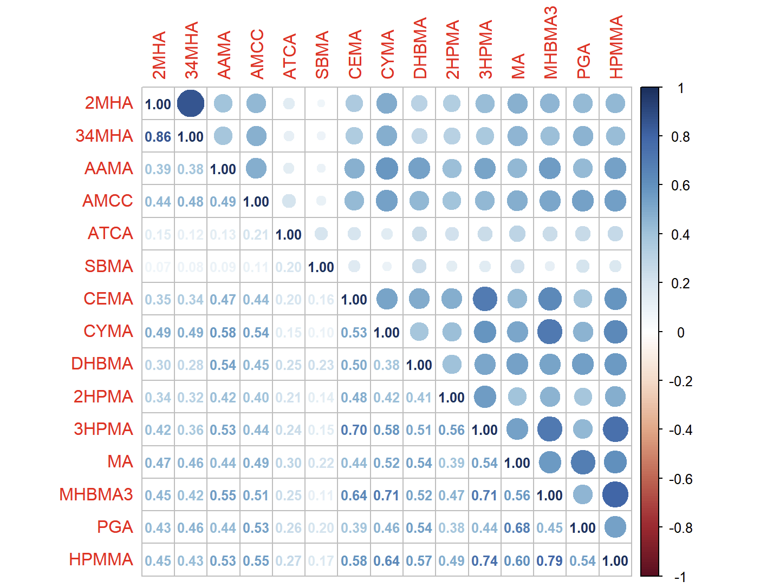
Figure S2. Spearman correlation of mVOCs in urine, NHANES 2011-2018. mVOCs, metabolites of volatile organic compounds; 2MHA，2-Methylhippuric acid; 3,4MHA，3- and 4-Methylhippuric acid; AAMA，N-Acetyl-S-(2-carbamoylethyl)-L-cysteine; AMCC，N-Acetyl-S-(N-methylcarbamoyl)-L-cysteine; ATCA, 2-Aminothiazoline-4-carboxylic acid; SAMA，N-Acetyl-S-(benzyl)-L-cysteine; CEMA，N-Acetyl-S-(2-carboxyethyl)-L-cysteine; CYMA，N-Acetyl-S-(2-cyanoethyl)-L-cysteine; DHBMA，N-Acetyl-S-(3,4-dihydroxybutyl)-L-cysteine; 2HPMA，N-Acetyl-S-(2-hydroxypropyl)-L-cysteine; 3HPMA，N-Acetyl-S-(3-hydroxypropyl)-L-cysteine; MA， Mandelic acid; MHBMA3，N-Acetyl-S-(4-hydroxy-2-butenyl)-L-cysteine; PGA，Phenylglyoxylic acid； HPMMA，N-Acetyl-S-(3-hydroxypropyl-1-methyl)-L-cysteine. Correlation coefficient P < 0.05.

