Supplementary Table 1. Time-restricted eating intervention adherence by the study participants. *Percentage of days with an eating window < 11 hours. **Number of participants with an eating window < 11 hours for 80% or more of the days in the given period. Abbreviations: TRE, time-restricted eating.
Parameter | Control, n = 25¹ | TRE, n = 23¹
Intervention duration, days | 83 (83, 86) | 83 (83, 84)
First caloric event, hours | 7.5 (6.8, 8.8) | 9.6 (9.1, 10.0)
Change in timing of first caloric event, hours | 0.0 (-0.3, 0.3) | 1.0 (0.2, 2.1)
End of last caloric event, hours | 21.5 (20.8, 21.9) | 19.4 (18.9, 19.9)
Change in timing of last caloric event, hours | 0.3 (-0.1, 0.6) | -1.8 (-3.4, -1.2)
Daily eating duration, hours | 13.6 (12.9, 14.4) | 9.8 (9.5, 10.0)
Difference in daily eating duration, hours | 0.3 (-0.2, 0.6) | -3.8 (-4.3, -3.1)
Adherence to TRE, percent of days* | 5 (1, 9) | 92 (87, 96)
Strict TRE, n** | 0 (0%) | 19 (83%)
Missing, percent | 0.00 (0.00, 0.00) | 0.00 (0.00, 0.60)
¹Median (IQR); n (%), TRE, time-restricted eating.

Supplementary Table 2. Complete cell count in blood samples and PBMC/platelet fraction used for Seahorse analysis from all participants and visits. Values are mean (SD) of 10⁹ cells/L for all cell types (except platelets, where values are 10¹² cells/L).
 | Red blood cells | Platelets | Neutrophils | Monocytes | Lymphocytes
Whole blood  (n = 101) | 6,199 (1,242) | 213,867 (104,224) | 4,382 (1,298) | 0,506 (0,195) | 2,207 (0,738)
PBMC/platelet fraction  (n = 101) | 0,011 (0,003) | 5,776 (3,809) | 0,296 (0,3791) | 0,662 (0,383) | 3,018 (0,877)

Supplementary Table 3. Mitochondrial respiratory parameters calculated using the OCR readings produced by the Seahorse extracellular flux analyzer.
Seahorse mitochondrial respiration parameter | Calculation
Basal Respiration | Difference between the average of all three OCR measurements per well before first injection and Non-Mitochondrial Respiration
ATP-linked respiration | Difference in OCR between Basal Respiration and Proton Leak
Proton Leak | Average of all four OCR measurements per well after oligomycin injection, after Non-Mitochondrial Respiration subtraction
Maximum Respiration | Average of all four OCR measurements per well after FCCP injection, after Non-Mitochondrial Respiration subtraction
Spare Respiratory Capacity | Difference in OCR between Maximum Respiration and Basal Respiration
Non-mitochondrial Respiration | Average of last two OCR measurements per well after rotenone/antimycin A injection

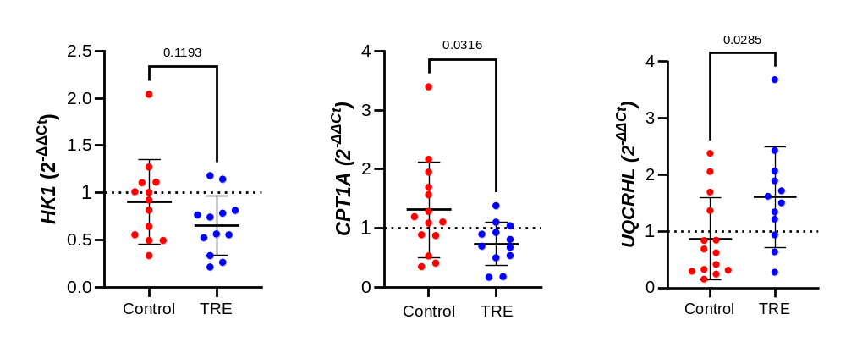
Supplementary Figure 1: Relative gene expression of hexokinase 1 (HK1), carnitine palmitoyltransferase 1A (CPT1A), and ubiquinol-cytochrome C reductase hinge protein like (UQCRHL) in PBMCs/platelets at visit 3 (end-of-study). Gene expression was measured by quantitative PCR using TaqMan assays. Target gene expression was normalized to the geometric mean of the housekeeping genes ACTB and HPRT1. Outliers were identified by the ROUT method and excluded before data analysis and graph presentation in GraphPad software. Fold change from visit 1 to visit 3 within each group was calculated by the delta-delta method. Individual data points are shown with mean ± SD. Unpaired t-test was used to examine differences between groups. P-values are indicated.

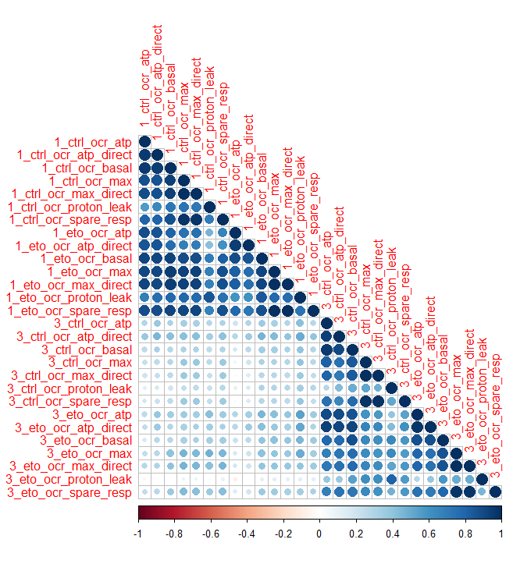

Supplementary Figure 2: Graphical representation of Spearman correlation of Seahorse measurements at visit 1 (baseline) and visit 3 (end-of-study). A relatively large degree of absence of association between measurements between the visits for the same participants is observed.

