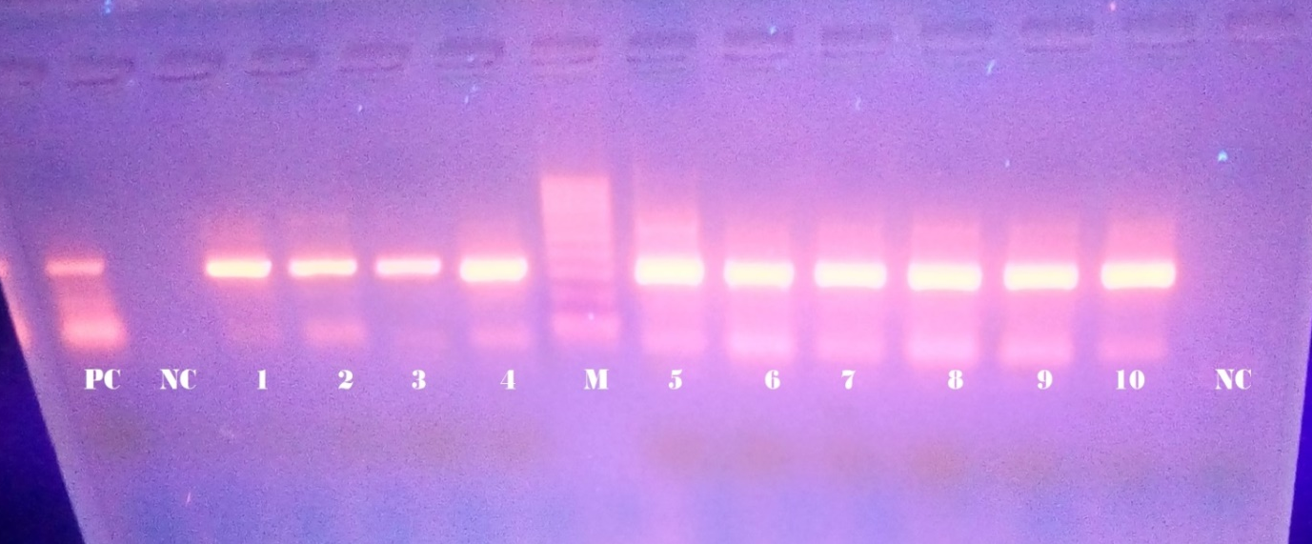

Supplementary material 1 Representative full-length gel electrophoresis results of An. arabiencis

