Supplementary Table 1. R scripts used for analysis

Analysis | R Script
Meta-analysis for beta | install.packages ("metafor")  library(metafor)  metamod<-rma(yi=BETA,data=data,sei=SE,method="DL")  summary(metamod)  forestplot<-forest(metamod,refline = 1,mlab="Random-effect Model for All Studies",xlab="β",showweights = T,digits = 3)
Meta-analysis for odds ratio | install.packages("meta")  library(meta)  lnor<-log(data[,"OR"])  lnuci<-log(data[,"UCI"])  lnlci<-log(data[,"LCI"])  selnor<- (lnuci-lnlci)/(2*1.96)  MetaOR=metagen(lnor,  selnor,  sm="OR",  studlab=paste(data$variable,data$lab,sep="-"),  fixed=F,  random=T,  data = data,byvar=bixu  )  summary(MetaOR)
FDR analysis | install.packages("fdrtool ")  library(fdrtool)  p.adjust(  c(0.066,0.896.....), # P-value list  method ="BH" )

FDR= false discovery rate.

Supplementary Table 2. Participants’ characteristics and bone mineral density (BMD) T-score: Bivariate analysis

Variables | Unit of Change or Comparison | Femoral Neck BMD  T-score |  | Total Hip BMD  T-score |  | Lumbar Spine BMD  T-score
Variables | Unit of Change or Comparison | β | P | Β | P | β | P
Age (years) | Per 1-SD increase | -0.192 | 0.024 | -0.194 | 0.059 | -0.036 | 0.784
Body mass index (kg/m²) | Per 1-SD increase | 0.272 | 0.001 | 0.336 | 0.001 | 0.441 | <0.001
Physical activity (MET-hours/week) | Per 1-SD increase on logarithmic scale | 0.190 | 0.022 | 0.203 | 0.042 | 0.150 | 0.254
Sex | Male vs. Female | 0.731 | <0.001 | 1.062 | <0.001 | 0.868 | 0.006
Smoking | Yes vs. No | 0.173 | 0.326 | 0.201 | 0.341 | -0.024 | 0.928
Alcohol intake >1 time/day (n, %) | Yes vs. No | 0.317 | 0.112 | 0.487 | 0.041 | 0.171 | 0.562
Milk intake >1 time/week | Yes vs. No | 0.170 | 0.356 | 0.150 | 0.499 | 0.460 | 0.100
Seafood intake >1 time/week | Yes vs. No | 0.031 | 0.860 | -0.048 | 0.822 | 0.020 | 0.939
Calcium supplement | Yes vs. No | 0.172 | 0.433 | 0.200 | 0.448 | 0.222 | 0.500
Coronary heart disease | Yes vs. No | -0.204 | 0.761 | -0.453 | 0.574 | -1.104 | 0.215
Type 2 diabetes | Yes vs. No | 0.556 | 0.073 | 0.686 | 0.065 | 1.669 | 0.001
Hypertension | Yes vs. No | 0.013 | 0.958 | 0.088 | 0.772 | -0.189 | 0.610
Height loss > 3 cm | Yes vs. No | -0.179 | 0.327 | -0.298 | 0.172 | -0.684 | 0.014
History of fractures (n, %) | Yes vs. No | 0.251 | 0.365 | 0.208 | 0.531 | 0.541 | 0.224
Family history of osteoporosis (n, %) | Yes vs. No | 0.609 | 0.122 | 0.751 | 0.111 | 0.792 | 0.214

SD = standard deviation; MET = metabolic equivalent task.

Supplementary Table 3. Multivariable logistic regression analysis of the interaction between amino acids and covariates in relation to osteoporosis
Amino acid | P for interaction with
Amino acid | Age | Sex | Alcohol Intake>1 time/day | Body Mass Index | Physical Activity | Type 2 Diabetes | Height Loss >3 cm
Essential Amino Acid
Leucine | 0.394 | 0.547 | 0.169 | 0.308 | 0.392 | 0.773 | 0.308
Lysine | 0.928 | 0.575 | 0.447 | 0.206 | 0.364 | 0.946 | 0.389
Methionine | 0.118 | 0.870 | 0.558 | 0.780 | 0.294 | 0.543 | 0.651
Phenylalanine | 0.800 | 0.257 | 0.120 | 0.696 | 0.437 | 0.714 | 0.153
Threonine* | 0.152 | 0.247 | 0.080 | 0.295 | 0.406 | 0.758 | 0.112
Tryptophan | 0.601 | 0.298 | 0.120 | 0.610 | 0.787 | 0.682 | 0.176
Non-essential Amino Acid
Valine | 0.775 | 0.240 | 0.948 | 0.896 | 0.744 | 0.786 | 0.364
Alanine | 0.695 | 0.468 | 0.085 | 0.750 | 0.606 | 0.556 | 0.232
Asparagine | 0.319 | 0.429 | 0.246 | 0.650 | 0.372 | 0.549 | 0.604
Aspartic acid | 0.957 | 0.923 | 0.551 | 0.962 | 0.453 | 0.358 | 0.185
Arginine | 0.291 | 0.604 | 0.959 | 0.118 | 0.638 | 0.742 | 0.268
Citrulline* | 0.094 | 0.572 | 0.527 | 0.059 | 0.616 | 0.501 | 0.163
Cysteine | 0.128 | 0.286 | 0.659 | 0.863 | 0.913 | 0.860 | 0.987
Glutamine | 0.928 | 0.575 | 0.447 | 0.207 | 0.364 | 0.946 | 0.389
Glutamic acid* | 0.643 | 0.394 | 0.781 | 0.799 | 0.995 | 0.856 | 0.220
Glycine | 0.143 | 0.790 | 0.876 | 0.252 | 0.092 | 0.300 | 0.304
Homocysteine | 0.805 | 0.214 | 0.185 | 0.626 | 0.057 | 0.764 | 0.345
Histidine | 0.055 | 0.566 | 0.314 | 0.411 | 0.120 | 0.992 | 0.397
Ornithine* | 0.980 | 0.174 | 0.637 | 0.617 | 0.723 | 0.323 | 0.514
Proline* | 0.724 | 0.228 | 0.107 | 0.717 | 0.243 | 0.449 | 0.755
Serine* | 0.457 | 0.967 | 0.328 | 0.935 | 0.092 | 0.759 | 0.756
Tyrosine | 0.170 | 0.324 | 0.632 | 0.948 | 0.966 | 0.915 | 0.964
*Amino acids are per 1-SD increase on the logarithmic scale; other amino acids are per 1-SD increase.
Supplementary Table 4. Multivariable linear regression analysis of the association between amino acid ratio and hip bone mineral density (BMD) T-score

Amino Acid Ratio | Femoral Neck BMD T-score |  |  |  |  |  | Total hip BMD T-score
Amino Acid Ratio | Unadjusted |  |  | Adjusted** |  |  | Unadjusted |  |  | Adjusted**
Amino Acid Ratio | β | P | FDR | β | P | FDR | β | P | FDR | β | P | FDR
Arginine/Ornithine | 0.057 | 0.525 | 0.849 | 0.066 | 0.431 | 0.779 | 0.093 | 0.391 | 0.690 | 0.121 | 0.202 | 0.419
Citrulline/Arginine* | -0.070 | 0.419 | 0.849 | -0.031 | 0.689 | 0.871 | -0.096 | 0.356 | 0.690 | -0.051 | 0.566 | 0.637
Glycine/Alanine* | -0.222 | 0.009 | 0.081 | -0.024 | 0.774 | 0.871 | -0.256 | 0.012 | 0.108 | 0.023 | 0.812 | 0.812
Methionine/Leucine | -0.043 | 0.621 | 0.849 | 0.105 | 0.212 | 0.779 | -0.125 | 0.226 | 0.678 | 0.068 | 0.481 | 0.618
Methionine/Phenylalanie | -0.061 | 0.472 | 0.849 | -0.074 | 0.351 | 0.779 | -0.126 | 0.218 | 0.678 | -0.148 | 0.101 | 0.419
Ornithine/Citrulline* | -0.016 | 0.849 | 0.849 | -0.046 | 0.544 | 0.816 | -0.038 | 0.710 | 0.859 | -0.084 | 0.334 | 0.501
Phenylalanine/Tyrosine* | -0.037 | 0.664 | 0.849 | 0.001 | 0.989 | 0.989 | 0.076 | 0.460 | 0.690 | 0.122 | 0.162 | 0.419
Tyrosine/Citrulline* | 0.017 | 0.845 | 0.849 | -0.064 | 0.433 | 0.779 | -0.019 | 0.859 | 0.859 | -0.111 | 0.233 | 0.419
Valine/Phenylalanine | -0.050 | 0.566 | 0.849 | -0.131 | 0.081 | 0.729 | -0.029 | 0.777 | 0.859 | -0.139 | 0.104 | 0.419

*Amino acid ratios were per 1-SD increase on the logarithmic scale; other ratios are per 1-SD increase. **Models were adjusted for age, sex, alcohol intake >1 time/day, body mass index, physical activity, type 2 diabetes, and height loss >3 cm.
FDR= false discovery rate.

Supplementary Table 5. Multivariable linear regression analysis of the association between amino acid ratio and lumbar spine bone mineral density (BMD) T-score

Amino Acid Ratio | Lumbar Spine BMD T-score
Amino Acid Ratio | Unadjusted |  |  | Adjusted**
Amino Acid Ratio | β | P | FDR | β | P | FDR
Arginine/Ornithine | -0.042 | 0.750 | 0.841 | 0.062 | 0.625 | 0.981
Citrulline/Arginine* | 0.027 | 0.841 | 0.841 | 0.002 | 0.984 | 0.984
Glycine/Alanine* | -0.238 | 0.070 | 0.210 | 0.039 | 0.770 | 0.981
Methionine/Leucine | -0.334 | 0.010 | 0.090 | -0.058 | 0.664 | 0.981
Methionine/Phenylalanie | -0.257 | 0.050 | 0.210 | -0.173 | 0.171 | 0.770
Ornithine/Citrulline* | 0.044 | 0.740 | 0.841 | -0.062 | 0.614 | 0.981
Phenylalanine/Tyrosine* | 0.118 | 0.370 | 0.833 | 0.090 | 0.458 | 0.981
Tyrosine/Citrulline* | -0.092 | 0.488 | 0.841 | -0.199 | 0.108 | 0.770
Valine/Phenylalanine | 0.067 | 0.610 | 0.841 | -0.019 | 0.872 | 0.981

*Amino acid ratios were per 1-SD increase on the logarithmic scale; other ratios are per 1-SD increase. **Models were adjusted for age, sex, alcohol intake >1 time/day, body mass index, physical activity, type 2 diabetes, and height loss >3 cm.
FDR= false discovery rate.

Supplementary Table 6. Multivariable linear regression analysis of the association of aromatic, sulfur, and branched-chain amino acid with bone mineral density (BMD) T-score

Amino Acid  (μmol/L) | Femoral Neck BMD T-score |  |  | Total Hip BMD T-score |  |  | Lumbar Spine BMD T-score
Amino Acid  (μmol/L) | β | P | FDR | β | P | FDR | β | P | FDR
Aromatic Amino Acid
Phenylalanine | 0.123 | 0.130 | 0.464 | 0.086 | 0.360 | 0.910 | 0.025 | 0.838 | 0.953
Tyrosine | 0.092 | 0.247 | 0.686 | -0.038 | 0.676 | 0.910 | -0.055 | 0.654 | 0.953
Tryptophan | 0.032 | 0.705 | 0.951 | 0.010 | 0.914 | 0.914 | 0.020 | 0.877 | 0.953
Aromatic amino acid | 0.084 | 0.075 | 0.304 | 0.019 | 0.729 | 0.908 | -0.004 | 0.954 | 0.974
Aromatic amino acid | Heterogeneity: Q = 0.63,P = 0.732, I² = 0 |  |  | Heterogeneity: Q = 0.92,P = 0.631, I² = 0 |  |  | Heterogeneity: Q = 0.27,P = 0.875, I² = 0
Sulfur Amino Acid
Methionine | 0.006 | 0.937 | 0.951 | -0.079 | 0.380 | 0.910 | -0.141 | 0.242 | 0.948
Cysteine | 0.130 | 0.083 | 0.375 | 0.210 | 0.013 | 0.325 | 0.253 | 0.034 | 0.750
Homocysteine | 0.101 | 0.199 | 0.622 | 0.015 | 0.863 | 0.910 | 0.126 | 0.291 | 0.948
Total sulfur amino acid | 0.081 | 0.067 | 0.304 | 0.051 | 0.556 | 0.908 | 0.080 | 0.489 | 0.974
Total sulfur amino acid | Heterogeneity: Q = 1.41,P = 0.495,  I² = 0 |  |  | Heterogeneity: Q = 5.95,P = 0.051, I² = 66.39％ |  |  | Heterogeneity: Q = 5.69,P = 0.058,  I² = 64.85％
Branched-chain Amino Acid
Leucine | -0.034 | 0.704 | 0.951 | -0.110 | 0.272 | 0.910 | -0.045 | 0.741 | 0.953
Valine | -0.015 | 0.866 | 0.951 | -0.060 | 0.540 | 0.910 | 0.034 | 0.797 | 0.953

Amino acids were per 1-SD increase. *Models were adjusted for age, sex, alcohol intake >1 time/day, body mass index, physical activity, type 2 diabetes, and height loss >3 cm.
FDR = false discovery rate.

Supplementary Figure 1. Pearson correlation coefficients (r) between amino acids

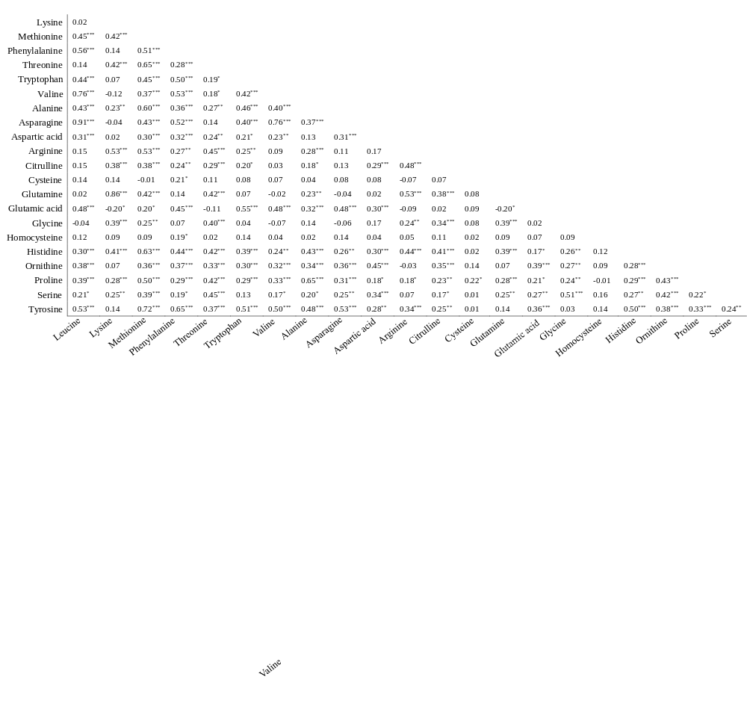
*P < 0.05; **P < 0.01; ***P < 0.001

Supplementary Figure 2. Multivariable logistic regression analysis of the association between amino acid and osteopenia

*Amino acids were per 1-SD increase on the logarithmic scale; other amino acids are per 1-SD increase. Models were adjusted for age, sex, alcohol intake >1 time/day, body mass index, physical activity, history of type 2 diabetes, and height loss >3 cm.

Supplementary Figure 3. Multivariable logistic regression analysis of the association between amino acid ratio and osteopenia

*Amino acid ratios were per 1-SD increase on the logarithmic scale; other ratios were per 1-SD increase. Odds ratios are adjusted for age, sex, alcohol intake >1 time/day, body mass index, physical activity, type 2 diabetes, and height loss >3 cm.

Supplementary Figure 4. Multivariable logistic regression analysis of the association between amino acid ratio and osteoporosis

* Amino acid ratios were per 1-SD increase on the logarithmic scale; other ratios were per 1-SD increase. Models were adjusted for age, sex, alcohol intake >1 time/day, body mass index, physical activity, type 2 diabetes, and height loss >3 cm.

Supplementary Figure 5. Multivariable logistic regression analysis of the association between aromatic, sulfur, and branched-chain amino acids with osteopenia

Amino acids were per 1-SD increase. Odds ratios were adjusted for age, sex, alcohol intake >1 time/day, body mass index, physical activity, type 2 diabetes, and height loss >3 cm.

Supplementary Figure 6. Multivariable logistic regression analysis of the association between aromatic, sulfur, and branched-chain amino acid with osteoporosis

Amino acids were per 1-SD increase. Odds ratios were adjusted for age, sex, alcohol intake >1 time/day, body mass index, physical activity, type 2 diabetes, and height loss >3 cm.

