Supplementary table 1. Transcript assembly statistics
Index | 300-500bp | 500-1kbp | 1k-2kbp | >2kbp | Total | Median length(bp) | N50(bp) | N90(bp)
Transcripts | 177717 | 152612 | 109751 | 64059 | 504139 | 678 | 1515 | 446
Unigenes | 112017 | 81872 | 42090 | 20571 | 256550 | 553 | 1138 | 396

Supplementary table 2. Comparison results of sample reference sequence
Sample name | Total reads | Total mapped
GY_0h_1 | 44482226 | 31685042
GY_0h_2 | 46384678 | 33449188
GY_0h_3 | 41467766 | 30709904
GY_8h_1 | 45446066 | 33460710
GY_8h_2 | 44333420 | 31662176
GY_8h_3 | 43804784 | 32052142
GY_24h_1 | 48054340 | 34892538
GY_24h_2 | 43132762 | 32795358
GY_24h_3 | 38394502 | 28438340
N1291_0h_1 | 46323968 | 32922246
N1291_0h_2 | 44621484 | 31767904
N1291_0h_3 | 41600418 | 29314678
N1291_8h_1 | 40323264 | 29694464
N1291_8h_2 | 44611954 | 32866100
N1291_8h_3 | 43129978 | 31294452
N1291_24h_1 | 41255826 | 30161576
N1291_24h_2 | 41725728 | 30717430
N1291_24h_3 | 47594890 | 34672506

Supplementary table 3. List of target gene primers
Gene ID | Forward primer（5'-3'） | Reverse primer（5'-3'）
18S（internal reference） | CAACCATAAACGATGCCGA | AGCCTTGCGACCATACTCC
Cluster-38255.79892 | TTCCAAGAAGCGGCACTG | GCAACCAATCATCAGAGGACTT
Cluster-38255.73940 | CGATGCTGAAGAGACTGA | GGATTCATACGCCATACAAC
Cluster-38255.76298 | ACCCAGAGAAGCGTGAGATA | TTCCACCACCTCCTCCAA
Cluster-38255.80127 | GGCAGTGAGGTTCTTGATGTA | TGGTGATGATGAGGGTGTTG
Cluster-38255.78588 | GGTGTGGAACGACAACGA | CTTCTCGATCAGGTGGTAGTC
Cluster-38255.77713 | CTACTCCGACGACAAGAT | GGCAGCATCAGGTAATTC

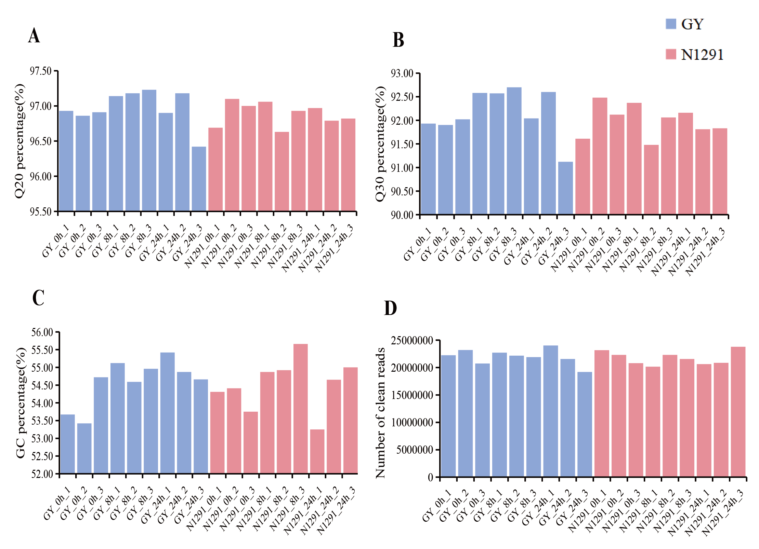
Supplementary figure 1. Sample sequencing quality results. (A) Q20 percentage; (B) Q30 percentage; (C) GC content percentage; (C) Number of clean reads.

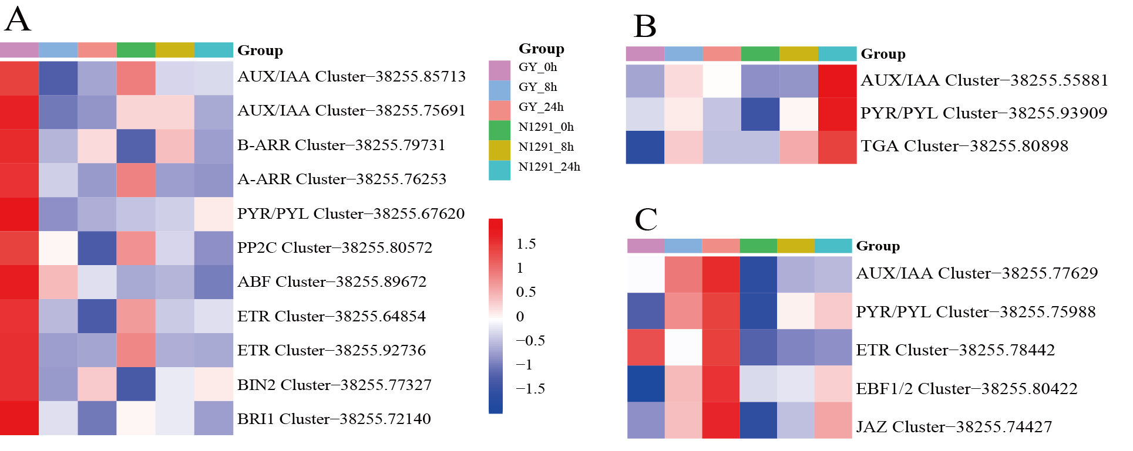

Supplementary figure 2. Heatmap analysis of differentially expressed gene clustering in plant hormone signaling pathways. (A-C) blue, green-yellow and purple module respectively.

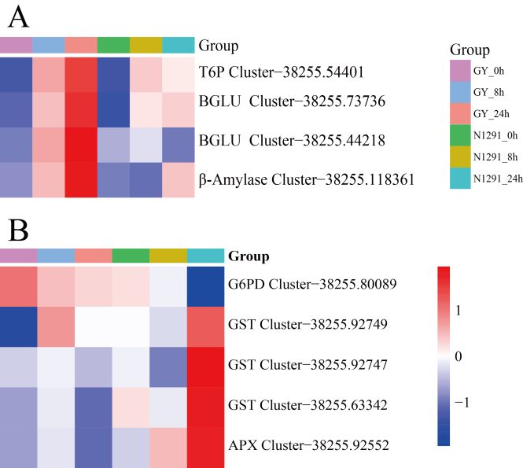

Supplementary figure 3. Gene clustering heat map analysis.(A) Clustering analysis of differentially expressed genes of starch and sucrose metabolic pathways (purple module); (B) Glutathione metabolism differentially expressed gene heat map(green-yellow module).

