Hepatotoxicity Evaluation Method Through Multiple-factor Analysis Using Human Pluripotent Stem Cell (hPSC)-derived Hepatic Organoids

Dae-Seop Shin , Jeong-Yoon Yang, Ha Neul Jeong , Seon Ju Mun, Hyunwoo Kim, Myung Jin Son, Myung Ae Bae

Table of contents
Supplementary materials and methods---------------------------------------------------------------2
Fig. S1--------------------------------------------------------------------------------------------------- 3
Fig. S2--------------------------------------------------------------------------------------------------- 3
Supplementary materials and methods

Cell staining. Before seeding cells into the matrigel dome, HO, HSC stellate cell, and THP-1 were stained with CellTracker™ Blue CMAC dye (C2110, Invitrogen), Green CMFDA dye (C2925, Invitrogen), and Orange CMTMR dye (C2927, Invitrogen), respectively. All procedures were performed according to the manufacturer’s recommendations. Stained cells were imaged by Lionheart FX Automated Microscope (BioTek Instruments, Winooski, VT, USA).

Reagents. Ambrisentan (Sigma-Aldrich; A5130), Buspirone (Sigma-Aldrich; B7417), Flumazenil (Sigma-Aldrich; F3030), Orphenadrine (Sigma-Aldrich; O2873), Azathioprine (Sigma-Aldrich; A6029), Clozapine (Sigma-Aldrich; C1808), Imipramine (Sigma-Aldrich; I8870), Ticlopidine (Sigma-Aldrich; T0656), Amiodarone (Sigma-Aldrich; A8670), Ketoconazole (Sigma-Aldrich; K0503), Nefazodone (Sigma-Aldrich; N0876), and Troglitazone (Sigma-Aldrich; T3512) were purchased from Sigma-Aldrich. All the drugs listed above were used in their commercially available forms according to the manufacturer’s instructions for in vitro studies. The compounds were dissolved in appropriate solvents and stored at recommended conditions before use.

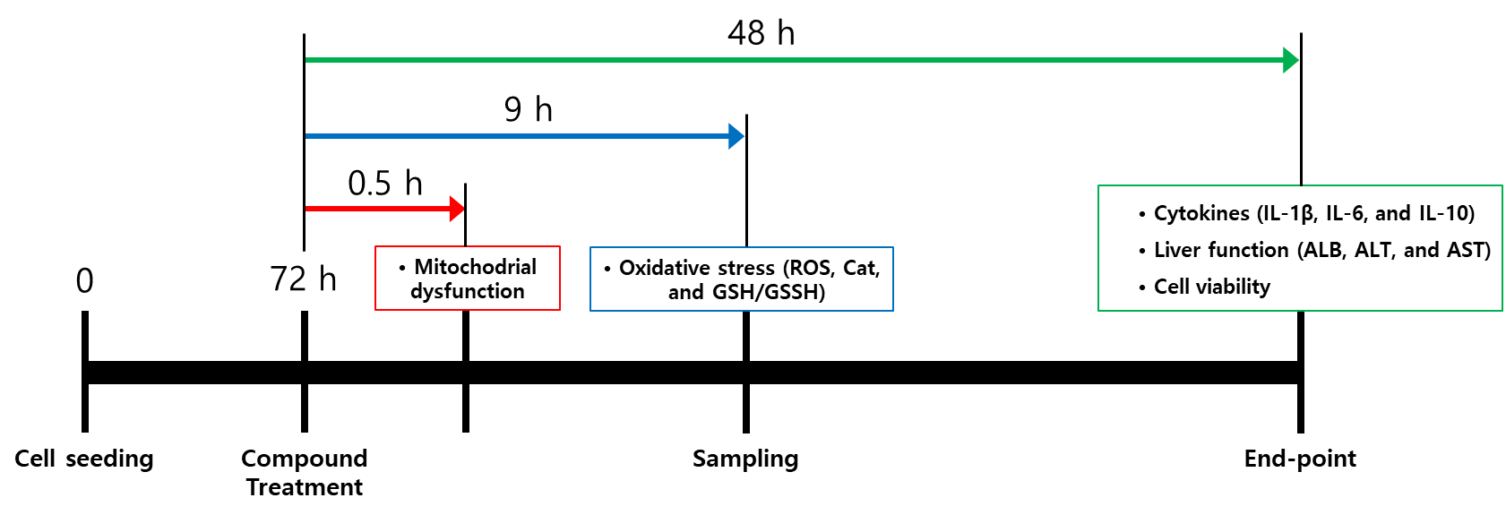
Fig. S1. Time flow chart of experimental design scheme. This figure shows the overall time plan and specific experiment schedule.

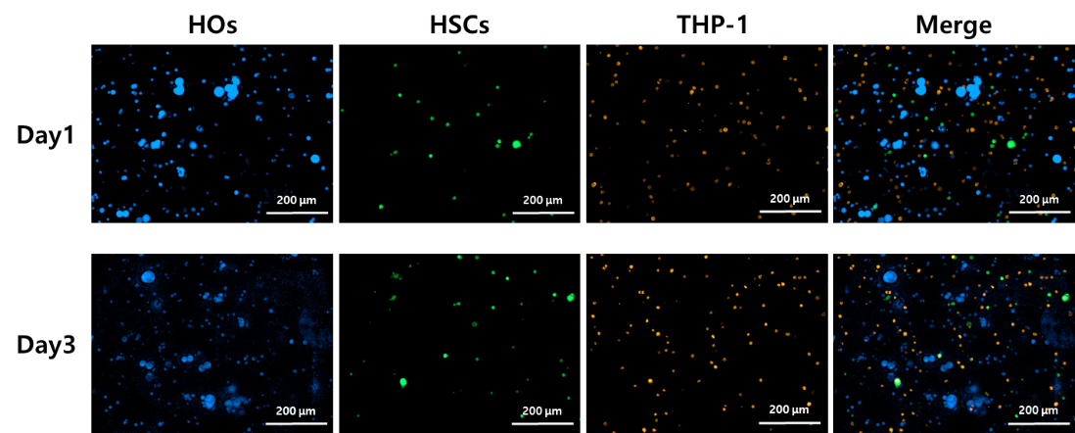

Fig. S2. Fluorescent imaging of HO, HSC, and THP-1 cells cultured in a 3D Matrigel system at days 1 and 3. HO, HSC, and THP-1 cells were pre-stained with CellTracker™ Blue CMAC dye, CMFDA dye, and Orange CMTMR dye, respectively, and mixed in Matrigel before seeding into a 96-well plate. Fluorescent images were captured at day 1 (top row) and day 3 (bottom row) post-seeding. Individual fluorescence channels represent HO (blue), HSC (green), and THP-1 cells (red). Scale bars: 200 µm.

