Synthesis, Biological Evaluation, Pharmacological Profiling, and Molecular Docking Studies of 4-Aminocoumarin Based Phenyliodonium Derivatives as Potent Therapeutic Agents
Serin Zachariahª, Shiji T.M^{b}, Kannan Vadakkadath Meethal^{b,c}, Sara Jones^{d}, Suchithra T.V^{a*}
ª Department of Bioscience and Engineering, National Institute of Technology, Calicut-673601, Kerala, India
^{b} Division of Biochemistry and Molecular Biology, Department of Zoology, University of Calicut, Malappuram -673635, Kerala, India
^{c} Centre for Advances in Molecular Biology, University of Calicut, Calicut University PO, Malappuram District, Malappuram, Kerala 673635, India
^{d} Pathogen Biology Group, Rajiv Gandhi Centre for Biotechnology, Thiruvananthapuram-695014, Kerala, India
*Corresponding author: Email ID: drsuchithratv@nitc.ac.in
Ph: +91 9744244461
Supplementary Figure S1. FTIR spectra for (A) 4-AC, (B) 4-A-3-PIC T, (C) 3-PIC-4-I, (D) 3-I-4-PAC (E) 4-PAC, and (F) 4-DPA-3-IC.
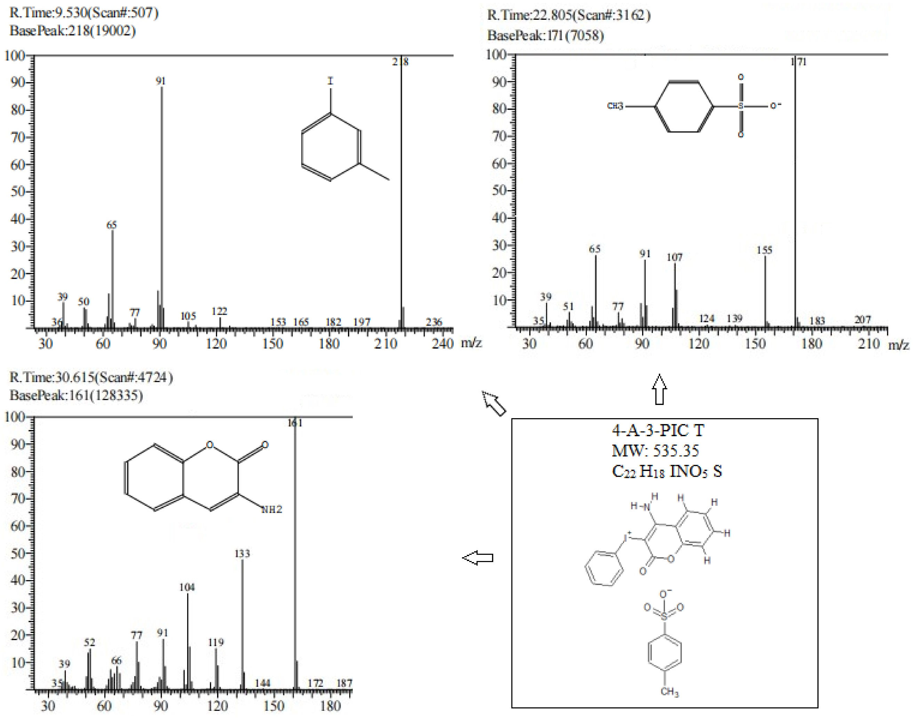
Supplementary Figure S2. GCMS profile for 4-A-3-PIC T.
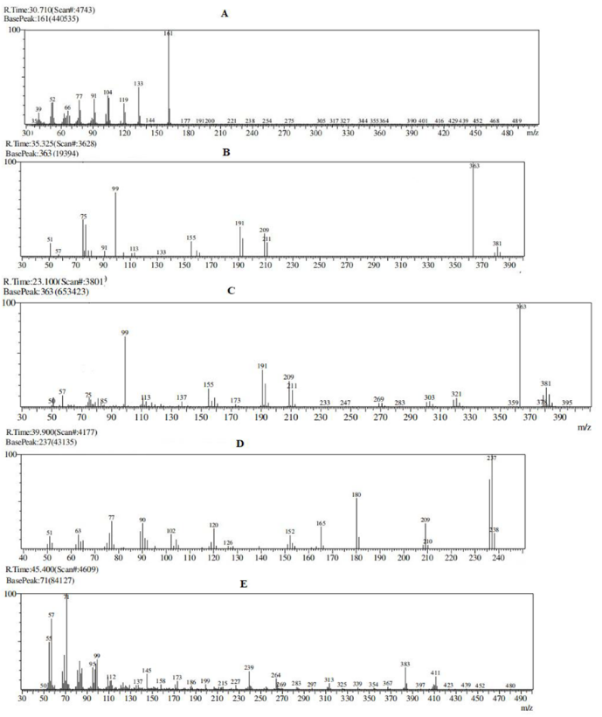
Supplementary Figure S3. GCMS profile for (A) 4-AC, (B) 3-PIC-4-I, (C) 3-I-4-PAC, (D) 4-PAC, and (E) 4-DPA-3-IC.
Supplementary Figure S4. UV Visible spectra for (A) 4-AC, (B) 4-A-3-PIC T, (C) 3-PIC-4-I, (D) 3-I-4-PAC, (E) 4-PAC, and (F) 4-DPA-3-IC.

Supplementary Figure S5. ¹H NMR spectra for (A) 4-AC, (B) 4-A-3-PIC T, (C) 3-PIC-4-I, (D) 3-I-4-PAC, (E) 4-PAC, and (F) 4-DPA-3-IC.

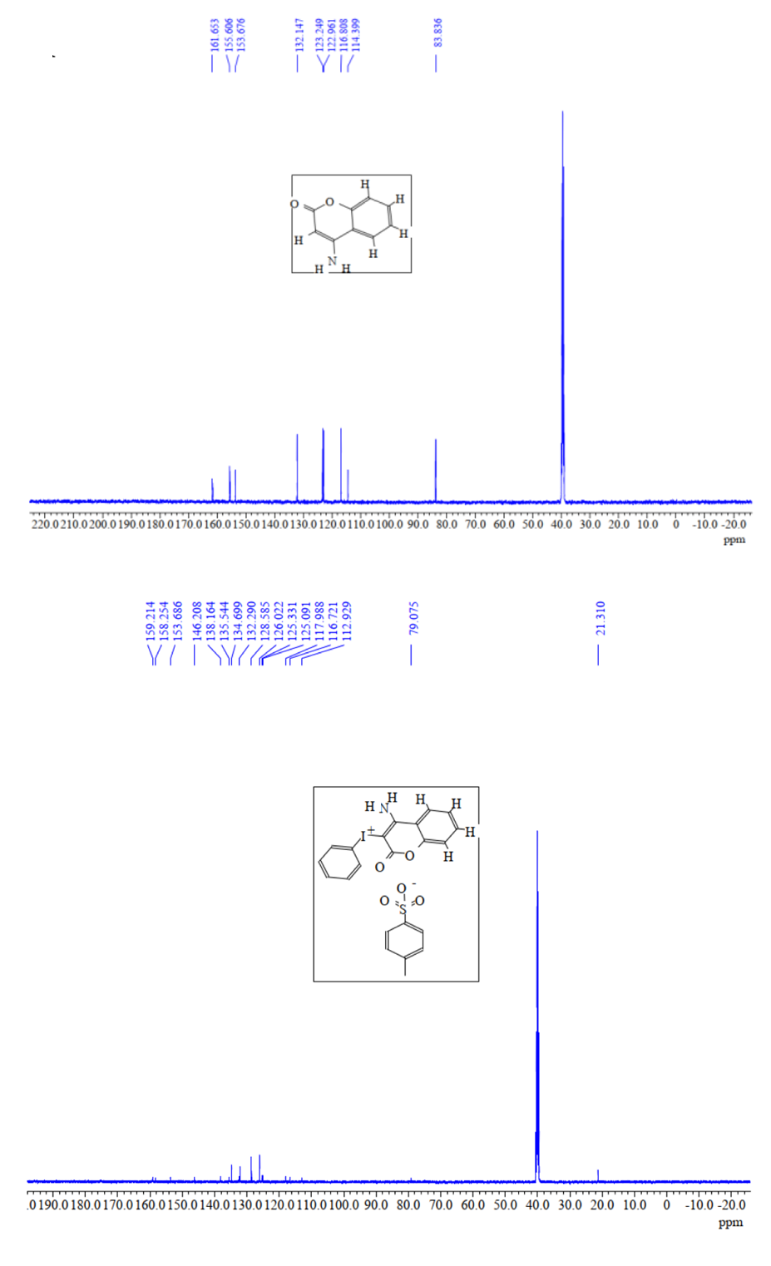
Supplementary Figure S6. ¹³C NMR spectra for (A) 4-AC, (B) 4-A-3-PIC T.
A
B

Supplementary Figure S7. ¹³C NMR spectra for (A) 3-PIC-4-I, (B) 3-I-4-PAC.
A
B
Supplementary Figure S8. CHNS analysis profile for (A) 4-AC, (B) 4-A-3-PIC T, (C) 3-PIC-4-I, (D) 3-I-4-PAC.

Supplementary Figure S9. Antibiogram of A. baumannii (A), B. subtilis (B), E. coli (C), K. pneumoniae (D), P. aeruginosa (E), P. mirabilis(F), S. aureus (G), S. typhimurium (H) against AC derivatives (1) 4-AC, (2) 4-A 3-PIC T, (3) 3-PIC-4-I, (4) 3-I-4-PAC, (5) PAC, and (6) 4-DPA-3-IC.
Supplementary Figure S10. Antifungal activity of 4-AC (T1),4-3-PIC T (T2), 3-I-4-PAC (T4) 4-DPA-3IC (T6), PS and NC (Positive and negative control) against Fusarium solani at 7th day of incubation.
Supplementary Figure S11. Antifungal activity of 4-AC (T1), 3-PIC-4-I (T3), 4-DPA-3IC (T6), PS, and NC (Positive and negative control) against Fusarium Oxysporum (7th day of incubation) and Candida albicans.
Supplementary Figure S12. Antifungal activity of 4-AC (T1), 3-PIC-4-I (T3), 3-I-4-PAC (T4), 4-DPA-3IC (T6), PS, and NC (Positive and negative control) against Aspergillus niger on the 7th day of incubation.

Supplementary Figure S13. Antifungal activity of 4-AC (T1), 4-3-PIC T (T2), 4-DPA-3IC (T6), PS, and NC (positive and negative control) against Penicillium chrysogenum on the 7th day of incubation.

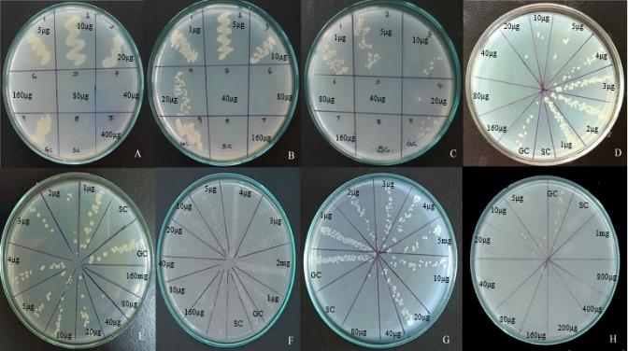
Supplementary Figure S14. MBC for 4-DPA-3-IC against S. aureus (A), E. coli (B), P. aeruginosa (C), S. typhimurium (D), K. pneumoniae (E), P. mirabilis(F), B. subtilis (G), A. baumannii (H).

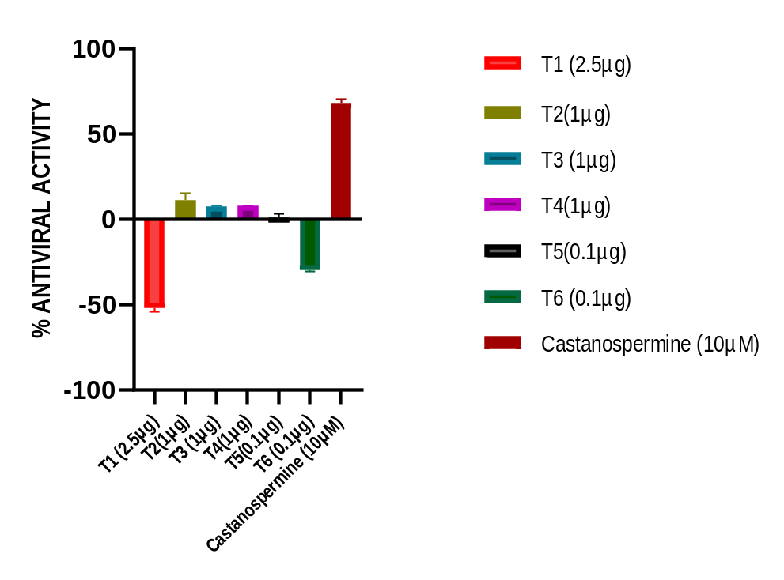
Supplementary Figure S15. Antiviral activity profile for the synthesized compounds (T1-T6) in BHK-21 cells.

Supplementary Figure 16. Graphical representation of the antioxidant activity of AC derivatives (4-AC, 4-A-3-PIC T, 3-PIC-4-I, 3-I-4-PAC, 4-PAC, 4-DPA 3-IC).

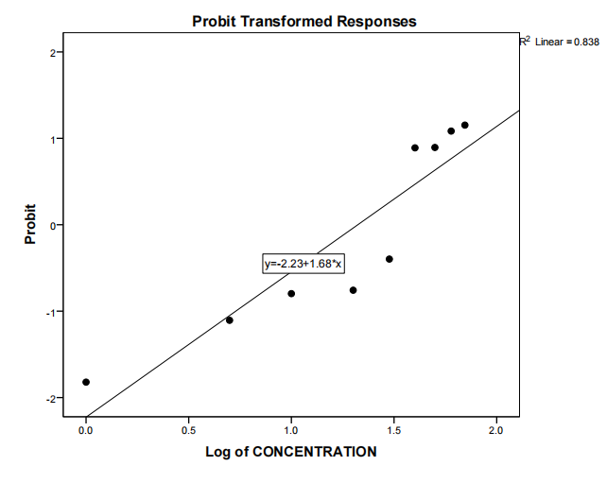
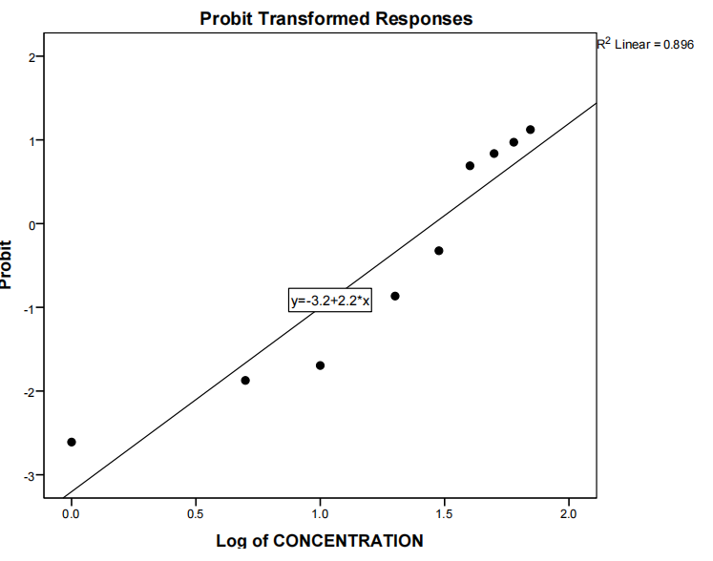
Supplementary Figure S17. Determination of IC₅₀ from Probit Transformed Response Curve for (A) 3-PIC-4-I (T3) and (B) 3-I-4-PAC (T4) in HaCat cells.
A
B

Supplementary Figure S18. Area calculated in scratch wound assay.

