A rapid nucleic and high-yield method for acid extraction –

Manjula Ramya Vutukuru, Divya Khandige Sharma, Ishita Chakraborty, Debnath Mukhopadhyay, and Nivedita Mitra

Supplementary information

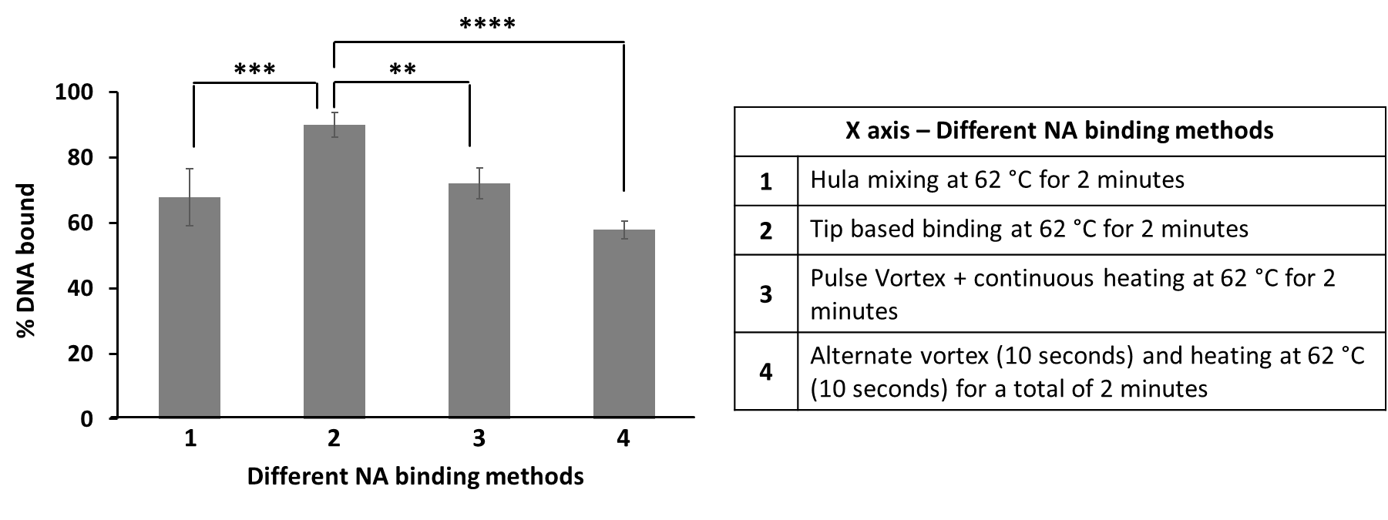

Figure S1: Comparison of different NA bead binding methods. Effect of different non-orbital bead mixing methods on percent DNA bound. “Tip-based” method results in maximum DNA binding to beads within 2 minutes. The Hula “end over end” mixing was done on the HulaMixer™ from ThermoFisher Scientific, Catalogue Number: 15920D. All mixing methods listed here were chosen based on mixing methods commonly available in the laboratory and tested with 100 ng input DNA (ultrasound lysed M. smegmatis) bound for 2 minutes at 62 °C using 10 µL magnetic beads, using a LBB at pH 4.1, with the binding mix pre-heated to 72 °C before sample addition. The “tip-based” binding method resulted in maximum DNA binding ~90% of DNA. While hula mixer resulted in 67.75% binding, vortex followed by heating and repeated vortex/heating resulted in 72.07% and 57.87% DNA bound respectively. The error bar in the graph depicts the SD.

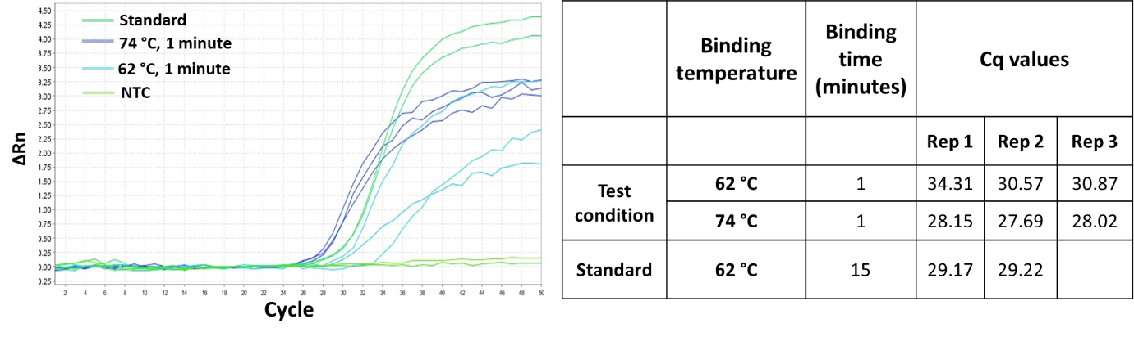
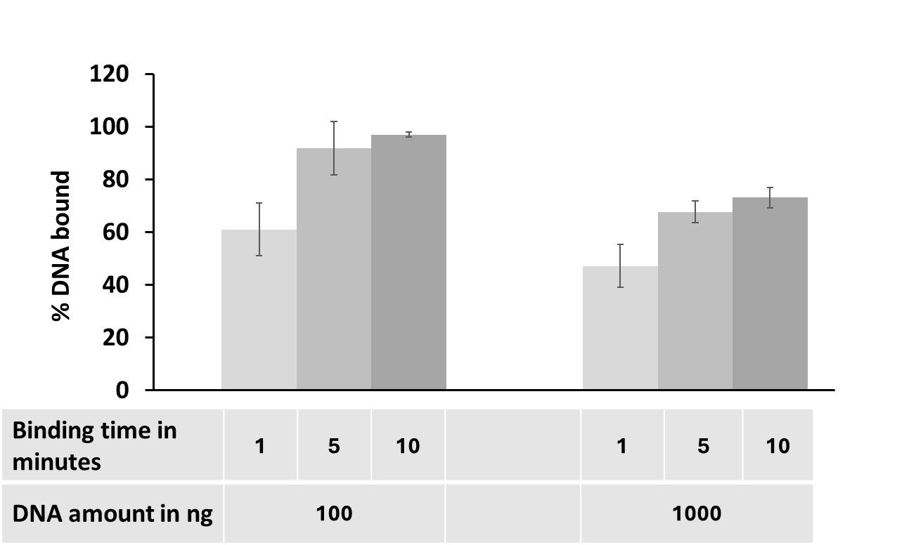
Figure S2: Effect of binding temperature on RNA yield from non-infectious HIV particles. When lysis/binding time is 1 minute, we see that a higher lysis/binding temperature (74 ⁰C) performed better than 62 ⁰C (p-value = 0.02).

Figure S3. The effect of binding time with shaking at both 100 ng and 1000 ng is shown here. This data is the extension of Figure 2b in the main manuscript. With increase in time, we see an increase in % DNA bound- 61.03% is bound in 1 minute vs. 91.72% bound in 5 minutes for 100 ng by orbital shaking method. However, we observe that with further increase in time from 5 to 10 minutes, we do not see a substantial increase in % DNA bound. A similar effect is seen for 1000 ng where in 1 minute, shaking results in 47.17% of DNA bound whereas in 5 minutes, we see nearly 67% bound and at 10 minutes, only 73% of the DNA is bound. The lower DNA binding observed at 1000 ng is likely because the smaller surface area of the 10 µL beads is saturated before completion of binding. The error bar in the graph depicts the SD.
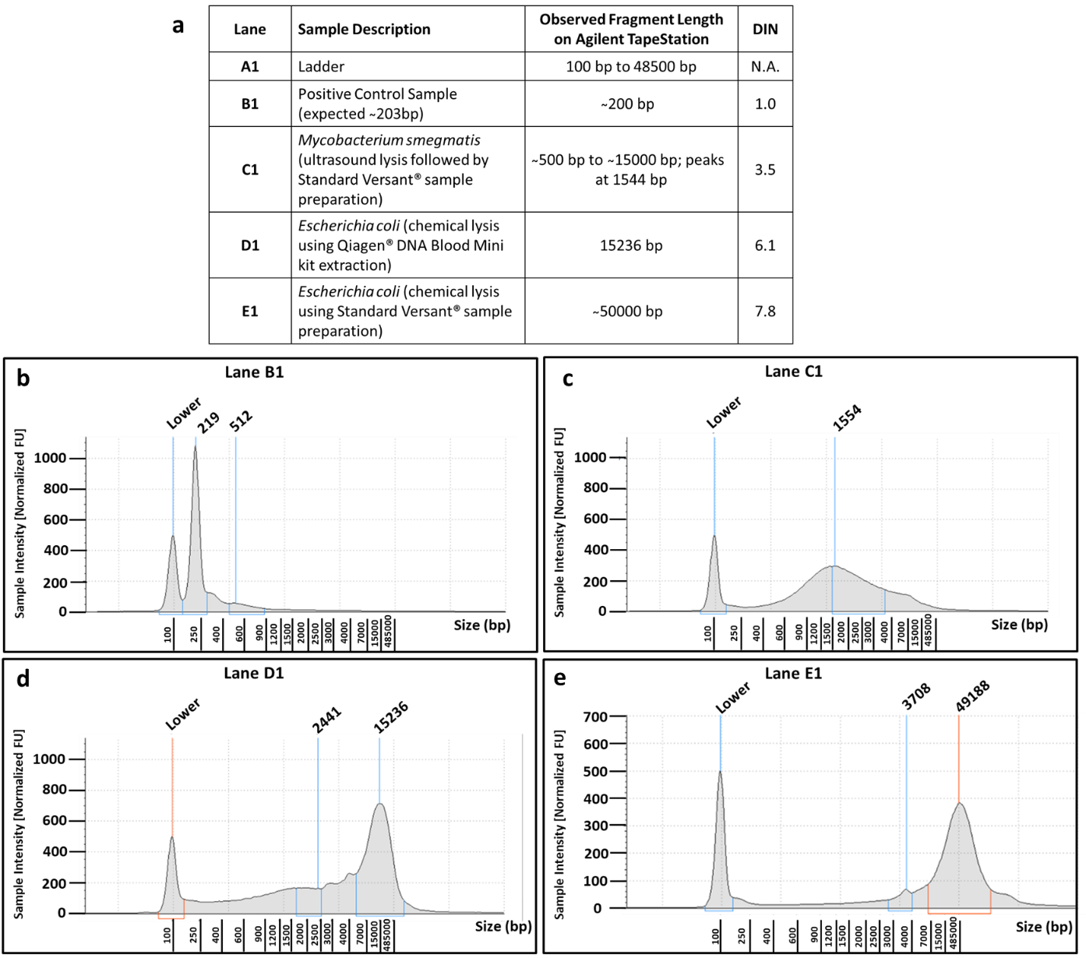
Figure S4: Evaluation of DNA of varying fragment lengths. Automated gel electrophoresis data of the genomic DNA screen tape on the Agilent TapeStation instrument for quality check of DNA samples of different fragment lengths. a. The table elaborates on the sample descriptions and their corresponding fragment lengths as observed on the TapeStation. Higher DIN (DNA Integrity Number) is indicative of better sample quality, lower sample degradation. b. Lane B1 Electrophoretogram of positive control sample with an expected length of ~203 bp. c. Lane C1 Electrophoretogram of shorter DNA fragment from ultrasound lysed M. smegmatis origin. d. Lane D1 Electrophoretogram of longer DNA fragment from chemically lysed E. coli. e. Lane E1 Electrophoretogram of E. coli origin, extracted through the VERSANT® SP method. A mixture of DNA on lanes C1 and E1 are used for the experiment shown in Figure S5.
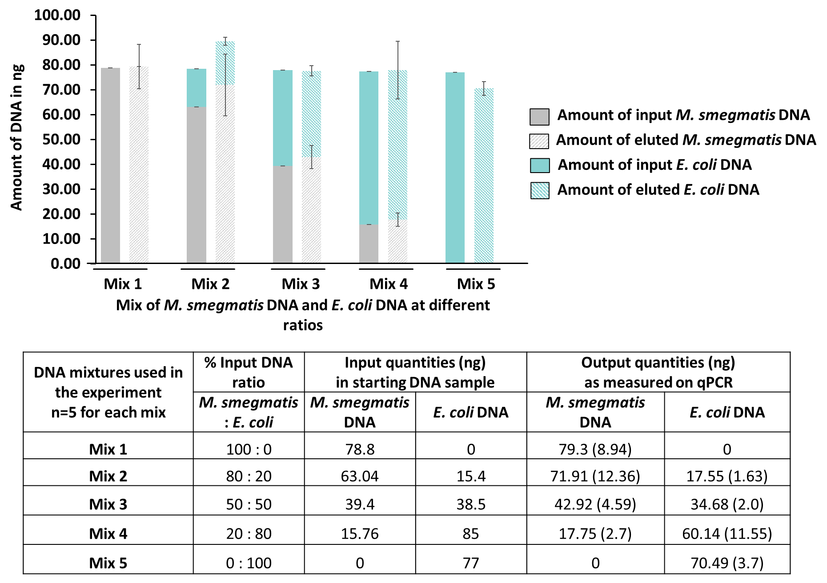
Figure S5: Performance of SHIFT-SP protocol with DNA of different fragment lengths. The protocol is equally efficient with both long (chemically lysed-50 Kbp) and short DNA fragments (ultrasound lysed- range of 500 to 15000 bp). The error bar in the graph and value in the bracket (mentioned in the table) depicts SD.
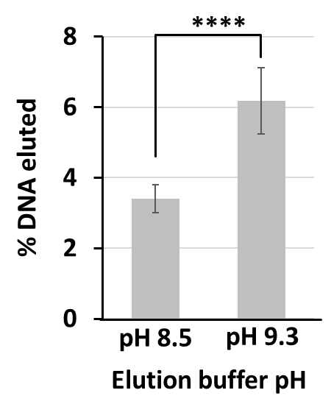
Figure S6: Effect of increased elution buffer pH. pH 9.3 yields more NA than pH 8.5 for extraction done with VERSANT® SP protocol and 10 µL elution volume. The error bar in the graph depicts SD.

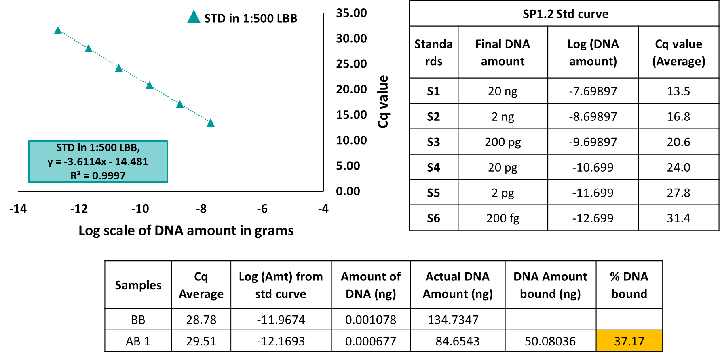
Figure S7: Quantification of % DNA bound to beads using a standard curve. To explain the quantification method, we use an example where the % DNA bound to beads is 37.17%. To estimate the % DNA bound, we run the before binding (BB) aliquot and after binding (AB) aliquot after the required amount of DNA binding to beads. These aliquots are diluted by 1:500 in 1X TE buffer (Tris-EDTA) to decrease the effects of PCR inhibitors in the LBB. A standard curve with DNA standards is made in a similar background as that of BB and AB aliquots (i.e. 1:500 diluted LBB). The standard curves and the corresponding DNA C_{q} values are shown in the above figure. Using the standard curve equation ($y=-3.6114x-14.481$), the total amount of DNA present (x values) in the BB and AB portions are calculated from the equation using C_{q} values obtained (y values) to be -11.96 and -12.169 respectively. The antilogs of these values are then calculated and the final DNA amounts in BB and AB are 0.00107788 and 0.00067723 ng respectively. These values are further corrected for PCR template volume to obtain the per µl DNA amount (4 µl template was used in PCR) i.e., (1/4th of 0.00107788); dilution factor (500 x (1/4th of 0.00107788)) and binding volume (1000 µL x 500 x (1/4th of 0.00107788)). This results in DNA amount in BB fraction to be 134.73 ng and AB fraction to be 84.65 ng respectively. DNA amount bound is then calculated as the difference between BB and AB portions to be 50 ng (134.73- 84.65 = 50.08 ng) in this example. % DNA bound is then calculated as a ratio of DNA amount bound to the beads to the total amount of DNA present in BB. $\% DNA bound=\frac{BB \left(134.73 ng\right)-AB(84.65 ng)}{BB (134.73 ng)}*100$ - this is estimated as 37.17% in this sample
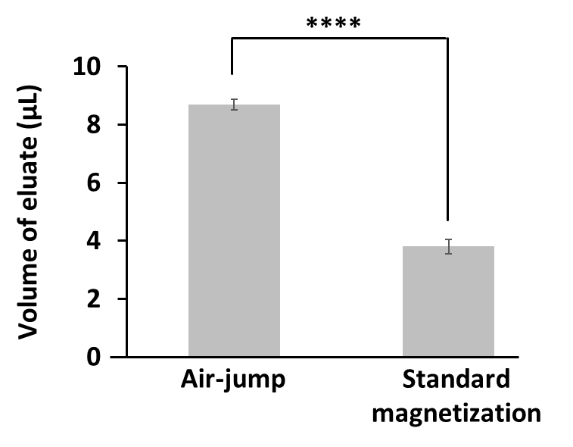
Figure S8: Effect of eluate separation method on volume of the eluate. The “air-jump” method of eluate separation yields a significantly higher volume of eluate, compared to standard eluate separation by magnetization and eluate collection with a pipette tip.

Starting DNA amount – 1000ng
Bead Amount (in µL) | Binding time (in minutes) | % DNA bound
Bead Amount (in µL) | Binding time (in minutes) | Avg (SD)
10 | 2 | 55.93 (6.59)
30 | 2 | 91.78 (3.18)
50 | 2 | 95.87 (1.4)

Table S1: Effect of increased bead quantity, in a “tip-based” binding method for a starting DNA amount of 1000 ng.

Condition # | Lysis/Binding step | Elution condition | Cq value of 1st eluate
SHIFT-SP 1. | Tip (10 µL beads, 74⁰C for 1 min, aspirate, dispense), n=5 | pH 9.3, 82 ⁰C, 3 min Bead and eluate separation done using tip | 26.1 (0.5)
SHIFT-SP 2. | Tip (10 µL beads, 74⁰C for 1 min, aspirate, dispense), n=5 | pH 9.3, 74 ⁰C, 3 min. Bead and eluate separation done using tip | 26.0 (0.4)
VERSANT® 3. | Standard orbital shaking (10 min, pH 8.0, 74⁰C, 1400 rpm), n=3 | pH 8.0, 74⁰C, 10 min, 1100 rpm | 27.4 (0.5)

Table S2: Effect of the SHIFT-SP on RNA yield compared to “Standard” VERSANT® SP method. SHIFT-SP condition 1 and 2 yield better Cq values compared to condition 3. p-values are 0.013 (condition 1 & 3) and 0.016 (condition 2 & 3) respectively. Error values in brackets are SD.

Starting DNA amount |  | Sample replicates | 1st Eluate Yield from SHIFT-SP | Elution wash yield from SHIFT-SP | Total yield (1st Eluate+ Elution wash) from SHIFT-SP
 |  |  | Avg ± SD | Avg ± SD | Avg ± SD
1000 ng | Exp 1 | n=8 | 68.90% (6.92%) | Not done | Not done
1000 ng | Exp 2 | n=8 | 66.35% (14.73%) | Not done | Not done
1000 ng | Exp 3 | n=8 | 75.63% (9.16%) | Not done | Not done
1000 ng | Exp 4 | n=7 | 81.42% (14.29%) | 10.75% (3.62%) | 92.20% (0.49%)
1000 ng | Exp 5 | n=5 | 77.5 % (10.12%) | 27.88 % (23.39 %) | 95% (14.04%)
100 ng | Exp 6 | n=5 | 93.1% (23.87%) | 6.37% (0.37%) | 99.47% (20%)

Table S3: Near complete recovery of the input DNA with SHIFT-SP: SHIFT-SP tested across multiple experiment and sample replicates for both 100 ng and 1000 ng input DNA. Total yield is > 90% when elution wash is done. Elution wash significantly improves DNA yield when input DNA is 1000 ng. p-value = 0.045 for Exp 4 and p-value = 0.031 for Exp 5 (between yield in 1st eluate and total yield after elution wash). p-value is not significant between 1st eluate yield and total yield after elution wash for 100 ng input DNA- Exp 6). Error values in brackets are SD.
 |  | pH 7.6 |  | pH 8.05 |  | pH 8.5 |  | pH 8.93 |  | pH 9.32 |  | Ref - on Ice
 |  | Condition  1 |  | Condition  2 |  | Condition  3 |  | Condition  4 |  | Condition  5 |  | Condition  16
74 °C | Cq Value | 27.54 | 27.79 | 27.8 | 27.65 | 27.63 | 27.67 | 27.43 | 27.47 | 27.67 | 27.82 | 27.33 | 27.61
74 °C | Avg | 27.67 |  | 27.73 |  | 27.65 |  | 27.45 |  | 27.75 |  | 27.47
74 °C | SD | 0.18 |  | 0.11 |  | 0.03 |  | 0.03 |  | 0.11 |  | 0.20
74 °C | Δ Cq wrt ref | 0.20 |  | 0.26 |  | 0.18 |  | -0.02 |  | 0.28
 |  | Condition  6 |  | Condition  7 |  | Condition  8 |  | Condition  9 |  | Condition  10
82 °C | Cq Value | 27.91 | 27.62 | 27.37 | 27.54 | 27.66 | 27.82 | 27.61 | 27.59 | 27.39 | 27.67
82 °C | Avg | 27.77 |  | 27.46 |  | 27.74 |  | 27.60 |  | 27.53
82 °C | SD | 0.21 |  | 0.12 |  | 0.11 |  | 0.01 |  | 0.20
82 °C | Δ Cq wrt ref | 0.30 |  | -0.02 |  | 0.27 |  | 0.13 |  | 0.06
 |  | Condition 11 |  | Condition 12 |  | Condition  13 |  | Condition  14 |  | Condition  15
90 °C | Cq Value | 27.61 | 27.88 | 27.58 | 27.59 | 27.33 | 27.61 | 28.15 | 27.96 | 27.75 | 28.71
90 °C | Avg | 27.75 |  | 27.59 |  | 27.47 |  | 28.06 |  | 28.23
90 °C | SD | 0.19 |  | 0.01 |  | 0.20 |  | 0.13 |  | 0.68
90 °C | Δ Cq wrt ref | 0.27 |  | 0.12 |  | 0.00 |  | 0.59 |  | 0.76

Table S4: Conditions tested for RNA stability - Purified HIV RNA incubated at a given pH and temperature for 3 minutes and then subjected to qPCR to analyze RNA stability. Favorable conditions are Condition 10 (highest temperature where RNA is stable at pH 9.3) and Condition 13 (highest pH where RNA is stable at 90 °C). Condition 16 is a reference where RNA is stored on ice prior to qPCR to prevent degradation. Conditions 14 & 15 show RNA degradation. We tested conditions 5 and 10, both pH 9.3, in RNA elution experiments to maintain the same EB pH as DNA. Please refer to supplementary results for more details.

