Supplementary Interactive Plot Data

Integrated Study of Chromium (VI) Adsorption on Olive Pomace-Derived Activated Carbon: Characterization, DFT calculations, RSM Optimization, Kinetics, Isotherms, and Thermodynamics

- Reagents
The chemicals and reagents used in this study were of analytical quality and procured from Sigma-Aldrich. The products used in this work included phosphoric acid (H₃PO₄ 85%), sodium hydroxide (NaOH 98%), hydrochloric acid (HCl 37%), potassium dichromate (K₂Cr₂O₇), and sulfuric acid (H₂SO₄ 95-97%). A stock solution of hexavalent chromium was prepared in distilled water, and subsequent dilutions were made to obtain the desired working concentrations. The initial pH of the solution was adjusted using hydrochloric acid (0.1M) or sodium hydroxide (0.1M). All solutions were prepared with distilled water.
Table S1. EDS analysis of AC before and after adsorption.
EDS (wt %) before adsorption |  | EDS (wt %) after adsorption
C% | 88 | C% | 77.36
O% | 10.94 | O% | 14.61
P% | 0.46 | P% | 4.51
Na% | 1.7 | Na% | 1.41
 |  | K% | 0.93
 |  | Cr% | 1.18

- HRTEM Analysis
High-resolution transmission electron microscopy (HRTEM) was carried out to verify further structural information and dimensions of the microcrystalline quality of the AC-prepared sample. The TEM images show that the char obtained from olive pomace biomass has a disordered carbon structure, revealing a characteristic typical of amorphous carbon¹⁻³. The images also confirm that the sample has an excellent pore structure derived from the accumulation of false carbon, indicating the presence of several pore sizes that can be seen as transparent sites and clearly show the abundant micropores in the surface of AC as shown in Fig. S1.
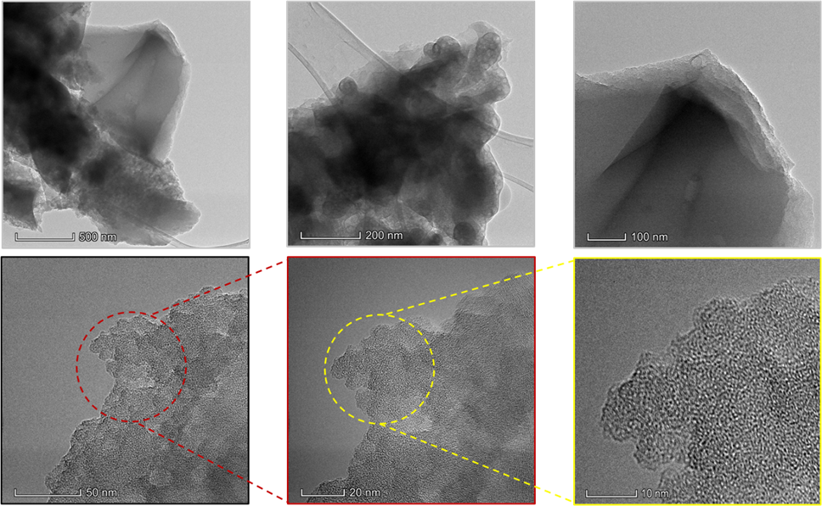
Fig S1: HRTEM images of activated charcoal AC.

Table S2. Experimental design conditions and Cr (VI) adsorption efficiency (R%).

Experiment | Factor: A | Factor: B | Factor: C | Response
Experiment | pH | Dose of AC (mg) | Concentration of Cr (VI) (mg/L) | R (%)
1 | 2 | 0.05 | 12.5 | 32.66
2 | 8 | 0.05 | 12.5 | 7.33
3 | 2 | 0.2 | 12.5 | 96
4 | 8 | 0.2 | 12.5 | 24
5 | 2 | 0.125 | 5 | 93.34
6 | 8 | 0.125 | 5 | 23.41
7 | 2 | 0.125 | 20 | 70.46
8 | 8 | 0.125 | 20 | 20
9 | 5 | 0.05 | 5 | 41
10 | 5 | 0.2 | 5 | 65
11 | 5 | 0.05 | 20 | 28.41
12 | 5 | 0.2 | 20 | 61.67
13 | 5 | 0.125 | 12.5 | 48
14 | 5 | 0.125 | 12.5 | 49.33
15 | 5 | 0.125 | 12.5 | 48.35

- RSM Approach and Statistical Analysis
The adequacy of the selected quadratic model was verified using a curve comparing the predicted values to the actual values, along with a normal residual plot (Fig. S2). This allowed for establishing the relationship between the experimental and predicted results, and assessing the model’s ability to predict the efficiency of hexavalent chromium removal by the activated carbon ACp. Figure 5a shows the correlation between the actual and predicted values. In Fig. S2b, the points are closely aligned along a straight line, indicating an ideal normal distribution of the residuals and their independence⁴. The statistical validation of the model is confirmed by Fig. S2b, where the actual and predicted values are close to each other. These results are also supported by the ANOVA analysis presented in Table S3.
The statistical significance of the quadratic model was analyzed through analysis of variance (ANOVA), considering the F and p values of the different terms in the elimination model. The ANOVA was calculated using Design Expert 12 software (Table S3). The high F values and low p values for the different terms indicate that the quadratic model is significant and well-suited. The F value of 36.21 suggests that the model is highly significant, with only a 0.05% probability that such a value is due to chance or noise ⁵. P values below 0.05 indicate that the model terms are significant. In this case, A, B, C, and AB are significant terms. However, the interaction terms AC and BC are not significant (p > 0.05).
The value of the adjusted determination coefficient Radj² of 0.9577 was very close to the determination coefficient R²= 0.985, confirming a good fit of the experimental data with the chosen model⁶. The difference between the predicted R² and the adjusted (0.9577) was less than 0.2, indicating that the predicted R² is in reasonable agreement with the adjusted. The quality of the model's regression was also evaluated by the adequate precision (AP) and CV%. This clearly shows that the differences between the experimental and predicted values are very small and confirms the capability of the developed model. AP measures the signal-to-noise ratio. A ratio greater than 4 is desirable. A ratio of 20.158 indicates an adequate signal. This model will be used to navigate the design space.
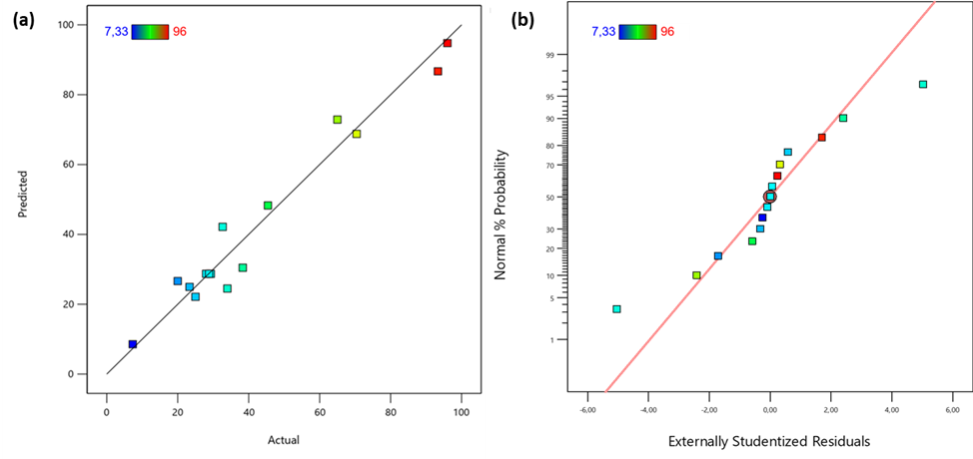
Fig S2: Model adequacy plots: actual vs predicted plot (a), normal plot of residuals (b).

Table S3. Analysis of variance (ANOVA) for the quadratic response surface model
Source | Sum of Squares | df | Mean Square | F-value | p-value
Model | 9472.58 | 9 | 1052.51 | 36.21 | 0.0005
A-pH | 5923.26 | 1 | 5923.26 | 203.78 | < 0.0001
B-Dose of AC | 2354.92 | 1 | 2354.92 | 81.02 | 0.0003
C- Concentration of Cr(VI) | 223.03 | 1 | 223.03 | 7.67 | 0.0394
AB | 544.44 | 1 | 544.44 | 18.73 | 0.0075
AC | 95.22 | 1 | 95.22 | 3.28 | 0.1301
BC | 21.42 | 1 | 21.42 | 0.7370 | 0.4299
A² | 30.97 | 1 | 30.97 | 1.07 | 0.3493
B² | 118.48 | 1 | 118.48 | 4.08 | 0.0995
C² | 138.42 | 1 | 138.42 | 4.76 | 0.0809
Residual | 145.34 | 5 | 29.07
Lack of Fit | 144.38 | 3 | 48.13 | 100.72 | 0.0098
Pure Error | 0.9557 | 2 | 0.4778
Cor Total | 9617.92 | 14
C.V. % | 11.41
R² | 0.9849
R²_{adji} | 0.9577
R²_{pred} | 0.7596
AP: Adeq. precision | 20.1576

- Establishment of Equilibrium
To establish the adsorption equilibrium of chromium (VI) on activated carbon, we monitored the variation in the percentage of chromium (VI) removal overtime at a temperature of 25°C. A quantity of 0.1 g of activated carbon was brought into contact with 250 mL of a chromium (VI) solution with an initial concentration of 5 mg/L. The solutions were analyzed after 10 minutes and up to 8 hours. The study of hexavalent chromium ion adsorption on activated carbon over time allows for determining the adsorbent-adsorbate contact time needed to establish adsorption equilibrium. The percentage of chromium removed by adsorption is calculated using Eq 1. The curve representing the variation in the percentage of chromium (VI) removal over time is shown in Fig. S3. The results show that the adsorption efficiency increases with contact time. Adsorption is rapid at the beginning of the process. After approximately 30 minutes, the adsorption rate is estimated at 34.68%, likely due to the availability of a large number of active sites on the surface of the carbon. As the active sites gradually become occupied, the adsorption process slows down. The equilibrium efficiency, reached after approximately 120 minutes, is estimated at 77%. The variation in the percentage of chromium (VI) removal over time shows that adsorption equilibrium on activated carbon is reached after 2 hours, a time frame that can be considered satisfactory.
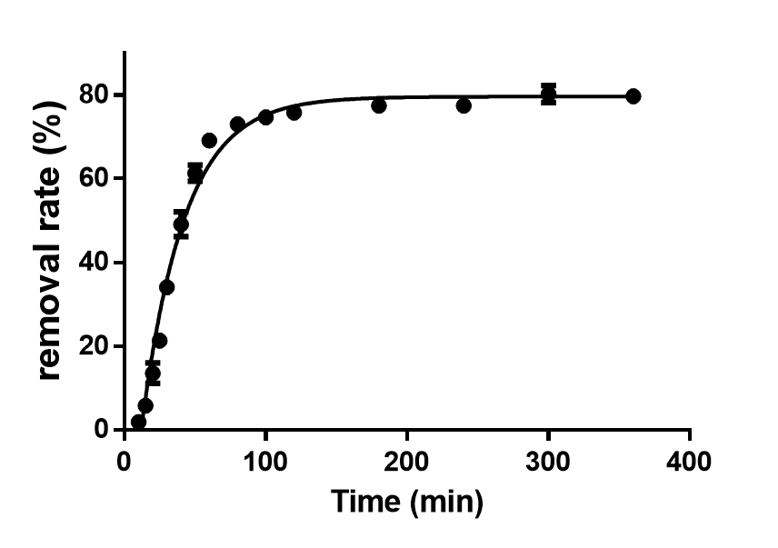
Fig S3: Variation in chromium removal rate as a function of time at pH=4.5 and C=5mg/l.

    - Adsorption Thermodynamics and Effect of Temperature
The effect of temperature on Cr (VI) adsorption was evaluated at five different temperatures: 16°C, 20°C, 30°C, 40°C, and 50°C. The solution pH was maintained at 2, consistent with the previously determined optimal conditions. An initial Cr (VI) concentration of 20 mg/L was used, and the stirring speed was set at 350 rpm. As shown in Fig. S4a, the removal efficiency of Cr (VI) increased from 74% to 97.7% as the temperature increased from 16°C to 50°C. This indicates that the adsorption process is endothermic. The observed trend aligns with Arrhenius' law, which suggests that increasing temperature facilitates the adsorption process. This enhancement is likely due to the increase in the diffusion coefficient of mass, which accelerates the diffusion rate of Cr (VI) molecules across the external boundary layer and their penetration into the internal pores of the activated carbon (AC) particle.
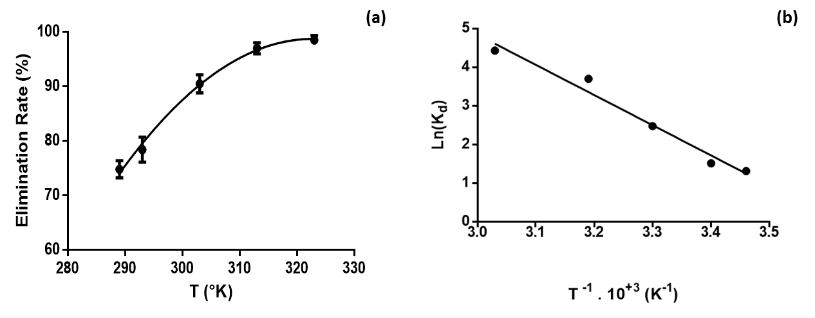
Fig S4: Variation in Cr(VI) removal rate as a function of temperature (a), Linearization of Ln (K_{d}) versus 1/T of Cr(VI) adsorption

References

1. Chen, S., Yue, Q., Gao, B., Li, Q., & Xu, X. Removal of Cr (VI) from aqueous solution using modified corn stalks: Characteristic, equilibrium, kinetic and thermodynamic study. Chemical Engineering Journal, 168(2), 909-917 (2011).
2. Gupta, G. K., Sagar, P., Pandey, S. K., Srivastava, M., Singh, A. K., Singh, J., & Srivastava, A. In situ fabrication of activated carbon from a bio-waste desmostachya bipinnata for the improved supercapacitor performance. Nanoscale research letters, 16(1), 85 (2021).
3. Zhao, J., Yu, L., Zhou, F., Ma, H., Yang, K., Wu, G. Synthesis and characterization of activated carbon from sugar beet residue for the adsorption of hexavalent chromium in aqueous solutions. RSC advances, 11(14), 8025-8032 (2021).
4. Castro-Castro, J. D., Macías-Quiroga, I. F., Giraldo-Gómez, G. I., & Sanabria-González, N. R. Adsorption of Cr (VI) in Aqueous Solution Using a Surfactant‐Modified Bentonite. The Scientific World Journal, 2020(1), 3628163 (2020).
5. Jawad, A. H., Abdulhameed, A. S., Abd Malek, N. N., & ALOthman, Z. A. Statistical optimization and modeling for color removal and COD reduction of reactive blue 19 dye by mesoporous chitosan-epichlorohydrin/kaolin clay composite. International journal of biological macromolecules, 164 4218-4230 (2020).
6. Leovac Maćerak, A., Kulić Mandić, A., Pešić, V., Tomašević Pilipović, D., Bečelić-Tomin, M., & Kerkez, D. “Green” nZVI-biochar as fenton catalyst: perspective of closing-the-loop in wastewater treatment. Molecules, 28(3), 1425 (2023).

