Characterization and Optimization of Azo Dyes Degrading Microbes Isolated from Textile Effluent

Arshiya Khan^{1,3}, Anuraj Nayarisseri^{1,2}, Sanjeev Kumar Singh^{3*}
*Corresponding authors: skysanjeev@gmail.com, anuraj@eminentbio.com
¹ In silico Research Laboratory, Eminent Biosciences, Indore – 452 010, Madhya Pradesh, India.
² Bioinformatics Research Laboratory, LeGene Biosciences Pvt Ltd, Indore - 452010, Madhya Pradesh, India.
³Computer Aided Drug Designing and Molecular Modeling Lab, Department of Bioinformatics, Alagappa University, Karaikudi-630 003, Tamil Nadu, India;

Corresponding authors

1. Dr. Sanjeev Kumar Singh
Designation: Professor
Affiliation: Computer Aided Drug Design and Molecular Modelling Lab, Department of Bioinformatics, Alagappa University, Karaikudi - 630003, Tamil Nadu, India.
Tel: +91-9894429800
E-mail: skysanjeev@gmail.com
ORCID: http://orcid.org/0000-0003-4153-6437

Table S1: Properties of the model dyes
Properties | Methyl Red | Direct Yellow -12 | Acid Black 210
No. of Azo bonds | 1 | 2 | 3
CAS number | 493-52-7 | 2870-32-8 | 99576-15-5
EC number | 207-776-1 | 220-698-2 | 421-880-6
CI | 13020 | 24895 | 300285
Synonyms | Acid Red 3 | Chrysophenine G | Jet Black
Light Fastness | 1-2 | 5 | 6

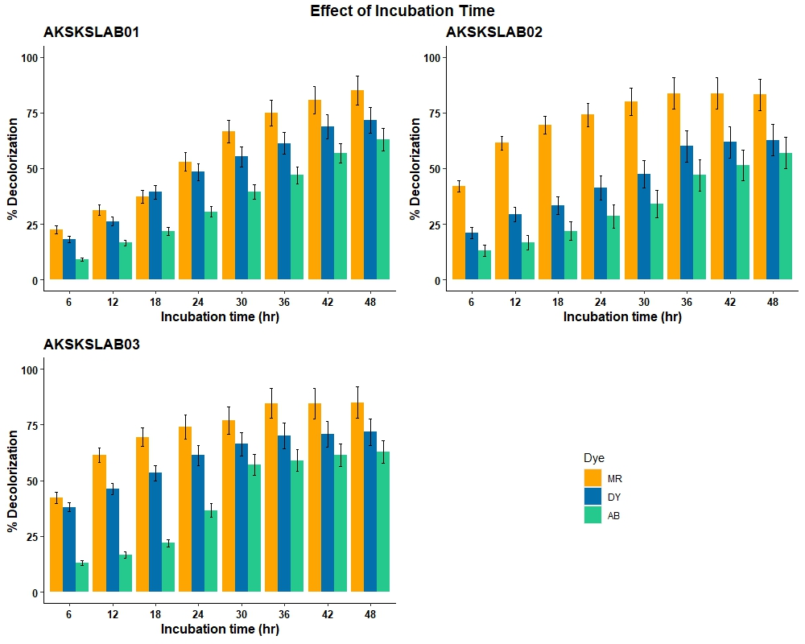

Fig. S1: Effect of Incubation time on decolorization of model dyes.
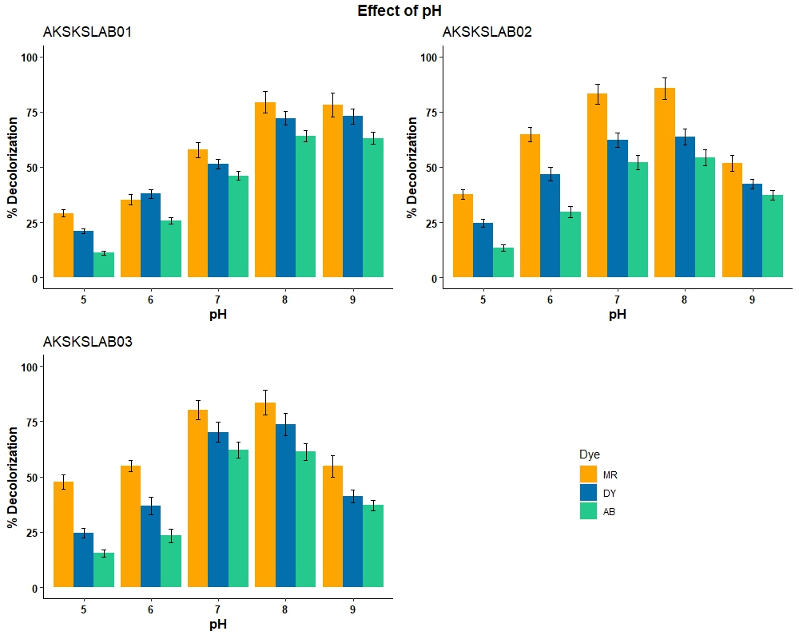
Fig. S2: Effect of pH on decolorization of model dyes
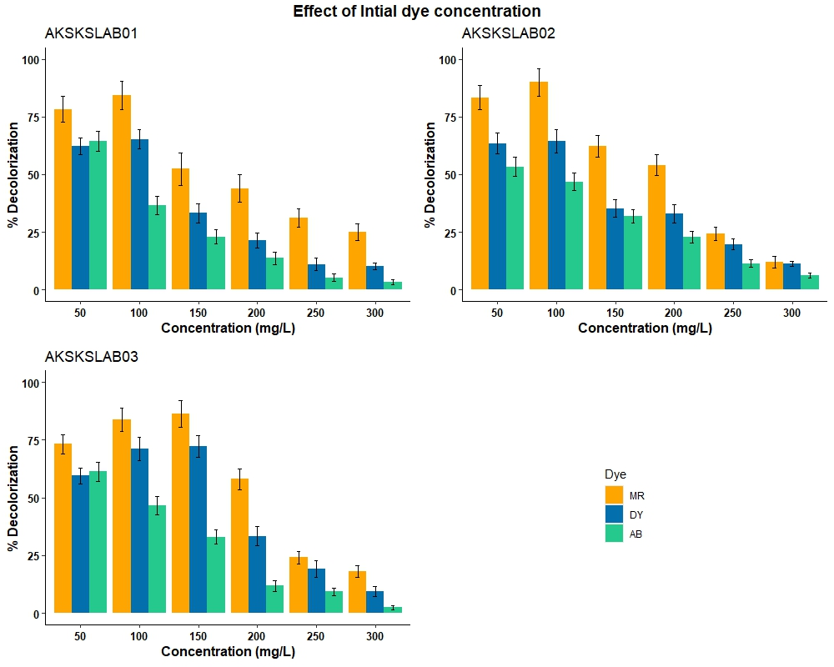
Fig. S3: Effect of initial Concentration on decolorization of model dyes.
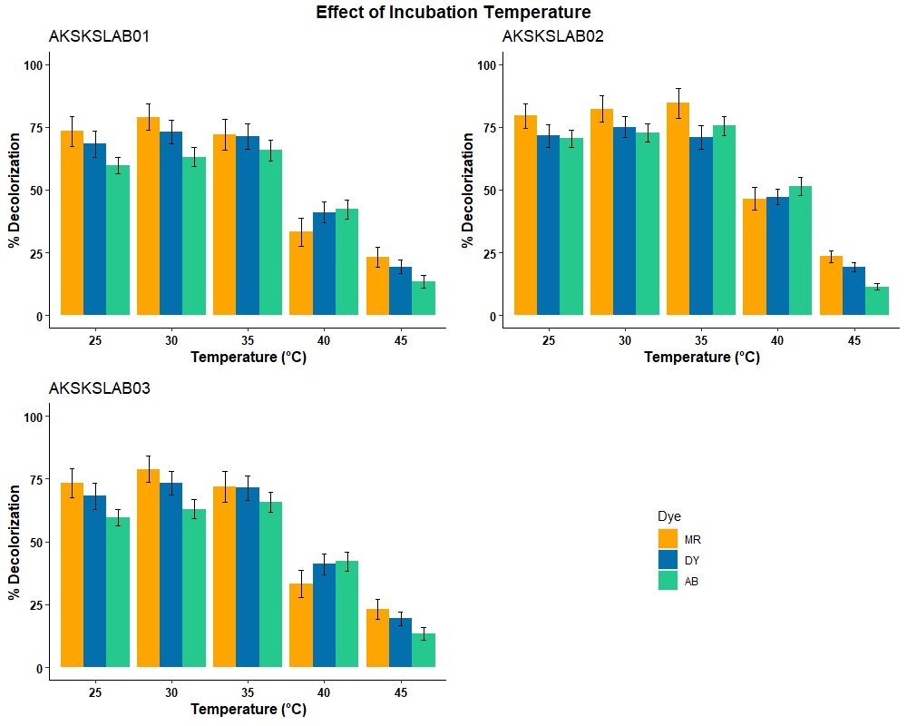
Fig. S4: Effect of Temperature on decolorization of model dyes.

Table S2: Experimental and predicted responses of model dyes
MR |  | DY 12 |  | AB 210
Response | Predicted | Response | Predicted | Response | Predicted
77.18 | 84.61 | 70.12 | 76.80 | 53.99 | 56.80
32.20 | 33.37 | 35.31 | 36.11 | 12.08 | 16.11
15.791 | 11.61 | 14.65 | 16.86 | 8.042 | 11.86
31.25 | 29.44 | 28.03 | 27.99 | 18.78 | 21.99
10.11 | 13.74 | 18.95 | 17.31 | 11.50 | 15.31
19.74 | 25.16 | 16.94 | 18.89 | 7.39 | 12.89
78.29 | 79.61 | 70.69 | 73.80 | 54.25 | 58.80
36.70 | 38.16 | 31.89 | 34.98 | 26.41 | 24.68
17.18 | 22.89 | 14.95 | 19.56 | 12.81 | 10.56
79.16 | 81.61 | 71.52 | 74.80 | 56.80 | 54.80
14.36 | 11.33 | 15.18 | 19.26 | 28.35 | 30.26
54.36 | 51.33 | 48.25 | 41.13 | 34.12 | 31.13
53.95 | 57.12 | 45.41 | 37.07 | 33.22 | 33.07
78.91 | 84.61 | 69.96 | 74.80 | 53.24 | 54.80
82.82 | 85.52 | 79.37 | 79.69 | 59.74 | 61.69
14.53 | 17.15 | 32.15 | 31.88 | 36.63 | 34.88
78.263 | 72.61 | 71.25 | 74.80 | 53.39 | 56.26
53.05 | 53.12 | 28.17 | 31.01 | 22.85 | 19.01
78.07 | 79.61 | 70.93 | 72.80 | 53.60 | 54.80
32.822 | 35.52 | 25.25 | 24.31 | 19.59 | 14.31

Table S3: Statistical Coefficients and their significant values of Methyl Red

 | Estimate | Std. Error | t value | Pr(>|t|)
Intercept | -287.1566606 | 42.30949213 | -6.78705052 | 4.81681E-05 | ***
ph_actual | 48.51233381 | 6.461607748 | 7.507780679 | 2.04445E-05 | ***
temp_actual | 8.806907667 | 1.291024494 | 6.821642583 | 4.6162E-05 | ***
conc_actual | 0.68398723 | 0.155251513 | 4.405671901 | 0.001323317 | **
ph_actual:temp_actual | -0.226077154 | 0.095686049 | -2.36269714 | 0.03976981 | *
ph_actual:conc_actual | -0.014024716 | 0.01275814 | -1.09927593 | 0.029740758 | *
temp_actual:conc_actual | 0.006333333 | 0.002551628 | 2.482075523 | 0.032427357 | *
ph_actual^2 | -2.996140169 | 0.358670816 | -8.35345401 | 8.04717E-06 | ***
temp_actual^2 | -0.115945887 | 0.014268373 | -8.1260763 | 1.02651E-05 | ***
conc_actual^2 | -0.002388111 | 0.000252274 | -9.46633796 | 2.62157E-06 | ***

Table S4: Statistical Coefficients and their significant values DY-12
 | Estimate | Std. Error | t value | Pr(>|t|)
Intercept | -141.191 | 24.21233 | -5.83136 | 0.000166 | ***
ph_actual | 27.79738 | 3.697765 | 7.517347 | 2.02E-05 | ***
temp_actual | 4.908006 | 0.738811 | 6.643117 | 5.76E-05 | ***
conc_actual | 0.260902 | 0.088845 | 2.936592 | 0.014872 | *
ph_actual:temp_actual | 0.19226 | 0.054758 | 3.511078 | 0.005622 | **
ph_actual:conc_actual | 0.019122 | 0.007301 | 2.619013 | 0.025641 | *
temp_actual:conc_actual | 0.004309 | 0.00146 | 2.950678 | 0.014518 | *
ph_actual^2 | -2.68646 | 0.205255 | -13.0884 | 1.29E-07 | ***
temp_actual^2 | -0.0996 | 0.008165 | -12.1985 | 2.5E-07 | ***
conc_actual^2 | -0.00156 | 0.000144 | -10.8071 | 7.77E-07 | ***

Table S5: Statistical Coefficients and their significant values AB-210
 | Estimate | Std. Error | t value | Pr(>|t|)
Intercept | -115.541 | 8.056022 | -14.3422 | 5.38E-08 | ***
ph_actual | 19.16861 | 1.230335 | 15.57999 | 2.43E-08 | ***
temp_actual | 3.87227 | 0.24582 | 15.75246 | 2.18E-08 | ***
conc_actual | 0.43288 | 0.029561 | 14.64364 | 4.4E-08 | ***
ph_actual:temp_actual | 0.028808 | 0.018219 | 1.58116 | 0.0144923 | *
ph_actual:conc_actual | 0.012158 | 0.002429 | 5.004715 | 0.000534 | ***
temp_actual:conc_actual | 0.001249 | 0.000486 | 2.571104 | 0.027838 | *
ph_actual^2 | -1.59097 | 0.068293 | -23.2961 | 4.81E-10 | ***
temp_actual^2 | -0.06071 | 0.002717 | -22.345 | 7.24E-10 | ***
conc_actual^2 | -0.00168 | 4.8E-05 | -34.9354 | 8.75E-12 | ***

The p-value determines the significance of the model values; ‘***’ denotes p-value < 0.001, ‘**’ denotes p-value < 0.01, ‘*’ denotes p-value <0.05, ‘.’ denotes p-value < 0.1.

Table S6: Conserved and variable regions
 | Sequence | Total positions | Conserved regions | Variable regions
1 | AKSKSLAB01 | 1162 | 1084 | 113
2 | AKSKSLAB02 | 1411 | 1297 | 95
3 | AKSKSLAB03 | 1407 | 1270 | 111
4 | AKSKSLAB04 | 1425 | 1239 | 181

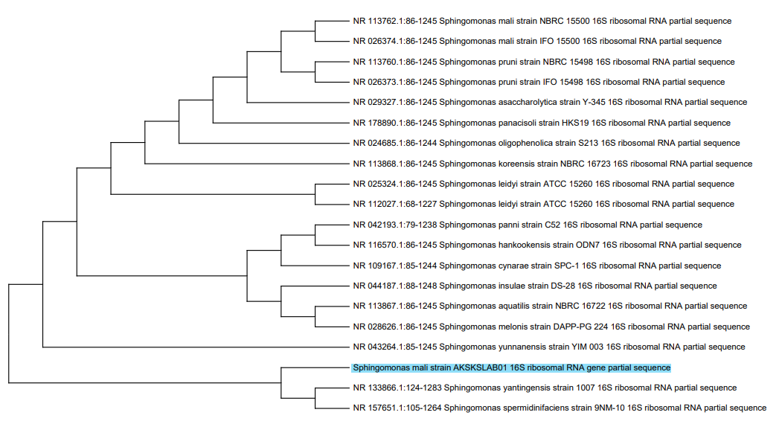
Fig. S5: Phylogenetic analysis of Sphingomonas mali strain AKSKSLAB01 against other species of Sphingomonas

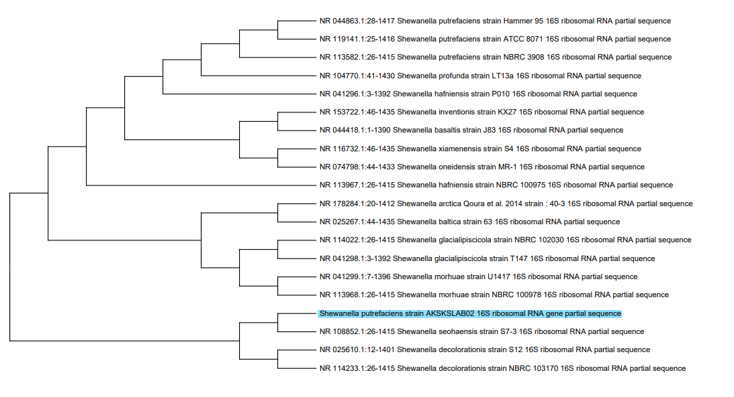
Fig. S6: Phylogenetic analysis of Shewanella Putrefaciens AKSKSLAB02 against other species of Shewanella
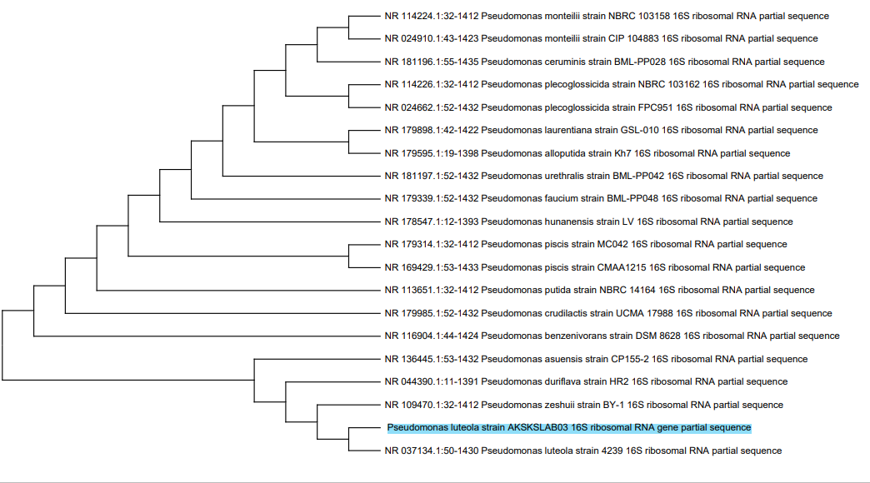
Fig. S7: Phylogenetic analysis of Pseudomonas luteola AKSKSLAB03 against other species of Pseudomonas

Table S7: Thermodynamics of the novel strains
Strain |  | Structural Element |  | δG |  | Information
Sphingomonas mali strain AKSKSLAB01 16S  δG = -450.30 kcal/mol |  | External loop |  | -2.80 |  | 11 ss bases & 3 closing helices
 |  | Stack |  | -2.10 |  | External closing pair is U ¹¹⁴¹-A ¹¹⁶²
 |  | Multi-loop |  | 0.60 |  | External closing pair is C ⁸⁹-G ¹¹³³  5 ss bases & 3 closing helices.
 |  | Helix |  | -12.10 |  | 7 base pairs.
 |  | Hairpin loop |  | 5.10 |  | Closing pair is U ¹⁰⁶⁹-G ¹⁰⁷⁵
 |  | Interior loop |  | 0.80 |  | External closing pair is C ⁹⁴²-G ¹¹¹⁰
 |  | Bulge loop |  | 1.40 |  | External closing pair is U ³⁸⁶-A ⁷⁹⁸
Shewanella putrefaciens strain AKSKSLAB02  δG = -550.80 kcal/mol |  | External loop |  | -1.90 |  | 2 ss bases & 2 closing helices.
 |  | Stack |  | -3.30 |  | External closing pair is G ¹³-C ¹⁴⁰³
 |  | Multi-loop |  | 0.70 |  | External closing pair is G ¹⁷-C ¹³⁹⁸  24 ss bases & 3 closing helices.
 |  | Helix |  | -2.40 |  | 2 base pairs.
 |  | Hairpin loop |  | 5.10 |  | Closing pair is G ¹³¹² - C ¹³²²
 |  | Interior loop |  | -1.10 |  | External closing pair is C ⁹⁵³-G ¹¹⁰⁸
 |  | Bulge loop |  | 0.50 |  | External closing pair is G ⁸-C ¹⁴¹⁰
 | Pseudomonas luteola strain AKSKSLAB03  δG =-538.90 kcal/mol |  | External loop |  | -1.90 |  | 9 ss bases & 1 closing helices.
 |  |  | Stack |  | -2.20 |  | External closing pair is G ⁴²-C ¹⁴²¹
 |  |  | Multi-loop |  | -0.5. |  | External closing pair is C ¹⁴-G ¹³⁹⁴  4 ss bases & 3 closing helices.
 |  |  | Helix |  | -9.40 |  | 2 base pairs.
 |  |  | Hairpin loop |  | 6.10 |  | Closing pair is A ¹²⁹⁶-U ¹³⁰⁶
 |  |  | Interior loop- |  | 0.40 |  | external closing pair is A ¹⁸⁹-U ¹³⁷⁶
 |  |  | Bulge loop |  | 1.70 |  | External closing pair is A ¹²-U ¹³⁹⁷

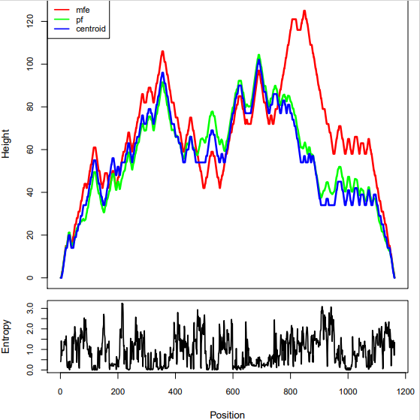
Fig. S8: Hill plot: energy and entropy distribution of 16S rRNA for Sphingomonas Mali AKSKSLAB01

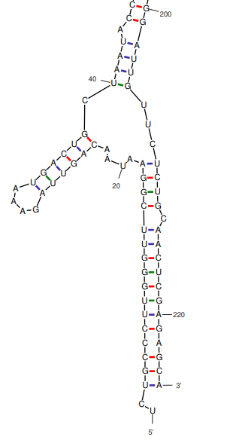
Fig. S9: 16S rRNA secondary structure of Sphingomonas Mali AKSKSLAB01
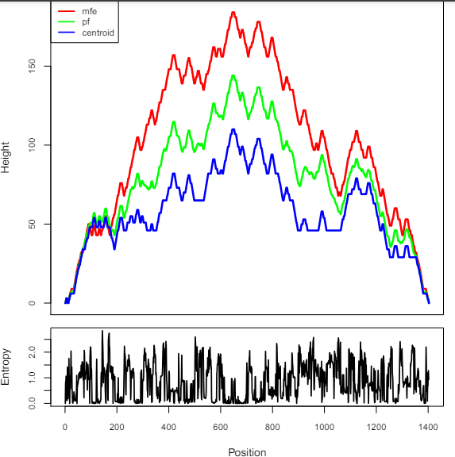
Fig.S10: Hill plot: energy and entropy distribution of 16S rRNA for Shewanella Putrefaciens AKSKSLAB02
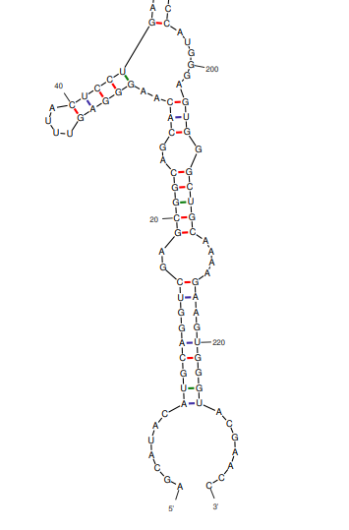
Fig. S11: 16S rRNA secondary structure of Shewanella Putrefaciens AKSKSLAB02
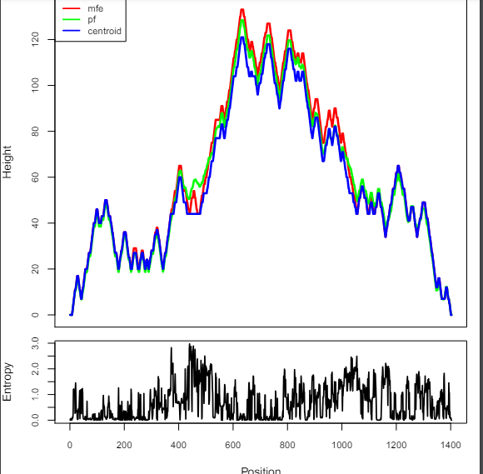
Fig.S12: Hill plot: energy and entropy distribution of 16S rRNA for Pseudomonas lueteola AKSKSLAB03

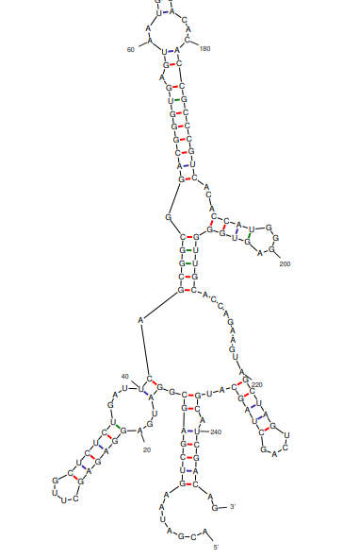
Fig. S13: 16S rRNA secondary structure of Pseudomonas Leuteola AKSKSLAB03

