Supplementary Information
for
A Paper-based Loop-Mediated Isothermal Amplification (LAMP) Assay for Highly Pathogenic Avian Influenza
Mohamed Kamel^{1,2}, Josiah Levi Davidson¹, Jenna M. Schober³, Gregory S. Fraley³
Mohit S. Verma^{1, 4, 5*}
¹Department of Agricultural and Biological Engineering, Purdue University, West Lafayette, IN, USA, 47907
²Department of Medicine and Infectious Diseases, Faculty of Veterinary Medicine, Cairo University, Giza 12211, Egypt
³Department of Animal Sciences, Purdue University, West Lafayette, IN 47907-2050, USA
⁴Birck Nanotechnology Center, Purdue University, West Lafayette, IN, USA, 47907
⁵Weldon School of Biomedical Engineering, Purdue University, West Lafayette, IN, USA, 47907

*Corresponding author: msverma@purdue.edu

Supplementary figures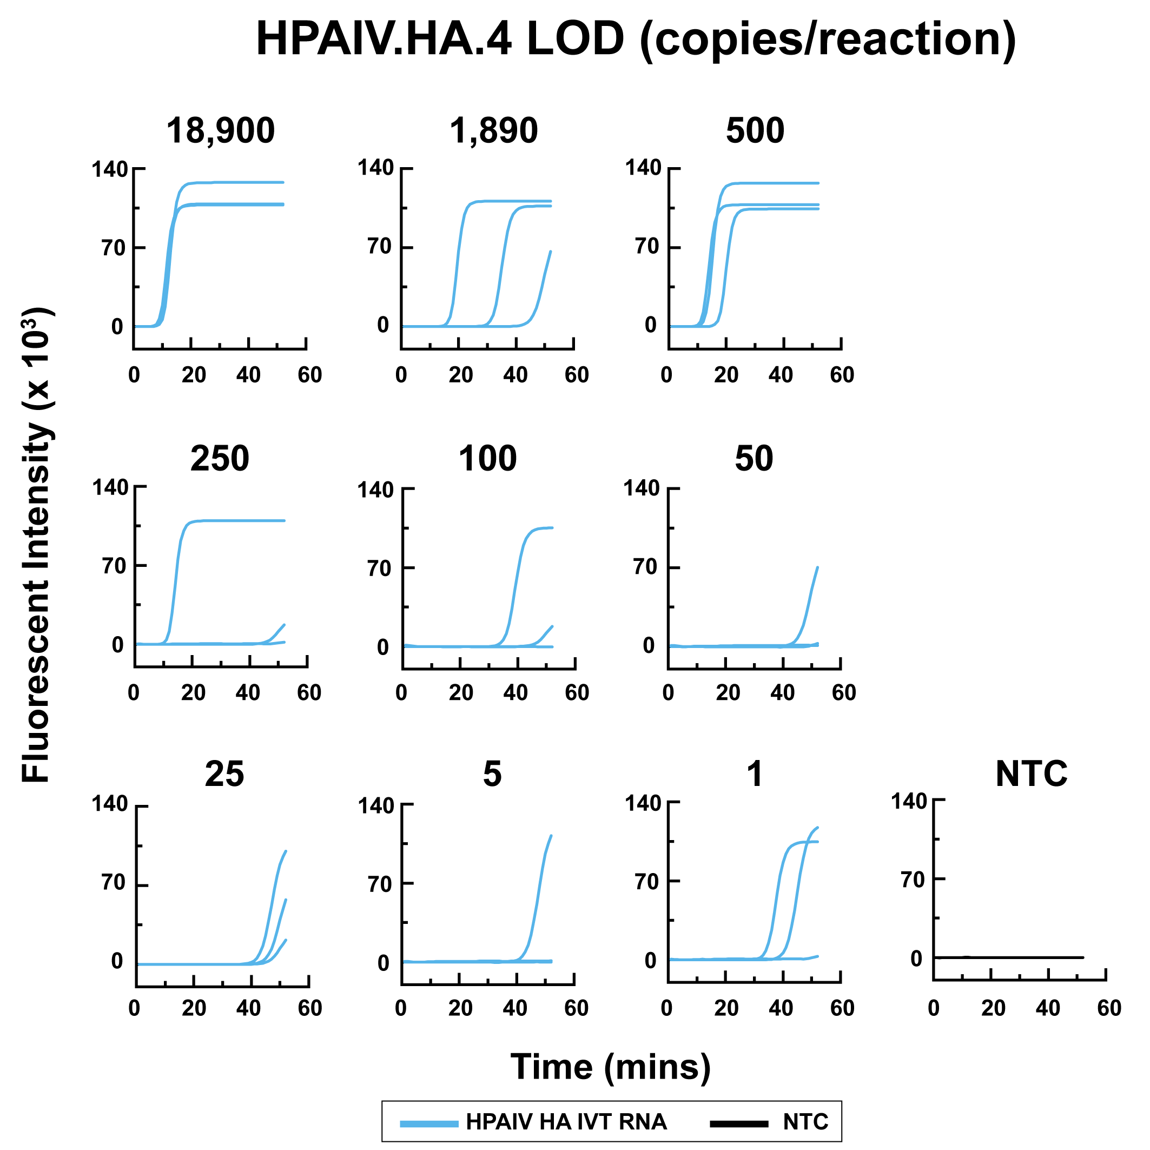
Supplementary Fig. 1: LOD experiment showing the result of the H5 subtype AIV qLAMP assay of the HPAIV.HA.4 primer set using the fluorescent qLAMP assay testing different concentrations of IVT RNA (18900, 1890, 500, 250, 125, 50, 25, 5, and 1 copies/reaction)

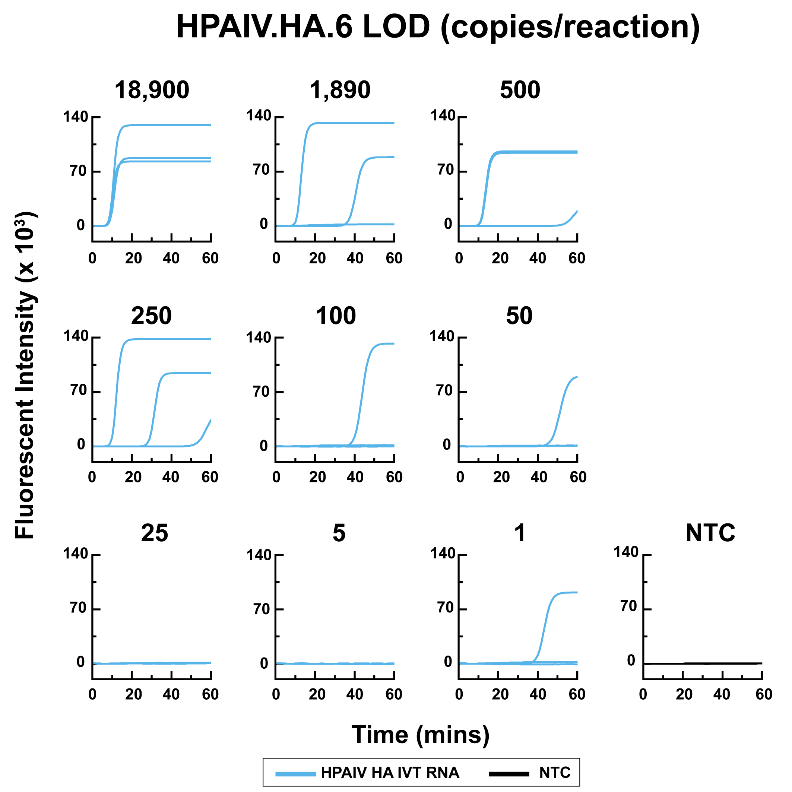
Supplementary Fig. 2: LOD experiment showing the result of the H5 subtype AIV qLAMP assay of the HPAIV.HA.6 primer set using the fluorescent qLAMP assay testing different concentrations of IVT RNA (18900, 1890, 500, 250, 125, 50, 25, 5, and 1 copies/reaction)

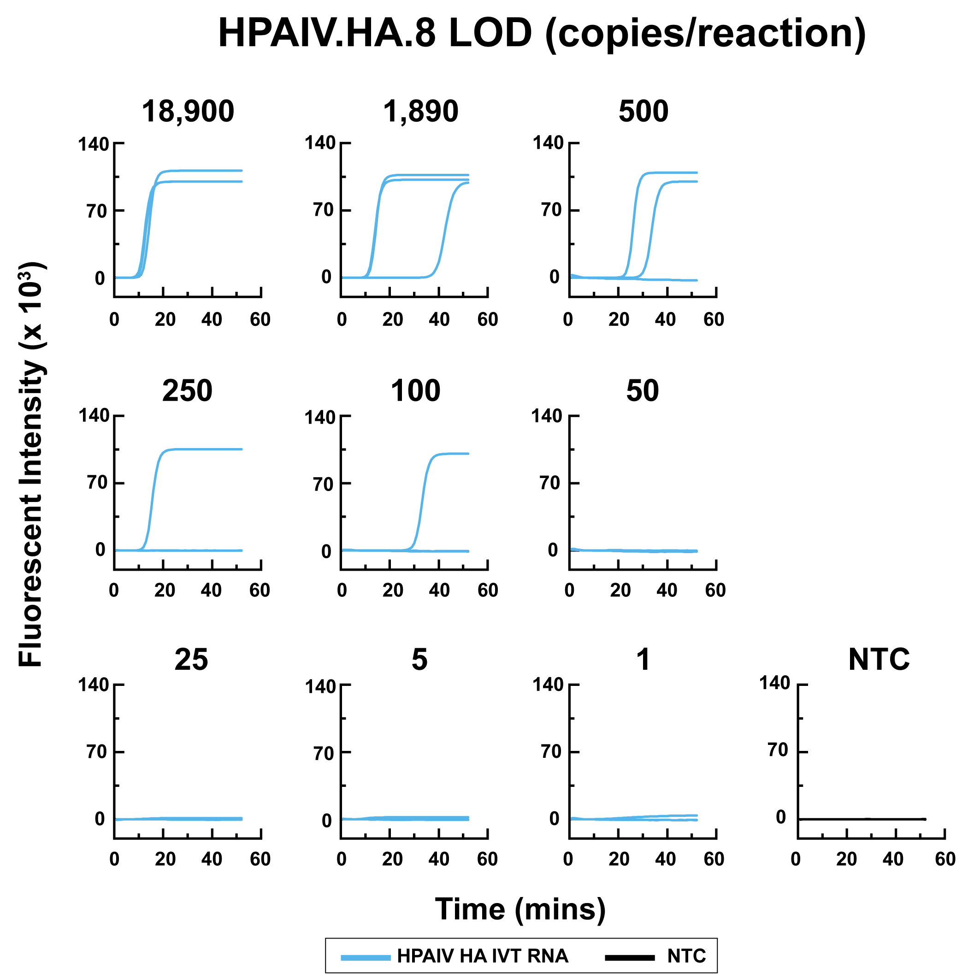
Supplementary Fig. 3: LOD experiment showing the result of the H5 subtype AIV qLAMP assay of the HPAIV.HA.8 primer set using the fluorescent qLAMP assay testing different concentrations of IVT RNA (18900, 1890, 500, 250, 125, 50, 25, 5, and 1 copies/reaction)

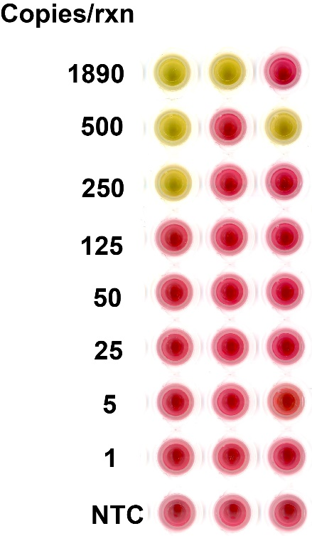
Supplementary Fig. 4: Limit of Detection (LOD) experiment of the H5 subtype AIV colorimetric liquid LAMP assay using the HPAIV.HA.4 primer set. The colorimetric liquid LAMP assay was performed to test various concentrations of IVT RNA (1890, 500, 250, 125, 50, 25, 5, and 1 copies/reaction).

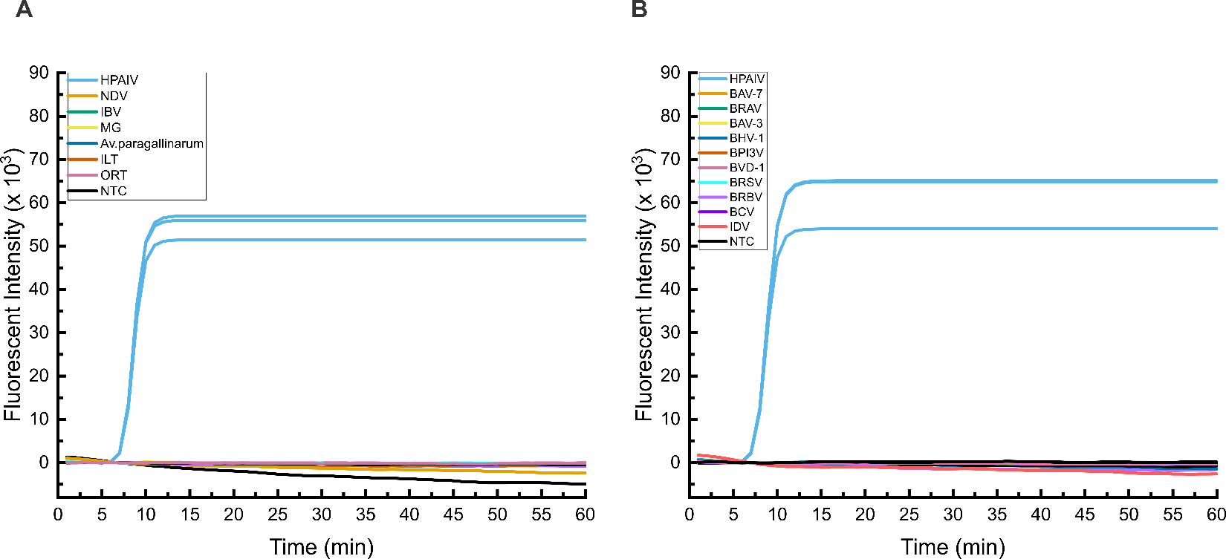

Supplementary Fig. 5: Cross-reactivity test of HPAIV.HA.5 against various avian and bovine pathogens.
(A) Cross-reactivity test of HPAIV.HA.5 against various avian pathogens including Newcastle Disease Virus (NDV) (non-virulent), Infectious Bronchitis Virus (IBV), Avian Infectious Laryngotracheitis Virus (ILT), Mycoplasma gallisepticum MG), Ornithobacterium rhinotracheale (ORT), and Avibacterium (Av) paragallinarum (Infectious Coryza).
(B) Cross-reactivity test of HPAIV.HA.5 against various bovine pathogens including Bovine Rhinitis A Virus (BRAV) , bovine rhinitis B virus (BRBV), Bovine Coronavirus (BCV), Influenza D Virus (IDV), Bovine Adenovirus type 3 (BAV-3), Bovine Herpesvirus type 1 (BHV-1), Bovine Viral Diarrhea Virus type 1 (BVDV-1), Bovine Respiratory Syncytial Virus (BRSV), Bovine Adenovirus type 7 (BAV-7), and Bovine Parainfluenza Virus type 3 (BPI3V).

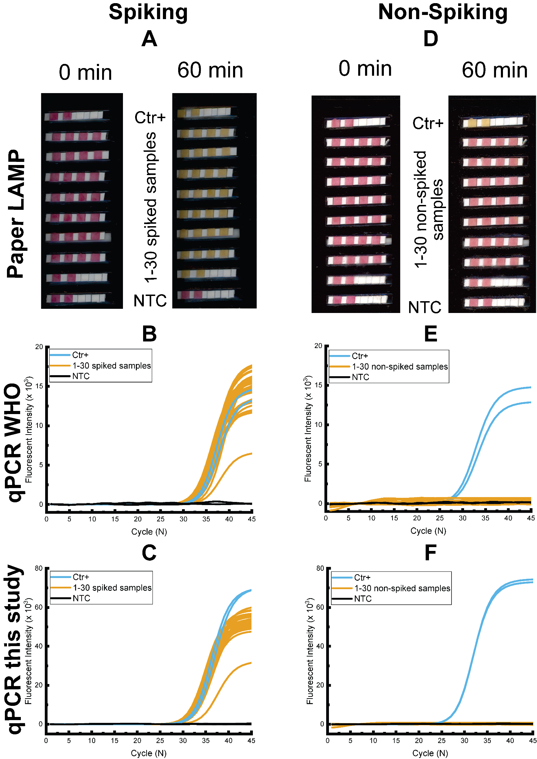
Supplementary Fig. 6: Comparison of Detection Methods for HPAIV in Spiked and Non-Spiked Oropharyngeal Swabs from Poultry
This figure illustrates the detection of HPAIV in oropharyngeal swab samples collected from poultry. A total of 60 samples were analyzed, including 30 spiked swabs containing 1000 copies of HPAIV (A, B, and C) and 30 non-spiked controls (D, E, and F) . Three detection methods were employed: paper LAMP (A, D), quantitative polymerase chain reaction (qPCR) as per WHO protocol (B, E), , and quantitative PCR developed in this study (C, F).

Supplementary tables
Supplementary Table 1: List of RT-LAMP primers designed and used in this study for the HA target gene.
Primer | Sequence (5'-3'）
HPAIV.HA.1_F3 | CAACGGGAAGCTCTGYGAT
HPAIV.HA.1_B3 | TTGAGGCTCCCTGGGTAA
HPAIV.HA.1_LF | GGAGCCATCCAGCTACAC
HPAIV.HA.1_LB | ATGGTCYTACATAGTGGAGM
HPAIV.HA.1_FIP | GTCGCACATTGGGTTTCCTTTTTGGTGAAGCCTCTGATTTTAAAGG
HPAIV.HA.1_BIP | AATTCATCAGAGTGCCGGATTTTTCAGAGGTCATTAGCTGGRTT
HPAIV.HA.2_F3 | ACGGGAAGCTCTGYGATCTA
HPAIV.HA.2_B3 | TTGAGGCTCCCTGGGTAA
HPAIV.HA.2_FIP | GTCGCACATTGGGTTTCCTTTTTGGTGAAGCCTCTGATTTTAAAGG
HPAIV.HA.2_BIP | AATTCATCAGAGTGCCGGATTTTTCAGAGGTCATTAGCTGGRTT
HPAIV.HA.2_LF | GGAGCCATCCAGCTACAC
HPAIV.HA.2_LB | ATGGTCYTACATAGTGGAGM
HPAIV.HA.3_F3 | CGGGAAGCTCTGTGATCTAAAT
HPAIV.HA.3_B3 | TTGAGGCTCCCTGGGTAA
HPAIV.HA.3_FIP | GTCGCACATTGGGTTTCCTTTTTGGTGAAGCCTCTGATTTTAAAGG
HPAIV.HA.3_BIP | AATTCATCAGAGTGCCGGATTTTTCAGAGGTCATTAGCTGGRTT
HPAIV.HA.3_LF | GGAGCCATCCAGCTACAC
HPAIV.HA.3_LB | ATGGTCCTACATAGTGGAGC
HPAIV.HA.4_F3 | CGGGAAGCTCTGTGATCTAAAT
HPAIV.HA.4_B3 | TTGAGGCTCCCTGGGTAA
HPAIV.HA.4_FIP | GTCGCACATTGGGTTTCCTTTTTAAGCCTCTGATTTTAAAGGATTGTA
HPAIV.HA.4_BIP | AATTCATCAGAGTGCCGGATTTTTCAGAGGTCATTAGCTGGRTT
HPAIV.HA.4_LF | GGAGCCATCCAGCTACAC
HPAIV.HA.4_LB | ATGGTCCTACATAGTGGAGC
HPAIV.HA.5_F3 | ATAATGGAAAAGAACGTCACTGTTA
HPAIV.HA.5_B3 | CGCTCCACTATGTAGGACC
HPAIV.HA.5_FIP | CCTTTAAAATCAGAGGCTTCACCTTTTTTGCCCAAGACATACTGGAAA
HPAIV.HA.5_BIP | GTGTAGCTGGATGGCTCCTTTTTTCCGGCACTCTGATGAATT
HPAIV.HA.5_LF | ACAGAGCTTCCCGTTGTG
HPAIV.HA.5_LB | GGAAACCCAATGTGCGAC
HPAIV.HA.6_F3 | GGAAAAGAACGTCACTGTTACAC
HPAIV.HA.6_B3 | CGCTCCACTATGTAGGACC
HPAIV.HA.6_FIP | CCTTTAAAATCAGAGGCTTCACCTTTTTTGCCCAAGACATACTGGAAA
HPAIV.HA.6_BIP | GTGTAGCTGGATGGCTCCTTTTTTCCGGCACTCTGATGAATT
HPAIV.HA.6_LF | ACAGAGCTTCCCGTTGTG
HPAIV.HA.6_LB | GGAAACCCAATGTGCGAC
HPAIV.HA.7_F3 | ATAATGGAAAAGAACGTCACTGTTA
HPAIV.HA.7_B3 | CGCTCCACTATGTAGGACC
HPAIV.HA.7_LF | ACAGAGCTTCCCGTTGTG
HPAIV.HA.7_LB | GGAAACCCAATGTGCGAC
HPAIV.HA.7_FIP | TACAATCCTTTAAAATCAGAGGCTTTTTTTTGCCCAAGACATACTGGAAA
HPAIV.HA.7_BIP | GTGTAGCTGGATGGCTCCTTTTTTCCGGCACTCTGATGAATT
HPAIV.HA.8_F3 | GGAAAAGAACGTCACTGTTACAC
HPAIV.HA.8_B3 | CGCTCCACTATGTAGGACC
HPAIV.HA.8_FIP | TACAATCCTTTAAAATCAGAGGCTTTTTTTTGCCCAAGACATACTGGAAA
HPAIV.HA.8_BIP | GTGTAGCTGGATGGCTCCTTTTTTCCGGCACTCTGATGAATT
HPAIV.HA.8_LF | ACAGAGCTTCCCGTTGTG
HPAIV.HA.8_LB | GGAAACCCAATGTGCGAC
HPAIV.HA.9_F3 | CAACGGGAAGCTCTGTGAT
HPAIV.HA.9_B3 | TTGAGGCTCCCTGGGTAA
HPAIV.HA.9_LF | GGAGCCATCCAGCTACAC
HPAIV.HA.9_LB | ATGGTCCTACATAGTGGAGC
HPAIV.HA.9_FIP | GTCGCACATTGGGTTTCCTTTTTGTGAAGCCTCTGATTTTAAAGGATT
HPAIV.HA.9_BIP | AATTCATCAGAGTGCCGGATTTTTCAGAGGTCATTAGCTGGRTT
HPAIV.HA.10_F3 | AACTTAGAAAGGAGGATAGAGAA
HPAIV.HA.10_B3 | CACTTTCCATACATTCATTATCRCA
HPAIV.HA.10_FIP | TCGTTTTCCATGAGAACTAGAAGTTGAACAAGAAAATGGAAGACGG
HPAIV.HA.10_BIP | AGAACCTTTACGACAAAGTCAGATTGAATTCGAAACAGCCGTT
HPAIV.HA.10_LF | AGCATTATAGGTCCAGACATCT
HPAIV.HA.10_LB | ACAGCTTAGGGATAATGCAAAG
HPAIV.HA.11_F3 | GGAAGACGGATTCCTAGATGTC
HPAIV.HA.11_B3 | ACGTCCCATTTCTCACACTT
HPAIV.HA.11_LF | GGAAATCTAGAGTCCTCTCGTTT
HPAIV.HA.11_LB | CAAAGGAGCTGGGTAACG
HPAIV.HA.11_FIP | CGTAAAGGTTCTTGACATTTGARTCTTTTTGACCTATAATGCTGAACTTCTAGTT
HPAIV.HA.11_BIP | CAAAGTCAGAYTRCAGCTTAGGGTTTTTCATTTGTGATAGAAYTCGAAACARC
HPAIV.HA.12_F3 | GGAAATCTAGAGTCCTCTCGTTT
HPAIV.HA.12_B3 | CAAAGGAGCTGGGTAACG
HPAIV.HA.12_FIP | TTTGTCGTAAAGGTTCTTGACATTTTTTTTGACCTATAATGCTGAACTTCTAGTT
HPAIV.HA.12_BIP | GTCAGAYTRCAGCTTAGGGATAATGTTTTTCATTTGTGATAGAAYTCGAAACARC
HPAIV.HA.12_LF | CTAGAGTCCTCTCGTTTTCCAT
HPAIV.HA.12_LB | CAAAGGAGCTGGGTAACG

