Supplemental Materials and Methods
Cells. HVOX human VF fibroblasts and THP-1 human monocytic cells (ATCC, Manassas, VA) were expanded to P16-18 and P13-15 as described previously.³⁶ Green fluorescent protein-expressing THP-1 (GFP-THP-1) were prepared by transfection of pAcGFP1-Actin (Takara Bio, Shiga, Japan) using DMRIE-C Transfection Reagent (Invitrogen) in accordance with manufacturer’s instructions. GFP-THP-1 cells were separated from GFP-negative cells using FACS Aria IIu (BD), and maintained in the growth medium containing 2mg/mL G418 sulfate (Gibco). Prior to co-culture, VF fibroblasts were exposed to serum-free Dulbecco’s Modified Eagle’s Medium (DMEM) overnight. THP-1-derived macrophages, differentiated through exposure to 50nM phorbol-12-myristate-13-acetate, were treated with 100ng/mL IFN-γ and 100ng/mL LPS (M(IFN/LPS)), and 10ng/mL TGF-β1 (M(TGF)).

Human Vocal Fold Fibroblast and Macrophage Co-Culture. Direct macrophage-fibroblast co-culture was performed as described previously, with some modifications.²⁷ Briefly, M(IFN/LPS) and M(TGF) macrophages were washed twice with PBS and then collected using Hank's balanced salt solution containing 2mM EDTA and 1mg/mL bovine serum albumin (BSA). Following removal of the solution by centrifuge, macrophages were spread onto serum-starved confluent fibroblasts at 2 × 10⁴ cells/cm². Macrophages and fibroblasts were co-cultured in DMEM containing 100 µg/mL BSA +/- 0.1-3,000nM methylprednisolone +/-3µM verteporfin for 24 hours. Indirect macrophage-fibroblast co-culture was performed as described previously.³¹

Quantitative Real-Time Polymerase Chain Reaction (qPCR). Following direct co-culture, HVOX fibroblasts and GFP-positive macrophages were collected together by trypsin/EDTA treatment, and then separated based on GFP expression using FACS Aria IIu. RNA extraction and reverse transcription were performed using the RNeasy Mini Kit (Qiagen, Valencia, CA) and High-Capacity cDNA Reverse Transcription Kit (Applied Biosystems). The TaqMan Gene Expression kit (Life Technologies) was employed for real-time polymerase chain reaction in StepOne Plus (Applied Biosystems). Taqman primer probes for human ACTA2 (Hs00426835_g1), CCN2 (Hs1026927_g1), COL1A1 (Hs00164004_m1), CXCL10 (Hs00171042_m1), FN1 (Hs01549976_m1), IL1B (Hs01555410_m1), TGM2 (Hs00190278_m1), TNF (Hs00174128_m1), PTGS2 (Hs00153133_m1), and GAPDH (Hs02758991_g1) were used. Expression levels relative to GAPDH were quantified by the ΔΔCt method.

Western blotting. Following direct co-culture of fibroblasts and GFP-negative macrophages, protein expression and phosphorylation were assessed by Western blotting as described previously.²⁷ Briefly, cells collected using a lysis buffer containing protease and phosphatase inhibitors were combined with 4x Laemmli Sample buffer (Bio-Rad) and 2-mercaptoethanol. Following electrophoresis, samples were transferred to PVDF membranes (Invitrogen). Membranes were blocked with 5% BSA (Fisher Scientific) and incubated with the antibodies shown in Table S1. Signals developed with SuperSignal™ West Femto Maximum Sensitivity Substrate (Pierce Biotechnology, Rockford, IL) were observed under ChemiDoc MP (Bio-rad, Hercules, CA).

Immunocytochemistry. Following direct co-culture of fibroblasts and GFP-negative macrophages, nuclear localization of GR and YAP/TAZ was assessed by immunocytochemistry as described previously.³⁷ Briefly, cells fixed using 4% paraformaldehyde were permeabilized with 0.2% Triton-X, incubated in PBS containing 0.05% Tween-20 and 2% normal donkey serum (Southern Biotech, Birmingham, AL), and reacted with primary and secondary antibodies shown in Table S1. To determine nuclear regions, 4′,6-diamidino-2-phenylindole (DAPI; PromoCell, Heidelberg, Germany) was employed. Specimens were imaged using a confocal laser microscope (LSM700; Carl Zeiss, Oberkochen, Germany).

Approximation of YAP/TAZ nuclear localization in VF fibroblasts. YAP/TAZ nuclear localization was analyzed on the immunofluorescence images using ImageJ. Macrophages stained with the mixture of CD11b and F480 antibodies and fibroblasts overlapped with macrophages in large parts of their nuclei were removed from the images. The nuclear regions were defined based on DAPI staining via auto-thresholding. A line was drawn over each nuclear region along its longitudinal axis. On this line, nuclear and peri-nuclear ROIs were defined as the portions within the nuclear region and 1-to-5 pixel outside the nuclear region, respectively. The histogram of immunofluorescence intensities was obtained across the nuclear and peri-nuclear ROIs, and the baseline was created based on the lowest intensities in the peri-nuclear ROI to dismiss the background staining of YAP/TAZ in the cytoplasm. The area of the histogram subtracted by the background staining was measured within the nuclear ROI and subsequently divided by the length of the nuclear ROI. The resultant value was determined as the nuclear localization of YAP/TAZ.

Data analysis. Data were collected by independently performed technical triplicate experiments, at least. The R drc package was employed on R studio to determine EC₅₀, IC₅₀, EC₉₀, and IC₉₀.⁴⁰ Concentration-dependent curves are illustrated for data that were applicable of the estimation of EC₅₀/IC₅₀ and fitting into sigmoid curves in all triplicate experiments. Smooth curves are presented for the other data. Means of EC_{x}/IC_{x}, as well as standard deviations, were calculated from the EC_{x}/IC_{x} estimations of triplicate experiments.

Supplemental Table

Table S1. Antibodies.
Target protein |  | Provider | Product ID | Application | Host | Dilution | Conjugation
Primary antibody
 | CD11b | Invitrogen | 14-0112-82 | ICC | Rat | x100
 | GAPDH | Cell Signaling Technology | 2118 | WB | Rabbit | ×10,000
 | GR | Cell Signaling Technology | 3660 | WB, ICC | Rabbit | ×3,000 (WB), x200 (ICC)
 | GR, Ser211-phorphorylated | Cell Signaling Technology | 4161 | WB, ICC | Rabbit | ×500 (WB), x100 (ICC)
 | GR, Ser203-phosphorylated | Garabedian Lab |  | WB | Rabbit | ×1,500
 | F4/80 | Invitrogen | 14-4801-82 | ICC | Rat | x200
 | TAZ | Atlas Antibodies | HPA007415 | ICC | Rabbit | x300
 | YAP | Santa Cruz Biotechnology | sc-101199 | ICC | Mouse | x100
Secondary Antibody
 | Mouse IgG | Cell Signaling Technology | 7076 | WB | Horse | ×20,000 | HRP
 | Mouse IgG | Invitrogen | A32787 | ICC | Donkey | ×2,000 | AlexaFluor647
 | Rabbit IgG | Cell Signaling Technology | 7074 | WB | Goat | ×20,000 | HRP
 | Rabbit IgG | Invitrogen | A32790 | ICC | Donkey | ×2,000 | AlexaFluor488
 | Rat IgG | Invitrogen | A48270 | ICC | Donkey | ×2,000 | AlexaFluor555
 | ICC: Immunocytochemistry. WB: Western blotting. HRP: Horse radish peroxidase.

Supplemental Figures

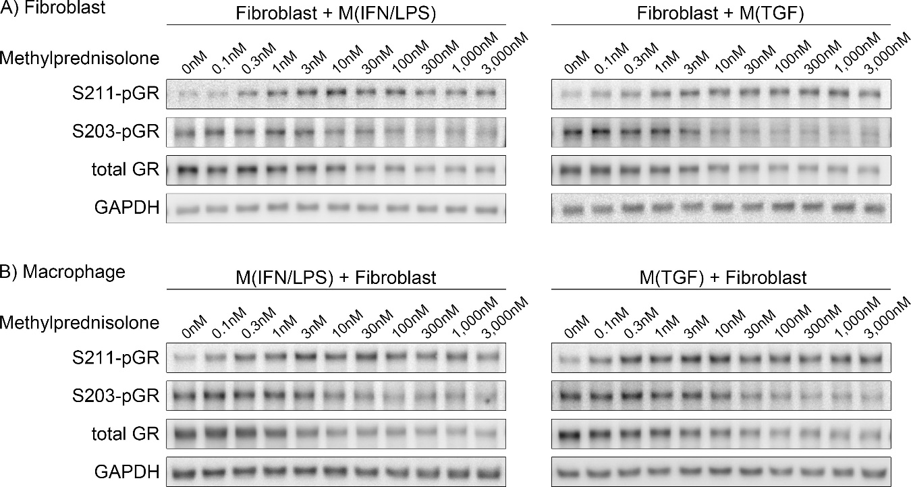

Figure S1. Western blots for S211-pGR, S203-pGR, and tGR from indirectly co-cultured human VF fibroblasts and macrophages. Human VF fibroblasts were indirectly co-cultured with M(IFN/LPS) or M(TGF) macrophages ± 0.1–3,000nM methylprednisolone for 24 hours. Protein from fibroblasts (A) and macrophages (B) was extracted separately after co-culture.

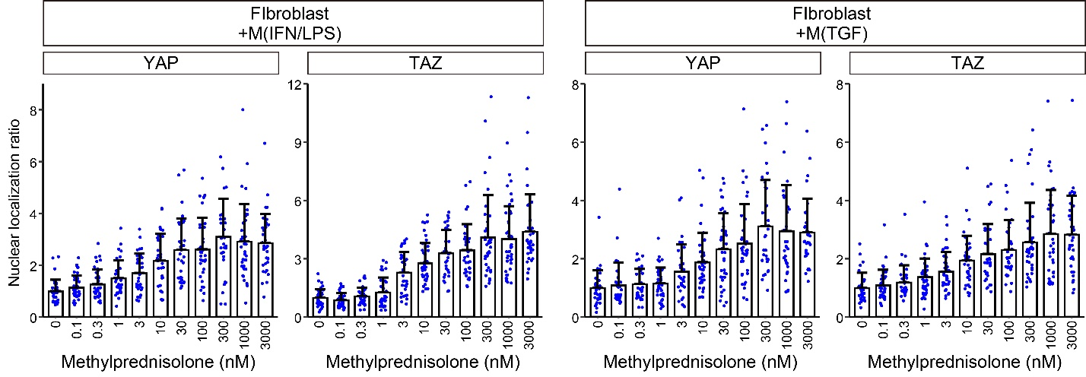
Figure S2. Nuclear localization of YAP/TAZ approximated based on immunofluorescence intensities in DAPI-stained areas in VF fibroblasts. Levels of nuclear localization of YAP/TAZ were determined in each fibroblast as described in Supplemental Materials and Methods. The mean nuclear localization in fibroblasts treated with 0nM methylprednisolone was set to 1. Ratios of nuclear localization were measured in >30 fibroblasts for each. Bar graphs illustrate mean nuclear localization ratio and SD.

Original Images of Western Blots

