Supporting information

An open source, PCR based, point-of-care testing platform
Yaping Xie¹, Zhou Sha¹, Shuaiwu Huang¹, Chiwei Yin¹, Liangcheng Wan¹, Jianjun Li¹, Jiangang Ling¹, Chang Wu¹, and Lizhong Dai^{1, *}
¹Research and development department, Sansure Biotech Co., Ltd., Changsha, 410125, China
*lizhongdai@sansure.com.cn

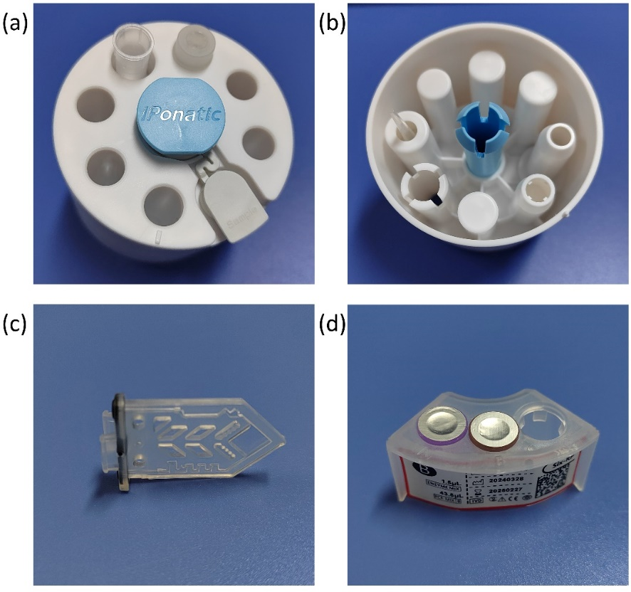
Figure S1 Physical images of various components. (a) Top of the upper shell (b) Bottom of the upper shell (c) PCR chip (d) Detachable reagent rack

Figure S2 The relationship between dye concentration and fluorescence intensity measured in the instrument (a) FAM (b) VIC (c) ROX (d) CY5 (e) Atto 425 (f) CY5.5

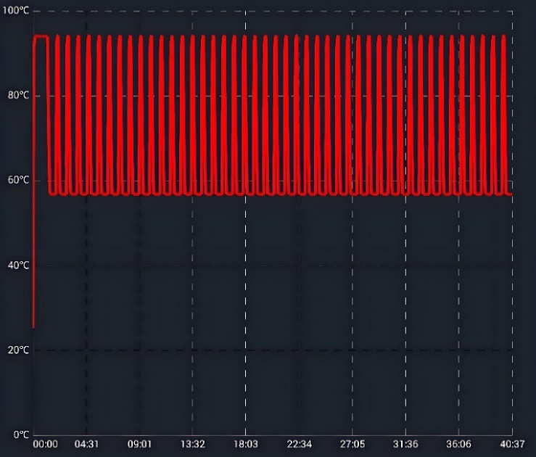
Figure S3 Temperature curve used in the detection of HPV viruses.

Figure S4 The software interface of the instrument. By tapping the corresponding area on the touchscreen, users can customize and modify many parameters, which could meet the needs of most PCR tests. During the nucleic acid extraction process, multiple parameters including pipetting volume, pipetting order, temperature, heating time and magnetic attraction mode could be modified. During the nucleic acid amplification process, multiple parameters including program segments, cycles and temperature could be modified.

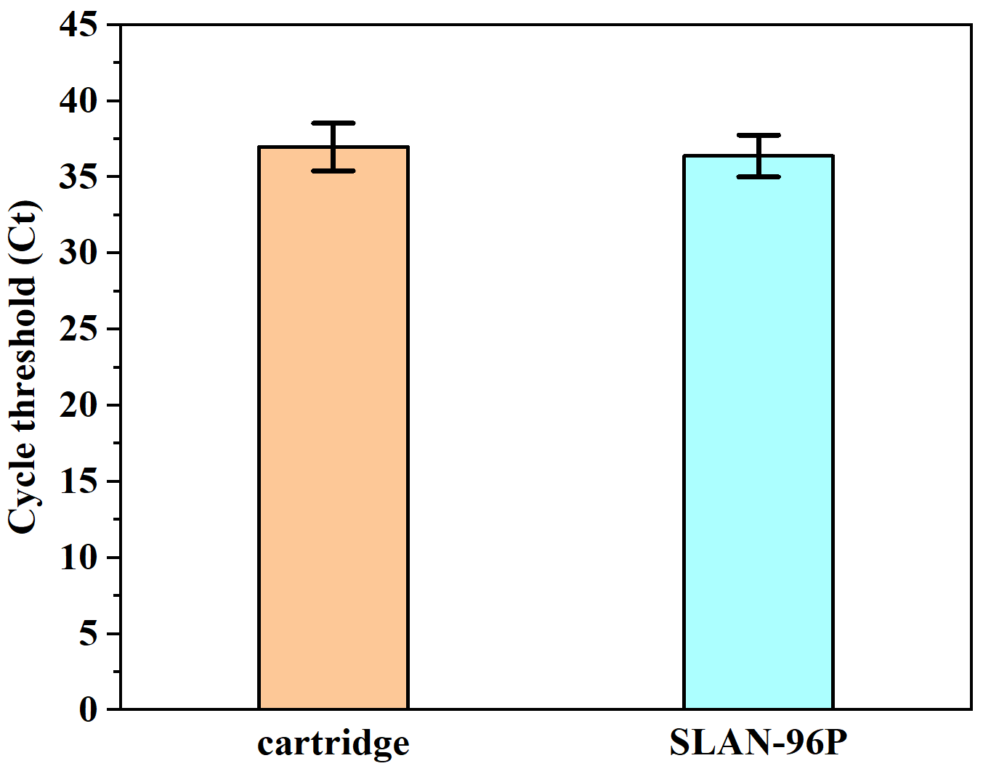
Figure S5 Detection of the novel coronavirus nucleic acid control dilution with a concentration of 200 copies per milliliter by this cartridge system and SLAN-96P.

Figure S6 Detection of 5 samples with reagents from different providers on this system. The amplification curve and temperature curve of the Beijing Applied reagents on the cartridge system was shown in the two images on the left.

Fluorescent Dye | Excitation Filter | Emission filter
Atto 425 | BP440/10 | BP480/10
FAM | BP488/15 | BP515/10
VIC | BP535/10 | BP557/8
ROX | BP580/10 | BP612/20
CY5 | BP635/20 | BP658/10
CY5.5 | BP700/13 | BP742/40
Table S1 Parameters of the filters corresponding to six types of fluorescent dyes

Component | Concentration
DNA template | 10 ng-1 µg per reaction
Primer | 0.1-1 µM
dNTPs | 200-500 µM (for each dNTP)
Polymerase | 2-4 U/100 µL
KCl | 10-50 mM
MgCl | 1.5-2.5 mM
Tris HCl | 10-50 mM
Table S2 Recommended reagent concentration for the PCR reaction

Video S1 A short video, which demonstrated the flow of liquids during the nucleic acid extraction, amplification, and detection process in the cartridge visually.

