Pretreatment PET dissemination features as biomarkers for survival outcomes in melanoma patients treated with immune-checkpoint inhibitors
Hanna Saadani*^{1,4}, Else A. Aalbersberg¹, Mutamba T. Kayembe², John B.A.G. Haanen³, Otto S. Hoekstra⁴, Ronald Boellaard⁴, Marcel P.M. Stokkel¹
1. Department of Nuclear Medicine, Netherlands Cancer Institute, Plesmanlaan 121, 1066 CX Amsterdam, the Netherlands
2. Department of Biometrics, Netherlands Cancer Institute, Plesmanlaan 121, 1066 CX Amsterdam, the Netherlands
3. Department of Molecular Oncology and Immunology, Netherlands Cancer Institute, Plesmanlaan 121, 1066 CX Amsterdam, the Netherlands
4. Department of Radiology and Nuclear Medicine, Amsterdam UMC, Vrije Universiteit Amsterdam, Cancer Center Amsterdam, De Boelelaan 1117, 1081 HV Amsterdam, the Netherlands
Corresponding author: Hanna Saadani, Department of Nuclear Medicine, Netherlands Cancer Institute, Plesmanlaan 121, 1066 CX Amsterdam, the Netherlands, h.saadani@nki.nl, phone:+31(0)205122285
First author: Hanna Saadani, Department of Nuclear Medicine, Netherlands Cancer Institute, Plesmanlaan 121, 1066 CX Amsterdam, the Netherlands, h.saadani@nki.nl, phone:+31(0)205122285

Supplemental Table S1. Dissemination feature names and definitions.
# | Name | Definition
1 | NumberLesions | Number of lesions (volumes of interest delineated)
2 | DmaxPatient | The maximum distance between 2 individual lesions
3 | DmaxBulk | The maximum distance between the largest lesion and another lesion
4 | SpreadPatient | The sum of the distances between all individual lesions
5 | SpreadBulk | The sum of the distances between the largest lesion and all other lesions
6 | VolSpreadBulk | The sum of differences in volume between the largest lesion and all other lesions
7 | DvolPatient | The maximum difference in volume between 2 individual lesions
8 | VolspreadPatient | The sum of differences in volume between all individual lesions
9 | DSUVmaxBulk | The maximum difference in SUV_{max} between the largest lesion and any other lesion
10 | DSUVmaxSumBulk | The sum of the differences in SUV_{max} between the largest lesion and all other lesions
11 | DSUVmaxPatient | The maximum difference in SUV_{max} between 2 individual lesions
12 | DSUVmaxSumPatient | The sum of the differences in SUV_{max} between all individual lesions
13 | DSUVmaxSumHot | The sum of the differences in SUV_{max} between the lesion with the highest SUV_{max} and all other lesions
14 | DSUVpeakBulk | The maximum difference in SUV_{peak} between the largest lesion and any other lesion
15 | DSUVpeakSumBulk | The sum of the differences in SUV_{peak} between the largest lesion and all other lesions
16 | DSUVpeakPatient | The maximum difference in SUV_{peak} between 2 individual lesions
17 | DSUVpeakSumPatient | The sum of the differences in SUV_{peak} between all individual lesions
18 | DSUVpeakSumHot | The sum of the differences in SUV_{peak} between the lesion with the highest SUV_{peak} and all other lesions

Supplemental Table S2. Univariable Cox regression analyses of the PET imaging biomarkers for OS.
PET imaging biomarker | Univariable Cox regression
Dissemination feature (median) | HR | 95%-CI | p-value
Number of lesions | 1.313 | 0.747-2.306 | 0.344
DmaxPatient | 1.783 | 1.008-3.154 | 0.047*
DmaxBulk | 1.949 | 1.100-3.453 | 0.022*
SpreadPatient | 1.320 | 0.751-2.320 | 0.334
SpreadBulk | 1.845 | 1.042-3.266 | 0.036*
VolSpreadBulk | 1.599 | 0.907-2.819 | 0.105
DvolPatient | 1.833 | 1.035-3.247 | 0.038*
VolSpreadPatient | 1.355 | 0.770-2.381 | 0.292
DSUVmaxBulk | 1.308 | 0.743-2.303 | 0.353
DSUVmaxSumBulk | 1.346 | 0.766-2.365 | 0.302
DSUVmaxPatient | 0.873 | 0.498-1.532 | 0.637
DSUVmaxSumPatient | 1.261 | 0.719-2.211 | 0.419
DSUVmaxSumHot | 1.141 | 0.651-2.000 | 0.646
DSUVpeakBulk | 1.535 | 0.868-2.717 | 0.141
DSUVpeakSumBulk | 1.283 | 0.732-2.251 | 0.384
DSUVpeakPatient | 1.111 | 0.633-1.951 | 0.714
DSUVpeakSumPatient | 1.417 | 0.806-2.490 | 0.226
DSUVpeakSumHot | 1.206 | 0.688-2.114 | 0.513
Conventional PET metrics (median)
SUVmax | 0.906 | 0.516-1.588 | 0.729
SUVmean | 1.333 | 0.757-2.347 | 0.319
SUVpeak | 1.063 | 0.606-1.865 | 0.831
Total MATV | 1.444 | 0.821-2.539 | 0.202
Total TLG | 1.261 | 0.719-2.212 | 0.419
* is significant
CI = confidence interval, HR = hazard ratio.

Supplemental Table S3. Univariable Cox regression analyses of the PET imaging biomarkers for PFS.
PET imaging biomarker | Univariable Cox regression
Dissemination feature (median) | HR | 95%-CI | p-value
Number of lesions | 1.101 | 0.638-1.903 | 0.729
DmaxPatient | 1.703 | 0.988-2.934 | 0.055
DmaxBulk | 2.151 | 1.238-3.739 | 0.007*
SpreadPatient | 1.394 | 0.812-2.392 | 0.226
SpreadBulk | 1.730 | 1.003-2.985 | 0.049*
VolSpreadBulk | 1.633 | 0.949-2.809 | 0.076
DvolPatient | 1.426 | 0.831-2.449 | 0.198
VolSpreadPatient | 1.442 | 0.840-2.475 | 0.184
DSUVmaxBulk | 0.959 | 0.558-1.648 | 0.880
DSUVmaxSumBulk | 1.293 | 0.753-2.221 | 0.352
DSUVmaxPatient | 0.793 | 0.462-1.362 | 0.400
DSUVmaxSumPatient | 1.231 | 0.718-2.112 | 0.449
DSUVmaxSumHot | 1.138 | 0.663-1.951 | 0.639
DSUVpeakBulk | 1.017 | 0.592-1.747 | 0.953
DSUVpeakSumBulk | 1.213 | 0.707-2.084 | 0.483
DSUVpeakPatient | 0.888 | 0.517-1.525 | 0.667
DSUVpeakSumPatient | 1.231 | 0.718-2.112 | 0.449
DSUVpeakSumHot | 1.187 | 0.692-2.036 | 0.534
Conventional PET metrics (median)
SUVmax | 0.708 | 0.411-1.219 | 0.213
SUVmean | 1.167 | 0.675-2.017 | 0.581
SUVpeak | 0.855 | 0.498-1.469 | 0.570
Total MATV | 1.325 | 0.773-2.272 | 0.307
Total TLG | 1.175 | 0.685-2.014 | 0.558
* is significant
CI = confidence interval, HR = hazard ratio.

Supplemental Table S4. Univariable Cox regression analyses of the clinical characteristics for OS.
Clinical characteristic | Univariable Cox regression
 | HR | 95%-CI | p-value
Age | 1.009 | 0.988-1.030 | 0.395
Sex | 1.468 | 0.832-2.589 | 0.185
Clinical stage (AJCC 8th edition)
Stage III | reference
Stage IV | 1.130 | 0.547-2.331 | 0.742
Tumor type
Cutaneous & unknown primary | reference
Mucosal | 3.719 | 1.704-8.116 | <0.001*
Immunotherapy type
Pembrolizumab | reference
Ipilimumab/nivolumab | 1.783 | 0.964-3.297 | 0.065
Nivolumab | 1.285 | 0.524-3.152 | 0.584
Ipilimumab/pembrolizumab | 1.076 | 0.145-7.993 | 0.943
Mutation
BRAF wild-type | reference
BRAF mutation | 0.428 | 0.207-0.882 | 0.021*
Performance status
0 | reference
1 | 1.729 | 0.920-3.247 | 0.089
2 | 0.967 | 0.131-7.120 | 0.974
3 | 5.369 | 0.703-41.038 | 0.105
LDH
Normal (≤ 248 U/L) | reference
Elevated (> 248 U/L) | 2.370 | 1.205-4.662 | 0.012*
Number of organs affected
< 3 organs | reference
≥ 3 organs | 1.300 | 0.739-2.284 | 0.362
* is significant
CI = confidence interval, HR = hazard ratio.

Supplemental Table S5. Univariable Cox regression analyses of the clinical characteristics for PFS.
Clinical characteristic | Univariable Cox regression
 | HR | 95%-CI | p-value
Age | 0.997 | 0.978-1.016 | 0.759
Sex | 1.254 | 0.726-2.164 | 0.417
Clinical stage (AJCC 8th edition)
Stage III | reference
Stage IV | 1.208 | 0.606-2.407 | 0.592
Tumor type
Cutaneous & unknown primary | reference
Mucosal | 1.994 | 0.930-4.278 | 0.076
Immunotherapy type
Pembrolizumab | reference
Ipilimumab/nivolumab | 1.666 | 0.923-3.007 | 0.090
Nivolumab | 1.297 | 0.532-3.158 | 0.567
Ipilimumab/pembrolizumab | 1.444 | 0.195-10.688 | 0.719
Mutation
BRAF wild-type | reference
BRAF mutation | 0.687 | 0.367-1.288 | 0.242
Performance status
0 | reference
1 | 1.050 | 0.548-2.012 | 0.882
2 | 0.849 | 0.116-6.220 | 0.872
3 | 3.408 | 0.457-25.397 | 0.232
LDH
Normal (≤ 248 U/L) | reference
Elevated (> 248 U/L) | 2.451 | 1.296-4.632 | 0.006*
Number of organs affected
< 3 organs | reference
≥ 3 organs | 1.191 | 0.694-2.045 | 0.525
* is significant
CI = confidence interval, HR = hazard ratio.

Supplemental figure S1. Correlation matrix four significant dissemination features for OS.
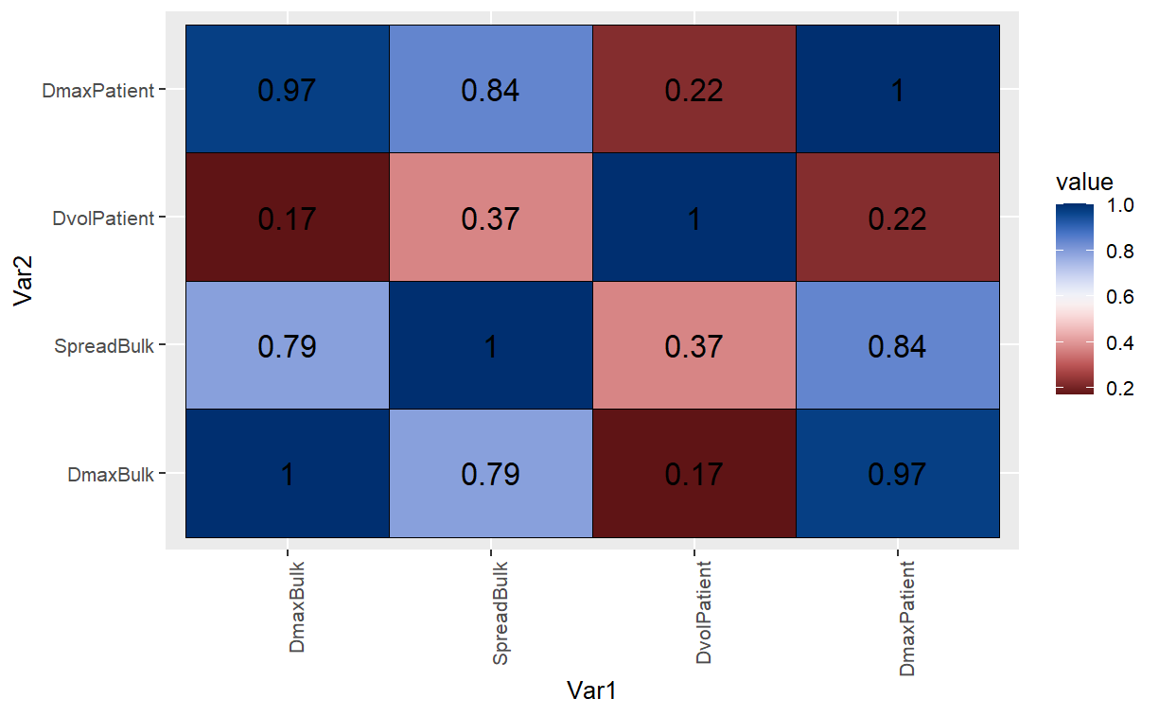

Supplemental figure S2. Correlation matrix two significant dissemination features for PFS.
