Appendix
A | B
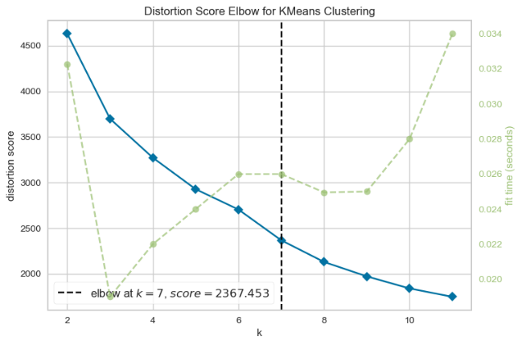 | 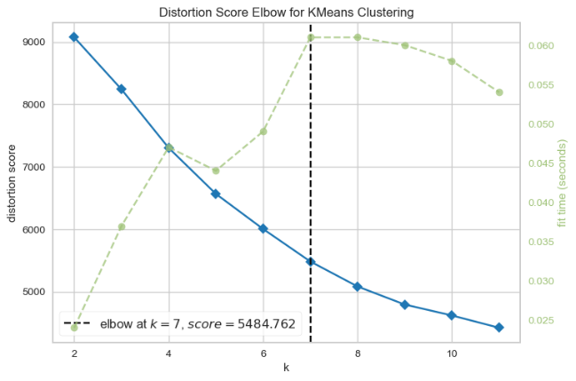
C | D
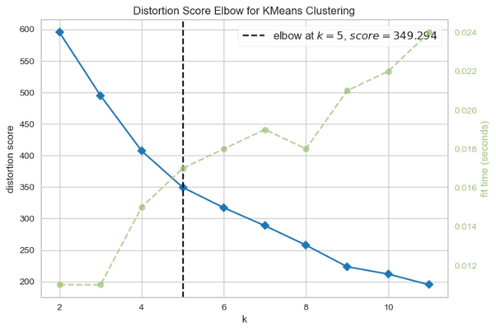 | 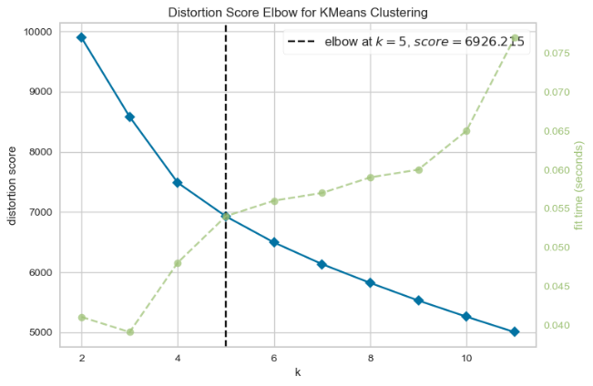
Distortion Score Elbow for K-Means Clustering of (A)Hurricane Ida; (B) Hurricane Harvey; (C) Hurricane Laura; (D) Winter Storm Uri

