Supplementary Material for:
“Controlling Mie Scattering Response to Refractive Index Variations via Light Field Manipulation”
Jianzhi Zeng¹, Hanqing Cai¹, Jiachen Liu^{1, 2, 3}, Haifeng Hu^{1, 2, 3, *}
1 School of Optical-Electrical and Computer Engineering, University of Shanghai for Science and Technology, Shanghai 200093, China
2 Zhangjiang Laboratory, 100 Haike Road, Shanghai 201204, China
3 Shanghai Key Laboratory of Modern Optical System, University of Shanghai for Science and Technology, Shanghai 200093, China
*Corresponding author: hfhu@usst.edu.cn

Comparison of the scattered field distributions obtained by the T-matrix method and the finite element method
According to Mie theory, we need to impose a restricted range on r for the scattered field in Eq. (2) as follows:
(S1)
where r> is the radius of the smallest circumscribing sphere of the particle centered at the origin of the laboratory coordinate system¹. In other words, as long as the radius r_{s}​ of the sphere selected for calculating the T-matrix is greater than r>, the scattered field outside the sphere will be theoretically valid. Therefore, we select an appropriate r_{s} as shown in the Figure S1.(a), where the radius of the blank circle in Figures 2.(c) to (f), and Figures S1.(b) to (c) is r_{s} ​.

To verify the accuracy of the obtained T-matrix, we choose a group of incident field coefficients (a₁₁=1, b₁₁=1) under the vacuum wavelength of 970 nm. Using the obtained T-matrix in main text, we calculated the scattering expansion coefficients according to Eq. (3) and use them to reconstruct the scattered field using Eq. (S1), obtaining the amplitude of the Z-component in the XZ and XY plane, as shown in Figure S1(b, d). Meanwhile, by applying the finite element method with the same incident light, we also simulate the scattered field distribution of the same particle, as illustrated in Figure S1. (c, e). It is visually evident that the two group of results are consistent, thereby validating the correctness of our derived T-matrix.
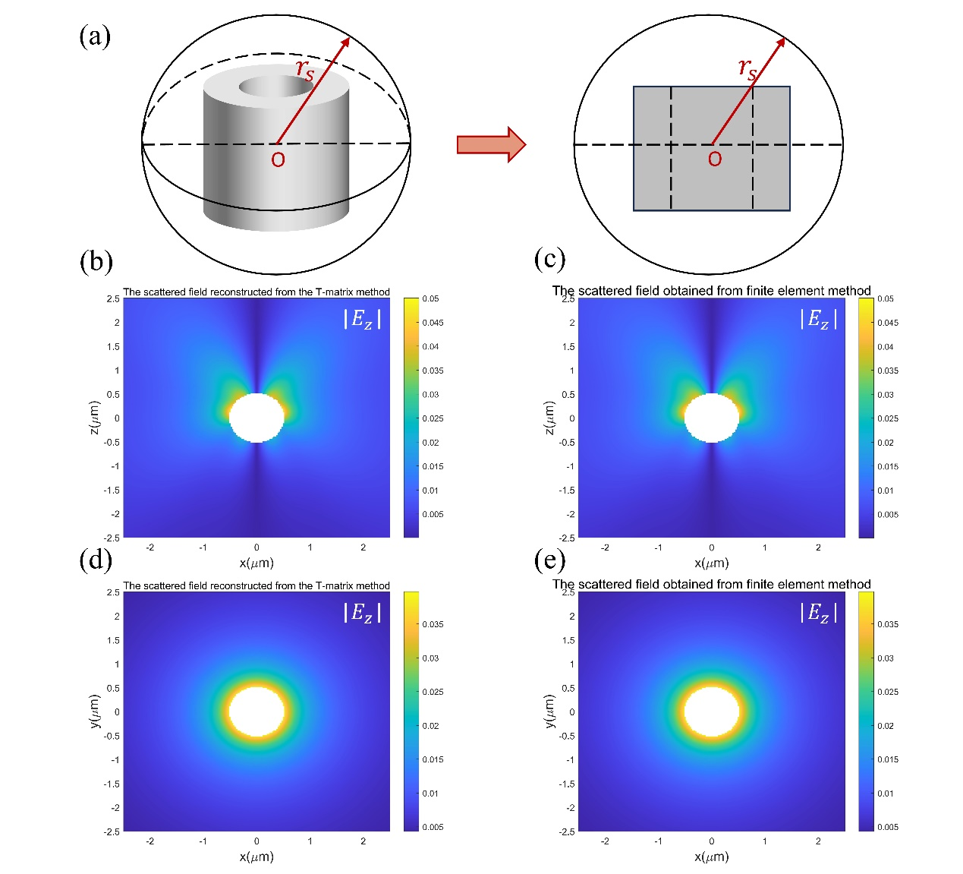
Figure S1. (a) Schematic diagram of the particle and the selected surrounding sphere. (b)(d) The scattered field reconstructed from the T-matrix method. (c)(e) The scattered field obtained from finite element method.

References
1 Mishchenko, M. I., Travis, L. D. & Lacis, A. A. Scattering, absorption, and emission of light by small particles. (Cambridge university press, 2002).

