Supplementary materials:

Tables

Table S1. List of 13 meteorological stations in this study.
No. | Station | Id | Latitude | Longitude | Elevation (m) †
1 | Baluntai | 51467 | 42.73°N | 86.3°E | 1739
2 | Kuche | 51644 | 41.72°N | 82.97°E | 1081.9
3 | Korla | 51656 | 41.25°N | 86.13°E | 931.5
4 | Kashgar | 51709 | 39.47°N | 75.98°E | 1289.4
5 | Aheqi | 51711 | 40.93°N | 78.45°E | 1984.9
6 | Bachu | 51716 | 39.8°N | 78.57°E | 1116.5
7 | Alaer | 51730 | 40.55°N | 81.27°E | 1012.2
8 | Tazhong | 51747 | 39°N | 83.67°E | 1099.3
9 | Tieganlike | 51765 | 40.63°N | 87.7°E | 846
10 | Ruoqiang | 51777 | 39.03°N | 88.17°E | 887.7
11 | Shache | 51811 | 38.43°N | 77.27°E | 1231.2
12 | Pishan | 51818 | 37.62°N | 78.28°E | 1375.4
13 | Hotan | 51828 | 37.13°N | 79.93°E | 1375
† Above sea level

Table S2. Four types of classified dust weather†
Risk Levels | Dust categories | Brief descriptions | Visibility  (km) | Wind | WMO code
Low | Dust in suspension | Widespread dust in suspension, which is not elevated at or near the station at the time of observation. | < 10 | - | 6
↓ | Blowing dust | Raised dust or sand at the time of observation. | 1-10 | - | 7, 8
↓ | Dust storm | Strong winds uplift large amounts of dust particles. | 0.2-1 | strong | 9, 30-32
High | Severe dust storm | Very strong winds uplift large amounts of dust particles. | < 0.2 | very strong | 33-35
†This classification table is based upon WMO’s protocol and references from Shao and Dong, (2006) and Zhang et al. (2023).

Figures

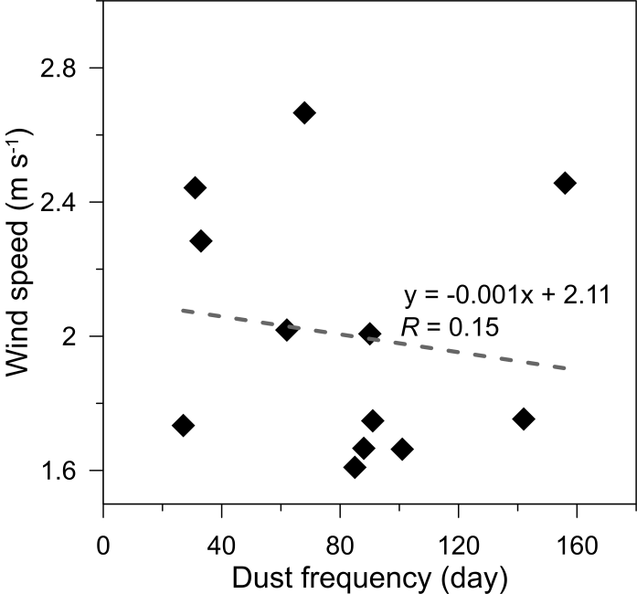
Fig S1. Co-relationship between dust occurrence and surface wind speed in the Tarim Basin.

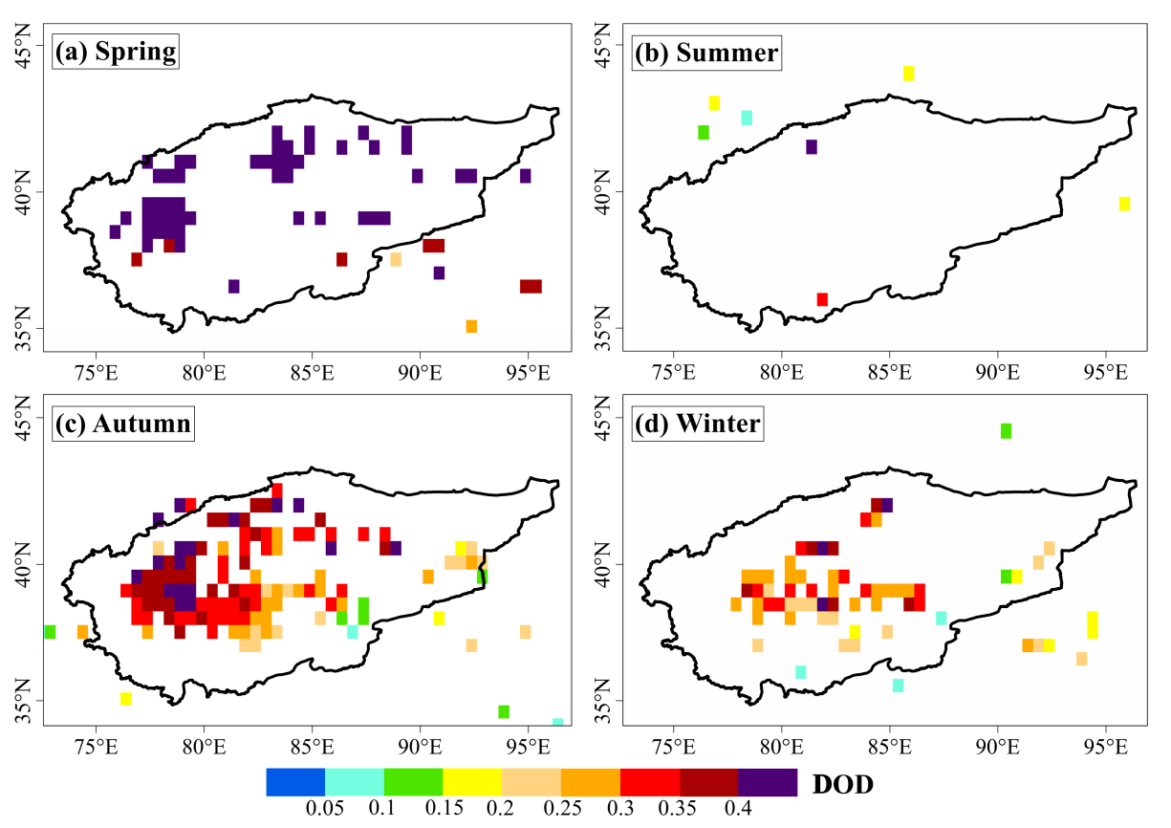
Fig S2. Spatial distribution of seasonal dust optical depth (DOD) in the Tarim Basin in 2015. The DOD is calculated as the averaged aerosol optical depth (AOD) only when the corresponding Angström Exponent is lower than 0.4 (Holben et al., 2001).

